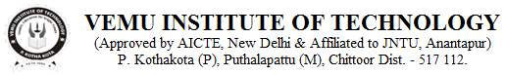__________________________________________________________________________________
04/02/2022
CIRCULAR
We are happy to announce that, we are launching Activity Based Communication Development Club (ABCD CLUB) in our college for the benefit of students. This is operational weekly twice- Friday & Saturday- from 04:15.pm to 06:00.pm.

Objectives:
- Increasing fluency accents and build confidence to think and speak English.
- Integrating students talents, needs, and interests with the English teaching processes.
- Helping them to gain a stage of courage through different activities, etc..

Participants:
1st & 2nd year B.Tech, interested students are required to enroll their names, with their respective class teachers, on or before 12-02-2022.

Note: Day scholars shall arrange their own transport.

Resource persons:
- Sri. S.N.Kareemulla, Soft skills trainer, Training and placement department.
- Sri.P.Jagadessh, Assistant Professor, Department of H&S

Principal

To:
- Chairman sir.
- Vice Principal
- All HODs, to read in the classrooms and to display in notice boards.

