FLUID MECHANICS AND HYDRAULIC MACHINES
(20A01302T)

LECTURE NOTES
II - B.TECH & I- SEM
Prepared by:

MrVinothkumar M, Assistant Professor

Department of Civil Engineering

VEMU INSTITUTE OF TECHNOLOGY
(Approved By AICTE, New Delhi and Affiliated to JNTUA, Ananthapuramu)
Accredited By NAAC, NBA( EEE, ECE & CSE) & ISO: 9001-2015 Certified Institution
Near Pakala, P.Kothakota, Chittoor- Tirupathi Highway
Chittoor, Andhra Pradesh-517 112
Web Site: www.vemu.org
Department of Civil Engineering
Course Code |  | FLUID MECHANICS AND HYDRAULIC MACHINES | L | T | P | C
20A01302T |  |  | 3 | 0 | 0 | 3
Pre-requisite |  | FLUID MECHANICS | Semester |  |  | III
Course Objective:
To impart ability to solve engineering problems in fluid mechanics
To explain basics of statics, kinematics and dynamics of fluids and various measuring techniques of hydrostatic forces on objects.
To enable the students measure quantities of fluid flowing in pipes, tanks and channels
To Introduce concepts of uniform and non-uniform flows through open channel.
To impart knowledge on design of turbines and pumps.
Course Outcomes (CO): After completion of the course, the student can able to
CO-1: Familiarize basic terms used in fluid mechanics
CO-2:Understand the principles of fluid statics, kinematics and dynamics
CO-3:Understand flow characteristics and classify the flows and estimate various losses in flow through channels
CO-4:Analyze characteristics for uniform and non-uniform flows in open channels.
CO-5:Design different types of turbines, centrifugal and multistage pumps.
Unit – I | Introduction to Fluid Statics
Distinction between a fluid and a solid - characteristics of fluids - Fluid Pressure: Pressure at a point, Pascal’s law, pressure variation with temperature, density and altitude. Piezometer, U-Tube Manometer, Single Column Manometer, U Tube Differential Manometer. pressure gauges, Hydrostatic pressure and force: horizontal, vertical and inclined surfaces. Buoyancy and stability of floating bodies.

Unit – II | Fluid kinematics and Dynamics
Classification of fluid flow - Stream line, path line, streak line and stream tube; stream function, velocity potential function. One, two and three - dimensional continuity equations in Cartesian coordinates.
Fluid Dynamics: Surface and body forces; Equations of motion - Euler’s equation; Bernoulli’s equation – derivation; Energy Principle; Practical applications of Bernoulli’s equation :Venturimeter, orifice meter and Pitot tube; Momentum principle; Forces exerted by fluid flow on pipe bend; Vortex Flow – Free and Forced; Definitions of Reynolds Number, Froude Number, Mach Number, Weber Number and Euler Number
Unit – III | Analysis Of Pipe Flow
Energy losses in pipelines; Darcy – Weisbach equation; Minor losses in pipelines; Hydraulic Grade Line and Total Energy Line; Concept of equivalent length – Pipes in Parallel and Series. Laminar Flow- Laminar flow through: circular pipes, annulus and parallel plates. Stoke’s law, Measurement of viscosity. Reynolds experiment, Transition from laminar to turbulent flow. Resistance to flow of fluid in smooth and rough pipes-Moody’s diagram – Introduction to boundary layer theory.
Varied FlowDynamic Equation of Gradually Varied Flow. Hydraulic Jump and classification - Elements and characteristics- Energy dissipation.

Unit – IV | Flow in Open Channels
Open Channel Flow-Comparison between open channel flow and pipe flow, geometrical parameters of a channel, classification of open channels, classification of open channel flow, Velocity Distribution of channel section. Uniform Flow-Continuity Equation, Energy Equation and Momentum Equation, Characteristics of uniform flow, Chezy’s formula, Manning’s formula. Computation of Uniform flow.Specific energy, critical flow, discharge curve, Specific force, Specific depth, and Critical depth. Measurement of Discharge and Velocity – Broad Crested Weir. Gradually

Unit – V | Hydraulic Machines
Impact of Jets- Hydrodynamic force of jets on stationary and moving flat, inclined and curved vanes - velocity triangles at inlet and outlet - Work done and efficiency - Hydraulic Turbines: Classification of turbines; pelton wheel and its design. Francis turbine and its design - efficiency - Draft tube: theory - characteristic curves of hydraulic turbines - Cavitation - Working principles of a centrifugal pump, work done by impeller; heads, losses and efficiencies; minimum starting speed; Priming; specific speed; limitation of suction lift, net positive suction head (NPSH); Performance and characteristic curves; Cavitation effects; Multistage centrifugal pumps; troubles and remedies – Introduction to Reciprocating Pump

Textbooks:
1. P. M. Modi and S. M. Seth, “Hydraulics and Fluid Mechanics”, Standard Book House
2. K. Subrahmanya, “Theory and Applications of Fluid Mechanics”, Tata McGraw Hill

Reference Books:
1. R. K. Bansal, A text of “Fluid Mechanics and Hydraulic Machines”, Laxmi Publications (P) Ltd., New Delhi.
2. K. Subramanya, Open channel Flow, Tata McGraw Hill.
3. N. NarayanaPillai, Principles of “Fluid Mechanics and Fluid Machines”, Universities Press Pvt Ltd, Hyderabad. 3rd Edition 2009.
4. C. S. P. Ojha, R. Berndtsson and P. N. Chadramouli, “Fluid Mechanics and Machinery”, Oxford University Press, 2010.
5. Banga& Sharma, “Hydraulic Machines”, Khanna Publishers.

UNIT-1

INTRODUCTION TO FLUID STATICS

FluidMechanicsisbasicallyastudyof:
- Physicalbehavioroffluidsandfluidsystemsandlawsgoverningtheirbehavior.
- Actionofforcesonfluidsandtheresultingflowpattern.
Fluidisfurthersub-dividedintoliquidandgas.Theliquidsandgasesexhibitdifferent characteristics on account of their different molecular structure. Spacing and latitudeofthemotionofmoleculesislargeinagasandweakinliquidsandverystronginasolid.Itis due to these aspects thatsolidis very compactand rigidinform,liquid accommodatesitselftothe shape ofthe container,and gasfillupthewhole ofthe vesselcontainingit.
Fluid mechanicscovermanyareaslike:
  - Designofwide rangeofhydraulicstructures(dams, canals,weirsetc) andmachinery(Pumps,Turbinesetc).
  - Designofcomplexnetworkofpumpingandpipelines fortransportingliquids.Flowofwaterthroughpipes anditsdistributiontoservicelines.
  - Fluidcontroldevicesbothpneumaticandhydraulic.
  - Designand analysisofgasturbinesandrocket enginesandair–craft.
  - Powergenerationfromhydraulic,streamand Gasturbines.
  - Methodsanddevices formeasurementofpressureandvelocityofafluidinmotion.

UNITSANDDIMENSIONS:
A dimension is a name which describes the measurable characteristics of an object such asmass, length and temperature etc. a unit is accepted standard for measuring the dimension.The dimensions used are expressed in four fundamental dimensions namely Mass, Length,Time andTemperature.
Mass (M) – KgLength (L) – mTime (T)–S
Temperature(t)–⁰CorK(Kelvin)
- Density:Massperunitvolume=kg/m³
- Newton: Unit of force expressed in terms of mass and acceleration, according toNewton’s 2nd law motion. Newton is that force which when applied to a mass of 1 kggivesanacceleration1m/Sec².F=MassxAcceleration= kg–m/sec²=N.
- Pascal:APascalisthepressure produced byaforceofNewtonuniformlyappliedoveranarea of1m².Pressure =Force perunitarea =N/m²= PascalorPa.
- Joule:Ajouleisthework donewhenthepoint ofapplicationofforceof1 Newtonis
displacedWork =Forceperunitarea=Nm=JorJoule.

- Watt:AWatt representsawork equivalentofaJouledoneper second.Power=Workdoneperunittime =J/Sec= WorWatt.
DensityorMass Density: Thedensityormassdensityofafluidis definedas theratioofthemass ofthefluidtoits volume.Thusthemassperunitvolumeofthefluidis called density.Itis denotedbyℓ
Theunit ofmassdensityis Kg/m³

𝜌=

Thevalueofdensityof water is1000Kg/m³.
Mass of fluidVolumeoffluid

SpecificweightorSpecificdensity:Itistheratiobetweentheweights ofthefluidto itsvolume.Theweightperunitvolumeof thefluidiscalledweightdensityanditisdenotedbyw.

w = Weightof fluid
Volumeof fluid
= Massoffluid×Acceleration due togravity
Volumeof fluid

= Massoffluid×gVolumeoffluid
=ρ×g

Specificvolume: Itisdefinedasthevolumeofthefluidoccupiedbyaunitmassorvolumeperunitmassof fluidiscalledSpecific volume.

Specificvolume=
VolumeofthefluidMass offluid
1 1
= Mass offluid =ρ
Volumeofthefluid

ThustheSpecificvolumeisthereciprocal ofMassdensity.Itis expressedas m³//kg/andiscommonlyappliedtogases.

Specific Gravity: It is defined as the ratio of the Weight density (or density) of a fluid to the Weightdensity (or density) of a standard fluid. For liquids the standard fluid taken is water and for gases thestandard liquid taken is air. The Specific gravity is also called relative density. It is a dimension lessquantityanditisdenotedbyѕ.

S(forliquids)=weightdensityofliquid
weightdensityofwater

S(forgases)=weightdensityofgas
weightdensityofair

Weightdensityofliquid=S×weightdensityofwater=S×1000 ×9.81N/m³
Densityofliquid= S×densityofwater=S ×1000 Kg/m³
Ifthespecificgravityoffluidis known,thenthedensityoffluidwillbeequaltospecificgravityofthefluidmultiplied bythe densityofwater
Example:Thespecificgravityofmercuryis 13.6
Hencedensityofmercury=13.6×1000=13600Kg/m³

VISCOSITY: It is defined as the property of a fluid which offers resistance to the movement of onelayer of the fluid over another adjacent layer of the fluid. When the two layers of a fluid, at a distance‘dy’ apart, move one over the other at different velocities, say u and u+du. The viscosity together withrelativevelocitiescausesashearstressactingbetweenthefluidlayers.
Thetoplayercausesashearstress ontheadjacentlowerlayerwhilethelowerlayercausesashearstressontheadjacenttoplayer.
This shear stress is proportional to the rate of change of velocity with respect to y. it is denoted bysymbolτ (tau)
duτ 𝖺
dy
duτ =μ
dy
Whereµis theconstantofproportionalityandisknownas theco-efficient ofdynamicviscosityor
onlyviscosity.durepresentstherateofshearstrainorrateofsheardeformationorvelocitygradient.
dy
Fromtheaboveequation,wehave μ=τ
du
dy

Thus,viscosityisalsodefinedastheshearstress requiredproducingunit rateofshearstrain.TheunitofviscosityinCGSiscalledpoiseandisequaltodyne-see/cm²
KINEMATICVISCOSITY:Itis definedas theratiobetween dynamicviscosityanddensityoffluid.Itisdenotedbysymbol𝖯 (nu)

𝖯 = viscosity =μ
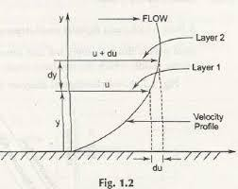
density ρ

Theunitofkinematicviscosityism²/sec

Thusonestoke=cm²/sec= 1

100
²m²/sec= 10⁻⁴m²/sec

NEWTONS LAW OF VISCOSITY: It states that the shearstress (τ) on a fluid element layer is directly proportional tothe rate of shear strain. The constant of proportionality iscalledtheco-efficientofviscosity.Itisexpressedas:
duτ =μ
dy

FluidswhichobeyaboverelationareknownasNEWTONIANfluidsandfluidswhichdonotobeythe aboverelationarecalledNON-NEWTONIANfluids.

UNITSOFVISCOSITY
Theunitsofviscosityisobtainedbyputting thedimensionsofthequantitiesin equation

𝑟
µ =
𝑑𝑢
𝑑𝑦

µ =

Shearstress

Changeofvelocity
changeofdistance
Force/Area

Force/Length²

Force×Time

= (Length)× 1 = 1
= Length2

Time Length Time

InMKSSystemForceisrepresentedby(Kgf)andLengthbymeters(m)InCGSSystemForceisrepresentedbydyne andlengthbycmand
InSISystemForce isrepresentedbyNewton(N)and Lengthbymeter(m)
MKSunitofViscosity=Kg f−Sec
m2
CGSUnitofViscosity=dyne−sec
cm 2

SIUnitofViscosity=Newton–sec Ns
=
m2 m2

(dyne−sec)

TheunitofViscosityin CGSiscalledPoise,whichisequalto .
cm2
ThenumericalconversionoftheunitofviscosityfromMKSunitstoCGSunitisas follows:

One Kg f−secm2
=
9.81N−secm2
(1Kgf= 9.81Newton)

But oneNewton=OneKg(mass)× m(Acceleration)
one
sec2

= (1000gms×100cm)
sec2gm−cm
=1000×100
sec2 cm
=1000×100dyne (dyne =gm× )
sec2
OneKgf−sec =9.81× dyne−sec
100000
m2 .
2
cm
=9.81×100000dyne−sec=9.81×100000 dyne−sec
cm² 100×100×cm²

=98.1dyne−sec
cm 2

(dyne−sec)

=98.1Poise =Poise
cm 2

OneNs
m2
=^{9.81}Poise=10Poise
9.81

Or 1Poise =1Ns
10m2

VARIATIONOFVISCOSITYWITH TEMPERATURE:

Temperature affects the viscosity. The viscosity of liquids decreases with the increase oftemperature,while the viscosity of gases increases with the increase of temperature. The viscousforces in a fluid are due to cohesive forces and molecular momentum transfer. In liquids cohesiveforces predominates the molecular momentum transfer, due to closely packed molecules and with theincrease in temperature, the cohesive forces decreases resulting in decreasing of viscosity. But, in caseof gases the cohesive forces are small and molecular momentum transfer predominates with theincrease in temperature, molecular momentum transfer increases and hence viscosity increases. Therelationbetweenviscosityandtemperatureforliquidsandgasesare:

- Forliquidsµ=µ0
1
1+𝖺t+βt²

Where, µ=ViscosityofliquidattcinPoise.µ0= Viscosityofliquidatоc
αandβareconstantsfortheLiquid.ForWater,µ0=1.79 x10⁻³poise,α=0.03368 andβ=0.000221
Theaboveequationshowsthattheincreaseintemp.TheViscositydecreases.

- Forgases µ= µ0+αt-βt²
For air µ0=0.000017,α=0.056x10⁻⁶,β=0.118 x10⁻⁹
Theaboveequationshowsthatwithincreaseoftemp.TheViscosityincreases.

TYPESofFLUIDS:Thefluidsmaybeclassifiedintothefollowingfivetypes.

1.Idealfluid 2.Realfluid 3.Newtonianfluid 4.Non-Newtonianfluid 5. Ideal plasticfluid
- Idealfluid:Afluidwhichiscompressibleandishavingnoviscosityisknownas idealfluid.Itisonlyanimaginaryfluid asallfluidshave someviscosity.

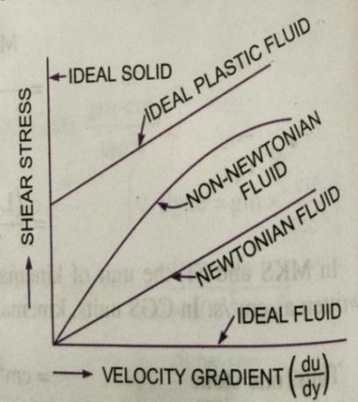
- Realfluid:Afluidpossessingaviscosityisknownasrealfluid.Allfluidsinactualpractice arerealfluids.

- Newtonianfluid:Arealfluid,inwhichthestressisdirectly proportional to the rate of shear strain, is known asNewtonianfluid.

- Non-Newtonianfluid:Arealfluidinwhichshear stressisnot
Proportional to the rate of shear strain is known as Non-Newtonianfluid.

- Idealplasticfluid:Afluid,inwhichshear stress is morethantheyield value and shear stress is proportional to the rate of shear strainisknownasidealplasticfluid.

SURFACETENSION:

Surfacetensionisdefinedasthetensileforceactingonthesurfaceofaliquidiscontactwithagasoronthesurfacebehaveslikeamembraneundertension.Themagnitudeofthisforceperunitlengthoffreesurfacewillhavethesamevalueasthesurfaceenergyperunitarea.Itisdenoted by𝜍(sigma). InMKSunitsitisexpressed asKgf/mwhileinSIunitsasN/m

SurfaceTensiononLiquidDroplet:
Considerasmallsphericaldropletofaliquidofradius‘r’ontheentiresurfaceofthedroplet,thetensileforcedue tosurface tensionwillbeacting
Letσ=surfacetensionoftheliquid
p=pressureintensityinsidethedroplet(Inexcessofoutsidepressureintensity)d= Diameterofdroplet
Let,thedropletiscutintotwohalves. Theforcesactingononehalf(saylefthalf) willbe
- Tensileforceduetosurfacetensionactingaroundthecircumferenceofthecut portion
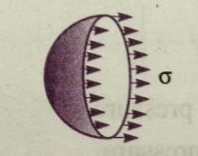
=σ×circumference =σ×𝜋d

- Pressureforceonthearea𝜋d2=p× 𝜋d2
4 4

Thesetwoforceswillbeequaltoandoppositeunder equilibriumconditionsi.e.

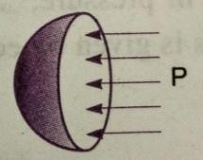
ς𝜋d
𝑝× d2=σ𝜋d, p=

p=𝟒𝜎

4 𝜋d2 𝐝
4

Surface Tension on a Hallow Bubble: A hallows bubble like soap in air has two surfaces incontact with air, one inside and other outside. Thus, two surfaces are subjected to surfacetension.
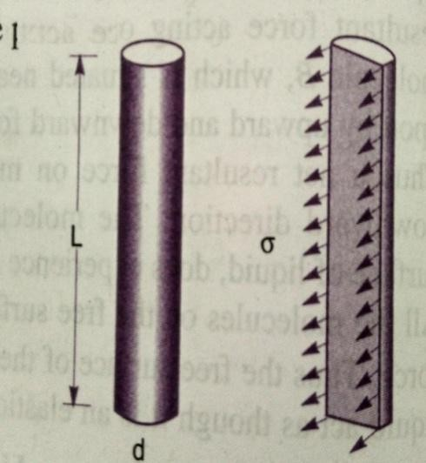
𝑝× d2 =2(σ𝜋)p =𝟖𝜎
4 𝐝

SURFACETENSIONONALIQUIDJET:

Consider a liquid jet of diameter ‘d’ length ‘L’Let,p=pressure intensityinsidethe liquid jetabovetheoutside pressure
σ = surface tension of the liquidConsidertheequilibriumofthesemi- jet

Force due to pressure = p × area of the semi-jet = p × L × dForce duetosurfacetension= σ× 2L
p× L× d=σ× 2L,
p=𝟐𝜎
𝐝

CAPILLARITY
Capillarity is defined as a phenomenon of rise or fall of a liquid surface in a small tube relative to theadjacent general level of liquid when the tube is held vertically in the liquid. The rise of liquid surfaceis known as capillary rise, while the fall of the liquid surface is known as capillary depression. It isexpressed in terms of ‘cm’ or ‘mm’ of liquid. Its value depends upon the specific weight of the liquid,diameterof thetubeandsurfacetensionof theliquid.

EXPRESSIONFORCAPILLARYRISE:
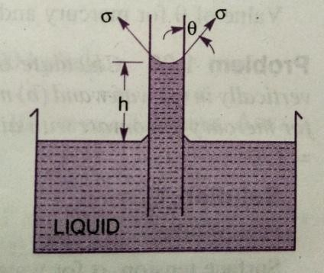
Consideraglass tubeofsmalldiameter‘d’openedat bothendsandis insertedinaliquid; theliquidwillriseinthetubeabovethe levelof theliquidoutsidethe
tube.
Let ‘h’ be the height of the liquid in the tube. Under a state ofequilibrium, the weight of the liquid of height ‘h’ is balanced by theforce at the surface of the liquid in the tube. But, the force at thesurfaceof the liquidinthetubeisduetosurfacetension.
Let σ= surfacetensionofliquid
Ѳ=Angleof contactbetweentheliquidandglasstube

Theweightoftheliquidofheight‘h’inthetube
=(areaofthetube×h)×𝜌× g=𝜋d2×h× 𝜌×g
4
Where‘𝜌′isthedensity oftheliquid.
Theverticalcomponentofthesurfacetensileforce=(σ×circumference) ×cosѲ=σ×𝜋d×cosѲ
Forequilibrium,𝜋 d²×h× 𝜌× g=σ𝜋dcosѲ, ℎ=𝜍𝜋𝑑𝑐𝑜𝑠𝜃=4𝜍 cos∅.

4 𝜋𝑑 2 𝜌×g
4
𝜌 × g×𝑑

𝟒𝝈

ThevalueofѲisequalto‘0’between waterandclean glasstube,thencosѲ=1, 𝒉=

𝝆× 𝐠×𝒅

EXPRESSIONFORCAPILLARYFALL:
Iftheglasstubeisdippedinmercury,theLevelofmercuryinthetubewillbelowerthanthegenerallevelof the outsideliquid.
Let, h = height of the depression in the tube. Then, in equilibrium, two forces are acting on themercuryinsidethetube.Firstoneisduetothesurfacetensionactinginthe downwarddirection=
𝜍×𝜋𝑑×cos𝜃
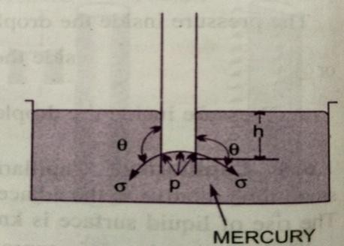
Thesecondforceisduetohydrostatic forceactingupwardandisequaltointensityof pressureatadepth‘h’× area=𝑝 ×𝜋𝑑2=𝜌𝑔ℎ 𝜋𝑑2(p=𝜌𝑔ℎ),
4 4
σ𝜋dcosѲ=𝜌gh𝜋𝑑2
4
(ThevalueofѲforglassandmercury128⁰)
ςπ dcos θρghπd2

h=
4

h =𝒐𝒔𝜽
𝛒 𝒈𝒅

VAPOURPRESSURE AND CAVITATION
A changefrom theliquid state to the gaseous state is known as Vaporizations. Thevaporization (which depends upon the prevailing pressure and temperature condition) occursbecauseofcontinuousescapingofthemoleculesthroughthe freeliquidsurface.

Consider a liquid at a temp. of 20°C and pressure is atmospheric is confined in a closedvessel. This liquid will vaporize at 100°C, the molecules escape from the free surface of theliquid and get accumulated in the space between the free liquid surface and top of the vessel.These accumulated vapours exert a pressure on the liquid surface. This pressure is known asvapourpressureoftheliquidorpressure at whichtheliquidisconverted into vapours.

Consider the same liquid at 20 ° c at atmospheric pressure in the closed vessel and thepressure above the liquid surface is reduced by some means; the boiling temperature will alsoreduce. If the pressure is reduced to such an extent that it becomes equal to or less than thevapour pressure, the boiling of the liquid will start, though the temperature of the liquid is20°C. Thus, the liquid may boil at the ordinary temperature, if the pressure above the liquidsurface is reduced so as to be equal or less than the vapour pressure of the liquid at thattemperature.
Now, consider a flowing system, if the pressure at any point in this flowing liquid becomesequal to or less than the vapour pressure, the vapourisation of the liquid starts. The bubbles ofthese vapours are carried by the flowing liquid in to the region of high pressure where theycollapse, giving rise to impact pressure. The pressure developed by the collapsing bubbles isso high thatthe material from the adjoiningboundaries gets eroded and cavities are formedonthem.This phenomenonis knownasCAVITATION.

Hence the cavitations is the phenomenon of formation of vapour bubbles of a flowingliquid in a region where the pressure of the liquid falls below the vapour pressure and suddencollapsing of these vapour bubbles in a region of high pressure,. When the vapour bubblescollapse, a very high pressure is created. The metallic surface, above which the liquid isflowing, is subjected to these high pressures, which cause pitting actions on the surface. Thuscavitiesare formedonthemetallicsurface andhence the nameiscavitation.

ABSOLUTE,GAUGE,ATMOSPHERICandVACCUMPRESSURES

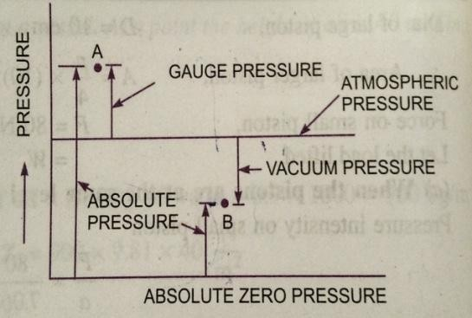
Thepressureonafluidismeasuredintwodifferent systems. In one system, it is measured abovethe absolute zero or complete vacuum and it is calledthe Absolute pressure and in other system, pressure ismeasured above the atmospheric pressure and is calledGauge pressure.
- ABSOLUTEPRESSURE:Itisdefinedasthepressure which is measured with reference to absolutevacuumpressure

- GAUGE PRESSURE: It is defined as the pressure, which is measured with the help of apressure measuring instrument, in which the atmospheric pressure is taken as datum. Theatmospheric onthescaleismarkedaszero.
- VACUUM PRESSURE:Itisdefinedasthepressurebelowtheatmosphericpressure
  - Absolutepressure=Atmosphericpressure+gaugepressurepab=patm+pguag
  - Vacuum pressure = Atmospheric pressure - Absolute pressureTheatmosphericpressureatsealevelat15⁰Cis10.13N/cm²or
101.3KN/m²inSIUnitsand1.033Kgf/cm²inMKSSystem.
The atmosphericpressureheadis 760mmofmercuryor10.33mofwater.

MEASUREMENTOFPRESSURE
Thepressureofafluidis measuredbythefallowingdevices.
1.Manometers2.Mechanicalgauges.
- Manometers: Manometers are defined as the devices used for measuring the pressure at apointin a fluid by balancing the column of fluidby the same or another column of fluid.Theyareclassifiedas:
a)SimpleManometersb)DifferentialManometers.
- Mechanical Gauges:are definedas the devices usedformeasuringthe pressurebybalancing the fluid column by the spring or dead weight. The commonly used Mechanicalpressure gaugesare:
a)Diaphragmpressure gauge b) Bourdontubepressuregauge
- Dead–Weight pressuregauge d)Bellowspressure gauge.
Simple Manometers: A simple manometer consists of a glass tube having one of its endsconnected to a point where pressure is to be measured and the other end remains open to theatmosphere.Thecommontypes ofsimplemanometers are:
  - Piezometer.
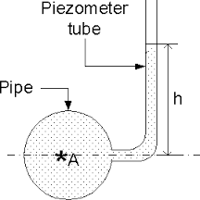
  - U-tubemanometer.
  - Singlecolumnmanometer.
- Piezometer: It is a simplest form of manometer used formeasuringgaugepressure.Oneendofthismanometerisconnected to the point where pressure is to be measured andother end is open to the atmosphere. The rise of liquid in thePiezometergivespressure head atthatpointA.
Theheightofliquid saywateris‘h’ inpiezometertube,then
PressureatA=𝛒g h 𝐍
𝐦𝟐

U-tubeManometer:
It consists of a glass tube bent in u-shape, one end of which is connected to a point at whichpressure is to be measured and other end remains open to the atmosphere. The tube generallycontainsmercury orany otherliquidwhose specific gravity is greater than the specificgravityoftheliquidwhose pressureis tobemeasured.
a)ForGaugePressure:LetBisthepointatwhichpressureistobemeasured, whosevalueisp.ThedatumlineA–A
Let h1 = height of light liquid above datum lineh2=heightofheavyliquidabovedatumline

S1=sp.gravityoflightliquid
ρ1= density of light liquid = 1000 S1S2=sp.gravityofheavyliquid
ρ2=densityof heavyliquid=1000S2
Asthepressureisthesameforthehorizontalsurface.HencethepressureabovethehorizontaldatumlineA–AintheleftcolumnandtherightcolumnofU–tubemanometershouldbesame.
Pressureabove A—Aiontheleftcolumn=p+𝜌₁gh₁Pressure above A – A in the left column = 𝜌₂gh₂Hence equatingthetwopressuresp+𝜌₁gh₁=𝜌₂gh₂
p=𝝆_{𝟐}gh₂-𝝆_{𝟏}gh₁

ForVacuumPressure:
Formeasuring vacuum pressure, the level of heavy fluid in the manometer will be as shown in fig.Pressureabove AAintheleftcolumn=𝜌₂gh₂+𝜌₁gh₁+P
Pressureheadintherightcolumnabove AA=O
𝜌₂gh₂+𝜌₁gh₁+P=O

p=-(𝝆_{𝟐}gh₂+𝝆_{𝟏}gh₁)
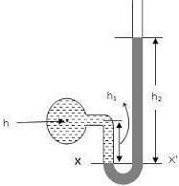
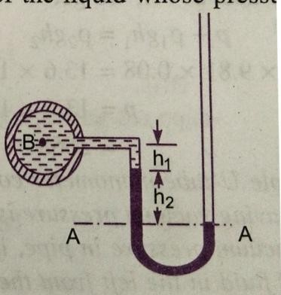

  - ForGaugePressure (b)ForVacuumPressure

SINGLECOLUMNMANOMETER:

Single column manometer is a modified form of a U- tube manometer in which a reservoir,having a large cross sectional area (about. 100 times) as compared to the area of tube isconnected to one of the limbs (say left limb) of the manometer. Due to large cross sectionalarea of the reservoirfor any variation in pressure, the change in the liquid level in thereservoir will be very small which may be neglected and hence the pressure is given by theheight of the liquid in the other limb. The other limb may be vertical or inclined. Thus, therearetwotypes ofsinglecolumnmanometer
1.Verticalsinglecolumnmanometer. 2.Inclinedsinglecolumnmanometer.

VERTICALSINGLECOLUMNMANOMETER:

LetX–Xbethedatumlineinthereservoirandintherightlimbofthemanometer,whenitisconnectedtothepipe,whentheManometerisconnectedtothepipe,duetohighpressureatATheheavyinthereservoir will bepusheddownwardsand willriseintherightlimb.

Let,∆ h= fall of heavy liquid in the reservoirh2= riseofheavy liquidintherightlimb
h1= height of the centre of the pipe above X – XpA= PressureatA,whichis tobemeasured.
A= Cross-sectionalareaofthereservoira = cross sectional area of the right limbS1=Specific.Gravity ofliquid inpipe
S2= sp.Gravityofheavyliquidinthereservoirandrightlimb

𝜌₁=densityof liquidinpipe

𝜌₂=densityofliquidinreservoir

Fallofheavyliquidreservoirwillcauseariseofheavy liquidlevelintherightlimb

A× ∆h=a×h2

∆h=𝑎×ℎ2
𝐴

Nowconsider thedatumlineY–Y

ThepressureintherightlimbaboveY–Y

= 𝜌2×g × (∆h+h2)Pressure inthe leftlimbaboveY—Y
=𝜌1× g× (∆h+h1)+ PA

--------(1)
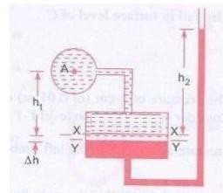

Equatingthepressures, wehave
𝜌2 g × (∆h+h2) = 𝜌1× g × (∆h+h1) + pApA=𝜌2× g× (∆h+h2)-𝜌1 × g×(∆h+h1)
=∆h(𝜌2g 𝜌1g) +h2𝜌2g -h1𝜌1g

But,fromeq(1) ∆h=𝑎×ℎ2
𝐴

𝑎P×Aℎ=2 (𝜌 g-𝜌g)+h₂𝜌g-h₁𝜌g
𝐴 2 1 2 1

AstheareaAisverylargeascomparedtoa,hencetheratioabecomesverysmalland canbe
A
neglectedThen,

pA=h2𝝆𝟐g-h1𝝆𝟏g (2)

INCLINEDSINGLECOLUMNMANOMETER:
The manometer is more sensitive. Due to inclination the distance moved by heavy liquid inthe rightlimbwillbemore.
LetL=lengthofheavyliquidmovedintheritelimb
Ѳ=inclinationofright.Limbwithhorizontal.
H2=verticalriseofheavyliquidintherightlimb aboveX–X
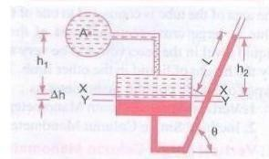
=LsinѲ
Fromaboveeq(2),thepressureatAispA=h2𝜌2g-h1𝜌1g
Substitutingthevalueofh2
pA=LsinѲ𝜌2g-h1𝜌1g

DIFFERENTIALMANOMETERS:

Differential manometers are the devices used for measuring the difference of pressure between twopoints in a pipe or in two different pipes. A differential manometer consists of a U-tube, containingheavy liquid, whose two ends are connected to the points, whose difference of pressure is to bemeasured.ThecommontypesofU-tubedifferentialmanometersare:

1. U-Tubedifferentialmanometer2.InvertedU-tubedifferential manometer.

1. U-Tubedifferentialmanometer:

- Let thetwopoints AandBareatdifferent levels andalsocontains liquidsofdifferentsp.gr.

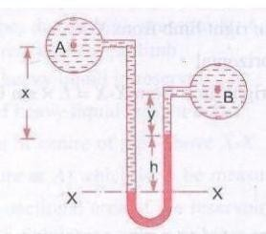
- ThesepointsareconnectedtotheU–Tubedifferentialmanometer.LetthepressureatAandB arepAandpB.

Let h=Differenceofmercurylevelsintheu–tube
y=Distanceof centreof B fromthe mercurylevelintherightlimb
x=Distanceof centreof Afromthe mercurylevelinthe

leftlimb

𝜌₁=DensityofliquidA

𝜌₂=DensityofliquidB
𝜌_{𝑔}= Density of heavy liquid or mercuryTakingdatumlineatX–X
PressureaboveX–Xintheleftlimb=𝜌₁g(h+x)+p_{A} (wherep_{A}=PressureatA)Pressure above X – X in the right limb = 𝜌_{𝑔}g h + 𝜌₂g y + P_{B} (where p_{B} = Pressure at B)Equatingtheabovetwopressures,wehave

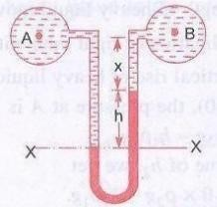
𝜌₁g(h+x)+p_{A} =𝜌_{𝑔}gh+𝜌₂gy+p_{B}
p_{A}-p_{B}=𝜌_{𝑔}gh+𝜌₂gy-𝜌₁g(h+x)
=h g (𝜌_{𝑔}-𝜌₁)+𝜌₂gy-𝜌₁g x
∴DifferenceofPressuresatAandB =hg(𝜌_{𝑔}-ℓ₁)+𝜌₂gy-𝜌₁gx

LetthetwopointsAandB arteatthesamelevelandcontainsthesameliquidofdensityℓ1
Then pressure above X – X in the right limb = 𝜌_{𝑔}g h + 𝜌₁g x + P_{B}PressureaboveX—Xintheleftlimb=𝜌₁g(h+x) +P_{A}
Equatingthetwopressures
𝜌_{𝑔}gh+𝜌₁gx+p_{B}= 𝜌₁g(h+x)+p_{A}P_{A-}P_{B}=𝜌_{𝑔}gh+𝜌₁gx-𝜌₁g(h+x)
=g h (𝜌_{𝑔}-𝜌₁)
DifferenceofpressureatAandB=gh(𝝆_{𝒈}-𝝆_{𝟏})InvertedU–Tubedifferentialmanometer
It consists of a inverted U – tube, containing a light liquid. The two ends of the tube areconnectedtothepointswhosedifferenceof pressureistobemeasured.Itisusedformeasuring difference of low pressures. Letan inverted U– tube differential manometerconnectedtothetwopointsAandB.LetpressureatAismorethanpressureatB.

Leth1= Height of the liquid in the left limb below the datum line X-X h2= Heightoftheliquidinthe rightlimb.

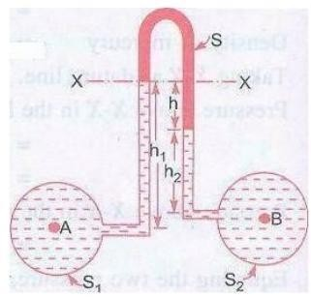
h=Differenceofheightofliquid

𝜌1=DensityofliquidA

𝜌2=DensityofliquidB

𝜌𝑠 = Density of light liquidpA=Pressure atA
pB= Pressure atBTaking x–xasdatumline
Thepressureintheleftlimbbelowx–x=pA-𝜌1gh1

Pressureintherightlimbbelowx–x=pB- 𝜌2gh2-𝜌𝑠ghEquatingtheabove twopressures
pA-𝜌1g h1=pB-𝜌2gh2-𝜌𝑠g hpA– pB=𝜌1gh1-𝜌2g h2-𝜌𝑠gh
Difference ofpressure atA andB=𝝆𝟏gh1-𝝆𝟐gh2-𝝆𝒔gh

PROBLEMS
- Calculatethedensity,specificweightand weight ofoneliter ofpetrolofspecificgravity=0.7

Sol: i)Densityofaliquid= S× Densityofwater= Sx1000 kg/m³

𝜌=0.7×1000

𝜌=700Kg/m³

    - Specificweightw=𝜌× g =700×9.81=6867 N/m³

    - Weight(w) Volume=1liter =1×1000cm³=1000m³⁼0.001m³
106

Weknowthat, specificweightw= weightoffluid
volumeofthefluid

Weightofpetrol=w×volumeofpetrol

= w× 0.001

= 6867× 0.001=6.867N

- Two horizontal plates are placed 1.25 cm apart, the space between them being filled withoilofviscosity14poises.Calculateshear stressinoil,iftheupper plateismovedvelocityof
2.5m/sec.
Sol: Givendistance betweentheplatesdy=1.25 cm=0.0125mViscosity µ=14poise=14Ns/m²
10

Velocityofupperplate u = 2.5 m/sec

Shearstress τ=µdu
dy

Wheredu =change ofvelocity betweenplates= u– 0 = u=2.5m/sec

τ=14
10
×2.5
0.0125

Shearstressτ =280N/m²

- The dynamic viscosity of oil used for lubrication between a shaft and sleeve is 6 poise. Theshaft dia. is 0.4m and rotates at 190 rpm. Calculate the power lost in the bearing for a sleevelengthof90mm.The thicknessfoilfilmis1.5mm
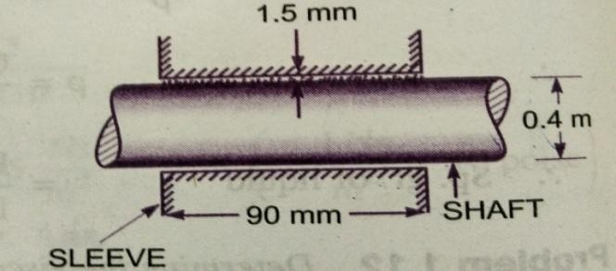
Sol:Given,Viscosityµ=6poise=6 Ns=0.6 Ns
10m2 m2

Dia.ofshaft D = 0.4MSpeedofshaftN=190rpm
SleevelengthL=90mm=90×10⁻³m
Thickness of a film t= 1.5mm = 1.5mm = 1.5 × 10⁻³ mTangentialvelocityofshaft=u =^{π}DN=^{π}×0.4×190=3.98 m/sec
60 60

Using therelationτ=µdu
dy

Where du = change of velocity = u – 0 = u = 3.98 m/secdy=changeofdistance=t=1.5×10⁻³m

τ =0.6× 3.98
1.5×10−3
=1592N/m²

This istheshear stressontheshaft

ShearforceontheshaftF= shearstress× area=1592×πDL= 1592× π× 0.4x90× 10⁻³
=180.05N

TorqueontheshaftT=Force ×D = 180.05×0.4= 36.01Nm
2 2

Powerlost=2πNT=36.01×2π×190×36.01
60 60

Powerlost=716.48 W

- A cylinder 0.12m radius rotates concentrically inside a fixed cylinder of 0.13 m radius. Bothcylinders are 0.3m long. Determine the viscosity of liquid which fills the space between the cylinders,ifatorqueof0.88Nmisrequiredtomaintainanangularvelocityof 2πrad/sec.
Sol: Diameter of inner cylinder = 0.24mDiameter of outer cylinder = 0.26 mLengthofcylinder L = 0.3 mTorque T=0.88NMw=2πN/60=2π
N =speed =60rpmLettheviscosity= µ
Tangentialvelocityofcylinderu =^{π}DN=^{π}×0.24×60= 0.7536 m/sec
60 60
SurfaceareaofcylinderA=πDL= π ×0.24 x0.3 =0.226 m²
Nowusingtherelationτ=µdu
dy
Wheredu=u–0=0.7536m/sec

dy=0.26−0.24
2
τ=µ×0.7536
0.01
=0.02=0.01m

Shearforce, F =shearstressxarea
= µ × 75.36 × 0.226 = 17.03 µTorqueT=F×D/2=17.03µ×0.24
2
0.88=µ×2.0436
µ=0.88
2.0436
=0.4306Ns/ m²
= 0.4306×10poise
Viscosity ofliquid=4.306 poise

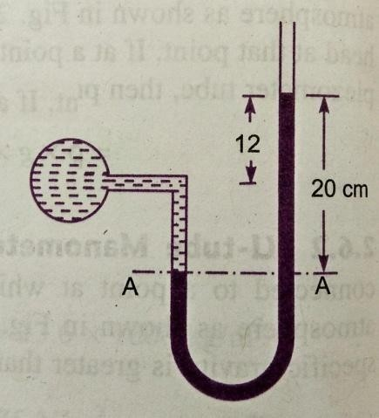
- The right limb of a simple U – tube manometer containing mercury is open to the atmosphere,whiletheleftlimbisconnectedtoapipeinwhichafluidofsp.gr.0.9isflowing.Thecentreofpipeis12cmbelowthe levelofmercuryintherightlimb.Findthe
pressure of fluid in the pipe, if the difference of mercury level in thetwolimbsis20cm.
Given,Sp.gr.ofliquidS1= 0.9
Densityof fluid𝜌₁=S₁× 1000=0.9× 1000=900kg/
m3
Sp.gr.of mercuryS2=13.6
Densityofmercury𝜌₂=13.6× 1000=13600kg/m³
Differenceofmercurylevelh2=20cm=0.2m
HeightofthefluidfromA–A h1=20–12=8cm=0.08mLet‘P’ bethepressureof fluidinpipe
EquatingpressureatA– A,wegetp+𝜌₁gh₁=𝜌₂gh₂

p+900× 9.81× 0.08=13.6× 1000× 9.81×0.2
p=13.6×1000× 9.81× 0.2–900× 9.81×0.08
p=26683–706p=25977N/m²
p = 2.597N/cm²
Pressureoffluid =2.597N/cm²

- A simpleU–tubemanometercontainingmercuryisconnectedtoapipeinwhichafluidofsp.gr.
  - And having vacuum pressure is flowing. The other end of the manometer is open to atmosphere.Find the vacuum pressure in pipe, if the difference of mercury level in the two limbs is 40cm. and theheightof thefluidinthelefttubefromthecentre of pipe is15cmbelow.

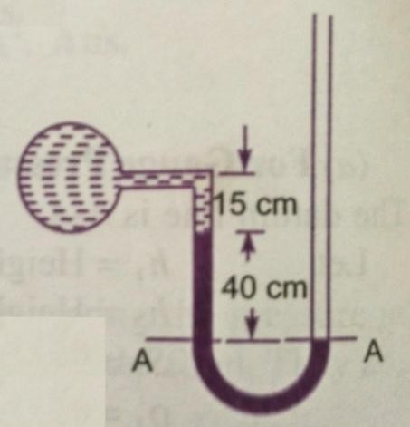
Given,
Sp.groffluid S1=0.8Sp.gr.ofmercuryS2=13.6
Densityofthefluid = S1 × 1000 = 0.8 × 1000 = 800Densityofmercury=13.6 × 1000
Difference of mercury level h2= 40cm = 0.4mHeightoftheliquidintheleftlimb= 15cm=0.15mLetthepressureinthepipe=p
EquatingpressuresabovedatumlineA-- A
𝜌₂gh₂+𝜌₁gh₁+P= 0
P=-[𝜌₂gh₂+𝜌₁gh₁]
=- [13.6×1000× 9.81× 0.4+800×9.81×0.15]
=53366.4+1177.2
=-54543.6N/m²
P= -5.454 N/cm²
- What are the gauge pressure and absolute pressure at a point 3m below the surface of a liquidhaving a density of 1.53 x 10³ kg/m³? If the atmospheric pressure is equivalent to 750mm of mercury.Thespecificgravityofmercuryis13.6anddensityofwater1000kg/m³
Given:

Depthof theliquid,z1=3m
Densityof liquid 𝜌₁=1.53×10³kg/m³
Atmosphericpressurehead z0=750mmof mercury=750
1000

= 0.75mofHg

Atmospheric pressurep_{atm} =𝜌₀×g×z₀

Where𝜌₀=densityof Hg=sp.gr.of mercuryxdensityof water
=13.6 ×1000kg/m³

Andz0=pressurehead intermsofmercury=0.75mofHgPatm=(13.6× 1000)×9.81× 0.75N/m²
= 100062N/m²

Pressureatapoint,whichisatadepthof 3mfromthefreesurfaceof theliquidisP=𝜌₁× g×z₁ =1.53× 10³× 9.81× 3
GaugepressureP=45028N/m²

AbsolutePressure=Gaugepressure+Atmosphericpressure
=45028+100062
AbsolutePressure=145090N/m²

- A single column manometer is connected to the pipe containing liquid of sp.gr.0.9. Find thepressureinthepipeiftheareaofthereservoiris100timestheareaofthetubeofmanometer.sp.gr.of mercury is 13.6. Height of the liquid from the centre of pipe is 20cm and difference in level ofmercuryis40cm.
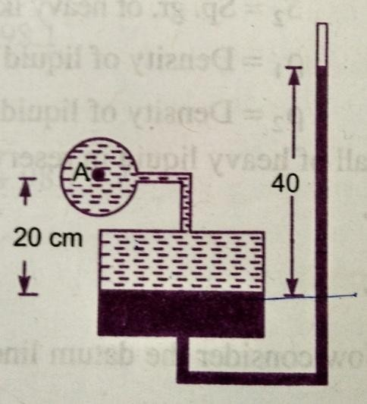
Given,
Sp.gr.ofliquidinpipe S1=0.9
Density 𝜌₁=900kg/m³
Sp.gr.of heavyliquid S2=13.6
Density 𝜌₂=13600

Area of reservoirAreaofrightlimb
=A=100
a

Height oftheliquid h1 = 20cm = 0.2mRiseofmercuryintherightlimb h2= 40cm = 0.4mPressureinpipeA
p=A×h[𝜌g-𝜌 g] h𝜌 g-h𝜌 g
A a 22 1 + 2 2 11

=1
100
×0.4[13600× 9.81–900x9.81]+0.4× 13600× 9.81–0.2× 900× 9.81

=0.4[133416–8829]+53366.4–1765.8
100
=533.664+53366.4–1765.8
=52134N/m²
PressureinpipeA=5.21N/cm²
- Apipecontains anoilofsp.gr.0.9.Adifferentialmanometeris connectedatthetwopoints AandB showsadifferenceinmercurylevelat15cm.findthe difference of pressureatthetwopoints.
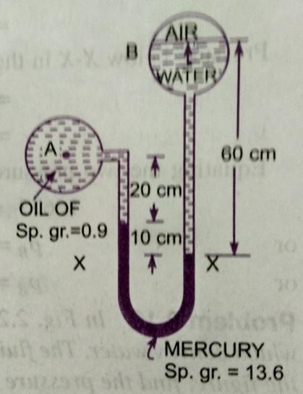
Given: Sp.gr.ofoilS₁=0.9:density 𝜌₁=0.9x1000=900kg/m³Differenceof levelinthe mercuryh=15cm=0.15m
Sp.gr. of mercury = 13.6, Density = 13.6 × 1000 = 13600 kg/m³The differenceof pressurep_{A}–p_{B}=g× h×(𝜌_{𝑔}-𝜌₁)
=9.81x0.15(13600 –900)

pA–pB=18688N/m²
- Adifferential manometeris connectedattwopointsAandB.AtBairpressureis9.81N/cm².FindabsolutepressureatA.
Density of air = 0.9 × 1000 = 900 kg/m³Densityofmercury= 13.6×10³kg/m³

Let pressure at A is pATakingdatumasX –X
PressureaboveX–Xintherightlimb
=1000× 9.81× 0.6+pB=5886+98100=103986
PressureaboveX–X intheleftlimb
=13.6× 10³× 9.81× 0.1+0900× 9.81× 0.2+pA
=13341.6+1765.8+pA
Equating the two pressures heads103986 =13341.6+1765.8+pA
=15107.4+pA
pA=103986–15107.4
=88878.6N/m²
pA =8.887N/cm²

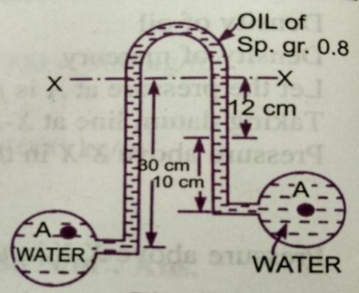
- Water is flowing through two different pipes to which an inverted differential manometer havingan oil of sp.gr. 0.8 is connected. The pressure head in the pipe A is 2m of water. Find the pressure inthepipeBforthemanometerreadingsshowninfig.
Given:PressureheadatA=pA =2mofwater
ρg
pA=ρ× g×2=1000× 9.81×2=19620N/m²
PressurebelowX–X intheleftlimb
=p_{A}-𝜌₁gh₁
=19620–1000×9.81×0.3=16677N/m²
PressurebelowX–X intherightlimb
=pB–1000×9.81× 0.1–800×9.81×0.12
=pB–981–941.76=pB–1922.76
Equatingthetwopressures,weget,
16677=pB-1922.76
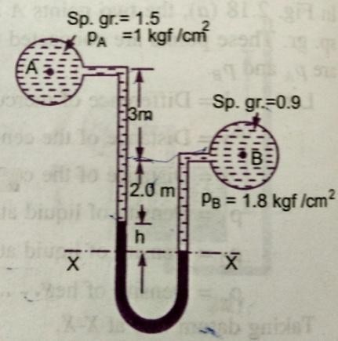
pB= 16677 + 1922.76pB=18599.76N/m²
- A different manometer is connected at two points A and B of twopipes. The pipe A contains liquid of sp.gr. = 1.5 while pipe B containsliquid of sp.gr. = 0.9. The pressures at A and B are 1 kgf/cm² and 1.80 Kgf/cm² respectively. Find the difference in mercury level in the differentialmanometer.
Sp.gr.of liquidatAS1=1.5

Sp.gr.ofliquidatBS2==0.9

Pressure at A pA= 1 kgf/c m² = 1 × 10⁴× kg/m² = 1 × 10⁴× 9.81N/m²PressureatBpB=1.8kgf/cm²⁼1.8×10⁴× 9.81N/m² [1kgf=9.81N]Densityofmercury=13.6 ×1000kg/m³
Taking X – X as datum linePressureaboveX– X inleftlimb
=13.6×1000×9.81×h+1500× 9.81(2+3)+(9.81x10⁴)

Pressure above X – X in the right limb = 900 × 9.81(h + 2) + 1.8 × 9.81 × 10⁴Equatingthetwopressures,we get
13.6×1000×9.81h+1500×9.81× 5+9.81×10⁴=900×9.81(h+2)+1.8 ×9.81×10⁴

Dividing both sides by 1000 × 9.8113.6h+7.5+10=0.9(h+2)+18
(13.6–0.9)h=1.8+18–17.5=19.8–17.5=2.3

h=2.3
12.7
=0.181m

h=18.1cm

UNIT-2

FLUID KINEMATICS AND DYNAMICS
Kinematics is defined as a branch of science which deals with motion of particles withoutconsidering the forces causing the motion. The velocity at any pointin a flow field at anytimeisstudiedinthis.Oncethevelocityisknown,thenthepressuredistributionandhencethe forces actingonthefluidcanbedetermined.
Stream line: A stream line is an imaginary line drawn in a flow field such that the tangentdrawn at any point on this line represents the direction of velocity vector. From the definitionit is clear that there can be no flow across stream line. Considering a particle moving along astream line for a very short distance ‘ds’ having its components dx , dy and dz, along threemutually perpendicular co-ordinate axes. Let the components of velocity vector Vs along x, yand z directions be u, v and w respectively. The time taken by the fluid particle to move adistance ‘ds’alongthe streamline witha velocityVsis:

=ds
Vs
Whichissameas𝑡=dx
u
=dy
v
=ds
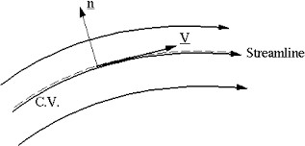
w

Hencethedifferentialequationofthe steamlinemaybewrittenas:
dx dy ds
= = u v w

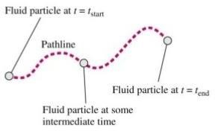
Path line: A path line is locus of a fluid particle as it moves along. In other words a path lineisacurve tracedbyasinglefluidparticleduringits
motion.Astreamlineattimet1indicatingthevelocityvectorsforparticlesAandB.Attimest2andt3theparticleAoccupiesthesuccessivepositions.Thelinecontainingthesevariouspositions ofArepresentsitsPathline

Streak line:When a dyeisinjectedin aliquidorsmokein a gas,soas totrace thesubsequent motion of fluid particles passing a fixed point, the path fallowed by dye or smokeis called the streak line. Thus the streak line connects all particles passing through a givenpoint.
In steady flow, the stream line remainsfixed with respect to co-ordinate axes.Streamlines in steady flow also represent the path lines and streak lines. In unsteady flow, a fluidparticle will not, in general, remain on the same stream line (except for unsteady uniformflow).Hencethestreamlinesandpath linesdonotcoincideinunsteadynon-uniformflow.
Instantaneous stream line: in a fluid motion which is independent of time, the position ofstream line is fixed in space and a fluid particle fallowing a stream line will continue to do so.In case of time dependent flow, a fluid particle fallows a stream line for only a short intervalof time, before changing over to another stream line. The stream lines in such cases are notfixed in space, but change with time. The position of a stream line at a given instant of time isknown as Instantaneous stream line. For different instants of time, we shall have differentInstantaneous stream lines in the same space.The Stream line,Path line and the streak lineare oneandthesame,iftheflowissteady.
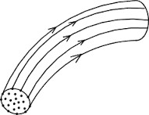
Stream tube: If stream lines are drawn through a closed curve, they form a boundary surfaceacross which fluid cannot penetrate. Such a surface bounded by stream lines is known asStreamtube.
From the definition of stream tube, itis evident thatnofluid can cross the bounding surface of the stream tube. Thisimplies that the quantity of fluid entering the stream tube at oneend must be the same as the quantity leaving at the other end.The Stream tubeis assumed tobe a small cross-sectional area,sothatthevelocityoveritcouldbeconsidereduniform.

CLASSIFICATIONOFFLOWS
Thefluidflow isclassifiedas:
    - Steadyandunsteadyflows.
    - UniformandNon-uniformflows.
    - LaminarandTurbulentflows.
    - Compressibleandincompressibleflows.
    - RotationalandIr-rotationalflows.
    - One,twoandthreedimensionalflows.

- SteadyandUn-steadyflows:Steadyflowisdefinedastheflowinwhichthefluidcharacteristics like velocity, pressure, density etc. at a point do not change with time.Thusforasteadyflow,we have
∂V ∂p ∂ρ

∂tx,y,z
=0, ∂t

x,y,z
=0,
=0
∂tx,y,z

Un-Steadyflow isthe flow inwhichthe velocity,pressure,densityatapointchangeswithrespecttotime.Thusforun-steadyflow,we have
∂V ∂p ∂ρ

∂tx,y,z
≠0, ∂t

x,y,z
≠0,
≠0
∂tx,y,z

- UniformandNon-uniformflows:
Uniformflowisdefinedastheflowinwhichthevelocityatanygiventimedoesnotchange withrespecttospace.(i.e.thelengthofdirectionofflow )
Foruniformflow ∂V =0
∂st=const
Where 𝜕𝑉=Changeofvelocity
𝜕s= Lengthofflowinthe directionof–S
Non-uniformistheflowinwhichthevelocityatanygiventimechangeswithrespect tospace.

ForNon-uniformflow
∂V

≠0
∂st=const

- Laminarandturbulentflow:
Laminar flow is defined as the flow in which the fluid particles move along well-definedpaths or stream line and all the stream lines are straight and parallel. Thus the particles movein laminas or layers gliding smoothly over the adjacent layer. This type of flow is also calledstreamlinefloworviscous flow.
Turbulent flow is the flow in which the fluid particles move in a zigzag way. Due to themovement of fluid particles in a zigzag way, the eddies formation takes place, which areresponsibleforhighenergyloss.For apipeflow,thetypeofflowisdeterminedbyanon-
DimensionalnumberVDcalledtheReynolds number.
𝑣
WhereD =Diameterofpipe.
V=Meanvelocityofflowinpipe.

𝑣=Kinematicviscosityoffluid.
IftheReynoldsnumberislessthan2000,theflow iscalledLaminarflow.IftheReynolds numberis morethan4000,itiscalledTurbulentflow.
IftheReynolds numberis between2000and4000theflowmaybeLaminarorTurbulentflow.
- CompressibleandIncompressibleflows:
Compressibleflowistheflowinwhichthedensityoffluidchangesfrompointtopointorinotherwordsthedensityisnotconstantforthefluid.
Forcompressibleflowρ≠Constant.
Incompressibleflowistheflowinwhichthedensityisconstantforthefluidflow.Liquidsare generallyincompressible,whilethe gasesarecompressible.
Forincompressibleflow ρ =Constant.
- RotationalandIrrotational flows:

Rotational flow is a type of flow in which the fluid particles while flowing along streamlines also rotate about their own axis. And if the fluid particles, while flowing along streamlines,donotrotateabouttheirownaxis,theflowiscalled Ir-rotationalflow.

- One,TwoandThree–dimensionalflows:

One dimensional flow is a type of flow in which flow parameter such as velocity is afunction of time and one space co-ordinate only, say ‘x’. For a steady one- dimensional flow,the velocity is a function of one space co-ordinate only. The variation of velocities in othertwomutuallyperpendiculardirectionsisassumednegligible.

Henceforonedimensionalflowu =f(x),v=0and w=0

Whereu, vandwarevelocitycomponents inx,yandzdirectionsrespectively.

Two – dimensional flow is the type of flow in which the velocity is a function of time andtwo space co-ordinates, say x and y. For a steady two-dimensional flow the velocity is afunction of two space co-ordinates only. The variation of velocity in the third direction isnegligible.
Thusfortwodimensionalflowu =f1(x,y),v =f2(x,y) and w=0.

Three – dimensional flow is the type of flow in which the velocity is a function of time andthree mutually perpendicular directions. But for a steady three-dimensional flow, the fluidparametersare functionsofthreespace co-ordinates(x,y,andz)only.
Thus for three- dimensionalflowu=f1(x,y,z),v=f2(x,y,z),z=f3(x,y,z).

RateoffloworDischarge(Q)
It is defined as the quantity of a fluid flowing per second through a section of pipe or channel.Foran incompressiblefluid (or liquid)the rate of flow ordischargeis expressed as thevolume of the liquid flowing cross the section per second. or compressible fluids, the rate offlowisusuallyexpressed asthe weightoffluidflowing acrossthesection.
Thusi) For liquids the unit of Q ism³/sec or Litres/sec. Ii)For gasestheunitofQisKgf/secorNewton/sec.

ThedischargeQ=A×V
Where, A=Areaofcross-sectionofpipe.
V=Averagevelocityoffluidacrossthesection.

CONTINUITYEQUATION
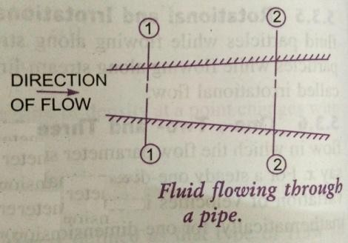
The equation based on the principle of conservation of mass is called Continuity equation.Thusfor a fluidflowing through the pipe atall cross-sections, the quantity of fluid persecondisconstant.Considertwocross-sectionsofapipe.
Let V1 = Average velocity at cross- section1-1ρ1= Densityoffluidatsection1-1
A1= Areaofpipeatsection1-1
AndV2, ρ2,A2arethecorrespondingvaluesatsection2—2Thenthe rateflow atsection1-1 =ρ1A1V1
Rate of flow at section 2—2 = ρ2A2V2Accordingtolawofconservationofmass
Rateofflow atsection1---1=Rateofflowatsection2---2

ρ1A1V1 = ρ2A2V2

This equation is applicable to the compressible as well as incompressible fluids and iscalled “Continuity equation”. If the fluid is incompressible, then ρ1 = ρ2 and the continuityequationreduces to

A1V1 =A2 V2

CONTINUITYEQUATIONINTHREEDIMENSIONALFLOW

Consider afluidelement oflengthsdx,dyand dzinthedirectionofx,yand z.Letu,vandw aretheinletvelocitycomponentsinx,yandz directionsrespectively.

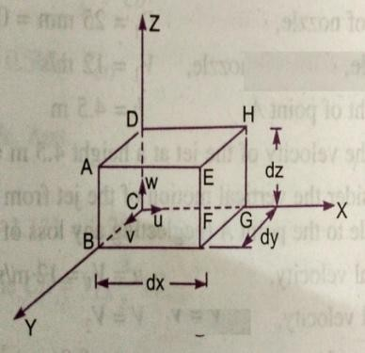
MassoffluidenteringthefaceABCDpersecond

ABCD
=ρ × velocityinx–direction×Areaof

=ρ × u×(dy×dz)

ThenthemassoffluidleavingthefaceEFGHpersecond

=ρ× u×(dy×dz)+𝜕
𝜕𝑥
ρudydzdx

Gainofmassin x-direction
=MassthroughABCD– MassthroughEFGH

persecond.

= ρudydz-ρudydz-𝜕
𝜕𝑥

ρudydzdx

= -𝜕
𝜕𝑥

= -𝜕
𝜕𝑥
ρudydzdx

ρudxdydz (1)

Similarlythenetgainofmassiny-direction.

= −𝜕
𝜕𝑦
𝜌𝑣dxdydz _(2)

Inz–direction =−∂ (ρw)dxdydz _(3)
∂z

Netgainofmass=− ρw dxdydz (4)
∂ | ρu+ | ∂ | ρv+ | ∂
∂x |  | ∂y |  | ∂z

Since mass is neither created nor destroyed in the fluid element , the net increase of mass perunit time in the fluid element must be equal to the rate of increase of mass of fluid in theelement.But themassoρffluidintheelementisρdxdydzanditsrateofincreasewithtime

is𝜕(ρ.dx.dy.dz.)or 𝜕

𝜕𝑡

𝜕𝑡
dx.dy. dz. (5)
.

Equatingthetwoexpressions(4) &(5)
-( ρu+𝜕 ρv + 𝜕ρw)dx dydz=𝜕ρ. dx. dy .dz.
𝜕
𝜕𝑥 𝜕𝑦 𝜕𝑧 𝜕𝑡

𝝏𝛒+ 𝝏𝛒𝐮 +𝝏 𝛒𝐯 + 𝐰 =o (6)
𝝏𝒕 𝝏𝒙 𝝏𝒚 𝝏𝒛
Thisequation isapplicableto
  - Steadyandunsteadyflow
  - Uniformand non-uniformflow,and
  - Compressibleandincompressibleflow.
For steadyflow𝝏𝛒=0 and henceequation(6)becomes
𝝏 𝝏𝒕 𝝏 𝝏
𝛒𝐮 + 𝛒𝐯 + 𝛒𝐰 =0 (7)
𝝏𝒙 𝝏𝒚 𝝏𝒛
Ifthefluidis incompressible, thenρisconstantandtheaboveequationbecomes

𝝏𝒖
𝝏𝒙
+𝝏𝒗
𝝏𝒚
+𝝏𝒘 =o
𝝏𝒛
(8)

This isthecontinuityequationinthree-dimensionalflow.

FLUIDDYNAMICS

A fluid in motion is subjected to several forces, which results in the variation of theacceleration and the energies involved in the flow of the fluid. The study of the forces andenergiesthatareinvolvedinthefluidflowisknownasDynamicsoffluidflow.

Thevarious forcesactingonafluidmass maybeclassifiedas:

- Bodyorvolume forces
- Surfaceforces
- Line forces.

Bodyforces:Thebodyforcesaretheforceswhich areproportionaltothevolumeofthebody.

Examples:Weight,Centrifugalforce,magneticforce,Electromotiveforceetc.

Surface forces: The surface forces are the forces which are proportional to the surface areawhich may include pressureforce,shear or tangential force,force of compressibility andforce duetoturbulenceetc.

Lineforces:Thelineforcesaretheforceswhichareproportionaltothelength.Exampleis surfacetension.
The dynamics of fluid flow is governed by Newton‟s second law of motion which statesthat the resultant force on any fluid element must be equal to the product of the mass andacceleration of the element and the acceleration vector has the direction of the resultantvector.Thefluidisassumed tobeincompressibleandnon-viscous.

∑F=M.a

Where ∑ F represents the resultant external force acting on the fluid element of mass Mand a is total acceleration. Both the acceleration and the resultantexternal force mustbealong same line of action. The force and acceleration vectors can be resolved along the threereferencedirectionsx,yandzandthecorrespondingequationsmaybe expressed as;

∑ Fx=M.ax

∑ Fy=M.ay

∑ Fz=M.az

Where ∑ Fx, ∑ Fyand∑ Fzare the components of the resultant force in the x, y and zdirections respectively, and ax , ay and az are the components of the total acceleration in x, yandzdirections respectively.

FORCESACTINGONFLUIDINMOTION:

Thevariousforcesthatinfluencethemotionoffluidareduetogravity, pressure,viscosity,turbulenceandcompressibility.
ThegravityforceFgisduetotheweightofthefluid andisequaltoMg.Thegravityforce perunitvolumeisequalto“ρg”.
ThepressureforceFpisexertedonthefluidmass,ifthereexistsapressuregradiantbetweenthetwopointsinthedirectionoftheflow.
TheviscousforceFvisduetotheviscosityoftheflowingfluid andthusexistsincaseofallreal fluids.
TheturbulentflowFtisduetotheturbulenceofthefluidflow.
The compressibility force Fc is due to the elastic property of the fluid and it is importantonlyforcompressiblefluids.
Ifacertainmassoffluidinmotionis influencedbyalltheaboveforces,thenaccordingtoNewton‟ssecondlawofmotion
Thenetforce Fx=M.ax= (Fg)x+ (Fp)x+ (Fv)x+ (Ft)x+(Fc)x
- ifthenetforceduetocompressibility(Fc)isnegligible,theresultingnetforceFx=(Fg)x+(Fp)x+(Fv)x+ (Ft)xand theequationofmotionsarecalled

Reynolds’sequationsofmotion.
- Forflowwhere(Ft) isnegligible, theresultingequationsofmotionareknownas

Navier–Stokesequation.
- Iftheflowisassumedtobeideal,viscousforce(Fv)iszeroandtheequationsof motionare knownasEuler’sequationofmotion.

EULER’SEQUATIONOFMOTION

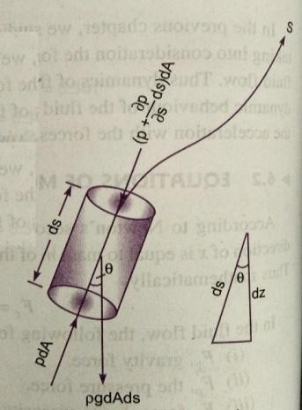
In this equation of motion the forces due to gravity and pressure are taken in toconsideration. This is derived by considering the motion of the fluid element along a stream-line as:
Consider a stream-line in which flow is taking place ins- direction. Consider a cylindrical element of cross-section dA andlengthds.
Theforcesactingonthecylindricalelementare:
- PressureforcepdAinthedirectionofflow.
- Pressureforce𝑝+∂pds𝑑𝐴
∂s
- Weightofelement𝜌gdA.ds
Let𝜃istheanglebetweenthedirectionofflowandtheline

ofactionoftheweightoftheelement.

TheresultantforceonthefluidelementinthedirectionofSmustbeequaltothemassoffluidelement×accelerationinthedirectionofs.
𝑝𝑑𝐴−𝑝+∂p𝑑𝑠𝑑𝐴−𝜌𝑔𝑑𝐴𝑑𝑠 cosθ
∂s
= 𝜌𝑑𝐴𝑑𝑠×𝑎𝑠 (1)Whereasistheaccelerationinthedirectionofs.

Now as= dvdt
where„v‟isafunctionofsand t.

= 𝜕𝑣 𝑑𝑠+𝜕𝑣 =𝑣𝜕𝑣+𝜕𝑣
𝜕𝑠𝑑𝑡 𝜕𝑡 𝜕𝑠 𝜕𝑡
Iftheflowissteady,then 𝜕𝑣 =0
𝜕𝑡
a=𝑣𝜕𝑣
s 𝜕𝑠
Substitutingthevalueofasinequation(1)andsimplifying,weget
−∂pdsdA−ρgdAdscosθ=ρdAds×∂v

∂s
Dividingby𝜌dA.ds,
1 ∂p
−×
ρ ∂s
- ∂p
∂s
−gcosθ=
v∂v

v ∂v

∂s
dz

×
ρ ∂s
+gcosθ+
∂s
=0 Butwehavecosθ=
ds

1 ∂p
×
ρ ∂s
+gdz+
ds
v∂v=0
∂s

^{𝛛𝐩}+ 𝐠𝐝𝐳+ 𝐯𝐝𝐯= 𝟎
𝛒
∴Thisequation isknownasEuler‟sequationofmotion.

BERNOULLI’SEQUATIONFROMEULER’SEQUATION

Bernoulli‟sequationisobtainedbyintegratingtheEuler‟sequationofmotionas

𝑑𝑝

𝜌

+𝑔𝑑𝑧+𝑣𝑑𝑣=𝐶𝑜𝑛𝑠𝑡𝑎𝑛𝑡

Ifthe flow isincompressible,𝜌isconstant and
p v2
+gz+
ρ 2
p v2
+z+
ρg 2g
p v2

=constant

=constant

+ + z = constantρg 2g

TheaboveequationisBernoulli‟sequation inwhich
p
=Pressureenergyperunitweightoffluidorpressurehead.
ρg

v2=Kineticenergyper unitweightoffluidorKinetichead.
2g

z=Potentialenergyper unitweightoffluidorPotentialhead.
Thefollowingaretheassumptions madeinthederivationofBernoulli‟sequation.

- Thefluid isideal.i.e.Viscosityiszero.
- Theflow issteady.
- Theflowisincompressible.
- Theflowisirrotational.

MOMENTUMEQUATION
Itisbasedonthelawofconservationofmomentumoronthemomentumprinciple, which states that the net force acting on a fluid mass equal to the change in themomentumof theflowperunittimeinthatdirection.Theforceactingonafluidmass„m„isgivenbyNewton’s secondlawofmotion.
F =m×a
Where‘a’istheaccelerationactinginthesamedirectionasforce
F.But𝑎 =𝑑𝑣

𝑑𝑡
𝑑𝑣
𝑑𝑚𝑣

𝐹=𝑚 =
𝑑𝑡

𝑑𝑡
(Since misaconstantandcanbetakeninsidedifferential)

𝑑𝑚𝑣
𝐹=

𝑑𝑡
isknownasthemomentumprinciple.

F.dt =d(mv) Isknownastheimpulsemomentumequation.
ItstatesthattheimpulseofaforceFactingonafluidmassminashortintervaloftimedtisequaltothechangeofmomentumd(mv)inthedirectionofforce.

Forceexertedbyaflowingfluidonapipe-bend:
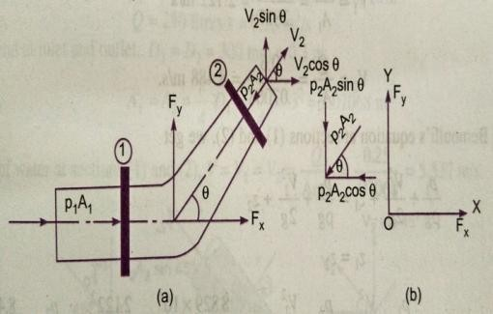
Theimpulsemomentumequationisusedtodetermine the resultant force exerted by a flowing fluidonapipebend.
Considertwosections(1)and(2)asaboveLetv1= Velocityofflowatsection(1)
P1=Pressureintensityatsection(1)
A1=Area ofcross-sectionofpipe atsection(1)
AndV2, P2, A2arecorrespondingvaluesofVelocity, Pressure,Areaatsection(2)
Let Fxand Fy be the components of the forces exerted by the flowing fluid on the bend in x and ydirections respectively. Then the force exerted by the bend on the fluid in the directions of x and ywill be equal to FX and FY but in the opposite directions. Hence the component of the force exertedby the bend on the fluid in the x – direction = - Fxand in the direction of y = - Fy. The other externalforces acting on the fluid are p1A1and p2A2on the sections (1) and (2) respectively. Then themomentumequationinx-directionis givenby
Net force acting on the fluid in the direction of x = Rate of change of momentum in x –directionp1A1–p2A2Cos𝜃-Fx=(Masspersecond)(Change ofvelocity)
=𝜌Q(Finalvelocityinx-direction–Initialvelocityinx-direction)
=𝜌Q(V2Cos 𝜃-V1)
Fx=𝜌Q(V1-V2Cos𝜃)+p1A1–p2A2Cos𝜃 (1)Similarlythemomentumequationiny-directiongives
0 -p2A2Sin𝜃-Fy=𝜌Q(V2Sin𝜃-0)
Fy=𝜌Q(-V2Sin𝜃)-p2A2Sin𝜃 (2)

Nowtheresultantforce(FR) actingonthebend

FR= 𝐹𝑥2+𝐹𝑦2

Andtheanglemadebytheresultantforcewiththehorizontaldirectionisgivenby
𝒕𝒂𝒏𝜽=𝑭𝒚
𝑭𝒙

PROBLEMS

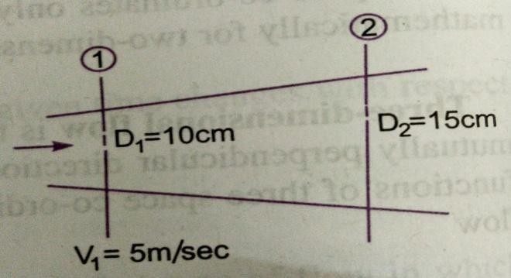
- The diameter of a pipe at sections 1 and 2 are 10 cm and 15cms respectively. Find thedischarge through pipe, if the velocity of water flowing through thepipe at section 1 is5m/sec.determinethevelocityatsection2.

Given:
Atsection1,

D1= 10cms=0.1m
𝐴 =𝜋𝐷2=𝜋0.1²=0.007254𝑚2
1 4 1 4
V1=5m/sec

Atsection2, D2=15cms=0.15m

𝐴2
=𝜋0.15²=0.01767𝑚2
4

Discharge throughpipe Q =A1×V1

=0.007854×5 = 0.03927 m³/sec
Wehave A1V1=A2V2
𝐴1 𝑉1 0.007854
𝑉= = ×5.0=2.22𝑚/𝑠
2 𝐴2 0.01767
- Water is flowing through a pipe of 5cm dia. Under a pressure of 29.43N/cm² and withmean velocity of 2 m/sec. find the total head or total energy per unit weight of water at across-section,whichis 5mabove datumline.

Given: | dia.Ofpipe | =5cm=0.05m
 | Pressure PVelocityV  DatumheadZ | =29.43N/cm²=29.43x10⁴N/m²  =2m/sec  =5m

Totalhead =Pressurehead+Kinetichead+Datum head

29.43×104
Pressurehead== =30𝑚
𝜌𝑔 1000×9.81
Kinetichead=𝑉2 =2×2
=0.204𝑚
2𝑔 2×9.81

Datumhead=Z=5m
𝑝+𝑉2+𝑍=30+0.204+5=35.204𝑚

𝜌𝑔
2𝑔

Totalhead=35.204m

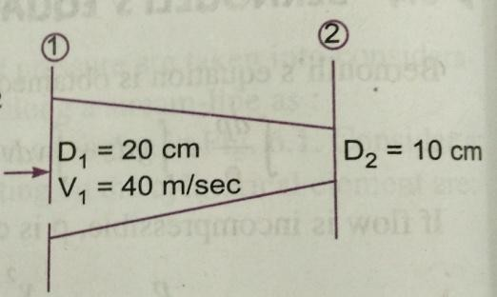
- A pipe through which water is flowing is having diameters 20cms and 10cms at cross-sections 1 and 2 respectively. The velocity of water at section 1 is 4 m/sec. Find the velocityheadatsection1and2andalsorateofdischarge?
Given: D1= 20cms= 0.2m
A1=𝜋× 0.2 ²=0.0314𝑚²
4
V1=4m/sec
D2=10cm=0.1m
A2= 𝜋×0.1 ²=0.007854𝑚²
4
2 4×4
- Velocityheadatsection1 𝑉1 = =

0.815𝑚
2𝑔 2×9.81

2

- Velocityheadat section2𝑉2
2𝑔
TofindV2,applycontinuityequation A𝐴1V1=0A.0231V42×4

𝑉 1𝑉1=

=16𝑚/𝑠𝑒𝑐

Velocityheadatsection2
2=𝐴2 0.00785

𝑉22=16×16=13.047𝑚

2𝑔
- Rateofdischarge
2×9.81

Q=A1V1=A2V2
=0.0314×4 = 0.1256 m³/sec

Q=125.6Liters/sec

- Water is flowing through a pipe having diameters 20cms and 10cms at sections 1 and 2respectively. The rate of flow through pipe is 35 liters/sec. The section 1 is 6m above thedatum and section 2 is 4m above the datum.If the pressure at section 1 is 39.24n/cm².Findthe intensityofpressureatsection2?
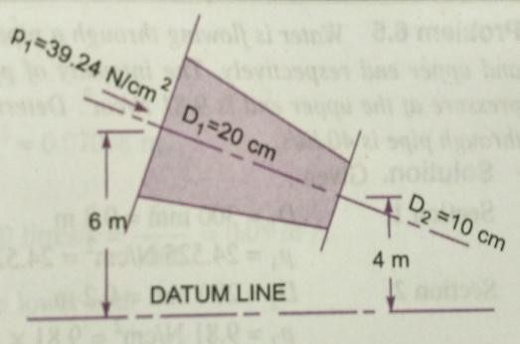
Given:Atsection1 D1=20cm=0.2m
A=𝜋×0.2²=0.0314𝑚2
1 4

10⁴N/m²
P1 = 39.24N/cm² =39.24 x

Z1= 6m

Atsection2 D2=10cm=0.1m
A=𝜋×0.1²=0.0007854𝑚2
2 4
Z2=4m, P2=?
RateofflowQ=35 lt/sec=(35/1000)m³/sec=0.035 m³/sec
Q=A1V1=A2V2
𝑉=𝑄 =0.035 = 1.114𝑚/𝑠𝑒𝑐

1 𝐴1
0.0314

𝑉=𝑄 = 0.035
=4.456𝑚/𝑠𝑒𝑐

2 𝐴2 0.007854

ApplyingBernoulli‟s equationatsections 1and2 𝑃1+𝑉12+𝑍 =𝑃2+𝑉22+𝑍
𝜌𝑔 2𝑔 1 𝜌𝑔 2𝑔 2

39.24×104 1000×9.81 +1.1142+6= 𝑃2
4.4562
+ +4

2×9.81 1000×9.81 2×9.81
40+0.063+6=𝑃2+1.102+4
9810
46.063=𝑃2+5.102
9810
𝑃2=46.063–5.102= 41.051
9810

P2=41.051×9810=402710N/m²

P2=40.271N/cm²

- Water is flowing through a pipe having diameter 300mm and 200mm at the bottom andupper end respectively. The intensity of pressure at the bottom end is 24.525N/cm² and thepressure at the upper end is 9.81N/cm². Determine the difference in datum head if the rate offlow throughis40lit/sec?

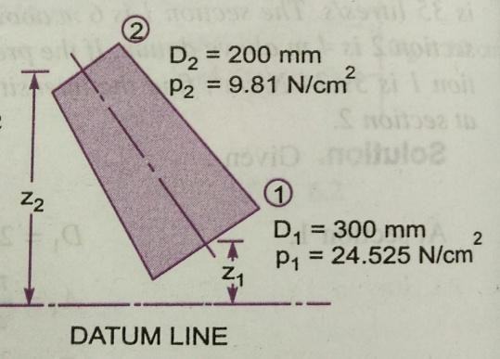
Given:

section1D1=300mm=0.3m
𝜋 2A= 0.07065m²
𝐴1= ×0.3 1
4

P1=24.525N/cm²=24.525×10⁴N/m²

Section2 D2=200mm0.2m

A2=)×(0.2)²
4

=0.0314 m²

P2=9.81N/cm² =9.81×10⁴ N/m²

Rateofflow Q = 40 lit/Sec =40/1000 = 0.04 m³/secQ =A1V1= A2V2

Q
𝑉1=
A1

Q
𝑉2=
A2
= 0.04
0.07065

= 0.04
00.0314
=0.566m/sec

=1.274m/sec

ApplyingBernoulli‟sequationatsections1and2
𝑃1 𝑉² 𝑃2 𝑉²

𝜌𝑔
+¹+ 𝑍=2𝑔 ¹
𝜌𝑔
+ ²+𝑍
2𝑔 ²

24.525× 104 0.566² 9.81×104 1.274²
1000 ×9.81+2 ×9.81+𝑍1=1000×9.81+2 ×9.81+𝑍2
.

25+0.32+Z1=10+1.623+ Z2

Z2–Z1= 25.32–11.623= 13.697orsay13.70m

Thedifferenceindatumhead=Z2–Z1=13.70m

- The water is flowing through a taper pipe of length 100m having diameters 600mm at theupperend and 300mmatthelowerend,at therateof50lts/sec.thepipe hasaslopeof1in30.Find thepressureatthelowerend,ifthepressure atthehigherlevel is19.62N/cm²?
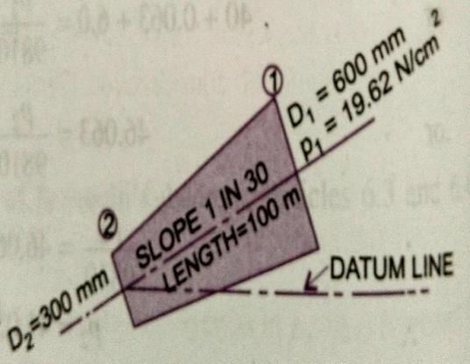
Given:LengthofpipeL=100m
Dia.Attheupperend D1=600mm= 0.6m

𝐴1
=π ×0.6²=0.2827m2
4

P1=19.62N/cm² =19.62×10⁴ N/m²
Dia.at thelowerend D2=300mm=0.3m

𝐴2
=π ×0.3²=0.07065m2
4

Rateofflow Q=50Lts/sec=50=0.05 m³/sec

1000

Let the datumlineispassingthroughthecentreofthe lowerend.ThenZ2= o

Asslopeis1in30means
𝑍1=
1 10
×100=m

30 3

Wealsoknowthat Q=A1V1=A2V2

𝑉1
=Q=0.05 =0.177m/sec
A1 0.2827

𝑉=Q = 0.05
=0.707m/sec

2 A2 0.07065
ApplyingBernoulli‟sequationatsections1and2
𝑉2
𝑃1+¹+𝑍

𝑃2 +

𝑉2 2 +𝑍

𝜌𝑔 2𝑔 1=𝜌𝑔 2𝑔 2
19.62×104 +0.1772+10= 𝑃2 +0.7072+0
1000×9.81 2×9.81 3 1000×9.81 2×9.81

20+0.001596+3.334=P2
9810

+0.0254

P
2
23.335= +0.0254
9810

P2
9810
=23.335–0.0254=23.31

P2=23.31×9810 = 228573N/m²

P2=22.857N/cm²
- A 45° reducing bend is connected to a pipe line, the diameters at inlet and out let of thebend being 600mm and 300mm respectively. Find the force exerted by the water on the bend,if the intensity of pressure at the inlet to the bend is 8.829N/cm² and rate of flow of water is600Lts/sec.
Given:Angleofbend𝜃=45°

Dia.atinletD1= 600mm=0.6m 𝐴₁
=×^{π}(0.6)=0.22827m 2
4

Dia.at out let D2=300mm= 0.3m A2=π×(0.3)²=0.07065m²
4
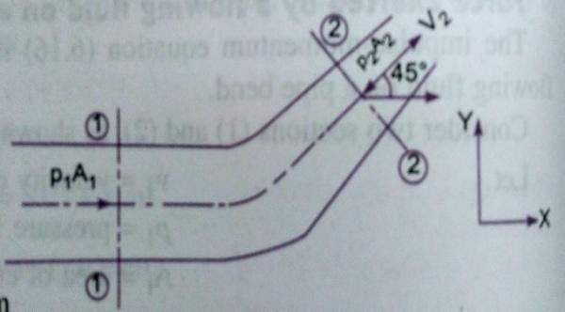
PressureatinletP1=8.829N/cm² =8.829×10⁴N/m²Q = 600Lts/sec= 0.6m³/sec

V1=
Q 0.6
= =2.122m/sec
A1 0.2827
Q 0.6

V2= =
A
2
0.07068=8.488m/sec

ApplyingBernoulli‟sequationatsections1and2,we get ^{𝑃}1+𝑉2+𝑍=𝑃+𝑉2+𝑍
1
2
2

𝜌𝑔 2𝑔 1 𝜌𝑔 2𝑔 2

ButZ =Z,then 𝑃1
𝑉122+𝑉2 2

+ =
1 2 𝜌𝑔 2𝑔 𝜌𝑔 2𝑔

8.829×104
2.1222 P₂
8.4882

+ = =

1000 ×9.81 2×9.81 1000×9.81
2×9.81

9+0.2295=P2
9810
+3.672 P2
9810

=9.2295-3.672=5.5575 mofwater

P2=5.5575× 9810= 5.45×10⁴N/m²
Force exerted on the bend in X and Y – directionsFx=𝜌Q(V1-V2Cos𝜃)+P1A1– P2A2Cos𝜃
=1000× 0.6(2.122–8.488Cos45°)+8.829×10⁴×0.2827–5.45× 10⁴× 0.07065×Cos45°
= -2327.9+24959.6–2720.3 =24959.6-5048.2=19911.4N
Fx=19911.4N
Fy=𝜌Q(-V2Sin𝜃)-P2A2Sin𝜃
=1000×0.6(-8.488Sin45°)-5.45×10⁴×0.07068Sin45°
=-3601.1-2721.1=-6322.2N
(- vesignmeansFyisactinginthedownwarddirection)

Fy=-6322.2N
Thereforethe ResultantForce FR= 𝐹𝑥2+𝐹𝑦2= (19911.4)²+(-6322.2)²=20890.9N

FR=20890.9N
TheanglemadebyresultantforcewithX–axisisTan𝜃 =Fx
Fy

=(6322.2/19911.4)=0.3175

𝜽=tan⁻¹0.3175=𝟏𝟕𝟎𝟑𝟔′

UNIT-3
ANALYSIS OF PIPE FLOW

The concept of boundary layer was first introduced by a German scientist, Ludwig Prandtl, in the year1904. Although, the complete descriptions of motion of a viscous fluid were known through Navier-Stokes equations, the mathematical difficulties in solving these equations prohibited the theoreticalanalysis of viscous flow. Prandtl suggested that the viscous flows can be analyzed by dividing the flowinto two regions; one close to the solid boundaries and other covering the rest of the flow. Boundarylayer is the regions close to the solid boundary where the effects of viscosity are experienced by theflow. In the regions outside the boundary layer, the effect of viscosity is negligible and the fluid istreated as inviscid. So, the boundary layer is a buffer region between the wall below and the inviscidfree-stream above.This approach allows the complete solution of viscous fluidflows which wouldhave been impossible through Navier-Stokes equation. The qualitative picture of the boundary-layergrowthoveraflatplateis shown inFig.1.

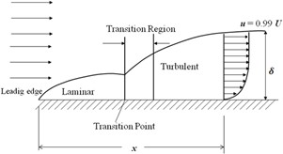

Fig.1:Representationofboundarylayer onaflatplate.

A laminar boundary layer is initiated at the leading edge of the plate for a short distance and extends todownstream. The transition occurs over a region, after certain length in the downstream followed byfully turbulent boundary layers. For common calculation purposes, the transition is usually consideredto occur at a distance where the Reynolds number is about 500,000. With air at standard conditions,moving at a velocity of 30m/s, the transition is expected to occur at a distance of about 250mm. Atypicalboundarylayerflowischaracterizedbycertainparametersasgivenbelow;

Boundary layer thickness: It is known that no-slip conditions have to be satisfied at the solidsurface: the fluid must attain the zero velocity at the wall. Subsequently, above the wall, the effectof viscosity tends to reduce and the fluid within this layer will try to approach the free streamvelocity. Thus, there is a velocity gradient that develops within the fluid layers inside the smallregions near to solid surface. The boundary layer thickness is defined as the distance from thesurface to a point where the velocity is reaches 99% of the free stream velocity. Thus, the velocityprofilemergessmoothlyandasymptoticallyintothe free streamasshown inFig.2.

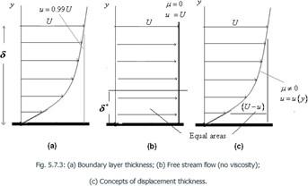

Fig. 2:(a)Boundarylayerthickness;(b)Freestreamflow(noviscosity);

(c)Conceptsofdisplacementthickness.

CLOSEDCONDUITFLOW:
REYNOLDS EXPERIMENT: It consists of a constant head tank filled with water, a smalltank containing dye, a horizontal glass tube provided with a bell-mouthed entrance a andregulating valve. The water was made to flow from the tank through the glass tube in to theatmosphere and the velocity if flow was varied by adjusting the regulating valve. The liquiddyehavingthesamespecificweightasthatofwaterwasintroducedintotheflowatthebell
–mouththrougha smalltube
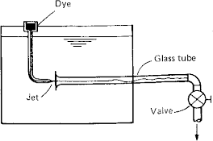
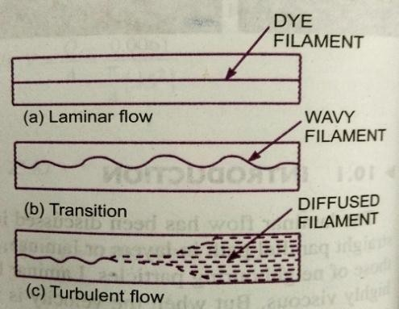

From the experiments it was disclosed that when the velocity of flow was low, the dyeremained in the form of a straight line and stable filament passing through the glass tube sosteady that it scarcely seemed to be in motion with increase in the velocity of flow a criticalstate was reached at which the filament of dye showed irregularities and began of waver.Further increase in the velocity of flow the fluctuations in the filament of dye became moreintense and ultimately the dye diffused over the entire cross-section of the tube,due tointerminglingofthe particles oftheflowingfluid

Reynolds‟s deduced from his experiments that at low velocities the intermingling ofthefluid particles was absentand thefluid particlesmovedin parallel layers orlamina,sliding past the adjacent lamina but not mixing with them. This is the laminar flow. At highervelocities the dye filament diffused through the tube it was apparent that the intermingling offluid particles was occurring in other words the flow was turbulent. The velocity at which theflow changes from the laminar to turbulent for the case of a given fluid at a given temperatureand in a given pipe is known as Critical Velocity. The state of flow in between these types offlowis knownas transitionalstateorflowintransition.
Reynoldsdiscoveredthattheoccurrenceoflaminarandturbulentflowwasgoverned by the relative magnitudes of the inertia and the viscous forces.Atlow velocitiesthe viscous forces become predominant and flow is viscous. At higher velocities of flow theinertial forces predominance over viscousforces.Reynolds related theinertia toviscousforcesandarrivedata dimensionlessparameter.

𝑅_{𝑒}
𝑜𝑟𝑁_{𝑒}
= inertia forceviscousforce
=𝐹𝑖
𝐹𝑣

According to Newton‟s 2nd law of motion, the inertia force Fi is given byFi=mass ×acceleration
=ρ ×volume ×acceleration ρ =massdensity

= ρ×L³×L
T2

=ρ L²V² ----------(1) L=Lineardimension

SimilarlyviscousforceFVisgivenbyNewton’s2ndlawofvelocityas
FV=τ×area τ=shearstress
=µdv×L²=µVL ----------------(2) V=AverageVelocityofflow
dy

R orN= ρL2V2=ρVL
µ=Viscosityoffluid

e R

IncaseofpipesL=D
μVL μ

Incaseofflowthroughpipes𝑅_{𝑒}
=ρDV
μ
or𝑉𝐷 𝜈
𝑣

Whereµ/ρ=kinematicviscosityoftheflowingliquidν
TheReynolds numberisaveryusefulparameterinpredictingwhether theflowis laminarorturbulent.

Re< 2000 viscous / laminar flowRe→ 2000to4000transientflowRe> 4000 Turbulentflow
FRICTIONALLOSSINPIPEFLOW–DARCYWEISBACKEQUATION

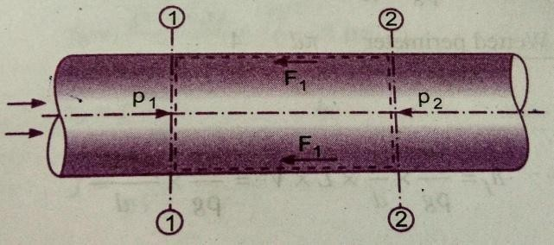
Whenaliquidisflowingthroughapipe,thevelocityoftheliquid layer adjacent to the pipe wall iszero. Thevelocity of liquidgoesonincreasingfromthewallandthusvelocitygradientandhenceshearstressesareproducedinthewholeliquiddue toviscosity.Thisviscousaction causes loss of energy, which isknownasfrictionalloss.

Consider auniformhorizontalpipehaving steadyflow. Let1-1,2-2 aretwosectionsofpipe.
Let P1=Pressureintensityatsection1-1V1=Velocityofflow atsection1-1
L = Length of pipe between section 1-1 and 2-2d=Diameterofpipe
𝑓′ = Fractional resistance for unit wetted area per a unit velocityhf=Loss ofheadduetofriction
And P2,V2=are valuesofpressureintensityand velocityatsection2-2

Applying Bernoulli’sequationbetweensections1-1and 2-2
Totalheadat1-1 =totalheadat2-2+ lossofheaddue tofrictionbetween1-1and2-2
1
2

𝑃1+
𝑉2

+𝑍
𝑃2 +

𝑉2

+𝑍

𝜌𝑔 2𝑔 1=𝜌𝑔 2𝑔 2
Z1=Z2aspipeis horizontal

V1=V2asdia.ofpipeissameat1-1 and 2-2

𝑃1
𝜌𝑔
=𝑃2+𝑕 Or
𝜌𝑔
𝑓

𝑕 =𝑃1−𝑃2 (1)

𝑓 𝜌𝑔 𝜌𝑔

Buth_{f}isheadis lostduetofrictionandhencetheintensityofpressurewillbereducedinthedirectionflowbyfrictionalresistance.

Now,FrictionalResistance=Frictionalresistanceper unitwettedareaperunitvelocity
×WettedArea×(velocity)²

𝐹₁= 𝑓′ ×𝜋𝑑𝐿×𝑉2 [∵Wettedarea =𝜋𝑑× 𝐿,Velocity= V=V₁=V₂]

𝐹1=𝑓′×𝑝𝐿𝑉² (2) [∵𝜋d= perimeter= p]

Theforcesacting onthefluid betweensection1-1 and 2-2are
Pressureforceatsection1-1 =P1×A whereA=areaofpipePressureforceatsection2-2=P2×A
Frictionalforce =F1
Resolvingall forces inthehorizontaldirection, wehave

P1A–P2A–F1=0

(P1–P2)A=F1= 𝑓′×𝑝×𝐿× 𝑉² fromequation –(2)

P1–P2
=𝑓′×𝑝×𝐿×𝑉2
A

Butfromequation(1)P1

-P2

= ρghf

EquatingthevalueofP1-P2,weget

ρgh_{f}

= 𝑓′×𝑝×𝐿×𝑉2
A

𝑕𝑓
=f′pg
×P×L×V2 (3)
A

Inthe equation(3)P=WettedPermiter

=πd=π

A Area
𝑓′ 4
πd2

4
d

𝑓′ 4𝐿𝑉2

𝑕=
× ×𝐿×𝑉²= ×

Putting 𝑓′ 𝑓

𝑓 𝜌𝑔 𝑑
𝜌𝑔 𝑑

=
𝜌 2
Wherefisknownasco-efficientoffriction.

Equation(4)becomesas

𝑕
=4𝑓× 𝐿𝑉2
𝑓 2𝑔 𝑑

𝑕=4𝑓𝐿𝑉2
𝑓
2𝑔𝑑
This Equation is known as Darcy – Weisbach equation, commonly used for finding loss ofheadduetofrictioninpipes
Then f is known as a friction factor or co-efficient of friction which is a dimensionlessquantity. f is not a constant but, its value depends upon the roughness condition of pipesurface andthe Reynolds numberoftheflow.

MINORLOSSESINPIPES:
Thelossofenergyduetofrictionisclassifiedasamajorloss,becauseincaseoflongpipelinesitismuchmorethanthelossofenergyincurred byothercauses.

The minor losses of energy are caused on account of the change in the velocity offlowing fluids (either in magnitude or direction). In case of long pipes these loses are quitesmallas comparedwiththelossofenergyduetofrictionandhence these are termed as
„‟minorlosses„‟

Which may even be neglected without serious error However in short pipes these losses maysometimes outweigh the friction loss. Some of the losses of energy which may be caused duetothechangeofvelocityare:

- Lossofenergyduetosuddenenlargement

- Lossofenergyduetosuddencontraction

𝑕
=𝑉1−𝑉22
2𝑔
=0.5𝑉2 2

- Lossofenergyatthe entrancetoapipe

- Lossofenergyat the exitfroma pipe
𝑐 2𝑔
= 0.5𝑉2
2𝑔

=𝑉2

2𝑔

- Lossofenergyduetogradualcontractionor enlargement
=𝑘𝑉1−𝑉22
2𝑔

- Loss ofenergyinthebends
=𝑘𝑉2
2𝑔
- LOSSOFHEADDUETOSUDDENENLARGEMENT

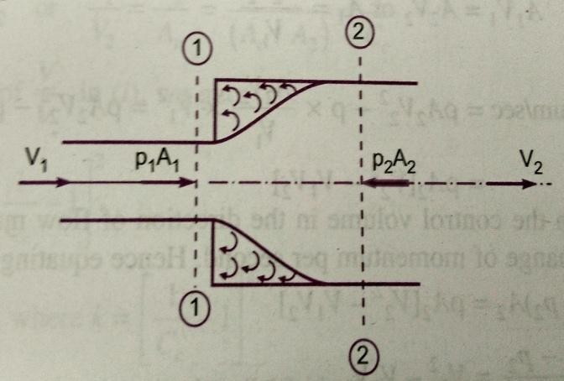
Consider a liquid flowing through apipewhichhassuddenenlargement.Consider two sections 1-1 and 2-2 beforeandafterenlargement.Duetosuddenchange of diameter of the pipe from D1toD2., The liquid flowing from the smallerpipe is not able to fallow the abrupt changeof the boundary. Thus the flow separatesfrom the boundary and turbulent eddies areformed. The loss of head takes place due tothe formationoftheseeddies.

Let 𝑝′ =Pressureintensityoftheliquid eddiesonthearea (A2–A1)

h_{e}=lossofhead duetothesuddenenlargement.

ApplyingBernoulli‟sequationatsection1-1 and 2-2
𝑝1+𝑉2+𝑧 =𝑝2 𝑉2+𝑧
1
+2
+Lossofhead due tosuddenenlargement

𝜌𝑔 2𝑔 1 𝜌𝑔 2𝑔 2

But z1=z2as pipeishorizontal
𝑝1+𝑉12=𝑝2+𝑉22+𝑕

𝜌𝑔 2𝑔 𝜌𝑔 2𝑔 𝑒
1
2

Or 𝑕=
𝑝1−
𝑝2+
𝑉2
−𝑉2 (1)

𝑒 𝜌𝑔 𝜌𝑔 2𝑔 2𝑔
Theforceactingontheliquidinthecontrolvolumeinthedirectionofflow

𝐹𝑥=𝑝1𝐴1+𝑝′𝐴2−𝐴1−𝑝2𝐴2

Butexperimentallyitisfoundthat𝑝′=𝑝1

𝐹𝑥=𝑝1𝐴1+𝑝1𝐴2−𝐴1−𝑝2𝐴2

=𝑝1𝐴2−𝑝2𝐴2

= 𝑝1−𝑝2𝐴2 (2)

Momentumofliquid/second atsection1-1 =mass×velocity

=𝜌𝐴1𝑉1×𝑉1

=𝜌𝐴1𝑉12

Momentumofliquid/second atsection2-2 𝜌𝐴2𝑉2× 𝑉2=𝜌𝐴𝑉²
2 2

Changeofmomentum/second=𝜌𝐴2𝑉22−𝜌𝐴1𝑉12 (3)

Butfromcontinuityequation,wehave

A1V1=A2V2

Or 𝐴1
=𝐴2𝑉2
𝑉1

∴Change ofmomentum/sec=𝜌𝐴𝑉2−𝜌×𝐴2𝑉2×𝑉2
2 2 𝑉1 1

=𝜌𝐴2𝑉22−𝜌𝐴1𝑉1𝑉2

=𝜌𝐴₂𝑉²−𝑉𝑉 (4)
2
1
2

Now the net force acting on the control volume in the direction of flow must be equal to rateofchange ofmomentumpersecond.Hence equatingequation(2)andequation(4)

𝑝1−𝑝2𝐴2=𝜌𝐴2𝑉22−𝑉1𝑉2
𝑝1− 𝑝2=𝑉2−𝑉𝑉
𝜌 2 12
𝑝1−𝑝2 𝑉22−𝑉1𝑉2
Dividingbothsidesby „g‟wehave =
𝜌𝑔 𝑔

Or 𝑝1 −𝑝2=𝑉2−𝑉1𝑉2
2
𝜌𝑔 𝜌𝑔 𝑔

Substitutinginequation(1)

𝑉2 2 2 2 2
𝑕 1=𝑉22−𝑉1𝑉2 + −𝑉2=2𝑉2−2𝑉1𝑉2+𝑉1−𝑉2

𝑒 𝑔 2𝑔 2𝑔 2𝑔

=𝑉1 2+𝑉22−2𝑉1𝑉2
2𝑔

𝑉₁−𝑉₂²
𝑕= 2𝑕
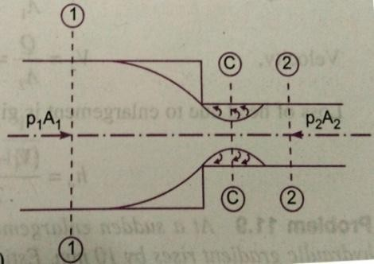
- LOSS OF HEAD DUE TO SUDDEN CONTRACTIONConsideraliquidflowinginapipe,whichhasasuddencontraction in area. Consider two sections 1-1 and 2-2 beforeand after contraction. As the liquid flows from larger pipe tosmallerpipe,theareaofflowgoeson decreasingandbecomes minimum at section C - C. This section is calledVena-contracta. After section C-C, a sudden enlargement ofareatakesplace.Thelossofheadduetosuddencontractionisactually due to sudden enlargement of area from vena-contractatosmallerpipe.

Let Ac=AreaofflowatsectionC-C
Vc=VelocityofflowatsectionC– CA2=Area offlow atsection2-2
V2=Velocityofflowatsection2-2
hc= Lossofhead due tosuddencontraction
Now,hc=Actuallossofhead dueto suddenenlargementfromsectionC-Ctosection2-2is

h=𝑉𝑐−𝑉22
c
2𝑔
Fromcontinuityequation,wehave
=
2
=2
𝑉
2𝑔

𝑉
𝑉𝑐−1
𝑉2
2
(1)

𝐴

AV=AV Or
𝑐 𝐴2

1 1 ∵𝑕= ^{𝑐}

cc 2 2 𝑉2 𝐴𝑐
Substituting thevalueof𝑉𝑐in equation(1)
𝑉2
=
𝐴𝑐
𝐴2
=
𝐶𝑐
𝑐 𝐴2

=𝑉22

2𝑔
1−1
𝐶𝑐
2 𝑘𝑉2
, Wherek=
= 2
2𝑔
2
1−1
𝐶𝑐

Ifthe valueofCcisassumedtobe equalto0.62,then

𝑘 =1
2
−1=0.375

0.6𝑘2𝑉22 𝑉22
Then hbecomesas = =0.375
c 𝑐 2𝑔 2𝑔
IfthevalueofCcisnotgiven,thentheheadlossdueto contraction istakenas
𝑉2
2
=0.52𝑔
- LOSSOFHEADATTHE ENTRANCE OFAPIPE
Thisisthelossofenergy whichoccurswhenaliquidentersapipewhichisconnectedtoa large tank or reservoir. This loss is similar to the loss of head due to sudden contraction.Thisloss depends on the form of entrance. For a sharp edge entrance, thislossis slightlymore than a rounded or bell mouthed entrance. In practice the value of loss of head at theentrance. In practice the value of loss of head at the entrance (inlet) of a pipe with sharpcornered entrance is taken as 0.5 v²/2g where v = velocity of liquid in pipe. This loss isdenotedbyhf

=0.5𝑉2
2𝑔

- LOSS OFHEADATTHE EXITOFAPIPE
This loss of head (or energy) due to the velocity of the liquid at the out let of the pipe, whichisdissipatedeitherintheformofafreejet(iftheoutletofthepipeisfree)oritislostin the
2
tankorreservoir.Thislossisequalto𝑉 ,whereVisthevelocityofliquidattheoutletof
2𝑔
thepipe.Thislossisdenotedbyho.

=𝑉2
2𝑔

V=velocityat outletofthepipe

- LOSSOFHEADDUETOOBSTRUCTIONINAPIPE
Whenever there is an obstruction in a pipe, the loss of energy take place due to reduction ofthe area of the cross section of the pipe at the place where obstruction is present. There is asudden enlargement of the area of flow beyond the obstruction dueto which loss of headtakes place.
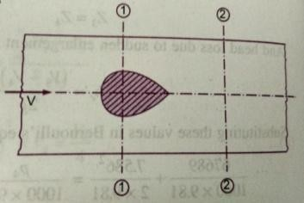
Consider a pipe of area of cross- section A having anobstruction
Let a = max. Area of obstructionA=Areaofpipe
V=velocityofliquidinpipe
Then(A-a)= Areaofflow ofliquidatsection1-1
As the liquid flows and passes through section 1-1, a vena - contracta is formedbeyond section 1-1- after which the stream of liquid widens again and velocity of flow atsection on 2-2 become uniform and equal to velocity, v in the pipe. This situation is similar tothe flowofliquidthroughsuddenenlargement.
Let Vc=velocityof liquidatvena–contracta
Then loss of head due to obstruction = loss of head due to enlargement from vena – contractatosection2-2
=^{𝑉𝑐−𝑉}2--------(1)
2𝑔
Fromcontinuityequationwehave ×𝑉𝑐=𝐴×𝑉 (2)Where ac=Areaofcross sectionatvena-contracta
If Cc=co-efficientofcontraction

Then 𝐶_{𝑐}
= 𝑎𝑟𝑒𝑎 𝑎𝑡 𝑣𝑒𝑛𝑎−𝑐𝑜𝑛𝑡𝑟𝑎𝑐𝑡𝑎
𝐴−𝑎
ac= Cc(A-a)
= 𝑎𝑐
𝐴−𝑎

Substitutingthisvalueinequation(2) Cc(A-a)Vc=AV

∴𝑉𝑐
= 𝐴×𝑉
𝐶𝑐𝐴−𝑎

SubstitutingthisvalueofVCinequation(1)
2 𝐴×𝑉 −𝑉2 2

Headlossduetoobstruction=𝑉𝑐−𝑉
= 𝐴−𝑎 𝐶𝑐 =𝑉2 𝐴

2𝑔 2𝑔 2𝑔 𝐴−𝑎𝐶𝑐

- LOSS OFHEADDUE TOBENDINPIPE:

When there is a bend in a pipe, the velocity flow changes, due to which separation oftheflowfromtheboundaryandalsoformationofeddiestakesplace,thustheenergyislost.

Lossofheadinpipeduetobendisexpressedas

=𝑘𝑉2
2𝑔

Where, =Lossofheadduetobend, V=Velocityofflow, k=Co-efficientofbend.Thevalueofkdependson
  - Angleofbend,
  - Radius ofcurvatureofbend,
  - Diameterofpipe.

- LOSSOFHEADINVARIOUS PIPEFITTINGS:
Thelossofheadinvariouspipefittingssuchas valves, couplingsetc. isexpressedas
=𝑘𝑉2.
2𝑔
WhereV=Velocityofflow,k=co-efficientofpipefitting.

LOSSOFENERGYDUETOGRADUALCONTRACTIONORENLARGEMENT:
The loss of energy can be considerably reduced if in place of a sudden contraction orsudden enlargement a gradual contraction or gradual enlargement is provided. This is becausein gradual contraction or enlargement the velocity of flow is gradually increased or reduced,the formationofeddiesresponsiblefordissipationofenergyareeliminated.
Thelossofheadingradualcontractionor gradualenlargementisexpressedas

=𝑘𝑉1−𝑉22
2𝑔

Where k is a co-efficient and V1 and V2 are the mean velocities at the inlet and the outlet the value of K depends on the angle of convergence or divergence and on the ratio of theupstream and the downstream cross-sectional areas. For gradual contraction the value of K isvery small evenforlargervaluesof theangleof convergence.Forgradual contractionwithout sharp cornersthelossofenergycausedissosmallthatitmaybeneglected.
Forgradualenlargementthevalue ofKdependsonthe angleofdivergence.
The value of K increases as the angle of divergence increases for a given ratio of thecross-sectional areas at the inlet and at the outlet. In the case of gradual enlargement, exceptfor very small angles of divergence, the flow of fluid is always subjected to separation fromthe boundaries and consequent formation of the eddies resulting in loss of energy. Thereforeinthecaseofgradualenlargementthelossofenergycan’tbe completelyeliminated.

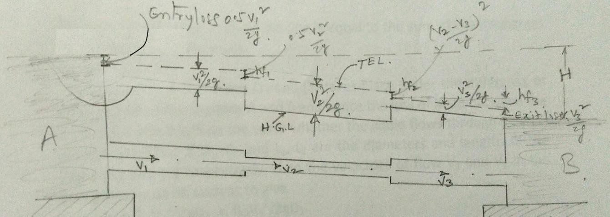
PIPESINSERIES:

If a pipe line connecting two reservoirs is made up of several pipes of different diameters d1,d2, d3, etc. and lengths L1, L2, L3etc. all connected in series ( i.e. end to end ), then thedifference in the liquid surface levels is equal to the sum of the head losses in all the sections.Furtherthedischargethrougheachpipewillbe same.

2 4𝑓𝐿𝑉2
0.5𝑉2
4𝑓𝐿𝑉2
0.5𝑉 2
4𝑓𝐿𝑉2

0.5𝑉1
𝐻= +
1 1 1
+
2 2 2 2
+ +
3 3 3 3
+

2𝑔
2𝑔𝑑₁
2𝑔
2𝑔𝑑₂
2𝑔
2𝑔𝑑₃

𝜋×𝑑2 𝜋×𝑑2 𝜋×𝑑2
1 2 3
Also 𝑄= ×𝑉1= ×𝑉2= ×𝑉3
4 4 4

Howeveriftheminorlossesareneglectedascomparedwiththelossofheadduetofrictionineachpipe,then
𝐻=4𝑓1𝐿1𝑉1 2 +4𝑓2𝐿2𝑉22 +4𝑓3𝐿3𝑉3 2
2𝑔𝑑1 2𝑔𝑑2 2𝑔𝑑3

Theaboveequationmaybeusedtosolvetheproblemsofpipelinesinseries.Therearetwotypesofproblemswhichmayariseforthepipelinesinseries.Viz.

- GivenadischargeQtodeterminetheheadH and
- GivenHtodeterminedischargeQ.

Iftheco-efficientoffrictionissamefor allthepipesi.e.f1=f2=f3,then

𝐻=4𝑓1𝐿1𝑉12+𝐿2𝑉22+𝐿3𝑉322𝑔 𝑑1 𝑑2 𝑑3

PIPESINPARALLEL:

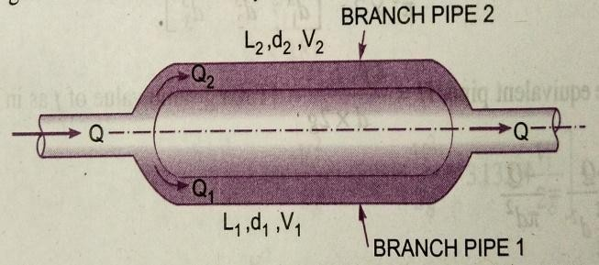
Whenamainpipelinedividesintotwoormoreparallelpipes,whichmayagainjointogetherdownstreamandcontinueas
mainline,thepipesaresaidtobeinparallel.Thepipesareconnectedinparallelinordertoincreasethedischargepassingthrough themain.Itis analogoustoparallelelectriccurrentinwhichthedropinpotentialandflowofelectriccurrentcanbecompared toheadlossandrateofdischargeinafluidflowrespectively.
The rateofdischargeinthemainlineisequaltothe sumofthe dischargesineachoftheparallelpipes.
ThusQ=Q1+Q2

The flow of liquid in pipes (1) and (2) takes place under the difference of headbetween the sections A and B and hence theloss of head between the sections A and B willbe the same whether the liquid flows through pipe (1) or pipe (2). Thus if D1, D2and L1, L2are the diameters and lengths of the pipes (1) and (2) respectively, then the velocities of flowV1andV2inthe twopipesmustbesuchastogive

𝑕𝑓=
𝑓𝐿1𝑉122𝑔𝑑1
𝑓𝐿2𝑉22
=
2𝑔𝑑2

Assumingsamevalueoffforeachparallelpipe
𝐿𝑉2 𝐿𝑉2
1 1 =2 2
2𝑔𝑑1 2𝑔𝑑2

HYDRAULICGRADIENTLINEAND TOTALENERGYLINE:
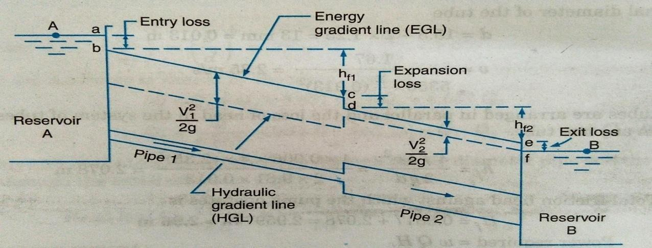
Consider a long pipe line carrying liquid from a reservoir A to reservoir B. At severalpoints along the pipeline let piezo meters be installed. The liquid will rise in the piezometersto certain heights corresponding to the pressure intensity at each section. The height of theliquid surface above the axis of the pipe in the piezometer at any section will be equal to thepressure head (p/w) at that section. On account of loss of energy due to friction, the pressurehead will decrease gradually from section to section of pipe in the direction of flow. If thepressure heads at the different sections of the pipe are plotted to scale as vertical ordinatesabove the axis of the pipe and all these points are joined by a straight line , a sloping line isobtained,whichisknownasHydraulicGradientLine(H.G.L).
Since at any section of pipe the vertical distance between the pipe axis and Hydraulicgradient line is equal to the pressure head at that section, it is also known as pressure line.Moreover if Z is the height of the pipe axis at any section above an arbitrary datum, then theverticalheightoftheHydraulicgradientlineabovethedatumatthatsectionofpiperepresents the piezometric head equal to (p/w + z). Sometimes the Hydraulic gradient line isalsoknownas piezometric headline.

At the entrance section of the pipe for some distance the Hydraulic gradient line is notvery well defined. This is because as liquid from the reservoir enters the pipe, a sudden dropin pressure head takes place in this portion of pipe. Further the exit section of pipe beingsubmerged, the pressure head at this section is equal to the height of the liquid surface in thereservoir B and hence the hydraulic gradient line at the exit section of pipe will meet theliquidsurfaceinthereservoirB.

If at different sections of pipe the total energy ( in terms of head) is plotted to scale asvertical ordinate above the assumed datum and all these points are joined, then a straightsloping line will be obtained and is known as energy grade line or Total energy line (T.E.L).Since totalenergyatanysectionisthe sumofthe pressure head(p/w),datumheadz and

velocityhead ^{𝑉}2
2𝑔
andtheverticaldistancebetweenthedatumandhydraulicgradelineis

equaltothepiezometrichead(p/w +z),theenergygradelinewillbeparalleltothehydraulic

grade line,withaverticaldistance betweenthemequalto ^{𝑉}2
2𝑔
.atthe entrance sectionofthe

pipethereoccurssomelossofenergycalled“Entranceloss”equaltoh
L=0.5
𝑉22𝑔
andhence

theenergygradeline atthissectionwilllie ataverticaldepthequalto 0.5 ^{𝑉}2 belowthe
2𝑔
liquidsurfaceinthereservoir A.Similarlyattheexitsectionofpipe,sincethereoccursan

exitlossequaltohL
= 𝑉2
2𝑔
. Theenergygradiantlineatthissectionwill lieatavertical

distanceequalto ^{𝑉}2
2𝑔
abovetheliquidsurfaceinthereservoir B. Sinceatanysectionofpipe

the vertical distance between the energy grade line and the horizontal line drawn through theliquid surfacein reservoir A will represents the total loss of energy incurred up to thatsection.

If the pipe line connecting the two reservoirs is horizontal, then the datum may beassumed to be along the pipe axis only. The piezometric head and the pressure head will thenbecome thesame.

IfapipelinecarryingliquidfromreservoirAdischargesfreelyintotheatmosphere at its exitend, the hydraulic grade line at the exitend of the pipe will passthrough the centre line of the pipe, since the pressure head at the exit end of the pipe will bezero(beingatmospheric).Theenergygradelinewillagainbeparalleltothehydraulicgrade
lineanditwill beataverticaldistanceof^{𝑉}2abovetheHydraulicgradeline
2𝑔

PITOT–TUBE
A Pitot tube is a simple device used for measuring the velocity of flow. The basicprinciple used in this is that if the velocity of flow at a particular point is reduced to zero,which is known as stagnation point, the pressure there is increased due to conversion of thekinetic energy in to pressure energy and by measuring the increase in pressure energy at thispoint,thevelocityofflowmaybe determined.
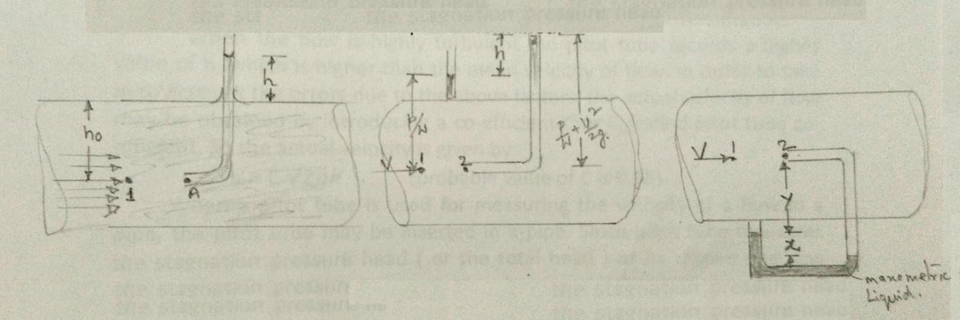

Simplestform of a pitot tube consists of a glass tube, large enough for capillaryeffects to be negligible and bentat rightangles. A single tube of this typeis used formeasuring the velocity of flow in an open channel. The tube is dipped vertically intheflowing stream of fluid with its open end A directed to face the flow and other open endprojectingabovethefluidsurfaceinthestream.Thefluidentersthetubeandthelevelofthe

fluidinthetubeexceedsthatofthefluidsurfaceinthesurroundingstream.Thisissobecause
the end A of the tube is a stagnation point, where the fluid is at rest, and the fluid approachingendA divides atthis pointand passes around tube. Since atstagnation point the kineticenergy is converted in to pressure energy, the fluid in the tube rises above the surroundingfluid surface by a height, which corresponds to the velocity of flow of fluid approaching endAofthetube.Thepressure atthestagnationpointisknownas stagnationpressure.
Consider a point 1 slightly upstream of end A and lying along the same horizontalplane in the flowing stream of velocity V. Now if the point 1 and A are at a vertical depth ofhO from the free surface of fluid and h is the height of the fluid raised in the pitot tube abovethe free surface of the liquid. Then by applying Bernoulli‟s equation between the point 1 andA,neglectingloss ofenergy,we get
𝑕=𝑉2=

𝑕
𝑜 2𝑔 𝑜
+𝑕

(ho+h)isthestagnation pressureheadatapointA,which consistsofstaticpressureheadhO
anddynamicpressureheadh.Simplifyingtheexpression,
𝑉2=𝑕 Or 𝑣= 2𝑔𝑕 (1)
2𝑔
Thisequationindicatesthatthedynamicpressureheadhisproportionaltothesquare ofthevelocityofflowclosetoendA.
Thus the velocity of flow at any point in the flowing stream may be determined bydipping the Pitot tube to the required point and measuring the height „h‟ of the fluid raised inthe tube above the free surface. The velocity of flow given by the above equation (1) is morethanactualvelocityofflowasnolossofenergyisconsideredinderiving theaboveequation.

When the flow is highly turbulent the Pitot tube records a higher value of h, which ishigher than the mean velocity of flow. In order to take in to account the errors due to theabove factors, the actual velocity of flow may be obtained by introducing a co-efficient C orCVcalledPitottubeco-efficient.Sotheactualvelocityisgivenby

𝑣=𝐶 2𝑔𝑕 (ProbablevalueofC is 0.98)

When a pitot tube is used for measuring the velocity of a flow in a pipe, the Pitot tube may beinserted in a pipe. Since pitot tube measures the stagnation pressure head (or the total head) atits dipped end, the static pressure head is also required to be measured at the same section,where tip of pitot tube is held, in order to determine the dynamic pressure head „h‟. Formeasuring the static pressure head a pressure tap is provided at this section to which a piezometer may be connected. Alternatively a dynamic pressure head may also be determineddirectly by connecting a suitable differential manometer between the pitot tube and pressuretap.

Consider point 1 slightly up stream of the stagnation point 2.ApplingBernoulli‟sequationbetweenthepoints1and2,weget
𝑃1+𝑉2=𝑃2 (2)

𝜔 2𝑔 𝜔

Where P1 and P2 are the pressure intensities at points 1 and 2, V is velocity of flow at point 1and 𝜔 is the specific weight of the fluid flowing through the pipe. P1 is the static pressure andP2 is the stagnation pressure. The equation for the pressure through the manometer in metersofwatermaybewrittenas,

𝑃
¹𝑥𝑠+𝑦𝑠+𝑥𝑠

= 𝑦+𝑥𝑠 +
𝑃2
𝑠 (3)

𝜔 𝑚 𝜔

Where s and sm are the specific gravities of the fluid flowing in the pipe and the manometricliquidrespectively.Bysimplifying
𝑃2−𝑃1=𝑥 𝑠𝑚−1
𝜔 𝜔 𝑠

Aftersubstitutingfor(²−𝑃1=)intheequation(2)andsolvingforV
𝜔 𝜔
𝑠𝑚
=𝐶 2𝑔𝑥 𝑠 −1

VENTURIMETER
A venture meter is a device usedfor measuring the rate of flow of fluid through apipe.Thebasicprincipleonwhichventuremeterworks isthatby reducingthecross-sectional area of theflow passage, a pressure differenceis created and themeasurementofthepressure difference enablesthe determinationofthe discharge throughthepipe.
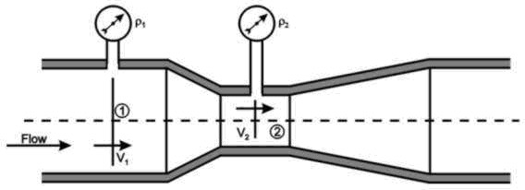
A venture meter consists of (1) an inlet section, followed by a converging cone (2) acylindrical throat and (3) a gradually divergent cone. The inlet section of venture meter is thesame diameter as that of the pipe which is followed by a convergent cone. The convergentcone is a short pipe, which tapers from the original size of the pipe to that of the throat of theventure meter. The throat of the venture meter is a short parallel – sided tube having its cross-sectional area smaller than that of the pipe. The divergent cone of the venture meter is agradually diverging pipe with its cross-sectional area increasing from that of the throat to theoriginal size of the pipe. At the inlet section and the throat i.e sections 1 and 2 of the venturemeterpressuregauges areprovided.
The convergent cone of the venture meter has a total included angle of21° + 1°and its length parallel to the axis is approx. equal to 2.7(D-d), where D is the dia. of pipe atinletsection and d is the dia.of the throat. The length of the throatis equal tod. Thedivergent cone has a total included angle 5° to 15°, preferably about 6°. This results in theconvergent cone of the venture meter to be of smaller length than its divergent cone. In theconvergent cone the fluid is being accelerated from the inlet section 1 to the throat section 2,but in the divergent cone the fluid is retarded from the throat section 2 to the end section 3 ofthe venture meter. The acceleration of the flowing fluid may be allowed to take place rapidlyin a relatively small length without resulting in loss of energy. However if the retardation ofthe flowis allowed to take place rapidly in small length, then the flowing fluid will notremain in contact with the boundary of the diverging flow passage or the flow separates fromthewallsandeddiesareformedandconsequentenergyloss.Thereforetoavoidflowseparation and consequent energy loss, the divergent cone is made longer with a gradualdivergence. Since separation may occur in the divergent cone this portion is not used fordischargemeasurement.
Since the cross-sectional area of the throat is smaller than the cross-sectional areaof the inlet section, the velocity of flow at the throat will become greater than that at inletsection, according to continuity equation. The increase in the velocity of flow at the throatresults in the decrease in the pressure. As such a pressure difference is developed between theinletsection and the throat section of the venturemeter. The pressure difference betweenthese sections can be determined either by connecting differential manometer or pressuregauges. Themeasurement of the pressure difference between these sections enables the rateof flow of fluid to be calculated. For greater accuracy the cross-sectional area of the throat isreduced so thatthepressure atthethroat isverymuchreduced.Butifthecross-sectionalarea

of the throat is reduced so much that pressure drops below the vapour pressure of the flowingliquid. The formation of vapour and air pockets results in cavitation, which is not desirable.Therefore in order to avoid cavitation to occur, they diameter of the throat can be reduced to1/3to3/4ofpipe diameter,more commonlythe diameterofthethroatis1/2ofpipediameter.
Let a1and a2be the cross-section l areas at inlet and throat sections, at which P1and P2the pressures and velocities V1and V2respectively. Assuming the flowing fluid isincompressibleandthereisnolossofenergybetweensection1and2andapplyingBernoulli‟sequationbetweensections 1and2,weget,
𝑃1 𝑣² 𝑃2 𝑣²
1 2
𝜔+2𝑔+𝑧1=𝜔+2𝑔+𝑧2
Where𝜔isthespecificweightofflowingfluid.
Ifthe venturimeteris connectedina horizontalpipe,thenZ1=Z2,then

𝑃1+𝑣12=𝑃2+𝑣22
𝜔 2𝑔 𝜔 2𝑔
𝑃1−𝑃2=𝑣22−𝑣12
𝜔 𝜔 2𝑔 2𝑔

Intheaboveexpression −𝑃2 𝑖𝑠𝑡𝑕𝑒𝑝𝑟𝑒𝑠𝑠𝑢𝑟𝑒𝑑𝑖𝑓𝑓𝑒𝑟𝑒𝑛𝑐𝑒 betweenthepressureheads
1
𝜔 𝜔
atsection1 and2 ,isknownasventureheadandisdenotedbyh
𝑕 =𝑣22−𝑣12
2𝑔 2𝑔
𝑄𝑡𝑕=𝑎1𝑣1=𝑎2𝑣2,

𝑣₁
=
𝑄𝑡
𝑎1
=𝑄𝑡𝑕
2 𝑎2
,𝑣

=𝑄𝑡𝑕21−1
2𝑔 𝑎2 𝑎2

𝑄𝑡𝑕
2 1

=𝑎1𝑎22𝑔𝑕
𝑎12−𝑎22

𝑄 =𝐶_{𝑑}𝑄𝑡𝑕

=𝐶𝑑𝑎1𝑎22𝑔
𝑎2−𝑎2
1 2

=𝐶_{𝑑}

∵𝐶 =1𝑎22𝑔

𝑎12−𝑎22

𝑸𝒂𝒄𝒕𝒖𝒂𝒍=𝑪𝒅𝑪𝒉
Cd=Co-efficient ofdischarge<1

ORIFICEMETER
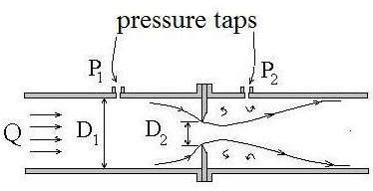
An orifice meter is a simple device for measuring the discharge through pipes. Orifice meteralso works on the same principle as that of venture meter i.e by reducing cross-sectional areaof the flow passage, a pressure difference between the two sections is developed and themeasurementofthepressuredifferenceenablesthedeterminationofthedischargethroughthe pipe.Orificemeteris acheaper
arrangementandrequiressmallerlength and can be used where space islimited.
Anorificemeterconsistsofaflatcircularplatewithacircularholecalled orifice, which is concentric withthepipeaxis.Thethicknessoftheplate tislessthanorequalto0.05
times the diameter of pipe. From the upstream face of the plate the edge of the orifice is madeflat for a thickness 0.02 times the diameter of pipe and the remaining thickness the plate isbeveled with the bevel angle 45°. The diameter of the orifice is kept at 0.5 times the diameterof pipe. Two pressure taps are provided one at section 1 on upstream side of the orifice plateand other at section 2 on the downstream side of the orifice plate. The upstream tap is locatedat a distance of 0.9 to 1.1 times the pipe diameter from the orifice plate. The position ofdownstream pressure tap, however depends on the ratio of the orifice diameter and the pipediameter. Since the orifice diameter is less than pipe diameter as the fluid flows through theorifice, the flowing stream converges, which results in the acceleration of the flowing fluid inaccordance with the consideration of continuity. The effect of convergence of flowing streamextends up to a certain distance upstream from the orifice plate and therefore the pressure tapon the upstream side is provided away from the orifice plate at a section where this effect isnon-existent. However on the downstream side the pressure tap is provided quite close to theorifice plate at a section where the convergingjet of fluid has the smallestcross-sectionalarea(whichisknownasveena-contracta)resultinginthemax.velocityofflowandconsequently the min. pressure at this section. Therefore a max. Pressure difference existsbetween the section 1 and 2, which is measured by connecting a differential manometerbetween the pressure taps at these sections or connecting separate pressure gauges. The jet offluid coming out of the orifice gradually expands from the veena-contracta to again fill thepipe. In case of an orifice meter an abrupt change in the cross-sectional area of the flowpassage is provided and there being no gradual change in the cross-sectional area of flowpassageasinthe caseofventuremeter,thereisagreaterlossofenergyinanorifice meter.
Let p1,p2and v1,v2be the pressures and velocities at sections 1 and 2 respectively.Thenforanincompressiblefluid,applyingBernoulli‟sequationbetweensection1and2and

neglectinglosses,wehave 2
𝑃1+𝑣1

+𝑧=𝑃2+𝑣22

+𝑧

𝑃 𝜔 2𝑃𝑔 1 𝜔2 2𝑣𝑔2 2

Or ¹+𝑧− ²+ 𝑧 =²−¹
𝜔 1 𝜔 2 2𝑔 2𝑔
𝑕=𝑣22 −𝑣12 (1)
2𝑔 2𝑔

Where h is the difference between piezo metric heads at sections 1 and 2. However ifthe orifice meter is connected in a horizontal pipe, then z1 = z2, in which case h will representthepressure headdifferencebetweensections1and2.Fromequation(1)wehave
𝑣2= 2𝑔𝑕+𝑣12 (2)
In deriving the above expression losses have not been considered, this expressiongives the theoretical velocity of flow at section 2. To obtain actual velocity,it must bemultipliedby afactor CV,calledco-efficientof velocity,whichisdefinedastheratiobetween the actual velocity and theoretical velocity. Thus actual velocity of flow at section 2isobtainedas
𝑣2=𝐶𝑣2𝑔𝑕+𝑣12) (3)
Furtherifa1and a2arethecross-sectionalareasofpipeatsection1and 2,BycontinuityequationQ =a1v1=a2v2 (4)
Theareaofjeta2at section2(i.e.atveena-contracta)may berelatedtotheareaoforificeao
bythefallowing expression
a2= CCaowhere CCis known as co-efficientof contraction,whichis definedas theratio between the area of the jet at veena - contracta and the area of orifice. Thus introducingthe valueofa2inequation(4),weget
𝑣=𝑣𝐶 𝑎0Bysubstitutingthis valueof𝑣 inequation(3),we get

1 2𝑐𝑎1
=
𝑣
+

𝐶 2𝑔

2𝐶
1

2𝑎2
0

2 𝑣 2 𝑐𝑎12
Solvingfor 𝑣₂,weget 𝑣2 = 2𝑔𝑕2
1−𝐶𝑣2𝐶𝑐2𝑎0
𝑎12
Now 𝑄=𝑎2𝑣2=𝐶𝑐𝑎0𝑣2and 𝐶𝑐𝐶𝑣=𝐶𝑑
𝑄=𝐶𝑐𝑎0 2𝑔𝑕 =𝐶𝑑𝑎02𝑔𝑕

1−𝐶 𝐶 𝑎2
1−𝐶2𝑎02

2 20
𝑣 𝑐 𝑎12
𝑑 𝑎12

WhereCdistheco-efficient ofdischargeoftheorifice.
Simplifying the above expression for the discharge through the orifice meter by using a co-efficientC expressedas

𝑕=𝐶𝑑
2
1−
0
𝑎1

1−𝐶𝑑
Sothat 𝑄=𝐶𝑎02
2𝑎 02

= 𝑕𝑕𝑕

2𝑔𝑕

𝑎 02 01𝑎12−𝑎02
1−𝑎1
𝑕= 𝑕𝑕𝑕 2𝑔𝑕
01𝑎12−𝑎2
0
Thisgivesthedischargethroughanorificemeterandissimilar tothedischarge
through venture meter. The co-efficient C may be considered as the co-efficient of dischargeof an orifice meter. The co-efficient of discharge for an orifice meter is smaller than that for aventure meter. Thisis because there are no gradual converging and divergingflow passagesas in the case of venture meter, which results in a greater loss of energy and consequentreductionofthe co-efficientofdischargeforanorificemeter.

PROBLEMSONFLOWTHROUGHPIPES
- Atasuddenenlargementofawatermainfrom240mmto480mmdiameter,thehydraulicgradientrises by10mm.Estimate therateof flow.
Given: Dia. of smaller pipe D1= 240mm =0.24mAreaA1=^{𝜋}D12=^{𝜋}(0.24)²
4 4
Dia.oflargerpipeD2= 480mm=0.48mAreaA2= ^{𝜋}𝐷²= ^{𝜋}(0.48)²
4 2 4
𝑃2 𝑃1 10 1
Riseofhydraulicgradienti.e.𝑍+ −𝑍 + =10mm= 𝑚= 𝑚

2 𝜌𝑔 1 𝜌𝑔 1000 100
Let the rateofflow =Q
ApplyingBernoulli’sequationtobothsectionsi.e smallerand largersections

P1+
2
¹+Z =
V

P2+
2
²+Z +Headlossduetoenlargement (1)
V

ρg 2g 1 ρg 2g 2
Butheadlossduetoenlargement, =V1−V22 (2)
2g

Fromcontinuityequation,wehaveA1V1=A2V2 𝑉1
=𝐴2𝑉2
𝑉1

𝜋𝐷2𝑉
𝐷 2 0.482

2

𝑉=⁴
2= 2

×𝑉=
𝑉=22𝑉=4𝑉

1 𝜋𝐷2
2 0.24 2 2 2

4 1 𝐷1

Substitutingthis valueinequation(2), weget
2 2 2
𝑕=4𝑉2−𝑉2 3𝑉2 9𝑉= =
2

𝑒 2𝑔 2𝑔 2𝑔
Nowsubstituting the valueofheandV1inequation(1)
P1 4𝑉2 P2 V2 9𝑉2
2 2 2
+ +𝑍= + +Z2+ 2𝑔
1 2g
ρg 2g ρg

2 V2
9𝑉2 P

16V2−2 −
2g 2g
2𝑔
²=P2+Z−
¹+𝑍1
ρg
1

ButHydraulicgradientrise=^{P2}+Z
ρg 2
− P 1

6V22=
+𝑍 = m

1m 𝑉=
ρg 2 ρg 1 100
^{2×9.81}=0.1808=0.181𝑚/𝑠𝑒𝑐

2g 100 2 6×100
Discharge Q=A2V2=^{𝜋}D²V2
2
4

=𝜋(0.48)²×0.181=0.03275m³/sec
4

=32.75Lts/sec

- A 150mm dia. pipe reduces in dia. abruptly to 100mm dia. If the pipe carries water at30lts/sec,calculate the pressure loss across thecontraction.Take co-efficientof contractionas 0.6
Given: Dia.oflargerpipe D1= 150mm=0.15m

AreaoflargerpipeA1=^{𝜋}(0.15)²=0.01767m²
4

Dia.ofsmallerpipe D2=100mm= 0.10m

Areaofsmaller pipeA2=^{𝜋}(0.10)²=0.007854m²
4

DischargeQ=30lts/sec=0.03m³/secCo-efficientofcontractionCC=0.6
Fromcontinuityequation,wehave Q=A1V1=A2V2

𝑉1
=𝑄
𝐴1
= 0.03
0.01767
=1.697𝑚/𝑠𝑒𝑐

𝑉=𝑄 = 0.03
=3.82𝑚/𝑠𝑒𝑐

2 𝐴2 0.007854
ApplyingBernoulli‟sequationbeforeandaftercontraction

P1+
2
¹+Z =
V

P2+
2
²+Z +h (1)
V

ρg 2g 1 ρg 2g 2 c

ButZ1=Z2andhctheheadlossduetocontractionisgiven bytheequation

𝑉2 1
2
=

−12=3.82
2 1−1 2=0.33

2𝑔
𝐶𝑐
2×9.81 0.6

Substitutingthesevaluesinequation(1), weget

𝑃 1.6972 𝑃
3.822

¹+ =
2 + +0.33

𝜌𝑔 2×9.81 𝜌𝑔 2×9.81
𝑃1+0.1467=𝑃2+0.7438+0.33
𝜌𝑔 𝜌𝑔

𝑃1 𝑃2
− =0.7438 +0.33−0.1467 =0.9271𝑚𝑜𝑓𝑊𝑎𝑡𝑒𝑟
𝜌𝑔 𝜌𝑔

𝑃1−𝑃2=𝜌𝑔×0.9271=1000×9.81×0.9271=0.909×10⁴𝑁/𝑚²

=0.909N/cm2

Pressurelossacrosscontraction =P1-P2=0.909N/cm²

- Water is flowing through a horizontal pipe of diameter 200mm at a velocity of 3m/sec. Acircular solid plate of diameter150mm is placed in the pipe to obstruct the flow. Find the lossofheadduetoobstructioninthe pipe,ifCC=0.62.
Given: DiameterofpipeD=200mm=0.2mVelocityV=3m/sec
AreaofpipeA=𝜋D²=𝜋(0.2)²=0.03141m²
4 4

Diameterofobstructiond=150mm=0.15m

Area ofobstructiona =𝜋(0.15)²=0.01767m
4

CC=0.62

2 𝐴 2

Theheadlossduetoobstruction=𝑉2
−1
2𝑔 −𝑎

= 3×3
2×9.81
0.03141 2

–1
0.62×0.03141−0.01767

= 9
19.62

=3.311m
[3.687–1]²

ProblemsonPitottube
- A pitot tube is placedin the centre of a 300mm pipeline has one endpointingupstreamand other perpendicular to it. The mean velocity in the pipe is 0.80 of the central velocity.Find the discharge through the pipe, if the pressure difference between the two orifices is60mmofwater.Co-efficientofPitottubeCV=0.98
Given: Diameterofpipe=300mm=0.3m
Differenceofpressure headh= 60mmofwater=0.06mofwaterMeanvelocity𝑉=0.80× centralvelocity
Centralvelocity=𝐶𝑣2𝑔𝑕=0.98× 2×9.81× 0.06=1.063𝑚/𝑠𝑒𝑐
Mean velocity =0.8 × 1.063 = 0.8504m/secDischargeQ=Areaofpipe×Meanvelocity=A× 𝑉
= 𝜋(0.3)²×0.8504
4

=0.06m3/sec

- Find the velocity of flow of an oil through a pipe, when the difference of mercury level in adifferential U-tube manometer connected to the two tappings of the pitot tube is 100mm. Co-efficientofpitottubeC =0.98andsp.gr.ofoil =0.8.
Given: Differenceofmercurylevelx=100mm= 0.1mSp.gr.ofoil=0.8,CV=0.98
Differenceofpressurehead𝑕=𝑥𝑆𝑚−1=0.113.6−1

𝑆

=1.6mofoil
0.8

Velocityofflow=CV2×𝑔×𝑕=0.982×9.81×1.6=5.49m/sec

=5.49m/sec
- A pitot tube is used to measure the velocity of water in a pipe. The stag nature pressurehead is 6m and static pressure head is 5m. Calculate the velocity of flow. Co-efficient of pitottube is 0.98.
Given: StagnaturepressureheadhS=6m
Static pressure head ht =5mh=hS–ht= 6–5=1m

VelocityofflowV=CV2×𝑔 ×𝑕

= 0.982 ×9.81 ×1

=4.34m/sec
- A submarine moves horizontally in a sea and has its axis 15m below the surface of thewater. A pitot tube is properly placed just in front of the submarine and along its axis isconnected to the two limbs of a U- tube containing mercury. The difference of mercury levelis found to be 170mm. Find the speed of the sub-marine. Specific gravity of mercury is 13.6andseawateris1.026withrespecttofreshwater.
Given: Differenceofmercurylevel=170mm=0.17mSpecificgravityofmercurySm=13.6,
SpecificgravityofseawaterSo=1.026

𝑆
𝑕=𝑥^{𝑚}
𝑆
−1=0.17
13.6

1.026
−1=3.0834

V= 2 𝑔𝑕= 2 × 9.81 × 2.0834

=6.393m/sec

=6.393×60×60
1000

=23.01km/hr

- A pitot tube is inserted in a pipe of 300mm diameter. The static pressure in the pipe is100mm of mercury (Vacuum). The stagnation pressure at the centre of the pipe is recorded byPitot tube is 0.981N/cm². Calculate the rate of flow of water through the pipe. The meanvelocityofflowis 0.85times thecentralvelocityCV=0.98
Given: Diameterofpiped=0.3m

Areaofpipea=𝜋(0.3)²=0.07068m²
4

Staticpressure head = 100mmofmercury=100× 13.6 =1.36mofwater
1000
4
Stagnaturepressurehead =0.981×10×9.81=1
𝑚
1000

h= Stagnation pressure head –static pressure head = 1 – (- 1.36) = 2.36mVelocityatcentre=CV2𝑔𝑕=0.982×9.81×2.36=6.668m/sec
Meanvelocity𝑉= 0.85×6.668=5.6678m/sec

Rateofflowofwater=𝑉× Areaofpipe

=5.6678×0.07068

= 0.4006m3/sec

UNIT-4
FLOW IN OPEN CHANNELS

Open-channel flow can be classified and described in various ways based on the change in flow depth with respect to time and space.^{[3]} The fundamental types of flow dealt with in open-channel hydraulics are:
- Time as the criterion
  - Steady flow
    - The depth of flow does not change over time, or if it can be assumed to be constant during the time interval under consideration.
  - Unsteady flow
    - The depth of flow does change with time.

- Space as the criterion
  - Uniform flow
    - The depth of flow is the same at every section of the channel. Uniform flow can be steady or unsteady, depending on whether or not the depth changes with time, (although unsteady uniform flow is rare).
  - Varied flow
    - The depth of flow changes along the length of the channel. Varied flow technically may be either steady or unsteady. Varied flow can be further classified as either rapidly or gradually-varied:
      - Rapidly-varied flow
        - The depth changes abruptly over a comparatively short distance. Rapidly varied flow is known as a local phenomenon. Examples are the hydraulic jump and the hydraulic drop.
      - Gradually-varied flow
        - The depth changes over a long distance.

  - Continuous flow
    - The discharge is constant throughout the reach of the channel under consideration. This is often the case with a steady flow. This flow is considered continuous and therefore can be described using the continuity equation for continuous steady flow.

  - Spatially-varied flow
    - The discharge of a steady flow is non-uniform along a channel. This happens when water enters and/or leaves the channel along the course of flow. An example of flow entering a channel would be a road side gutter. An example of flow leaving a channel would be an irrigation channel. This flow can be described using the continuity equation for continuous unsteady flow requires the consideration of the time effect and includes a time element as a variable.

The liquid comes out in the form of a jet from the outlet of a nozzle, the liquid is flowing underpressure. If some plate, which may be fixed or moving, is placed in the path of the jet, a force isexerted by the jet on the plate. This force is obtained by Newton’s second law of motion or fromImpulse–Momentumequation.
F= ma or 𝐹×𝑑𝑡=𝑑𝑚𝑣

Thus the impact of jet means, the force exerted by the jet on a plate, which may be stationary ormoving.
Thefallowingcasesofimpactofjeti.e.theforceexertedbythejetonaplatewillbeconsidered.

- Forceexerted bythejet onastationaryplate, when

  - Plateisverticaltothejet.
  - Plateisinclinedtothejetand
  - Plateiscurved

- Forceexertedbythejetonamovingplate,when

  - Plateisverticaltothejet.
  - Plateis inclinedtothe jet.
  - Plateiscurved.

FORCEEXERTEDBYTHEJETONASTATIONARYVERTICALPLATE:
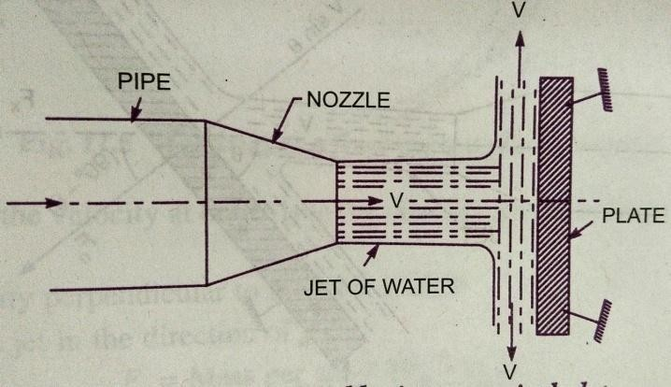
Considerajetofwatercomingoutfromthenozzle, strikesaflatverticalplate.Let V=Velocityofjet.
d=Diameterofjet.

a = Areaofcross-sectionofjet.=𝜋d²
4

The jet of water after striking the plate will movealong the plate. But the plate is at right angles tothejet.Hencethejetafterstrikingwillbedeflectedthrough90°.

Hencethecomponent ofthevelocityofthejet,inthedirectionofjet,afterstriking willbe
zero.

Theforceexerted bythejetontheplateinthe directionofjet,Fx= Rateofchange ofmomentuminthe directionofforce.
=Initialmomentum−Finalmomentum
Time

=Mass× Initialvelocity−Mass×Finalvelocity
Time

=𝑀𝑎𝑠𝑠(Initialvelocity–Finalvelocity)
𝑇𝑖𝑚𝑒

=𝑀𝑎𝑠𝑠/𝑠𝑒𝑐×(Velocityofjetbeforestriking–Finalvelocityofjetafterstriking)

=𝜌aV(V –o)

𝐹=𝜌𝑎𝑉²
For deriving the above equation, we have taken initial velocity minus final velocity and notfinal velocity minus initial velocity. If the force exerted on the jet is to be calculated, then finalvelocity minus initial velocity is to be taken. But if the force exerted by the jet on the plate is to becalculated,theninitialvelocityminusfinalvelocityistobetaken.
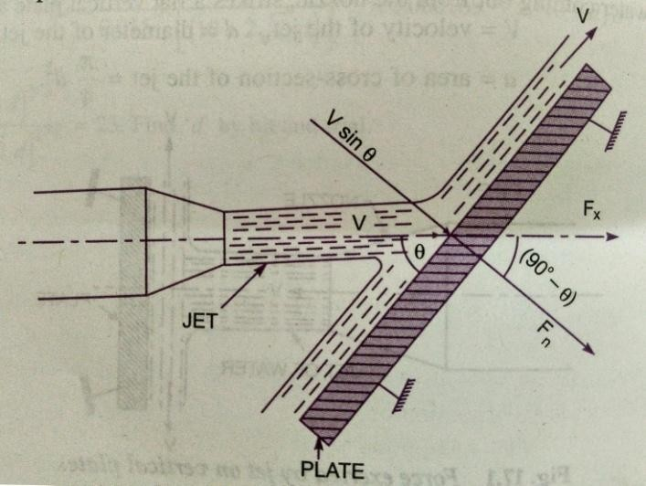
- Force exerted by a jet on a stationary inclined Flat plate:Letajetofwatercomingoutfromthenozzle, strikesaninclinedflatplate.V =VelocityofjetinthedirectionofX
𝜃=Anglebetweenthejetandplate.a =Areaofcross-sectionofjet.
Massofwaterpersecondstrikingtheplate =𝜌av
Iftheplateissmoothandthereisnoloss of
energyduetoimpactofthejet,thejetwillmoveover theplateafterstriking
withavelocityequaltoinitialvelocity. i.e.
withavelocityV.Letusfind theforceexerted bythejet ontheplateinthedirectionnormaltothe plate.Letthisforceis representedbyFn.
Then Fn=Massofjetstrikingpersecond

×(Initialvelocityofjetbeforestrikinginthedirectionofn

–Finalvelocityofjetafter strikinginthedirectionofn)

= 𝜌a V (Vsin𝜃–0)= 𝜌a V²sin𝜃 (1)
This forcecanberesolvedintwocomponents,oneinthedirectionofthejetandtheotherperpendiculartothedirectionofflow.
Thenwehave Fx=ComponentofFninthedirectionofflow.

𝐹𝑥=𝐹𝑛cos90−𝜃=𝐹𝑛sin𝜃−𝜌𝑎𝑉²sin𝜃×sin𝜃

𝐹𝑥=𝜌𝑎𝑉²𝑠𝑖𝑛²𝜃 (1)
And Fy=Component ofFninthedirectionperpendicularto theflow.

𝐹𝑦=𝐹𝑛sin90−𝜃=𝐹𝑛cos𝜃=𝜌𝑎𝑣²sin𝜃×cos𝜃

𝐹𝑦=𝜌𝑎𝑣²𝑠𝑖𝑛𝜃𝑐𝑜𝑠𝜃 (2)

ForceexertedbyajetonastationaryCurvedplate:

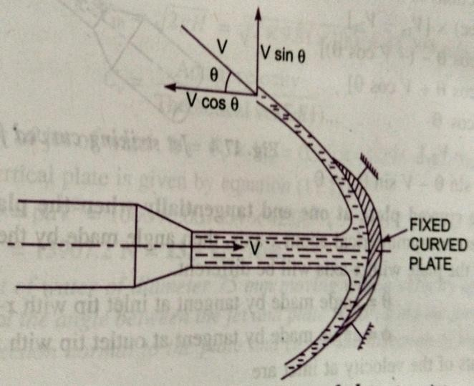
Jetstrikesthecurvedplateatthecentre:
The jet after striking the plate comes outwith same velocity, if the plate is smooth andthere is no loss of energy due to impact of thejet, in the tangential direction of the curvedplate. The velocity at the out let of the platecan be resolved in to two components, one inthedirectionofthejetandotherperpendiculartothe directionofjet.

Componentofvelocityin thedirectionofjet=−𝑉𝐶𝑜𝑠𝜃
(-vesignistakenasthevelocityat outletisintheoppositedirectionofthejetofwater comingoutfromnozzle.)
Componentofvelocityperpendiculartothejet=Vsin𝜃

Forceexertedbythejetinthedirectionofthejet
Fx=Masspersec(V1x– V2x)
WhereV1x=Initialvelocityinthedirectionofjet =V
V2x=Finalvelocity inthedirectionofjet=−𝑉𝐶𝑜𝑠𝜃
Fx= 𝜌aV [V–(−𝑉𝐶𝑜𝑠𝜃)]=𝜌aV [V+V Cos𝜃]=𝜌aV²(1+Cos𝜃) (1)
SimilarlyF_{y}= Masspersecond(V_{1y}–V_{2y})
WhereV_{1y}= Initialvelocityinthe directionofy=0
V_{2y}=Finalvelocityin thedirectionofy =Vsin𝜃
Fy=𝜌aV[0 –VSin𝜃]=−𝜌aV²Sin𝜃 (2)

-vesignmeanstheforceisactinginthedownwarddirection.
Inthiscasethe angle ofdeflectionofjet= 180°-𝜃

Jetstrikesthecurvedplateatoneendtangentiallywhentheplateissymmetrical:
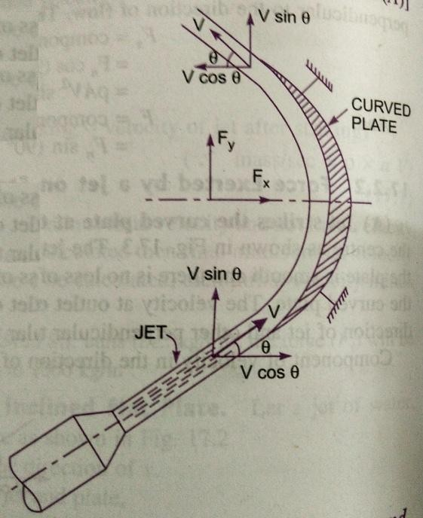
Letthejetstrikesthecurvedfixedplateatoneendtangentially.Letthecurvedplateissymmetrical aboutx–axis.Then the anglemade by the tangents at the two ends of theplate willbe same.
Let V = Velocityofjetofwater.
𝜃 = Angle made by the jet with x–axis at theinlettipofthe curvedplate.

If the plate is smooth and loss of energy due toimpact is zero, then the velocity of water at the outlet tip of the curved plate will be equal to V. Theforce exerted by the jet of water in the direction of xandyare
Fx=(mass/sec)×(V1x–V2x)

= 𝜌aV [V Cos𝜃−(−𝑉𝐶𝑜𝑠𝜃)]

=2 𝝆aV²Cos𝜽
F_{y}=𝜌aV(V_{1y}–V_{2y})=𝜌aV[Vsin𝜃−𝑉𝑆𝑖𝑛𝜃]= 0

Jetstrikesthecurvedplateatoneendtangentiallywhentheplateis un-symmetrical:
Whenthecurvedplateisunsymmetricalaboutx-axis,thentheanglesmadebytangentsdrawnatinletandoutlettips oftheplate withx-axis willbedifferent.
Let𝜃=Anglemadebytangentattheinlettipwithx-axis.
∅=Anglemadebytangentattheoutlettipwithx-axisThe twocomponentsofvelocityatinletare
V1x=Vcos𝜃and V1y=Vsin𝜃Thetwocomponentsofvelocityat outletare
V_{2x}=−𝑉cos∅ andV_{2y}=Vsin∅
The forces exerted by the jet of water in the directions of x and y are:F_{x}=𝜌aV(V_{1x}–V_{2x})=𝜌aV(VCos𝜃 +VCos∅)
=𝜌𝑎𝑉2+𝑐𝑜𝑠∅

F_{y}=𝜌aV(V_{1y}– V_{2y}) =𝜌aV[Vsin𝜃−Vsin ∅]=𝝆aV²(sin𝜽-Sin∅)

FORCE EXERTED BYA JETONMOVINGPLATES
Thefallowingcasesofthemovingplateswillbeconsidered:
  - Flatverticalplatemovinginthedirectionofjetand awayfromthejet.
  - Inclinedplatemovinginthedirectionofjet and
  - Curvedplatemovinginthedirectionofjetorinthehorizontaldirection.

Forceonflatverticalplatemovinginthedirectionofjet:
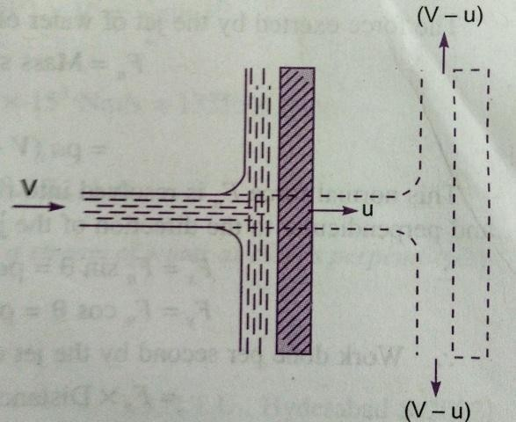
Letajetofwaterstrikingaflatverticalplatemovingwitha uniformvelocityawayfromthejet.

Let V = Velocityofjet.
a = Area of cross-section of jet.u= Velocityofflatplate.

In this case, the jet does not strike the plate with avelocityv,butitstrikeswitharelativevelocity,which is equal to the absolute velocity of jet of waterminusvelocityoftheplate.

Hence relative velocity of the jet with respect to plate = V – uMassofwaterstrikingtheplate persecond
=𝜌× 𝐴𝑟𝑒𝑎𝑜𝑓𝑗𝑒𝑡×𝑣𝑒𝑙𝑜𝑐𝑖𝑡𝑦𝑤𝑖𝑡𝑕𝑤𝑕𝑖𝑐𝑕𝑗𝑒𝑡𝑠𝑡𝑟𝑖𝑘𝑒𝑠𝑡𝑕𝑒𝑝𝑙𝑎𝑡𝑒

=𝜌a(V–u)

∴Forceexerted bythejetonthe movinginthe directionoftheplate
Fx=massofwaterstrikingpersecond×(Initialvelocitywithwhichwaterstrikes–Finalvelocity)
= 𝜌a (V–u)[(V–u)–0]= 𝜌a(V–u)² (1)
Sincefinalvelocityinthedirectionofjetiszero.

Inthis, casetheworkwillbedonebythejetontheplate,astheplateismoving.For stationaryplates,theworkdoneiszero.
∴Theworkdonepersecond bythejetonthe plate
=𝐹𝑜𝑟𝑐𝑒×Distanceinthedirectionofforce
Time

= Fx× u =𝝆a(v–u)²×u (2)
In the above equation (2), if the value of 𝜌 for water is taken in S.I units (i.e.1000kg/m³) the workdone willbeinNm/s.ThetermNmisequaltoWatt(W).
s

Forceoninclinedplatemovinginthedirectionofjet:
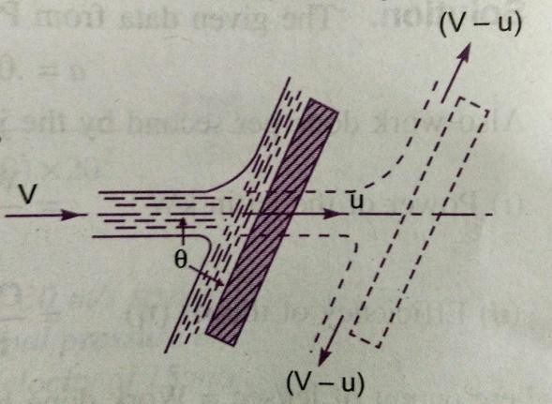
Letajetofwater strikesaninclinedplate,whichis movingwithauniformvelocityinthedirectionofjet.
LetV=Absolutevelocityofwater.

u = Velocityofplateinthe directionofjet.a = Cross-sectionalarea ofjet
𝜃=Anglebetweenjetandplate.

Relative velocityofjetofwater=𝑉−𝑢

Thevelocitywithwhichjetstrikes=𝑉−𝑢

Massofwaterstriking persecond =𝜌a (V – u)

Iftheplateissmoothandlossofenergyduetoimpact ofthe jetisassumedzero,thejet ofwaterwillleavetheinclinedplatewithavelocityequalto𝑉−𝑢.
Theforceexerted bythejetofwateronthe plateinthedirectionnormalto theplateisgivenas

Fn=Massstrikingpersecx(Initialvelocityinthenormal directionwithwhichjetstrikes–finalvelocity)
= 𝜌a (V–u)[(V–u)sin𝜃−0]

=𝝆a(V– u)²sin𝜽

ThisnormalforceF_{n}isresolvedintotwocomponents,namelyFxand Fyinthedirectionofjetandperpendiculartothedirectionofjetrespectively.

𝐹𝑥=𝐹𝑛𝑠𝑖𝑛𝜃=𝜌𝑎𝑉−𝑢 ²𝑠𝑖𝑛²𝜃

𝐹𝑦=𝐹𝑛𝑐𝑜𝑠𝜃=𝜌𝑎𝑉−𝑢²𝑠𝑖𝑛𝜃𝑐𝑜𝑠𝜃

Workdonepersecond bythejetontheplate

=Fx×Distanceper secondinthedirectionofx

=Fx×u =𝜌a(V–u)²sin²𝜃×u
=𝝆a(V –u)²usin²𝜽Nm/sec

Forceonthecurvedplatewhentheplateismovinginthedirectionofjet:
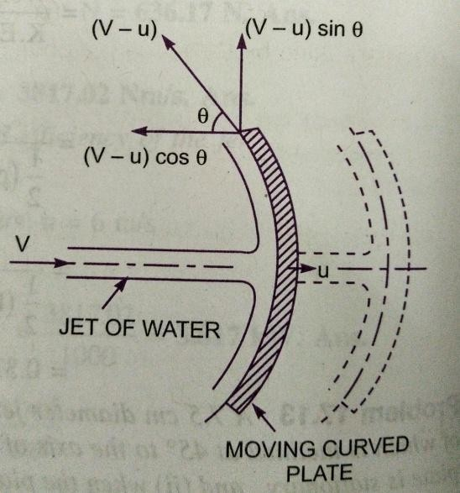
Letajet ofwater strikesacurvedplateatthecentreoftheplate,which ismoving withauniformvelocityinthedirectionofjet.
Let V=absolutevelocityofjet.a =areaofjet.
u= Velocityofplateinthe directionofjet.
Relative velocityofjetofwaterorthe velocitywithwhichjetstrikesthe curvedplate = V–u
If the plate is smooth and the loss of energy due toimpactofjetiszero,thenthevelocitywithwhichthe
jetwillbeleavingthecurvedvane=(V–u)

Thisvelocitycanberesolvedintotwocomponents,oneinthedirectionofjetandtheotherperpendiculartothedirectionofjet.
Componentofthevelocityinthedirectionofjet=-(V– u)Cos𝜃

(-ve sign is taken as at the out let, the component is in the opposite direction of the jet).Component of velocity in the direction perpendicular to the direction of jet = (V – u) sin𝜃Massofwaterstrikingtheplate =𝜌𝑎 × velocitywithwhich jetstrikesthe plate.
=𝜌𝑎(V –u)

∴Force exertedbythejetofwateronthe curvedplateinthe directionofjetFx

Fx=Massstrikingpersec[Initialvelocitywithwhichjetstrikestheplatein
thedirectionofjet−Finalvelocity]
=𝜌𝑎𝑉−𝑢𝑉−𝑢−−𝑉−𝑢cos𝜃

=𝜌−²1+cos𝜃 (1)Workdonebythejetonthe platepersecond
=Fx×Distancetravelledpersecondinthedirectionofx
=𝐹𝑥×𝑢=𝜌𝑎𝑉−𝑢²1+cos𝜃×𝑢

=𝜌𝑎𝑉−𝑢²×𝑢 1+cos𝜃

Forceexertedbyajet ofwateronanun-symmetricalmovingCurvedplatewhenJetstrikestangentiallyatoneofthetips:
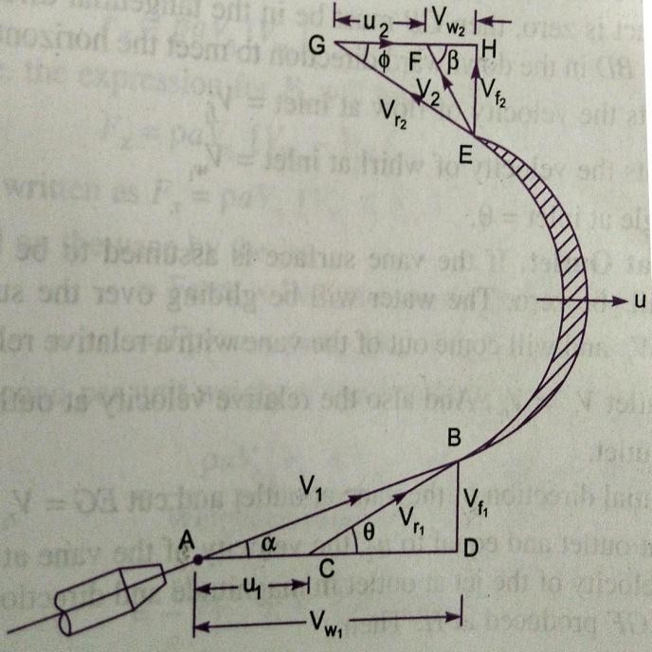
Letajetofwaterstrikingamovingcurvedplatetangentially,atoneofitstips.
Asthejetstrikestangentially,thelossofenergyduetoimpactofthejetwillbe zero. In this case as plate is moving, thevelocity with which thejetof water strikesis equal to the relative velocity of jet withrespecttotheplate.Alsoastheplateismoving in different direction of the jet, therelative velocity at inlet will be equal to thevectordifferenceofvelocityofjetandvelocityoftheplate atinlet.
Let V1=Velocityofjetatinlet.
𝑢1=Velocityofthe plate atinlet.
𝑉_{𝑟}1=Relativevelocityofjetandplateatinlet.
𝛼=Anglebetweenthedirectionofjetand directionofmoving plate.
𝜃=Anglemadebyrelativevelocity(𝑉_{𝑟}2)withdirectionofmotionatinlet.
(Vaneangleatinlet)
𝑉_{𝑤}1and𝑉_{𝑓}1=ThecomponentsofvelocityofthejetV1,inthedirectionof motionand
Perpendiculartothedirectionofmotionrespectively.
𝑉_{𝑤}1=Velocityofwhirlatinlet.
𝑉_{𝑓}1=Velocityofflowat inlet.
V2 = Velocity of jet at the outlet of the vane.u2= Velocityofvane atoutlet.
𝑉_{𝑟}2=Relativevelocityofjetw.r.tthevaneattheoutlet.
=Anglemade bythe velocityV2withdirectionofmotionofvaneatoutlet.
=Anglemadebytherelativevelocity𝑉_{𝑟}2withthedirectionof motionofthe
Vaneatoutlet.
𝑉_{𝑤}2and𝑉_{𝑓}2=ComponentsofvelocityV2inthedirectionofmotionofvaneand Perpendicular tothedirectionofmotionofvaneat outlet.
𝑉_{𝑤}2=Velocityofwhirlatoutlet.
𝑉_{𝑓}2=Velocityofflowatoutlet.
Thetriangles ABDandEGHarecalledvelocitytrianglesatinletandoutlet.

Velocity triangle at inlet: Take any point A and draw a line AB = V1 in magnitude and directionwhich means line AB makes an angle 𝛼 with the horizontal line AD. Next draw a line AC = u₁inmagnitude. Join C to B. Then CB represents the relative velocity of the jet at inlet. If the loss ofenergy at inlet due to impact is zero, then CB must be in the tangential direction to the vane atinlet. From B draw a vertical line BD in the downward direction to meet the horizontal line ACproducedatD.
Then BD=Representsthevelocityofflowatinlet= 𝑉_{𝑓}1AD=Representsthevelocityofwhirlatinlet=𝑉_{𝑤}1
∠BCD=Vaneangleatinlet=𝜃

Velocity triangle at outlet: If the vane surface is assumed to be very smooth, the loss of energydue to friction will be zero. The water will be gliding over the surface of the vane with a relativevelocity𝑉_{𝑟}1andwillcomeoutofthevanewitharelativevelocity𝑉_{𝑟}2.Thismeansthattherelative velocityatoutlet𝑉_{𝑟}2=𝑉_{𝑟}1.Therelativevelocityatoutletshouldbeintangentialdirectiontothe vane atoutlet.
Draw EGin the tangential direction of the vane at outlet and cut EG = 𝑉_{𝑟}2 .From G, draw aline GF in the direction of vane at outlet and equal to u2, the velocity of vane at outlet. Join EF.Then EF represents the absolute velocity of the jet at outlet in magnitude and direction. From Edraw averticallineEH tomeetthelineGFproducedatH.
Then,EH=Velocityofflowatoutlet. =𝑉_{𝑓}2 .
FH =Velocityofwhirlatoutlet=𝑉_{𝑤}2
∅=Angleofvaneat outlet
𝛽=AnglemadebyV2withthedirectionofmotionofvaneat outlet.
Ifvaneissmoothandishavingvelocityinthedirectionofmotionatinletandoutletequal,thenwehave
𝑢1=𝑢2=𝑢=velocityofvanein thedirectionofmotionand

𝑉_{𝑟}1=𝑉_{𝑟}2
Nowmassofwaterstrikingthevanepersecond𝜌𝑎𝑉_{𝑟}1 (1)
Wherea=areaofjetof water,𝑉_{𝑟}1=Relativevelocityatinlet.
∴Forceexerted bythejetinthedirectionofmotion

FX = Mass of water striking per second × [Initial velocity with which jet strikes in thedirectionofmotion–Finalvelocityofjetinthedirectionofmotion] (2)

Butinitialvelocitywithwhichjetstrikesthevane=𝑉_{𝑟}1
Thecomponentofthisvelocityinthedirectionofmotion=𝑉𝑟1cos𝜃𝑉𝑤1−𝑢1 similarly,the componentofrelativevelocityattheoutletinthe directionof motion
=𝑉𝑟2𝑐𝑜𝑠∅=−𝑢2+𝑉𝑤2
Vesignistakenasthecomponentofthe relativevelocityVr2inthedirectionof motionisintheoppositedirection
Substitutingtheequation(1)andalltheabovevaluesofthevelocitiesinequation(2),weget

=𝜌𝑎𝑉𝑟1 𝑉𝑤1−𝑢1− − 𝑢2+𝑉𝑤2 =𝜌𝑎𝑉𝑟1𝑉𝑤1−𝑢1+𝑢2−𝑉𝑤2
=𝜌𝑎𝑉𝑟1𝑉𝑤1+𝑉𝑤2 (3) 𝑠𝑖𝑛𝑐𝑒𝑢1=𝑢2
Theequation(3)istrueonlywhenangle𝛽isanacuteangle.If𝛽=90°,then𝑉𝑤2=0
Thenequation(3)becomesasFX= 𝜌a Vr1Vw1

If𝛽isanobtuse angle,thentheexpression forFXwillbecome

=𝜌𝑎𝑉𝑟11−𝑉𝑤2

Thusingeneral,Fxiswrittenas =𝜌𝑎𝑉𝑟11±𝑉𝑤2
Workdonepersecondonthevanebythejet

=Force×distanceper secondinthedirectionofforce

=𝐹×𝑢=1𝑤1±𝑉𝑤2×𝑢 (5)
∴Workdonepersecondperunitweightoffluidstrikingpersecond

= 𝜌𝑎𝑉𝑟1𝑉𝑤1±𝑉𝑤2×𝑢 𝑁𝑚/𝑠=𝜌𝑎𝑉𝑟1𝑉𝑤1±𝑉𝑤2×𝑢=𝑁𝑚/𝑁

𝑤𝑒𝑖𝑔𝑕𝑡𝑜𝑓𝑓𝑙𝑢𝑖𝑑
𝑠𝑡𝑟𝑖𝑘𝑖𝑛𝑔/𝑠
𝑁/𝑠 𝑔×𝜌𝑎𝑉𝑟1

= 1𝑉 ±𝑉 × 𝑢𝑁𝑚/𝑁 (6)
𝑔 𝑤1 𝑤2
Workdone/secondperunitmassoffluidstrikingpersecond

= 𝜌𝑎𝑉𝑟1𝑉𝑤1±𝑉𝑤2×𝑢 𝑁𝑚/𝑠=𝜌𝑎𝑉𝑟1𝑉𝑤1±𝑉𝑤2×𝑢 𝑁𝑁/𝑁𝑁

𝑤𝑒𝑖𝑔𝑕𝑡𝑜𝑓𝑓𝑙𝑢𝑖𝑑𝑠𝑡𝑟𝑖𝑘𝑖𝑛𝑔
/𝑠
𝑘𝑔/�� 𝜌𝑎𝑉𝑟1

= ±𝑽𝒘𝟐 ×𝒖𝑵𝒎/𝒌𝒈 (7)

Efficiency of jet: The work done by the jet on the vane given by equation (5) is the output of thejet whereas the initial kinetic energy of the jet is the input. Hence the efficiency of jet is expressedas

Efficiency η = 𝑂𝑢𝑡𝑝𝑢𝑡
𝐼𝑛𝑝𝑢𝑡
=𝑊𝑜𝑟𝑘𝑑𝑜𝑛𝑒𝑝𝑒𝑟𝑠𝑒𝑐𝑜𝑛𝑑𝑜𝑛𝑡𝑕𝑒𝑣𝑎𝑛𝑒
𝐼𝑛𝑖𝑡𝑖𝑎𝑙𝐾.𝐸𝑝𝑒𝑟𝑠𝑒𝑐𝑜𝑛𝑑𝑜𝑓𝑡𝑕𝑒𝑗𝑒𝑡

=𝜌𝑎𝑉𝑟1𝑉𝑤1±𝑉𝑤2×𝑢
1𝑚𝑉2
2 1
Where m = Mass of fluid per second in the jet =𝜌𝑎𝑉1V1=Initialvelocityofjet
Efficiency 𝜂=𝜌𝑎𝑉𝑟1𝑉𝑤1±𝑉𝑤2×𝑢 (8)
1𝜌𝑎𝑉1×𝑉1 2
2

PROBLEMS
- Water is flowing through a pipe at the end of which a nozzle is fitted. The diameter of thenozzle is 100 mm and the head of the water at the centre of the nozzle is 100m. Find the forceexerted bythejetofwaterona fixedverticalplate.The co-efficientofvelocityisgivenas0.95.Given: Diameterofnozzle d=100mm=0.1m
Area ofnozzle =𝜋× 0.1 ²=0.00785𝑚2
4
HeadofwaterH=100m
Co-efficientofvelocity𝐶𝑣=0.95
Theoreticalvelocityofjetof waterVth=2𝑔𝑕= 2×9.81×100 =44.294m/secButC= 𝐴𝑐𝑡𝑢𝑎𝑙𝑣𝑒𝑙𝑜𝑐𝑖𝑡𝑦

v 𝑇𝑕𝑒𝑜𝑟𝑖𝑡𝑖𝑐𝑎𝑙𝑣𝑒𝑙𝑜𝑐𝑖𝑡𝑦

∴Actualvelocityofjetofwater=𝐶𝑣× Vth= 0.95×44.294=42.08m/sec

Forceexertedona fixed verticalplate

F= 𝜌𝑎𝑉2=1000× 0.007854× 42.08²

F=13907.2N=13.9kN
- A jet of water of diameter 75mm moving with avelocity of 25m/sec strikes a fixed plate insuch a way that the angle between the jet and plate is 60°. Find the force exerted by the jet on theplate
  - Inthe direction normaltotheplate and
  - Inthe directionofthejet.
Given: Diameter of the jetd =75mm = 0.075mAreaofthejet𝜋×0.075²=0.004417𝑚2
4
VelocityofjetV=25m/sec
Anglebetweenjetandplate𝜃=60°
- Theforce exerted bythejetofwaterinthedirectionnormalto theplate

𝐹𝑛=𝜌𝑎𝑉²𝑠𝑖𝑛𝜃=1000×0.004417 ×25²𝑠𝑖𝑛 60⁰

𝑭𝒏=𝟐𝟑𝟗𝟎.𝟕 𝑵

- Theforceinthedirectionofjet

𝐹𝑥=𝜌𝑎𝑉²𝑠𝑖𝑛²𝜃=1000 × 0.004417×25²× 𝑠𝑖𝑛²60⁰

𝑭𝒙=𝟐𝟎𝟕𝟎.𝟒 𝑵

- Ajetofwaterofdia.50mmmovingwithavelocityof40m/secstrikesacurvedfixedsymmetrical plate at the centre. Find the force exerted by the jet of water in the direction of jet, ifthe directionofjetisdeflectedthroughanangle of120°attheoutletofcurved plate.
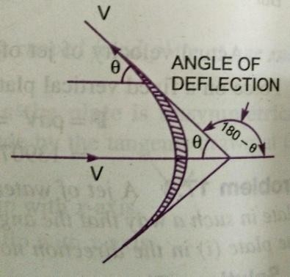
Given: Dia.ofjetd =0.05m
Areaofjeta =𝜋× 0.05 ²=0.001963𝑚2
4
Velocityofjet V=40m/sec

Angle of deflection = 180 – 𝜃 = 180 – 120 = 60°Forceexertedbythejetonthecurved plateinthedirectionofjet
𝐹𝑥=𝜌𝑎𝑉²1+𝑐𝑜𝑠𝜃

𝐹𝑥=1000 × 0.001963×40 ²× 1 +cos60⁰

𝑭𝒙=𝟒𝟕𝟏𝟏.𝟏𝟓 𝑵

- A jet of water of dia. 75mm moving with a velocity of 30m/sec strikes a curved fixed platetangentially at one end at an angle of 30° to the horizontal. The jet leaves the plate at an angle of20⁰ to the horizontal. Find the force exerted by the jet on the plate in the horizontal and verticaldirection.
Given: Dia.ofjetd=75mm=0.075m,
Areaofjet𝑎=𝜋× 0.075²=0.004417𝑚2
4
Velocityofjet V=30m/sec

Angle made by the jet at inlet tip with the horizontal 𝜃 =30°Anglemadebythejetatoutlettipwiththehorizontal∅=20°
Theforceexerted bythejetofwaterontheplateinhorizontaldirectionFx

𝐹=𝜌𝑎𝑉²cos𝜃+cos∅

=1000×0.004417cos300+cos200×30²

𝑭𝒙=𝟕𝟏𝟕𝟖.𝟐 𝑵

Theforceexerted bythejetofwaterontheplateinverticaldirectionFy

𝐹𝑦=𝜌𝑎𝑉²𝑠𝑖𝑛𝜃−𝑠𝑖𝑛∅

=1000 ×0.004417sin 300−sin200× 30²

𝑭𝒚=𝟔𝟐𝟖.𝟏𝟑 𝑵

- Anozzleof50mmdia.deliversastreamofwaterat 20m/secperpendiculartotheplatethatmovesawayfromtheplateat5m/sec.Find:
- Theforceontheplate.

- Theworkdoneand

- Theefficiencyofthejet.

Given: Dia.ofjetd=50mm=0.05m,

Areaofjeta=𝜋
4
(0.05)²=0.0019635m²

Velocityofjet V=20m/sec,

Velocityofplateu=5m/sec

- Theforceontheplate 𝐹𝑥=𝜌𝑎𝑉−𝑢²

𝐹𝑥=1000× 0.0019635×20 −5²

𝑭𝒙=𝟒𝟒𝟏.𝟕𝟖 𝑵

- Theworkdonebythejet =𝐹_{𝑥}×𝑢
=441.78×5

=𝟐𝟐𝟎𝟖.𝟗𝑵𝒎/𝒔
- Theefficiencyofthejet𝜂=𝑂𝑢𝑡𝑝𝑢𝑡𝑜𝑓𝑗𝑒𝑡
𝐼𝑛𝑝𝑢𝑡𝑜𝑓𝑗𝑒𝑡

=𝑊𝑜𝑟𝑘𝑑𝑜𝑛𝑒/𝑠𝑒𝑐
𝐾.𝐸𝑜𝑓𝑗𝑒𝑡/𝑠𝑒𝑐

𝐹𝑥×𝑢
=
1𝜌𝑎𝑉𝑉2

𝐹𝑥×𝑢

1𝑚𝑣2
2
=

2

2208.9
=
11000×0.0019635×20×202
2

=2208.9
6540

= 0.3377=33.77%
- A7.5cmdia.jethaving avelocityof30m/secstrikesaflatplate,thenormalofwhichisinclinedat45°tothe axis ofthejet.Findthe normalpressure ontheplate:
  - Whentheplateis stationaryand
  - Whentheplateismoving withavelocityof15m/secawayfromthejet.Alsodeterminethe powerandefficiencyofthejetwhenthe plateismoving.

Given: Dia.ofthejetd= 7.5cm= 0.075m

Areaofjeta=𝜋
4
(0.075)²=0.004417m²

Anglebetween jetand plate𝜃=90° –45° =45°
Velocityofjet V=30m/sec
- Whentheplateisstationary, thenormalforce𝐹𝑛ontheplateis

𝐹𝑛=𝜌𝑎𝑉²sin𝜃=1000 × 0.004417×30 ²× sin 45⁰

=𝟐𝟖𝟏𝟎.𝟗𝟔 𝑵

- Whenthe plate ismovingwitha velocityof15m/secawayfromthejet,the normal force onthe plate𝐹𝑛
𝐹𝑛=𝜌𝑎𝑉−𝑢²sin 𝜃=1000 × 0.004417× 30−15²× sin45⁰

= 702.74N
- The power and efficiency of the jet, when the plate is moving is obtained asWorkdone/secbythejet
=ForceinthedirectionofjetxDistancemoved byplateinthedirectionofjet/sec

=𝐹𝑥×𝑢 Where 𝐹𝑥=𝐹𝑛sin𝜃=702.74×sin45⁰=496.9𝑁

Work done/ sec=496.9×15=7453.5Nm/s

𝑊𝑜𝑟𝑘𝑑𝑜𝑛𝑒/𝑠𝑒𝑐
∴ PowerinkW=
1000
=7453.5=7.453kW
1000

Efficiencyofjet=𝑂𝑢𝑡𝑝𝑢𝑡
𝐼𝑛𝑝𝑢𝑡

= 7453.5
=𝑊𝑜𝑟𝑘𝑑𝑜𝑛𝑒𝑝𝑒𝑟 𝑠𝑒𝑐
𝐾.𝐸𝑜𝑓 𝑗𝑒𝑡𝑝𝑒𝑟 𝑠𝑒𝑐

=7453.5

1𝑎𝑉×𝑉 2
2
1𝜌𝑎𝑉3
2

= 7453.5
1× 1000×0.004417×30³
2

=0.1249≃0.125=12.5%

- A jet of water of dia. 7.5cm strikes a curved plate at its centre with a velocity of 20m/sec. thecurved plate is moving with a velocity of 8m/sec in the direction of the jet. The jet is deflectedthroughanangleof165°.Assumingplate is smooth,find
  - Force exertedonthe plateinthe directionof jet.
  - Powerofjet.
  - Efficiencyofjet.

Given: Dia.ofjetd=7.5cm=0.075m

Areaofjeta=𝜋
4
(0.075)²=0.004417m²

Velocity of jet V = 20m/secVelocityofplate u = 8m/sec
Anglemadebytherelativevelocityattheout letoftheplate𝜃= 180 °-165°=15°

- Forceexerted bythejet ontheplate inthe directionofjet

𝐹𝑥=𝜌𝑎𝑉−𝑢²1+cos𝜃

𝐹𝑥=1000 ×0.004417× 20 −8²1 +cos15⁰

=𝟏𝟐𝟓𝟎.𝟑𝟖𝑵

- Workdonebythejetontheplatepersecond

=𝐹𝑥×𝑢

=1250.38×8

=𝟏𝟎𝟎𝟎𝟑.𝟎𝟒 𝑵𝒎/𝒔

∴ Powerofjet=
10003.04

1000
=10kW

𝑂𝑢𝑡𝑝𝑢𝑡
- Efficiencyofthejet=
𝐼𝑛𝑝𝑢𝑡
=𝑊𝑜𝑟𝑘𝑑𝑜𝑛𝑒𝑝𝑒𝑟 𝑠𝑒𝑐
𝐾.𝐸𝑜𝑓 𝑗𝑒𝑡𝑝𝑒𝑟 𝑠𝑒𝑐

=1250.38×8

= 1250.38×8

1 2 1 3

𝜌𝑎𝑉.𝑉
2
2×1000×0.004417×(20)20

=0.564= 56.4%

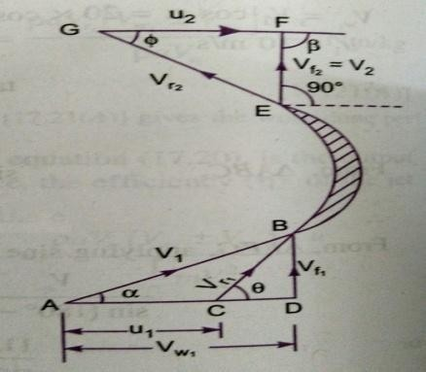
- A jet of water having a velocity of 40m/sec strikes a curved vane, which is moving with avelocity of 20m/sec. The jet makes an angle of 30° with the direction of motion of vane at inletand leaves at an angle of 90° to the direction of motion of vane at out let. Draw velocity trianglesat inlet and outlet and determine vane angles at inlet and outlet, so that the water enters and leavesthe vanes withoutshock.
Given: Velocityofjet𝑉1=40m/sec

Velocity of vane u1= 20m/secAngle made by jet at inlet 𝛼 =30°Anglemadebyleavingjet=90°
∴𝛽=180°-90°=90°

u1=u2=u=20m/sec
Vaneanglesatinletandoutletare𝜃and∅

From∆BCDwehavetan𝜃=𝐵𝐷=𝐵𝐷= 𝑉𝑓1
𝐶𝐷 𝐴𝐷−𝐴𝐶 𝑉𝑤1−𝑢1
0
Where 𝑉𝑓1=𝑉1sin𝛼=40×sin30=20𝑚/𝑠
𝑉𝑤=𝑉1cos𝛼 =40×cos30⁰=34.64𝑚/𝑠
1

𝑢1=20𝑚/𝑠

20

∴ tan𝑁=
=20 = 1.366= tan 53.79⁰

34.64−20
14.64

∴ 𝜽=𝟓𝟑.𝟕𝟗𝟎𝒐𝒓 𝟓𝟑𝟎𝟒𝟕.𝟒′
Alsofrom∆BCD wehavesin𝜃=𝑉𝑓1

𝑜𝑟𝑉

=1 = 20

𝑉𝑟1
𝑟1
sin𝜃
sin53.790 =24.78 𝑁/𝑁

∴ 𝑉𝑟1=24.78𝑚/𝑠
But 𝑉𝑟2=𝑉𝑟1=24.78

Hence,From∆EFG, cos∅=²
𝑉𝑟2
= 20
24.78

=0.8071=cos36.18⁰

∅=𝟑𝟔.𝟏𝟖𝟎𝒐𝒓𝟑𝟔𝟎𝟏𝟎.𝟖′

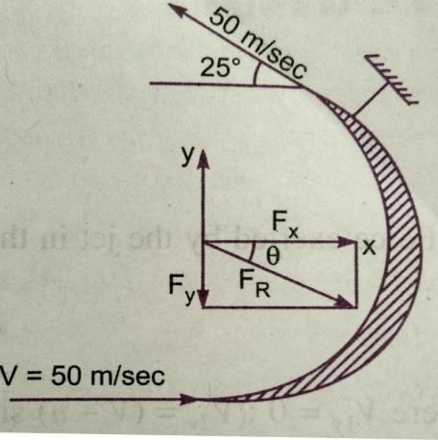
- A stationary vanehaving an inletangle of zero degree and an outletangle of 25°,receiveswater at a velocity of 50m/sec. Determine the components of force acting on it in the direction ofjet velocity and normal to it. Also find the resultant force in magnitude and direction per unitweightoftheflow.
Given: VelocityofjetV=50m/sec

Angleatoutlet=25°

Forthestationaryvane,theforceinthedirectionofjet.

𝐹𝑥=𝑀𝑎𝑠𝑠𝑝𝑒𝑟𝑠𝑒𝑐× 𝑉1𝑥−𝑉2𝑥

Where 𝑉1𝑥= 50m/sec,𝑉2𝑥=−50 cos25⁰=−45.315
∴Forceinthedirectionofjetperunitweight ofwater𝐹𝑥

𝐹=𝑀𝑎𝑠𝑠/sec[50−−45.315]=𝑀𝑎𝑠𝑠/sec⁡[50+45.315]

𝑥 𝑊𝑒𝑖𝑔𝑕𝑡𝑜𝑓𝑤𝑎𝑡𝑒𝑟
/𝑠𝑒𝑐

=95.315=9.716𝑁/𝑁
9.81
𝑚𝑎𝑠𝑠/𝑠𝑒𝑐×𝑔

Forceexertedbythejetinperpendiculardirectiontothejetperunitweightofflow

𝑉1=0 𝑉2𝑦=50sin25⁰

𝐹_{𝑦}
=𝑀𝑎𝑠𝑠/sec(𝑉1𝑦− 𝑉2)
𝑔×𝑚𝑎𝑠𝑠𝑝𝑒𝑟 𝑠𝑒𝑐

=(0−50𝑆𝑖𝑛25°)=−50𝑆𝑖𝑛25°

𝑔

=-2.154N
9.81

-vesignmeanstheforceFyisactinginthedownwarddirection.

∴ResultantForceperunitweight ofwaterFR=𝐹𝑥2+𝐹𝑦2

𝐹𝑅= (9.716)²+ (2.154)²=9.952N
TheanglemadebytheResultantForcewithx-axis
tan𝜃=Fy=2.154=0.2217
Fx 9.716
𝜽= 𝒕𝒂𝒏−𝟏0.2217= 12.50°

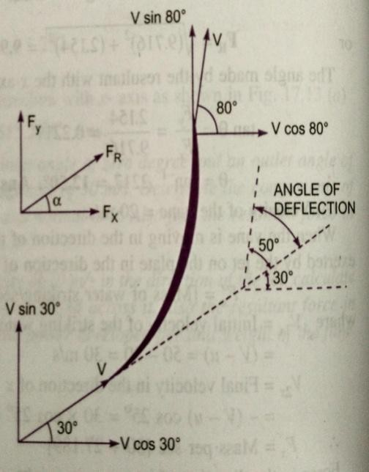
- A jet of water diameter 50mm moving with a velocity of 25m/sec impinges on a fixed curvedplate tangentially at one end at an angle of 30° to the horizontal. Calculate the resultant force ofthe jetonthe plate,ifthejetisdeflectedthroughanangle of50°.Takeg=10m/sec².

Given:
Dia. ofjetd=50mm=0.05m,
Areaofjet𝑎=𝜋(0.05)²=0.0019635m²
4
VelocityofjetV=25m/sec,
Angle made by the jet at inlet with horizontal 𝜃 = 30°Angleofdeflection=50°
Anglemadebythejetat theoutletwithhorizontal∅
∅ =+ 𝑎𝑛𝑔𝑙𝑒 𝑜𝑓 𝑑𝑒𝑓𝑙𝑒𝑐𝑡𝑖𝑜𝑛 = 30°+50° = 80° TheForce exertedbythejetofwaterinthe directionofx
𝐹𝑥=𝜌𝑎𝑉𝑉1𝑥−𝑉2𝑥

Where 𝜌=1000
=𝜋 0.05² V = 25m/s
4
𝑉1𝑥=𝑉cos30⁰=25cos30⁰
𝑉2𝑥=𝑉cos80⁰=25cos80⁰

𝐹𝑥
=1000×𝜋0.05²×2525cos300−25cos800=𝟖𝟒𝟗.𝟕 𝑵
4

The Force exertedbythejetofwaterinthe directionofy
𝐹𝑦=𝜌𝑎𝑉𝑉1𝑦−𝑉2𝑦
𝜋

𝐹𝑦=1000×
0.05²× 2525sin 300−25sin 800 =−𝟓𝟗𝟒.𝟗 𝑵
4

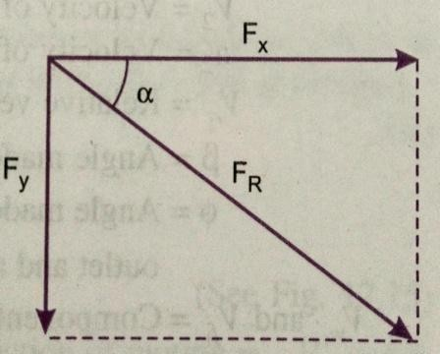
- vesignshowsthatForceFyisactinginthedownwarddirection.

TheResultantforce FR=𝐹𝑥2+𝐹𝑦2

=(849.7)²+(594.9)²
=1037N
Anglemade bytheResultantForcewiththeHorizontal
tan=𝐹𝑦=594.9=0.7

𝐹𝑥
849.7

𝑎=𝒕𝒂𝒏−𝟏0.7=35°

HYDRAULICTURBINES

Turbinesaredefinedasthehydraulicmachineswhichconvertshydraulicenergyintomechanical energy. This mechanical energy is used in running an electric generator which isdirectly coupled to the shaft of Turbine. Thus mechanical energy is converted in to electricalenergy. The electric power which is obtained from the hydraulic energy is known as theHydro-electric power.
EfficiencyofaTurbine:ThefollowingaretheimportantefficienciesofTurbine.

- HydraulicEfficiency,
- MechanicalEfficiency,
- VolumetricEfficiency,
- OverallEfficiency,
- Hydraulic Efficiency ( ): it is defined as the ratio of power given by the water to therunner of a turbine (runner is a rotating part of a turbine and on the runner vanes are fixed) tothe power supplied by the waterat the inletof the turbine.The powerat the inletof theturbine is more and this power goes on decreasing as the water flows over the vanes of theturbine due to hydraulic losses as the vanes are not smooth. Hence power delivered to therunnerofthe turbine willbelessthanthe poweravailable at theinletoftheturbine.
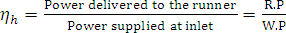

R.P=Powerdeliveredtotherunner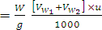kW for PeltonTurbine
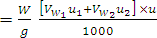kW RadialflowTurbine.
W.P =powersuppliedatinletofturbine=kW

Where W=weightofwaterstrikingthevanes oftheturbinepersecond=
Q=Volumeofwaterper second =Velocityofwhirlatinlet. = Velocityofwhirlatoutlet
=Tangentialvelocityofvane
=Tangentialvelocityofvaneatinlet ofradialvane.
=Tangentialvelocityofvaneatoutlet ofradial vane.
H=Nethead ontheTurbine.

Powersupplied attheinletoftheturbineinSIUnitsisknownasWater Power.
W.P=K.W (Forwater =1000Kg/m³)

=kW
- Mechanical Efficiency ( ): The power delivered by the water to the runner of a turbineis transmitted to the shaft of the turbine. Due to mechanical losses, the power available at theshaftoftheturbineislessthanthepowerdeliveredtotherunneroftheturbine.Theratioof
poweravailableattheshaftoftheturbine(KnownasS.PorB.P)tothepowerdeliveredto
therunnerisdefinedasMechanicalefficiency.

- Volumetric Efficiency ( ): The volume of the water striking the runner of the turbine isslightly less than thevolume of watersupplied to the turbine.Some of thevolume of thewater is discharged to the tailrace without striking the runner of the turbine. Thus the ratio ofthevolume ofthe watersuppliedto theturbineisdefinedasVolumetric Efficiency.
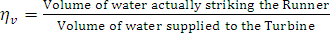

- Overall Efficiency (): It is defined as the ratio of power available at the shaft of theturbine tothepowersuppliedbythe wateratthe inletoftheturbine.

If shaft power (S.P) is taken in kW, Then water power should also be taken in kW. Shaftpoweris representedbyP.

Waterpowerin Where =1000Kg/m³
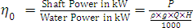
WhereP=ShaftPower

CLASSIFICATIONOFHYDRAULICTURBINES:
The Hydraulic turbines are classified according to the type of energy available at the inlet ofthe turbine, direction of flow through the vanes, head at the inlet of the turbine and specificspeed oftheturbine.Thefollowing are theimportantclassificationoftheturbines.
  - According tothetype ofenergyatinlet:
    - Impulseturbineand
    - Reactionturbine
  - Accordingtothedirectionofflowthroughthe runner:
    - Tangentialflowturbine
    - Radialflow turbine.
    - Axialflowturbine
    - Mixedflowturbine.
  - Accordingtotheheadatinletoftheturbine:
    - Highheadturbine
    - Mediumheadturbineand
    - Lowheadturbines.
  - Accordingtothespecificspeedoftheturbine:
    - Lowspecificspeedturbine
    - Mediumspecificspeedturbine
    - Highspecificspeedturbine.
If at the inlet of turbine, the energy available is only kinetic energy, the turbine isknown as Impulse turbine. As the water flows over the vanes, the pressure is atmosphericfrom inlet to outlet of the turbine. If at the inlet of the turbine, the water possesses kineticenergy as well as pressure energy, the turbine is known as Reaction turbine. As the waterflows through runner, the water is underpressureand the pressure energy goes on changingin to kinetic energy. The runner is completely enclosed in an air-tight casing and the runnerandcasingis completelyfullofwater.

If the water flows along the tangent of runner, the turbine is known as Tangential flowturbine. If the water flows in the radial direction through the runner, the turbine is calledRadial flow turbine. If the water flows from outward to inwards radially, the turbine isknown as Inward radial flow turbine, on the other hand, if the water flows radially frominward to outwards, the turbine is known as outward radial flow turbine. If the water flowsthrough the runner along the direction parallel to the axis of rotation of the runner, the turbineis called axial flow turbine. If the water flows through the runner in the radial direction butleaves in the direction parallel to the axis of rotation of the runner, the turbine is called mixedflowturbine.

PELTONWHEEL(Turbine)
It is a tangential flow impulse turbine. The water strikes the bucket along the tangentof the runner. The energy available at the inlet of the turbine is only kinetic energy. Thepressure at the inlet and out let of turbine is atmospheric. This turbine is used for high headsandisnamedafterL.A.PeltonanAmericanengineer.
The water from the reservoirflows through the penstocks at the outlet of which anozzle is fitted. The nozzle increases the kinetic energy of the water flowing through thepenstock. At the outlet of the nozzle, the water comes out in the form of a jet and strikes thebuckets(vanes)ofthe runner.Themainpartsofthe Peltonturbineare:
- Nozzleandflowregulatingarrangement(spear)
- Runnerand Buckets.
- Casingand
- Breakingjet

- Nozzle and flow regulating arrangement: The amount of water striking the buckets(vanes) of the runner is controlled by providing a spear in the nozzle. The spear is a conicalneedlewhichisoperatedeitherbyhandwheelorautomaticallyinanaxialdirectiondepending upon the size of the unit. When the spear is pushed forward in to the nozzle, theamount of water striking the runner is reduced. On the other hand, if the spear is pushed back,the amountofwaterstrikingtherunnerincreases.
- Runner with buckets: It consists of a circular disc on the periphery of which a number ofbuckets evenly spaced are fixed. The shape of the buckets is of a double hemispherical cup orbowl. Each bucket is divided in to two symmetrical parts by a dividing wall, which is knownassplitter.

The jet of water strikes on the splitter. The splitter divides the jet in to twoequal parts and the jet comes out at the outer edge of the bucket. The buckets are shaped insuch a way that the jet gets deflected through an angle of 160or 170. The buckets are madeof cast Iron, cast steel, Bronze or stainless steel depending upon the head at the inlet of theturbine.
- Casing: The function of casing is to prevent the splashing of the water and to discharge thewater to tailrace. Italsoacts as safeguard againstaccidents. It is made of CastIron orfabricatedsteel plates.Thecasingof thePeltonwheel doesnotperform anyhydraulicfunction.
- Breaking jet: When the nozzle is completely closed by moving the spear in the forwarddirection, the amount of waterstriking the runner reduces to zero.But the runner due toinertia goes on revolving for a long time. To stop the runner in a short time, a small nozzle isprovided, which directs the jet of water on the back of the vanes. This jet of water is calledBreakingjet.

VelocitytrianglesandworkdoneforPeltonwheel:
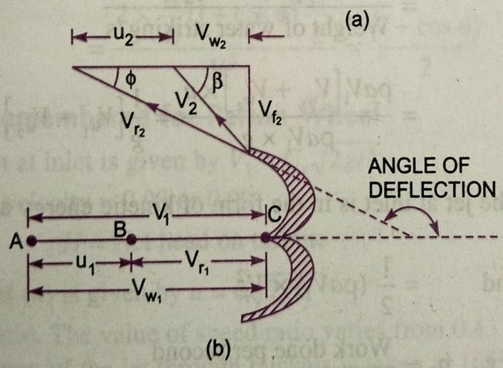
The jet of water from the nozzle strikes the bucketat the splitter, which splits up thejet into two parts. These parts of the jet, glides over the inner surfaces and comes out at theouter edge. The splitter is the in let tip and outer edge of the bucket is the outlet tip of thebucket. The inlet velocity triangle is drawn at the splitter and outer velocity triangle is drawnattheouteredgeofthebucket.
Let
H=Netheadacting onthePeltonWheel
Where =GrossHead
Where =diameterofpenstock,D=Diameterofwheel,d= DiameterofJet,
N =Speedofthe wheelinr.p.m
ThenV1=Velocityofjetatinlet

TheVelocityTriangleatinletwillbeastraightlinewhere

Fromthe velocitytriangle at outlet,wehave

Theforceexerted bytheJet ofwaterinthe directionofmotionis

(1)

As the angle β is an acute angle, +ve sign should be taken. Also this is the case ofseries of vanes, the mass of water striking is and not . In equation (1) „a‟ is theareaofthejet=
Nowwork donebythejet ontherunnerper second

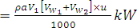
Powergiventotherunnerbythejet

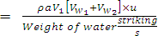
Workdone/sperunitweightofwaterstriking/s

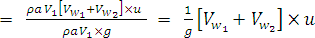 (3)
Theenergysupplied tothejetatinletisintheformofkineticenergy
K.E.ofjetpersecond

Hydraulicefficiency, 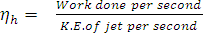
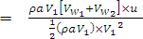
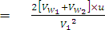 (4)
Now
And

Substitutingthevaluesofandinequation(4)
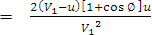(5)
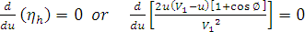
Theefficiencywillbemaximumforagivenvalueofwhen
Or
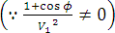
Or

Or Or (6)
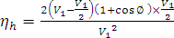
Equation (6) states that hydraulic efficiency of a Pelton wheel will be maximum when thevelocityof thewheelishalf thevelocity of thejetwateratinlet.Theexpressionformaximumefficiencywill beobtainedbysubstitutingthevalueofinequation(5)

Max.

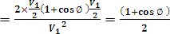
(7)

RADIALFLOWREACTIONTURBINE:
In the Radial flow turbines water flows in the radial direction. The water may flowradially from outwards to inwards (i.e. towards the axis of rotation) or from inwards tooutwards. If the water flows from outwards to inwards through the runner, the turbine isknown as inwards radial flow turbine. And if the water flows from inwards to outwards, theturbineis knownasoutwardradialflowturbine.
Reaction turbine means that the water at the inlet of the turbine possesses kineticenergy as well as pressure energy. As the water flows through the runner, a part of pressureenergy goes on charging into kinetic energy. Thus the water through the runner is underpressure. The runner is completely enclosed in an air-tight casing and the runneris alwaysfullofwater.

MainpartsofaRadialflowReaction turbine:
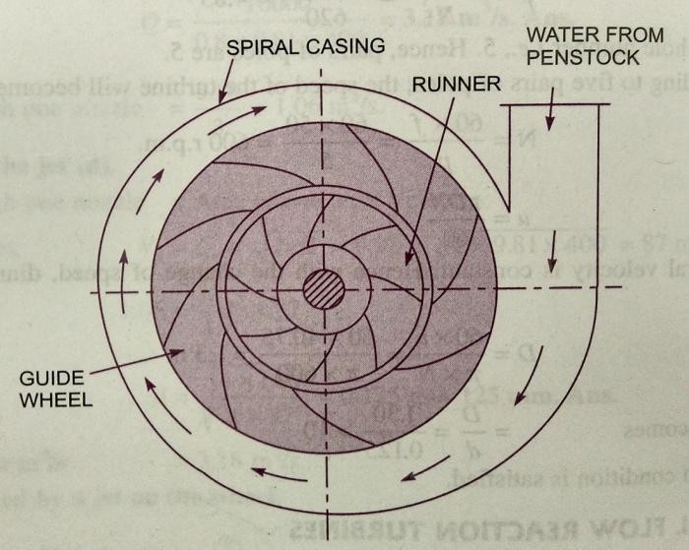
  - Casing
  - Guidemechanism
  - Runner and
  - Draft tube.
- Casing: in case of reaction turbine,casingandrunnerarealwaysfullofwater.Thewaterfromthepenstocksenters the casing which is of spiral shapein which area of cross-section one of thecasinggoesondecreasinggradually.Thecasingcompletelysurroundstherunneroftheturbine.Thewaterenters
therunneratconstantvelocitythroughoutthecircumferenceoftherunner.
- Guide Mechanism: It consists of a stationary circular wheel all around the runner of theturbine. The stationary guide vanes are fixed on the guide mechanism. The guide vanes allowthe water to strike the vanes fixed on the runner without shock at inlet. Also by suitablearrangement, the width between twoadjacentvanes of guidemechanism can be altered sothatthe amountofwaterstrikingtherunnercanbevaried.
- Runner: It is a circular wheel on which a series of radial curved vanes are fixed. Thesurfaces of the vanes are made very smooth. The radial curved vanes are so shaped that thewater enters and leaves the runner without shock. The runners are made of cast steel, cast ironorstainless steel.Theyarekeyedtotheshaft.
- Draft - Tube: The pressure at the exit of the runner of a reaction turbine is generally lessthan atmospheric pressure. The water at exit can‟tbe directly discharged to the tail race. Atube or pipe of gradually increasing area is used for discharging the water from the exit of theturbine tothetailrace.This tube ofincreasingareaiscalleddraft-tube.
Inward Radial Flow Turbine: In the inward radial flow turbine, in which case the waterfrom the casing enters the stationary guiding wheel. The guiding wheel consists of guidevanes which direct the water to enter the runner which consists of moving vanes. The waterflowsover themovingvanesintheinwardradialdirectionandisdischargedat theinner

diameteroftherunner. Theouterdiameteroftherunneristheinletandtheinnerdiameteristhe outlet.

Velocitytrianglesandworkdonebywateronrunner:
Workdone persecondonthe runnerbywater
(1)
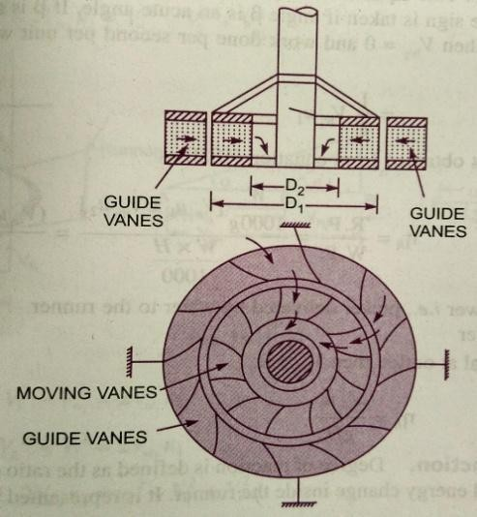
Theequationrepresentstheenergytransfer per secondtotherunner.Where Velocityofwhirlatinlet
Velocity of whirl at outletTangentialvelocityat inlet
, Where Outerdia.Ofrunner,Tangentialvelocityat outlet
Where Inner dia.Ofrunner,
N=Speedofthe turbineinr.p.m.
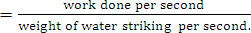
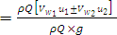
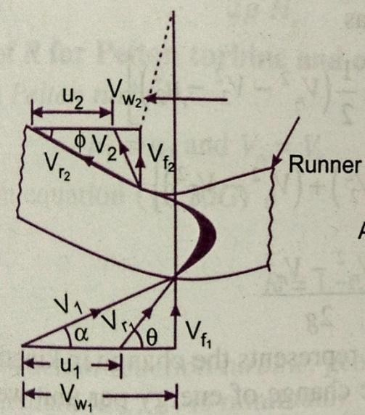
Theworkdoneper secondperunitweightofwaterpersecond

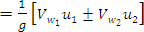 (2)
Equation(2)representstheenergytransferperunitweight/stothe runner.Thisequationis knownbyEuler’sequation.
Inequation +vesignistaken ifβisanacuteangle,
-vesign istaken ifβisanobtuseangle.
Ifthenandworkdonepersecondperunitweightofwaterstriking/s
Workdone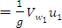
Hydraulicefficiency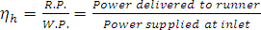
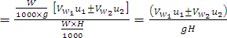 (3)
Where R.P.=RunnerPoweri.e.powerdeliveredbywaterto therunner
W.P.=WaterPower

Ifthedischargeisradialat outlet,then
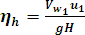

Definitions:
The following terms are generally used in case of reaction radial flow turbines whichare definedas:
- SpeedRatio:Thespeedratioisdefinedas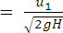Where tangentialvelocityofwheelatinlet
- Flow Ratio: The ratio of velocity of flow atinletto the velocity given isknownas theflowratio.
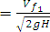 WhereH=Head onturbine
- Dischargeoftheturbine:Thedischargethroughareactionradialflowturbineis

Where Diaofrunneratinlet Diaofrunneratoutlet
Widthoftherunnerat inlet Widthofrunnerat outlet Velocityofflowatinlet Velocityofflowatoutlet
Ifthethicknessofthevanesaretakenintoconsiderationthentheareathroughwhich flowtakesplaceis givenby

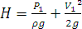
- Head:The (H)ontheturbineisgivenby
Where Numberofvanesand
Thicknessofeachvane

WherePressureatinlet

- Radial Discharge: This means the angle made by absolute velocity with the tangent on thewheelisandthecomponentof whirl velocity is zero. Theradial dischargeatoutletmeansand whileradialdischargeatinlet meansand
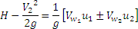
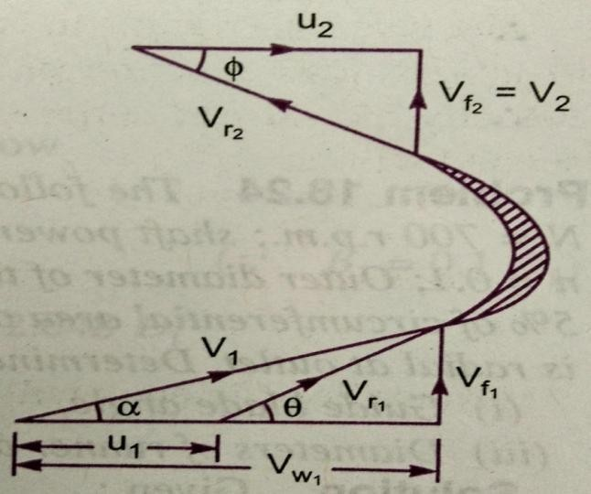
- If there is no loss of energy when the waterflowsthroughthe vanes thenwe have

FRANCISTURBINE:
The inward flow reaction turbine having radial discharge at outlet is known as FrancisTurbine. The water enters the runner of the turbine in the radial direction at outlet and leavesin the axial direction at the inlet of the runner. Thus the Francis turbine is a mixed flow typeturbine.

The velocity triangle at inlet and outlet of the Francis turbine are drawn in the sameway as in case of inward flow reaction turbine. As in case of inward radial flow turbine. ThedischargeofFrancis turbine is radialat outlet; the velocity of whirlat outletwill bezero.Hence theworkdone bywateronthe runnerpersecondwillbe

=
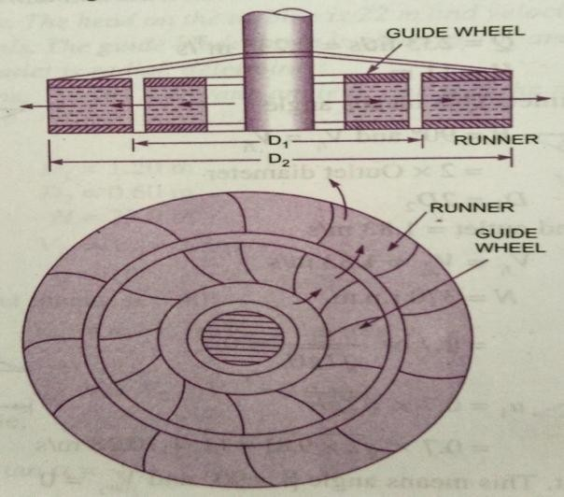
Theworkdonepersecondper unitweightofwaterstriking/sec=Hydraulicefficiency 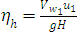

ImportantrelationsforFrancisturbines:

  - Theratioofwidthofthe wheeltoitsdiameterisgivenas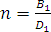.The value ofnvariesfrom0.10to0.40
  - Theflowratioisgivenas
Flowratioandvariesfrom0.15to0.30
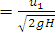
  - Thespeed ratio variesfrom0.6to0.9

OutwardradialFlowReactionTurbine:
In the outward radial flow reaction turbine water from the casing enters the stationaryguide wheel. The guide wheel consists of guide vanes which direct the water to enter therunner which is around the stationary guide wheel. The water flows through the vanes of therunner in the outward radial direction and is discharges at the outer diameter of the runner.Theinnerdiameterofthe runnerisinletandouterdiameteristhe outlet.
The velocity triangles a inlet and outlet will be drawn by the same procedure asadopted for inward flow turbine. The work done by the water on the runner per second, thehorse power developed and hydraulic efficiency will be obtained from the velocity triangles.In this case as the inlet of the runner is at the inner diameter of the runner, the tangentialvelocityatinletwillbelessthanthatofanoutlet.i.e.
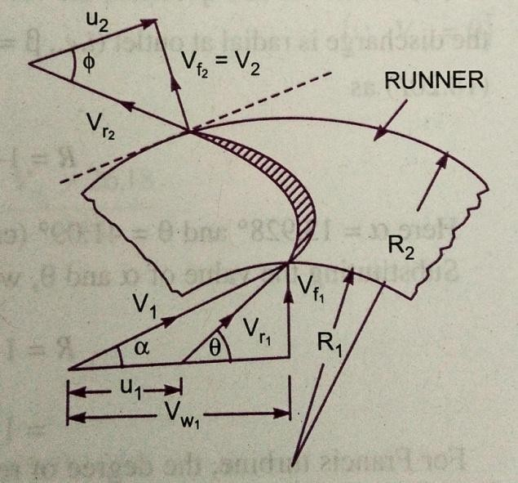
AsAll
theworkingconditionsflowthroughtherunnerbladeswithoutshock.AssucheddylosseswhichareinevitableinFrancisandpropellerturbinesarealmostcompletelyeliminatedinaKaplanturbine.
Thedischargethroughtherunnerisobtainedas
Whereouterdiameteroftherunner
Diameterofthe hub Velocityofflowatinlet

ImportantpointsforKaplanturbine:
- Theperipheralvelocityatinletandoutletare equal.
WhereOuterdiameter ofrunner.
- Velocityofflowatinletandoutletareequal.
- Areaofflowatinlet=Areaofflowatoutlet

AXIALFLOWREACTIONTURBINE:
If the water flows parallel to the axis of the rotation shaft the turbine is known as axialflow turbine. If the head at inlet of the turbine is the sum of pressure energy and kineticenergy and during the flow of the water through the runner a part of pressure energy inconvertedintokineticenergy,the turbineis knownasreactionturbine.
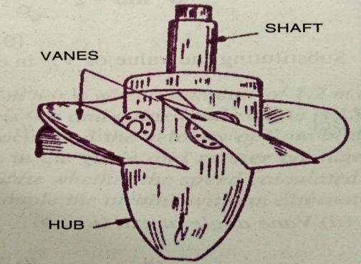
For axial flow reaction turbine, the shaftof the turbineis vertical. Thelower end ofthe shaftis made longer known as “hub” or “boss”. The vanes are fixed on the hub and actsas a runner for the axial flow reaction turbine. The important types of axial flow reactionturbines are:
  - PropellerTurbine
  - KaplanTurbine

Whenthevanesarefixedtothehubandtheyarenotadjustable the turbine is known as propeller turbine. But ifthe vanes on the hub are adjustable, the turbine is known asKaplanturbine.Thisturbineissuitable,wherelargequantityofwateratlow headsisavailable.
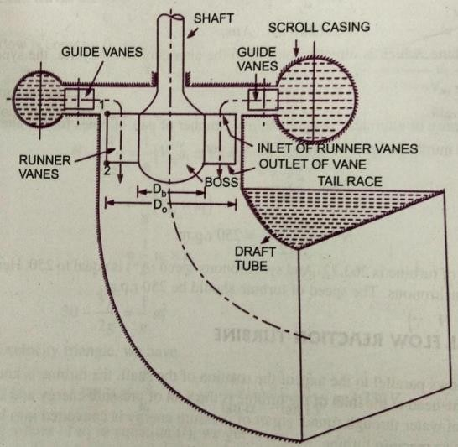
Themain partsoftheKaplanturbineare:

- Scrollcasing
- Guidevanesmechanism
- Hubwithvanesorrunner oftheturbine
- Draft tube

Between the guide vanes and the runnerthewaterintheKaplanturbineturnsthrough a right angle in to the axial angledirectionandthenpossesthroughtherunner.Therunner oftheKaplanturbinehas
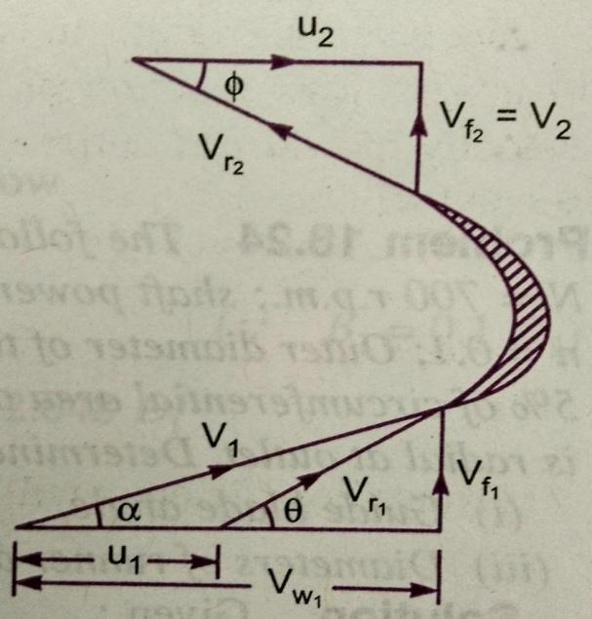
fourorsixoreightinsomecasesbladesanditcloselyresemblesashipspropeller.Theblades(vanes) attached toahuborbossesaresoshaped thatwaterflowsaxiallythroughtherunner.

The runner blades of a propeller turbine arefixed but the Kaplan turbine runner heads can beturned about their own axis, so that their angle ofinclination may be adjusted while the turbine is inmotion.Theadjustmentof therunnerbladesinusually carried outautomatically by means of aservomotor operating inside the hollow coupling ofturbine and generator shaft. When both guide vaneangleand runnerbladeanglemaythusbevarieda

high efficiency can be maintained over a wide range of operating conditions. i.e. even at partload,when alowerdischargeisfollowingthrough the runnera high efficiency can beattained in case of Kaplan turbine. The flow through turbine runner does not affect the shapeof velocity triangles as blade angles are simultaneously adjusted, the water under all theworkingconditionsflowsthroughtherunnerbladeswithoutshock.TheeddylosseswhichareinevitableinFrancisandpropellerturbinesarecompletelyeliminatedinaKaplanTurbine.

WorkingProportions ofKaplanTurbine:
ThemaindimensionsofKaplanTurbinerunnersaresimilartoFrancisturbinerunner.
Howeverthefollowingaremaindeviations,

- Chooseanappropriatevalueoftheratio,wheredinhuborbossdiameter andD isrunneroutside diameter.Thevalue ofnvariesfrom0.35to0.6
- ThedischargeQflowingthroughtherunnerisgiven by
ThevalueofflowratioforaKaplanturbineis0.7
- The runner blades of the Kaplan turbine are twisted, the blade angle being greater atthe outer tip than at the hub.Thisis because the peripheral velocity of the bladesbeing directly proportional to radius. It will valy from section to section along theblade, and hence in order to have shock free entry and exit of water over the bladeswithanglesvaryingfromsectiontosectionwillhavetobedesigned.

DRAFTTUBE:
The draft tube is a pipe of gradually increasing area, which connects the outlet of therunner to the tail race. It is used for discharging water from the exit of the turbine to the tailrace. This pipe of gradually increasing area is called a draft tube. One end of the draft tube isconnected to the outlet of the runner and the other end is submerged below the level of waterin the tail race. The draft tube in addition to save a passage for water discharge has thefollowingtwopurposes also:
  - It permits a negative head to be established at the outlet of the runner and their byincrease the net head on the turbine. The turbine may be placed above the tail racewithout anylossofnetheadand hence turbinemaybeinspectedproperly.
  - It converts a large portion of the kinetic energy 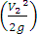rejected at the outlet of theturbine into useful energy. Without the draft tube the kinetic energy rejected at theturbine willgowastetothetailrace.
Hencebyusingthedrafttube,thenetheadonturbineincreases. Theturbinedevelopsmore powerandalsothe efficiencyoftheturbineincrease.
If a reaction turbine is not fitted with a draft tube, the pressure at the outlet ofthe runner will be equal to atmospheric pressure. The water from the outlet of the runnerwilldischargefreelyintothetailrace.Thenetheadontheturbine will belessthanthatof

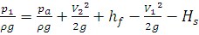
areactionturbinefittedwithadrafttube. Alsowithoutdrafttubethekineticenergyrejectedattheoutletofthewillgowatertothetail race.

TypesofDraftTube:
    - ConicalDraftTube
    - SimpleElbowTubes
    - MoodySpreadingtubes
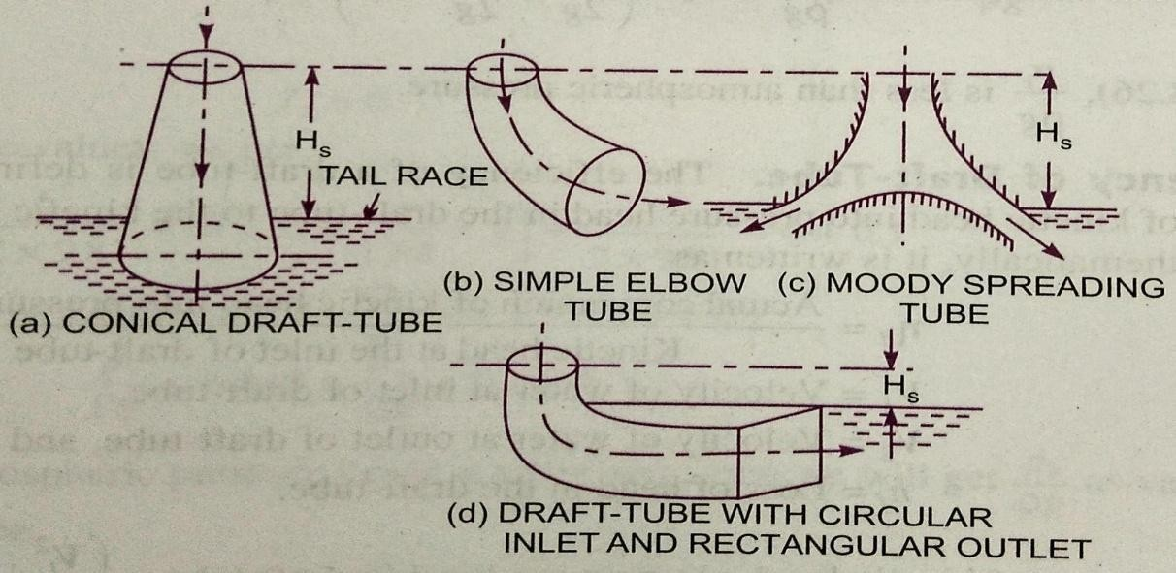
    - ElbowDraftTubeswithCircularinletandrectangularoutletTheconicaldrafttubes

and moodyspreadingdrafttubesaremostefficientwhilesimpleelbowdrafttubeand elbowdrafttubeswithcircularinletandrectangularoutletrequirelessspaceas comparedtootherdrafttubes.
Drafttubetheory:Consideraconicaldrafttube VerticalheightofdrafttubeabovetailraceY=Distanceofbottomofdrafttubefromtailrace.
ApplyingBernoulli‟sequationtoinletsection1-1andoutletsection2-2ofthedraft
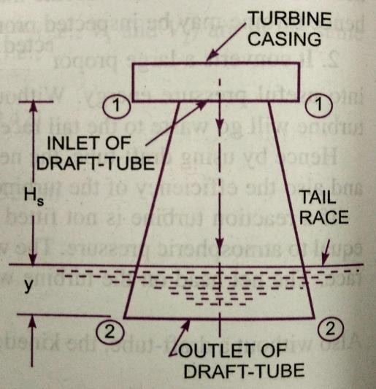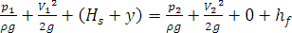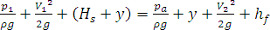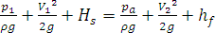tubeand takingsection2-2 adatum,weget
(1)
Where
loss ofenergybetweensection1-1and2-2.
But
AtmosphericPressure+ y=
Substitutingthisvalueof in equation(1)weget

(2)
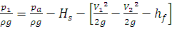
Inequation(2) is lessthanatmosphericpressure.

Efficiency of Draft Tube: the efficiency of a draft tube is defined as the ratio of actualconversion of kinetic head in to pressure in the draft tube to the kinetic head at the inlet of thedrafttube.
LetVelocityofwateratinlet ofdraft tube Velocityofwateratoutletofdraft tube Lossofheadinthe drafttube
TheoreticalconversionofKineticheadintoPressureheadin

Drafttube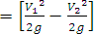
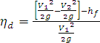
ActualconversionofKineticheadintopressurehead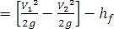NowEfficiencyofdrafttube

PROBLEMS
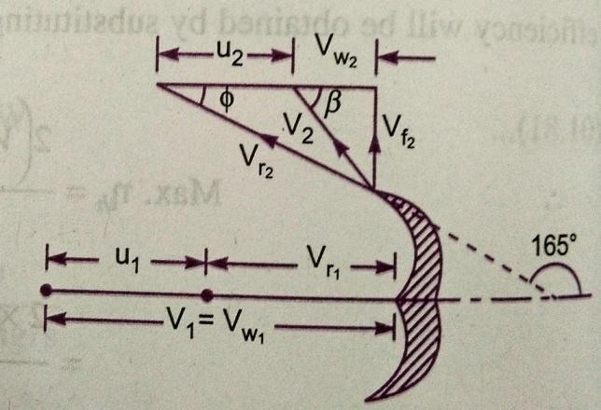
- A pelton wheel has a mean bucket speed of 10m/s with a jet of water flowing at the rate of700lts/sec under a head of 30 m. the buckets deflect the jet through an angle of 160⁰ calculatethe power given by the water to the runner and hydraulic efficiency of the turbine? Assumeco-efficientofvelocity=0.98

Given:
Speedofbucket Discharge Q = 700lt/sec=0.7m³ /sHeadofwaterH=30m
Angledeflection =160⁰
Co-efficientofvelocity The velocityofjet

Fromtheoutletvelocitytriangle

Workdonebythejet/secontherunnerisgiven byequation

Powergiventotheturbine
Thehydraulicefficiencyoftheturbineisgivenby equation
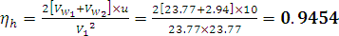
Or =94.54%

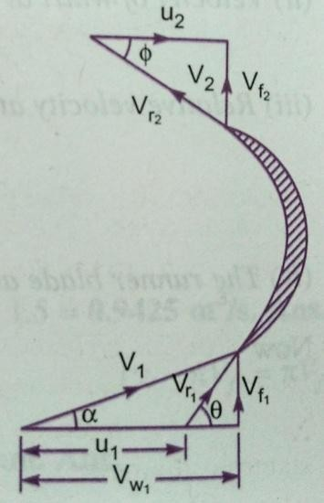
- A reaction turbine works at 450rpm under a head of 120m. its diameter at inlet is 120cmandflow area is 0.4m².The anglesmade by absolute and relativevelocities atinletare 20⁰and60⁰respectively,withthe tangentialvelocity.Determine
i)Volumeflow rate ii)thepowerdeveloped
iii) Thehydraulicefficiency.Assumewhirlatoutletiszero.
Given: Speed of turbineN = 450rpmHead H=120m
Diameter of inletD1 = 120cm=1.2mFlowarea
Angle madebyabsolutevelocityAnglemadebyrelativevelocity Whirlatoutlet Tangentialvelocityoftheturbineatinlet
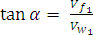
Frominlettriangle

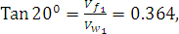
(1)

Also

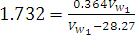

Fromequation(1)
- Volumeflowrateisgiven byequationas
- Work donepersecond ontheturbineisgivenbyequation

Powerdevelopedin
- Thehydraulicefficiencyisgivenbyequation
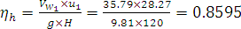
= 85.95%
- The internal and external diameters of an outward flow reaction turbine are 2m and 2.75mrespectively. The turbine is running at 250rpm and the rate of flow of water through theturbine is 5m³/s. the width of the runner is constant at inlet and outlet is equal to 250mm. thehead on the turbine is 150m. Neglecting the thickness of the vanes and taking discharge radialatoutlet,determine:
i)Vaneangleatinletandoutlet ii)velocityofflowinletandoutlet
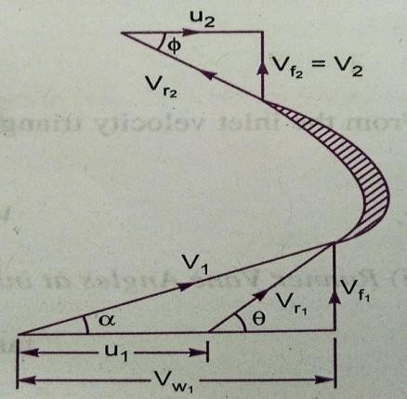
Given: InternaldiameterD1=2m
External diameter D2=2.75mSpeed of turbine N=250rpmDischarge Q=5m³/s
Width at inlet and outlet B1=B2=250mm=0.25mHeadH=150m
Dischargeatoutlet=radial
Thetangentialvelocityofturbineatinletandoutlet

Thedischargethroughtheturbineisgivenby

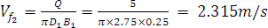
Usingequation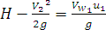Butforradialdischarge

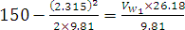
Or

- Vaneangleatinletandoutlet
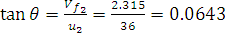
Fromtheinletvelocitytriangle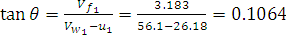
Fromoutletvelocitytriangle

- Velocityofflowatinletandoutlet
- A Francis turbine with an overall efficiency of 75% is required to produce 148.25kWpower. It is working under a head of 7.62m. The peripheral velocity=0.26 and theradialvelocityofflowatinletis0.96.Thewheelrunsat150rpmandthehydraulic
losses intheturbineare22%oftheavailableenergy.Assumingradialdischargedetermine
i) Theguidebladeangle. ii)Thewheelvaneangleatinlet
iii)The diameterofthe wheelatinlet,and iv)Widthofthewheelatinlet.
Given: OverallefficiencyHeadH=7.62rpm
PowerProducedS.P.=148.25kW
SpeedN= 150rpm
Hydraulicloses=22%ofenergy
Peripheralvelocity
Dischargeatoutlet=Radial

Thehydraulicefficiency

But ,
- Theguide bladeanglei.e. Frominletvelocitytriangle

- Thewheelangleatinlet

- ThediameterofwheelatinletUsingrelation

- Widthofthewheelatinlet
But

Usingequation

- A Kaplan turbine runner is to be designed to develop 7357.5kW shaft power. The netavailable head is 5.50m. Assume that the speed ratio is 2.09 and flow ratio is 0.68 and theoverall efficiency is 60%. The diameter of boss is of the diameter of runner. Find thediameteroftherunner,its speedandspecificspeed.
Given: ShaftpowerP=7357.5kW

Head H=5.5m
Speed ratio =
Flowratio

OverallEfficiency Diameterofboss
Usingtherelation 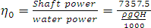
Discharge

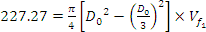
Usingequationfordischarge

Usingtherelation
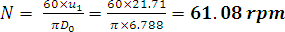

Thespecificspeed

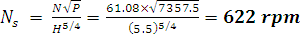

Geometricsimilarity

Thegeometricsimilaritymustexistbetweenthemodelanditsprototype. theratioofallcorrespondinglineardimensionsinthemodelanditsprototype are equal.

Let lengthofmodel Breadthofmodel Diameterofmodel Area ofmodel
Volumeofmodel
AndCorrespondingvaluesoftheprototype.

Forgeometricalsimilaritybetweenmodelandprototype,wemusthavetherelation,
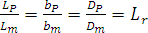

Whereiscalledscaleratio.

Forarea‟sratioandvolume‟sratiotherelationshouldbe,
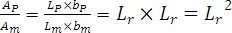
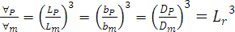

PerformanceofHydraulicTurbines
In order to predictthe behavior of a turbine working undervaryingconditions ofhead, speed, output and gate opening , the results are expressed in terms of quantities whichmay be obtained when the head on the turbine is reduced to unity. The conditions of theturbine under unit head are such that the efficiency of the turbine remains unaffected. Thethree importantunitquantitiesare:
  - Unit speed,
  - Unitdischarge,and
  - Unitpower

- UnitSpeed:itisdefinedasthespeedofaturbineworkingunder aunithead.Itisdenotedby. Theexpressionofunitspeedis obtainedas:
Let N=Speedofthe turbineunderahead H

H=Headunder whichaturbineisworking

u=Tangentialvelocity.

Thetangentialvelocity,absolutevelocityofwaterandheadonturbinearerelatedas:

Where (1)
Alsotangentialvelocity(u)isgivenby

WhereD=Diameterofturbine.

Foragiventurbine, thediameter(D)isconstant

Or Or

(2) Whereisconstantofproportionality.Ifheadonthe turbinebecomesunity,the speedbecomesunitspeedor
When H=1,N=Nu

Substitutingthesevaluesinequation(2),weget

SubstitutingthevalueofK1inequation(2)

(I)
- Unit Discharge: It is defined as the discharge passing through a turbine, which is workingunderaunithead(i.e. 1m).Itisdenotedbytheexpressionforunitdischarge isgivenas:
Let H =headofwaterontheturbine
Q=Dischargepassing throughturbinewhen headisHontheturbine.
= Area offlow ofwater

Thedischargepassingthroughagiventurbineunderahead‘H’is givenby,Q=Areaofflow Velocity
Butfor aturbine, areaofflowisconstantandvelocityisproportionalto
Or (3)

Whereisconstantofproportionality
If H = 1, (By definition)Substitutingthese valuesinequation(3)weget
Substitutingthevalueof inequation(3)weget
(II)
- Unit Power: It is defined as the power developed by a turbine working under a unit head(i.e.under aheadof1m).Itisdenotedby.Theexpressionforunitpowerisobtainedas:
Let H=Headofwaterontheturbine
P=Powerdeveloped bytheturbineunderahead ofHQ=Discharge throughturbine undera headH
The overallefficiency isgivenas
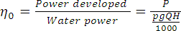

(4)Whereisaconstantofproportionality
When H=1m,
Substitutingthevalueof in equation(4)weget

(III)

UseofUnitQuantities:

If a turbineis working under differentheads,the behaviour of the turbine can beeasily known from the values of the unit quantities i.e. from the value of unit speed, unitdischarge andunitpower.

Let H1,H2,H3, arethe headsunderwhicha turbine works,
N1,N2,N3, arethecorrespondingspeeds,
Q1,Q2,Q3, arethedischargeand
P1,P2,P3, arethepowerdeveloped bytheturbine.
UsingequationI,II,IIIrespectively,

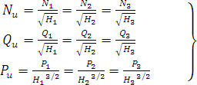
(IV)

Hence, if the speed, discharge and power developed by a turbine undera head are known,then by using equation (IV) the speed, discharge, power developed by the same turbine adifferentheadcanbeobtainedeasily.

CHARACTERISTICCURVESOFHYDRAULICTURBINES:
Characteristic curves of a hydraulic turbine are the curves, with the help of which theexact behaviour and performance of the turbine under different working conditions can beknown. These curves are plotted from the results of the tests performed on the turbine underdifferentworkingconditions.
Theimportantparameterswhicharevaried duringatestonturbineare:
1)Speed(N) 2)Head(H) 3)Discharge(Q)
- Power(P) 5)OverallEfficiency( )and 6)Gateopening.
Out of the above six parameters, three parameters namely speed (N), Head (H) anddischarge (Q)areindependentparameters.
Out of the three independent parameters, (N, H, Q) one of the parameter is keptconstant (say H) and the variation of other two parameters with respect to any one of theremainingtwoindependentvariables (say NandQ)areplottedandvarious curves areobtained. These curves are called characteristiccurves. Thefollowing are theimportantcharacteristic curves ofaturbine.
  - MainCharacteristicCurvesorConstantHeadCurves.
  - OperatingCharacteristicCurvesorConstantSpeedCurves.
  - MuschelCurvesorConstantEfficiencyCurves.

MainCharacteristicCurvesorConstant HeadCurves:

These curves are obtained by maintaining a constant head and a constant gate opening(G.O.) on the turbine. The speed of the turbine is varied by changing the load on the turbine.For each value of the speed, the corresponding values of the power (P) and discharge (Q) areobtained.Thentheoverallefficiency( )foreachvalueofthespeediscalculated.From
thesereadingsthevaluesofunitspeed(), unit power ( ) and unit discharge ( ) aredetermined.Taking asabscissa,thevaluesof Pand areplotted.Bychanging
the gateopening,the | valuesof | and and | aredeterminedandtaking | as
abscissa, thevaluesof | and | areplotted.
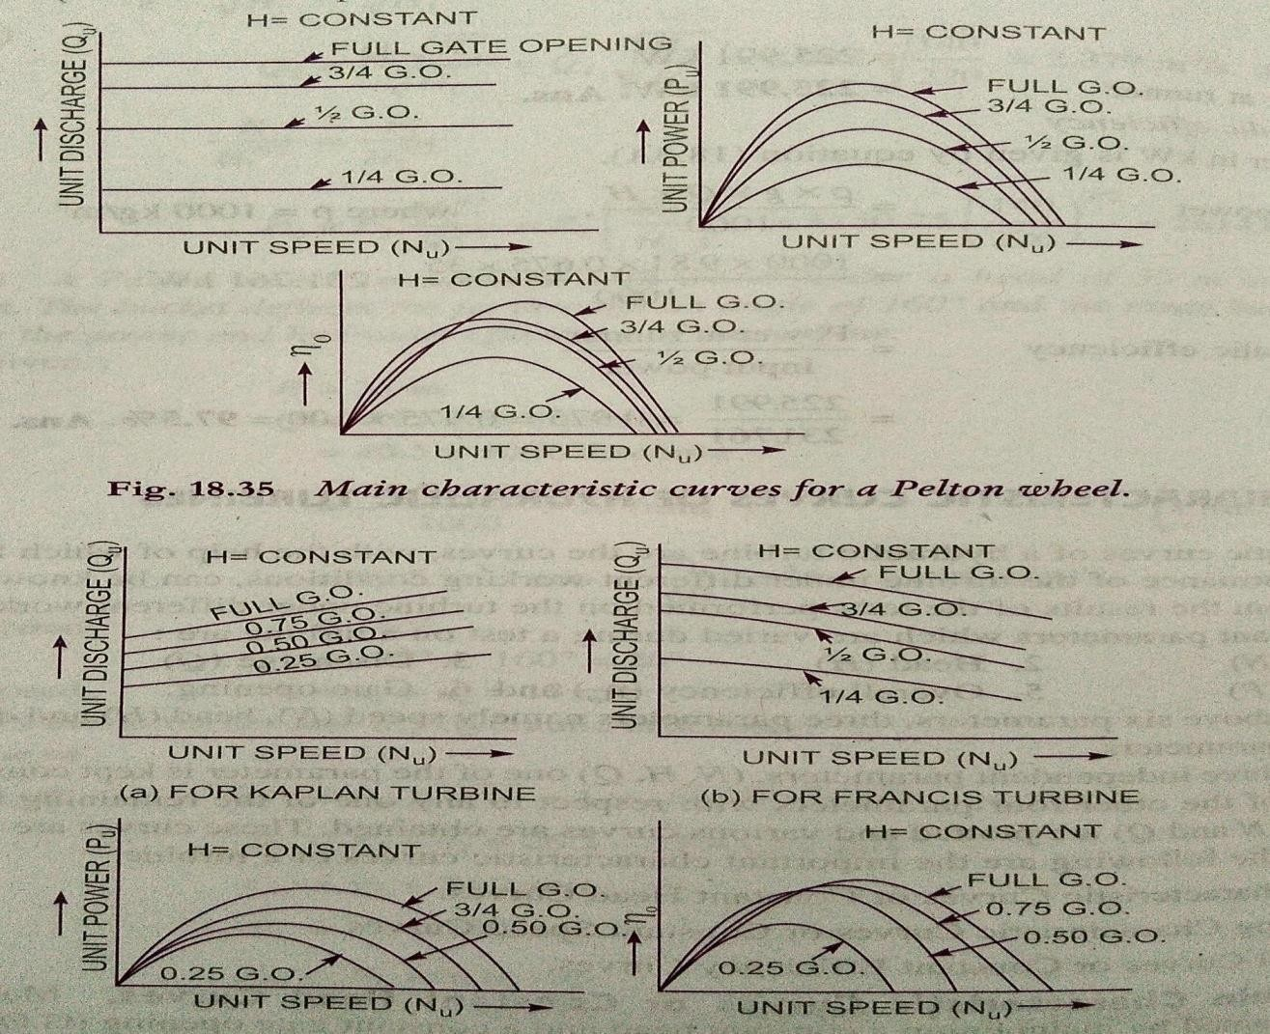

OperatingCharacteristicCurvesorConstantSpeedCurves:
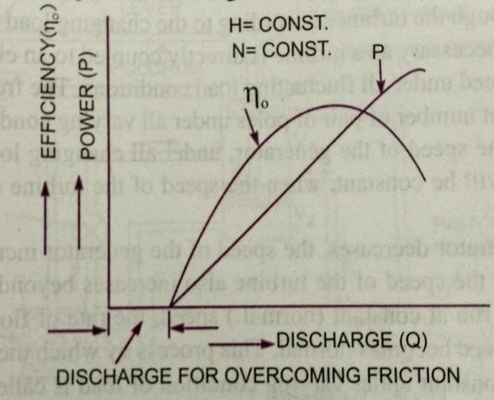
These curves are plotted when the speedon the turbine is constant. In case turbines, thehead is generally constant. As already discussedthere are three independent parameters namely N,H and Q. For operating characteristics N and Hareconstantandhencethevariation of powerand the efficiency with respect to discharge Q areplotted. The power curve for the turbine shall notpass through the origin,because certain amountofdischargeisneededtoproduce powerto
overcome initial friction. Hence the power and efficiency curves will be slightly away fromthe origin on the x-axis, as to overcome initial friction certain amount of discharge will berequired.

ConstantEfficiencyCurvesorMuschelCurvesorIso-EfficiencyCurves:
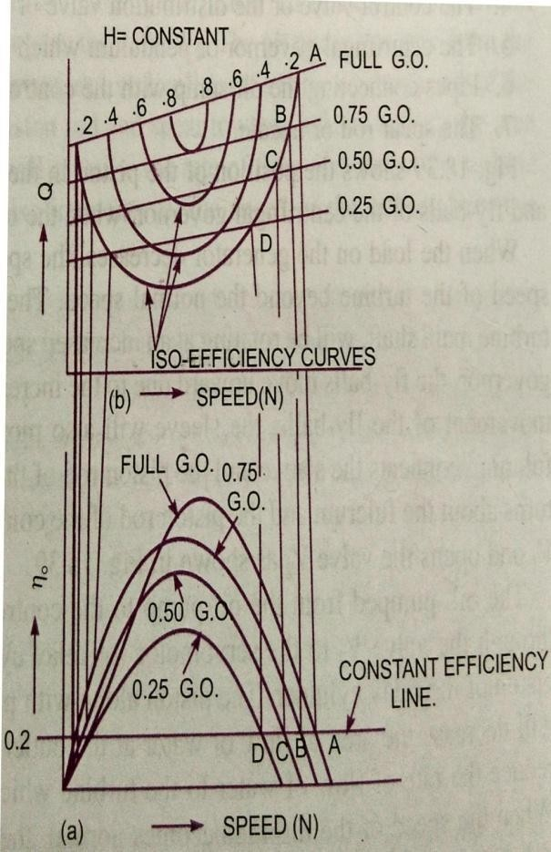
These curves are obtained from the speed vs.efficiency and speed vs. discharge curves fordifferent gate openings. For a given efficiencyfromthevs. curvestherearetwo
speeds. From the vs.curves,corresponding to twovalues of speeds thereare two values of discharge. Hence for a givenefficiencytherearetwovaluesofdischargefor
aparticulargate opening.Thismeansforagiven efficiency there are two values of speedsand two values of discharge for a given gateopening. If the efficiency is maximum there isonly one value. These two values of speed andtwo values of discharge. Corresponding to aparticulargateopeningareplotted.Theprocedureisrepeatedfordifferentgateopenings and the curves Q vs. N are plotted.Thepointshavingthesameefficienciesarejoined. Thecurveshavingthesameefficiency
arecalledIso-efficiencycurves. Therecurvesarehelpfulfordeterminingthezoneofconstantefficiencyandforpredicating theperformanceoftheturbineatvariousefficiencies.
ForplottingtheIso-efficiencycurves,horizontallinesrepresentingthesameefficiencyaredrawnonthe speedcurves.Thepointsatwhichtheselinescuttheefficiency curves at various gate opening are transferred to the corresponding speedcurves. The points having the same efficiency are then joined by smooth curves. Thesesmoothcurves representtheIso-efficiencycurves.

Cavitation :Cavitationisdefinedasthephenomenonof formationof vapourbubblesofa flowing liquid in a region, where the pressure of the liquid falls below its vapour pressureand the sudden collapsing of these vapour bubbles in a region of higher pressure. When thevapour bubbles collapse, a very high pressure is created. The metallic surfaces, above whichthese vapour bubbles collapse, is subjected to these high pressures, which cause pitting actionon the surface. Thus cavities are formed on the metallic surface and also considerable noiseandvibrations areproduced.

Cavitation includes formation of vapour bubbles of the flowing liquid and collapsingof the vapour bubbles. Formation of vapour bubbles of the flowing liquid take place onlywhenever the pressure in any region falls below vapour pressure. When the pressure of theflowing liquid is less than its vapour pressure, the liquid starts boiling and the vapour bubblesare formed. These vapour bubbles are carried along with the flowing liquid to higher pressurezones, where thesevapour condense and thebubbles collapse. Due tosudden collapsing ofthe bubbles on the metallic surface, high pressure is produced and metallic surfaces aresubjectedtohighlocalstress.Thusthesurfacesaredamaged.
PrecautionagainstCavitation:ThefollowingarethePrecautionagainstcavitation
- The pressure of the flowing liquid in any part of the hydraulic system should not beallowed to fall below its vapour pressure. If the flowing liquid is water, then theabsolute pressureheadshouldnotbebelow2.5mofwater.
- The special materials or coatings such as Aluminum-bronze and stainless steel, whichare cavitationresistantmaterials,shouldbeused.
EffectsofCavitation:thefollowing aretheeffectsofcavitation.
- Themetallicsurfacesaredamagedandcavitiesareformedonthesurfaces.
- Due tosudden collapse of vapour bubbles, considerable noise andvibrations areproduced.
- The efficiency of a turbine decreases due to cavitation. Due to pitting action, thesurface of the turbine blades becomes rough and the force exerted by the water on theturbine blades decreases.Hence,the workdone by water or outputhorse powerbecomesless andefficiencydecreases.
HydraulicMachinesSubjectedtoCavitation:ThehydraulicmachinessubjectedtoCavitationarereactionturbineandcentrifugalpumps.
Cavitation in Turbines: in turbines, only reaction turbines are subjected to cavitation. Inreaction turbines the cavitation may occur at the outlet of the runner or at the inlet of the drafttube where the pressure is considerably reduced. (i.e. which may be below vapour pressure ofthe liquid flowing through the turbine) Due to cavitation, the metal of the runner vanes anddraft tube is gradually eaten away, which results in lowering the efficiency of the turbine.Hence the cavitation in a reaction turbine can benoted by a sudden drop in efficiency. Inorder to determine whether cavitation will occur in any portion of a reaction turbine, thecriticalvalueofThoma‟scavitationfactorssigmaiscalculated.
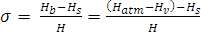,
WhereBarometric pressureheadinmofwater,Atmospheric pressure head in m of water,Vapourpressureheadinmofwater,

Suctionpressure at theoutletofreactionturbinein mofwaterorheightofturbine runnerabove thetailwatersurface,

H=Netheadontheturbineinm.
SurgeTank:

When the load on the generator decreases, the governor reduces the rate of flow ofwater striking the runner to main constant speed for the runner. The sudden reaction of rate offlow in the penstock may lead to water hammer in pipe due to which the pipe may burst.When theload on the generator increases the turbine requiresmore water. Sugar tankandfore bays are usually employed to meet the above requirements. Surge tanks are employed incase of high head and medium head hydro power plants where the penstock is very long andfore bays are suitable for medium and low head hydro power plants where the length ofpenstockisshort.

Anordinarysugartankisacylindricalopentopedstoragereservoir,whichisconnected to the penstock at a point as close as possible to the turbine. The upper lip of thetank is kept well above the maximum water level in the supply reservoir. When the load onthe turbine is steady and normal and there are no velocities variations in the pipe line therewill be normal pressure gradient oaa1. The water surface in the surge tank will be lower thanthe reservoir surface by an amount equal to friction head loss in the pipe connecting reservoirand sugar tank. When theload on the generator is reduced, the turbine gates are closed andthe water moving towards the turbine has to move back ward. The rejected water is thenstored in the surge tank, raising the pressure gradient. The retarding head so built up in thesurgetankreducesthevelocityofflowinthepipelinecorrespondingtothereduceddischarge requiredbythe turbine.

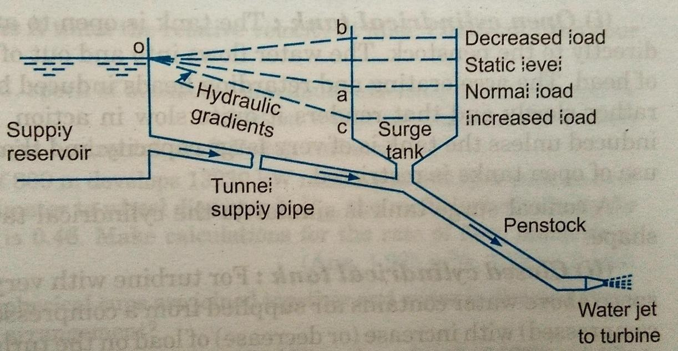
When the load on the generator increases the governor opens the turbine gates toincrease the rate of flow entering the runner. The increased demand of water by the turbine ispartly met by the water stored in the surge tank. As such the water level in the surge tank fallsandfallingpressuregradientisdeveloped.Inotherwords,thesurgetankdevelopsanacceleratingheadwhichincreasesthevelocityofflowinthepipelinetoavalvecorrespondingtotheincreaseddischarge requiredbythe turbine.

DepartmentofMechanicalEngineering, MRCET

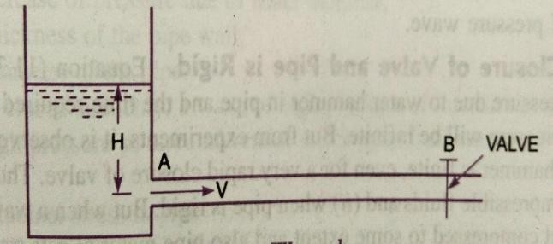
WaterHammer:
Consider a long pipe AB, connected atone end to a tank containing waterat a heightof H from the centre of the pipe. At the otherend of the pipe, a valve to regulate the flow ofwaterisprovided.Whenthevalveiscompletelyopen,thewaterisflowingwitha
velocity, V in the pipe. If now the valve is suddenly closed, the momentum of the flowingwater will be destroyed and consequently a waveof high pressure will be setup. This waveof high pressure will be transmitted along the pipe with a velocity equal to the velocity ofsound wave and may create noise called knocking. Also this wave of high pressure has theeffectofhammering actiononthewallsofthepipeand henceitisknownaswaterhammer.
Thepressureriseduetowater hammer dependsupon:
  - Velocityofflow ofwaterinpipe.
  - Thelengthofpipe.
  - Timetakentoclosethe valve.
  - Elasticpropertiesofthematerialofthe pipe.
Thefollowingcasesofwaterhammerinpipeswillbeconsidered.
- Gradualclosure ofvalve
- Suddenclosureofvalveconsideringpipeinrigid
- Suddencloser ofvalveconsideringpipeelastic.

1.GradualClosureofValve:
WhereA= Area ofcross-sectionofthe pipeL=Lengthofpipe
The valve is closed gradually in time „T‟ seconds and hence the water is brought from initialvelocityVtozerovelocityintimeseconds.
(1)
Ifpistheintensityofpressure waveproducedduetoclosureofthe valve,the forcedue topressure wave
(2)
Equating thetwo forcesgivenbyequation(1)&(2)

Headofpressure
- Thevalveclosureissaidtobegradualif T
Where T =Timeinsec,C=VelocityofPressurewave
- Thevalveclosureissaidtobesuddenif Where C=VelocityofPressure Wave

2) SuddenClosureof ValveandPipeisRigid:
In sudden closure of valve T=0, the increase in pressure will be infinite when wave ofhigh pressure is created the liquid gets compressed to some extent and pipe material getsstretched.For a sudden closure of valve,the valve of Tis very small andhence a wave ofhighpressureiscreated.
When the valve is closed suddenly, the kinetic energy of flowing water is converted into strain energy of water if the effect of friction is neglected and pipe wall is assumed to berigid.

EquatinglossofKineticenergytogainofstrainenergy
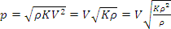
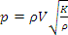
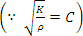

WhereC=velocityofpressurewave.

UNIT-5
HYDROULIC MACHINES

CENTRIFUGALPUMPS
The hydraulic machines which convert the mechanical energy in to hydraulic energyare called pumps. The hydraulic energy is in the form of pressure energy. If the mechanicalenergy is convertedin topressure energy by means of centrifugal force actingon the fluid,the hydraulicmachineis calledcentrifugalpump.
Thecentrifugal pumpactsasa reversedof aninwardradial flowreaction turbine.Thismeans thatthe flowin centrifugal pumpsisin the radial outward directions.Thecentrifugal pump works on the principle of forced vertex flow which means that when acertain mass of liquid is rotated by an external torque, the rise in pressure head of the rotatingliquidtakesplace.Therisein pressureheadatanypointoftherotatingliquidisproportional
tothesquareoftangentialvelocityoftheliquidatthatpoint.(i.e.riseinpressurehead=𝑉2
2𝑔
or2𝑟2).Thustheoutlet oftheimpeller,whereradiusismore,theriseinpressureheadwill
2𝑔
bemoreandtheliquidwillbedischargedattheoutletwithahighpressurehead.Duetothishighpressure head,theliquidcanbeliftedtoahighlevel.
Thefollowing arethemain partsofacentrifugalpump.
1)Impeller. 2) Casing. 3)Suctionpipewithfootvalveandastrainer4) Deliverypipe.
- Impeller: The rotating part of a centrifugal pump is called impeller. It consists of a seriesof backward curved vanes. The impeller is mounted on a shaft which is connected to the shaftofanelectricmotor.
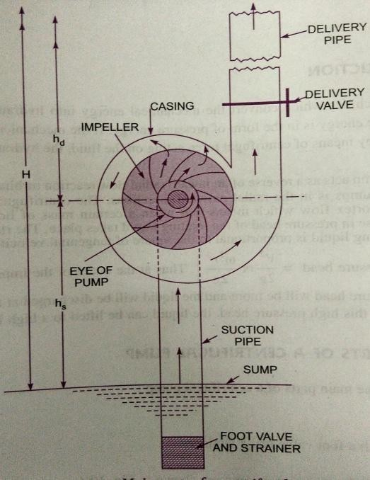
- Casing: the casing of a centrifugal pump is similar to the casing of a reaction turbine. It isan air tight passage surrounding the impeller and is designed in such a way that the kineticenergy of the water discharged at the outlet of the impeller is converted in to pressure energybefore the water leaves the casing and enters the delivery pipe. The following three types ofthe casingarecommonlyadopted.
  - Volute b)Vortex
c)Casingwithguideblades

- Volute Casing: It is the casing surrounding the impeller.It is of a spiral type,in whicharea of flow increases gradually. The increase in area of flow decreases the velocity of flow.The decrease in velocity increases the pressure of the water flowing through the casing. It hasbeen observed that in case of volute casing, the efficiency of the pump increase slightly as alargeamountofenergyin lostduetothe formationofeddiesinthistype ofcasing.
- Vortex Casing: If a circular chamber is introduced between the casing and the impeller,the casing is known as vortex casing. By introducing the circular chamber, the loss of energydue to the formation of eddies is reduced to a considerable extent. Thus the efficiency of thepumpismorethantheefficiencywhenonlyvolute casingisprovided.

- Casing with guide blades: in this type of casing the impeller is surrounded by a series ofguide blades mounted on a ring known as diffuser. The guide vanes are designed in whichawaythatthe waterfromtheimpellerentersthe guidevaneswithoutshock.

Also the area of guide vanes increases thus reducing the velocity of flow through guide vanesand consequently increasing the pressure of the water. The water from the guide vanes thenpass through the surrounding casing,which isin mostof the cases concentric with theimpeller.

- Suction pipe with a foot valve and a strainer: A pipe whose one end is connected to theinlet of the pump and other end dips in to water in a sump is known as suction pipe. A footvalve which is a non-return valve or one-way type of valve is fitted at the lower end of thesuction pipe. The foot valve opens only in the upward direction. A strainer is also fitted at thelowerendofthesuctionpipe.
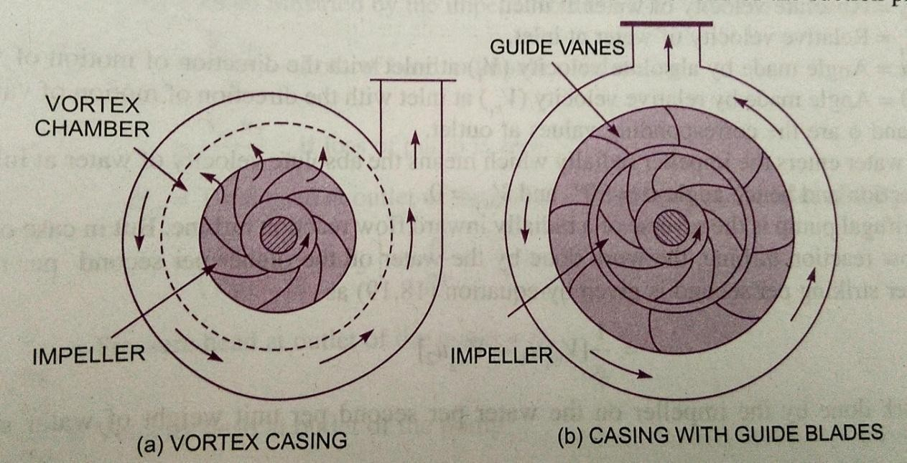
- Delivery pipe: A pipe whose one end is connected to the outlet of the pump and the otherenddeliversthe wateratthe requiredheightisknownas deliverypipe.

Workdonebythecentrifugalpump onwater:

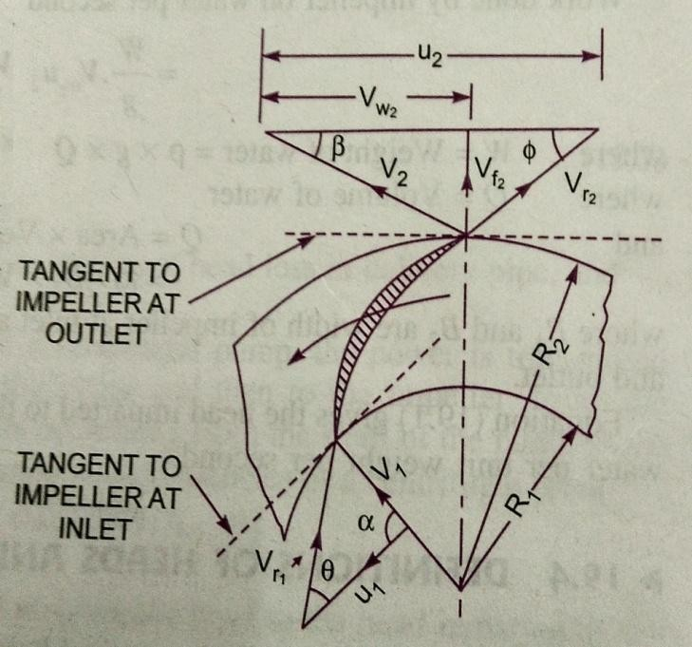
In the centrifugal pump, work is doneby the impeller on the water. The expressionfortheworkdonebytheimpelleronthewaterisobtainedbydrawingvelocitytriangles at inlet and outlet of the impeller inthesameway asfora turbine.Thewaterenters the impeller radially at inlet for bestefficiencyofthepump,whichmeanstheabsolute velocity of water at inlet makes anangle of 900with the direction of motion ofthe impeller at inlet. Hence angle 𝛼= 900and 𝑉𝑤1=0 for drawing the velocity triangles the same notations are used as thatforturbines.

Let N=Speedoftheimpellerinr.p.m.

𝐷1=Diameterofimpeller atinlet
=Tangential velocityofimpeller atinlet=𝜋𝐷1𝑁
𝑢1
60

𝐷2=Diameterofimpellerat outlet

𝑢2
=Tangential velocityofimpeller at outlet ^{𝜋𝐷2𝑁}
60
=

𝑉1=Absolutevelocityofwaterat inlet.

𝑉𝑟1=Relativevelocityofwaterat inlet
𝛼=Anglemadebyabsolutevelocity𝑉1atinletwiththedirectionofmotionofvane

𝜃=Anglemadebyrelativevelocity(𝑉𝑟1)atinletwiththedirectionofmotionofvaneAnd𝑉2,𝑉𝑟2,𝛽𝑎𝑛𝑑 ∅arethecorrespondingvalvesatoutlet.
Asthe waterentersthe impellerradiallywhichmeansthe absolute velocityofwaterat
inletisintheradialdirectionand henceangle𝛼=90⁰and 𝑉𝑤=0.
1

A centrifugal pump is the reverse of a radially inward flow reaction turbine. But incase of a radially inward flow reaction turbine, the work done by the water on the runner persecond perunitweight ofthe waterstrikingpersecondisgiven byequation.
1
= 𝑤1𝑢1−𝑉𝑤2𝑢2

∴Workdonebytheimpeller onthewaterper secondperunitweightofwaterstriking/second

=−𝑤𝑜𝑟𝑘𝑑𝑜𝑛𝑒𝑖𝑛𝑐𝑎𝑠𝑒𝑜𝑓𝑎𝑡𝑢𝑟𝑏𝑖𝑛𝑒

1
=− 𝑉1−𝑉𝑤𝑢2
1 2
𝑔

1
= 𝑤2𝑢2−𝑉𝑤1𝑢1
1
= 𝑉𝑤𝑢₂ (1) ∵_{𝑤} =0
2 1
𝑔

Work donebytheimpelleronwaterpersecond
=𝑊×𝑉𝑢 WhereW= Weightofwater=𝜌× 𝑔 ×𝑄
𝑔 𝑤22

Q= Volumeofwater

Q=Area ×Velocityofflow

=𝐷1𝐵1×𝑉𝑓1
=𝜋𝐷2𝐵2×𝑉𝑓2
Where𝐵1and𝐵2arewidthofimpelleratinletandoutletand

𝑉𝑓1And𝑉𝑓2 arevelocitiesofflowatinletandoutlet

Head imparted tothewaterbytheimpellerorenergygiven byimpellerto waterperunitweightpersecond
𝟏
= 𝑽_{𝒘}𝟐𝒖_{𝟐}
𝒈

HEADSOFA CENTRIFUGALPUMP:
- Suction Head :It is the vertical height of the centre line of centrifugal pump, abovethe water surface in the tank or sump from which water is to be lifted. This height is alsocalledsuctionlift ′𝑕𝑠′.
- Delivery Head :The vertical distance between the centre line of the pump and the watersurfaceinthetanktowhichwaterisdeliveredisknownasdeliveryhead.Thisisdenotedby
′𝑕𝑑′.
- StaticHead:Thesumofsuction headand deliveryheadisknownasstaticshead′𝐻𝑠′.
𝐻𝑠=𝑕𝑠+𝑕𝑑
- ManometricHead:Manometricheadisdefinedastheheadagainstwhichacentrifugalpumphas towork.Itis denotedby𝐻.

- 𝐻𝑚=Headimparted bytheimpellertothewater–Lossofheadinthepump
=𝑉𝑤2𝑢2−Lossofheadin impeller and casing
𝑔

=𝑉𝑤2𝑢2
𝑔
………… Iflossofheadinpumpiszero.

- 𝐻𝑚=Totalhead at outlet ofpump– Totalhead attheinletofthepump
𝑃0 𝑉02 𝑃𝑖 𝑉𝑖 2

= + +𝑍− + +𝑍
𝜌𝑔 2𝑔 0 𝜌𝑔 2𝑔 𝑖
Where 𝑃0=Pressureheadatoutletofthepump=𝑕
𝜌𝑔 𝑑
𝑉02=Velocityhead atoutlet ofthepump
2𝑔
= Velocityheadindeliverypipe=𝑉𝑑2
2𝑔
𝑍0=Verticalheight ofthe outlet ofthe pumpfromdatumline,and

,𝑉𝑖2,𝑍
𝑖
𝜌𝑔2𝑔

i.e.,𝑉𝑠2
=Correspondingvaluesofpressurehead,velocity headand datumhead attheInletofthepump,

𝑎𝑛𝑑 𝑍 respectively.
𝑠 2𝑔 𝑠

=𝑕+𝑕+ +
𝑕𝑕
+𝑉𝑑2

𝑚 𝑠 𝑑 𝑓𝑠 𝑓𝑑 2𝑔
Where𝑠=Suctionhead,
𝑕= Deliveryhead,
𝑕𝑓𝑠=Frictionalheadlossinsuctionpipe,
𝑕𝑓𝑑=Frictionalheadlossindeliverypipe
𝑉𝑑=Velocityofwaterindeliverypipe.
- Efficiencies of a Centrifugal Pump: In a centrifugal pump, the power is transmitted fromelectric motor shaft to pump shaft and then to the impeller. From the impeller, the power isgiven to the water. Thus the power is decreasing from the shaft of the pump to the impellerandthentothewater. Thefollowingaretheimportantefficiencies ofacentrifugalpump:
  - Manometricefficiency,𝜂𝑚𝑎𝑛 b)Mechanicalefficiency,𝜂𝑚and
c)Overallefficiency,𝜂0.
- Manometric Efficiency𝜼𝒎𝒂𝒏:The ratio of the Manometrichead to theheadimpartedbytheimpellertothe wateris knownas
𝑀𝑎𝑛𝑜𝑚𝑒𝑡𝑟𝑖𝑐𝑕𝑒𝑎𝑑
𝑀𝑎𝑛𝑜𝑚𝑒𝑡𝑟𝑖𝑐𝐸𝑓𝑓𝑖𝑐𝑖𝑒𝑛𝑐𝑦𝜂𝑚𝑎𝑛=𝐻𝑒𝑎𝑑𝑖𝑚𝑝𝑎𝑟𝑡𝑒𝑑𝑏𝑦𝑖𝑚𝑝𝑒𝑙𝑙𝑒𝑟𝑡𝑜𝑤𝑎𝑡𝑒𝑟
= 𝐻𝑚 =𝑔𝐻𝑚

𝑉𝑤 2𝑢2
𝑔
𝑉𝑤2𝑢2

The power at the impeller of the pump is more than the power given to the water atoutlet of the pump. The ratio of power given to the water at outlet of the pump to the poweravailable attheimpelleris knownasManometric efficiency.
Thepower giventothewater atoutletofthepump=𝑊𝐻𝑚𝑘𝑤
1000

Thepowerattheimpeller=𝑊𝑜𝑟𝑘𝑑𝑜𝑛𝑒𝑏𝑦 𝑖𝑚𝑝𝑒𝑙𝑙𝑒𝑟𝑝𝑒𝑟𝑠𝑒𝑐𝑜𝑛𝑑
1000
𝑘𝑊

=𝑊×𝑉𝑤2×𝑢2𝑘𝑊
𝑔 1000

𝑊𝐻𝑚
𝜼𝒎𝒂𝒏= 1000 =
𝒈×𝑯𝒎

𝑊𝑉𝑤 2×𝑢2 𝑽𝒘×𝒖𝟐
𝑔× 1000 𝟐
- Mechanical Efficiency :The power at the shaft of the centrifugal pump is more thepoweravailableattheimpellerofthepump.Theratioofthepoweravailableattheimpellertothe powerat the shaftofthe centrifugalpumpisknownasmechanicalefficiency.

𝜂_{𝑚}
=𝑃𝑜𝑤𝑒𝑟𝑎𝑡𝑡𝑕𝑒𝑖𝑚𝑝𝑒𝑙𝑙𝑒𝑟
𝑃𝑜𝑤𝑒𝑟𝑎𝑡𝑡𝑕𝑒𝑠𝑕𝑎𝑓𝑡

ThepowerattheimpellerinkW =𝑊𝑜𝑟𝑘𝑑𝑜𝑛𝑒𝑏𝑦 𝑖𝑚𝑝𝑒𝑙𝑙𝑒𝑟𝑝𝑒𝑟𝑠𝑒𝑐𝑜𝑛𝑑 =𝑊×𝑉𝑤2×𝑢2
1000 𝑔 1000

𝜼_{𝒎}=
𝑾𝑽𝒘𝟐×𝒖𝟐

𝒈𝟏𝟎𝟎𝟎
𝑺.𝑷

Where S.P.=Shaftpower.
- Overall Efficiency :It is defined as the ratio of power output of the pump to thepowerinputtothepump.

ThepoweroutputofthepumpinkW =𝑊𝑒𝑖𝑔𝑕𝑡𝑜𝑓𝑤𝑎𝑡𝑒𝑟𝑙𝑖𝑓𝑡𝑒𝑑
×𝐻𝑚
1000
=𝑊𝐻𝑚
1000

Thepower input tothepump =Powersuppliedbytheelectricmotor
=S.P.Ofthepump
𝑾𝑯𝒎
∴ 𝜼 =𝟏𝟎𝟎𝟎
𝟎
𝑺.𝑷.
𝜼𝟎=𝜼𝒎𝒂𝒏×𝜼𝒎

SPECIFICSPEEDOFACENTRIFUGALPUMP:
The specific speed of a centrifugal pump is defined as the speed of a geometricallysimilar pump, which would deliver one cubic meter of liquid per second against a head of onemeter.Itis denotedby′𝑁𝑠′.
ThedischargeQforacentrifugalpumpisgivenbytherelation
𝑄=𝐴𝑟𝑒𝑎× 𝑉𝑒𝑙𝑜𝑐𝑖𝑡𝑦 𝑜𝑓𝑓𝑙𝑜𝑤
=𝐷×𝐵×𝑉𝑓 Or 𝑄𝖺𝐷×𝐵× 𝑉𝑓 (1)Where D= Diameteroftheimpellerofthe pumpand
B=WidthoftheimpellerWeknowthat𝐵𝖺𝐷
Fromequation(1)wehave 𝖺𝐷²×𝑉𝑓 (2)

Wealsoknowthatthetangentialvelocity isgivenby

𝑢=𝜋𝐷𝑁
60
𝖺𝐷𝑁 (3)

Nowthetangentialvelocity(u)andvelocityofflow𝑉𝑓arerelatedtoManometrichead𝐻𝑚as
𝖺𝑉𝑓𝖺 𝐻𝑚 (4)Substitutingthe value of(u)inequation(3),weget

𝐻𝑚
𝖺 𝐷𝑁 Or 𝐻𝑚
𝑁
𝐷𝖺

Substituting thevaluesofDinequation(2)
𝐻𝑚
𝑄𝖺 ×𝑉
𝑁2 𝑓
𝐻𝑚
𝖺 ×𝐻 ∵𝐹𝑟𝑜𝑚𝑒𝑞4𝑉𝖺𝐻

𝑁2 𝑚
𝖺𝐻𝑚3/2
𝑁2
=𝐾𝐻𝑚3/2 (5)
𝑁2
WhereKisaconstantofproportionality
If𝐻𝑚=1𝑚and𝑄=1𝑚³/𝑠𝑒𝑐N becomes 𝑁𝑠
Substitutingthesevaluesinequation(5),weget
1=𝐾13/2=𝐾

𝑓 𝑚

∴ 𝐾=𝑁2
𝑠
𝐻𝑚
𝑁𝑠2

SubstitutingthevalueofKinequation(5),weget

𝑄 =𝑁2
𝑠
𝐻_{𝑚}
3/2 𝑁2𝑄
𝑜𝑟 𝑁2=

𝑁2
𝑠
𝐻_{𝑚}
3/2

𝑵 = 𝑵𝑸
(6)

𝒔 𝑯𝒎𝟑/𝟒

MULTI-STAGECENTRIFUGALPUMPS:
If centrifugal pump consists of two or more impellers, the pumpis called a multi-stagecentrifugal pump. The impeller may be mounted on the same shaft or on different shafts. Amulti-stage pumpishavingthefollowing twoimportantfunctions:
- To produceahigh head and 2)To dischargealargequantityofliquid.
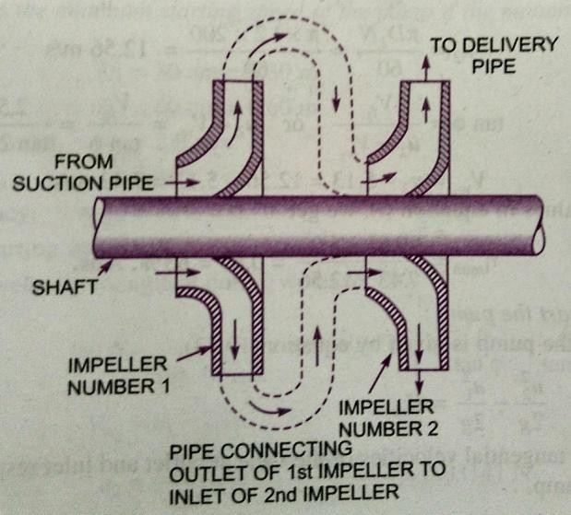
If ahighheadis tobe developed,theimpellers are connected in series (or on the sameshaft)whilefordischarginglargequantity ofliquid, the impellers (or pumps) are connected inparallel.

Multi-Stage Centrifugal Pumps for High Heads: For developing a high head, a number ofimpellersaremountedinseries onthesameshaft.
The water from suction pipe enters the 1st impeller at inlet and is discharged at outletwith increased pressure. The water with increased pressure from the outlet of the 1st impelleris taken to the inlet of the 2nd impeller with the help of a connecting pipe. At the outlet of the2nd impeller the pressure of the water will be more than the water at the outlet of the 1stimpeller. Thus if more impellers are mounted on the same shaft, the pressure at the outlet willbeincreasedfurther.
Let n=Number ofidenticalimpellersmountedonthesameshaft,
𝐻𝑚=Head developedbyeach impeller.
ThentotalHeaddeveloped=𝑛 × 𝐻𝑚
Thedischargepassing througheachimpellerissame.

Multi-StageCentrifugalPumpsforHighDischarge:
For obtaining high discharge, the pumps should be connected in parallel. Each of thepumps lifts the water from a common sump and discharges water to a common pipe to whichthe delivery pipes of each pump is connected. Each of the pumps is working against the samehead.
Let n= Numberofidenticalpumps
arrangedinparallel.
Q=Dischargefromonepump.
∴ TotalDischarge=𝒏×𝑸

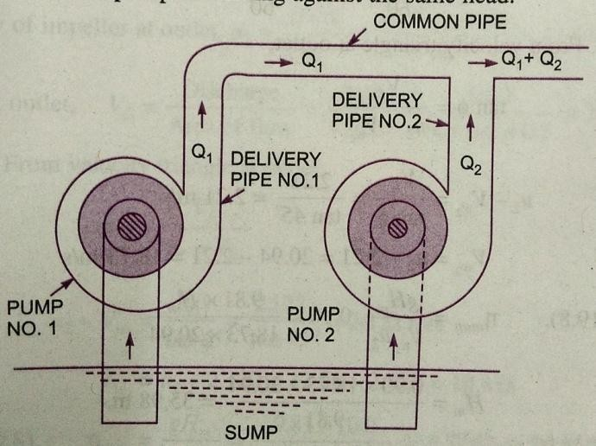

PerformanceCharacteristicCurvesofcentrifugalpumps

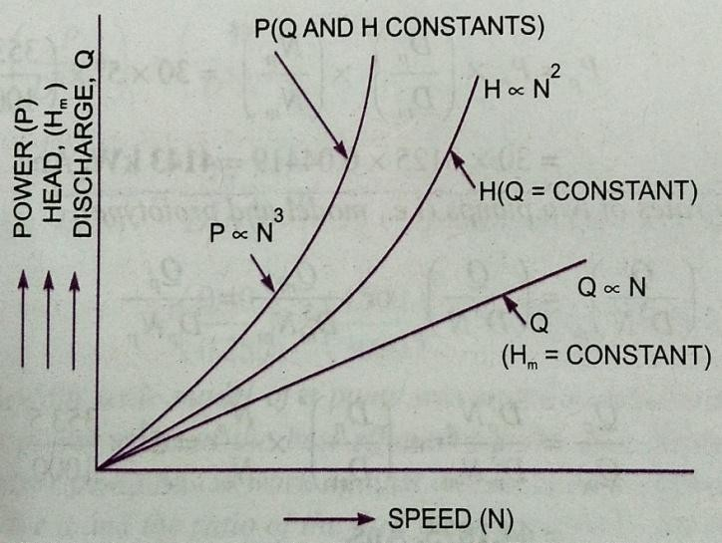
The characteristic curves of a centrifugal pump are defined as those curves which are plottedfrom the results of a number of tests on the centrifugal pump. These curves are necessary topredict the behavior and performance of the pump, when the pump is working under differentflow rate, head and speed. The following are the important characteristic curves for thepumps:

  - Maincharacteristiccurves.
  - Operatingcharacteristiccurvesand
  - ConstantefficiencyorMuschelcurves.

- MainCharacteristicCurves:themaincharacteristiccurvesofacentrifugalpumpconsistsofahead(Manometrichead)poweranddischargewithrespecttospeed.ForplottingcurvesofManometricheadversus speed, discharge is kept constant. Forplotting curvesofdischarge versus speed,
Manometric head () is kept constant. For plotting curves power versus speed, Manometricheadanddischargearekeptconstant.

For plotting the curve of 𝐻𝑚 versus speed (N) the discharge is kept constant. From theequationitisclearthat𝐻𝑚is aconstantor𝐻 𝖺𝑁2.Thismeans thattheheaddevelopedby
𝐷𝑁 𝑚
apumpisproportionalto𝑁².Hencethecurveof𝐻𝑚v/sNisaparaboliccurve.

Fromequation𝑷is a constant.Hence𝑃𝖺𝑁3.Thismeansthatthe curve Pv/sNis
𝑫𝟓𝑵𝟑
acubiccurve.

Theequation =𝑐𝑜𝑛𝑠𝑡𝑎𝑛𝑡.Thismeans𝑄𝖺𝑁foragivenpump.HencethecurveQ
𝑫𝟑𝑵
v/sN isstraightline.

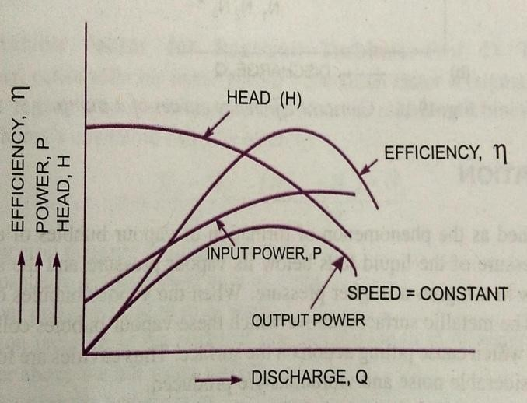
OperatingCharacteristicCurves:

Ifthespeediskeptconstant,thevariationofManometrichead,powerandefficiency with respecttodischargegives theoperatingcharacteristicsofthe pump.

The input power curve for pumps shallnot pass through the origin. It will be slightlyaway from the origin on the y-axis, as even atzerodischargesomepowerisneededto

overcomemechanicallosses.

Theheadcurvewill havemaximumvalueofheadwhenthedischargeiszero.
The output power curve will start from origin as at Q=0, output power 𝜌𝑄𝑔𝐻 will be zero.Theefficiencycurve willstartfromorigin asat=0,𝜂=0. ∵𝜂=𝑂𝑢𝑡𝑝𝑢𝑡
𝐼𝑛𝑝𝑢𝑡

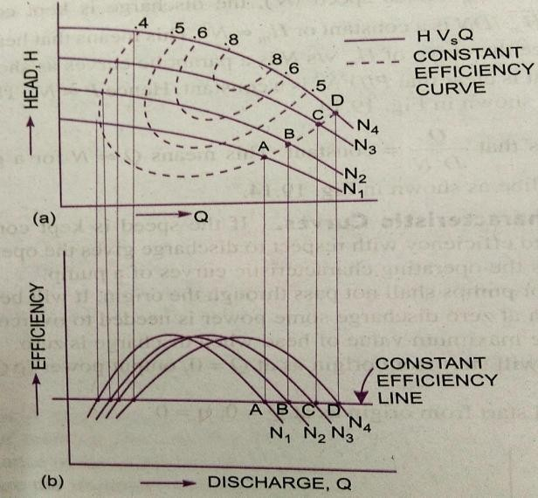
ConstantEfficiencyCurves:

For obtaining constant efficiency curvesfor a pump, the head versus dischargecurvesand efficiency v/s discharge curves for differentspeedsareused.Bycombining thesecurves
∼𝑄𝑐𝑢𝑟𝑣𝑒𝑠𝜂∼𝑄𝑐𝑢𝑟𝑣𝑒𝑠 constantefficiencycurvesareobtained.
Forplottingtheconstantefficiencycurves (Iso– efficiency curves), horizontal linesrepresenting constant efficiencies are drawn onthe 𝜂 ∼ 𝑄 curves. The points, at which theselinescuttheefficiencycurvesatvariousspeeds,
aretransferredtothecorresponding𝐻∼𝑄curves.Thepointshavingthesameefficiencyarethenjoinedbysmoothcurves.Thesesmoothcurvesrepresenttheiso–efficiencycurves.

NETPOSITIVESUCTIONHEAD(NPSH)
ThetermNPSHisverycommonlyused selectionofapump.TheminimumsuctionconditionsarespecifiedintermsNPSH.
Itisdefinedasthe absolutepressureheadattheinlettothepumpminusthevapourpressure headplusvelocityhead.
∴NPSH=Absolutepressureheadatinletofpump–vapourpressurehead(absoluteunits)

𝑝1

𝑝
𝑣𝑠2
+Velocityhead

= − +
𝜌𝑔 𝜌𝑔
2𝑔
(1)
𝐴∵𝑏𝑠𝑜𝑙𝑢𝑡𝑒𝑝𝑟𝑒𝑠𝑠𝑢𝑟𝑒𝑎𝑡𝑖𝑛𝑙𝑒𝑡𝑜𝑓𝑝𝑢𝑚𝑝=𝑝₁

Theabsolutepressureheadatinletofthepumpisgivenbyas

𝑝1=𝑝𝑎 𝑣𝑠2
𝜌𝑔 −2𝑔+𝑕𝑠+𝑕𝑓𝑠
Substitutingthis valueintheaboveequation

𝑝𝑎
𝑣𝑠2 2

𝑁𝑃𝑆𝐻=
− −𝑕−𝑕−𝑝𝑣+𝑣𝑠
𝜌𝑔 2𝑔 𝑠 𝑓𝑠 𝜌𝑔 2𝑔

=𝑝𝑎−𝑝𝑣−𝑕−𝑕

𝜌𝑔 𝜌𝑔
=𝐻−𝐻
𝑠 𝑓𝑠
𝑝
𝑎
−𝑕 ∵ =𝐻 =𝐴𝑡𝑚𝑜𝑠𝑝𝑕𝑒𝑟𝑖𝑐𝑝𝑟𝑒𝑠𝑠𝑢𝑟𝑒𝑕𝑒𝑎𝑑,

𝑎 𝑣 𝑠 𝑓𝑠 𝜌𝑔 𝑎
=−𝑕− −𝐻 (2) ∵𝑝𝑣=𝐻 =𝑉𝑎𝑝𝑜𝑢𝑟𝑕𝑒𝑎𝑑
𝑎 𝑠 𝑓𝑠 𝑣 𝜌𝑔 𝑣
The right hand side of the above equation is the total suction head. Hence NPSH is equal tothe total suction head. Thus NPSH may also be defined as the total head required to make theliquidflowthroughthesuctionpipetothepumpimpeller.

For any pump installation, a distinction is made between the required NPSH and theavailable NPSH. The value of required NPSH is given by the pump manufacturer. This valuecan also be determined experimentally. For determining its value the pump is tested andminimumvalue of𝑕𝑠isobtained at whichthe pump givesmaximumefficiencywithout any noise. (i.e. cavitation free). The required NPSH varies with the pump design, speed of thepumpandcapacityofthepump.

Whenthepumpisinstalled,theavailableNPSHiscalculatedfromtheaboveequation (2). In order to have cavitation free operation of centrifugal pump, the availableNPSH shouldbegreaterthantherequiredNPSH.

RECIPROCATINGPUMPS
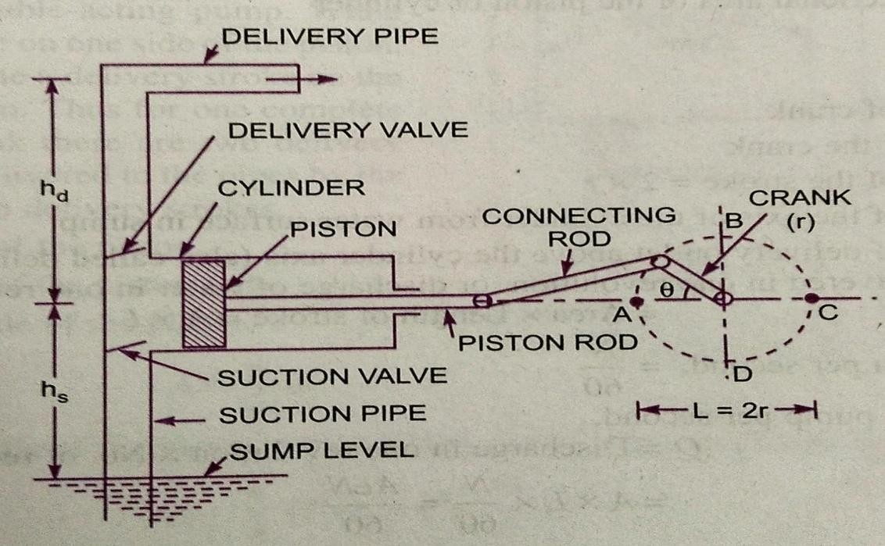
Themechanical energy is convertedin tohydraulic energy (pressure energy)bysucking the liquidin to a cylinderin which a piston is reciprocating, which exerts the thruston the liquid and increases its hydraulic energy (pressure energy) the pump is known asreciprocatingpump.

A single acting reciprocating pump consists of a piston, which moves forwards andbackwards in a close fitting cylinder. The movement of the piston is obtained by connectingthe piston rod to crank by means of a connecting rod. The crank is rotated by means of anelectricmotor.Suctionanddeliverypipeswithsuctionvalveanddeliveryvalveareconnected to the cylinder. The suction and delivery valves are one way valves or non-returnvalves, which allow the water to flow in one direction only. Suction valve allows water fromsuction pipe to the cylinder which delivery valve allows water from cylinder to delivery pipeonly.
When the crank starts rotating, the piston moves to and fro in the cylinder. When thecrank is at A the piston is at the extreme left position in the cylinder. As the crank is rotatingfrom A to C (i.e. from𝜃 = 0 𝑡𝑜 1800 ) the piston is moving towards right in the cylinder. Themovement of the piston towards right creates a partial vacuum in the cylinder. But on thesurface of the liquid in the sump atmospheric pressure in acting, which is more than thepressure inside the cylinder. Thus the liquid is forced in the suction pipe from the sump. Thisliquidopens thesuctionvalveandenters thecylinder.
When crank is rotating from C to A (i.e. from 𝜃 = 1800 𝑡𝑜 3600 ), the piston from itsextreme right position starts moving towards left in the cylinder. The movement of the pistontowards the left increases the pressure on the liquid inside the cylinder more than atmosphericpressure. Hence the suction valve closes and delivery valve opens. The liquid is forced in tothe deliverypipe andis raisedtotherequiredheight.

DischargethroughaReciprocatingPump:
Considerasingleactingreciprocatingpump.Let D = Diameterofcylinder

A=Cross-sectionalareaofpistonorcylinderr=Radius ofcrank
N=r.p.m.ofthecrank
L=Lengthofthestroke=2×𝑟
=𝜋𝐷²
4

𝑕=Heightoftheaxisofthecylinderfromwatersurfaceinsump
𝑕=Heightofdeliveryoutletabovethecylinderaxis(alsocalleddeliveryhead)Volumeofwaterdeliveredinonerevolutionor
Discharge ofwaterinonerevolution=Are×Lengthofstroke
=𝐴×𝐿
Number ofrevolutionsper second=𝑁
60
Dischargeofpump persecond Q=Dischargeinonerevolution×No.ofrevolutionspersec
=𝐴×𝐿×𝑁
60
=𝐴𝐿𝑁
60

Weightofwaterdelivered persecond𝑊=𝜌×𝑔 ×𝑄
=𝜌𝑔𝐴𝐿𝑁
60

(1)

WorkdonebyReciprocatingPump:
Workdoneper second=Weightofwater liftedper second×Totalheightthroughwhich
waterislifted
= × 𝑕+𝑕𝑑 (2)
Where +𝑕𝑑 =Totalheightthroughwhichwaterislifted Fromequation(1)weight ofwaterisgivenby
𝑊=𝜌𝑔𝐴𝐿𝑁
60
Substituting thevalueofWinequation(2),wegetWorkdonepersecond=𝜌𝑔𝐴𝐿𝑁×𝑕+𝑕
60 𝑠 𝑑
PowerrequiredtodrivethepumpinkW

𝑃=𝑊𝑜𝑟𝑘𝑑𝑜𝑛𝑒𝑝𝑒𝑟𝑠𝑒𝑐𝑜𝑛𝑑
1000
𝑃=𝜌𝑔×𝐴𝐿𝑁×𝑕𝑠+𝑕𝑑

𝑘𝑊
60,000

SLIPOFRECIPROCATINGPUMP
=𝜌𝑔×𝐴𝐿𝑁×𝑕𝑠+𝑕𝑑
60×1000

Slip of a pumpis defined as the difference between the theoretical discharge andactualdischargeofapump.Theactualdischargeofpumpislessthanthetheoreticaldischarge due to leakage. The difference of the theoretical discharge and actual discharge isknownas slipofthepump.
Hence 𝑠𝑙𝑖𝑝= 𝑕−𝑄𝑎𝑐𝑡

Butslipismostlyexpressedaspercentageslip
𝑃𝑒𝑟𝑐𝑒𝑛𝑡𝑎𝑔𝑒𝑠𝑙𝑖𝑝=𝑄𝑡𝑕−𝑄𝑎𝑐𝑡× 100= 1−𝑄𝑎𝑐𝑡× 100
𝑄𝑡𝑕 𝑄𝑡𝑕
=1−𝐶 ×100 ∵𝑄𝑎𝑐𝑡=𝐶

𝑑

Where𝐶𝑑= Co-efficientofdischarge.
𝑄𝑡𝑕 𝑑

NegativeSlipoftheReciprocatingPump:
Slip is equal to the difference of theoretical discharge and actual discharge. If actualdischarge is more than the theoretical discharge, the slip of the pump will become –ve. In thatcase theslipofthe pumpis knownasnegativeslip.
Negative slip occurs when the delivery pipe is short, suction pipe is long and pump isrunningathighspeed.

INDICATORDIAGRAM
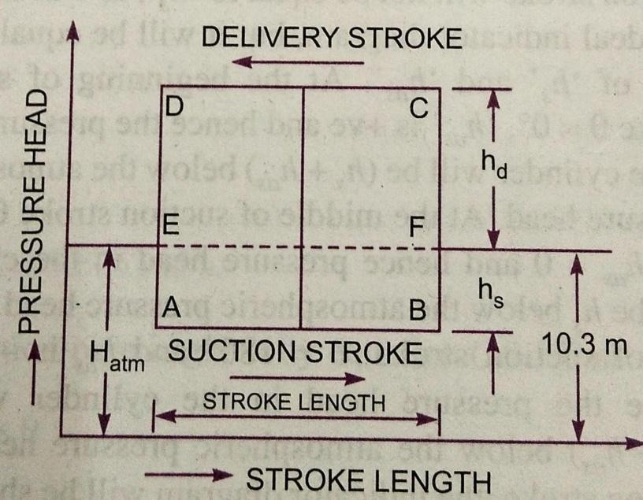
The indicator diagram for a reciprocating pump is defined the graph between thepressure head in the cylinder and the distance travelled by piston from inner dead centre forone complete revolution of the crank. As the maximum distance travelled by the piston isequal to the stroke length and hence the indicator diagram is a graph between pressure headand stroke length of the piston for one complete revolution. The pressure head is taken asordinate andstrokelengthasabscissa.

IdealIndicatorDiagram:
The graph between pressure head inthe cylinder and the stroke length ofpiston for one complete revolutionof the crank underideal conditionsis known as ideal indicator diagram.Line EF represents the atmosphericpressure head equal to 10.3 metersofwater.

Let 𝐻= Atmosphericpressure head= 10.3mofwater
L =Lengthofthestroke
𝑕=Suctionheadand
𝑕=Deliveryhead
During suction stroke, the pressure head in the cylinder is constant and equal to suctionhead 𝑕𝑠, which isbelowthe atmospheric pressurehead𝐻𝑎𝑡𝑚by a height of𝑕𝑠. The pressure head during suction stroke is represented by a horizontal line AB which isbelowthelineEFbyaheightof ′𝑕𝑠′
During delivery stroke, the pressure head in the cylinder is constant and equal todelivery head( 𝑕𝑑), which isabove the atmospheric head by a height of ′𝑕𝑑′. Thusthe pressure head during the delivery stroke is represented by a horizontal line CD,whichisabovethelineEFbyaheightof𝑕.Thusforonecompleterevolutionofcrank, thepressure head in the cylinder is represented by the diagram ABCD. This diagram isknownasidealindicatordiagram.
Theworkdonebythepumppersecond=𝜌𝑔𝐴𝐿𝑁×𝑕+𝑕
60 𝑠 𝑑

=𝐾×𝐿 𝑕𝑠+𝑕𝑑

𝖺𝐿× +𝑕𝑑 (1)

Where𝐾=𝜌𝑔𝐴𝑁
60
= 𝑐𝑜𝑛𝑠𝑡𝑎𝑛𝑡

AreaofIndicatordiagram=𝐴𝐵×𝐵𝐶=𝐴𝐵× 𝐹+𝐹𝐶 =𝐿× 𝑕+𝑕𝑑

16

Substitutingthis valueinequation(1),weget

Workdonebypump𝖺AreaofIndicator diagram

Problemsonreciprocatingpump.
- A single acting reciprocating pump running at 50 r.p.m. delivers 0.01 𝑚3/𝑠 of water. Thediameterofpistonis200mmandstroke lengthin400mm.Determine
i)Thetheoreticaldischargeofpumpii)Co-efficientofdischarge

iii)Slipandthepercentageslipofpump

Given: The speed of the pump N = 50 rpmActualdischarge 𝑄𝑎𝑐𝑡= 0.01𝑚³/𝑠
Dia.Ofpiston D=200mm=0.2m
Area 𝐴 =𝜋𝐷2=𝜋0.2²=0.031416𝑚2
4 4

- Thetheoreticaldischarge 𝑄 𝐴𝐿𝑁 0.031416×0.4×50
= =

𝑡𝑕 60 60

- TheCo-efficientofdischarge 𝐶
=𝟎.𝟎𝟏𝟎𝟒𝟕𝒎𝟑/𝒔

=𝑄𝑎𝑐𝑡= 0.01

𝑑 𝑄𝑡
𝑕
0.01047

=𝟎.𝟗𝟓𝟓

iii)Slip 𝑄𝑡−𝑄𝑎𝑐𝑡=0.01047−0.01

=𝟎.𝟎𝟎𝟎𝟒𝟕𝒎𝟑/𝒔
PercentageSlip = ^{𝑡𝑕}−𝑄𝑎𝑐𝑡 ×100
𝑄𝑡𝑕

=0.01047−0.01× 100
0.01047

=𝟒.𝟒𝟖𝟗%

- A double acting reciprocating pump, running at 40 r.p.m. is discharging 1.0m3 of water perminute. The pumphas a stroke of 400mm. the diameter of piston is 200mm. the deliveryand suction head are 20m and 5m respectively. Find the slip of the pump and power requiredtodrivethepump.

Given: Speedofthepump N=40r.p.m.

Actualdischarge 𝑄

𝑎𝑐𝑡
= 1𝑚3/𝑠=1
60
=0.01666𝑚3/𝑠

Stroke L = 400mm = 0.4mDiameterofpiston D=200mm=0.2m
∴ 𝐴𝑟𝑒𝑎 𝐴=𝜋𝐷2=𝜋0.2²=0.031416𝑚2
4 4

SuctionHead 𝑕=5𝑚

Deliveryhead 𝑕=20𝑚

Theoreticaldischargefordoubleactingpump

2𝐴𝐿𝑁 2×0.31416×0.4×40
𝑄 = =

𝑡𝑕 60 60

=𝟎.𝟎𝟏𝟔𝟕𝟓𝒎𝟑/𝒔

Slip 𝑄𝑡−𝑄𝑎𝑐𝑡=0.01675−0.1666

=𝟎.𝟎𝟎𝟎𝟎𝟗𝒎𝟑/𝒔

Powerrequiredtodrivethedoubleactingpump

𝑃=2×𝜌𝑔×𝐴𝐿𝑁×𝑕𝑠+𝑕𝑑
60,000

=2×1000×9.81×0.031416×0.4×40×5+20
60,000

=𝟒.𝟏𝟎𝟗𝒌𝑾

