GEOTECHNICAL ENGINEERING - I
(19A01601T)

LECTURE NOTES
III - B.TECH & II- SEM
Prepared by:

Mr. T. Murali Krishna, Professor

Department of Civil Engineering

VEMU INSTITUTE OF TECHNOLOGY
(Approved By AICTE, New Delhi and Affiliated to JNTUA, Ananthapuramu)
Accredited By NAAC, NBA( EEE, ECE & CSE) & ISO: 9001-2015 Certified Institution
Near Pakala, P.Kothakota, Chittoor- Tirupathi Highway
Chittoor, Andhra Pradesh-517 112
Web Site: www.vemu.org

UNIT – 01
INTRODUCTION

Soil Engineering
1). Soil Mechanics and 2). Foundation Engineering.
Soil Engineering is an applied science which deals with the applications of the principles of Soil Mechanics to the Practical (or) actual construction problems.
Soil Engineering includes Site Investigation, Design and Construction of Foundations, Earth Retaining Structures and Earth Structures.
Soil Mechanics is a branch of Mechanics which deals with the action of forces on soil and with the flow of water in soil.
The soil consists of discrete solid particles which are neither strongly bonded as in solids nor they are free as the particles of fluids. Consequently, the behaviour of soil is somewhat intermediate between that of solid and a fluid.
As the soil is inherently a particulate system, the Soil Mechanics is also called the Particulate Mechanics.
Rock Mechanics is the applied science dealing with the mechanics of rocks.
Scope of Soil Engineering
Soil Engineering has the vast applications in the construction of various Civil Engineering works. Some of the important applications are as below.
1). Foundations
Every Civil Engineering structure, whether it is a building, a bridge or a dam is founded on or below the surface of the earth. Foundations are required to transmit the loads of structure to the soil safely and efficiently.
The foundation is termed as shallow foundation when it transmits the loads to the upper strata of the earth,
The foundation is termed as deep foundation when it transmits the loads to the strata at considerable depth below the ground surface. The Pile Foundation is a type of deep foundation.
Foundation Engineering is an important branch of Soil Engineering.
2). Earth Retaining Structures
When sufficient space is not available for a mass of soil to spread and to form a safe slope, an earth retaining structure is required to retain the soil.
An earth retaining structure is also required to keep the soil at different levels on its either sides.
The earth retaining structure may be a rigid retaining wall or a sheet pile bulkhead which is relatively flexible.
Soil Engineering gives the theories of earth pressure on earth retaining structures.
3). Stability of Soil Slopes
If the soil surface is not horizontal, then there is a component of the weight of the soil which tends to move it downwards and outwards and thus causes the instability of the soil slope.
The figure shows the embankment soil slope and also the cutting soil slope.
Soil Engineering provides the methods for checking the stability of soil slopes.
4). Underground Structures
The design and construction of underground structures, such as tunnels, shafts and conducts require the evaluation of forces exerted by the soil on the underground structures.
The figure shows a tunnel constructed below the ground level and also a conduit laid below the ground surface.
Soil engineering provides the methods for the calculating the forces exerted by the soil on these structures.
5). Pavement Design
The pavement is a hard crust placed on the sub-grade soil for the purpose of providing a smooth and strong surface on which vehicles can move.
The pavement consists of sub-base course, base course and bitumen layer.
The behaviour of sub-grade under various conditions of loading and environmental changes is studied in Soil Engineering.
6). Earth Dams
The earth dams are huge structures which are built for creating the water reservoirs.
In earth dams, the soil is used as a construction material.
Hence extreme care is taken in the design and construction of earth dams. The earth dam requires a thorough knowledge of soil engineering.
7). Miscellaneous Soil Problems
The Geotechnical Engineer sometimes has to tackle miscellaneous problems related with soil such as soil heave, soil subsidence, frost heave, shrinkage and swelling of soils.
Soil Engineering provides an in-depth study of such problems.
Development of Soil Mechanics
The use of soil for construction purposes dates back to Prehistoric times. The knowledge on soil in that period was empirical and based on trial and error and experience.
The Hanging Gardens of Babylon (Iraq, 2000 BC) were supported by huge retaining walls, the construction of which should have required some knowledge, though empirical on earth pressures on retaining walls.
The large public buildings, forts, harbours, bridges and roads of Roman (During the Roman Civilization) indicate some knowledge of engineering behaviour of soils.
This has been evident from the writings of “Vitruvis”, the Roman Civil engineer in the first century, 100 BC.
Mansar and Viswakarma, in India, wrote books on “Construction Science “during the Medieval period.
Coulomb, the French Civil Engineer, published his wedge theory of earth pressure in 1776, which is the first major contribution to the scientific study of soil behaviour.
Coulomb, was the first person to introduce the concept of shearing resistance of soil as composed of the two components 1). Cohesion (C) and 2). Angle of internal friction ($∅$).
Poncelet, Culmann and Rebhann were the other men who extended the work of Coulomb.
D’Arcy and Stokes were notable for their laws for the flow of water through soil and settlement of solid particles in liquid medium. These laws are still valid and play an important role in Soil Mechanics.
Rankine gave his theory of earth pressure in 1857. However he did not consider Cohesion in soil although he knew of its existence.
Otto Mohr in 1871, gave a graphical method of representation of the state of stress at a point called “Mohr Circle of Stress”. This is an extensive application in the strength theories applicable to soil.
Boussinesq in 1885, gave his theory of stress distribution in elastic medium under a point load on the surface.
Atterberg, the Swedish soil scientist gave in 1911, the concept of “Consistency Limits” for the soil. This concept made possible to understand the physical properties of soil.
Prandtl, gave his theory of equilibrium of plasticity in 1920. This theory became the basis for the development of various theories of bearing capacity of soils.
The Swedish method of slices for the slope stability analysis of soil slopes was developed by “Fellenius” in 1926.
Karl Terzaghi, gave his “Theory of Consolidation” in 1923 which became an important development in Soil Mechanics.
Karl Terzaghi also published in 1925 the first treatise on Soil Mechanics, a term coined by him.
Karl Terzaghi was born on October 2, 1883 in praggue and died on October 25 1963 in Winchester, Massachusetts in USA.
Karl Terzaghi’s contribution for the development of Soil Mechanics and Foundation Engineering is so vast that he may truly be called as the “Father of Soil Mechanics”.
Karl Terzaghi’s activity on Soil Mechanics extended over a period of about 50 years starting from the year 1913.
Karl Terzaghi defined Soil Mechanics as follows
“Soil Mechanics is the application of the Laws of Mechanics and Hydraulics to Engineering problems dealing with sediments and other unconsolidated accumulations of solid particles produced by the mechanical and chemical disintegration of rocks regardless of whether or not they contain an admixture of organic constituents”.
Later on Proctor, Casagrande, Meyerhoff, Taylor, Vesic and the host of others were responsible for the development of Soil Mechanics and Foundation Engineering as a full fledged discipline in Civil Engineering.

Soil - Definition
The term ‘Soil’ is derived from the Latin word ‘Solium’ this means the upper layer of the earth that may be dug or plowed.
The word ‘Soil’ has different meanings in different scientific fields.
To an Agricultural Scientist, the soil means “The loose material on the earth crust consisting of disintegrated rock with an admixture of organic matter, which supports the plant life”.
To a Geologist, the soil means “The disintegrated rock material which has not been transported from the place of origin”.
To a Civil Engineer, the soil means
“The loose unconsolidated inorganic material on the earth’s crust produced by the disintegration of rocks, overlying hard rock with or without organic matter”
The term ‘Soil’ in Soil Engineering is defined as an unconsolidated material, composed of solid particles, produced by the disintegration of rocks.
The properties of soils depend upon the properties of the rocks from which they are derived.
The rocks that are encountered at the surface of the earth or beneath are commonly classified into three groups according to their modes of origin
1). Igneous rocks 2). Sedimentary rocks and 3). Metamorphic rocks

Origin of Soils
Soils are formed by weathering of rocks due to Mechanical Disintegration or Chemical Decomposition.
When the rock surface gets exposed to atmosphere for an appreciable time, it disintegrates (or) decomposes into small particles and thus the soils are formed.
Soil may be considered as an incidental material obtained from the Geological Cycle which goes on continuously in nature.
The Geological Cycle consists of
1) Erosion
2) Transportation
3) Deposition and
4) Upheaval of soil.
The exposed rocks are eroded and degraded by various physical and chemical processes.
The products of erosion are picked up by the agencies of transportation such as water, wind and glaciers and are carried to new locations where they are deposited.
This shifting of material disturbs the equilibrium of forces on the earth and causes large scale earth movements and upheaval. This process results in further exposure of rocks and the geological cycle gets repeated.
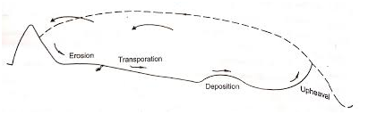
Geological Cycle

Formation of Soil
Solis are formed by either Mechanical Disintegration or Chemical Decomposition of rocks.
1). Mechanical Disintegration
The Mechanical Disintegration (or) Physical Disintegration (or) Mechanical Weathering of rocks occurs due to the following physical processes.
a). Temperature Changes
Different minerals of a rock have different coefficients of thermal expansion. Unequal expansion and contraction of these minerals occur due to temperature changes.
When the stresses induced due to such changes are repeated many times, the particles get detached from the rocks and the soils are formed.
b). Wedging action of ice
Water in the pores and minute cracks of rocks gets frozen in very cold climates. As the volume of ice formed is more than that of water, the expansion of crack in the rock occurs.
Rocks get broken into pieces when large stresses are develop in the cracks due to wedging action of the ice formed and thus the soils are formed.
c). Spreading of roots of plants
As the roots of trees and shrubs grow in the cracks and fissures of the rocks, forces act on the rock. Due to this the segments of rock are formed and the disintegration of rock occurs and thus the soils are formed.
d). Abrasion
As water, wind and glaciers move over the surface of rock, the abrasion and scouring of rock takes place. It results in the formation of soil.
In all the above processes of Mechanical Disintegration, there is no change in the chemical composition. Thus the soils formed due to Mechanical Disintegration have the same properties as that of the parent rocks.
Coarse grained soils such as gravel and sand are formed by the process of Mechanical Disintegration.

2). Chemical Decomposition
When Chemical Decomposition (or) Chemical Weathering of rocks takes place, original rock minerals are transformed into new minerals by chemical reactions.
Due to this the soils formed by Chemical Decomposition do not have the same properties as that of the parent rock.
The following Chemical Decomposition processes are generally occur in nature
a). Hydration
In hydration, water combines with the rock minerals and results in the formation of a new chemical compound.
This chemical reaction causes the decomposition of rock into small particles and thus the soils are formed.
b). Carbonation
It is a type of chemical decomposition in which the carbon dioxide (CO₂) in the atmosphere combines with water to form carbonic acid.
The carbonic acid reacts chemically with rocks and causes the decomposition of rocks.
c). Oxidation
Oxidation occurs when oxygen ions combines with minerals in the rocks. Oxidation results in decomposition of rocks.
Oxidation of rocks is somewhat similar to the rusting of steel
d). Hydrolysis
It is a chemical process in which water gets dissociated into $H^{+}$and ${OH}^{-}$ ions. The hydrogen cations replace the metallic ions such as calcium, sodium and potassium in rock minerals and soils are formed with a new chemical composition.
Chemical Decomposition of rocks results in formation of clay minerals.
These clay minerals impart plastic properties to soils. Clayey soils are formed by the Chemical Decomposition.

Comparison of Soil with other Construction Materials
Soil is a highly complex material. It differs from the conventional structural materials such as steel and concrete.
1).Steel is a manufactured material, the properties of which are accurately controlled. The properties of concrete are also controlled to some extent during its preparation. However soil is a material which has been subjected to various natural agents without any controlled. Consequently, the soil is a highly heterogeneous and unpredictable material.
2).The properties of soil changes not only from one place to the other but also at the same place with depth. The soil properties also changes with the change in the environmental, loading and drainage conditions.
The properties of a soil depend not only on its type but also on the conditions under which it exists.
3).The main engineering properties of steel and concrete are the modulus of elasticity, the tensile strength and the compressive strength. Most of the design works can be done if these properties are known (or) determined.
However the engineering properties of soils depend upon number of factors and it is not possible to characterise them by two or three parameters. Elaborate testing is required to determine the characteristics of soil before design can be made.
4). Steel and concrete can be inspected before use, where as soils for foundations are at greater depth and not open to inspection.
The samples of soil taken from the bore holes are generally disturbed and they do not represent the true in-situ conditions of soil.

Terminology of Different Types of Soils
The geotechnical engineer should be well versed with the nomenclature and terminology of different types of soils.
The following list gives the names and salient characteristics of different types of soils.
1). Boulders
Boulders are rock fragments of large size more than 300 mm in size.
2). Cobbles
Cobbles are large size particles in the range of 80 mm to 300 mm.
3). Gravel
Gravel is a type of coarse grained soil. The particle size ranges from 4.75 mm to 80 mm. It is a cohesionless soil.
4). Sand
It is coarse grained soil, having particle size between 0.075 mm to 4.75 mm. The particles are visible to naked eyes. The sand is cohesionless and pervious.
5). Silt
It is a fine grained soil, with particle size in between 0.002 mm and 0.075 mm. The particles are not visible to naked eyes.
Inorganic silt consists of bulky, equidimensional grains of quartz. It has little or no plasticity and is cohesionless.
Organic silt contains an admixture of organic matter. It is a plastic soil and is cohesive.
6). Clay
Clay is a fine grained soil. It is cohesive soil. The particle size is less than 0,002 mm.
Clay consists of microscopic and sub-microscopic particles derived from the chemical decomposition of rocks. It contains large quantity of clay minerals.
It can be plastic by adjusting the water content. It exhibits considerable strength when it is dry.

Soil Structures
The geometrical arrangement of soil particles with respect to one another is known as soil structure.
The soils in nature have different structures depending upon the particle size and mode of formation. The following types of soil structures are usually found in nature.
1). Single grained structure
2). Honey - comb structure
3). Flocculated structure
4). Dispersed structure
5). Coarse – grained skeleton
6). Clay – matrix structure
Single grained structure and Honey comb structure are developed in coarse grained soils.
Flocculated structure and dispersed structure are developed in clayey soils.
Coarse – grained skeleton and Clay matrix structure are developed in mixed soils.

1). Single Grained Structure
The coarse grained cohesionless soils such as gravel and sand are composed of bulky grains in which the gravitational forces are more predominant than the surface forces.
When the deposition of these soils occurs the particles settle under gravitational forces and take an equilibrium position as shown in figure.
Each particle is in contact with those surrounding it. The soil structure so formed is known as the single grained structure.
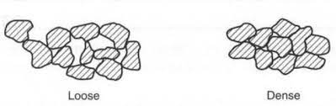
In single grained structure, depending upon the relative position of the particles, the soil may have a loose structure or dense structure.
The figure shows spherical particles in the loosest condition and those in the densest condition.
In the loosest condition the void ratio is 0.90 and in densest condition the void ratio is 0.35.
The engineering properties of sands improve considerably with a decrease in void ratio.
In general, the smaller the void ratio the higher is the shear strength and the lower is the compressibility and permeability.
Loose sands are inherently more unstable. When subjected to vibration the particles in loose sand compressed into dense state. Dense sands are quite stable as they are not affected by vibrations.
2). Honey – comb Structure
The honey – comb structure develops when the particle size is between 0.002 mm and 0.02 mm. The honey – comb structure exists in silt and rock flour.
Due to relatively smaller size, when these particles settle under gravity, the particle surface forces play an important role.
In silt and rock flour, the particles when settling develop a particle to particle contact that bridges over large voids in the soil mass. The particles wedge between one another into a stable condition and form a skeleton like an arch to carry the weight of the overlying materials. The structure so formed is known as Honey – comb structure.
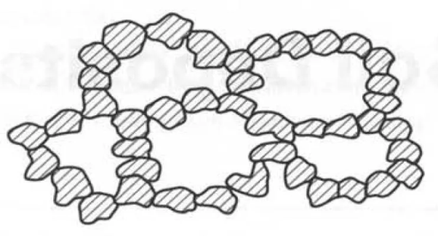
As shown in figure, the soils with honey- comb structure are in loose condition. They can support loads only under static conditions. When subjected to vibrations and shocks the honey – comb structure collapses and large deformation takes place.
3). Flocculated Structure
The flocculated structure occurs in clays. The clay particles have larger surface area and the electrical forces are important in such soils.
The clay particles have negative charge on the surfaces and a positive charge on the edges.
Due to this the inter particle contact develops between the positively charged edges and the negatively charged surfaces. This results in a flocculated structure.
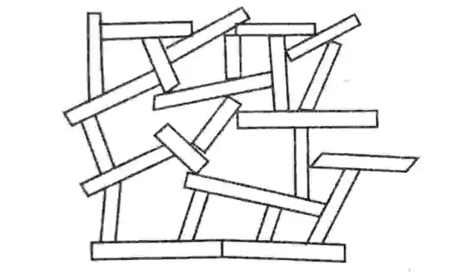
The flocculated structure is formed when there is a net attractive force between the particles.
When clay particles settle in water, the deposits formed have the flocculated structure.
The degree of flocculation of a clay deposit depends upon the type and concentration of clay particles and the presence of salts in water.
Clays settling out in salt water solution have more flocculent structure than those settling out in a fresh water solution. Salt water acts as an electrolyte and reduces the repulsive forces between the clay particles.
Soils with a flocculated structure are light in weight and have high void ratio and water content. However these soils are quite strong and can resist the external forces effectively because of the strong bond due to attraction between the clay particles.
In general, the soils with flocculated structure have low compressibility, high permeability and high shear strength. These soils are insensitive to vibrations.
4). Dispersed Structure
Dispersed structure develops in clays that have been reworked or remoulded.
The clay deposits with flocculated structure when transported to other places by nature or man get remoulded.
The remoulding converts the edge-to-face orientation to face-to-face orientation.
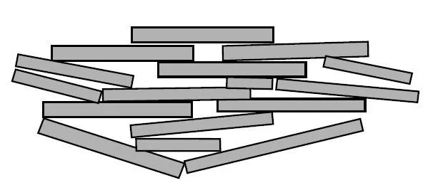
In face-to-face orientation, the clay particles are arranged in more or less the parallel orientation known as the dispersed structure.
The soils in dispersed structure generally have low shear strength, high compressibility and low permeability.
Remoulding causes a loss of shear strength in cohesive soils. However with the passage of time the soils may regain some of its shear strength.
This phenomenon of regain of strength of soil with the passage of time with no change in water content is known as “Thixotrophy”.
5). Coarse Grained Skeleton
The coarse grained skeleton is composite structure which is formed when the soil contains particles of different types.
When the amount of bulky, cohesionless soil particles are large with that of fine grained clayey particles then the bulky grains are in particle-to-particle contact.
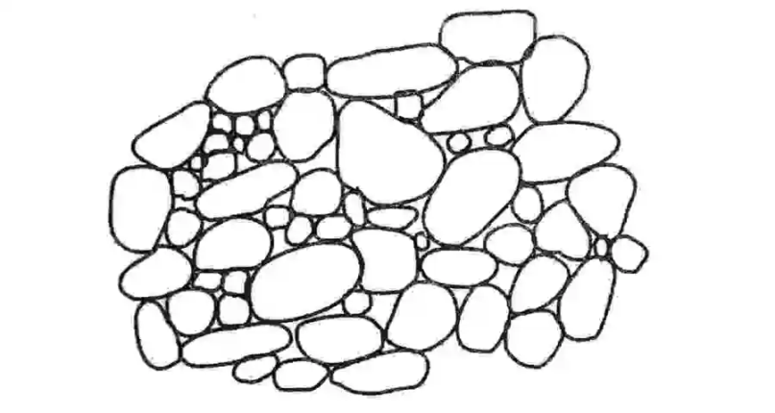
These bulky soil particles form a framework or skeleton as shown in figure known as the coarse grained skeleton.
The space between the bulky grains is occupied by clayey particles known as binders.
As long as the soil structure is not disturbed, the coarse grained skeleton can take heavy loads without much deformation.
However, when the soil structure is disturbed then the load is transformed from coarse-grained particles to clayey particles. Due to this the supporting power and also the stability of soil is considerably reduced.
6). Clay Matrix Structure
The clay matrix structure is also a composite structure formed by soils of different types.
However, in this case the amount of clay particles is very large as compared with the bulky coarse grained particles.
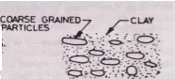
The clay forms a matrix in which bulky grains were floating without touching one another.
The soils with clay matrix structure have almost the same properties as clay. Their behaviour is similar to that of an ordinary clay deposit.
However they are more stable, as disturbances have very little effect on the soil formation with a clay matrix structure.

Soil as a Three Phase System
The soil mass is a three phase system, consisting of solid particles (called soil grains), water and air.
The void space between the soil grains is filled partly with water and partly with air.
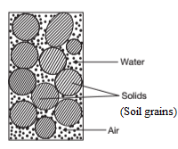
However in a dry soil mass, the voids are filled with air only. In the case of a perfectly saturated soil, the voids are filled completely with water.
In general the soil mass has the three constituents (Soil grains, Water and Air) which do not occupy separate spaces but are blended together forming the complex soil material.
The properties of soils depend upon the relative percentages of these three constituents and their arrangement.
For study purpose, it is always more convenient to show these three constituents occupying the separate spaces as shown in the diagram.
The diagram which represents the three constituents separately is known as the three phase diagram (or) the block diagram.
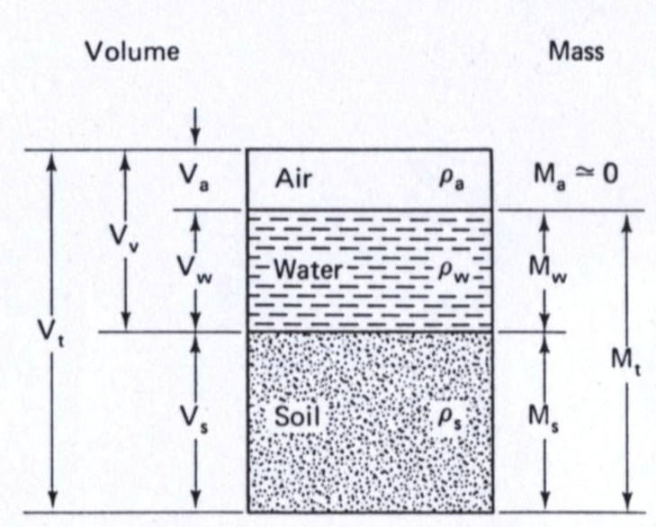
It may be noted that the three constituents cannot be actually segregated.
The three phase diagram is an artifice used for easy understanding.
The three phase diagram is a simple diagrammatic representation of the real soil.
The three phase diagram is extremely useful for studying the various terms used in Soil Engineering and their inter-relationships.
In a three phase diagram, it is conventional to write the volumes on the left side and the masses (or) the weights on the right side.
The total volume of soil mass is designated as ‘V’. It is equal to the sum of the volume of solids (V_{s}), the volume of water (V_{w}) and the volume of air (V_{a}).
However, the sum of the volume of water (V_{w}) and the volume of air (V_{a}) is known as the volume of voids (V_{V})
The total mass of soil is represented as ‘M’. The mass of air (M_{a}) is very small and it is neglected. Hence the total mass of soil (M) is equal to the mass of soil solids (M_{s}) and the mass of water (M_{w}).
$∴$ V = V_{v} + V_{s} and
V_{v} = V_{a} + V_{w}
$∴$ V = V_{a} + V_{w} + V_{s}
When the soil is perfectly dry then V_{w} = 0
Hence V_{v} = V_{a} and V = V_{a} + V_{s}
When the soil is completely saturated then V_{a} = 0
Hence V_{v} = V_{w} and V = V_{w} + V_{s}
The total mass of soil = M = M_{w} + M_{s}
When soil is perfectly dry M_{w} = 0
Hence M = M_{s}
Similarly, the total weight of soil = W = W_{w} + W_{s}

Volumetric Relationships
The following five volumetric relationships are widely used in Soil Engineering
1). Void Ratio (e)
It is defined as the ratio of the volume of voids (V_{v}) to the volume of solids (V_{s})
Thus, the void ratio = e = $\frac{V_{V}}{V_{s}}$
The void ratio is expressed as decimal, such as 0.4,0.5 etc. For coarse grained soils, the void ratio is generally smaller than that for fine grained soil. For some soils, it may have a value even greater than unity.
2). Porosity (n)
It is defined as the ratio of the volume of voids (Vv) to the total volume (V).
Thus the porosity = n = $\frac{V_{v}}{V}$
Porosity is generally expressed as percentage such as 43%, 52%, etc.
The porosity of a soil cannot exceed 100%. The porosity is also known as the percentage of voids.
Both the void ratio and porosity are the measure of the looseness or the denseness of soils. As the soil becomes more and more dense, their values decrease.
The inter-relationship between void ratio (e) and the porosity (n) is given by
The porosity = n = $\frac{V_{v}}{V} ⇰ \frac{1}{n}= \frac{V}{V_{v}}$ But V = V_{v} + V_{s}
$∴ \frac{1}{n}= \frac{V_{v} + V_{s}}{V_{v}}=1+ \frac{V_{s}}{V_{v}}$ But $\frac{V_{s}}{V_{v}}= \frac{1}{e}$
$$∴ \frac{1}{n}= 1+ \frac{1}{e} = \frac{e+1}{e}$$
$$∴ n= \frac{e}{1+e}------ (1)$$
From equation (1) we get
$$\frac{1+e}{e}= \frac{1}{n} ⇰ \frac{1}{e}+ 1= \frac{1}{n} ⇰ \frac{1}{e}=\frac{1}{n}- 1= \frac{1-n}{n }$$
$$∴ e= \frac{n}{1-n}------ (2)$$
From equation (1) we get
$$∴1+e= \frac{e}{n}$$
From equation (2) we get
$$∴ 1-n= \frac{n}{e}$$
$$∴\left(1+e\right)\left(1-n\right)= \frac{e}{n}x \frac{n}{e}=1$$
$$∴\left(1+e\right)\left(1-n\right)=1-----(3)$$
In Soil Engineering the term Void ratio (e) is more popular. It is more convenient to use Void ratio (e) than Porosity (n).
When the volume of soil mass changes, only the numerator i.e. V_{v} in the Void ratio (e) changes and the denominator i.e. V_{s} remains constant.
However if the Porosity (n) is used, both the numerator (V_{v}) and also the denominator (V) changes and it becomes inconvenient.
3). Degree of Saturation (S_{r})
The degree of saturation (S_{r}) is defined as the ratio of the volume of water (V_{w}) to the volume of voids (V_{v}).
$$∴ S_{r}= \frac{V_{w}}{V_{v}}$$
The degree of saturation (S_{r}) is generally expressed as a percentage.
The degree of saturation (S_{r}) is zero when the soil is absolutely dry.
The degree of saturation (S_{r}) is 100% when the soil is fully saturated.
The degree of saturation (S_{r}) is also known as the percentage saturation.
4). Percentage air voids (n_{a})
The percentage air voids (n_{a}) is defined as the ratio of the volume of air (v_{a}) to the total volume (V).
$∴ n_{a}= \frac{V_{a}}{V}$
The percentage air voids (n_{a}) is expressed as a percentage.

5). Air content (a_{c})
The air content (a_{c}) is defined as the ratio of the volume of air (Va) to the volume of voids (V_{v}).
$$∴ a_{c}= \frac{V_{a}}{V_{v}}$$
The air content (a_{c}) is also expressed as a percentage.
Both air content (a_{c}) and percentage air voids (n_{a}) are zero when the soil is fully saturated.
The percentage air voids =$n_{a}= \frac{V_{a}}{V}$
$∴ n_{a}= \frac{V_{a}}{V}= \frac{V_{a}}{V_{v}} x \frac{V_{v}}{V}= a_{c} x n$
$∴ n_{a}=n a_{c}$
The air content =$a_{c}= \frac{V_{a}}{V_{v}}$
But V_{a} = V_{v} – V_{w}
$$∴ a_{c}= \frac{V_{v}-V_{w} }{V_{v}}=1- \frac{V_{w}}{V_{v}}=1-S_{r}$$
$$∴ a_{c}=1-S_{r}$$
Water content (w)
The water content (w) is defined as the ratio of the mass of water (M_{w}) to the mass of soil solids (M_{s}).
$∴$ The water content = w = $\frac{M_{w}}{M_{s}}= \frac{W_{w}}{W_{s}}$
The water content is also known as the moisture content (m).
The water content is expressed as percentage.
The water content of fine grained soils such as slit and clays is generally more than that of the coarse grained soils such as gravels and sands.
The water content of some of the fine grained soils may be even more than 100%, which indicates that more than 50% of the total mass is that of water.
The water content of a soil is an important property. The characteristics of a soil, especially the fine grained soils change to a marked degree with a variation of its water content.
Bulk Density ( $ρ$)
The bulk density or the moist density is defined as the total mass (M) of the soil per unit total volume (V) of the soil.
$$∴ ρ= \frac{M}{V}$$
The bulk density is expressed in terms of gm/cm³ (or) Kg/m³.
Dry Density ($ρ_{d})$
The dry density is defined as the mass of soil solids (M_{s}) per unit total volume (V) of the soil.
$$∴ ρ_{d}= \frac{M_{s}}{V}$$
The dry density is expressed in terms of gm/cm³ (or) Kg/m³.
The dry density is used to express the denseness of the soil. A high value of dry density indicates that the soil is in compact condition.
Density of Soil Solids ($ρ_{s}$)
The density of soil solids or the density of solids is defined as the mass of soil solids (M_{s}) per unit volume of soil solids (V_{s}).
$$∴ ρ_{s}= \frac{M_{s}}{V_{s}}$$
The density of soil solids is expressed in terms of gm/cm³ (or) Kg/m³.
Saturated Density ( $ρ_{sat}$)
When the soil mass is saturated, its bulk density is known as the saturated density. Thus the saturated density defined as the total mass of the saturated soil (M_{sat}) of the soil per unit total volume (V) of the soil.
$$∴ ρ_{sat}= \frac{M_{sat}}{V}$$
The saturated density is expressed in terms of gm/cm³ (or) Kg/m³.

Bulk unit weight ($γ$ )
The bulk unit weight or the moist unit weight is defined as the total weight (W) of the soil per unit total volume (V) of the soil.
$$∴ γ = \frac{W}{V}$$
The bulk unit weight is expressed in terms of N/m³.
Dry unit weight ($γ_{d})$
The dry unit weight is defined as the weight of soil solids (W_{s}) per unit total volume (V) of the soil.
$$∴ γ_{d}= \frac{W_{s}}{V}$$
The dry unit weight is expressed in terms of N/m³.
The dry unit weight is used to express the denseness of the soil. A high value of dry unit weight indicates that the soil is in dense and compact condition.
Unit weight of Soil Solids ($γ_{s}$)
The unit weight of soil solids is defined as the weight of soil solids (W_{s}) per unit volume of soil solids (V_{s}).
$$∴ γ_{s}= \frac{W_{s}}{V_{s}}$$
The unit weight of soil solids is expressed in terms of N/m³.
Saturated unit weight ( $γ_{sat}$)
When the soil mass is saturated, its bulk unit weight is known as the saturated unit weight. Thus the saturated unit weight is defined as the total weight of the saturated soil (W_{sat}) of the soil per unit total volume (V) of the soil.
$$∴ γ_{sat}= \frac{W_{sat}}{V}$$
The saturated unit weight is expressed in terms of N/m³.
Note:
The relation between the unit weight ($γ$) and the mass density ($ρ$) is given by
The Unit weight ($γ$) = The mass density ($ρ$) X The acceleration due to gravity (g)
Specific Gravity (G)
The specific gravity of soil solids is defined as the ratio of the mass of a given volume of soil solids (m_{s}) at a given temperature to the mass of an equal volume of distilled water (m_{w}) at the same temperature, both masses being taken at the same temperature.
$∴$The specific gravity = G = $\frac{m_{s}}{m_{w}}$
$∴$The specific gravity = G = $\frac{m_{s}}{m_{w}}=\frac{ρ_{s}}{ρ_{w}}= \frac{w_{s}}{w_{w}}= \frac{γ_{s}}{γ_{w}}$
The specific gravity of most of the soils ranges from 2.65 to 2.80.
The specific gravity of soil solids is an important property of soils. It is used in the determination of void ratio and particle size.
In addition to the specific gravity of soil solids (G), the mass specific gravity (G_{m}) is also occasionally used in Soil Engineering.
The mass Specific gravity (G_{m}) is defined as the ratio of the mass density of the soil ($ρ$) to the mass density of water ($ρ_{w}$).
$∴$The mass specific gravity = G_{m} =$\frac{ρ}{ρ_{w}}= \frac{γ}{γ_{w}}$
The value of the mass specific gravity (G_{m}) of a soil is much smaller than the value of the specific gravity of soil solids (G).
The mass specific gravity is also known as the bulk specific gravity (or) the apparent specific gravity.

The Functional Relationship
1). The relation between e, G, w and S_{r}
The relation between void ratio (e), specific gravity of soil solids (G), water content (w) and degree of saturation (S_{r}) is obtained from the three phase diagram in terms of void ratio as shown in figure.
From the diagram
The volume of soil solids = V_{s} = 1
The volume of water = V_{w} = e_{w}
Now
1). The void ratio of soil = $e= \frac{V_{V}}{V_{s}}=\frac{V_{V}}{1}= V_{V}$
2). The degree of saturation = S_{r} = $\frac{V_{w}}{V_{v}}= \frac{e_{w}}{e}$
$$∴ e_{w}=e S_{r}----(1)$$
3). The water content = w = $\frac{W_{w}}{W_{s}}= \frac{γ_{w} V_{w}}{γ_{s}V_{s}}= \frac{γ_{w} e_{w}}{γ_{s }x 1}=\frac{γ_{w} e_{w}}{γ_{s }}----(2)$
4). The specific gravity of soil solids = G = $\frac{γ_{s}}{γ_{w}}$
$$∴ γ_{s}=G γ_{w}-----(3)$$
Substituting the equation (3) in equation (2), we get
w = $\frac{γ_{w} e_{w}}{γ_{s }}= \frac{γ_{w} e_{w}}{G γ_{w}}= \frac{e_{w}}{G}$
$$∴ e_{w}=w G----(4)$$
From equations (1) and (4), we get
$$e S_{r}= w G$$
$$∴e=\frac{w G}{S_{r}}$$
Note : when the soil is saturated S_{r} = 1
Hence, in saturated soil e = w G

2). The relation between e, S_{r} and n_{a}
The relation between void ratio (e), degree of saturation (S_{r}) and percentage of air voids (n_{a}) is obtained from the three phase diagram in terms of void ratio as shown in figure.
From the diagram
The volume of soil solids = V_{s} = 1
The volume of water = V_{w} = e_{w} and
Total volume of soil mass = V = 1+e
Now
1). The void ratio of soil = $e= \frac{V_{V}}{V_{s}}=\frac{V_{V}}{1}= V_{V}$
2). The degree of saturation = S_{r} = $\frac{V_{w}}{V_{v}}= \frac{e_{w}}{e}$
$$∴ e_{w}=e S_{r}----(1)$$
3). The percentage of air voids = n_{a} = $\frac{V_{a}}{V}$
V = 1+e and V_{a} = V_{v} – V_{w} = e – e_{w}
$$∴ n_{a}= \frac{e- e_{w}}{1+e}------(2)$$
Substituting the equation (1) in equation (2), we get
$$n_{a}= \frac{e- e S_{r}}{1+e}$$
$$∴ n_{a}= \frac{e (1- S_{r} )}{1+e}$$
3). The relation between n_{a} , a_{c} and n
Here n_{a} = The percentage of air voids = $\frac{V_{a}}{V}$
a_{s} = The air content = $\frac{V_{a}}{V_{v}}$ and n = The porosity = $\frac{V_{v}}{V}$
$∴$n_{a} = $\frac{V_{a}}{V}= \frac{V_{a}}{V_{v}} x \frac{V_{v}}{V}$
$∴$n_{a} = a_{c} x n
4). Relation between $γ_{d }$, e and G
The relation between the dry unit of weight of soil ($γ_{d }$), void ratio (e) and specific gravity of soil solids (G), is obtained from the three phase diagram in terms of void ratio as shown in figure.
From the diagram
The volume of soil solids = V_{s} = 1 and
Total volume of soil mass = V = 1+e
Now
1). The dry unit weight of soil = $γ_{d}= \frac{W_{s}}{V}$
But, the weight of soil solids = W_{s} = $γ_{s} V_{s}$
$$∴ γ_{d}= \frac{γ_{s} V_{s}}{V}=\frac{γ_{s} X 1}{1+e}= \frac{γ_{s} }{1+e} -----(1)$$
2). The specific gravity of soil solids = G = $\frac{γ_{s}}{γ_{w}}$
$$∴ γ_{s}=G γ_{w}----(2)$$
Substituting the equation (2) in equation (1), we get
$$∴ γ_{d}= \frac{G γ_{w} }{1+e}$$
$$∴e= \frac{G γ_{w}}{γ_{d}}- 1$$
5). Relation between $γ_{d }$, n and G
The relation between the dry unit of weight of soil ($γ_{d }$), porosity (n) and specific gravity of soil solids (G), is obtained from the three phase diagram in terms of porosity as shown in figure.
From the diagram
Total volume of soil mass = V = 1 and
The volume of soil solids = V_{s} = 1 – n

Now
1). The dry unit weight of soil = $γ_{d}= \frac{W_{s}}{V}$
But, the weight of soil solids = W_{s} = $γ_{s} V_{s}$
$$∴ γ_{d}= \frac{γ_{s} V_{s}}{V}=\frac{γ_{s} X (1-n)}{1}= γ_{s} X (1-n)-----(1)$$
2). The specific gravity of soil solids = G = $\frac{γ_{s}}{γ_{w}}$
$$∴ γ_{s}=G γ_{w}----(2)$$
Substituting the equation (2) in equation (1), we get
$$∴ γ_{d}=(1-n) G γ_{w}$$
Note :
In terms of densities
$$∴ ρ_{d}= \frac{G ρ_{w} }{1+e}$$
$$∴e= \frac{G ρ_{w}}{ρ_{d}}- 1$$
$$∴ ρ_{d}=(1-n) G ρ_{w}$$

Diffuse double layer and Adsorbed water
The faces of clay minerals carry a net negative charge. The edges of the mineral may have either positive or negative charge.
In water molecules, the hydrogen atoms are not symmetrically oriented around the oxygen atoms. Due to this the water molecules acts as a bar magnets or as a dipole.
As the faces of clay particles carry a negative charge, there is a attraction between the negatively charged faces and the positive ends of water molecules as shown in figure
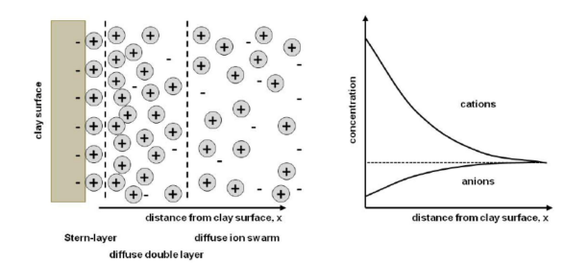
Because of the net negative charge on the surface, the clay particles also attract cations, such as Potassium, Calcium and Sodium from the moisture present in the soil. These cations are attached to the soil surfaces and water dipoles are attached to these cations through their negative charged ends as shown in figure.
The cations and also the water molecules attached to the clay mineral surface try to move away from the surface because of their thermal energy.
The net effect of the forces due to attraction and that due to repulsion is the force of attraction which decreases exponentially with an increase in distance from the clay particle surface as shown in figure.
Immediately surrounding the clay particle there is a thin and very tightly held layer of water of about 10 A⁰ thick. This layer is known as Stern layer or Rigid layer.
Beyond this thickness, there is a second layer in which water is more mobile. The second layer extends up to the limit of attraction and is known as diffuse double layer.
The water held in diffused double layer is known as adsorbed water or oriented water. Outside the diffuse double layer, the water is normal and non-oriented. The total thickness of diffused double layer is about 400 A⁰⁻.
The water held by electro-chemical forces existing on soil surface is known as adsorbed water. As the adsorbed water is under the influence of electrical forces, its properties are different from that of normal water.
The adsorbed water is much more viscous and its surface tension is also greater. It is heavier than normal water. The boiling point is higher and the freezing point is lower than the normal water.
The pressure required to pull away the adsorbed water layer from the soil surface is very high. It may be as high as 10,000 atmospheres.

The properties of a soil mass are basically classified into
1). Engineering Properties and
2). Index Properties

Engineering Properties
The main engineering properties of soils are Permeability, Consolidation and Shear strength.
Permeability indicates the facility with which water can flow through soils. It is required for the estimation of seepage discharge through earth masses.
Consolidation is related with the deformations produced in soils when they are subjected to compressive loads. The consolidation characteristics are required for computation of the settlements of structures founded on soils.
Shear strength of a soil is its ability to resist the shear stress. The shear strength determines the stability of slopes, bearing capacity of soils and the earth pressure on retaining structures.

Index Properties
The tests required to determine the engineering properties of soils are generally elaborate and time consuming.
Sometimes the Geotechnical Engineer is interested to have some rough assessment of the engineering properties without conducting the elaborate tests. This is possible if Index properties are determined.
The properties of soils which are not of primary interest to the Geotechnical Engineer but which are indicative of the engineering properties of soils are known as the index properties of soils.
The simple tests which are required to determine the index properties are known as the classification tests.
The soils are classified and identified based on index properties
The index properties of soils are
1). Water content 2). Specific gravity 3). Particle size distribution 4). Insitu density
5). Density index or Relative density and
6). Consistency limits or Atterberg’s limits
The main index properties of coarse grained soils are Particle size distribution and relative density.
The main index property of fine grained soils is the Consistency limits (or) the Atterberg’s limits.
The index properties of soils are also divided into two categories
1). The index properties of individual soil particles (or) the soil grain index properties
2). The index properties of the soil mass (or) the soil aggregate properties.
The principle soil grain index properties of are specific gravity and the particle size distribution.
The most significant soil aggregate index property of cohesionless soil is the relative density.
In cohesive soils the most significant soil aggregate index property is the Atterberg’s limits.
The index properties give some information about the engineering properties.
It is tacitly assumed that the soils with like index properties have identical engineering properties.
However the correlation between the index properties and the engineering properties of soils is not perfect.
A liberal factor of safety should be provided if the design is based on the index properties.
The design of large and important structures should be done only after determination of engineering properties.

Determination of Water content
The water content of a soil is an important soil aggregate index property.
The water content is a quantitative measure of the wetness of a soil mass.
The water content of a soil sample can be determined by the following methods
1). Oven drying method 2). Pycnometer method
3). Sand bath method 4). Calcium carbide method
5). Alcohol method 6). Radiation method

Oven Drying Method
The oven drying method is a standard laboratory method. This is a very accurate method.
In this method, the soil sample is taken in a non-corrodible air tight container.
According to IS: 2720 (Part II) – 1973, the mass of sample and the mass of container are determined by using an accurate weighing balance up to an accuracy of 0.01 percent.
The quantity of soil sample to be taken for the test depends upon the maximum size of the soil particles in the soil sample. The following table gives the minimum quantity of soil sample to be taken for the test.
A clean non-corrodible container is taken and its mass (M₁) is determined with its lid.
The specimen of wet soil sample is placed in the container and the lid is replaced. The mass of container and the soil sample (M₂) is determined.
The lid id removed and the container with the wet soil is placed in a thermostatically controlled oven for 24 hours at a temperature of 110 + 5⁰C.
The temperature selected (110 + 5⁰C ) is suitable for most of the soils. The temperature lower than (110 + 5⁰C) may not cause the complete evaporation of water. The temperature higher than (110 + 5⁰C0 may cause the breaking down of the crystalline structure of the soil particles and loss of chemically bound structural water.
For complete drying the sandy soils take about four hours and clays take about 14 to 16 hours. Usually the soil sample is kept for about 24 hours in the oven so that the complete drying is assured,
For highly organic soils lower temperature of about 60⁰C is preferable to prevent the oxidation of organic matter.
Certain soil samples contain gypsum, which on heating loses its crystallisation water. Such soil samples are dried at a temperature not more than 80⁰C but for a longer period of time.
After drying, the container is removed from the oven and allowed to cool in desiccators. The lid is replaced, the mass of container, lid and dry soil sample (M₃) is determined.

S. No | Size of soil particles more than 90% passing | Quantity of soil in gm
1 | 425 micron | 25
2 | 2 mm | 50
3 | 4.75 mm | 200
4 | 10 mm | 300
5 | 20 mm | 500
6 | 40mm | 1000

Thus the observations are
1). The mass of an empty container with lid = M₁
2). The mass of container with lid + wet soil = M₂
3). The mass of container with lid + dry soil = M₃
Now
The mass of wet soil = M₂ – M₁
The mass of dry soil = M₃ – M₁
$∴$ The mass of water in the soil = (M₂ – M₁) – (M₃ – M₁) = M₂ – M₃
$∴$ The water content of the soil = w = $\frac{Mass of water}{Mass of dry soil}$
$$∴w=\frac{M_{2}-M_{3}}{M_{3}- M_{1}} x 100 \%$$
In terms of weights
$$∴w=\frac{W_{2}-W_{3}}{W_{3}- W_{1}} x 100 \%$$

Specific Gravity Determination
The specific gravity of soil solids (G) is useful in the determination of void ratio (e), degree of saturation (S_{r}), water content (w) etc.,
The specific gravity of solids is determined in the laboratory by using the following methods
1). Density bottle method
2). Pycnometer method
3). Measuring flask method
4). Gas jar method
5). Shrinkage limit method
The density bottle method is the standard method in the laboratory. The density bottle method is the most accurate and is suitable to determine the specific gravity of soil solids (G) for all the types of soils.
The Pycnometer method (or) the measuring flask method is used to determine the specific gravity of soil solids (G) of only for coarse –grained soils.

Density Bottle Method
The specific gravity of soil particles (G) can be determined in the laboratory by using a density bottle fitted with a stopper having a hole. The density bottle of 50 ml capacity is generally used.
The density bottle is cleaned and dried at a temperature of 105⁰C to 110⁰C and cooled. The mass of empty specific gravity bottle including the stopper (M₁) is taken.
About 5 to 10 gm of oven dry soil sample is taken in the specific gravity bottle. The mass of specific gravity bottle with soil sample including the stopper (M₂) is taken.
The remaining volume of specific gravity bottle is gradually filled with distilled water or kerosene. The entrapped air in the soil sample should be removed by applying the vacuum. Water is added to the specific gravity bottle to make it full. The stopper is inserted in the bottle. The mass of specific gravity bottle, soil, water and stopper (M₃) is taken. The temperature is also recorded.
Lastly, the specific gravity is emptied, washed and then refilled with distilled water. The mass of specific gravity bottle completely filled with water (M₄) is taken.
The above masses are represented in terms of phase diagrams as shown in figure.
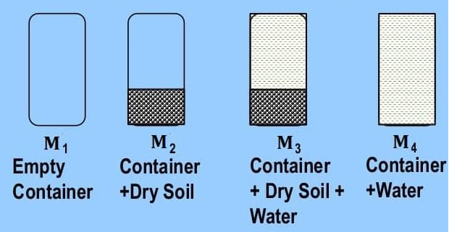
Thus, the observations are
M₁ = The mass of empty specific gravity bottle
M₂ = The mass of specific gravity bottle + dry soil
M₃ = The mass of specific gravity bottle + dry soil + water and
M₄ = The mass of specific gravity bottle + water
From the phase diagrams (1) and (2) as shown in figure
The mass of soil solids in the dry soil = M_{s} = M₂ – M₁

We know that
The specific gravity of soil solids = G = $\frac{ρ_{s}}{ρ_{w}}$
$$∴ ρ_{s}=Gρ_{w}$$
Now, the volume of soil solids = $V_{s}= \frac{M_{s}}{ρ_{s}}= \frac{M_{s}}{Gρ_{w} }$
From the three phase diagrams (3) and (4) we get
$$M_{4}= M_{3}- M_{s}+ ρ_{w} V_{s}= M_{3}- M_{s}+ ρ_{w}\frac{M_{s}}{Gρ_{w} }$$
$$∴ M_{4}= M_{3}- M_{s}+ \frac{M_{s}}{G}$$
$$∴ \frac{M_{s}}{G} = M_{4}- M_{3}+ M_{s}=\left(M_{2}-M_{1}\right)- (M_{3}- M_{4})$$
$$∴ \frac{\left(M_{2}- M_{1}\right)}{G} =\left(M_{2}-M_{1}\right)- (M_{3}- M_{4})$$
$∴ G= \frac{\left(M_{2}- M_{1} \right)}{\left(M_{2}-M_{1}\right)- (M_{3}- M_{4})} = \frac{M_{s}}{M_{s}- (M_{3}- M_{4})}$ ---------- (1)
The above equation gives the specific gravity of soil solids at the test temperature.
The specific gravity of soil solids is generally reported either at 27⁰C (or) at 4⁰C.
If ‘G_{t}’ is the specific gravity of soil solids at the test temperature of t⁰C then
1). The specific gravity of soil solids at 27ºC is given by
G₂₇ = G_{t} x $\frac{Specific gravity of water at t^{o}C}{Specific gravity of water at 27^{o}c}$
2). The specific gravity of soil solids at 4ºC is given by
G₂₇ = G_{t} x Specific gravity of water at tºc

Mass Density Determination
The bulk density ($ρ$) of a soil mass is the total mass of the soil per unit total volume of the soil.
$$∴The Bulk Density of soil = ρ= \frac{The total mass of soil }{The total volume of soil}= \frac{M}{V}$$
Although the mass of soil can be determined very accurately, it is rather difficult to determine the volume of soil sample accurately.
Once the bulk density ($ρ$) has been determined, the dry density 0f soil ($ρ_{d}$) is given by
$$ρ_{d}= \frac{ρ}{1+w}$$
The following methods are generally used for the determination of bulk density or mass density of soil.
1). Water replacement method 2). Submerged mass density method
3). Core cutter method 4). Sand replacement method
In the above methods, the first two methods are laboratory methods. The remaining are field methods.

Water Displacement Method
In this method the volume of soil specimen is determined by water displacement.
As the soil mass disintegrates when it comes in contact with water, the soil sample is coated with paraffin wax to make it impervious.
In this method, first the soil specimen is trimmed to a regular shape and its mass M₁ is to be determined.
The soil specimen is then coated with paraffin wax by dipping it in molten wax.
The soil specimen is allowed to cool and its mass M₂ is to be determined.
Now
M₂ – M₁ = The mass of paraffin wax
The waxed soil specimen is then immersed in a water displacement container.
The volume of waxed soil specimen is equal to the volume of water which comes out from the overflow tube.
However, the actual volume of soil specimen (V) is less than the volume of the waxed soil specimen (V_{t})
Now
The actual volume of soil specimen = V = $V_{t}- \frac{\left(M_{2}- M_{1}\right)}{ρ_{p}}$
Here $ρ_{p}$ = The mass density of paraffin wax = 0.998 gm/ml
A representative soil sample is taken from the middle of soil specimen for water content determination.
Once, the mass, volume and water content of soil specimen have been determined
The bulk density of soil specimen ($ρ$) is given by
$ρ= \frac{The total mass of soil }{The total volume of soil}= \frac{M_{1}}{V}$ and
The dry density of soil specimen ($ρ_{d}$) is given by
$$ρ_{d}= \frac{ρ}{1+w}$$

Submerged Mass Density Method
This method is based on the Archimedes’s Principle that when a body is submerged in water, the reduction in mass of body is equal to the mass of water displaced by the body.
In this method, the soil specimen is first trimmed and its mass ‘M₁’ is to be determined.
The soil specimen is then coated with paraffin wax by dipping it in molten wax. The soil is allowed to cool and its mass ‘M₂’ is to be determined,
The soil sample is then placed in the cradle of the special balance .The cradle is dipped in water contained in the bucket placed just below it. The mass of waxed soil specimen in water ‘M₃’ is to be determined.
Now, the volume of soil specimen ‘V’ is given by
$$V= \left[\frac{M_{2}- M_{3}}{ρ_{w}}\right]- \left[\frac{M_{2}- M_{1}}{ρ_{p}}\right]$$
Here $ρ_{p}$ = The mass density of paraffin wax = 0.998 gm/ml
A representative soil sample is taken from the middle of soil specimen for water content determination.
Once, the mass, volume and water content of soil specimen have been determined
The bulk density of soil specimen ($ρ$) is given by
$ρ= \frac{The total mass of soil }{The total volume of soil}= \frac{M_{1}}{V}$ and
The dry density of soil specimen ($ρ_{d}$) is given by
$$ρ_{d}= \frac{ρ}{1+w}$$
This method is suitable for fine grained soils.

Core Cutter Method
The core cutter method is a field method for determination of mass density.
The core cutter contains a removable dolly and a cylindrical core cutter with a sharp cutting edge.
The dolly is placed over the cutter and it is rammed into the soil. The dolly is required to prevent the burring of the edges of the cutter.
The core cutter containing the soil is taken out of the ground. Any soil extruding above the edges of core cutter is removed.
The mass of core cutter filled with soil is to be determined. A representative soil sample is taken for water content determination.
The volume of soil sample is equal to the internal volume of cutter, which can be determined from the internal dimensions of the core cutter.
Now
The bulk density of soil = $ρ= \frac{M_{2}- M_{1}}{V}$
Here
M₁ = The mass of empty core cutter
M₂ = The mass of core cutter with soil and
V= The internal volume of core cutter
The dry density of soil specimen ($ρ_{d}$) is given by
$$ρ_{d}= \frac{ρ}{1+w}$$
This method is suitable for soft fine grained soils. This method cannot be used for stony and gravelly soils.
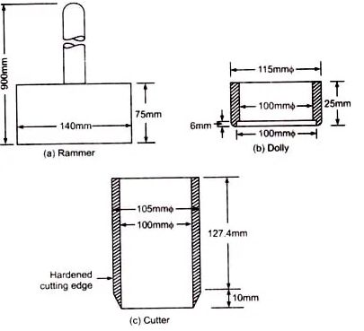
Particle size distribution
The percentage of various sizes of soil particles in a given dry soil mass is determined by using the particle size distribution.
The particle size distribution (or) the particle size analysis is also known as the Mechanical analysis (or) the grain size analysis.
The mechanical analysis is a method of separation of soils into different fractions based on the particle size. It is expressed quantitatively by the mass of various sizes of soil particles present in a soil.
The mechanical analysis is done in two stages
1). The sieve analysis and
2). The sedimentation analysis
The sieve analysis is meant for coarse grained soils (Soil particle size greater than 75 micron) which can easily passes through the set of sieves.
The sedimentation analysis is used for fine grained soils (Soil particle size lesser than 75 micron)
Sedimentation analysis is also known as the wet analysis.
Sometimes the soil mass may contains the particles of both soils. In that case the combined analysis may be required for such soils.
Sieve Analysis
In sieve analysis, the soil is sieved through a set of sieves. According to IS: 1498 – 1970, the sieves are designated by the size of square opening in mm (or) in micron (μ) (one micron = 10⁻³ mm). Sieves of various sizes ranging from 80 mm to 75 micron are available. The diameter of sieve is generally between 15 cm to 20 cm.
The sieve analysis is done for coarse grained soils.
The coarse grained soils can be further sub-divided into gravel fraction (80 mm < size > 4.75 mm) and sand fraction ( 75 μ < size < 4.75 mm).
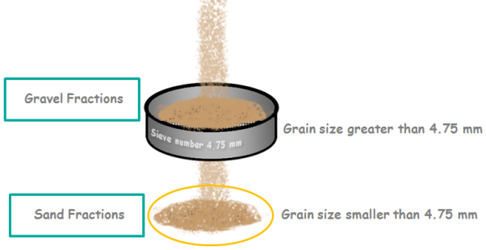
The set of coarse grained sieves, consisting of the sieves of size 80 mm, 40 mm, 20 mm, 10 mm and 4.75 mm are required for gravel fraction.
The second set of sieves consisting of the sieves sizes 4.75 mm, 2 mm, 1 mm, 600 μ, 425 μ, 300 μ, 150 μ and 75 μ are required for sand fraction.
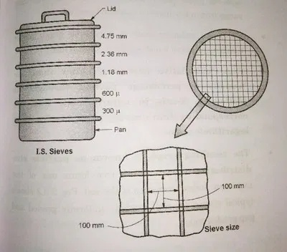
The sieves are stacked one over the other with decreasing size from top to the bottom. A lid or a cover is placed at the top of the larger sieve. A receiver known as the pan, which has no opening is placed at the bottom of the smallest sieve.
The sieve analysis is done in two stages
1). The dry sieve analysis and 2). The wet sieve analysis
1). Dry Sieve Analysis
In dry sieve analysis, the soil sample is taken in suitable quantity.
The soil sample should be oven dry. It should not contains any lumps. If necessary it should be pulverised.
First the soil sample should be sieved through 4.75 mm IS sieve. The portion of soil retained on the 4.75 mm sieve is the gravel fraction or plus 4.75 mm material. The portion of soil passing through 4.75 mm sieve is known as the sand fraction or the minus 4.75 mm material.
The gravel fraction is sieved through the set of coarse sieves (80 mm, 40 mm, 20 mm, 10 mm and 4.75 mm) either manually or by using a mechanical shaker. After sieve the weight of soil retained on each sieve is to be determined.
The sand fraction is sieved through the set of fine sieves(2 mm, 1 mm, 600 μ, 425 μ, 300 μ, 150 μ and 75 μ). The soil sample is placed in the top sieves and the set of fine sieves are kept on the mechanical shaker. Normally 10 minutes of shaking is sufficient for most soils.
The mass of soil retained each sieve and also on the pan is to be determined nearest to 0.1 gm.
Dry sieve analysis is suitable for cohesionless soils with little or no fines.
2). Wet Sieve Analysis
If the soil contains a substantial quantity (more than 50%) of fine particles, the wet sieve analysis is required.
A representative soil sample in the required quantity is taken and dried in the oven.
The dry soil sample is taken in the tray and soaked in water. The soil slurry is then taken in 75 μ sieve and washed with the jet of water until the wash water becomes clear.
The soil retained on the 75 μ sieve is collected and dried in an oven. This dried soil is sample is then sieved through 4.75 mm sieve.
The portion of soil retained on the 4.75 mm sieve is the gravel fraction (or) plus 4.75 mm material.
The portion of soil passing through 4.75 mm sieve is known as the sand fraction (or) the minus 4.75 mm material.
The gravel fraction is sieved through the set of coarse sieves (80 mm, 40 mm, 20 mm, 10 mm and 4.75 mm) either manually or by using a mechanical shaker. After sieve the weight of soil retained on each sieve is to be determined.
The sand fraction is sieved through the set of fine sieves(2 mm, 1 mm, 600 μ, 425 μ, 300 μ, 150 μ and 75 μ). The soil sample is placed in the top sieves and the set of fine sieves are kept on the mechanical shaker. Normally 10 minutes of shaking is sufficient for most soils.
The mass of soil retained each sieve and also on the pan is to be determined nearest to 0.1 gm.
Computation of the Percentage Passing through (or) the Percentage Finer
To determine the particle size distribution, the computation of the percentage of particles passing through or the percentage of particles finer than a particular size is required. This can be done as follows,
The set of fine sieves are 2 mm, 1 mm, 600 μ, 425 μ, 300 μ, 150 μ and 75 μ.
Consider the sieving of a soil sample through the set of fine sieves.
Let M = The total mass of soil sample
M₁, M₂, M₃, M₄,M₅,M₆ and M₇ = The mass of soil retained on the set of fine sieves 2 mm, 1 mm, 600 μ, 425 μ, 300 μ, 150 μ and 75 μ respectively and
M₈ = The mass of soil retained on the pan.
Here M = M₁+M₂+M₃+M₄+M₅+M₆+M₇+M₈
Now, the percentage of soil retained on each sieve and also on the pan is given by
$P_{1}= \frac{M_{1}}{M} x 100$, $P_{2}= \frac{M_{2}}{M} x 100$ --------- $P_{8}= \frac{M_{8}}{M} x 100$,
The cumulative percentage of material (C) retained on any sieve is equal to the sum of the percentage of soil retained on the sieve and that retained on all sieves coarser than that sieve.
$∴ C_{1}= P_{1}, C_{2}= P_{1}+P_{2}, C_{3}= P_{1}+P_{2}+P_{3}$--------- $C_{7}= P_{1}+P_{2}+ P_{3}+ P_{4}$+ P₅ + P₆ + P₇
Now, the percentage passing through or the percentage finer (N) than any sieve size is obtained by subtracting the cumulative percentage retained on that sieve from 100%.
$∴ N_{1}=100- C_{1}, N_{2}=100- C_{2}$, N₃ = 100 – C₃ , ---------------- N₇ = 100 – C₇

Hydrometer Method
The hydrometer is an instrument used for the determination of the specific gravity of the liquids.
The special type of hydrometer with a long stem (or) a long neck can be used for the particle size analysis. The stem is marked from top to bottom in the range of 0.995 to 1,030 and they indicated on the right side of the steam of hydrometer as shown in the figure.
These readings directly indicates the specific gravity soil suspension situated at the centre of the bulb of the hydrometer.
These readings on the stem of hydrometer are usually converted into the hydrometer readings (R_{h}) which are indicated on the left side of the steam of the hydrometer as shown in the figure.
The hydrometer readings (R_{h}) are obtained by subtracting ‘1’ from the specific gravity readings and multiplying the resulting value with 1000.
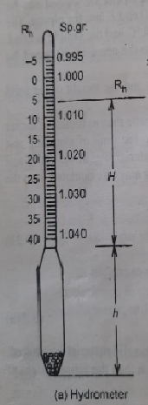
The hydrometer reading = R_{h} = (1.030 – 1) x 1000 = 30
The specific gravity of the soil suspension depends upon the particle size. At the time of the commencement of the sedimentation the specific gravity of suspension is uniform at all depths.
But when sedimentation takes place, the larger particles settle more deeper than the smaller particles. This results in non-uniform specific gravity of the suspension at different depths.
The lower layers of the suspension have specific gravity greater than the upper layers.
The hydrometer measures the specific gravity of suspension at a point indicated by the centre of its immersed volume.
If the volume of stem is neglected, the centre of the immersed volume of the hydrometer is the same as the centre of the bulb.
Thus the hydrometer gives the specific gravity of suspension at the centre of the bulb.
The first step in hydrometer method is to calibrate the hydrometer.
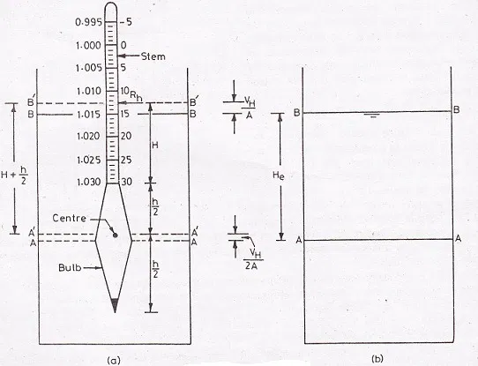
For a given set of hydrometer and sedimentation jar, the values of V_{H} , h and A are constants.
Now, from the above equation it is clear that the effective height (H_{e}) at which the specific gravity of soil suspension is measured depends on the height ‘H’ which in turns depends on the observed hydrometer reading ‘R_{h}’.
As the effective depth ‘H_{e}’ depends on the observed hydrometer reading ‘R_{h}’, a calibration chart can be obtained between the hydrometer reading ‘R_{h}’ and the effective depth ‘H_{e}’ as shown in figure.
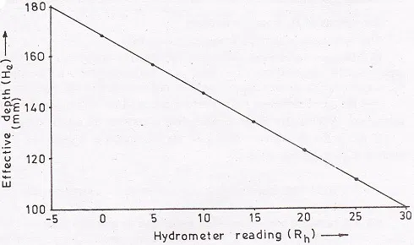
As the sedimentation progresses the specific gravity of the suspension decreases and the hydrometer goes deeper and deeper. Due to this the effective height ‘H_{e}’ increases. But the hydrometer reading decreases.
Test Procedure
Prepare 1000 ml of uniform soil suspension in a sedimentation jar by adding suitable quantity of dispersion solution and distilled water.
The sedimentation jar is then placed on a table and the stop watch is started.
The hydrometer is inserted slowly in the sedimentation jar and the hydrometer readings are taken at 1/2, 1, 2 and 4 minutes of the commencement of sedimentation.
The hydrometer is then removed slowly from the sedimentation jar. It is cleaned with distilled water and inserted in an another 1000 ml comparison measuring jar contacting distilled water with same concentration of dispersing agent as the soil suspension.
Further readings are taken after 8,15 and 30 minutes and 1,2,4,8 and 24 hours time interval from beginning of sedimentation.
For each reading, the hydrometer is inserted in the sedimentation jar about 30 seconds before reading.
After taking the reading, the hydrometer is slowly removed from the sedimentation jar and it is inserted in the comparison measuring jar.
Relation between the Percentage finer (N) and the Corrected Hydrometer reading (R)
The corrected hydrometer reading ‘R’ can be used to determine the percentage of particles finer (N) than the size ‘D’ as indicated below.
Let ‘M_{s}’ is the total mass of dry soil in a suspension of volume ‘V’.
At the beginning of sedimentation the soil suspension is uniform.
Hence the mass of soil solids per unit volume of suspension at any depth = $\frac{M_{s}}{V}$
The initial density of soil suspension ($ρ_{i}$) is given by
$ρ_{i}$ = $\frac{Mass of dry soil in the suspension+mass of water in the suspension}{Total volume of the suspension}$
$∴$ $ρ_{i}$ = $\frac{M_{s}+ M_{w}}{V}$ = $\frac{M_{s}}{V}+ \frac{M_{w}}{V}$ ------------ (1)
Let G = The specific gravity of soil solids and
$ρ_{s}$ = The density of soil solids
We know that
G = $\frac{ρ_{S}}{ρ_{w}}$ ⇰ $ρ_{S}=G ρ_{w}$
Let V_{S} = The volume of soil solids in the suspension
Here $V_{s}= \frac{M_{s}}{ρ_{s}}= \frac{M_{s}}{Gρ_{w} }$
Let V_{W} = The volume of water in the suspension
Now
The total volume of soil suspension = The volume of soil solids + The volume of water
$∴$ V = V_{S} + V_{W} ⇰ V_{W} = V – V_{S} = V - $\frac{M_{s}}{Gρ_{w} }$
Let M_{W} = The mass of water in the soil suspension
Here M_{W} = $ρ_{w}V_{w}$ = $ρ_{w}$ $\left[V - \frac{M_{s}}{Gρ_{w} } \right]$
$∴$ M_{W} = $ρ_{w}V$ $\left[1 - \frac{M_{s}}{GVρ_{w} } \right]$
$∴$ $\frac{M_{w}}{V}$ = $ρ_{w}$ $\left[1 - \frac{M_{s}}{GVρ_{w} } \right]$
Now from equation (1)
$ρ_{i}$ = $\frac{M_{s}+ M_{w}}{V}$ = $\frac{M_{s}}{V}+ \frac{M_{w}}{V}$ = $\frac{M_{s}}{V}+ ρ_{w}$ $\left[1 - \frac{M_{s}}{GVρ_{w} } \right]$
$∴$ $ρ_{i}$ = $\frac{M_{s}}{V}+ ρ_{w}- \frac{M_{s}}{GV }$ = $ρ_{w}+ \frac{M_{s}}{V} \left[1 - \frac{1}{G}\right]$
$∴$ $ρ_{i}$ = $ρ_{w}+ \frac{M_{s}}{V} \left[\frac{G-1}{G} \right]$ ------------ (2)
We know that with the increases of time the soil solids in the suspension gradually settle down.
From equation (2), if ‘$ρ_{t}$’ is the density of soil suspension after a time period of ‘t” s at a depth ‘H_{e}’ them from equation (2) we get
$ρ_{t}$ = $ρ_{w}+ \frac{M_{D}}{V} \left[\frac{G-1}{G} \right]$ -------------- (3)
Here, ‘M_{D}’ is the mass of soil particles in the soil suspension at depth ‘H_{e}’ after a time period of ‘t’ s.
Now the percentage of particles finer (N) than the size ‘D’ is given by
N = $\frac{M_{D}}{M_{s}}$ x 100
$∴$ M_{D} = $\frac{NM_{S} }{100}$ --------- (4)
From equations (3) & (4) we get
$ρ_{t}$ = $ρ_{w}+ \frac{NM_{S} }{Vx100} \left[\frac{G-1}{G} \right]$
$∴ ρ_{t}$ - $ρ_{w}= \frac{NM_{S} }{Vx100} \left[\frac{G-1}{G} \right]$
$∴$ $ρ_{w}\left[\frac{ρ_{t}}{ρ_{w}} -1 \right]$ = $\frac{NM_{S} }{Vx100} \left[\frac{G-1}{G} \right]$
In sedimentation analysis the volume of suspension jar V = 1000 ml and
The density of water = $ρ_{w}$= 1 gm / cm³
$∴$ $ρ_{w}\left[\frac{ρ_{t}}{ρ_{w}} -1 \right]$ = $\frac{NM_{S} }{1000x100} \left[\frac{G-1}{G} \right]$
$∴ \left[\frac{ρ_{t}}{ρ_{w}} -1 \right]$ x 1 x1000 = $\frac{NM_{S} }{100} \left[\frac{G-1}{G} \right]$ ------- (5)
But $\frac{ρ_{t}}{ρ_{w}}$ = The Specific gravity of soil suspension after a time of period of ‘t’ s
Now if ‘R’ is the hydrometer reading after a time period of ‘t’ s
Then R = $\left[\frac{ρ_{t}}{ρ_{w}} -1 \right]$ x 1000
Therefore from equation (5) we get
R = $\frac{NM_{S} }{100} \left[\frac{G-1}{G} \right]$
$∴$N = $\left[\frac{G}{G -1} \right] x \frac{R}{M_{S}}$x 100 --------- (6)
The particle size ‘D’ in the soil suspension after a time period of ‘t’ s can be calculated from the following equation
D = M $\sqrt{\frac{H_{e}}{T}}$ -------- (7)
Here M = $\sqrt{\frac{0.3 η }{g\left(G-1\right)ρ_{w}} }$ and
The effective depth ‘H_{e}’ is obtained from the calibration chart.
By using the equations (7) and (6) Calculate the particle size ‘D’ and the percentage of particles finer (N) than the size ‘D’ for all hydrometer readings (R) taken at different intervals of time.
Now plot the percentage finer (N) against the particle size ‘D’ to obtain the particle size distribution curve.

Limitations of Sedimentation analysis
The sedimentation analysis does not give the correct values of the particle size (D) and the percentage finer (N) due to the following limitations
1). The Stoke’s law is applicable only when the liquid is infinite. The presence of walls of the sedimentation jar affects the results to some extent.
2). In Stoke’s law, it has been assumed that only one sphere settles and there is no interference from the other spheres. In the sedimentation analysis as many particles settle simultaneously, there is some interference will develop between the particles.
However the above two limitations are minimised if the mass of dry soil used per 1000 ml of suspension is not more than 50 gm.
3). The sedimentation analysis cannot be used for soil particles size larger than 0.2 mm as the turbulent conditions will develop and the particles will not settle as per the Stoke’s law.
4). The sedimentation analysis is not applicable for soil articles smaller than 0.2 µ as the Brownian movement will takes place and the particles do not settle as per the Stoke’s law.
5).The soil particles are not spherical, the sedimentation analysis gives the particle size in terms of equivalent diameter of soil particle. The equivalent diameter is close to the thickness rather than the length and width.
6).The specific gravity of soil solids for different particles is different. Hence the use of an average value of ‘G’ in the percentage of finer (N) is a source of error. However as the variation of value of ‘G’ is small, the error is negligible.
Inspite of the above limitations, the sedimentation analysis is used for the determination of the particle size of fine grained soils. The index properties of fine grained soils are the plasticity characteristics and not the particle size.
The main use of sedimentation analysis is to determine the clay content (Particles less than 2 µ size) in a soil mass.
Combined Sieve and Sedimentation analysis
If the mass of soil consists of both coarse grained and fine grained soils then a combined analysis, both sieve analysis and sedimentation analysis is to be done.
First the wet sieve analysis is done on the soil. In this wet sieve analysis, the material retained on 4,75 mm sieve is oven dried and coarse sieve analysis is done. The material retained on 75 µ sieve is also oven dried and the fine sieve analysis is done.
The suspension passing through 75 µ sieve is mixed with a deflocculating agent. The hydrometer test is performed on the soil suspension. The percentage finer than any size can be calculated on the basis of the original mass of soil taken for the combined analysis.
Determination of Relative Density
The most important soil mass index property of cohesionless soil is its relative density (D_{r})
The engineering properties of cohesionless soil depend to a large extent on its relative density.
The relative density is also known as the density index (I_{D}).
The relative density (D_{r}) is defined as
$D_{r}= \frac{e_{max}- e}{e_{max}- e_{min}}$ ---------------- (1)
Here
e_{max} = The maximum void ratio of the soil in the loosest condition.
e_{min} = The minimum void ratio of the soil in the densest condition and
e = The void ratio of the soil in the natural condition.
The relative density gives more clear idea about the denseness of cohesionless soil.
Two types of sands having the same relative density usually behave in identical manner.
The figure shows a soil in the densest, loosest and natural states.

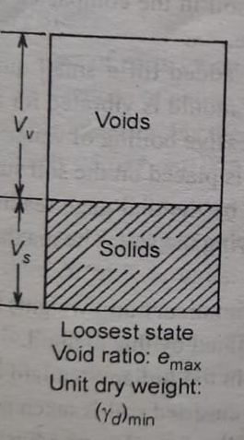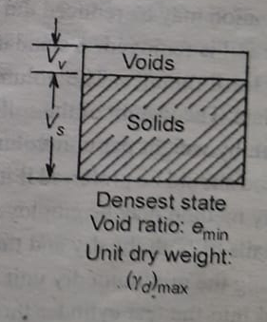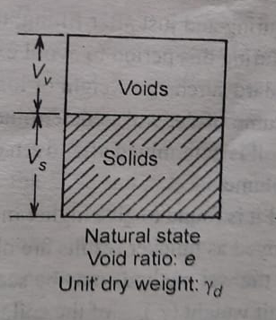
Dense state Loose state Natural state
We know that
The dry unit weight of soil = $γ_{d}= \frac{G γ_{w} }{1+e}$
Let
$γ_{d min}$ = The minimum dry unit weight of the soil in the loosest state
$γ_{d}$ = The dry unit weight of soil in the natural state and
$γ_{d max}$ = The maximum dry unit weight of the soil in the densest state.
Here
$γ_{d min}= \frac{G γ_{w} }{1+e_{max}}$ ⇰ $e_{max}=\frac{G γ_{w}}{γ_{d min}}-1$
Similarly
$γ_{d}= \frac{G γ_{w} }{1+e}$ ⇰ $e=\frac{G γ_{w}}{γ_{d }}-1$ and
$γ_{d max}= \frac{G γ_{w} }{1+e_{min}}$ ⇰ $e_{min}=\frac{G γ_{w}}{γ_{d max}}-1$
Now
The relative density of soil = D _{r} = $\frac{e_{max}- e}{e_{max}- e_{min}}$
$$∴ D_{r}= \frac{\left(\frac{G γ_{w}}{γ_{d min}}-1\right)- \left(\frac{G γ_{w}}{γ_{d }}-1\right)}{\left(\frac{G γ_{w}}{γ_{d min}}-1\right)- \left(\frac{G γ_{w}}{γ_{d max}}-1\right)}$$
$$∴ D_{r}= \left(\frac{γ_{d}- γ_{d min}}{γ_{d max}- γ_{d min}}\right) \left(\frac{γ_{d max}}{γ_{d}}\right)$$
In terms of density of soil
$$∴ D_{r}= \left(\frac{ρ_{d}- ρ_{d min}}{ρ_{d max}- ρ_{d min}}\right) \left(\frac{ρ_{d max}}{ρ_{d}}\right)$$
The above equation is used to determine the relative density (D_{r}) of an insitu soil deposit.
First determine the natural dry density ($ρ_{d}$ ) of soil by using either the core cutter method or the sand replacement method.
To determine the minimum dry density ($ρ_{d min}$) take a representative quantity of oven dry soil sample. The soil sample is then pulverised and sieved through the required sieve.
The minimum dry density ($ρ_{d min}$) is found by pouring the dry soil in a mould using a pouring device. The spout of the pouring device is so adjusted that the height of free fall is always 25 mm. When the mould is completely filled with soil, the mass and volume of the soil are to be determined.
Now the minimum dry density ($ρ_{d min}$) of in the loosest condition is given by
$ρ_{d min}$ = $\frac{M_{min}}{V_{M}}$
Here M_{min} = The mass of dry soil in loosest condition
V_{M} = Volume of soil in the mould.
The maximum dry density ($ρ_{d max}$) is determined either by dry method or by wet method.
In the dry method, the mould is completely filled with oven-dry soil. A surcharge load is placed on the soil surface and the mould is placed on a vibrating deck.
The soil sample is vibrated for 8 minutes. The mass and volume of soil are to be determined.
Now the maximum dry density ($ρ_{d max}$) of soil in the densest condition is given by
$ρ_{d max}$ = $\frac{M_{max}}{V_{M}}$
Here M_{max} = The mass of dry soil in densest condition
V_{M} = Volume of soil in the mould.
The maximum dry density ($ρ_{d max}$) of soil can also be determined by using the wet method.
In this method the mould is filled with wet soil and water is added till a small quantity of free water accumulates on the surface of soil. During and just after filling the mould, vibration is done for a total time of six minutes, Water appearing on the surface of soil is remould. A surcharge load is placed on the soil and the mould is vibrated again for 8 minutes.
The volume of soil (V_{M}) is determined. The mass (M_{max}) of soil is determined after oven drying the soil sample.
Now the maximum dry density ($ρ_{d max}$) of soil in the densest condition is given by
$ρ_{d max}$ = $\frac{M_{max}}{V_{M}}$
Classification of Soils
The various terms commonly used to designate a soil are “Gravel”, “Sand”, “Silt”, and “Clay”. This designation is based on average particle size or grain size.
Most of the soils in nature are the mixtures of two or more of these types with or without organic matter.
For designating the soil mixtures, the minor component of soil mixture is prefixed as an adjective to the major component like “Silty Sand”, “Sandy Clay” etc.
The soil consisting of approximately equal percentages of sand, silt and clay is referred to as “Loam”.
In nature wide variety of soils with large variations in their properties and behaviour exist.
Soil classification may be defined as the arrangement of soils into different groups according to their engineering and various other characteristics such that soils in a particular group have similar behaviour.
From Civil Engineering point of view, the soil classification may be made with the objective of finding the suitability of a soil for its use either as a foundation material or as a construction material.

Systems of Classification of Soils
A number of systems of classification of soils have been evolved for Civil Engineering purposes
1). Preliminary classification by soil types (or) Descriptive classification
2). Geological classification (or) Classification by origin
3). Classification by structure
4). Particle size classification (or) Grain size classification
5). Textural classification
6). AASHTO classification system
7). Unified soil classification system
8). Indian standard classification system
In Preliminary classification by soil types (or) Descriptive classification, the soils described by designations (Based on their appreance) such as “Boulders”, “Gravel”, “Sand”, “Silt”, “Rock flour”, “Clay”, “Peal”, “Loam”, “Loess”, “Bentonite”, “China clay”, “Caliche”, “Fill”, “Black cotton soil”, “Moorum” etc.,
In geological classification, the soils are classified on the basis of their origin.
The origin of a soil may refer either to its constituents (or) to the agencies responsible for its present state.
Based on the constituents, the soils may be classified as
1). Inorganic soils – Which are formed by disintegration and weathering of rocks
2). Organic soils – Which are formed by decomposition of plant life (or) vegetal matter and animal life.
Based on the agencies responsible for their present state, soils may be classified as
1). Residual soils – which remain in position at the place of their origin.
2). Transported soils – Which are deposited at a place away from the place of their origin.
Depending upon the transporting agencies and the place of deposition, the transported soils are subdivided as below
1). Alluvial Soils Transported by water
2). Aeolian Soils Transported by wind
3). Glacial Soils Transported by glaciers
4). Lacustrine Soils Deposited in lakes
5). Marine Soils Deposited in seas
The structure of a soil may be defined as the manner of arrangement and the state of aggregation of soil grains. The soils may be classified on the basis of their structure as follows
1). Soils of single grained structure 2). Soils of honey-comb structure
3). Soils of flocculent structure
Soils of single grained structure are coarse grained soils with a particle size greater than 0.02 mm.
Soils of honey-comb structure are fine grained soils such as silt and rock flour.
Soils of flocculent structure are fine grained soils such as clays.
Particle size classification (or) Grain size classification
In Particle size classification (or) Grain size classification soils are arranged according to the particle size or grain size.
The terms such as gravel, sand, silt and clay are used to indicate certain ranges of particle sizes.
Some of the classification systems based on the particle sizes are as listed below
1). International classification system
2). Indian standard classification system
International Classification System
The International classification system was proposed at the international soil congress held at Washington D.C. in 1927.
This classification system was also known as the Swedish classification system.
The classification of soils as per the International classification system is as follows
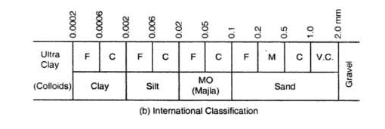
Indian Standard Classification System
The classification of soils as per Indian standard classification (IS: 1498-1970) is as shown in figure.
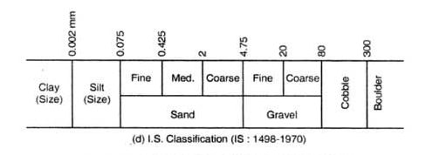

Unified Soil Classification System
The Unified Soil Classification (USC) system was first developed by Casagrande in 1948.
This system has also been adopted by “American Society of Testing Materials (ASTM)”.
This system is the most popular system for use in all types of engineering problems involving soils.
The various symbols used in this system are as listed below.
 | Symbol | Description
`  Primary | G | Gravel
 | S | Sand
 | M | Silt
 | C | Clay
 | O | Organic
 | Pt | Peat
Secondary | W | Well graded
 | P | Poorly graded
 | C | Plastic fines
 | M | Non-plastic fines
 | L | Low plasticity
 | H | High plasticity

The unified soil classification system uses both the particle size analysis and the plasticity characteristics of soils.
In this system the soils are classified into 15 groups.

First the soils are classified into two groups
1). Coarse grained soils
If more than 50% of the soil is retained on 75 µ sieve, it is designated as the coarse grained soil.
The coarse grained soil is designated as gravel (G) if more than 50% of the soil is retained on 4.75 mm sieve; otherwise it is designated as sand (S).
There are 8 groups of coarse grained soils.
If the coarse grained soils contain less than 5% of fines and are well graded (W), they are given the symbols “GW” and “SW”.
If the coarse grained soils contain less than 5% of fines and are poorly graded (P), they are given the symbols “GP” and “SP”.
If the coarse grained soils contain more than 12% of fines they are designated as “GM”, “GC”, “SM” or “Sc”.
If the percentage of fines in the coarse grained soils is in between 5% to 12% they are designated with dual symbols such as “GW-GM”, “GW-GC”, “SW-SM”, “SW-SC” etc.,
2). Fine grained soils
If more than 50% of the soil is passes through 75 µ sieve, it is designated as the fine grained soil.
There are 6 groups of fine grained soils.
The fine grained soils are further divided into two groups
1). Soils of low compressibility (L) if the liquid limit is 50% or less. These are given the symbols ML, CL and OL
2). Soils of high compressibility (H) if the liquid limit is more than 50%. These are given the symbols MH, CH and OH.
The exact type of the fine grained soil is determined from the plasticity chart.
3). Highly organic soils are identified by visual inspection. These are termed as Peat (Pt).

Plasticity Chart as per Unified Soil Classification System
Arthur Casagrande devised the plasticity chart which is useful for identifying and classifying the fine grained soils.
In this chart, the ordinate represents the values of the plasticity index (I_{P}) and the abscissa represents the values of the liquid limit (W_{L}) as shown in figure.
There is a inclined straight line in the plasticity chart known as A – line.
The equation of A – line is given by
I_{P} = 0.73 (W_{L} – 20)
The whole region in the graph is divided into four parts by drawing a vertical line through liquid limit of 50%.
The portion of graph lying to the left of the vertical line comes under low to medium compressibility and plasticity (L).
The portion of graph lying to the right of the vertical line comes under high compressibility and plasticity. (H).
In Unified Soil Classification (USC) system, as per plasticity chart the grouping of fine grained soils are as below
ML = Inorganic slit with slight plasticity having liquid limit less than 50%
CL = Inorganic clay with low to medium plasticity having liquid limit less than 50%
OL = Organic soils of low plasticity having liquid limit less than 50%
MH = Inorganic silt with liquid limit more than 50%
CH = Inorganic clay of medium to high plasticity with liquid limit more than 50%
OH = Organic clays of medium to high plasticity with liquid limit more than 50%
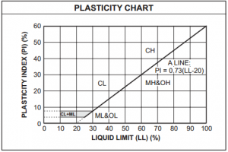
Indian Standard Classification System
The Indian Standard Classification (ISC) system adopted by Bureau of Indian Standard (BIS) is in many respects similar to the Unified Soil Classification (USC) system.
However, there is one basic difference in the classification of fine-grained soils.
The fine grained soils in ISC system are subdivided into three categories as low, medium and high compressibility instead of two categories as low and high compressibility in USC system.
In ISC system the soils are broadly classified into three categories
1). Coarse grained soils
If more than 50% of the soil is retained on 75 µ sieve it is designated as the coarse grained soil.
2). Fine grained soil
If more than 50% of the soil is passes through 75 µ sieve it is designated as the fine grained soil.
3). Peat
If the soil is highly organic and contains large percentage of organic matter and particles of decomposed vegetation, it is designated as Peat (Pt).

In ISC system, there are 18 groups of soils; 8 groups of coarse grained soils, 9 groups of fine grained soils and one peat. The basic soil components and their symbols used in ISC system (IS 1498-1970) are as listed below.
Soil | Soil Component | Symbol | Soil Description
1). Coarse Grained Soil | Boulders | None | Particle size more than 300 mm
 | Cobble | None | Particle size between  300 mm – 80 mm
 | Gravel | G | Particle size between  80 mm to 4.75 mm  1). Coarse gravel :  80 mm to 20 mm  2). Fine gravel:  20 mm to 4.75 mm
 | Sand | S | Particle size in between  4.75 mm to 75 µ  1). Coarse sand :  4.75 mm to 2.0 mm  2). Medium sand :  2.0 mm to 425 µ  3). Fine sand  425 µ to 75 µ
2). Fine Grained Soil | 1). Silt | M | Particle size smaller than 75 µ  Slightly plastic or Non- plastic
 | 2). Clay | C | Particle size smaller than 75 µ  Exhibits plasticity property
 | 3). Peat | Pt | Organic matter in various sizes and stages of decomposition

1). Coarse Grained Soils
In ISC system the coarse grained soils are sub-divided into Gravel and Sand.
The coarse grained soil is designated as gravel (G) if more than 50% of the soil is retained on 4.75 mm sieve; otherwise it is designated as sand (S).
In this system the coarse grained soils are further subdivided into 8 groups as listed below
2). Fine grained soils
If more than 50% of soil is passing through 75 µ sieve, it is designated as the fine grained soil. In ISC system, the fine grained soils are further subdivided into three groups
1). Soils of low compressibility (L) :
If the liquid limit is 35% or less then the soils are designated as low compressibility soils. These soils are given the symbols ML, CL and OL.
2). Soils of intermediate compressibility (I)
If the liquid limit is greater than 35% but less than or equal to 50% then the soils are designated as intermediate compressibility soils. These soils are given the symbols MH, CH and OH.
3). Soils of high compressibility (H)
If the liquid limit is greater than 50% then the soils are designated as high compressibility soils. These soils are given the symbols MH, CH and OH.
The exact type of fine grained soil is determined from the plasticity chart.
Plasticity Chart – ISC System
In the plasticity chart as per ISC system, the ordinate represents the values of the plasticity index (I_{p}) and the abscissa represents the values of the liquid limit (W_{L}).
There is an inclined straight line in the plasticity chart known as the A-line.
The equation of A-line is given by
I_{P} = 0.73 (W_{L} – 20)
The whole region in the graph is divided into six parts by drawing the vertical lines through the liquid limits of 35% and 50% respectively.
The portion of graph lying to the left of the vertical line passing through 35% of liquid limit comes under low compressibility and plasticity (L).The portion of graph lying between the two vertical lines comes under intermediate compressibility and plasticity (M).The portion of graph lying to the right of the vertical line passing through 50% of liquid limit comes under high compressibility and plasticity (H).
In ISC system, there are 9 groups of fine grained soils.
As per the plasticity chart the grouping of fine grained soils is as below
1). ML – Inorganic silt with low compressibility and plasticity having liquid limit less than 35% and below the A- line.
2). CL – Inorganic clay with low compressibility and plasticity having liquid limit less than 35% and above the A - line.
3). OL – Organic soil with low compressibility and plasticity having liquid limit less than 35% and below the A – line.
4). MI – Inorganic silt with intermediate compressibility and plasticity having liquid limit in between 35% to 50% and below the A – line.
5). CI – Inorganic clay with intermediate compressibility and plasticity having liquid limit in between 35% to 50% and above the A – line.
6). OI – Organic soil with intermediate compressibility and plasticity having liquid limit in between 35% to 50% and below the A – line.
7). MH – Inorganic silt with high compressibility and plasticity having liquid limit more than 50% and below the A – line.
8). CH – Inorganic clay with high compressibility and plasticity having liquid limit more than 50% and above the A – line.
9). OH – Organic soil with high compressibility and plasticity having liquid limit more than 50% and below the A – line.
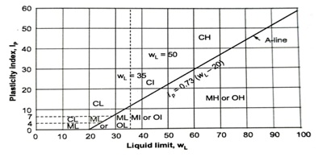

UNIT – 02
PERMEABILITY
&
SEEPAGE THROUGH SOILS

Permeability of Soils
The material is porous if it contains interstices. The porous material is permeable, if the interstices are interconnected.
Water can flow through the permeable material.
All soils are permeable.
The property of soil which permits the flow of water through it is known as permeability.
Based on permeability soils are classified as
1). Pervious soils and 2). Impervious soils
The soil is pervious when water can flow through it easily. Pervious soils have high value of permeability.
The soil is impervious when water cannot flow through it easily. Impervious soils have low value of permeability.
Permeability is an important engineering property of soils.
The knowledge of permeability is essential in number of soil engineering problems such as settlement of buildings, yield of wells, seepage through and below the earth structures.
The permeability of soils is also required in the design of filters used to prevent the piping in hydraulic structures.

Darcy’s Law
The flow of water through soil is governed by Darcy’s law.
According to Darcy’s law
For laminar free water flow in a homogeneous soil, the velocity of flow (V) is directly proportional to the hydraulic gradient (i).
$∴V ∝ i ⇰ V=K i$ ---------------- (1)
Here K = The coefficient of permeability of soil
The velocity of flow (V) is also known as the discharge velocity (or) the superficial velocity.
Now if ‘A’ is the cross-sectional area of the soil normal to the direction of flow, then
The discharge of flow through the soil = q = VA = K i A ----------- (2)
The area ‘A’ includes both the soil solids and also the voids.
Now from equation (1)
If the hydraulic gradient ‘i’ is unity then
V = 1 x K = K
Thus the coefficient of permeability ‘K’ is defined as
“The velocity of flow which would occurs through the soil under unit hydraulic gradient”.
The coefficient of permeability (K) has the dimensions of velocity $M^{O}L^{1}T^{-1}$
The SI unit of coefficient of permeability is ms⁻¹
According to USBR, the soil having the coefficient of permeability greater than 10⁻³ mm/s are classified as pervious. The soils having the coefficient of permeability less than 10⁻⁵ mm/s are impervious. The soils having coefficient of permeability in between 10⁻³ to 10⁻⁵ mm/s are designated as semi-pervious.

Determination of Coefficient of Permeability
The coefficient of permeability of a soil can be determined by using the following methods
1). Laboratory Methods
In the laboratory the coefficient of permeability soil can be determined by using the following methods
a). Constant head permeability test and b). Variable head permeability test
The instruments used in laboratories are known as the permeameters.
The constant head permeability test is suitable for relatively more pervious soils and the falling head permeability test is suitable for less pervious soils.
2). Field Methods
The coefficient of permeability of the insitu soil deposit can be determined by using the following methods
a). Pumping out test and b). Pumping in test
The pumping out test influence the large area around the pumping well and gives an overall value of the coefficient of permeability of the soil deposit.
The pumping in test influence small area around the pumping well and gives the value of coefficient of permeability of the soil surrounding the pumping well.
3). Indirect Methods
The coefficient of permeability of the soil can also be determined indirectly by using
a). The effective size of soil particle (D₁₀) or its specific surface
b). The coefficient of volume change (C_{V}) from the consolidation test.
4). Capillarity – Permeability Test
The coefficient of permeability of an unsaturated soil can be determined by using Capillarity-Permeability test.

Constant Head Permeability Test
The constant head permeability test is used for determining the coefficient of permeability of relatively more pervious soil.
The apparatus used in this test is known as the constant head permeameter and it is as shown in the figure.
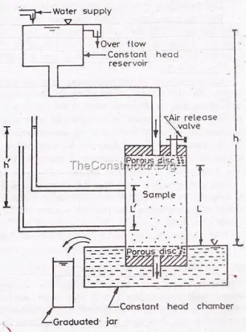
The constant head permeameter consists of a metallic mould with an internal diameter of 100 mm and an internal effective height of 127.3 mm.
The mould is provided with a removable extension collar 100 mm internal diameter and 60 mm height, which is required during the compaction of the soil.
At the bottom the mould is fitted with a detachable base plate called drainage base which is having a provision for inserting 12 mm thick porous disc and a water outlet valve.
The drainage base is also provided with a dummy plate of 12 mm thick which is to be used in the place of porous disc when the soil sample is compacted in the mould.
At the top the mould is fitted with a detachable drainage cap with an inserted porous disc 12 mm thick and having an inlet water valve and also an air release valve.
The porous disc should have permeability more than 10 times the expected permeability of soil sample.
The mould assembly is connected through the top inlet valve to a constant head over head tank and it is placed in a constant level bottom tank as shown in figure.
Preparation of Test Soil sample
About 2.5 Kg of an air dried soil sample is to be taken. The soil is mixed uniformly with the required quantity of water so that its water content is equal to the optimum moisture content of the soil determined by Proctors test.
The mould is clamped between the compaction base plate and the extension collar. The inside of mould is lightly greased. Arrange the dummy plate over the base plate.
The soil sample is filled into the mould assembly and compacted to achieve the maximum dry density.
After compacting the collar is removed and the excess soil is trimmed level upto the top of mould. Also detach the base plate and remove the dummy plate.
The mould with compacted soil is assembled to the drainage base and drainage cap having the porous discs as shown in the figure.
The porous discs should be completely saturated in order to deair them before assembling to the mould.
Test Procedure
In constant head permeability test, it is essential that the soil sample in the mould should be fully saturated.
This is done by attaching the constant level over head tank to the outlet valve of drainage base and allowing water to flow upwards from the base to the top of the soil sample in the mould. The upward flow is maintained sufficient time till all the air has been expelled out from the soil sample.
After the soil sample has been fully saturated, the constant level overhead tank is connected to the inlet valve of the drainage cap.
The water in the constant level overhead tank flows through the soil sample in the mould from top to bottom and reaches the drainage base. From the outlet valve of drainage base the water flow into the constant level bottom tank.
At the start of the experiment the constant level bottom tank is filled with water upto the level of its overflow tube.
The water enters into the constant level bottom tank (after flowing through the soil sample) flows out through the over flow tube.
When study state is established, the water flows out through the over flow tube is collected in a graduated jar for a convenient time (t).
Now, the discharge of water flowing through the soil sample (Q) is equal to the volume of water collected divided by the time (t).
The head (h) causing the flow of water through the soil sample is equal to the difference in water levels between the constant level over head tank and the constant level bottom tank.
If ‘A’ is the cross-sectional area of soil sample
Then for Darcy’s law
The discharge of water flow through the soil sample = Q = K i A
$$∴Q=K i A=K \frac{h}{L} A$$
$$∴K= \frac{Q L}{h A}$$
Here
L = The length of soil sample and
K = The coefficient of permeability of soil sample

Factors Affecting the Permeability of Soils
The generalised Hazen-Poisseuille equation for the velocity of laminar flow of water through the soils is given by
$V=C \left[\frac{γ_{W}}{μ}\right] \left[\frac{e^{3}}{1+e}\right] D^{2}i=K i$
Here
K = The coefficient of permeability of soil = $C \left[\frac{γ_{W}}{μ}\right] \left[\frac{e^{3}}{1+e}\right] D^{2}$
Here
D = The size of soil particle and
e = The void ratio of soil
The following factors will affect the permeability of soils
1). Particle size
It is clear from the above equation that the coefficient of permeability of a soil is directly proportional to the square of the particle size (D).
The coefficient of permeability of coarse grained soil is very large as compared to that of fine grained soils. The permeability of coarse sand may be more than one million times as much that of clay.
Allen Hazen based on his experiments on filter sands of particle size between 0.1 and 3 mm found that
The coefficient of permeability = K = C $D_{10}^{2}$
Here K = The coefficient of permeability of soil in cm/s
D₁₀ = The effective size in cm and
C = A constant $≅$ 100
2). Structure of soil mass
In soil mass, the size of the flow passage depends upon the structural arrangement of soil particles.
For the same void ratio, the permeability is more in the case of flocculated structure as compared to that in dispersed structure.
The stratified soil deposits have greater permeability parallel to the plane of stratification than that perpendicular to the plane of stratification.
3). Shape of soil particle
The permeability of a soil depends on the shape of soil particles.
The permeability is inversely proportional to the specific surface area of soil particles.
The angular soil particles have greater specific surface area as compared with the rounded soil particles.
Hence, for the same void ratio the soils with angular particles are less permeable than those with rounded particles.
4). Void ratio
The Hazen-Poisseuille equation indicates that the coefficient of permeability (K) is directly proportional to $\frac{e^{3}}{1+e}$
Thus for a given soil, the greater the void ratio the higher will be the value of coefficient of permeability.
If the permeability of a soil at a void ratio of 0.85 is known, than its value at another void ratio ‘e’ can be determined by using the following equation given by Casagrande.
K = 1.4 K_{0.85} e²
Here
K_{0.85} = The coefficient of permeability of soil at void ratio 0.85
K = The coefficient of permeability of soil at void ratio ‘e’
5). Properties of water
It is clear from Hagen-Poisseuille equation that the coefficient of permeability (K) is directly proportional to the unit weight of water ($γ_{W}$) and is inversely proportional to the dynamic viscosity ($μ$) of water.
The unit weight of water ($γ_{W}$) does not vary much with the change in temperature of water.
However the dynamic viscosity ($μ$) of water decreases with an increase in temperature of water.
Hence the coefficient of permeability (K) of soil increases with an increase in temperature.

6). Degree of saturation of soil
If the soil is not fully saturated it contains entrapped air or air pockets in the voids.
The presence of air pockets in voids of soil opposes the flow of water through the soil.
Hence the permeability of a partially saturated soil is considerably smaller than that of a fully saturated soil.
The Darcy’s law is not strictly applicable to partially saturated soils.
The coefficient of permeability of partially saturated soil is determined in the laboratory by using capillarity-permeability test.
7). Adsorbed water
The fine grained soil particles have a layer of adsorbed water strongly attached to their surface.
This adsorbed water layer is not free to move under gravity. It causes an obstruction to the flow of water in the pores and hence reduces the permeability of soils.
It is estimated that the void ratio occupied by the adsorbed water is 0.1. Hence the effective void ratio available for the flow of water in fine grained soils is about (e – 0.1)
8). Impurities in water
The impurities in water plug the flow passage in soils and reduce the effective voids. Hence the permeability of reduces.

Coefficient of Permeability of Stratified Soil Deposits
A stratified soil deposit consists of number of soil layers having different coefficient of permeabilities.
The average coefficient of permeability of the stratified soil deposit having the water flow parallel to the planes of stratification and also perpendicular to the planes of stratification can be determined as below
1). Water flow parallel to the planes of stratification
Consider the stratified soil deposit having the water flow parallel to the planes of stratification as shown in figure.
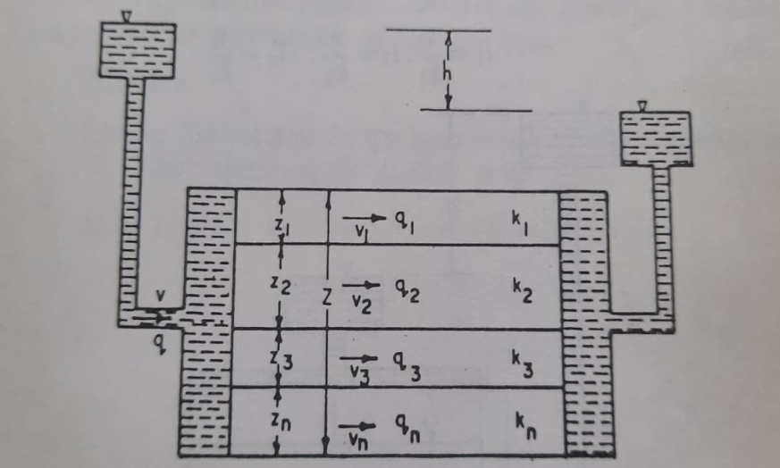
Let
Z₁ = The thickness of soil layer (1)
K₁ = The coefficient of permeability of soil layer (1)
Z₂, K₂ = The corresponding values of soil layer (2) and
Z₃, K₃ = The corresponding values of soil layer (3)
For water flow parallel to the planes of stratification the hydraulic gradient ‘i’ is same for all the soil layers.
However since the coefficient of permeability (K) is different for each layer, the velocity of water flow (V) is different in each soil layer.
Let
V₁ = The velocity of water flow through soil layer (1) = K₁ i
V₂ = The velocity of water flow through soil layer (2) = K₂ i and
V₃ = The velocity of water flow through soil layer (3) = K₃ i
Consider the unit width of soil deposit
Now
The cross-sectional area of soil layer (1) = A₁ = B₁ Z₁ = 1 x Z₁ = Z₁
The discharge of water flow through soil layer (1) = Q₁ = V₁ x A₁ = K₁ i Z₁
Similarly
The discharge of water flow through soil layer (2) = Q₂ = V₂ x A₂ = V₂ x B₂ x Z₂
= K₂ i x 1x Z₂ = K₂ i Z₂ and

The discharge of water flow through soil layer (3) = Q₃ = V₃ x A₃ = V₃ x B₃ x Z₃
= K₃ i x 1x Z₃ = K₃ i Z₃
Now
The total discharge of water flow through the soil deposit = Q = Q₁ + Q₂ + Q₃
$∴$ Q = K₁ i Z₁ + K₂ i Z₂ + K₃ i Z₃ = i ( K₁Z₁ + K₂Z₂ + K₃Z₃ ) -------------- (1)
Let K_{P} is the average coefficient of permeability of the entire layered soil deposit
The total thickness of soil deposit = Z = Z₁ + Z₂ + Z₃
The hydraulic gradient of soil deposit = i
Now
The velocity of water flow though he soil deposit = V = K_{P} i
The cross- sectional area of soil deposit = A = B x Z = 1 x (Z₁ + Z₂ + Z₃) = (Z₁ + Z₂ + Z₃)
$∴$ The total discharge of water flow through the soil deposit = Q = V x A
= K_{P} i (Z₁ + Z₂ + Z₃) ------ (2)
From the equations (1) and (2) we get
K_{P} i (Z₁ + Z₂ + Z₃) = i ( K₁Z₁ + K₂Z₂ + K₃Z₃ )
$$∴ K_{P}= \frac{K_{1}Z_{1}+K_{2}Z_{2}+K_{3}Z_{3}}{Z_{1}+Z_{2}+Z_{3}}$$

2). Water flow perpendicular to the planes of stratification
Consider the stratified soil deposit having the water flow perpendicular to the planes of stratification as shown in figure.
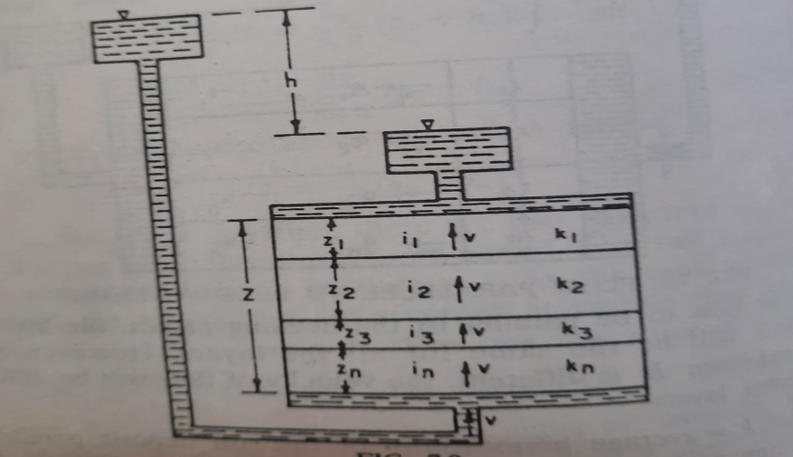
Let
Z₁ = The thickness of soil layer (1)
K₁ = The coefficient of permeability of soil layer (1)
Z₂, K₂ = The corresponding values of soil layer (2) and
Z₃, K₃ = The corresponding values of soil layer (3)
For water flow perpendicular to the planes of stratification, the velocity of water flow (V) and the discharge of water flow (Q) is same for each layer.
However the coefficient of permeability and the thickness is different for each soil layer.
Hence the hydraulic gradient ‘i’ and the loss of head (h) are different for each soil layer.
Let h₁, h₂ and h₃ are the loss of heads in soil layers (1), (2) and (3) respectively
Now
The head lost = h = h₁ + h₂ + h₃
Let i₁, i₂ and i₃ are the hydraulic gradients developed in soil layers (1), (2) and (3) respectively
Here
$i_{1}= \frac{h_{1}}{Z_{1}}$ , $i_{2}= \frac{h_{2}}{Z_{2}}$ and $i_{3}= \frac{h_{3}}{Z_{3}}$
The velocity of water flow (V) through the soil layers is given by
V = K₁ i₁ = K₂ i₂ = K₃ i₃
$$∴V= K_{1}i_{1}= K_{1} \frac{h_{1}}{Z_{1}} ⇰ h_{1}= \frac{V Z_{1}}{K_{1}}$$
Similarly

$$h_{2}= \frac{V Z_{2}}{K_{2}} and h_{3}= \frac{V Z_{3}}{K_{3}}$$
Now
The total loss of head = h = h₁ + h₂ + h₃
$∴$ $h= \frac{V Z_{1}}{K_{1}}+ \frac{V Z_{2}}{K_{2}} +\frac{V Z_{3}}{K_{3}}$
$∴h=V \left[\frac{Z_{1}}{K_{1}}+ \frac{Z_{2}}{K_{2}}+ \frac{Z_{3}}{K_{3}}\right]$ --------- (1)
Let ‘K_{V}’ is the average coefficient of permeability of the entire soil deposit
The total thickness of soil deposit = Z = Z₁ + Z₂ + Z₃
The loss of head = h
$∴$ The hydraulic gradient = $i= \frac{h}{Z}= \frac{h}{Z_{1}+ Z_{2}+ Z_{3}}$
Now
The velocity of water flowing through the soil deposit = $V= K_{V}i= K_{V} \left[\frac{h}{Z_{1}+ Z_{2}+ Z_{3}}\right]$
$∴h=V \left[\frac{Z_{1}+ Z_{2}+ Z_{3}}{K_{V}}\right]$ ------------- (2)
From equations (1) and (2) we get
$$V \left[\frac{Z_{1}+ Z_{2}+ Z_{3}}{K_{V}}\right]= V \left[\frac{Z_{1}}{K_{1}}+ \frac{Z_{2}}{K_{2}}+ \frac{Z_{3}}{K_{3}}\right]$$
$$∴ K_{V}= \frac{Z_{1}+ Z_{2}+ Z_{3}}{\frac{Z_{1}}{K_{1}}+ \frac{Z_{2}}{K_{2}}+ \frac{Z_{3}}{K_{3}}}$$

EFFECTIVE STRESS AND NEUTRAL STRESS

Geostatic Stresses
The stresses within a soil mass are caused by the external loads applied on to the soil and also by the self weight of the soil.
The pattern of stresses in the soil mass caused by external loads is usually very complicated.
Similarly the pattern of stresses in the soil mass caused by the self weight of soil can also be complicated.
But when the ground surface is horizontal and the nature of the soil does not vary significantly in the horizontal direction then the self – weight of the soil gives rise to a very simple pattern of the stresses in the soil mass.
This situation exists frequently in the case of sedimentary soil deposits.
The intensity of stresses in the soil mass caused by the self weight of soil when the ground surface is horizontal and the nature of the soil does not vary significantly in the horizontal direction are referred to as “Geostatic stresses”
If the unit weight of soil $\left(γ\right)$ is constant with depth
Then the vertical geostatic stress $\left(σ_{V}\right)$ at depth (Z) from the ground surface is given by
$σ_{V}= γ Z$ ---------- (1)
From the above equation it is clear that the vertical geostatic stress $\left(σ_{V}\right)$ varies linearly with depth as shown in figure.
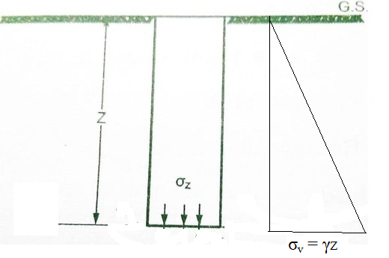
However, it is known that the unit weight of soil $\left(γ\right)$ is seldom constant with depth.
Usually the soil becomes denser with depth due to the compression caused by the geostatic stresses.
If the unit weight of soil $\left(γ\right)$ varies continuously with depth, then the vertical geostatic stress $\left(σ_{V}\right)$ is given by
$σ_{V}= \int_{0}^{Z}{γ dz}$------------- (2)
If the soil is a stratified deposit with different unit weights for each stratum then the vertical geostatic stress $\left(σ_{V}\right)$ is given by
$$σ_{V}= \sum{γ ∆Z= γ_{1}∆Z_{1}+ γ_{2}∆Z_{2}+ γ_{3}∆Z_{3}+ ----}$$

Effective Stress and Neutral Stress
The total stress ($σ$) either due to self weight of the soil (or) due to external applied forces or due to both, is transferred to the soil grains through their points of contact and also to the water present in the void space or pore space of soil mass.
Thus
The total stress (𝛔) = The stress transferred to the soil + The stress transferred to grains through their points of water present in the pore contact space
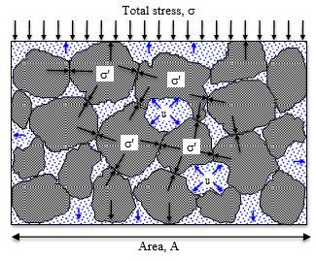
1). Effective Stress $\left(\overline{σ}\right)$
Karl Terzaghi was the first to recognize the importance of effective stress
The effective stress is the stress transmitted from particle to particle through their points of contact through the soil mass.
This stress is effective in decreasing the voids ratio of the soil mass and in mobilising its shear strength.
The effective stress is also termed as “Intergranular stress” or “Effective pressure”
Note
At every point of contact, the effective stress can be resolved into the normal component and the tangential component. As the effective stress is random in direction throughout the soil mass, the tangential components neutralise one another and the resultant of all normal components is downwards.
Thus the effective stress is the normal stress transmitted through the soil particles.
2). Neutral Stress (u)
The neutral stress is the stress transmitted through the pore water. The neutral stress is also termed as the pore water pressure (or) the pore pressure.
In soil mass, the neutral stress acts equally in all sides of soil particles and does not cause them to press against one another. Hence the neutral stress is not effective in decreasing the voids ratio or in increasing the shear strength of the soil mass.
At any point in a soil mass, the neutral stress is equal to the hydrostatic pressure.
The hydrostatic pressure is equal to the piezometric head (h_{W}) times the unit weight of water $\left(γ_{W}\right)$.
The piezometric head (h_{W}) represents the elevation above the point under consideration upto which the free water will rise in a piezometer starting from the said point and open to atmosphere.
$∴$ The neutral stress = u = The hydrostatic pressure = $γ_{w}h_{W}$
$∴$ u = $γ_{w}h_{W}$
Thus, the total vertical stress ($σ$) at any plane in a soil mass is equal to the sum of the vertical effective stress $\left(\overline{σ}\right)$and the neutral stress (u).
Hence the fundamental equation of stress is given by
$$σ= \overline{σ}+ u$$
$$∴ \overline{σ} =σ - u$$
Here
$σ$ = The total vertical stress
= The stress due to external loads + The stress due to self weight of soil
$\overline{σ}$ = The vertical effective stress and
$u$ = The neutral stress
The effective stress principle enunciated by Karl Terzaghi in 1936 forms an extremely useful basis of the most important theories in soil engineering.
The effective stress ($\overline{σ}$) cannot be measured in the field by any instrument. It can be calculated after measuring the total stress ($σ$) and the pore pressure (u).
Thus the effective stress is not a physical parameter, but it is very useful mathematical concept for the determination of engineering behaviour of soil.
Effective Stresses in a Soil Mass under Hydrostatic Conditions
Consider a soil mass under the hydrostatic conditions as shown in figure. As the interstices in the soil mass are interconnected water level rises to the same elevation in different piezometers fixed to the soil mass.
In this hydrostatic condition, the effective stress at various sections in the soil mass can be determined by using the equation
The effective stress ( $\overline{σ)} =Total stree \left(σ \right)– The pore water pressure (u)$
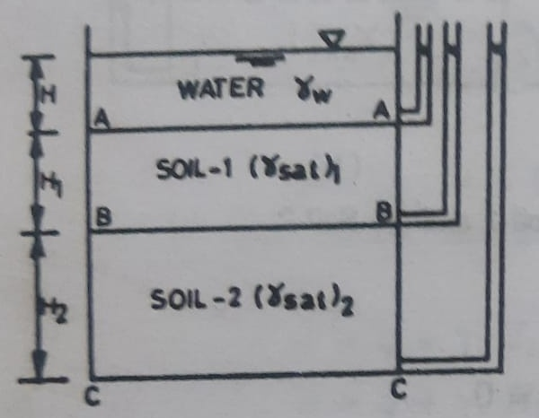
1). Water table above the soil surface A - A
Let H = the height of water table above the soil surface as shown in figure
Now
a). At section A – A
a). The total stress ($σ$) at section A – A is given by
$$σ= γ_{W} H$$
b). The pore water pressure (u) at section A – A is given by
$$u= γ_{W} H$$
c). The effective stress ($\overline{σ}$) at section A – A is given by
$\overline{σ} =σ – u$ = $=γ_{W} H-γ_{W} H=0$ ---------- (1)

b). At section B – B
a). The total stress ($σ$) at section B – B is given by
$$σ= γ_{W} H+ {\left(γ_{Sat}\right) }_{1} H_{1}$$
b). The pore water pressure (u) at section B – B is given by
$$u= γ_{W} \left(H+ H_{1}\right)$$
c). The effective stress ($\overline{σ}$) at section B – B is given by
$\overline{σ} =σ – u$ = $γ_{W} H+ {\left(γ_{Sat}\right) }_{1} H_{1}- γ_{W} \left(H+ H_{1}\right)= H_{1} \left({\left(γ_{Sat}\right) }_{1}- γ_{W}\right)$
$∴ \overline{σ}= {γ^{|}}_{1} H_{1}$ ------------- (2)
b). At section C – C
a). The total stress ($σ$) at section C – C is given by
$$σ= γ_{W} H+ {\left(γ_{Sat}\right) }_{1} H_{1}+ {\left(γ_{Sat}\right) }_{2} H_{2}$$
b). The pore water pressure (u) at section C – C is given by
$$u= γ_{W} \left(H+ H_{1}+ H_{2}\right)$$
c). The effective stress ($\overline{σ}$) at section C – C is given by
$\overline{σ} =σ – u$ = $γ_{W} H+ {\left(γ_{Sat}\right) }_{1} H_{1}+ {\left(γ_{Sat}\right) }_{2} H_{2}- γ_{W} \left(H+ H_{1}+ H_{2}\right)$
= $H_{1} \left({\left(γ_{Sat}\right) }_{1}- γ_{W}\right)+ H_{2} \left({\left(γ_{Sat}\right) }_{2}- γ_{W}\right)$
$∴ \overline{σ}= {γ^{|}}_{1} H_{1}+ {γ^{|}}_{2} H_{2}$ ------------ (3)
Here ${γ^{|}}_{1}$ = Submerged unit weight of soil 1 and
${γ^{|}}_{2}$ = Submerged unit weight of soil 2

Increase in Effective Stresses due to Surcharge
Let us consider the case when the soil surface is subjected to a surcharge load of intensity ‘q’ per unit area. Let us assume that the water table is at level B – B as shown in the figure
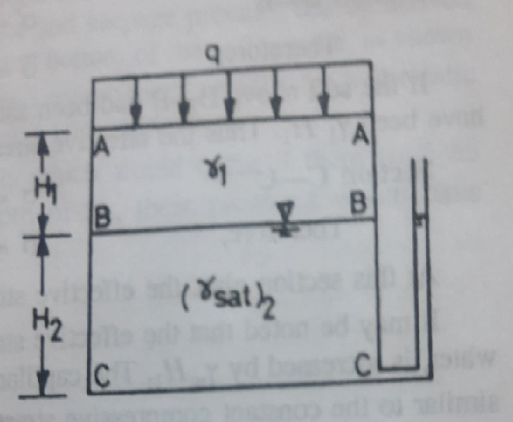
The stresses at various sections are determined as under
a). At section A –A
a). The total stress ($σ$) at section A – A is given by
$$σ=q$$
b). The pore water pressure (u) at section A – A is given by
$$u= 0$$
c). The effective stress ($\overline{σ}$) at section A – A is given by
$\overline{σ} =σ – u=q-0=q$
Thus all the points on the soil surface are subjected to an effective stress equal to ‘q’
b). At section B – B
a). The total stress ($σ$) at section B – B is given by
$σ= q+γ_{1}H_{1}$
b). The pore water pressure (u) at section B – B is given by
$$u= 0$$
c). The effective stress ($\overline{σ}$) at section B – B is given by
$\overline{σ} =σ – u$ = q + $γ_{1}H_{1}-0= {q+γ}_{1}H_{1}$
Effective Stress in Soils Saturated by Capillary Action
If the soil above the water table is saturated by capillary action, the effective stress can be determined by using the equation
$$The effective stress\left(\overline{ σ}\right)=The total stress \left(σ\right)– The pore water pressue (u)$$
However in this case the pore water pressure (u) above the water table due to capillarity is taken as negative.
Let the water table is at level B – B as shown in the figure
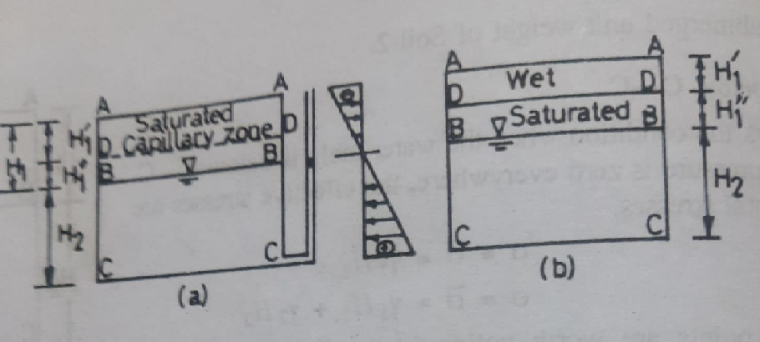
Let us consider the following two cases
1). Soil saturated upto surface level A – A due to capillarity and
2). Soil saturated upto level D – D due to capillarity.
1). Soil saturated upto level A – A due to capillarity
The stresses at various sections are determined as under
a). At section A –A
a). The total stress ($σ$) at section A – A is given by
$$σ=0$$
b). The pore water pressure (u) at section A – A is given by
$$u= - γ_{W}H_{1}$$
c). The effective stress ($\overline{σ}$) at section A – A is given by
$\overline{σ} =σ – u=0 - \left(- γ_{W}H_{1}\right)= γ_{W}H_{1}$
If the soil was not saturated with capillary action, the effective stress at section A – A would have been zero. Thus the capillary action has increased the effective stress by $γ_{W}H_{1}$. In other words, the negative pressure acts like a surcharge (q).
b). At section D – D
Consider the section D – D at a depth of ‘$H_{1}^{|}$’
a). The total stress ($σ$) at section D – D is given by
$σ= {\left(γ_{sat}\right)}_{1}H_{1}^{|}$
Here $H_{1}^{|}+ H_{1}^{||}= H_{1}$
b). The pore water pressure (u) at section D – D is given by
$$u= - γ_{W}H_{1}^{||}= - γ_{W} \left(H_{1}- H_{1}^{|}\right)$$
c). The effective stress ($\overline{σ}$) at section D – D is given by
$$\overline{σ} =σ – u= {\left(γ_{sat}\right)}_{1}H_{1}^{|}- \left(- γ_{W} \left(H_{1}- H_{1}^{|}\right)\right)$$
$= H_{1}^{|} \left({\left(γ_{sat}\right)}_{1}- γ_{W}\right)+ γ_{W}H_{1}$
$$∴\overline{σ}= γ_{1}^{|} H_{1}^{|}+ γ_{W}H_{1}$$
If the soil had been saturated due to rise in water table upto level A – A , then the effective stress at section D – D would have been $γ_{1}^{|} H_{1}^{|}$.
Thus the effective stress at section D – D is increased by $γ_{W}H_{1}$ due to capillary action.
c). At section B – B
a). The total stress ($σ$) at section B – B is given by
$σ= {\left(γ_{sat}\right)}_{1}H_{1}$
b). The pore water pressure (u) at section B – B is given by
$$u= 0$$
c). The effective stress ($\overline{σ}$) at section B – B is given by
$\overline{σ} =σ – u$ = ${\left(γ_{sat}\right)}_{1}H_{1}-0= {\left(γ_{sat}\right)}_{1}H_{1}$
$$∴\overline{σ}= {{\left(γ_{sat}\right)}_{1}H_{1}=γ}_{1}^{|}H_{1} + γ_{W}H_{1}$$
If the soil above the section B –B had been saturated due to rise in water table upto the level A – A then the effective stress at section B – B is $γ_{1}^{|}H_{1}$. Thus the effective stress at section B - B is increased by $γ_{W}H_{1}$ due to capillary action.
c). At section C – C
a). The total stress ($σ$) at section C – C is given by
$σ= {\left(γ_{Sat}\right) }_{1} H_{1}+{\left(γ_{Sat}\right) }_{2} H_{2}$
b). The pore water pressure (u) at section C – C is given by
$$u= γ_{w}H_{2}$$
c). The effective stress ($\overline{σ}$) at section C – C is given by
$\overline{σ} =σ – u$ = ${\left(γ_{Sat}\right) }_{1} H_{1}+{\left(γ_{Sat}\right) }_{2} H_{2}- γ_{w}H_{2}$
$∴\overline{σ}= {\left(γ_{Sat}\right) }_{1} H_{1}+γ_{2}^{|} H_{2}= γ_{1}^{|}H_{1} + γ_{2}^{|} H_{2}+γ_{W}H_{1}$
If the soil above the section C –C had been saturated due to rise in water table upto the level A – A then the effective stress at section C – C is${ γ}_{1}^{|}H_{1} + γ_{2}^{|} H_{2}$. Thus the effective stress at section C – C is increased by $γ_{W}H_{1}$ due to capillary action.
It may be noted that the effective stress at all levels below the plane of saturation A – A, due to capillary water is increased by $γ_{W}H_{1}$. The capillary water pressure $γ_{W}H_{1}$acts as a surcharge.
2). Soil saturated upto level D – D due to capillarity
Let us consider the case when the soil above the water table B – B is saturated only upto level D – D upto a height${ H}_{1}^{||}$.
The soil above the level D – D is wet and has a unit weight of ‘$γ_{1}$’
The stresses at various sections are determined as under
a). At section A –A
a). The total stress ($σ$) at section A – A is given by
$$σ=0$$
b). The pore water pressure (u) at section A – A is given by
$$u= 0$$
c). The effective stress ($\overline{σ}$) at section A – A is given by
$\overline{σ} =σ – u=0 – 0= 0$
There is no effect of capillary water on the stresses at section A – A.
b). At section D – D
Consider the section D – D at a depth of ‘$H_{1}^{|}$’
a). The total stress ($σ$) at section D – D is given by
$σ= γ_{1}H_{1}^{|}$ Here $H_{1}^{|}+ H_{1}^{||}= H_{1}$
b). The pore water pressure (u) at section D – D is given by
$$u= - γ_{W}H_{1}^{||}$$
c). The effective stress ($\overline{σ}$) at section A – A is given by
$$\overline{σ} =σ – u= γ_{1}H_{1}^{|}- \left(- γ_{W}H_{1}^{||} \right)$$
$= γ_{1}H_{1}^{|}+ γ_{W}H_{1}^{||}$
$$∴\overline{σ}= γ_{1}H_{1}^{|}+ γ_{W}H_{1}^{||}$$
Thus the effective stress at section D – D is increased by $γ_{W}H_{1}^{||}$ due to capillary action.
c). At section B – B
a). The total stress ($σ$) at section B – B is given by
$σ= {γ_{1}H_{1}^{|}+\left(γ_{sat}\right)}_{1}H_{1}^{||}$
b). The pore water pressure (u) at section B – B is given by
$$u= 0$$
c). The effective stress ($\overline{σ}$) at section B – B is given by
$\overline{σ} =σ – u$ = ${γ_{1}H_{1}^{|}+\left(γ_{sat}\right)}_{1}H_{1}^{||}-0= {γ_{1}H_{1}^{|}+\left(γ_{sat}\right)}_{1}H_{1}^{||}$
$$∴\overline{σ}={γ_{1}H_{1}^{|}+\left(γ_{sat}\right)}_{1}H_{1}^{||}= γ_{1}H_{1}^{|} + γ_{1}^{|}H_{1}^{||}+γ_{w}H_{1}^{||}$$
Thus the effective stress at section B - B is increased by $γ_{w}H_{1}^{||}$ due to capillary action.
c). At section C – C
a). The total stress ($σ$) at section C – C is given by
$σ= {γ_{1}H_{1}^{|}+\left(γ_{sat}\right)}_{1}H_{1}^{||} +{\left(γ_{Sat}\right) }_{2} H_{2}$
b). The pore water pressure (u) at section C – C is given by
$$u= γ_{w}H_{2}$$
c). The effective stress ($\overline{σ}$) at section C – C is given by
$\overline{σ} =σ – u$ = ${γ_{1}H_{1}^{|}+\left(γ_{sat}\right)}_{1}H_{1}^{||}+{\left(γ_{Sat}\right) }_{2} H_{2}- γ_{w}H_{2}$
$∴\overline{σ}= γ_{1}H_{1}^{|} + γ_{1}^{|}H_{1}^{||}+γ_{w}H_{1}^{||}+γ_{2}^{|} H_{2}= γ_{1}H_{1}^{|} + γ_{1}^{|}H_{1}^{||} + γ_{2}^{|} H_{2}+ γ_{w}H_{1}^{||}$
Thus the effective stress at section C – C is increased by $γ_{w}H_{1}^{||}$ due to capillary action.
The following points may be noted from the study of both cases
1). The capillary water above the water table causes a negative pressure $γ_{w}H$, where ‘H’ is the capillary rise. This negative pressure causes an increase in the effective stress at all levels below the saturation level. The increase in effective pressure is equal to $γ_{w}H$. The capillary action is equal to a surcharge$q =γ_{w}H$.
2). If the soil is saturated due to rise in water table, the effective stress depends upon the submerged unit weight; whereas for the soil saturated with capillary water the effective stress depends upon the saturated unit weight. In the later case, the water does not contribute to hydrostatic pressure.
3). If the water table rises to the top soil surface the air – water interface is destroyed and the capillary water changes to the free water and the effective stress is reduced throughout.
4). It should always be remembered that the pore water pressure (u) in the capillary zone is negative.

UNIT – 03
STRESS DISTRIBUTION IN SOILS

Introduction
Compaction of a soil may be defined as the process by which the soil particles are artificially rearranged and packed together into a state of close contact by mechanical methods such as rolling, tamping or vibration, in order to decrease its porosity and thus increase its mass density.
During compaction, air is expelled from the void space in the soil mass.
Compaction of a soil is done to improve its engineering properties.
Compaction generally increases the shear strength of soil and hence the stability and bearing capacity.
It is also useful in reducing the compressibility and permeability of the soil.
Compaction is entirely different process than consolidation.
Compaction differs from consolidation in the following respects
1). Consolidation is a gradual process of reduction of volume under sustained, static loading.
Whereas compaction is a rapid process of reduction of volume by mechanical means such as rolling, tamping and vibration.
2). Consolidation causes a reduction in volume of a saturated soil due to squeezing out of water from the soil.
Whereas in compaction the volume of a partially saturated soil decreases because of expulsion of air from the voids at the unaltered water content. Thus compaction involves the expulsion of only air from the voids of the soil mass
3). Consolidation is a process which occurs in nature when the saturated soil deposits are subjected to static loads caused by the weight of the buildings and other structures.
On the other hand compaction is a artificial process which is done to increase the density of the soil to improve its engineering properties before it is put to any use.
Compaction of soil is required for the construction of earth dams, canal embankments, highways, runways and in many other engineering applications.
For supporting highways (or) for retaining water in earth dams, the soil materials must possess certain properties.
These desirable properties can be achieved by proper placement and compaction of an appropriate soil material.
Most of these desirable properties of soils are associated with dry density of the soils and hence high dry density may be achieved by proper compaction of soils.
Compaction phenomenon and its effects
The compaction of a soil mass is accompanied by the expulsion of only air from the voids of the soil mass.
In practice, soils of medium cohesion are compacted by means of rolling while cohesionless soils are most effectively compacted by vibration.
The degree of compaction of a soil is characterised by its dry density.
The degree of compaction depends on the water content, the amount of compactive effort (or) energy applied and the nature of soil.
The change in water content (or) compactive effort brings about a change in dry density of the soil.
Thus for compaction of soil certain amount of water and certain amount of rolling are necessary.
The following are the main effects of compaction
1). Compaction increases the dry density of the soil, thus increasing its shear strength and bearing capacity.
2). Compaction decreases the tendency for settlement of soil and
3). Compaction brings about a low permeability of the soil.

Relationship between Water Content and Dry Density of Soil
The degree of compaction of a soil is characterised by its dry density.
Thus in order to assess the degree of compaction of a soil it is essential to determine its dry density.
The dry density of a soil depends on the water content and the amount of compaction energy applied on the soil.
In 1933, R.R. Proctor showed that for any soil there exists a definite relationship between the water content and the dry density to which the soil can be compacted and that for a specific amount of compaction energy applied on the soil there is a particular water content at which the soil attains its maximum dry density.
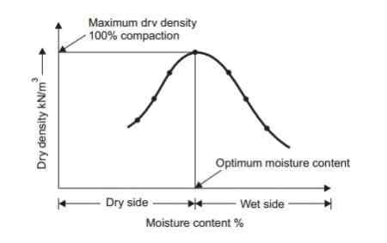
The figure shows the relation between water content and dry density of a soil at a particular compaction energy.
The addition of water to a dry soil helps in brining the soil particles together coating them with thin film of water.
At low water content the soil is stiffer and it is difficult to pack it together.
As the water content is increased, water starts acting as a lubricant, the soil particles start coming closer due to increased workability and under a given amount of compactive effort, the soil-water-air mixture starts occupying less volume, thus causing gradual increase in dry density.
As more and more water is added, a stage is reached where the air content in soil attains a minimum volume, thus making the dry density a maximum.
The water content corresponding to the maximum dry density (MDD) is called “Optimum water content (OWC) or Optimum moisture content (OMC)”.
Addition of water beyond the optimum moisture content reduces the dry density because the extra water starts occupying the space which the soil could have occupied.
The curve between water content and dry density of a soil as shown in figure is known as the “Water content – Dry density curve” or the “Compaction curve”.
The state at the peak of the curve is said to be 100% compaction at the particular compactive effort. The curve is usually of a hyperbolic form.
Effect of Compactive Effort on Dry Density of Soil
The increase in compactive effort (or) energy expended results in an increase in the maximum dry density of soil and decrease in the corresponding optimum moisture content as shown in figure.
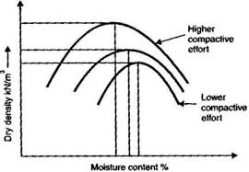
Thus for the purpose of standardization, especially in the laboratory, compaction tests are conducted at a certain specific amount of compactive effort expended in a standard manner.

Zero Air-Voids Line (or) Saturation Line
A line which shows relation between water content (w) and dry density ($ρ_{d }$) of compacted soil having a constant percentage of air-voids is known as air-voids line. The air-voids line may be represented by the equation as given below
$ρ_{d}= \frac{\left(1-n_{a}\right)G ρ_{w}}{1+wG}$ ---------- (1)
Where
$n_{a}$ = Percentage air voids
w = Water content of compacted soil
$ρ_{d}$ = Dry density of compacted soil corresponding to water content ‘w’
G = Specific gravity of soil solids and
$ρ_{w}$ = Density of water
The theoretical maximum compaction of a soil for any given water content corresponds to zero air-voids condition, $n_{a}$ = 0 (i.e., there are no air voids and hence at the given water content the degree of saturation (S_{r}) is equal to 100 %).
For a compacted soil having zero air voids, the line showing the relation between the dry density ($ρ_{d }$) of the soil and the water content (w) is known as the zero air-voids line (or) the 100% saturation line, which may be represented by the equation given below
$ρ_{d}= \frac{G ρ_{w}}{1+wG}$ ---- (2)
The lines for the other percentages of air – voids ($n_{a}$) equal to 10%, 20% etc., may be drawn by using the equation (1).
The air-voids lines are sometimes drawn along with the compaction curve on the same axes as shown in figure.
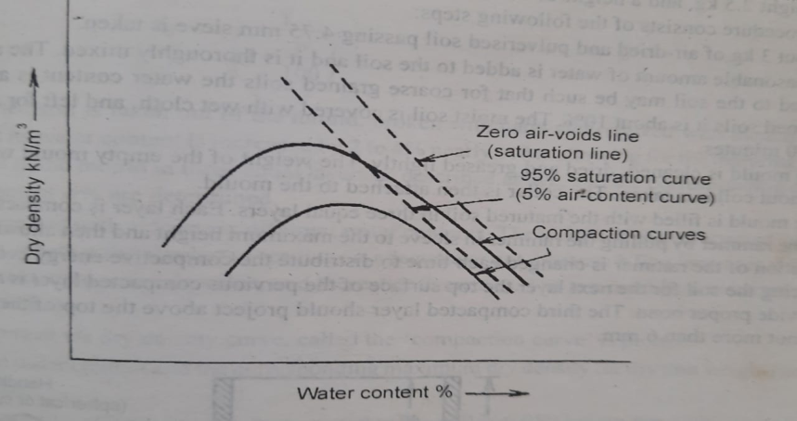
It may, however, be mentioned that it is not possible to remove all the air-voids by any compaction method. Hence the zero air-voids line or 100% saturation line is only a theoretical line which cannot be obtained by a compaction test. But it can be computed from equation (2). It represents the theoretical maximum dry density of a soil for any given water content corresponding to the zero air-voids or 100% saturation condition.
Note
1). We know that in terms of air voids ($n_{a}$ )
$ρ_{d}= \frac{\left(1-n_{a}\right)G ρ_{w}}{1+wG}$ --------- (1)
Theoretically, the dry density becomes maximum when $n_{a}$ = 0
$${∴ ρ}_{d max}= \frac{G ρ_{w}}{1+wG}$$
2). We know that in terms of degree of saturation (S_{r})
${ ρ}_{d}= \frac{G ρ_{w} }{1+\frac{w G}{S_{r}}}$ ------ (2)
Theoretically, the dry density becomes maximum when $S_{r}$ = 100%
$${∴ ρ}_{d max}= \frac{G ρ_{w}}{1+wG}$$
Thus , the zero-air void line and 100% saturation line are identical.
3). For 10% of air voids ($n_{a}$ = 10%), from equation (1) we get
$$ρ_{d}= \frac{0.9G ρ_{w}}{1+wG}$$
4). For 90% of degree of saturation (S_{r} = 0.9), from equation (2) we get
$${ ρ}_{d}= \frac{G ρ_{w} }{1+\frac{w G}{0.9}}$$
Thus, it may be noted that 10% air-void line and 90% saturation line are not identical.

Factors Affecting Compaction of Soils
The dry density of the soil is increased by compaction. The increase in the dry density depends upon the following factors
1). Water Content
At low water content, the soil is stiff and offers more resistance to compaction. As the water content is increased, the soil particles get lubricated. The soil mass becomes more workable and the soil particles have closer packing. The dry density of soil increases with an increase in the water content till the optimum moisture content is reached. At this stage, the air voids attain approximately a constant volume.
With further increase in water content, the air voids do not decrease, but the total voids (air + water) increase and the dry density decrease. Thus the higher dry density is achieved upto the optimum water content due to forcing the air out and to further reduce the air voids.
2). Amount of Compaction
The effect of increasing the amount of compactive effort is to increase the maximum dry density and to decrease the optimum moisture content. At water content less than the optimum, the effect of increased compaction is more predominant. At water content more than the optimum, the volume of air voids becomes almost constant and the effect of increased compaction is not significant.
It may be noted that the maximum dry density does not goes on increasing with an increase in the compactive effort. For a certain increase in the compactive effort, the increase in the dry density becomes smaller and smaller. Finally, a stage is reached beyond which there is no further increase in the dry density with an increase in the compactive effort.
3). Type of Soil
The dry density achieved depends upon the type of soil. The maximum dry density and the optimum moisture content for different types of soils are as shown in figure.
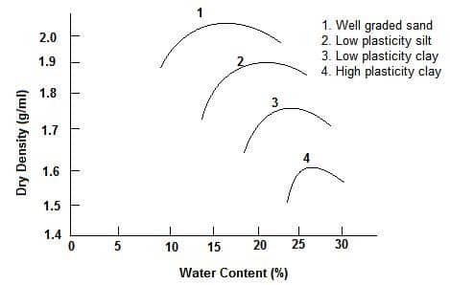
In general the coarse grained soils can be compacted to higher dry density than the fine grained soils. With the addition of even a small quantity of fines to a coarse grained soil, the soil attains a much higher dry density for the same compactive effort. However, if the quantity of fines is increased to a value more than the required to fill the voids of the coarse grained soil, the maximum dry density decreases. A well graded sand attains a much higher dry density than a poorly graded soil.
Cohesive soils have higher air voids. These soils attain a relatively lower maximum density as compared with cohesionless soils. Cohesive soils require more water than cohesionless soils and therefore the optimum moisture content is high.
Heavy clays of very high plasticity have very low dry density and a very high optimum water content.
4). Method of Compaction
The dry density achieved depends not only upon the amount of compaction effort but also on the method of compaction. For the same amount of compactive effort, the dry density will depends upon whether the method of compaction utilizes kneading action, dynamic action or static action.
For example in Harvard Miniature compaction test, the soil is compacted by the kneading action and therefore the compaction curve obtained is different from the other conventional tests in which equal compactive effort is applied.
5). Admixtures
The compaction characteristics of the soils are improved by adding other materials known as admixtures. The most commonly used admixtures are lime, cement and bitumen. The density achieved depends upon the type and amount of admixtures.

Effect of Compaction on Soil Properties
The various properties of soil are improved by compaction. The effect of compaction on soil structure and various soil properties is discussed below. In the following discussions the dry of optimum means the water content less than the optimum moisture content and the wet of optimum means the water content more than the optimum moisture content.
1). Soil Structure
The structure of a compacted soil is mainly depends on the water content at which the soil is compacted. Soils compacted at water content less than the optimum moisture content generally attains a flocculated structure regardless of the method of compaction. On the other hand, the soils compacted at water content more than the optimum moisture content usually have dispersed soil structure if the compaction induces large shear strains and flocculated structure if the induced shear strains are relatively small.
2). Permeability
The permeability goes on decreasing with increasing dry density of a compacted soil because the voids go on reducing. For the same dry density, fine grained soils compacted dry of optimum are more permeable than those compacted wet of optimum.
This is because the soil compacted dry of optimum tends to have more random orientation of particles (Flocculated Structure) resulting in large pore-sizes than the soils with more parallel orientation of soil particles (dispersed structure) obtained when compacted wet of optimum.
Further with the increase in the compactive effort, the permeability of the soil decreases due to increase in dry density and better orientation of soil particles.
3). Shrinkage and Swelling
For the same dry density the soils compacted dry of optimum and therefore having flocculated structure shrink much less than those compacted wet of optimum and therefore having dispersed structure. The soils compacted wet of optimum shrink more because the soil particles in the resulting dispersed structure have nearly parallel orientation and hence can pack more efficiently.
For the same dry density the soils compacted dry of optimum tends to swell more than the soils compacted wet of optimum. Because soils compacted dry of optimum have high water deficiency and more random orientation of soil particles, consequently they absorb more water and tend to swell more than the soils compacted wet of optimum at the same dry density.
4). Pore Water Pressure
Soils compacted dry of optimum have low water content and hence the pore water pressure developed for the soils compacted dry of optimum is less than for the same soils compacted wet of optimum.
5). Compressibility
In low pressure range, the soils compacted wet of optimum are more compressible than those compacted dry of optimum. This is so because soils compacted wet of optimum have already oriented soil particles (dispersed structure) which offers less resistance to compression, whereas soils compacted dry of optimum have randomly oriented soil particles (flocculated structure) which offer more resistance to compression.
However, in high pressure range, soils compacted dry of optimum are more compressible than those compacted wet of optimum. This is so because large pressure may cause greater reorientation of particles and hence a greater volume change per unit increase of pressure in soils compacted dry of optimum than in soils compacted wet of optimum which already has more parallel orientation of soil particles.
6). Stress-Strain Relationship
Soils compacted dry of optimum have steeper stress-stain curve than those compacted wet of optimum. The modulus of elasticity for the soils compacted dry of optimum is therefore high. Such soils have brittle failure like dense sands or over consolidated clays.
Soils compacted wet of optimum have a relatively flat stress-strain curve and a lower value of modulus of elasticity. The failure in this case occurs at a large strain and is of plastic type.

Methods of Compaction of Soils Used in Field
The soils can be compacted in the field by rolling, ramming (impact) and vibration. Corresponding to these the various equipments used for compaction of soils in the field can be grouped under three categories 1). Rollers 2). Rammers and 3). Vibrators
1). Rollers
The different types of rollers which are commonly used for the compaction of soils in the field are as below
i). Smooth-Wheel Rollers
These rollers either three-wheel type with two large smooth-faced steel wheels in the rear and one small smooth-faced steel drum in the front or tandem type having two large smooth-faced steel wheels drums, one in the front and one in the rear. The usual weights range from 20 kN to 150 kN. Heavier rollers upto about 200 kN are also in use. These rollers are self-propelled by diesel engines. The compaction is achieved by the static compression imparted by the rollers to the soil.
These rollers are best suited for compacting gravels, sands, crushed rock and any material requiring crushing action. Thus these rollers are extensively used for compacting subgrades, base courses and paving mixtures for highways and airfields. These rollers are however not effective for compacting earthfills or deep layers of soils, because the compaction pressures induced are relatively low due to large contact area.
ii). Sheep’s Foot Rollers
These rollers consist of a hollow steel drum provided with numerous projecting studs known as feet as shown in the figure. The weight of drums can be varied by filling partly or fully with water or sand and they are mounted either singly or in pairs on a steel frame which is towed by either pneumatic tyred tractors or track laying tractors. The self propelled units of these rollers are also available.
The feet are usually either club-shaped (100 mm x 75 mm) or tapered (57 mm x 57 mm) and according to the shape of the feet the rollers are classified as club-foot type or taper-foot type. The loaded weight per drum ranges from 25 kN to 130 kN. The number of feet on a 50kN roller ranges from 64 to 88. The contact pressure of feet ranges from 700 kN/m² to 4200 kN/m².
The sheep’s foot rollers compact the soil from bottom upwards. Initially, as the roller passes on the loose soil, the studs or feet sink into the loose soil and compact the soil near the lowest portion of the layer. In successive passes of the roller, the zone of compaction continues to rise upwards until the surface is reached, the penetration of the studs or feet decreases and the roller is said to ‘Walk-Out’.
These rollers are found suitable for compacting cohesive soils. They are not effective on coarse-grained cohesionless soils. The kneading action of the sheep’s foot roller results in a better bond between the compacted layers as compared to other types of rollers. However the tendency of void formation is more in soils compacted with sheep’s foot rollers.
iii). Pneumatic –Tyred Rollers
These rollers consist of a box or container mounted on two axles to which pneumatic tyred wheels are fixed. There are usually 9 t0 11 wheels on the two axles, the rear axle having one wheel more than the front axle. The wheels are mounted in a staggered fashion and so spaced that the entire width between the extreme wheels is covered during each pass. The weight supplied by the ballast or other material placed in the container may range from 120 kN to 450 kN, although smaller rollers of capacity 40 kN or exceptionally heavy rollers of capacity 2000 kN may also be used.
These rollers compact the soil primarily by kneading action. The contact pressure may be varied from 200kN/m² to 1000 kN/m².
The pneumatic tyred rollers are suitable for compacting most types of soils, and are quite effective for compacting wet cohesive soils.
2). Rammers
The rammers are of three types i). Dropping weight type ii). Pneumatic type and iii). Internal commission type.
The dropping weight type is the simplest rammer which has a block of iron or stone weighing 30 N to 40 N attached to a wooden handle. It is operated manually and is known as hand rammer.
The pneumatic type and the internal commission type are the mechanical rammers which weigh from 0.3 kN to 1.5 kN. The internal commission type jumping rammers are known as ‘frog rammers’ weight as much as 10 kN.
The rammers may be used for compaction of compacting cohesionless soils, specially in small restricted and confined areas such as bed of drainage trenches and back fills of bridge abutments.
3). Vibrators
The vibrators consist of a vibrating unit which may be either mounted on a plate or on a roller. The roller with a vibrating unit incorporated is known as vibratory roller. The vibratory roller may be either pneumatic-tyred or smooth wheel tandem type roller. Hand propelled light vibratory rollers are also available. A vibrating plate typically consists of a number of small plates each of which is operated by a separate vibrating unit.
The vibrators are highly effective for the compaction of cohesionless soils. Behind the retaining wall where the soil is confined, back fill, much deeper in thickness, may be effectively compacted by vibration type compactors.
Compaction Vs Consolidation
The phenomenon of compaction of soil is different from the phenomenon of consolidation of soil. The primary differences between the two phenomena are as given in the table below
S.No | Compaction of soil | Consolidation of soil
1 | Expulsion of pore air | Expulsion of pore water
2 | Soil involved is partially saturated | Soil involved is full saturated
3 | Applies to cohesive as well as cohesionless soils | Applies to cohesive soils only
4 | Brought about by human or artificial agency | Brought about by application of load or natural agencies
5 | Dynamic loading is commonly applied | Static loading is commonly applied
6 | Improves bearing capacity and settlement characteristics | Improves bearing capacity and settlement characteristics
7 | Relatively quick process | Relatively slow process
8 | Useful primarily in construction of earth dams and embankments | Useful as mean of improving the properties of foundation soil

UNIT – 04
CONSOLIDATION

Introduction
When a soil mass is subjected to a compressive force, the volume of soil mass decreases.
The property of soil due to which the decrease in volume of soil occurs under the action of compressive forces is known as the compressibility of soil.
The compression of soil occurs due to the following reasons
1). Compression of solid particles and water in the voids.
2). Compression and expulsion of air in the voids and
3). Expulsion of water in the voids.
Compression of solid particles is negligibly small. Compression of water in voids is also extremely small. Hence the compression due to first cause is not much significant.
Air exists only in dry soils and partially saturated soils. The compression of soil due to expulsion of air in the voids is known as the compaction of soil.
The compression of soil due to expulsion of air is not relevant in fully saturated soils.
When the soil is fully saturated, the compression of soil is mainly due to the expulsion of water from the voids of the soil.
The compression of a saturated soil under a study static pressure due to the expulsion of water from the voids of the soil is known as the “Consolidation of soil”.
The compression of soil due to expulsion of air from the voids due to dynamic methods such as rolling and tamping is known as “Compaction of soil” .
The compaction of soil is a quick process and the consolidation of soil is prolonged process.
The settlement of a structure is its vertically downward movement due to the decrease in volume of the soil on which it is built.
Initial, Primary and Secondary Consolidation
The consolidation of a soil deposit can be divided into the following three stages
1). Initial consolidation
2). Primary consolidation and
3). Secondary consolidation

1). Initial Consolidation
When the load is applied on a partially saturated soil, the decrease in volume of soil occurs due to expulsion and compression of air in the voids of the soil. A small decrease in volume of soil also occurs due to the compression of the solid particles.
The reduction in volume of soil just after the application of the load is known as the “Initial Consolidation”.
In fully saturated soils, the initial consolidation is mainly due to compression of solid particles.
2). Primary Consolidation
After the initial consolidation, when load is continues to be applied. then the further reduction in volume of soil will occurs due to the expulsion of water from the voids which is known as the “Primary Consolidation”.
When a fully saturated (or) partially saturated soil is subjected to a load, initially all the applied load is taken by the water in the voids as an excess pore water pressure because the water is almost incompressible as compared to the solid soil particles of the soil mass.
A hydraulic gradient then develops in the water and the water starts flowing out from the voids and a decrease in volume will occurs. The decrease in volume will depends upon the permeability of the soil and it is time dependent. This decrease in volume of soil is known as “Primary Consolidation”.
In fine-grained soils the primary consolidation occurs over a long time due to low permeability of the soil. On the other hand in coarse-grained soils, the primary consolidation occurs quickly due to high permeability of the soil.
As water escapes from the soil, the applied pressure is gradually transferred from the water in the voids to the solid soil particles. Thus, the effective stress in the soil is increased.
3). Secondary Consolidation
The reduction in the volume of a soil mass continues, though at a slow rate, even after the excess pore water pressure is fully dissipated and the primary consolidation is completed.
This addition reduction in volume of a soil mass after the primary consolidation is completed is known as “Secondary Consolidation’.
During the secondary consolidation, some of the highly viscous water existing between the points of contact of the soil particles is forced out.
The causes for secondary consolidation are not fully established. It is attributed to the plastic readjustment of the solid soil particles and the adsorbed water to the new stress system.

Consolidation Test
The consolidation test is conducted in the laboratory to study the compressibility characteristics of a soil mass. The test is performed in the consolidation test apparatus.
The consolidation test apparatus developed by Terzaghi is called the ‘Oedometer’ which was later improved by Casagrande and Gilboy and is known as ‘Consolidometer’.
As shown in the figure, the Consolidometer consists of a loading device and a cylindrical container known as the ‘Consolidation cell’. The soil sample is placed in the consolidation cell ring between the top and bottom porous stones.
The consolidation cells are of two types 1). Floating (or) Free ring cell and 2). Fixed ring cell
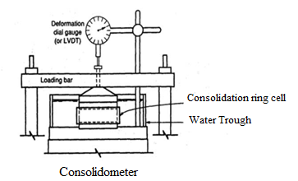
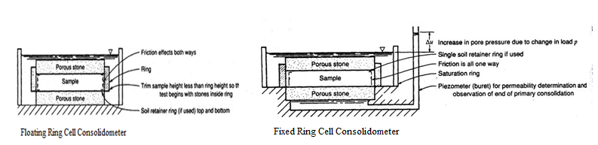
In floating ring cell both the top and bottom porous stones are free to move. The top porous stone can move downward and the bottom porous stone can move upward during the consolidation of the soil sample.
In fixed ring cell, the bottom porous stone cannot move and only the top porous stone can move downward during the consolidation of the soil sample.
The inside surface of the ring cell should be smooth and polished to reduce the friction. The ring cell should impose a condition of zero lateral stain on the soil sample.
The internal diameter of ring cell is usually 60 mm, but the ring cells with a diameter up to 100 mm are also available.
The thickness of soil sample used in the consolidation test is fixed from the following considerations
1). The thickness of the soil sample should be as small as possible to reduce the side friction. But a minimum thickness of 20 mm is usually required to get uniform distribution of pressure on the soil sample.
2). The diameter to thickness ratio of soil sample should be a minimum of three.
3). The thickness of the soil sample should not be less than 10 times the maximum size of the soil particle.
The thickness of soil sample for 60 mm diameter ring cell is usually taken as 20 mm. The soil samples of diameter 50 mm, 70 mm and 100 mm may be used in special cases.
The Consolidometer apparatus has the arrangements for
1). The application of desired load increment
2). Saturation of soil sample and
3). Measurement of change in thickness of the soil sample at every stage of consolidation process.
The consolidation cell is placed in a water jacket (or) water trough so that water has free access into and out of the soil sample.
The ring cell is provided with a perforated pressure pad at its top for the application of load.
The load is applied either by suspending weights from a hanger resting at the centre of the pressure pad (or) by a lever arrangement.
The arrangement for the saturation of soil sample consists of a small water reservoir connected to the ring cell with a plastic tube.
A dial gauge is used to measure the change in thickness as the consolidation takes place. The soil sample is kept submerged under water tp prevent the evaporation from its surface.
Before conducting the consolidation test, the porous stones are saturated either by boiling them in distilled water for about 15 minutes (or) by keeping them submerged in water for about 48 hours.
The bottom porous stone first placed in the consolidation ring cell and filter paper is fixed on the porous stone.
The ring containing the soil sample is then placed on the bottom porous stone. Another filter paper is kept on the top of the soil sample and then the top porous stone is placed.
The loading pad is placed on the top porous stone. The bolts are tightened so as to hold the entire assembly and then the consolidation cell is kept under the loading unit. It should be centered carefully so that the load applied is axially on the soil sample.
The dial gauge is mounted and adjusted. The mould assembly is connected to the water reservoir to saturate the soil sample. The level of water in the reservoir should be approximately same as that of the soil sample.
An initial setting pressure load of about 5.0 kN/m² (for very soft soil it is 2.5 kN/m²) is applied on the soil sample. The initial setting pressure load is chosen such that there is no swelling.
The initial setting pressure load is allowed to stand till there is no change in the dial gauge reading (or) 24 hours whichever is less. The final dial gauge reading under the initial setting pressure load is noted.
The first increment of load to give a pressure of 10kN/m² is then applied to the soil sample. The dial gauge readings are taken after 0.25, 1.0, 2.25, 4.0, 6.25, 9.0, 12.25, 16.0, 20.25, 25, 36, 49, 64, 81, 100, 121, 144, 169, 196, 22, 289, 324, 400, 500, 600 and 1440 minutes (24 hours). Sometimes after 49 minutes, readings are taken at 1, 2, 4, 8, 10 and 24 hours.
The primary consolidation of soil sample usually completed within 24 hours.
The second increment of the load is then applied. it is usual practice to double the previous load in each load increment. The successive pressure loads usually applied are 20, 40, 80, 160, 320 and 640 kN/m² etc., till the desired maximum required load intensity is reached.
The maximum load intensity is governed by the actual loading on the soil in the field after the construction of the structure.
After the consolidation under the final load increment is completed, the load is reduced to one-fourth of the final load i.e 160 kN/m² and allowed to stand for 24 hours. The soil sample takes water and swells. the reading of dial gauge is taken when the swelling is completed.
The load is further reduced to one-fourth intensity i.e 40 kN/m² and the swelling is recorded after 24 hours. The load is then reduced to 10kN/m² and the swelling is noted. The load is finally reduced to the initial setting load i.e 5.0 kN/m² and kept for 24 hours and the final dial gauge reading is taken. Throughout the test the container box should be kept filled with water.
Immediately after the complete unloading, the cell ring with soil sample is taken out.
The excess surface water is dried using a blotting paper. the weight of the cell ring and the soil sample is taken.
The soil sample is then dried in an oven for about 24 hours and its dry mass ‘M_{S}’ is taken and the water content (w) in the soil sample is determined.

Determination of void ratio at various load increments
The results of consolidation test are plotted in the form of a plot between the void ratio (e) and the effective stress ($\overline{σ}$).
It is therefore required to determine the void ratio (e) at various load increments.
There are two methods to determine the void ratio (e)
1). Height of solids method and 2). Change in void ratio method
1). Height of solids method
In this method, the equivalent height of solids (H_{S}) is determined from the dry mass of soil sample (M_{S}). The height of solids (H_{S}) is given by
$$H_{s}= \frac{V_{s}}{A}= \left(\frac{M_{s}}{G ρ_{w}}\right) . \frac{1}{A}$$
Here
H_{s} = The height of soil solids
V_{S} = The volume of soil solids
M_{S} = The mass of dry soil sample
G = The specific gravity of soil solids and
A = The cross-sectional area of soil sample
Now, from the definition of void ratio (e)
$e= \frac{Volume of voids}{Volume of soil solids}= \frac{V_{V}}{V_{S}}= \frac{V- V_{s}}{V_{s}}$ -------- (1)
The equation (1) can also be written as
$e= \frac{\left(A x H\right)- \left(A x H_{s}\right)}{\left(A x H_{s}\right)}= \frac{H- H_{S}}{H_{S}}$ --------- (2)
Here
H = The total height (or) thickness of the soil sample
Thus, the void ratio is determined from the total height (H) and the height of soil solids (H_{S}).
In consolidation test the total thickness of soil sample at the beginning of the test = H₀ = 25 mm
At the other stages of the loading
The total thickness of soil sample (H) is worked out from the initial thickness (H₀) and the difference in dial gauge readings
$∴H= H_{0} ± ∆H$ --------- (3)
Here
H₀ = The initial height of soil sample and
∆H = The change in height of soil sample
From equation (2), it is clear that the initial void ratio (e₀) of the soil sample at the beginning of the consolidation test is given by
$e_{0}= \frac{H_{0}- H_{S}}{H_{S}}$ ---------- (4)
From the calculated void ratios (e), a plot of void ratio (e) versus ‘log $\overline{σ}$’ can be prepared.
2). Change in void ratio method
In this method, the final void ratio (e_{f}) of the soil sample corresponding to complete swelling conditions after the entire load has been removed is determined by using the water content (w) of the soil sample as below.
$e_{f}=w G$ ----- (1)
Here
w = The water of the soil sample after the completion of consolidation test and
G = The specific gravity of soil solids
In the above equation it is assumed that the soil sample is fully saturated after the completion of consolidation test.
Now, the void ratio (e) of the soil sample at the other loading condition can be determined as below
As per the definition of void ratio (e)
$e= \frac{Volume of voids}{Volume of soil solids}= \frac{V_{V}}{V_{S}}= \frac{V- V_{s}}{V_{s}}= \frac{V}{V_{S}}- 1$ -------- (2)

Here
V = The volume of soil sample and
V_{S} = The volume of soil solids
The equation (2) can be written as
$V= V_{S} (1+e)$ ------ (3)
But, The total volume of soil sample = V = A x H
Here
A = The cross sectional area of soil sample and
H = The height of soil sample
$∴A x H= V_{S} (1+e)$ -------- (4)
By partial differentiation of the equation (4) we get
$∴A x dH= V_{S} x de$ --------- (5)
From $\frac{\left(5\right)}{\left(4\right)}$ we get
$\frac{dH}{H}= \frac{de}{1+e}$
$∴de= \frac{\left(1+e\right)}{H} dH$
$∴∆e= \frac{\left(1+e\right)}{H} ∆H$ -------- (6)
Substituting the final void ratio (e_{f}) and the final height (H_{f}) of the soil sample after the completion of consolidation test in the above equation we get
$∴∆e= \frac{\left(1+e_{f}\right)}{H_{f}} ∆H$ ------- (7)
As the final void ratio (e_{f}) and the final height (H_{f}) of the soil sample after the completion of consolidation test are known, the change in void ratio ($∆e$) of the soil sample at every load increment can be determined by using the equation (7) after calculating the change in thickness ($∆H$) of the soil sample from the dial gauge readings.
Now, the void ratio (e) ratio of the soil sample at every load increment can be determined by working backwards from the known value of the final void ratio ‘e_{f}’ of the soil sample.

Consolidation test results
1). Dial gauge reading – Time plot
The figure shows the graph between the dial gauge reading (R) and time (t) for a particular load increment for both clay soil sample and sand soil sample.
The thickness of soil sample just after the application of the load increment ( t = 0) is maximum which decreases as the time ‘t’ increases.
The decrease in thickness is rapid initially but it slows down as the time ‘t’ increases. There is practically no change in thickness after 24 hours.
The consolidation at every load increment is considered to be completed at 24 hours.
For sand, the change in thickness occurs very quickly and stops after a few minutes. this is due to high permeability of sand which permits easy flow of water.
The plot between the dial gauge reading and time is required for determining the coefficient of consolidation (C_{V}) of the soil sample, which is useful to determine the rate of consolidation in the field.
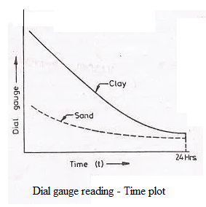

2). Final void ratio – Effective stress plot
The thickness of the soil sample after 24 hours of the application of the load increment is taken as the final thickness for that load increment.
The final void ratio (e_{f}) of the soil sample corresponding to the final thickness for every load increment can determined either by using the height of solids method (or) by using the change in void ratio method.
The figure shows the graph between the final void ratio e_{f1}, e_{f2}, e_{f3} ….. etc and the corresponding effective stresses $\overline{σ_{1}}, \overline{σ_{2}}, \overline{σ_{3}}$ ….. for every load increment.
As the sand is relatively less compressible, the change in void ratio is small.
The plot between final void ratio and the effective stress is required for the determination of the magnitude of the consolidation settlement in the field.
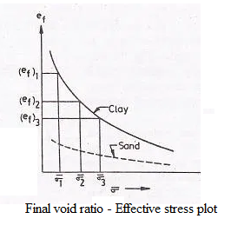
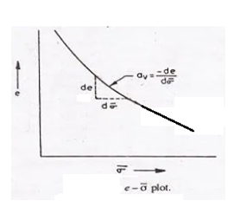

The figure shows the graph between the final void ratio (e) and the effective stress ($\overline{σ}$).
The curve has concavity upwards. The slope of the curve is different at different points.
The slope decreases with an increase in effective.
The slope of the graph between the final void ratio (e) and the effective stress ($\overline{σ}$) is known as the coefficient of compressibility ($a_{V}$).
$∴$ The coefficient of compressibility = $a_{V}=- \frac{de}{d\overline{σ}}=- \frac{∆e}{∆\overline{σ}}$
3). Final void ratio – log $\overline{σ}$ plot
It is more common to plot the results of the final void ratio (e) and the effective stress ($\overline{σ}$) on a semi-log graph, in which the final void ratio is plotted on the natural scale as ordinate and the effective stress as abscissa on the log scale.
The graph between final void ratio (e) versus log $\overline{σ}$ is a straight line for normally consolidated clay as shown in figure (b).
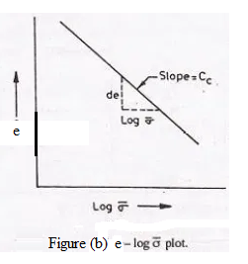
The slope of the straight line drawn between final void ratio (e) versus log $\overline{σ}$ is known as the compression index (C_{c}).

4). Loading, Unloading and Reloading plot
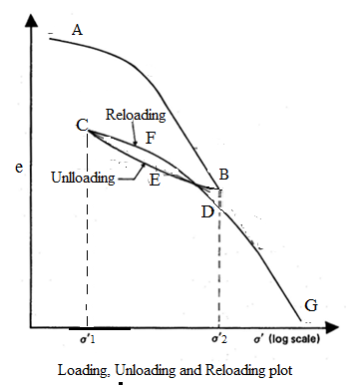
As shown in the figure, the curve ‘AB’ indicates the decrease in void ratio with an increase in the effective stress. The curve ‘AB’ is the loading curve.
After the soil sample has reached the equilibrium at the effective stress of “$\overline{σ_{2}}$” as shown in the figure with point ‘B’, the load on the soil sample is reduced and the soil sample is allowed to take up water and swell. The curve ‘BEC’ is obtained in unloading.
The curve ‘BEC’ is known as the expansion curve (or) the swelling curve. It may noted that the soil sample cannot attain the void ratio existing before the start of the test and there is always some permanent set (or) residual deformation in soil sample.
If the soil sample which has swelled up to the point ‘C’ is reloaded, the recompression curve (or) the reloading curve ‘CFD’ is obtained.
As the load approaches the maximum value of the load previously applied corresponding to the point ‘B, there is reversal of curvature of the curve and then the plot ‘DG’ continues as an extension of the first loading curve ‘AB’.
However, the reloaded soil specimen remains at slightly lower void ratio at point ‘D’ than that attained at point ‘B’ during the initial compression for the same load.

Basic Definitions
The following basic definitions related to the consolidation of soil mass are very important
1). Coefficient of compressibility (a_{v})
The coefficient of compressibility (a_{v}) is defined as decrease in void ratio per unit increase in effective stress. It is equal to the slope of the $e-\overline{σ}$ curve at the point under consideration.
$∴$ The coefficient of compressibility = $a_{V}=- \frac{de}{d\overline{σ}}=- \frac{∆e}{∆\overline{σ}}$ -------- (1)
As the effective stress increases, the void ratio decreases, and hence the ratio ‘$\frac{∆e}{∆\overline{σ}}$’ is negative.
The value of ‘a_{v}’ is different at various effective stresses. The coefficient of compressibility (a_{v}) decreases with an increase in the effective stress.
The SI unit of coefficient of compressibility (a_{v}) is m²/N
2). Coefficient of volume change (m_{v})
The coefficient of volume change (or) the coefficient of volume of compressibility (m_{v}) is defined as the volumetric strain per unit increase in effective stress.
$$∴The coefficient of volume change= m_{V}=- \frac{Volumetric strain}{Change in effective stress }$$
$$∴m_{V}=- \frac{Volumetric strain}{Change in effective stress }=- \frac{\frac{Change in volume}{Original volume}}{Change in effective stress} =- \frac{\frac{∆V}{V_{0}}}{∆\overline{σ}}$$
$∴m_{V}=- \frac{\frac{∆V}{V_{0}}}{∆\overline{σ}}$ ------------ (1)
Here
$m_{V}$ = The coefficient of volume change
$∆V$ = The change in volume
$V_{0}$ = The initial volume and
$∆\overline{σ}$ = The change in effective stress
For most clays the value of ‘m_{V}’ is in between 1 x 10⁻³ m²/kN to 1 x 10⁻⁴ m²/kN
The volumetric strain $\left(\frac{∆V}{V_{0}}\right)$ can be expressed either in terms of void ratio or in terms of the thickness of the soil sample as explained below

a). In the soil sample
Let the volume of soil solids is unity and ‘e₀’ is the initial void ratio
$∴$ The volume of voids = e₀
$∴$ The initial volume of soil sample = V₀ = 1 + e₀
Let ‘$∆e$’ is the change in void ratio due to the change in volume of ‘$∆V$’
$∴$ ‘$∆V$ = ‘$∆e$
$∴$ The volumetric strain = $\frac{∆V}{V_{0}}= \frac{∆ e}{1+ e_{0}}$
From equation (1)
$∴The coefficient of volume change= m_{V}= - \frac{\frac{∆ e}{1+ e_{0}}}{∆\overline{σ}}$ ------------ (2)
b). As the area of cross section of the soil specimen in the consolidometer remains constant
The change in volume of the soil specimen ‘$∆V$’ is equal to the change in thickness of the soil specimen ‘$∆V$’
$∴$ The volumetric strain = $\frac{∆V}{V_{0}}= \frac{∆ H}{H_{0}}$
Here
H₀ = The initial volume of the soil specimen
From equation (1)
$∴The coefficient of volume change= m_{V}= - \frac{\frac{∆ H}{H_{0}}}{∆\overline{σ}}$
$∴ ∆H= - m_{v} H_{0} ∆\overline{σ}$ ----------- (3)
The relationship between the coefficient of compressibility (a_{v}) and the coefficient of volume change (m_{v}) is given by
$m_{V}= \frac{a_{v}}{1+ e_{0}}$ ------ (4)
The coefficient of volume change (m_{v}) depends upon the effective stress at which it is determined. Its value also decreases with an increase in the effective stress.
The SI unit of the coefficient of volume change (m_{V}) is m²/N.

Normally consolidation and Over-consolidation soil
A normally consolidated soil is the one which had not been subjected to a pressure greater than the present existing pressure.
The soil is said to be over consolidated if it had been subjected in the past to a pressure in excess of the present pressure.
As shown in the figure, the portion ‘AB’ of the curve represents the soil in normally consolidated condition.
The curve ‘AB’ in this range is known as the “Virgin compression curve”
During recompression, the soil in the portion ‘CD’ of the curve represents the over-consolidated condition, as the soil had been previously subjected to a pressure “$\overline{σ_{2}}$” which is greater than the pressure in the range ‘CD’
The ratio between the maximum pressure to which an over-consolidated soil had been previously subjected in the past to the present acting on the soil is known as the “Over-consolidation ratio”.
For example the soil indicated by the condition at point ‘C’ in the above diagram has an over-consolidation ratio (OCR) of “ $\frac{\overline{σ_{2}}}{\overline{σ_{1}}}$”.
The normally consolidated soil and the over-consolidated soil are not the different types of soils, but these are conditions in which a soil exists.
The same type of soil can behave as normally consolidated in a certain pressure range and as an over-consolidated soil in some other pressure range.

For example in the above diagram,
1). The soil is normally consolidated in pressure range ‘AB’
2). The soil is over-consolidated in the pressure range ‘CD’ and
3). The soil is again normally consolidated in the pressure range ‘DG’
The liquidity index of a normally consolidated clay is generally between 0.6 and 1.00
The liquidity index of a over-consolidated clay is generally between 0.0 and 0.60.
Since the recompression index (C_{r}) is very small as compared with the compression index (C_{c}), the soils in the over-consolidated condition state have smaller compressibility.
The settlements of the structures built on an over-consolidated soil are smaller.
Under-consolidated soil
If the soil deposit has not reached the equilibrium under the applied overburden loads, then the soil is said to be under-consolidated.
This normally occurs in areas of recent land fills.

Terzaghi’s Theory of Consolidation
Terzaghi (1925) gave the theory of consolidation for the determination of the rate of consolidation of a saturated soil mass subjected to a static steady load.
The Terzaghi’s theory of consolidation is based on the following assumptions
Assumptions
1). The soil is homogeneous and isotropic
2). The soil is fully saturated
3). The soil solid particles and the water in the voids are incompressible. The consolidation occurs due to the expulsion of water from the voids.
4). The coefficient of permeability of the soil has the same value at all points, and it remains constant during the entire period of consolidation.
5). Darcy’s law is valid throughout the consolidation process
6). Soil is laterally confined and the consolidation takes place only in the axial direction. Drainage of water also occurs in vertical direction.
7). The time lag in consolidation is only due to the low permeability of the soil.
8). There is a unique relationship between the void ratio and the effective stress and this relationship remains constant during the load increment. In other words the coefficient of compressibility (a_{V}) and the coefficient of volume change (m_{V}) are constant.
In the Terzaghi’s theory of consolidation, the basic differential equation of one dimensional consolidation can be derived as explained below
Derivation of Differential Equation
Let us consider the saturated clay layer of thickness ‘H = 2d’ sandwiched between two layers of sand as shown in the figure.
When an uniform pressure of ‘∆σ’ is applied on the surface of the top sand layer, the total stress developed at all points in the clay layer is increased by ‘∆σ’.
According to the spring analogy model, initially the entire uniform pressure ‘∆σ’ is taken up by the water in the voids and the excess hydrostatic pressure of “ $\frac{∆σ}{γ_{w}}$” develops.

The figure shows the excess hydrostatic pressure diagram on the right side.
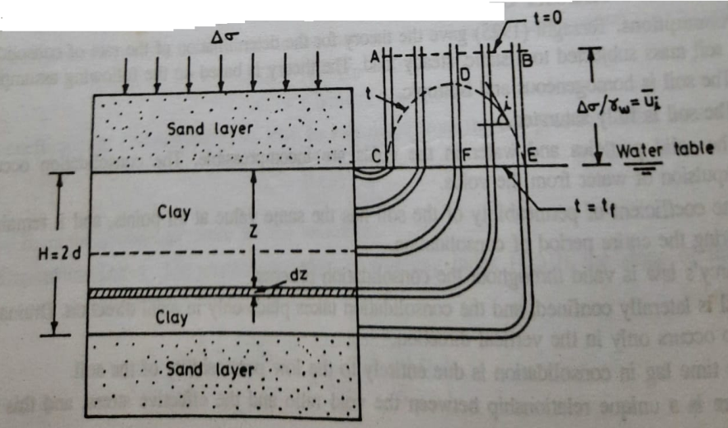
It is assumed that various points along the thickness of the clay layer are connected by flexible tubes to the piezometers.
Thus, at time t =0 , that is just after the application of the uniform pressure of ‘∆σ’, throughout the clay layer the excess hydrostatic pressure $\left(\overline{u_{i}}\right)$ in the water in the voids is equal to “ $\frac{∆σ}{γ_{w}}$”
In the above diagram, this excess hydrostatic pressure “$\overline{u_{i}}$” is represented by the horizontal line ‘AB’.
The excess hydrostatic pressure is independent of the position of the water table. For convenience the water table is assumed to be at the level of the surface of the clay layer.
Due to the development of the excess hydrostatic pressure, the water in the clay layer starts escaping towards the upper and lower sand layers.
Due to this escape of water from the clay layer, the excess hydrostatic pressure at the top and at the bottom of clay layer drop to zero as indicated by the point ‘C’ and the point ‘E’ respectively in the pressure distribution diagram as shown the above figure.
However the excess hydrostatic pressure in the middle portion of clay layer remains high as indicated by the point ‘D’ in the pressure distribution diagram.
The curve ‘CDE’ indicates the distribution of excess hydrostatic pressure at time ‘t’
As the consolidation progresses, the excess hydrostatic pressure in the middle portion of the clay layer also decreases.
Finally at time t = t_{f}, the whole excess hydrostatic pressure has been completely dissipated and the pressure distribution is indicated by the horizontal isochrone ‘CFE’
Let us consider the equilibrium of an element of the clay at a depth ‘Z’ from the top of clay layer as shown in the figure.
At this clay element at time ‘t’, the applied consolidation pressure ‘∆σ’ is partly carried by pore water and partly by soil particles.
$∴ ∆σ= \overline{∆σ}+ \overline{u}$ ------------- (1)
Here
$\overline{u}$ = The excess hydrostatic pressure in the pore water and
$\overline{∆σ}$ = The effective stress developed in the soil particles
Now
1). At time ‘t’, the excess hydrostatic pressure head (h) developed in the clay element is given by
$h= \frac{\overline{u}}{γ_{w}}$ ------------ (2)
2). The hydraulic gradient (i) in the clay element at a depth ‘Z’ is given by
$i= \frac{∂h}{∂z}= \frac{∂ \left(\frac{\overline{u}}{γ_{w}}\right)}{∂z}= \frac{1}{γ_{w}} \left(\frac{∂\overline{u}}{∂z}\right)$ ------- (3)
The hydraulic gradient (i) at the clay element is also equal to the slope of the curve ‘CDE’ at a horizontal distance of ‘Z; from the point ‘C’ in the pressure diagram.
The expression for the hydraulic gradient (i) at the clay element is also obtained in the another manner as explained below
Let us consider an elemental clay layer of thick ‘∆Z’ at a vertical depth ‘Z’ from the top of the clay layer as shown in the figure.
Let
$\overline{u}$= The excess hydrostatic pressure at the top of the clay element and
$\overline{u}+ \frac{∂\overline{u}}{∂z} .dz$ = The excess hydrostatic pressure at the bottom of the clay element

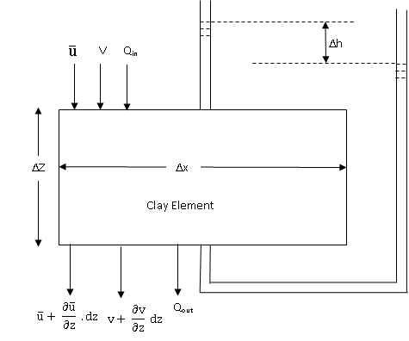
Now, the excess hydrostatic pressure difference (∆$\overline{u}$) across the thickness of the clay element is given by
∆$\overline{u}$ = $\left(\overline{u}+ \frac{∂\overline{u}}{∂z} .dz \right)$ - $\overline{u}$ = $\frac{∂\overline{u}}{∂z} .dz$
Now
1). The unbalanced excess hydrostatic pressure head (∆h) developed in the clay element is given by
$∆ h= \frac{∆ \overline{u}}{γ_{w}}= \frac{1}{γ_{w}} \left(\frac{∂\overline{u}}{∂z} .dz\right)$ and
2). The hydraulic gradient (i) in the clay element at a depth ‘Z’ is given by
$i= \frac{∂h}{∂z}= \frac{∂ \left(\frac{\overline{u}}{γ_{w}}\right)}{∂z}= \frac{1}{γ_{w}} \left(\frac{∂\overline{u}}{∂z}\right)$ --------- (4)
The equation (4) is same as the equation (3)

Now, from the Darcy’s law
1). The velocity of water flow (V) at the top of the clay element is given by
$v$ = K x i = K x $\frac{1}{γ_{w}} \left(\frac{∂\overline{u}}{∂z}\right)$
2). The velocity of water flow at the bottom of the clay element is
$v+ \frac{∂v}{∂z} dz=v+ \frac{∂}{∂Z} \left[K x \frac{1}{γ_{w}} \left(\frac{∂\overline{u}}{∂z}\right)\right] dz$
$∴ v+ \frac{∂v}{∂z} dz-v= \frac{∂}{∂Z} \left[K x \frac{1}{γ_{w}} \left(\frac{∂\overline{u}}{∂z}\right)\right] dz$
$∴ \frac{∂v}{∂z} dz= \frac{∂}{∂Z} \left[K x \frac{1}{γ_{w}} \left(\frac{∂\overline{u}}{∂z}\right)\right] dz$
$$∴ \frac{∂v}{∂z} = \frac{∂}{∂Z} \left[K x \frac{1}{γ_{w}} \left(\frac{∂\overline{u}}{∂z}\right)\right]$$
$∴ \frac{∂v}{∂z} = \frac{K}{γ_{w}} \frac{∂^{2} \overline{u}}{∂ Z^{2}}$ ------- (5)
Now
1). The discharge of water flow entering into the clay element (Q_{in}) is given by
Q_{in} = v ( ∆ x . ∆y)
2). The discharge of water flow leaving the clay element (Q_{out}) is given by
Q_{out} = $\left(v+ \frac{∂v}{∂z} dz\right)$ ( ∆ x . ∆y)
Hence, the net discharge of water squeezed out from the clay element is given by
$$∆Q= Q_{out}- Q_{in}$$
$∴∆Q= \left(v+ \frac{∂v}{∂z} dz\right) \left( ∆ x . ∆y\right)-$v ( ∆ x . ∆y)
$∴∆Q= \frac{∂v}{∂z} ( ∆ x . ∆y . ∆Z)$ --------- (6)
As the water is squeezed out from the clay element, the effective stress in clay element is increases and the volume of clay element is decreases.

Limitations of Consolidation Theory
One –dimensional consolidation theory is based on a number of assumptions. The following are the limitations of the one-dimensional consolidation theory
1). The value of coefficient of consolidation (C_{V}) has been assumed to be constant. But, it changes with a change in the consolidation pressure. For accurate predictions of the time-rate of consolidation in the field, its value should be determined for the expected pressure range.
2). The distance ‘d’ of the drainage path cannot be measured accurately in the field. The thickness of the deposit is generally variable and an average value has to be estimated.
3). The equation is based on the assumption that the consolidation is one-dimensional. In the field, the consolidation is generally 3 – dimensional. The lateral drainage may have a significant effect on the time rate of consolidation.
4). The initial consolidation and the secondary consolidation have been neglected. Sometimes, these consolidations form an important part of the total consolidation.
5). In actual practice, the pressure distribution may be far from linear (or) uniform. The theory becomes complicated when correct distribution is considered.

Determination of Coefficient of Consolidation (C_{V})
The curve between dial gauge reading (R) and time (t) obtained in the laboratory consolidation testing of the soil sample is similar in shape to the theoretical curve between ‘U’ and ‘T_{V}’ obtained from the consolidation theory.
This similarity between the laboratory curve and the theoretical curve is used for the determination of the coefficient of consolidation (C_{V}) of the soil sample.
The following two methods are commonly used to determine the coefficient of consolidation “C_{V}” of the soil
1). Square – Root Time Method and
2). Logarithm of Time Method
1). Square – Root Time Method
This method was devised by Taylor. This method utilizes the theoretical relationship between “U” and “$\sqrt{T_{V}}$”. The relationship is linear up to the value of “U” equal to about 60%.
It has been further established that at U = 90%, the value of $\sqrt{T_{V}}$ is 1.15 times the value obtained by the extension of the initial straight line portion as shown in the figure.
The soil sample, whose coefficient of consolidation (C_{V}) is to be determined is to be tested in the consolidation test.
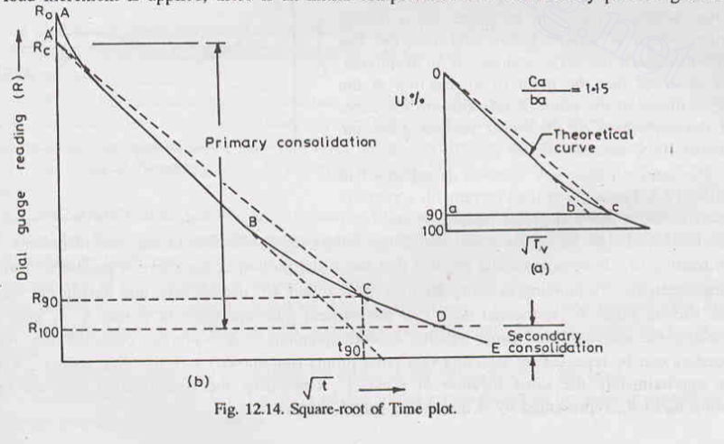
During the consolidation test, for a given load increment, the dial gauge readings are taken for different time intervals (t). A curve ‘ABCDE’ is plotted between the dial gauge reading (R) as ordinate and $\sqrt{t}$ as abscissa as shown in the figure. The point ‘A’ indicates the dial gauge reading ‘R₀’ at time ‘t₀’.
When the load increment is applied there is an initial compression. It is obtained by producing back the initial linear part of the curve to intersect the dial – gauge reading axis at point ‘$A^{'}$’. This corresponds to the corrected zero reading (R_{C}). The consolidation between the dial gauge reading ‘R₀’ and ‘R_{C}’ is the initial compression. The Terzaghi theory of consolidation is not applicable in this range.
From the corrected zero reading point ‘$A^{'}B$’, a line ‘$A^{'}$C’ is drawn such that its abscissa is 1.15 times that of the initial linear portion ‘$A^{'}$B’ of the curve.
The intersection of this line with the curve at point ‘C’ indicates 90% of ‘U’ and the corresponding abscissa as $\sqrt{t_{90}}$.
The point ‘D’ for 100% primary consolidation can be obtained from ‘R₉₀’ as
$\frac{R_{C}- R_{100}}{100}= \frac{R_{C}- R_{90}}{90}$
The consolidation after 100% of primary consolidation, in the range DE, is the secondary consolidation.
The value of coefficient of consolidation (C_{V}) of the soilsample for that load increment is obtained from the value of $\sqrt{t_{90}}$ obtained from the above plot.
We know that
When U = 90% = 0.90
$T_{V}= -0.933 \log_{10} \left(1-U\right)- 0.085$ = $-0.933 \log_{10} \left(1-0.9\right)- 0.085$ = 0.848
Now, from the equation
$T_{V}= \frac{C_{V} t}{d^{2}}$
$C_{V}= \frac{T_{V} d^{2} }{t}= \frac{0.848 d^{2} }{t_{90}}$ ---------- (1)
The distance of the drainage path ‘d’ is half the thickness of the soil sample.
The total thickness may be taken as the average of the initial thickness (H_{i}) and the final thickness (H_{f}) of the soil sample.
Thus
a). For double drainage
$d= \frac{H}{2}= \frac{1}{2} \left[\frac{H_{i}+ H_{f}}{2}\right]$
b). For single drainage
$d = H= \left[\frac{H_{i}+ H_{f}}{2}\right]$
The test is repeated for different load increments and an average value of ‘C_{V}’ will be determined as shown in the figure.
