Advanced Structural Design (15A01802)

LECTURE NOTES IV-B.TECH & I-SEM
Prepared by:

Mr. B. RAMU, Assistant Professor
Department of Civil Engineering

VEMU INSTITUTE OF TECHNOLOGY

(Approved By AICTE, New Delhi and Affiliated to JNTUA, Ananthapuramu) Accredited By NAAC, NBA( EEE, ECE & CSE) & ISO: 9001-2015 Certified Institution Near Pakala, P.Kothakota, Chittoor- Tirupathi Highway
Chittoor, Andhra Pradesh-517 112 Web Site: www.vemu.org

JAWAHARLAL NEHRU TECHNOLOGICAL UNIVERSITY ANANTAPUR B.Tech (CE)– IV-II
(15A01802) ADVANCED R.C.C STRUCTURAL DESIGN PROFESSIONAL ELECTIVE-IV
Course Objectives:
- To design and detailing of reinforcement of an interior panel of a flat slab
- To design a circular bunker with the detailing of reinforcement
- To design a concrete chimney with detailing of reinforcement.
- To design different elements of the circular and rectangular shape water tanks.
- To design and detailing of the reinforcement in the various members of the cantilever and counter fort retaining walls.
UNIT-I
Design of a flat slab (Interior panel only)
Learning Outcomes:
After completion of this unit student will
- To know the components of interior slab panel
- To understand the design procedure and detailing of reinforcement of interior panel of the flat slab
UNIT-II
Design of concrete bunkers of circular shape – (excluding staging) – Introduction to silos
Learning Outcomes:
After completion of this unit student will
- To know and understand the components of bunker
- To have a clear view of the design procedure and detailing of reinforcement of bunker
UNIT-III
Design of concrete chimney (excluding seismic loads)
Learning Outcomes:
After completion of this unit student will
- To have a comprehensive understanding of various forces acting on the chimney.
- To design the concrete chimney.
UNIT-IV
Design of circular and rectangular water tank resting on the ground
Learning Outcomes:
After completion of this unit student will
- To have a good understanding of design of water tanks resting on the ground.
UNIT-IV
Design of cantilever and counter forte retaining wall with horizontal back fill only.
Learning Outcomes:
After completion of this unit student will
- To know the applications of cantilever and counter forte retaining walls.
- To perform the stability analysis of the retaining walls
- To design and detailing of the cantilever and counter forte retaining walls
TEXT BOOKS:-
1. Krishnam Raju, “Structural Design and drawing (RCC and steel)” Universites .Press , New Delhi
- Dr. B. C. Punmia, Ashok Kumar Jain, Arun Kumar Jain, R.C.C “Structures”, Laxmi Publications, New Delhi
- Varghese , “Advanced RCC”, PHI Publications, New Delhi.
- M.L.Gambhir “Design of RCC structures”, P.H.I. Publications, New Delhi.
REFERENCE BOOKS:-
- Sushil kumar , “R.C.C Designs standard” publishing house.
- N.C.Sinha and S.K.Roy, “Fundamentals of RCC”, S.Chand Publications, New Delhi.

Introduction

FLAT SLABS

Common practice of design and construction is to support the slabs by beams and support the beams by columns. This may be called as beam-slab construction. The beams reduce the available net clear ceiling height. Hence in warehouses, offices and public halls some times beams are avoided and slabs are directly supported by columns. This type of construction is aesthetically appealing also. These slabs which are directly supported by columns are called Flat Slabs. Fig. 1.1 shows a typical flat slab.
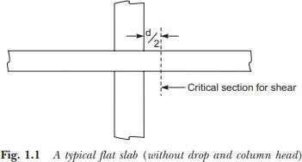
The column head is some times widened so as to reduce the punching shear in the slab. The widened portions are called column heads. The column heads may be provided with any angle from the consideration of architecture but for the design, concrete in the portion at 45º on either side of vertical only is considered as effective for the design [Ref. Fig. 1.2]
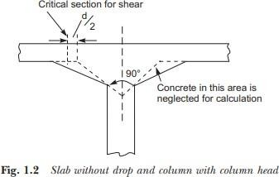
Moments in the slabs are more near the column. Hence the slab is thickened near the columns by providing the drops as shown in Fig. 1.3. Sometimes the drops are called as capital of the column. Thus we have the following types of flat slabs:
  - Slabs without drop and column head (Fig. 1.1).
  - Slabs without drop and column with column head (Fig. 1.2).
  - Slabs with drop and column without column head (Fig. 1.3).
  - Slabs with drop and column head as shown in Fig. 1.4.

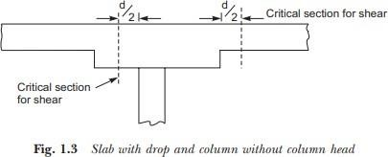

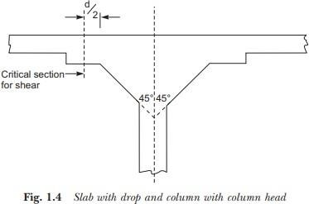
The portion of flat slab that is bound on each of its four sides by centre lines of adjacent columns is called a panel. The panel shown in Fig. 1.5 has size L1 × L2. A panel may be divided into column strips and middle strips. Column Strip means a design strip having a width of 0.25L1 or 0.25L2, whichever is less. The remaining middle portion which is bound by the column strips is called middle strip. Fig. 1.5 shows the division of flat slab panel into column and middle strips in the direction y.
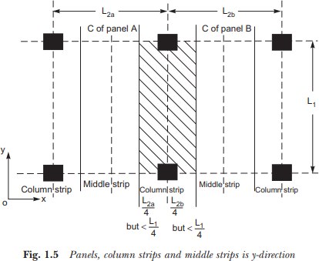

Proportioning of Flat Slabs
IS 456-2000 [Clause 31.2] gives the following guidelines for proportioning:
    - Drops: The drops when provided shall be rectangular in plan, and have a length in each direction not less than one third of the panel in that direction. For exterior panels, the width of drops at right angles to the non-continuous edge and measured from the centre-line of the columns shall be equal to one half of the width of drop for interior panels.
    - Column Heads: Where column heads are provided, that portion of the column head which lies within the largest right circular cone or pyramid entirely within the outlines of the column and the column head, shall be considered for design purpose as shown in Figs. 1.2 and 1.4.
    - Thickness of Flat Slabs: From the consideration of deflection control IS 456-2000 specifies minimum thickness in terms of span to effective depth ratio. For this purpose larger span is to be considered. If drop as specified in 1.2.1 is provided, then the maximum value of ratio of larger span to thickness shall be
= 40, if mild steel is used
= 32, if Fe 415 or Fe 500 steel is used
If drops are not provided or size of drops do not satisfy the specification 1.2.1, then the ratio shall not exceed 0.9 times the value specified above i.e.,
= 40 × 0.9 = 36, if mild steel is used.
= 32 × 0.9 = 28.8, if HYSD bars are used
It is also specified that in no case, the thickness of flat slab shall be less than 125 mm.

For Determination of Bending Moment & Shear Force:
For this IS 456-2000 permits use of any one of the following two methods:
- The Direct Design Method
- The Equivalent Frame Method

THE DIRECT DESIGN METHOD
This method has the limitation that it can be used only if the following conditions are fulfilled:
- There shall be minimum of three continuous spans in each directions.
- The panels shall be rectangular and the ratio of the longer span to the shorter span within a panel shall not be greater than 2.
- The successive span length in each direction shall not differ by more than one-third of longer span.
- The design live load shall not exceed three times the design dead load.
- The end span must be shorter but not greater than the interior span.
- It shall be permissible to offset columns a maximum.

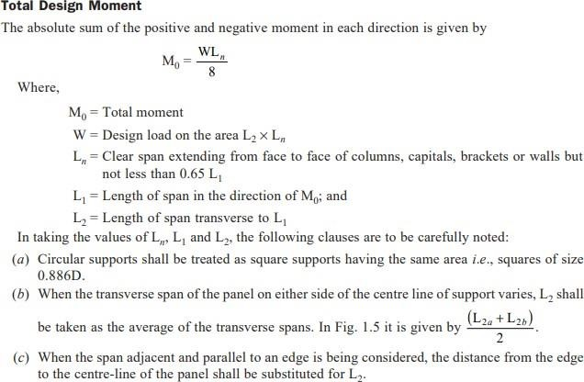

Distribution of Bending Moment in to -ve and +ve Moments
The total design moment M0 in a panel is to be distributed into –ve moment and +ve moment as specified below:
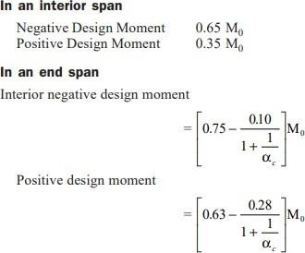

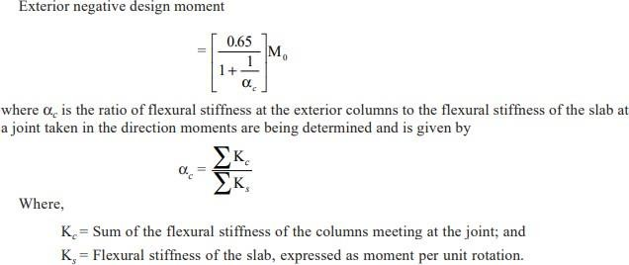

Distribution of the Bending Moment across the Panel Width
The +ve and –ve moments found are to be distributed across the column strip in a panel as shown in Table 1.1. The moment in the middle strip shall be the difference between panel and the column strip moments.
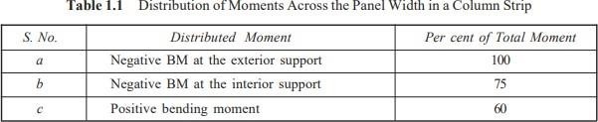

Moments in Columns
In this type of constructions column moments are to be modified as suggested in IS 456–2000 [Clause No. 31.4.5].

Shear Force
The critical section for shear shall be at a distance d/2 from the periphery of the column/capital drop panel. Hence if drops are provided there are two critical sections near columns. These critical sections are shown in Figs. 1.1 to 1.4. The shape of the critical section in plan is similar to the support immediately below the slab as shown in Fig. 1.6.
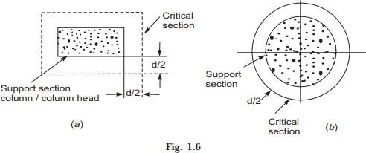

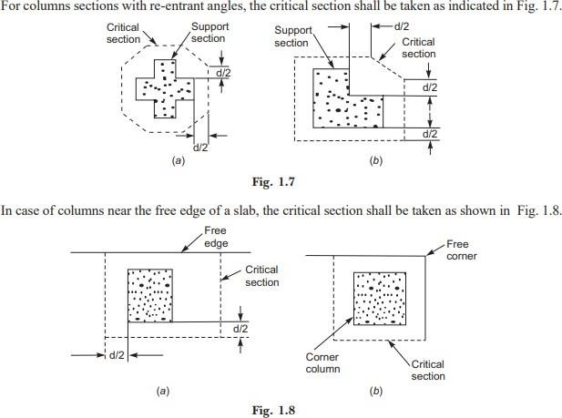
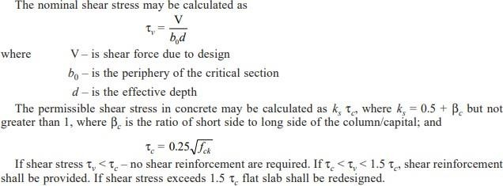

EQUIVALENT FRAME METHOD
IS 456–2000 recommends the analysis of flat slab and column structure as a rigid frame to get design moment and shear forces with the following assumptions:
  - Beam portion of frame is taken as equivalent to the moment of inertia of flat slab bounded laterally by centre line of the panel on each side of the centre line of the column. In frames adjacent and parallel to an edge beam portion shall be equal to flat slab bounded by the edge and the centre line of the adjacent panel.
  - Moment of inertia of the members of the frame may be taken as that of the gross section of the concrete alone.
  - Variation of moment of inertia along the axis of the slab on account of provision of drops shall be taken into account. In the case of recessed or coffered slab which is made solid in the region of the columns, the stiffening effect may be ignored provided the solid part of the slab does not extend more than 0.15 lef into the span measured from the centre line of the columns. The stiffening effect of flared columns heads may be ignored.
  - Analysis of frame may be carried out with substitute frame method or any other accepted method like moment distribution or matrix method.

Loading Pattern
When the live load does not exceed ¾th of dead load, the maximum moments may be assumed to occur at all sections when full design live load is on the entire slab. If live load exceeds ¾th dead load analysis is to be carried out for the following pattern of loading also:
- To get maximum moment near mid span – ¾th of live load on the panel and full live load on alternate panel
- To get maximum moment in the slab near the support – ¾th of live load is on the adjacent panel only
It is to be carefully noted that in no case design moment shall be taken to be less than those occurring with full design live load on all panels.
The moments determined in the beam of frame (flat slab) may be reduced in such proportion that the numerical sum of positive and average negative moments is not less than the value of total design moment
M0 = WLn / 8 .
The distribution of slab moments into column strips and middle strips is to be made in the same manner as specified in direct design method.

Slab Reinforcement
  - Spacing: The spacing of bars in a flat slab, shall not exceed 2 times the slab thickness.
  - Area of Reinforcement: When the drop panels are used, the thickness of drop panel for determining area of reinforcement shall be the lesser of the following:
    - Thickness of drop, and
    - Thickness of slab plus one quarter the distance between edge of drop and edge of capital.
    - The minimum percentage of the reinforcement is same as that in solid slab i.e., 0.12 percent if HYSD bars used and 0.15 percent, if mild steel is used.

  - Minimum length of Reinforcement: At least 50 percent of bottom bars should be from support to support. The rest may be bent up. The minimum length of different reinforcement in flat slabs should be as shown in Fig. 1.9 (Fig. 16 in IS 456– 2000). If adjacent spans are not equal, the extension of the –ve reinforcement beyond each face shall be based on the longer span. All slab reinforcement should be anchored property at discontinuous edges.
NUMERICALS
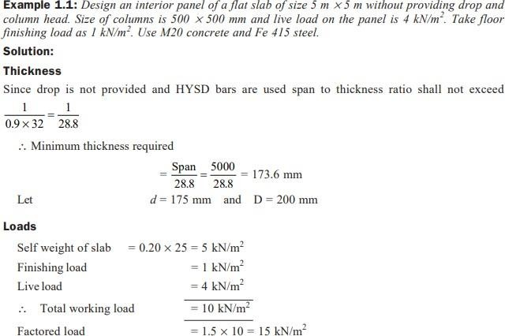

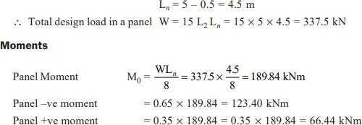

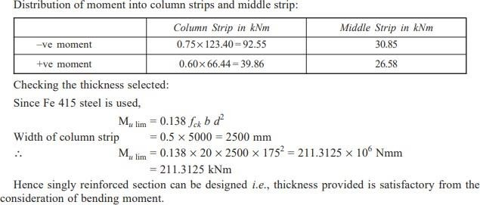
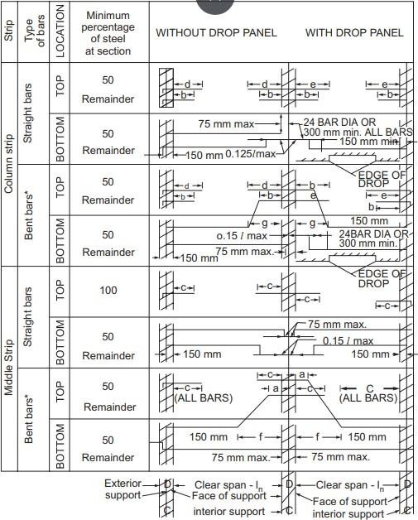

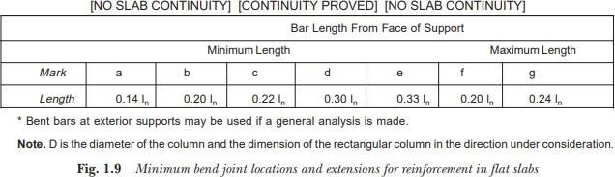
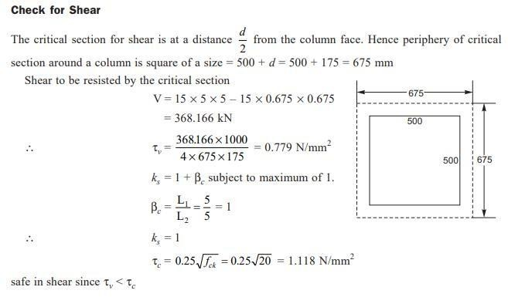
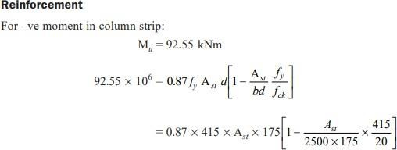

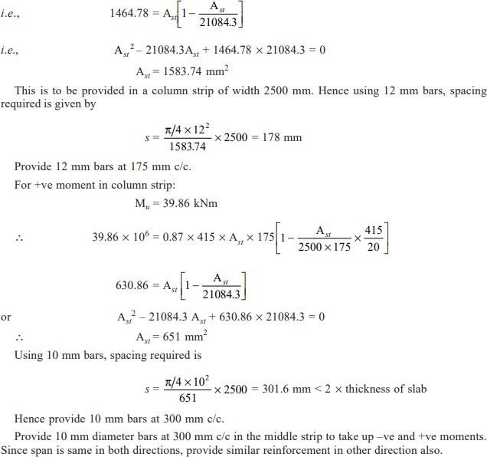

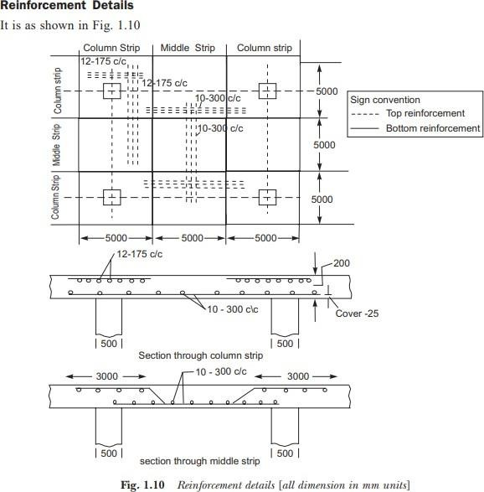
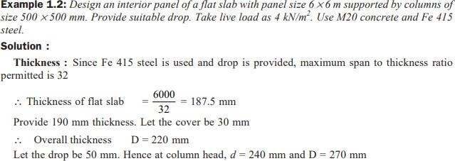

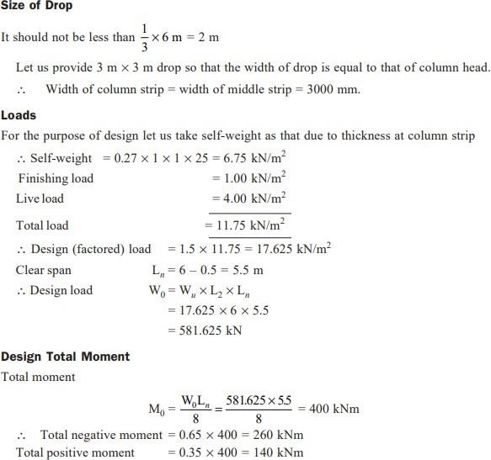
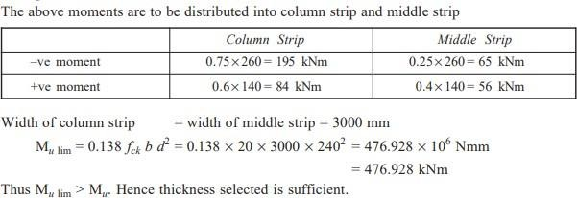

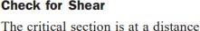

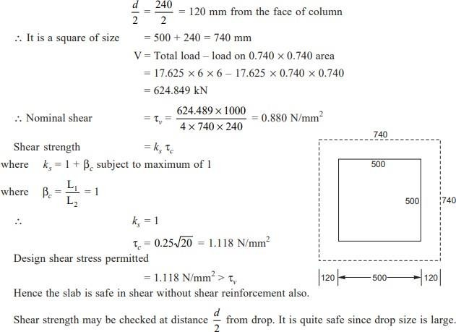
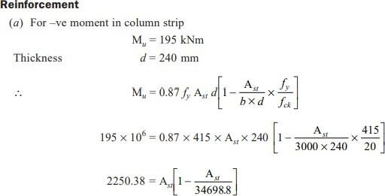

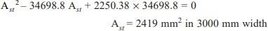

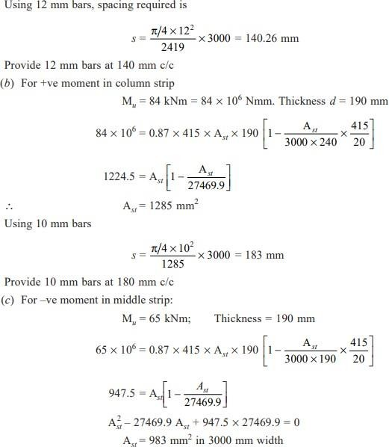
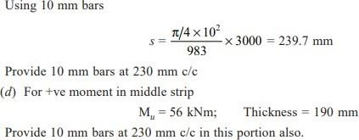

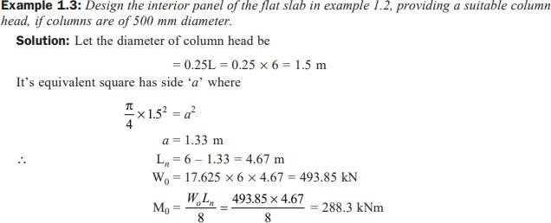
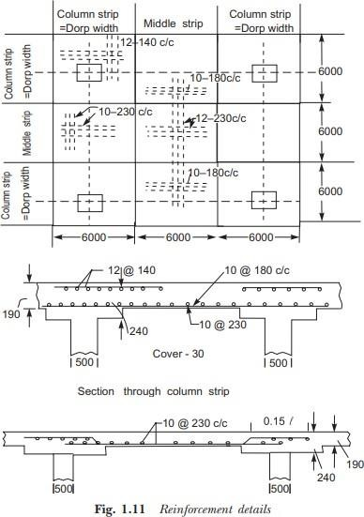

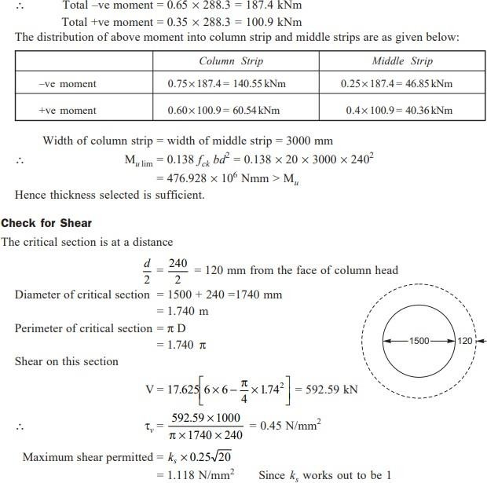
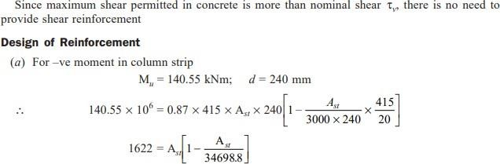

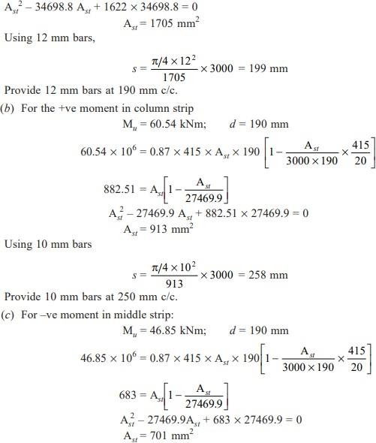
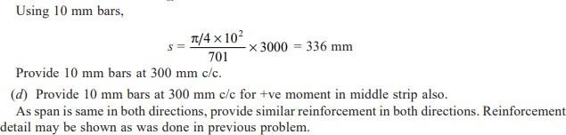
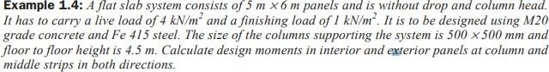

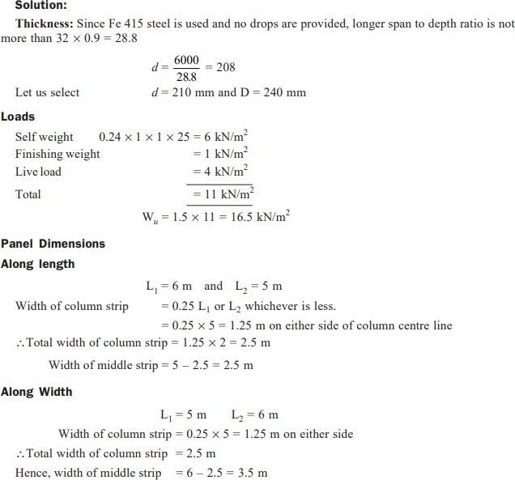

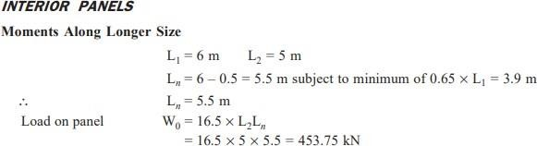

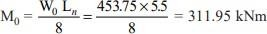

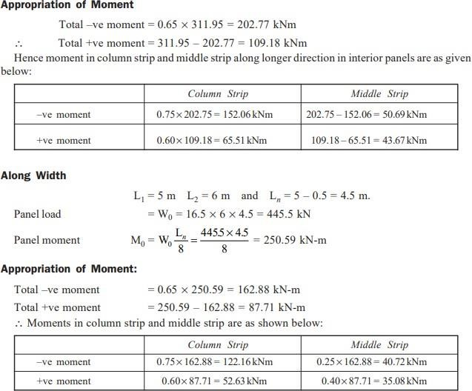

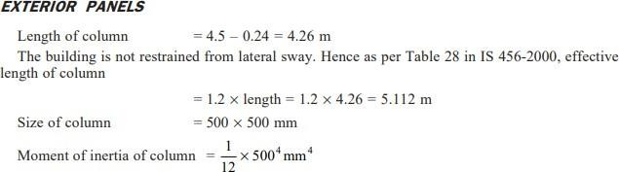

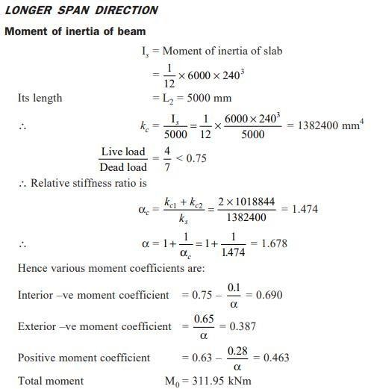
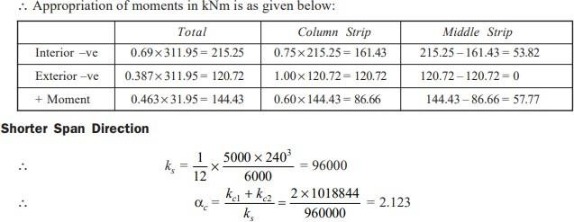

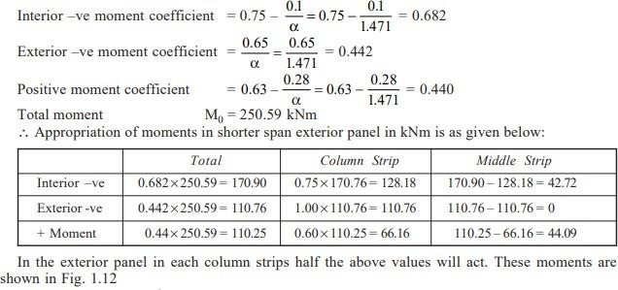
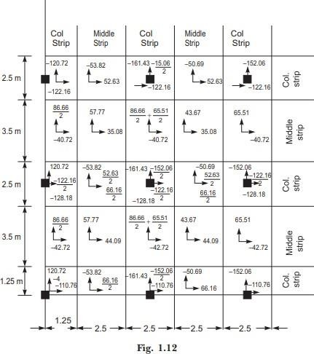

INTRODUCTION RETAINING WALL ANALYSIS & DESIGN
Retaining walls are structures used to provide stability for earth or other materials at their natural slopes. In general, they are used to hold back or support soil banks and water or to maintain difference in the elevation of the ground surface on each of wall sides. Also, retaining walls are often used; in the construction of buildings having basements, roads, or bridges when it is necessary to retain embankments or earth in a relatively vertical position. Retaining walls are commonly supported by soil (or rock) underlying the base slab, or supported on piles; as in case of bridge abutments and where water may erode or undercut the base soil as in water front structures.

TYPES OF RETAINING WALLS
There are many types of retaining walls; they are mainly classified according to their behavior against the soil:-
- Gravity retaining walls are constructed of plain concrete or stone masonry. They depend mostly on their own weight and any soil resting on the wall for stability. This type of construction is not economical for walls higher than 3m.
- Semi-gravity retaining walls are modification of gravity wall in which small amounts of reinforcing steel are introduced for minimizing the wall section.
- Cantilever retaining walls are the most common type of retaining walls and are generally used for wall high up to 8m. It derives its name from the fact that its individual parts behave as, and are designed as, cantilever beams. Its stability is a function of strength of its individual parts.
- Counterfort retaining walls are similar to cantilever retaining walls, at regular intervals, however, they have thin vertical concrete slabs behind the wall known as counterforts that tie the wall and base slab together and reduce the shear and bending moment. They are economical when the wall height exceeds 8m. Whereas, if bracing is in front of the wall and is in compression instead of tension, the wall is called Buttress retaining wall.
- Bridge abutments are special type of retaining walls, not only containing the approach fill, but serving as a support for the bridge superstructure.
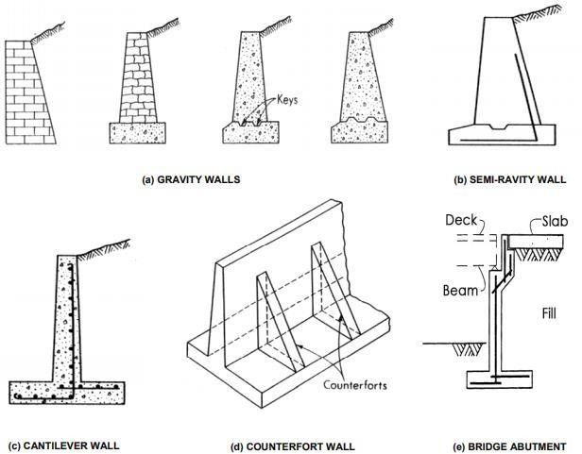

Cantilever Wall:
The ‘cantilever wall’ is the most common type of retaining structure and is generally economical for heights up to about 8 m. The structure consists of a vertical stem, and a base slab, made up of two distinct regions, viz. a heel slab and a toe slab. All three components behave as one-way cantilever slabs: the ‘stem’ acts as a vertical cantilever under the lateral earth pressure; the ‘heel slab’ acts as a (horizontal) cantilever under the action of the weight of the retained earth (minus soil pressure acting upwards from below); and the ‘toe slab’ also acts as a cantilever under the action of the resulting soil pressure (acting upward). The detailing of reinforcement (on the flexural tension faces) is accordingly as depicted in Fig. below. The stability of the wall is maintained essentially by the weight of the earth on the heel slab plus the self weight of the structure.

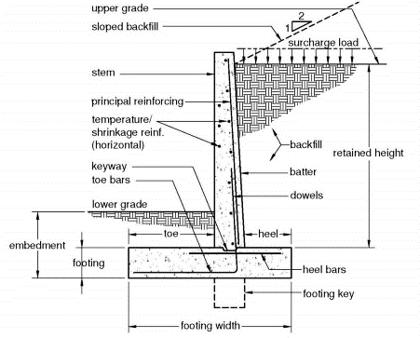
Fig: Cantilever Retaining Wall

Counterfort Wall:
For large heights, in a cantilever retaining wall, the bending moments developed in the stem, heel slab and toe slab become very large and require large thicknesses. The bending moments (and hence stem/slab thicknesses) can be considerably reduced by introducing transverse supports, called counterforts, spaced at regular intervals of about one-third to one-half of the wall height), interconnecting the stem‡ with the heel slab. The counterforts are concealed within the retained earth (on the rear side of the wall). Such a retaining wall structure is called the counterfort wall, and is economical for heights above (approx.) 7 m. The counterforts subdivide the vertical slab (stem) into rectangular panels and support them on two sides (suspender-style), and themselves behave essentially as vertical cantilever beams of T-section and varying depth. The stem and heel slab panels between the counterforts are now effectively ‘fixed’ on three sides (free at one edge), and for the stem the predominant direction of bending (and flexural reinforcement) is now horizontal (spanning between counterforts), rather than vertical (as in the cantilever wall).

EARTH PRESSURES AND STABILITY REQUIREMENTS
Lateral Earth Pressures
The lateral force due to earth pressure constitutes the main force acting on the retaining wall, tending to make it bend, slide and overturn. The determination of the magnitude and direction of the earth pressure is based on the principles of soil mechanics.
In general, the behaviour of lateral earth pressure is analogous to that of a fluid, with the magnitude of the pressure p increasing nearly linearly with increasing depth z for moderate depths below the surface:

p = Cγez
where γe is the unit weight of the earth and C is a coefficient that depends on its physical properties, and also on whether the pressure is active or passive. ‘Active pressure’ (pa) is that which the retained earth exerts on the wall as the earth moves in the same direction as the wall deflects. On the other hand, ‘passive pressure’ (pp) is that which is developed as a resistance when the wall moves and presses against the earth (as on the toe side of the wall). The coefficient to be used in Eq. 14.9 is the active pressure coefficient, Ca, in the case of active pressure, and the passive pressure coefficient, Cp, in the case of passive pressure; the latter (Cp) is generally much higher than the former (Ca) for the same type of soil.
In the absence of more detailed information, the following expressions for Ca and Cp, based on Rankine’s theory, may be used for cohesionless soils and level backfills:
Ca = 1 - sin φ / 1 + sin φ Cp = 1 + sin φ/ 1 - sin φ
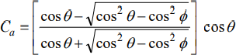
where φ is the angle of shearing resistance (or angle of repose). For a typical granular soil (such as sand), φ ≈ 30º , corresponding to which, Ca = 1/3 and Cp = 3.0. When the backfill is sloped†, the expression for Ca should be modified as follows:

where θ is the angle of inclination of the backfill, i.e., the angle of its surface with respect to the horizontal.
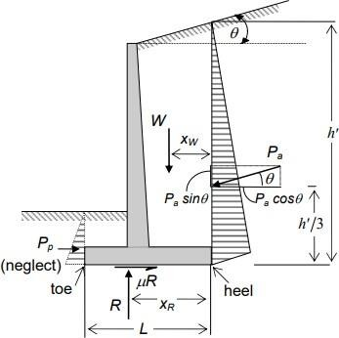

Fig: Forces acting on Cantilever Retaining wall

The direction of the active pressure, pa, is parallel to the surface of the backfill. The pressure has a maximum value at the heel, and is equal to Caγeh′, where h’ is the height of the backfill, measured vertically above the heel.
For the case of a level backfill, θ = 0 and h’ = h, and the direction of the lateral pressure is horizontal and normal to the vertical stem. The force, Pa, exerted by the active earth pressure, due to a backfill of height h’ above the heel, is accordingly obtained from the triangular pressure distribution as:
This force has units of kN per m length of the wall, and acts at a height h′/3 above the heel at an inclination θ with the horizontal. The force, Pp, developed by passive pressure on the toe side of the retaining wall is generally small (due to the small height of earth) and usually not included in the design calculations, as this is conservative.

Effect of Surcharge on a Level Backfill
Frequently, gravity loads act on a level backfill due to the construction of buildings and the movement of vehicles near the top of the retaining wall. These additional loads can be assumed to be static and uniformly distributed on top of the backfill, for calculation purposes. This distributed load ws (kN/m²) can be treated as statically equivalent to an additional (fictitious) height, hs = ws/γe, of soil backfill with unit weight γe. This additional height of backfill is called surcharge, and is expressed either in terms of height hs, or in terms of the distributed load ws
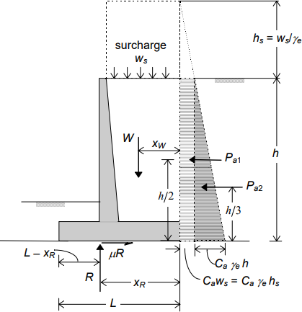
Fig: Effect of Surcharge on the level backfill
The presence of the surcharge not only adds to the gravity loading acting on the heel slab, but also increases the lateral pressure on the wall by Caγehs = Caws. The resulting trapezoidal earth pressure distribution is made up of a rectangular pressure distribution, superimposed on the triangular pressure distribution due to the actual backfill. The total force due to active pressure acting on the wall is accordingly given by:
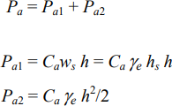
with the lines of action of Pa1 and Pa2 at h/2 and h/3 above the heel.

Stability Requirements
The Code (Cl. 20) specifies that the factors of safety against overturning (Cl. 20.1) and sliding (Cl. 20.2) should not be less than 1.4. Furthermore, as the stabilising forces are due to dead loads, the Code specifies that these stabilising forces should be factored by a value of 0.9 in calculating the factor of safety, FS. Accordingly,
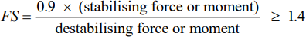

Overturning
If the retaining wall structure were to overturn, it would do so with the toe acting as the centre of rotation. In an overturning context, there is no upward reaction R acting over the base width L. The expressions for the overturning moment Mo and the stabilising (restoring) moment Mr depend on the lateral earth pressure and the geometry of the retaining wall. For the case of a sloping backfill:
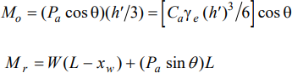
where W denotes the total weight of the reinforced concrete wall structure plus the retained earth resting on the footing (heel slab), and xw is the distance of its line of action from the heel.
For the case of a level backfill with surcharge:
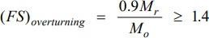
The factor of safety required against overturning is obtained as:

Sliding
The resistance against sliding is essentially provided by the friction between the base slab and the supporting soil, given by F = μR
where R = W is the resultant soil pressure acting on the footing base and μ is the coefficient of static friction between concrete and soil. [In a sloping backfill, R will also include the vertical component of earth pressure, Pa sinθ. The value of μ varies between about 0.35 (for silt) to about 0.60 (for rough rock).
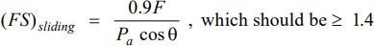
The factor of safety against sliding is obtained as:

When active pressures are relatively high (as when surcharge is involved), it will be generally difficult to mobilise the required factor of safety against sliding, by considering frictional resistance below the footing alone. In such a situation, it is advantageous to use a shear key projecting below the footing base and extending throughout the length of the wall.
When the concrete in the ‘shear key’ is placed in an unformed excavation (against undisturbed soil), it can be expected to develop considerable passive resistance.

PROPORTIONING AND DESIGN OF CANTILEVER AND COUNTERFORT WALLS
Prior to carrying out a detailed analysis and design of the retaining wall structure, it is necessary to assume preliminary dimensions of the various elements of the structure using certain approximations. Subsequently, these dimensions may be suitably revised, if so required by design considerations.

Position of Stem on Base Slab for Economical Design
An important consideration in the design of cantilever and counterfort walls is the position of the vertical stem on the base slab. It can be shown that an economical design of the retaining wall can be obtained by proportioning the base slab so as to align the vertical soil reaction R at the base with the front face of the wall (stem). For this derivation, let us consider the typical case of a level backfill. The location of the resultant soil reaction, R, is dependent on the magnitude and location of the resultant vertical load, W, which in turn depends on the dimension X (i.e., the length of heel slab, inclusive of the stem thickness). For convenience in the derivation, X may be expressed as a fraction, αx, of the full width L of the base slab (X = αxL). Assuming an average unit weight γe for all material (earth plus concrete) behind the front face of the stem (rectangle abcd), and neglecting entirely the weight of concrete in the toe slab,
R = W = γe hX = γe h (αXL)
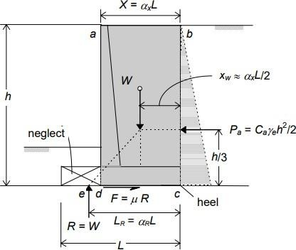

Fig: Proportioning of Retaining Wall
For a given location of R corresponding to a chosen value of X, the toe projection of the base slab (and hence its total width, L) can be so selected by the designer as to give any desired distribution of base soil pressure. Thus, representing the distance, LR, from the heel to R as a fraction αR of base width L, the base pressure will be uniform if L is so selected as to make αR = 0.5. Similarly, for αR = 2/3, the base pressure distribution will be triangular. Thus, for any selected distribution of base pressure, αR is a constant and the required base width L = LR/αR.
Considering static equilibrium and taking moments about reaction point e, and assuming Xw ≈ αXL/2,
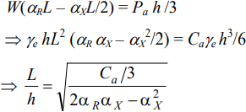

For economical proportioning for a given height of wall (h), the length of the base (L) must be minimum, i.e., L/h should be minimum. This implies that (2 αR αX – αX 2 ) should be maximum. The location of R, and hence the base width for any selected pressure distribution, is dependent on the variable X, i.e., αx. For maximising (2αR αx – α² x),
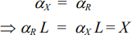

Width of Base
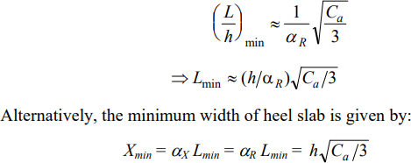
Applying the above principle, an approximate expression for the minimum length of base slab for a given height of wall is obtained as:
The effect of surcharge or sloping backfill may be taken into account, approximately, by replacing h with h + hs , or h's, respectively. Alternatively, and perhaps more conveniently, using the above principle, the heel slab width may be obtained by equating moments of W and Pa about the point d. The required L can then be worked out based on the base pressure distribution desired.
It may be noted that the total height h of the retaining wall is the difference in elevation between the top of the wall and the bottom of base slab. The latter is based on geotechnical considerations (availability of firm soil) and is usually not less than 1 m below the ground level on the toe side of the wall.
After fixing up the trial width of the heel slab ( = X) for a given height of wall and backfill conditions, the dimension L may be fixed up. Initially, a triangular pressure distribution may be assumed, resulting in L = 3/2 X . Using other approximations related to stem thickness and base slab thickness, a proper analysis should be done to ascertain that
  - the factor of safety against overturning is adequate;
  - the allowable soil pressure, qa, is not exceeded; and
  - the factor of safety against sliding is adequate.
Condition (1) is generally satisfied; however, if it is not, the dimensions L and X may be suitably increased. If condition
(2) is not satisfied, i.e., if qmax > qa, the length L should be increased by suitably extending the length of the toe slab; the dimension X need not be changed. If condition (3) is not satisfied, which is usually the case, a suitable ‘shear key’ should be designed.

Proportioning and Design of Elements of Cantilever Walls Initial Thickness of Base Slab and Stem
For preliminary calculations, the thickness of the base slab may be taken as about 8 percent of the height of the wall plus surcharge (if any); it should not be less than 300 mm. The base thickness of the vertical stem may be taken as slightly more than that of the base slab. For economy, the thickness may be tapered linearly to a minimum value (but not less than 150 mm) at the top of the wall; the front face of the stem is maintained vertical. If the length of the heel slab and/or toe slab is excessive, it will be economical to provide a tapered slab. With the above preliminary proportions, the stability check and determination of soil pressure (at the base) may be performed, and dimensions L and X of the base slab finalised. It may be noted that changes in thicknesses of base slab and stem, if required at the design stage, will be marginal and will not affect significantly either the stability analysis or the calculated (gross) soil pressures below the base slab.

Design of Stem, Toe Slab and Heel Slab
The three elements of the retaining wall, viz., stem, toe slab and heel slab have to be designed as cantilever slabs to resist the factored moments and shear forces. For this a load factor of 1.5 is to be used. In the case of the toe slab, the net pressure is obtained by deducting the weight of the concrete in the toe slab from the upward acting gross soil pressure. The net loading acts upward (as in the case of usual footings) and the flexural reinforcement has to be provided at the bottom of the

toe slab. The critical section for moment is at the front face of the stem, while the critical section for shear is at a distance d from the face of the stem. A clear cover of 75 mm may be provided in base slabs. In the case of the heel slab, the pressures acting downward, due to the weight of the retained earth (plus surcharge, if any), as well as the concrete in the heel slab, exceed the gross soil pressures acting upward. Hence, the net loading acts downward, and the flexural reinforcement has to be provided at the top of the heel slab. The critical section for moment is at the rear face of the stem base.
In the case of the stem (vertical cantilever), the critical section for shear may be taken d from the face of the support (top of base slab), while the critical section for moment should be taken at the face of the support. For the main bars in the stem, a clear cover of 50 mm may be provided. Usually, shear is not a critical design consideration in the stem (unlike the base slab). The flexural reinforcement is provided near the rear face of the stem, and may be curtailed in stages for economy. Temperature and shrinkage reinforcement (Ast,min = 0.12 percent of gross area) should be provided transverse to the main reinforcement. Nominal vertical and horizontal reinforcement should also be provided near the front face which is exposed.

Proportioning and Design of Elements of a Counterfort Wall Initial Thicknesses of Various Elements
In a counterfort wall, counterforts are usually provided at a spacing of about one-third to one-half of the height of the wall. The triangular shaped counterforts are provided in the rear side of the wall, interconnecting the stem with the heel slab. Sometimes, small buttresses are provided in the front side below the ground level, interconnecting the toe slab with the lower portion of the stem. The presence of counterforts enables the use of stem and base slab thicknesses that are much smaller than those normally required for a cantilever wall. For preliminary calculations, the stem thickness and heel slab thickness may be taken as about 5 percent of the height of the wall, but not less than 300 mm. If the front buttress is provided, the thickness of the toe slab may also be taken as 0.05h; otherwise, it may be taken as in the case of the cantilever wall (0.08h). The thickness of the counterforts may be taken as about 6 percent of the height of the wall at the base, but not less than 300 mm. The thickness may be reduced along the height of the wall. With the above preliminary proportions, the stability check and determination of soil pressures (at the base) may be performed, and dimensions L and X of the base finalised, as in the case of the cantilever wall.
Each panel of the stem and heel slab, between two adjacent counterforts, may be designed as two-way slabs fixed on three sides, and free on the fourth side (free edge). These boundary conditions are also applicable to the toe slab, if buttresses are provided; otherwise the toe slab behaves as a horizontal cantilever, as in the case of the cantilever wall. The loads acting on these elements are identical to those acting on the cantilever wall discussed earlier. For the stem, bending in the horizontal direction between counterforts† is generally more predominant than bending in the vertical direction. Near the counterforts, the main reinforcement will be located close to the rear face of the stem, whereas midway between counterforts, the reinforcement will be close to the outside face. These two-ways slabs, subject to triangular/trapezoidal pressure distributions may be designed by the use of moment and shear coefficients (based on plate theory), available in various handbooks, and also in the IS Code for the design of liquid storage structures, viz., IS 3370 (Part 4). Alternatively, the slabs may be designed by the yield line theory. An alternative simplified method of analysis is demonstrated in example later on.

Design of Counterforts
The main counterforts should be firmly secured (by additional ties) to the heel slab, as well as to the vertical stem, as the loading applied on these two elements tend to separate them from the counterforts. In addition, the counterfort should be designed to resist the lateral (horizontal) force transmitted by the stem tributary to it. The counterfort is designed as a vertical cantilever, fixed at its base. As the stem acts integrally with the counterfort, the effective section resisting the cantilever moment is a flanged section, with the flange under compression. Hence, the counterforts may be designed as T-beams with the depth of section varying (linearly) from the top (free edge) to the bottom (fixed edge), and with the main reinforcement provided close to the sloping face. Since these bars are inclined (not parallel to the compression face), allowance has to be made for this in computing the area of steel required.

Example 1:
Determine suitable dimensions of a cantilever retaining wall, which is required to support a bank of earth 4.0 m high above the ground level on the toe side of the wall. Consider the backfill surface to be inclined at an angle of 15º with the horizontal. Assume good soil for foundation at a depth of 1.25 m below the ground level with a safe bearing capacity of 160 kN/m². Further assume the backfill to comprise granular soil with a unit weight of 16 kN/m³ and an angle of shearing resistance of 30º. Assume the coefficient of friction between soil and concrete to be 0.5.
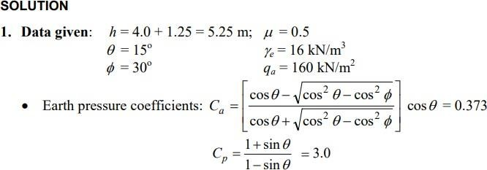

Preliminary proportions:
  - Thickness of footing base slab ≈ 0.08h = 0.08 × 5.25 = 0.42 m Assume a thickness of 420 mm.
  - Assume a stem thickness of 450 mm at the base of the stem, tapering to a value of 150 mm at the top of the wall.
  - For an economical proportioning of the length L of the base slab, it will be assumed that the vertical reaction R at the footing base is in line with the front face of the stem. For such a condition, (assuming the height above top of wall to be about 0.4 m), the length of the heel slab (inclusive of stem thickness):
  - Assuming a triangular base pressure distribution, L = 1.5X = 3.0 m
  - The preliminary proportions are shown in Fig.
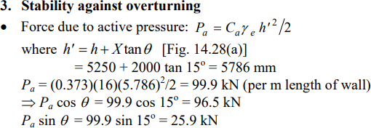
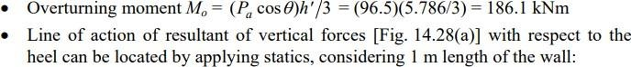

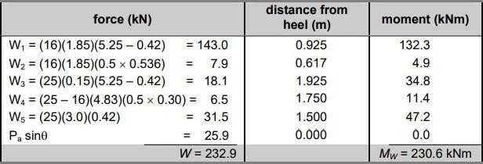

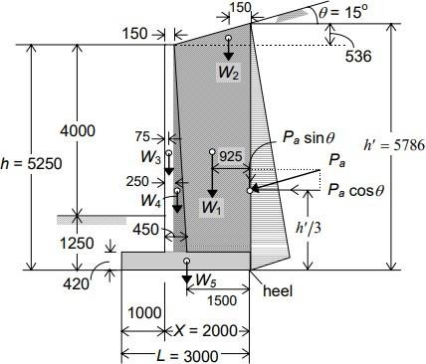
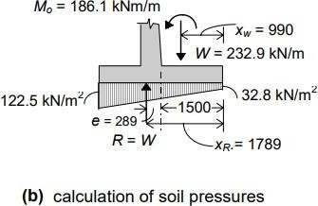

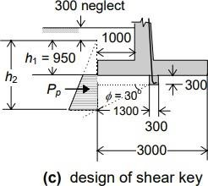
Fig: Forces on wall (with preliminary proportions)
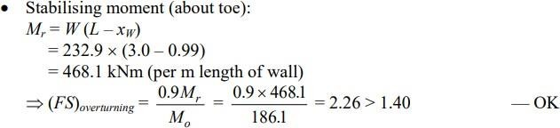
⇒ distance of resultant vertical force from heel xW = MW /W = 230.6/232.9 = 0.990 m

4. Soil Pressure at footing base:
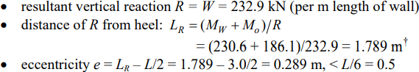

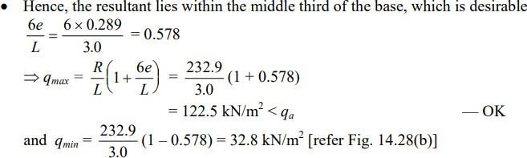
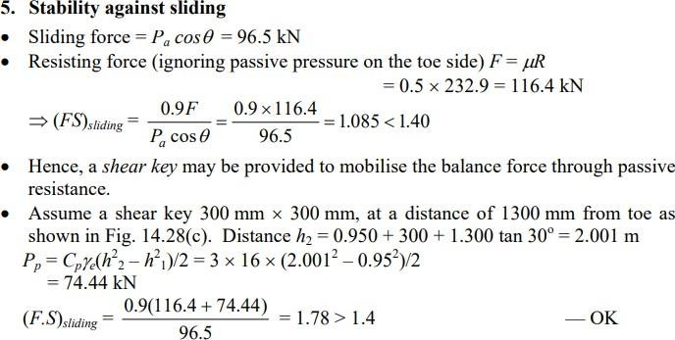

Example 2: Repeat the problem in Example 1, considering the backfill to be level, but subject to a surcharge pressure of 40 kN/m2 (due to the construction of a building). Design the retaining wall structure, assuming M 20 and Fe 415 steel.
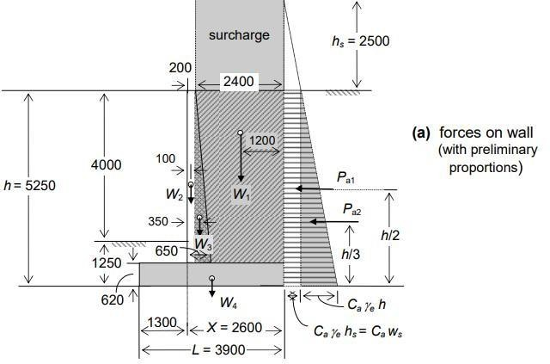

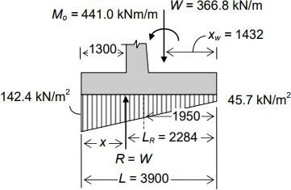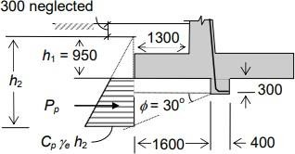

Fig. Calculation of Soil Pressures Fig. Design of Shear key
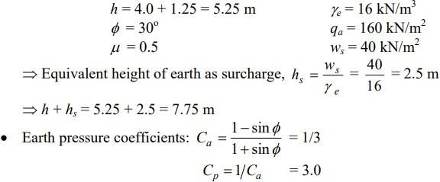

Preliminary proportions
  - Thickness of footing base slab ≈ 0.08 (h + hs) = 0.08 × 7.75 = 0.620. Assume a thickness of 620 mm.
  - Assume a stem thickness of 650 mm at the base of the stem, tapering to a value of 200 mm at the top of the wall.
  - For an economical proportioning of the length L of the base slab, it will be assumed that the vertical reaction R at the footing base is in line with the front face of the stem. For such a condition, the length of the heel slab (inclusive of stem thickness).
  - Assuming a triangular soil pressure distribution below the base, L = 1.5X = 1.5 × 2.6 = 3.9 m
  - The preliminary proportions are shown in Fig.
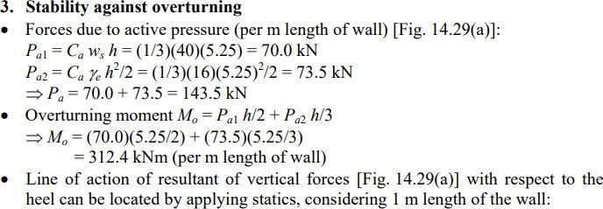

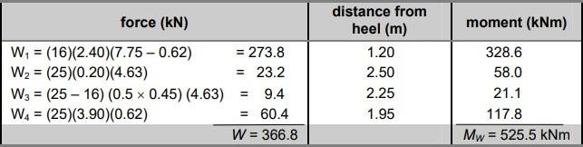
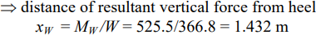
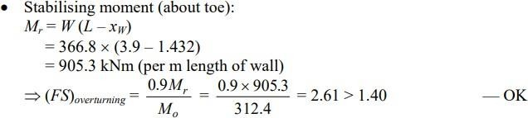

4. Soil Pressure at footing Base:
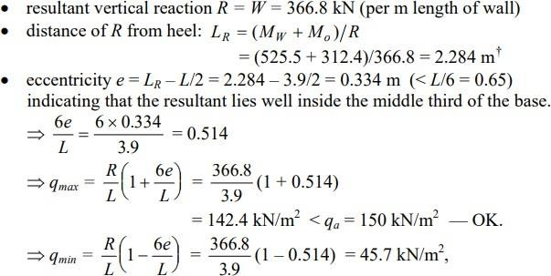
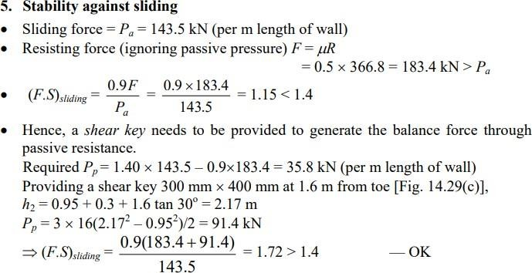

- Design of toe slab
  - The loads considered for the design of the toe slab are as shown in fig. The net pressures, acting upward, are obtained by reducing the uniformly distributed self-weight of the toe slab from the gross pressures at the base. Self-weight loading = 25 × 0.62 = 15.5 kN/m²
  - The net upward pressure varies from 126.9 kN/m² to 94.7 kN/m²
  - Assuming a clear cover of 75 mm and 16 φ bars, d = 620 – 75 – 8 = 537 mm
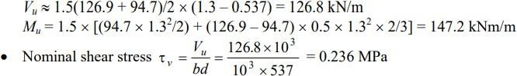
  - Applying a load factor of 1.5, the design shear force (at d = 537 mm from the front face of the stem) and the design moment at the face of the stem are given by:
For a τc = 0.24 MPa, the required pt = 0.10 with M 20 concrete
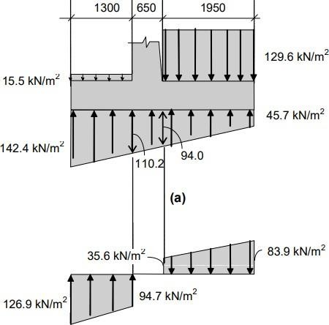

Fig: Net Soil pressures acting on base slab
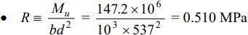
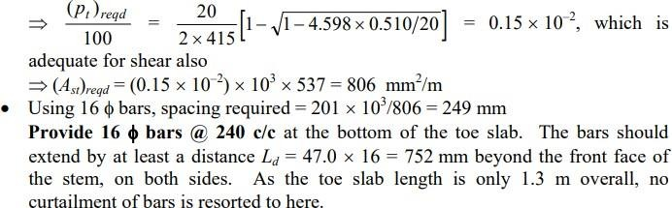

Design of Heel Slab
  - The loads considered for the design of the heel slab are as shown in Fig. The distributed loading acting downward on the heel slab is given by
o Overburden + surcharge @ 16 × (7.75 – 0.62) = 114.1 kN/m2
o Heel slab @ 25 × 0.62 = 15.5 kN/m² ⇒ w = 129.6 kN/m²
  - The net pressure acts downwards, varying between 35.6 kN/m2 and 83.9 kN/m² as shown in Fig.
  - Applying a load factor of 1.5, the design shear force and bending moment at the (rear) face of the stem are given by
o Vu = 1.5(35.6 + 83.9)/2 × 1.95 = 174.8 kN/m
o Mu = 1.5 × [(35.6 × 1.952 /2) + (83.9 – 35.6) × 0.5 × 1.952 × 2/3] = 193.4 kNm/m
  - Assuming a clear cover of 75 mm and 16 φ bars, d = 620 – 75 – 8 = 537 mm
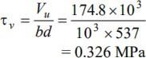
  - Nominal shear stress

Corresponding τc = 0.33, with M 20 concrete; So (pt)reqd.= 0.20
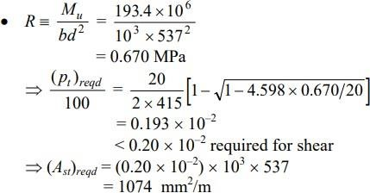
    - Using 16 φ bars, spacing required = 201 × 103 /1074 = 187 mm
Provide 16 φ bars @ 180 c/c at the top of the heel slab. The bars should extend by at least a distance
Ld = 47.0 × 16 = 752 mm beyond the rear face of the stem, on both sides. The bars may be curtailed part way to the heel; however, since the length is relatively short, this is not resorted to in this example.

Design of vertical stem
  - Height of cantilever above base h = 5.250 – 0.62 = 4.63 m
  - Assuming a clear cover of 50 mm and 20 φ bars, d (at the base) = 650 – 50 – 10 = 590 mm
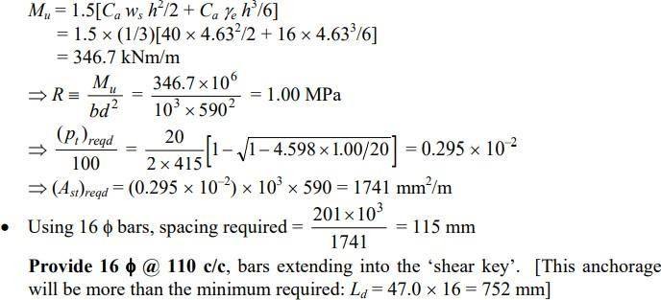
  - Assuming a load factor of 1.5, maximum design moment

Check for Shear:
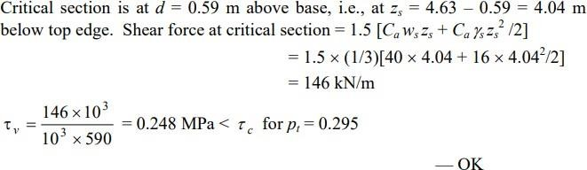
Note that since the shear stress is low and flexural reinforcement ratio also is low, the thickness of stem at base could be reduced for a more economical design.
- Curtailment of bars:
The curtailment of the bars may be done in two stages (at one-third and two-third heights of the stem above the base) as shown in Fig. below. It can be verified that the curtailment satisfies the Code requirements.
- Temperature and Shrinkage reinforcement Provide two-thirds of the (horizontal) bars near the front face (which is exposed to weather and the remaining one-third near the rear face. For the lowermost onethird height of the stem above base,
Ast = (0.0012 × 103 × 650) × 2/3 = 520 mm² /m
- Using 8 φ bars, spacing required = 50.3 × 10³ /520 = 97 mm ≈ 100 mm. Provide 8 φ @ 100 c/c near front face and 8 φ @ 200 c/c near rear face in the lowermost one-third height of the wall; 8 φ @ 200 c/c near front face and 8 φ @ 400 c/c in the middle one-third height; and 8 φ @ 300 c/c near front face and 8 φ @ 600 c/c near the rear face in the top one-third height of the wall.
- Also provide nominal bars 10 φ bars @ 300 c/c vertically near the front face.
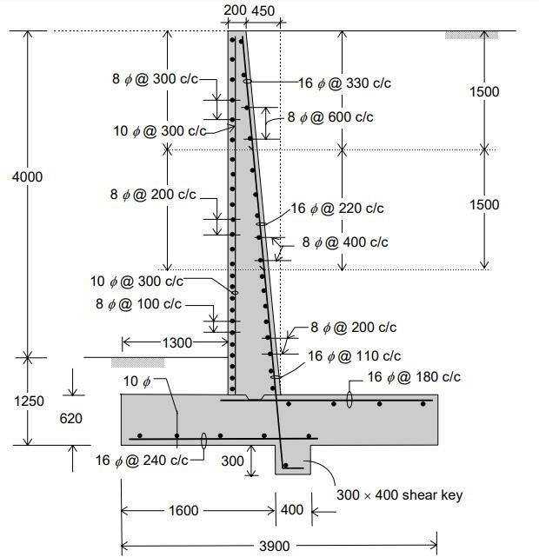

Fig: Detailing of cantilever wall

Counterfort Retaining Wall Numerical

Example 1:
Design a suitable counterfort retaining wall to support a level backfill, 7.5 m high above the ground level on the toe side. Assume good soil for foundation at a depth of 1.5 m below the ground level with a safe bearing capacity of 170 kN/m². Further assume the backfill to comprise granular soil with a unit weight of 16 kN/m³ and an angle of shearing resistance of 30º . Assume the coefficient of friction between soil and concrete to be 0.5. Use M 25 and Fe 415 steel.

Solution:
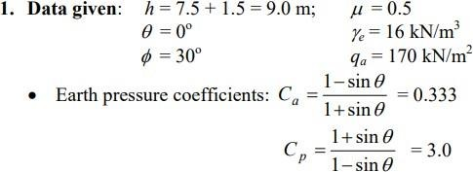

- Preliminary proportions:
  - The (triangular shaped) counterforts are provided on the rear (backfill) side of the wall, interconnecting the stem with the heel slab.
    - Spacing of counterforts ≈ h 3 1 to h 2 1 = 3.0 m to 4.5 m
    - Assume the counterforts are placed with a clear spacing of 3.0 m.
    - Thickness of counterforts ≈ 0.05h = 0.05 × 9.0 = 0.45 m. Assume a thickness of 500 mm.
  - Thickness of heel slab ≈ 0.05h = 0.05 × 9.0 = 0.45 m. Assume a thickness of 500 mm
  - Assuming that the front buttresses are not provided, Thickness of toe slab ≈ 0.08h = 0.08 × 9.0 = 0.72 m. Assume a thickness of 720 mm
  - Thickness of stem slab ≈ 0.06h = 0.06 × 9.0 = 0.54 m. Assume a stem thickness of 600 mm at the base of the stem, tapering to a value of 300 mm at the top of the wall.
  - For an economical proportioning of the length L of the base slab, it is assumed that the vertical reaction R at the footing base is in line with the front face of the stem. For such a condition, (inclusive of stem thickness)
  - Assuming a triangular base pressure distribution, L = 1.5X = 4.5 m
  - The preliminary proportions are shown in Fig.

Stability against overturning
  - Forces due to active pressure (per m length of wall)
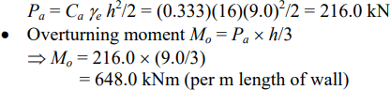
  - Line of action of resultant of vertical forces with respect to the heel can be located by applying statics, considering 1 m length of the wall (the marginal additional weight due to counterfort is ignored)
⇒ distance of resultant vertical force from heel xW = MW /W = 864.8 / 506.9 = 1.706 m

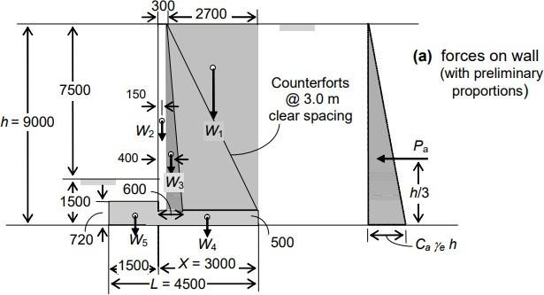

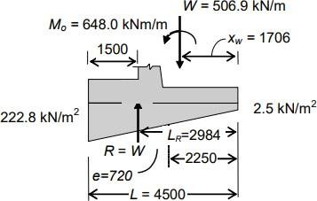
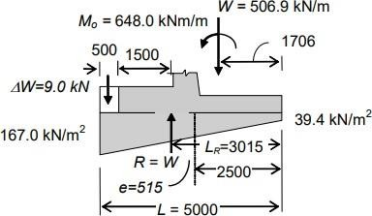

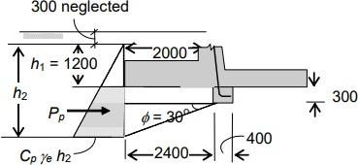
Fig: Cal. Of Soil Pressure Fig: Revised design for safe soil pressures

Fig: Design of Shear Key

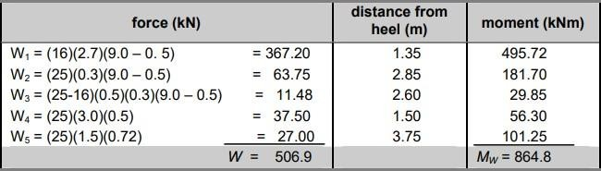

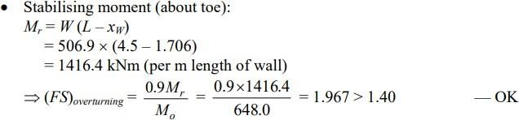

Soil Pressure at Footing Base:
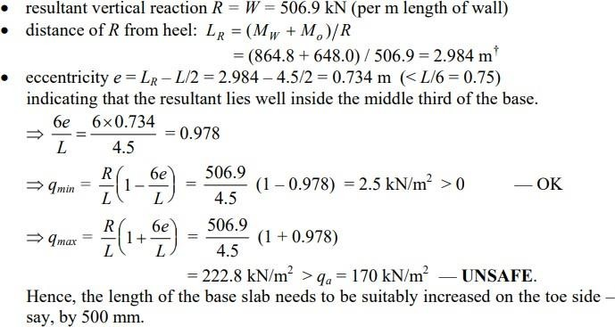
Let L = 5.0 m. Additional weight due to 500 mm extension of toe slab ΔW = 25 × 0.5 × 0.72 = 9.0 kN
⇒ R = W + ΔW = 506.9 + 9.0 = 515.9 kN
Considering moments about the heel: 515.9 LR = 864.8 + (9.0)(5.0 – 0.25) + 648.0 ⇒ LR =3.015 m
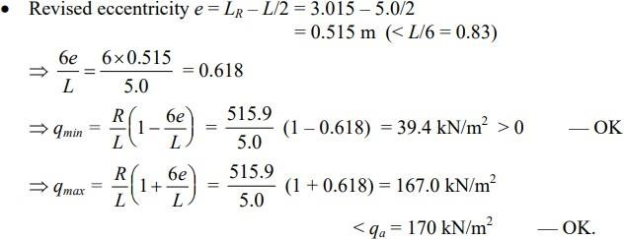
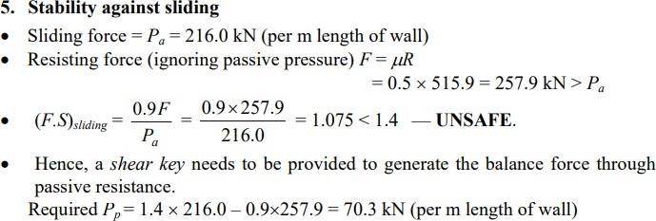

Providing a shear key 400 mm × 300 mm at 2.4 m from toe,
h2 = 1.2 + 0.3 + 2.4 tan 30º = 2.89 m Pp = 3 × 16(2.89² – 1.2²)/2 = 165.9 kN

Design of toe slab
  - The loads considered for the design of the toe slab are as shown in Fig.
  - The net pressures, acting upward, are obtained by reducing the uniformly distributed self-weight of the toe slab from the gross pressures at the base. Self-weight loading = 25 × 0.72 = 18.0 kN/m²
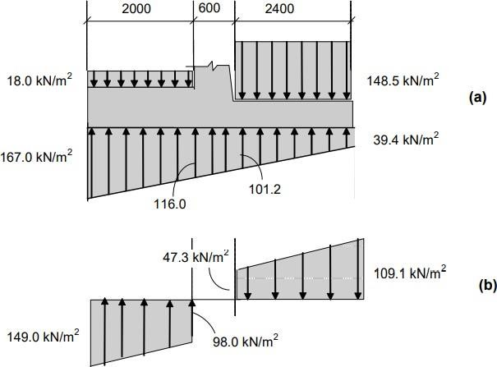

Fig: Net soil pressures acting on base slab
  - The net upward pressure varies from 149.0 kN/m2 to 97.9 kN/m², as shown above.
  - Assuming a clear cover of 75 mm and 16 φ bars, d = 720 – 75 – 8 = 637 mm
  - Applying a load factor of 1.5, the design shear force (at d = 637 mm from the front face of the stem) and the design moment at the face of the stem are given by:
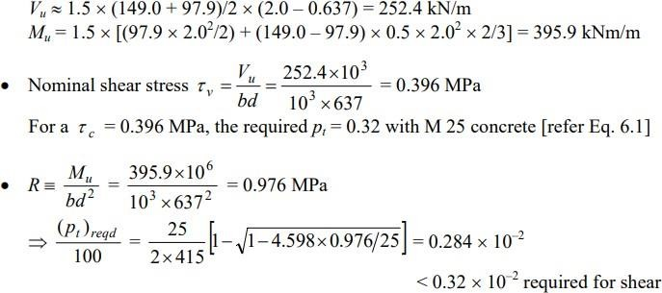

  - Using 16 φ bars, spacing required = 201 × 10³ /2039 = 98.6 mm
  - Using 20 φ bars, spacing required = 314 × 10³ /2039 = 154 mm
  - Provide 20 φ bars @ 150 c/c at the bottom of the toe slab.
  - The bars should extend by at least a distance Ld = 47.0 × 20 = 940 mm beyond the front face of the stem, on both sides.
  - Distribution steel: Provide 10 φ bars @ 200 c/c for the transverse reinforcement.

Design of heel slab
  - The loads (net pressures) considered for the design of the heel slab are as shown in Fig. above.
  - The distributed loading acting downward on the heel slab is given by
o overburden @ 16 × (9.0 – 0.5) = 136.0 kN/m²
o heel slab @ 25 × 0.5 = 12.5 kN/m² ⇒ w = 148.5 kN/m²
  - The net pressure acts downwards, varying between 47.3 kN/m2 and 109.1 kN/m2 as shown in Fig.
  - The counterforts are provided at a clear spacing of 3.0 m throughout the length of the wall. Thus, each heel slab panel (2.4m × 3.0m) may be considered to be fixed (continuous) at three edges (counterfort locations and junction with stem) and free at the fourth edge. The moment coefficients given in IS 456 do not cater to this set of boundary conditions, and reference needs to be made to other handbooks. Alternatively, we may apply the formulas obtained from yield line theory.
  - A common simplified design practice is to assume that some tributary (triangular) portion of the net load acting on the heel slab is transmitted through cantilever action, while much of the load (particularly near the free edge) is transmitted in the perpendicular direction through continuous beam action. The reinforcements in the remaining regions are judiciously apportioned. This procedure is followed here.

Design of heel slab for continuous beam action
Assuming a clear cover of 75 mm and 16 φ bars, d = 500 – 75 – 8 = 417 mm Consider a 1 m wide strip near the free edge of the heel. The intensity of pressure at a distance of 1 m from the free edge is 83.4 kN/m² .
Hence, the average loading on the strip may be taken as (83.4 + 109.1)/2 = 96.25 kN/m² . Applying a load factor of 1.5, wu = 1.5 × 96.25 = 144.4 kN/m² . The effective span is given by l = 3.0 + 0.417 = 3.417 m.
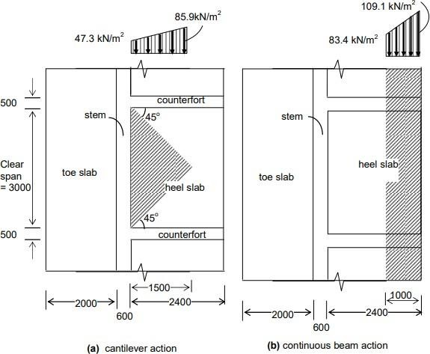

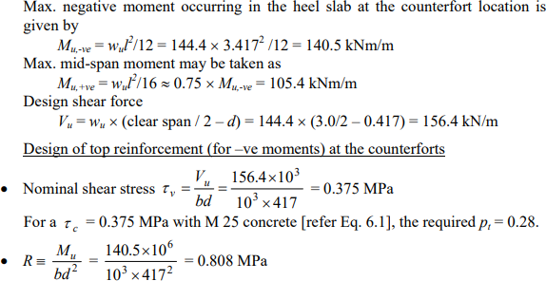
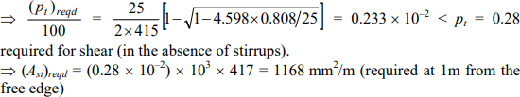
  - Using 16 φ bars, spacing required = 201 × 103 / 1168 = 172 mm
  - Using 12 φ bars, spacing required = 113 × 103 / 1168 = 96 mm
  - Minimum reinforcement for temperature and shrinkage:
o Min. Ast = .012/100 * 1000 * 500 = 600 mm² /m < 1168 mm2 /m OK.
  - At a distance beyond 1m from the free edge, only minimum reinforcement need be provided:
    - Spacing of 12 φ bars required for min. reinf. = 113 × 103 / 600 = 188 mm
  - Provide 12 φ bars @ 180 c/c at the top of the heel slab throughout, and introduce additional 12 φ bars in between two adjacent bars at the counterforts near the free edge over a distance of approx. 1m;
    - i.e., Provide 5 additional 12 φ bars on top, extending 1m from either side of the face of the counterfort.
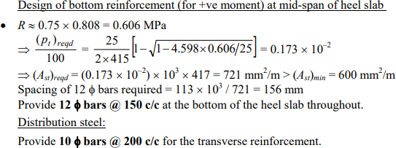

Design of heel slab for cantilever action
Consider the triangular loading on the heel slab to be carried by cantilever action with fixity at the face of the stem.
  - The intensity of load at the face of the stem = 47.3 kN/m².
  - The intensity of load at a distance of 1.5m from the face of the stem is 85.9 kN/m².

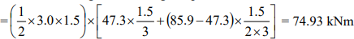
  - Total B.M. due to loading on the triangular portion

This moment is distributed non-uniformly across the width of 3.0m. For design purposes, the max. moment intensity (in the middle region) may be taken as two times the average value.
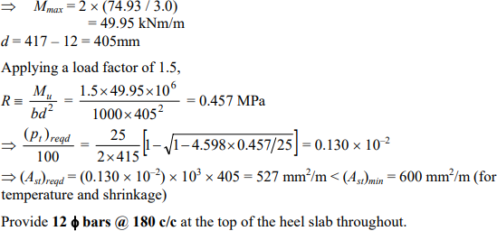

Design of vertical stem
The simplified analysis procedure adopted for the heel slab is used here for the vertical stem also. The cantilever action is limited to the bottom region only (triangular portion) with fixity at the junction of the stem with the base slab. Elsewhere, the stem is treated as a continuous beam spanning between the counterforts. The bending moments reduce along the height of the stem, owing to the reduction in the lateral pressures with increasing height.
Height of stem above base h = 9.0 – 0.5 = 8.5 m.
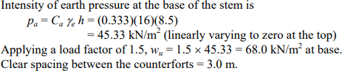
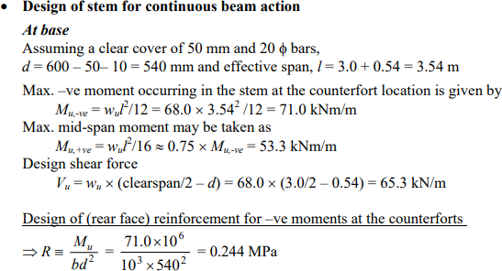

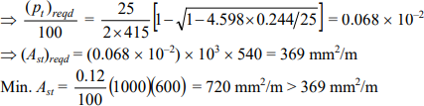
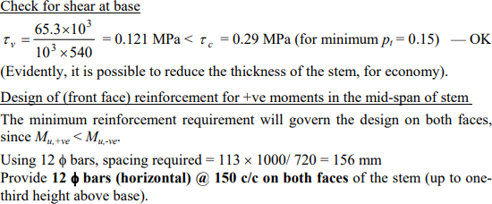
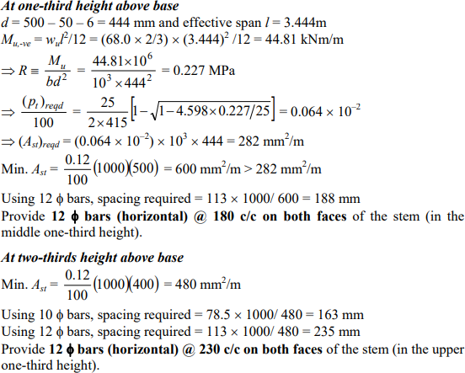

Design of interior counterfort
The typical interior counterfort acts as a T beam of varying section cantilevering out of the base slab. The design should include:
  - provision for beam action
  - provision of horizontal ties against separation from stem
  - provision of vertical ties against separation of base

Design of counterfort for T-beam action
The thickness of counterforts = 500 mm Clear spacing of counterforts = 3.0 m
Thus, each counterfort receives earth pressure from a width of l= 3.0 + 0.5 = 3.5 m
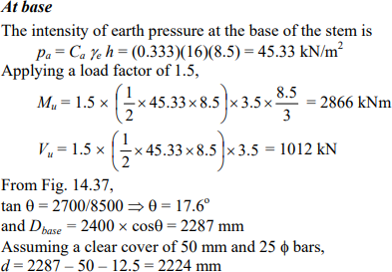
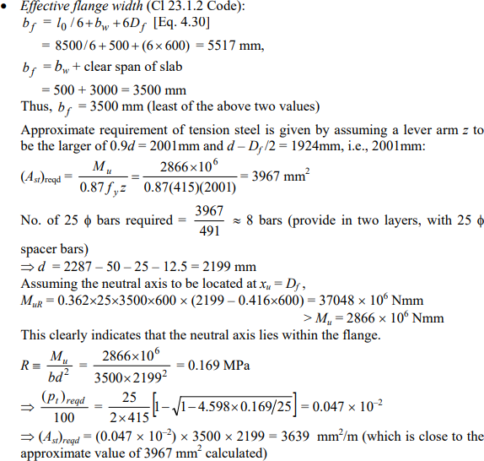

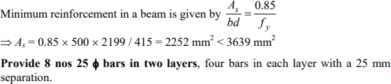
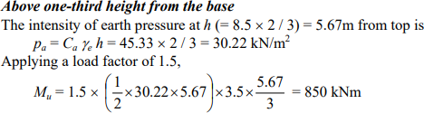
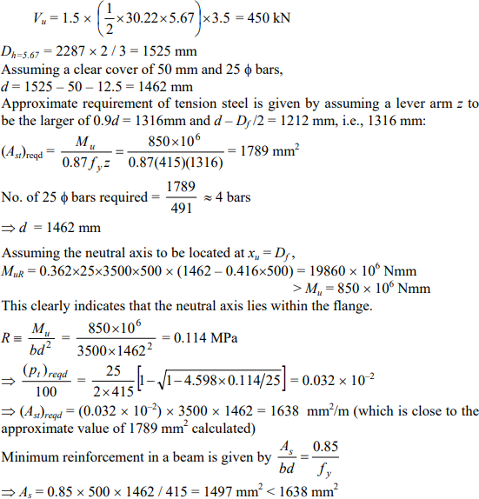

Curtail 4 nos 25 φ bars and extend 4 nos 25 φ bars (rear face).
In order to satisfy the minimum reinforcement criteria, 4 nos 25 φ bars may be extended to the top of the counterfort, without any further curtailment.

Detailed Figure on next Page:

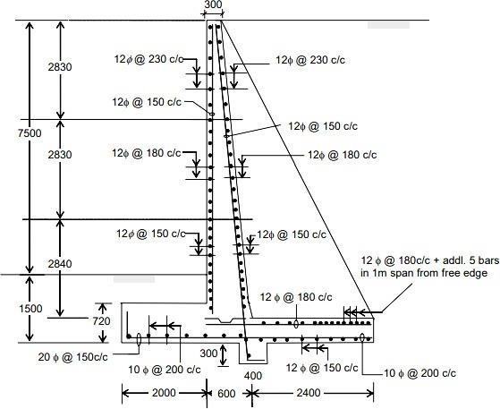

Fig: Reinforcement details of stem, toe slab and heel slab

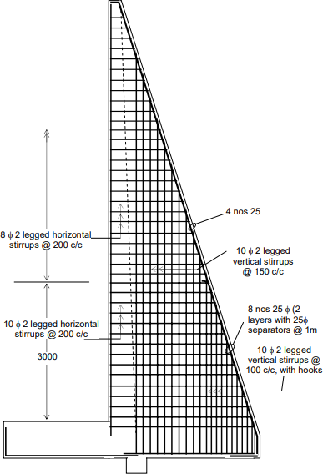

Fig: Section through counterfort showing counterfort reinforcement

Introduction

WATER TANKS

Tank (or reservoir) is a liquid storage structure that can be below or above the ground level. The liquid to be stored may be water, liquid petroleum, petroleum products or similar liquids. Though the tanks can be made of Reinforced Concrete (RC), steel or synthetic materials but in this unit only RC tanks have been covered. The tanks are often classified based on the following features:
  - Shape: Circular (flexible or rigid base), Rectangular, Intze, Conical or Funnel etc.
  - Location with respect to ground: Underground, Resting on ground, Partially underground and Overhead.
  - Capacity: Large, Medium and Small.
The shape has a very important role to play because the structural behaviour of different components of the tank depends upon it. Flexure being predominant in rectangular tanks, its section are heavier in comparison to other shapes. But based on the economic considerations due to its simple form, rectangular tanks are sometimes prefered especially for small capacity.
Reservoir below ground level are normally built to store large quantities of water, whereas, the overhead type are built for direct distribution by gravity flow and are usually of smaller capacity. The capacity requirement of a tank helps in deciding what type of tank will be suitable.

General Design Consideration
Besides strength, water tightness is one of the main considerations in the design of RC water tanks. It has to be ensured in their design that the concrete does not crack on the water face. Minimum grade of concrete used in water tanks is M 20. Imperviousness of concrete can be ensured by implementing the following recommendations:
  - Concrete mix containing well graded aggregate with water cement ratio less than 0.5 be used.
  - Concrete should be richer in cement and very well compacted.
  - Defects such as segregation and honey combing which are the potential source of leakage be avoided. The crack of concrete can be controlled by adopting the following measures:
  - The cracking due to shrinkage and temperature variation can be minirnised by keeping the concrete moist and filling the tank as soon as possible.
  - Avoid the use of thick timber shuttering that prevents the easy escape of the heat of hydration from the concrete mass.
  - Cracking is controlled by increasing the requirement of minimum reinforcement as given in Table below.
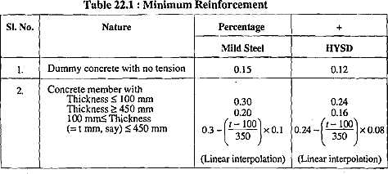

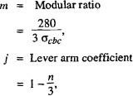
  - Use of deformed bars or ribbed steel improves the level of cracking strains in concrete by even distribution and slip minimization.
  - The cracking of concrete is also kept within allowable limits by reducing the allowable stresses in steel as given in Table below:
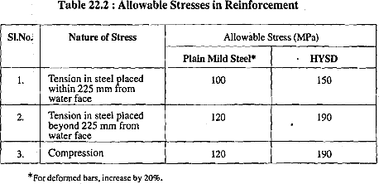
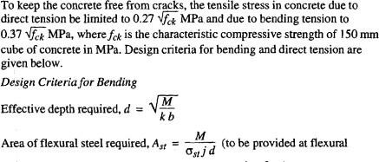
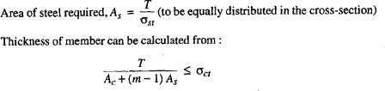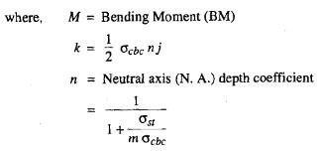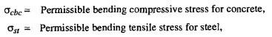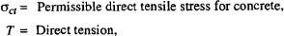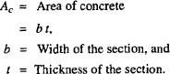

  - The concrete cover to the reinforcement is kept more for controlling the cracking. The minimum recommended cover is :
Clear cover = 20 rnm or diameter of bar for steel in direct tension
= 25 mrn for steel in bending tension
= 30 mm for alternate drying and wetting condition
Joints in Water Tanks
The various types of joints that are provided in water tanks can be categorized under three heads :
- Movement Joints
- Construction Joints
- Temporary Open Joints

Movements Joints
These are provlded for accommodating relative movement of the two sides. All movement joints are essentially flexible joints and require the incorporation of special materials in order to maintain water tightness. The movement joints are of three types :
  - Contraction Joint
  - Expansion Joint
  - Sliding Joint
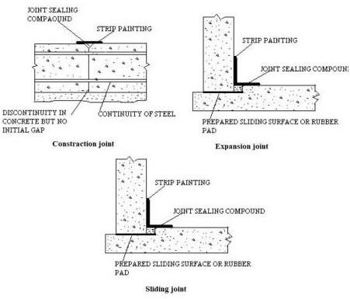

Design of tanks resting on ground
The water tanks resting on ground may be of the following types :
- Circular Tank with Flexible Base
- Circular Tank with Rigid Base
- Rectangular Tank
If the floor slab is resting continuously on the ground, a minimum thickness of 150 mm may be provided with a nominal reinforcement of 0.24% HYSD steel bars (0.3% for MS bars) in each direction. The slab should rest on a 75 mm thick layer of lean concrete (M 10 mix). The layer of lean concrete.should be first cured and then it should be covered with a layer of tarfelt to enable the floor slab to act independent of the bottom layer of concrete.
The design of tank walls of various types has been discussed in the following sections :
- Circular Tank with Flexible Base
Due to water pressure, the wall of a circular tank with flexible base between wall and base slab expand circurnferentially which increases linearly from zero at top to a maximum at the base as shown in Figure 22.4 by dotted line AB '. The circumferential expansion causes only hoop tension in the wall which will also increase linearly from top to the base of the wall. If D is the internal diameter of the tank, hoop tension at
This will be zero at the top of the wall where h is zero and maximum at the base of the wall.
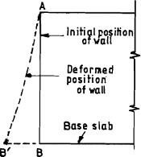

Fig. Circular Tank with Flexible base
- Circular Tank with Rigid Base
When the joint between the wall and face is rigid, there will not be any circumferential movement of the wall at its base and the wall will take the shape ACB (Figure below). The upper portion of the wall will have hoop tension while the lower part will bend like a cantilever fixed at B. In this case hoop tension will not be maximum at the base as in circular tank with flexible base. There are various methods for the determination of cantilever BM and hoop tension along the height of the wall. These methods are :
  - Reissner's Method
  - Carpenter's Simplified Method
  - BIS Code Method
  - Approximate Method

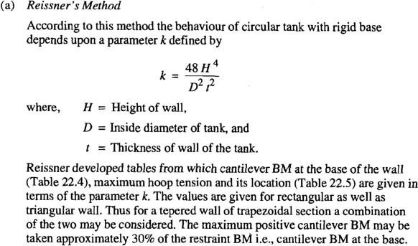
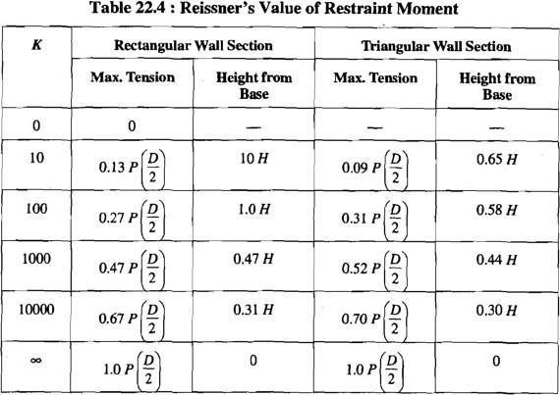
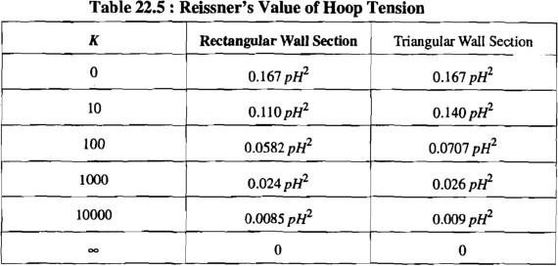

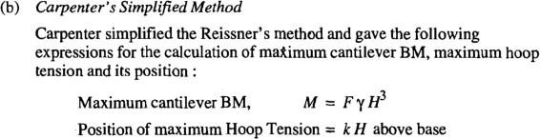

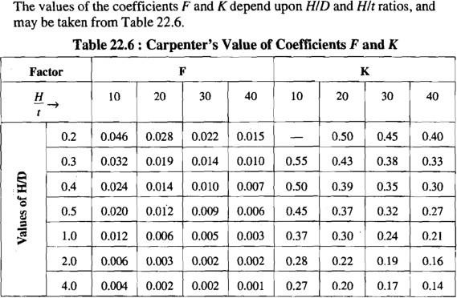
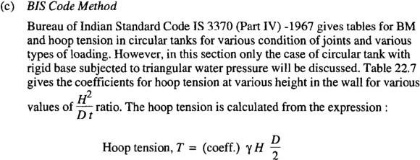

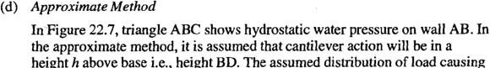
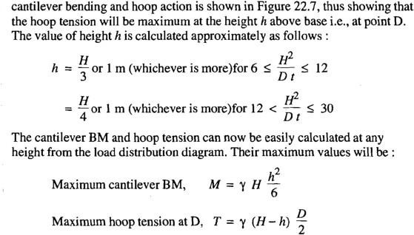

The reinforcement for cantilever BM will have to be provided on water face, whereas, hoop reinforcement will be in the form of rings to be provided either in the middle of the thickness of wall or on both faces.
- Rectangular Tank
For small capacity sometimes a rectangular tank is adopted to avoid exessive expenditure on curved shuttering required for circular water tanks. These tanks, however, are uneconomical for large capacity. The walls of a rectangular water tank are subjected to vertical as well as horizontal BM and pull on some portion of walls. The top edge of the walls which supports a relatively light roof slab can be treated as hinged or free, if the tank is open. The bottom edge of the walls which is normally built integrally with the base slab is treated as fixed.
There are situations where master pads, etc. are provided between the wall and the bottom slab, then the joint is treated as hinged.
The analysis of moments in walls of the tank is more difficult as the water pressure applies a triangular load on them. The magnitude of moments will depend upon the relative proportions of length, width and height of the tank and the support conditions of the top and bottom edges of the walls. The analysis of moments in the walls of a tank is made by elastic theory. The resulting differential equation is not easy to solve and therefore accurate solutions covering all cases are not available. IS 3370 (Part IV) gives tables from which moments and shears in walls for certain edge conditions can be calculated either directly or with suitable modifications. Alternatively, an approximate method can be employed for the design of open rectangular tanks. The method is discussed below.

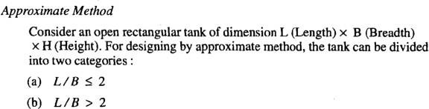

- L / B <= 2 : In Figure 22.9(a), triangle MPQ shows hydrostatic water pressure on wall MP. It is assumed that the cantilever action will be in a height h above base. The assumed distribution of load causing vertical cantilever bending and horizontal bending is shown in Figure 22.9(a), which shows that the horizoiltal bending will be maximum at the height h above base. The value of height h is taken as H //44 or 1 m whichever is greater. The final horizontal BM is calculated by the analysis of the continuous frame shown in Figure 22.9(b). The moment distribution method can be employed for the purpose. The cantilever BM at the base can be easily calculated as below :
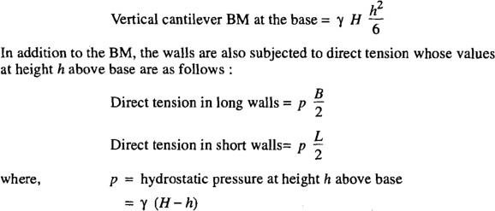
- L / B > 2 : The long walls are assumed to bend vertically as cantilever under the action of triangular hydrostatic pressure. In short walls, cantilever action is assumed in a height h above base. The distribution of load causing cantilever action and horizontal bending is same as for L / B I 2. The bending moments can thus be calculated easily as given below :
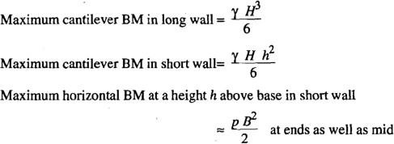

In addition to the bending moments, the long and short walls are subjected to direct tension. Since the short walls are assumed to be supported on long walls at its ends, there will be pull in the long walls which will be maximum at height h above base and can be calculated as below :
As the long walls behave as cantilever, therefore, no pull is transmitted to short wall because of water pressure on long walls. However, the water pressure on the end 1 m width of long wall is assumed to cause direct tension in short wall because cantilever action will not be there close to the ends. Thus,
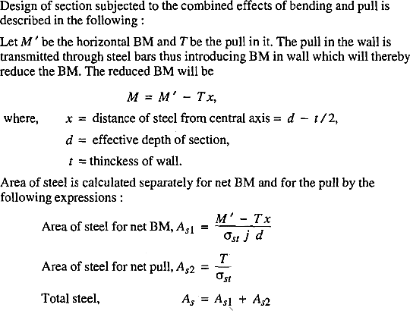

NUMERICALS
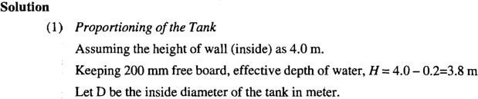
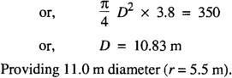
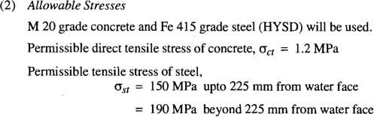
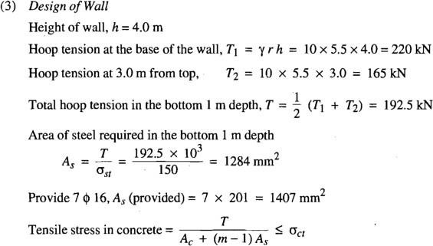

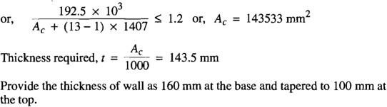
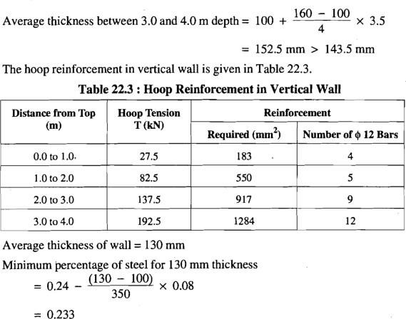

Minimum steel reinforcement = 0.233/100 * 1000 * 130
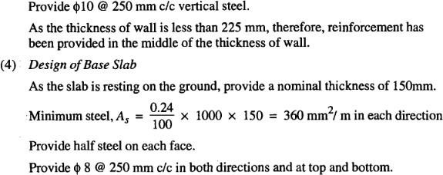

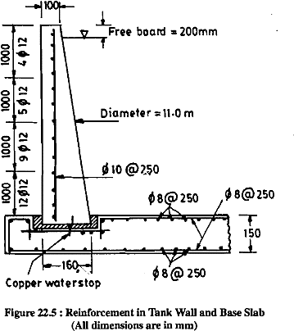

Q. Redesign the tank of above example, assuming that the base of the wall is monolithic with the base slab.
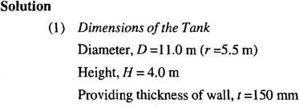
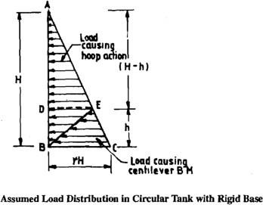

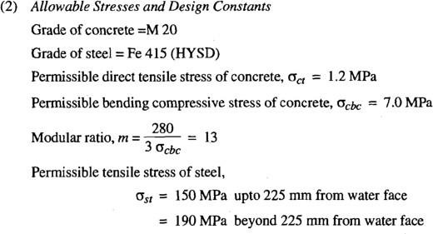
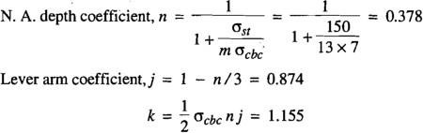
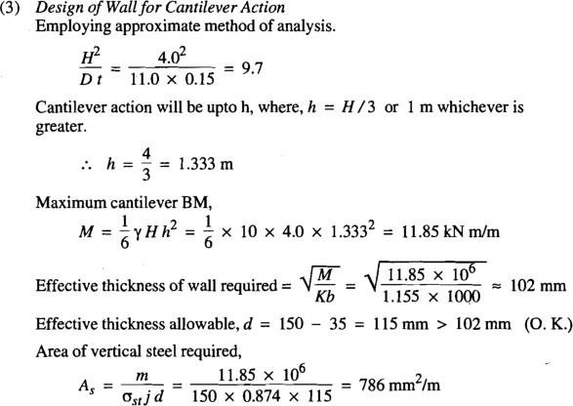

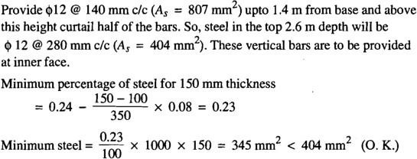

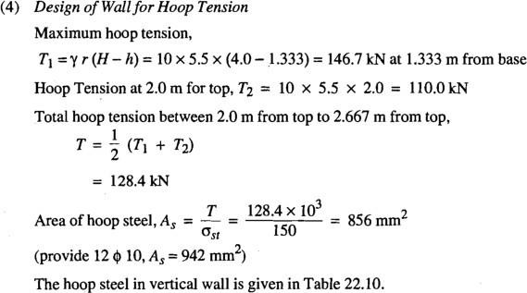
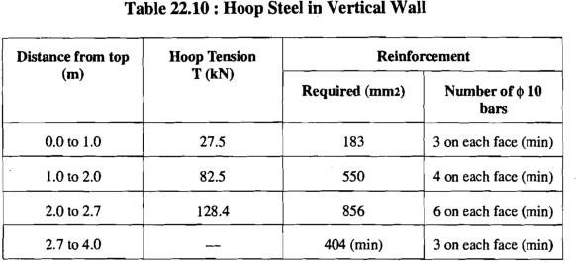

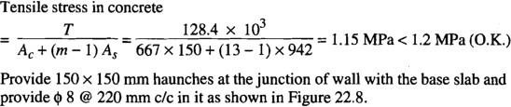

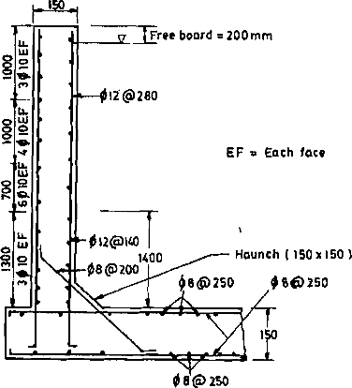

(5) Design of Base Slab: Same as previous example.

Q.2 RECTANGULAR WATER TANK DESIGN
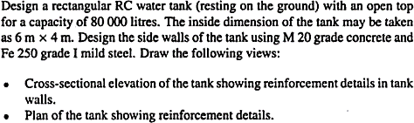
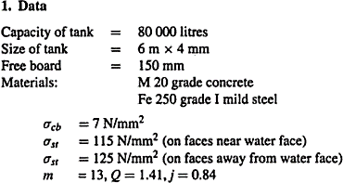
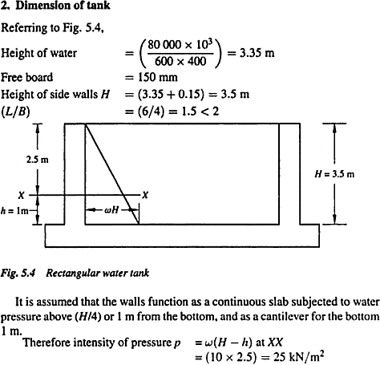

Alternatively, the design Tables of IS:3370 (Part-IV)-1967, clause 2.2 can be used for computation of moments in tank walls.
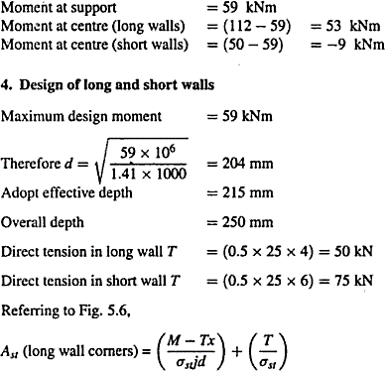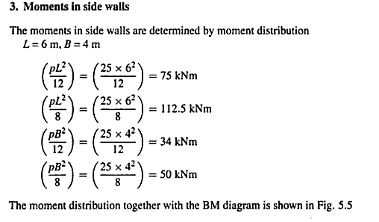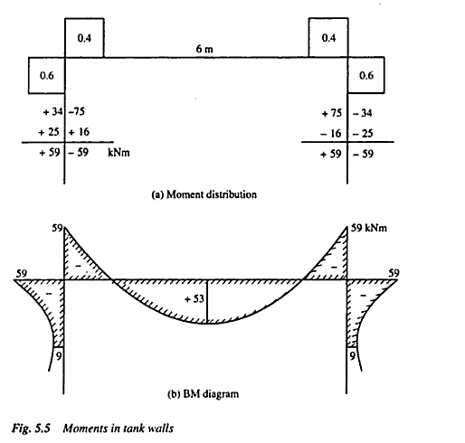

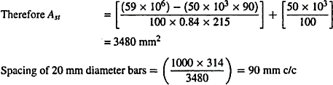
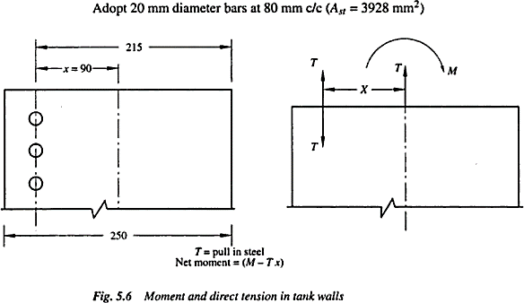
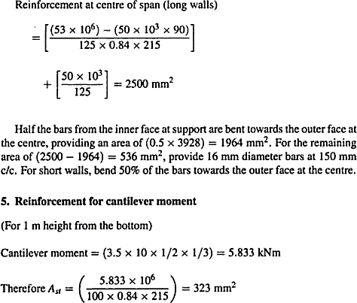

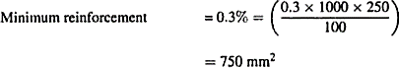

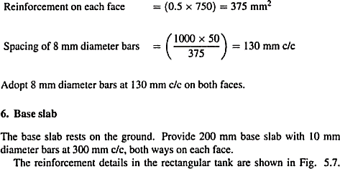
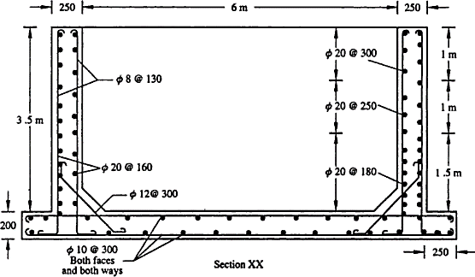

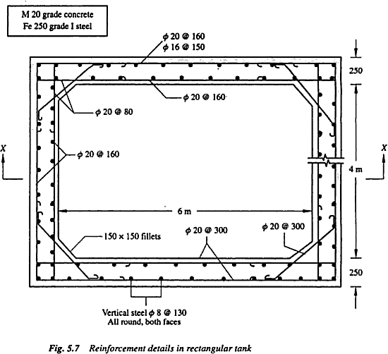

Numerical 3:
