Advanced Strength of Materials (20A01301)

LECTURE NOTES II-B.TECH & I-SEM
Prepared by:
Mr. B. RAMU, Assistant Professor
Department of Civil Engineering

VEMU INSTITUTE OF TECHNOLOGY

(Approved By AICTE, New Delhi and Affiliated to JNTUA, Ananthapuramu) Accredited By NAAC, NBA( EEE, ECE & CSE) & ISO: 9001-2015 Certified Institution Near Pakala, P.Kothakota, Chittoor- Tirupathi Highway
Chittoor, Andhra Pradesh-517 112 Web Site: www.vemu.org

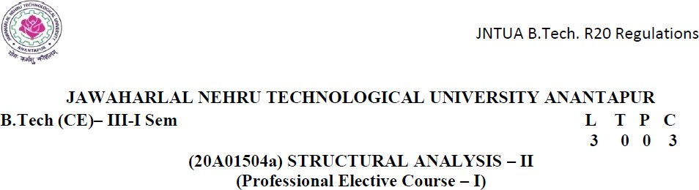
Course Objectives:
- To demonstrate analytical methods for determining strength & stiffness and assess stability of
- structural members.
- To enable the student analyze indeterminate trusses
- To make the student to understand the analysis procedures for analyzing fixed and Continuous beams.
- To enable the student to undergo analysis procedure using slope deflection method and moment distribution method.
- To enable the student to analyze the two hinged and three hinged arches
Course Outcomes (CO):
- Determine deflection at any point on a beam under simple and combined loads
- Apply energy theorems for analysis of indeterminate structures
- Analyze indeterminate structures with yielding of supports
- Analyze beams and portal frames using slope deflection and moment distribution methods
- Analyze bending moment, normal thrust and radial shear in the arches
UNIT - I Deflection of Beams
Uniform bending – slope, deflection and radius of curvature – Differential equation for elastic line of a beam – Double integration and Macaulay’s methods. Determination of slope and deflection for cantilever and simply supported beams under point loads, U.D.L. uniformly varying load-Mohr’s theorems – Moment area method – application to simply supported and overhanging beams- analysis of propped cantilever beams under UDL and point loads.
UNIT - II Torsion
Torsion: Theory of pure torsion – Assumptions and Derivation of Torsion formula for circular shaft – Torsional moment of resistance – Polar section modulus – power transmission through shafts – Combined bending and torsion –. Springs -Types of springs – deflection of close coiled helical springs under axial pull and axial couple – Carriage or leaf springs.
UNIT – III Columns and Struts
Introduction – classification of columns – Axially loaded compression members – Euler’s crippling load theory – derivation of Euler’s critical load formulae for various end conditions – Equivalent length – Slenderness ratio – Euler’s critical stress – Limitations of Euler’s theory – Rankine – Gordon formula – eccentric loading and Secant formula – Prof. Perry’s formula.
UNIT - IV Springs
Axial load and torque on helical springs - stresses and deformations - strain energy - compound springs
- leaf springs.
UNIT - V Thin and Thick Cylinders
Introduction - Thin Cylindrical shells - hoop stress - longitudinal stresses - Lame’s theory - Design of thin & thick cylindrical shells- Wire wound thin cylinders - Compound cylinders - Shrink fit - compound cylinders
Textbooks:
- Bansal R. K, "Strength of Materials", Laxmi Publications, 2010.
- B. C. Punmia Strength of Materials by.- Laxmi publications.
Reference Books:
- Schaum’s outline series Strength of Materials, Mc Graw hill International Editions.
- L.S. Srinath, Strength of Materials, Macmillan India Ltd., New Delhi
- Gere J.M. and Goodno B.J. “Strength of Materials” Indian Edition (4th reprint), Cengage Learning India Private Ltd., 2009.
- R.S.Khurmi and N.Khurmi, “Strength of Materials (Mechanics of Solids)”, S Chand And Company Limited, Ramnagar, New Delhi-110 055
- B. S. Basavarajaiah and P. Mahadevappa, “Strength of Materials” 3rd Edition 2010, in SI UNITs, Universities Press Pvt Ltd, Hyderabad.

SLOPE OF A BEAM:
INTRODUCTION

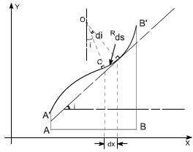
  - slope at any section in a deflected beam is defined as the angle in radians which the tangent at the section makes with the original axis of the beam.
  - slope of that deflection is the angle between the initial position and the deflected position.

DEFLECTION OF A BEAM:
  - The deflection at any point on the axis of the beam is the distance between its position before and after loading.
  - When a structural is loaded may it be Beam or Slab, due the effect of loads acting upon it bends from its initial position that is before the load was applied. It means the beam is deflected from its original position it is called as Deflection.

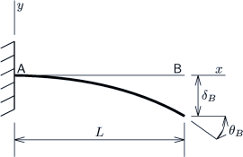
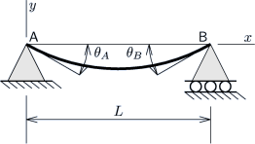

BASIC DIFFERENTIAL EQUATION:

Consider a beam AB which is initially straight and horizontal when unloaded. If under the actionof loads the beam deflect to a position A'B' under load or infact we say that the axis of the beam bends to a shape A'B'. It is customary to call A'B' the curved axis of the beam as the elastic line or deflection curve.

In the case of a beam bent by transverse loads acting in a plane of symmetry, the bending moment M varies along the length of the beam and we represent the variation of bending moment in B.M diagram. Futher, it is assumed that the simple bending theory equation holdsgood.
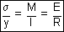

If we look at the elastic line or the deflection curve, this is obvious that the curvature at every point is different; hence the slope is different at different points.
To express the deflected shape of the beam in rectangular co-ordinates let us take two axes x andy, x-axis coincide with the original straight axis of the beam and the y – axis shows the deflection.

Further, let us consider an element ds of the deflected beam. At the ends of this element let us construct the normal which intersect at point O denoting the angle between these two normal be di.

But for the deflected shape of the beam the slope i at any point C is defined,
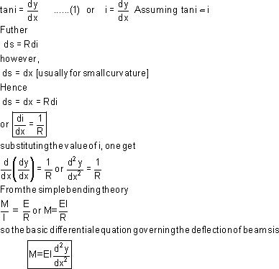

This is the differential equation of the elastic line for a beam subjected to bending in the plane of symmetry.

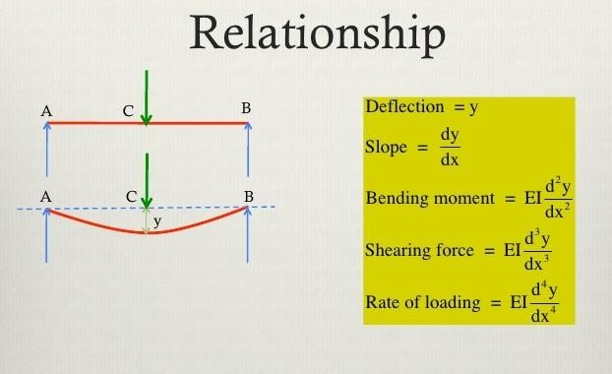

METHODS FOR FINDING THE SLOPE AND DEFLECTION OF BEAMS:

    - Double integration method
    - Moment area method
    - Macaulay’s method
    - Conjugate beam method
    - Strain energy method

DOUBLE INTEGRATION METHOD:
  - The double integration method is a powerful tool in solving deflection and slope of a beam at any point because we will be able to get the equation of the elastic curve.
  - This method entails obtaining the deflection of a beam by integrating the differential equation of the elastic curve of a beam twice and using boundary conditions to determine the constants of integration.
  - The first integration yields the slope, and the second integration gives the deflection.

CONJUGATE BEAM:
  - Conjugate beam is defined as the imaginary beam with the same dimensions (length) as that of the original beam but load at any point on the conjugate beam is equal to the bending moment atthat point divided by EI.
  - Slope on real beam = Shear on conjugate beam
  - Deflection on real beam = Moment on conjugate beam

PROPERTIES OF CONJUGATE BEAM:
- The length of a conjugate beam is always equal to the length of the actual beam.
- The load on the conjugate beam is the M/EI diagram of the loads on the actual beam.
- A simple support for the real beam remains simple support for the conjugate beam.
- A fixed end for the real beam becomes free end for the conjugate beam.
- The point of zero shear for the conjugate beam corresponds to a point of zero slope for the real beam.
- The point of maximum moment for the conjugate beam corresponds to a point of maximum deflection for the real beam.
SLOPE AND DEFLECTION FOR A SIMPLY SUPPORTED BEAM WITH CENTRAL POINT LOAD:

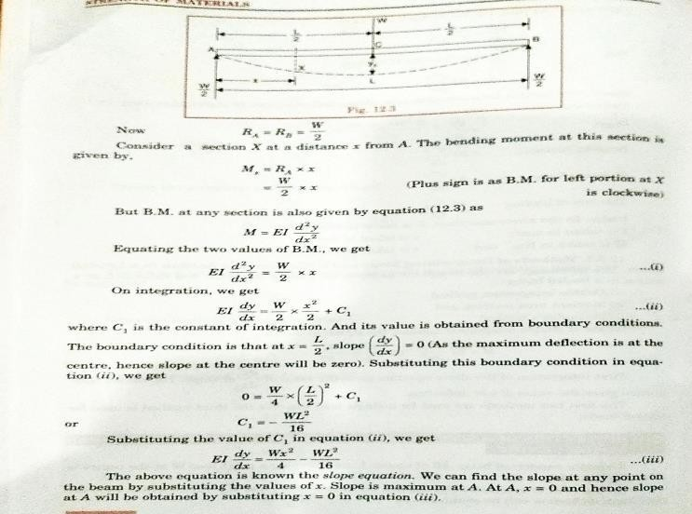

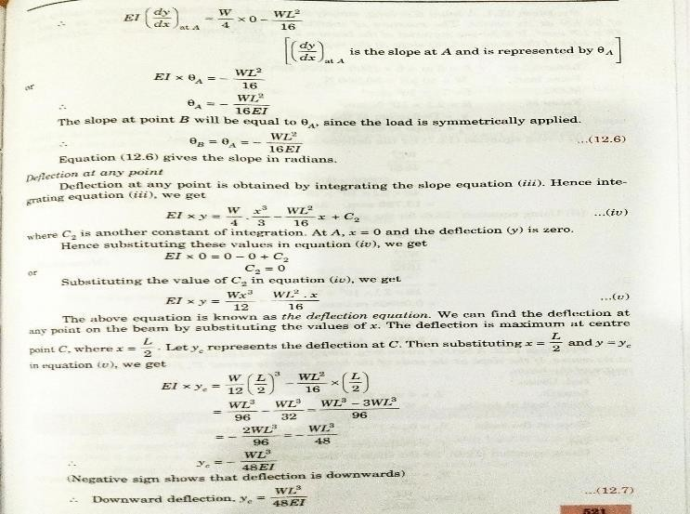

PROBLEMS:
1.A beam 6 m long, simply supported at its ends, is carrying a point load of 50 KN at its centre. The moment of inertia of the beam is 78 x 106 mm4. If E for the material of the beam = 2.1 X 105 N/mm2. calculate deflection at the centre of the beam and slope at the supports.
GIVEN DATA:
L = 6 m
W = 50 KN = 50 X 10³ N
I = 78 X 10 mm⁴
E = 2.1 X 10⁵ N/mm²
SOLUTION:
- DEFLECTION AT THE CENTRE OF THE BEAM, yc = WL³ / 48 EI
= 50000 X 6000³ / ( 48 X 2.1 X 10⁵ X 78 X 10⁶ )
= 13.736 mm.
- SLOPE AT THE SUPPORTS,

ϴA = ϴB = - WL² / 16 EI
= 50000 X 6000² / (16 X 2.1 X 10⁵ X 78 X 10⁶ )
= 0.06868 radians.
- A beam carries 4 m long simply supported at its ends, carries a point load W at its centre. If the slope at the ends of the beam is not to exceed 1° , find the deflection at the centre of the beam.
GIVEN DATA:
L = 4 m
ϴA = ϴB = 1° = 1° X (π /180) = 0.01745 radians.
SOLUTION:
  - DEFLECTION AT THE CENTRE OF THE BEAM, ϴA = ϴB = - WL² / 16 EI
0.01745 = WL² / 16 EI
yc = WL³ / 48 EI
= WL² / 16 EI X (L/3)
= 0.01745 X (4000/3)
= 23.26 mm.
- A beam 3 m long, simply supported at its ends, is carrying a point load W at the centre. If the slope at the ends of the beam should not exceed 1° , find the deflection at the centre of the beam.
GIVEN DATA:
L = 3 m
ϴA = ϴB = 1° = 1 X (π /180) = 0.01745 radians.
SOLUTION:
1.DEFLECTION AT THE CENTRE OF THE BEAM, ϴA = ϴB = - WL² / 16 EI
0.01745 = WL² / 16 EI
yc = WL³ / 48 EI
= WL² / 16 EI X (L/3)
= 0.01745 X (3000/3)
= 17.45 mm.

SLOPE AND DEFLECTION FOR A SIMPLY SUPPORTED WITH A UNIFORMLY DISTRIBUTED LOAD:
- A simply supported beam AB of length L and carrying a uniformly distributed load of w per unit length over the entire length is shown in fig.
- The reactions at A and B will be equal.
- Also, the maximum deflection will be at the centre of the beam.
- Each vertical reaction = (w X L)/2
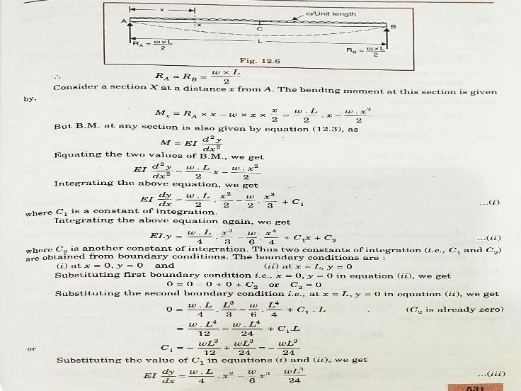

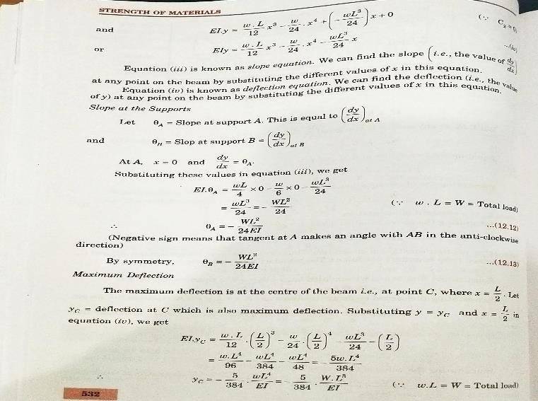

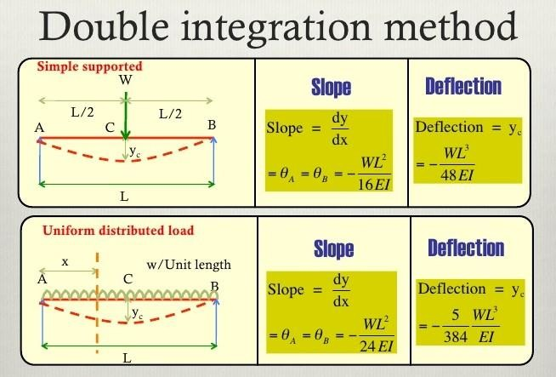
- A beam of uniform rectangular section 200 mm wide and 300 mm deep is simply supported at its ends. It carries a uniformly distributed load of 9 KN/m run over the entire span of 5 m. if the value of E for the beam material is 1 X 104 N/mm2 , find the slope at the supports and maximum deflection.
GIVEN DATA:
L = 5 m = 5 X 10³ mm
w = 9 KN/m = 9000 N/m E = 1 X 10⁴ N/mm²
b = 200 mm
d = 300 mm
SOLUTION:
  - SLOPE AT THE SUPPORTS,
ϴA = - WL² / 24 EI W = w.L = 9000 X 5 = 45000 N
= 45000 X 5000² I = bd³/12 = 200 X 300³ / 12
24 X 1 X 10⁴ X 4.5 X 10⁸ = 4.5 X 10⁸ mm⁴
= 0.0104 radians.

  - MAXIMUM DEFLECTION, y = 5 W L³
384 E I
= 5 X 45000 X 5000³
384 X 1 X 10⁴ X 4.5 X 10⁸
= 16.27 mm.
- A beam of length 5 m and of uniform rectangular section is simply supported at its ends. It carries a uniformly distributed load of 9 KN/m run over the entire length. Calculate the width and depth of the beam if permissible bending stress is 7 N/mm2 and central deflection is not to exceed 1 cm.
GIVEN DATA:
L = 5 m = 5 X 10³ mm, w = 9 KN/m = 9000 N/m

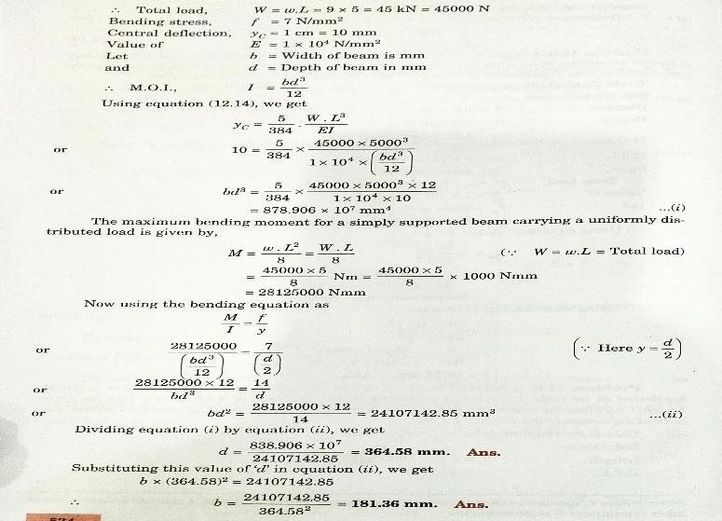

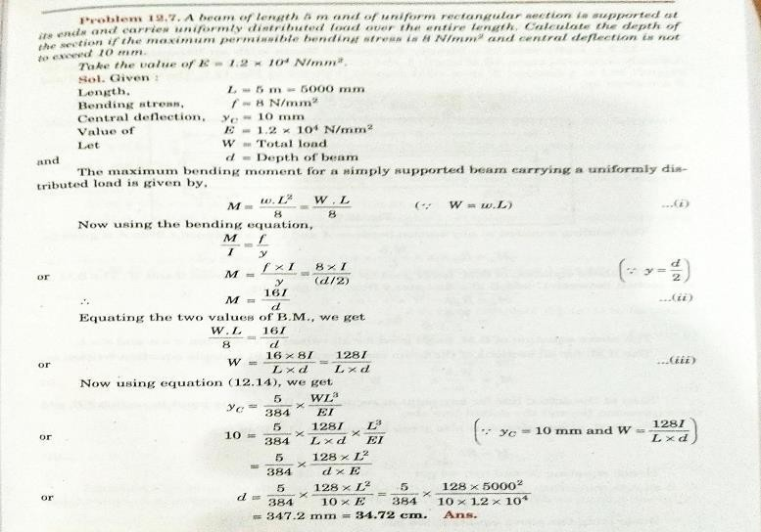

SLOPE AND DEFLECTION FOR A SIMPLY SUPPORTED BEAM WITH AN ECCENTRIC POINT LOAD
  - SLOPE AT THE LEFT SUPPORT,
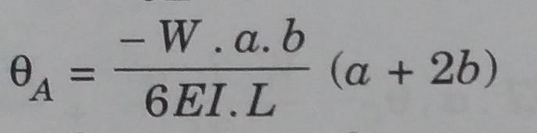
  - MAXIMUM DEFLECTION,

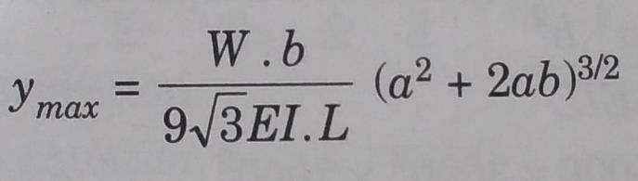

  - DEFLECTION UNDER THE POINT LOAD,
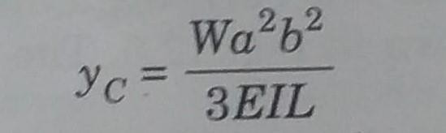

- Determine slope at the left support, deflection under the load and maximum deflection of a simply supported beam of length 5 m, which is carrying a point load of 5 KN at a distance of 3 m from the left end. Take E = 2 X 105 N/mm2 and I = 1 X 108 mm4.
GIVEN DATA:
L = 5 m = 5 X 10³ mm
W = 5 KN = 5 X 10³ N
I = 1 X 10⁸ mm⁴.
E = 2 X 10⁵ N/mm²
a = 3 m
b = L – a = 5 – 3 = 2 m = 2 X 10³ mm
SOLUTION:
- SLOPE AT THE LEFT SUPPORT,
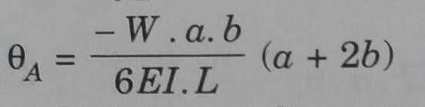
= 0.00035 radians.
- DEFLECTION UNDER THE POINT LOAD,
= 0.6 mm.
- MAXIMUM DEFLECTION,

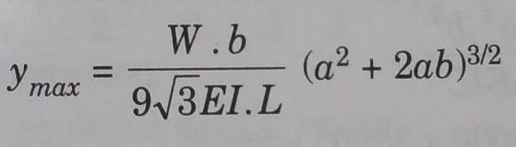

= 0.6173 mm.
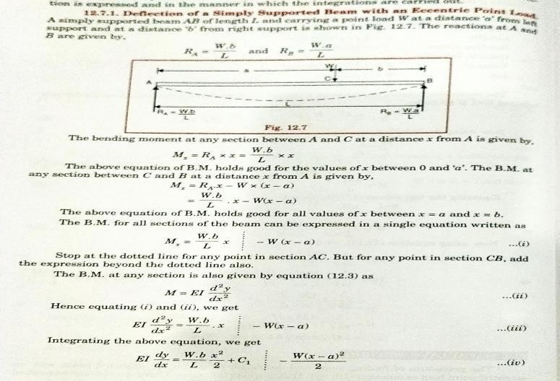

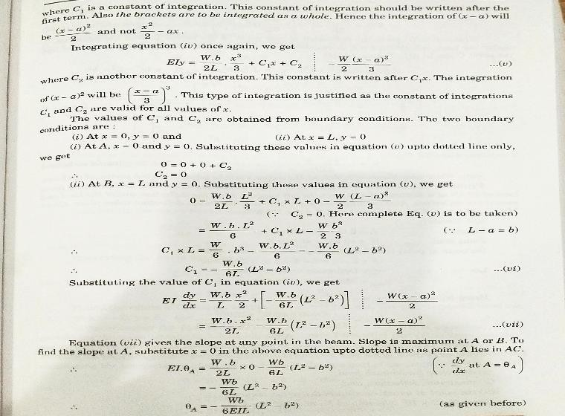
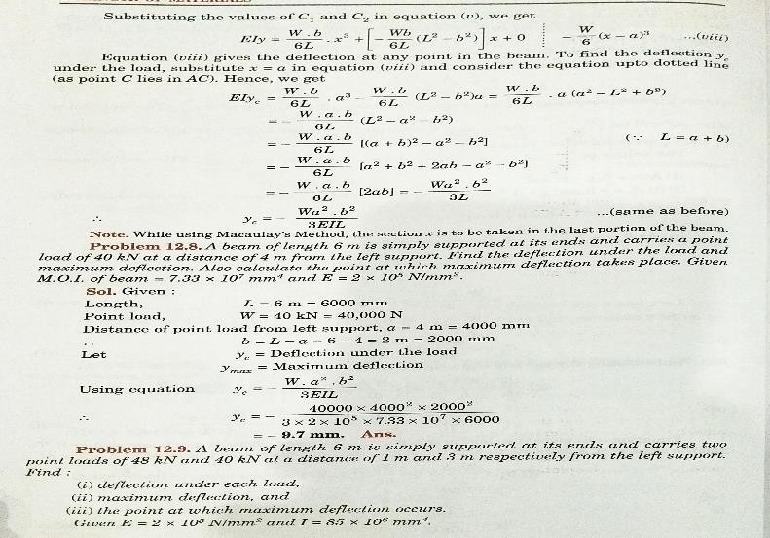

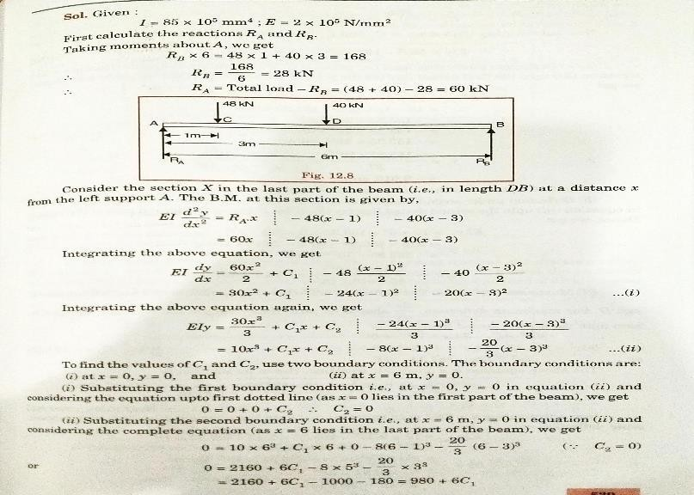
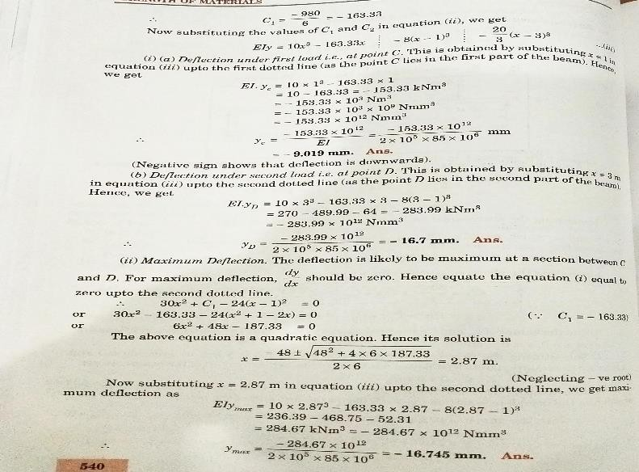

MOMENT AREA METHOD:
- MOHR’S THEOREM – I:
The change of slope between any two points is equal to the net area of the B.M. diagram between these points divided by EI.
- MOHR’S THEOREM – II:
The total deflection between any two points is equal to the moment of the area of B.M. diagram between the two points about the last point divided by EI.
MOHR’S THEOREMS IS USED FOR FOLLOWING CASES:
  - Problems on Cantilevers
  - Simply supported beams carrying symmetrical loading
  - Fixed beams

SLOPE AND DEFLECTION FOR A SIMPLY SUPPORTED BEAM WITH CENTRAL POINT LOAD:
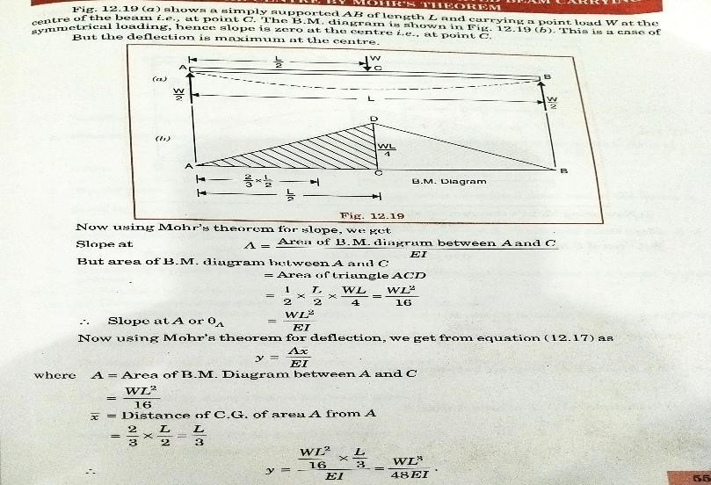

SLOPE AND DEFLECTION FOR A SIMPLY SUPPORTED WITH A UNIFORMLY DISTRIBUTED LOAD:
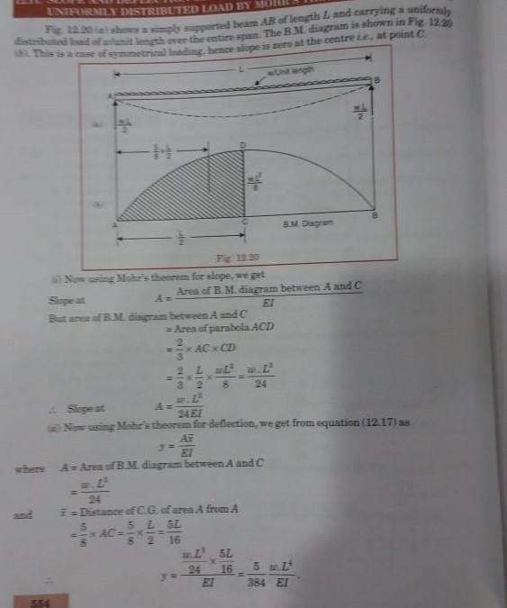

CONJUGATE BEAM METHOD:
- CONJUGATE BEAM:
  - Conjugate beam is an imaginary beam of length equal to that of the original beam but for which the load diagram is the M/EI diagram.
- NOTE 1 :
  - The slope at any section of the given beam is equal to the shear force at the corresponding section of the conjugate beam.
- NOTE 2 :
  - The deflection at any section for the given beam is equal to the bending moment at the corresponding section of the conjugate beam.
SLOPE AND DEFLECTION FOR A SIMPLY SUPPORTED BEAM WITH CENTRAL POINT LOAD:

  - A simply supported beam AB of length L carrying a point load W at the centre C.
  - The B.M at A and B is zero and at the centre B.M will be WL/4.
  - Now the conjugate beam AB can be constructed.

  - The load on the conjugate beam will be obtained by dividing the B.M at that point by EI.
  - The shape of the loading on the conjugate beam will be same as of B.M diagram.
  - The ordinate of loading on conjugate beam will be equal to M/EI = WL/4EI.
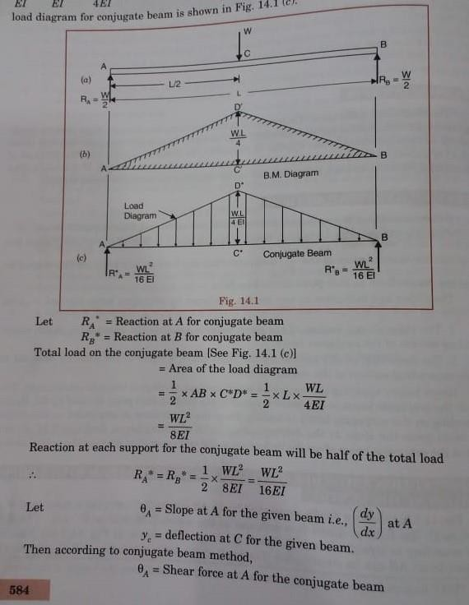

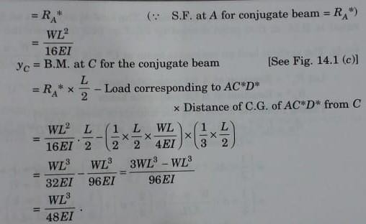

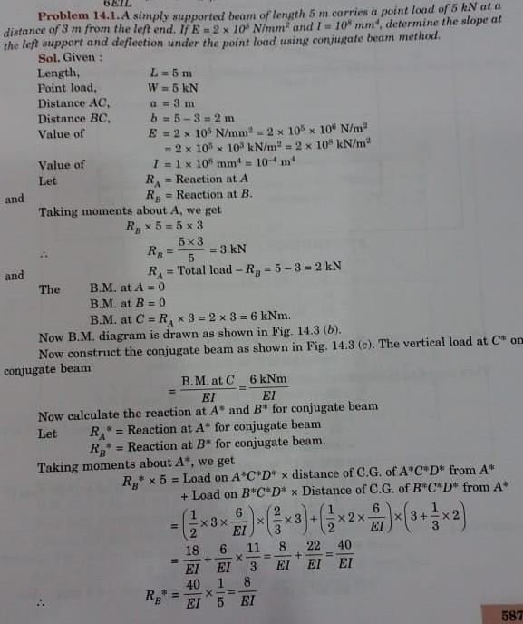

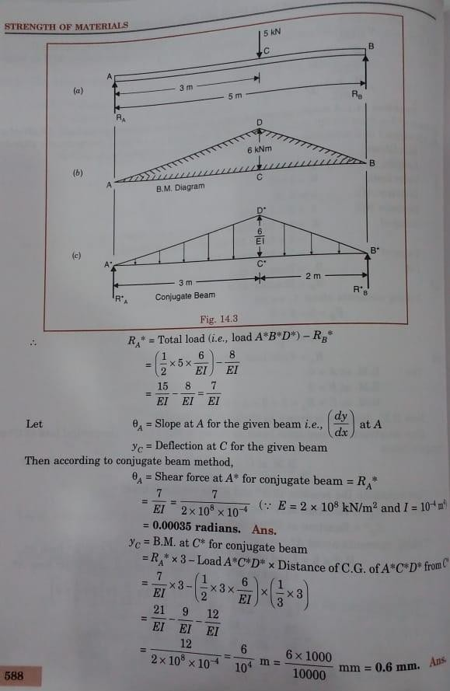

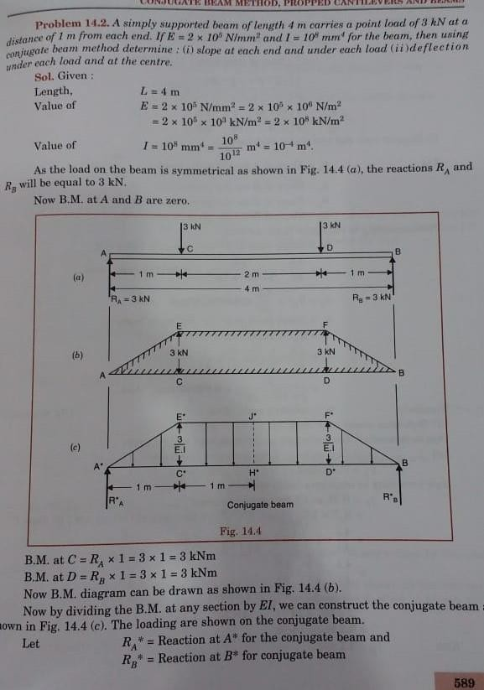

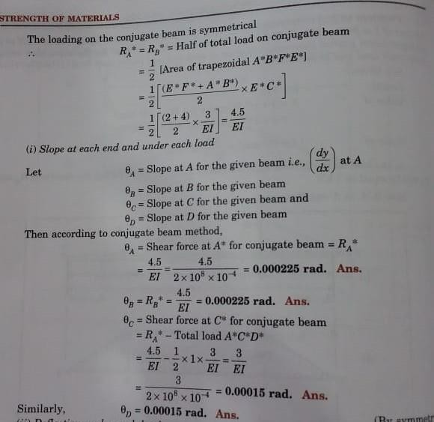

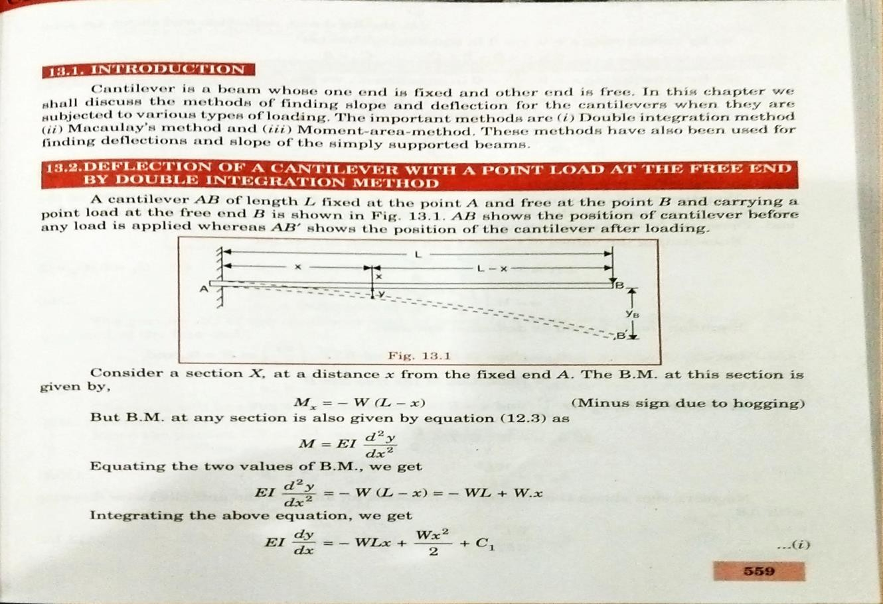
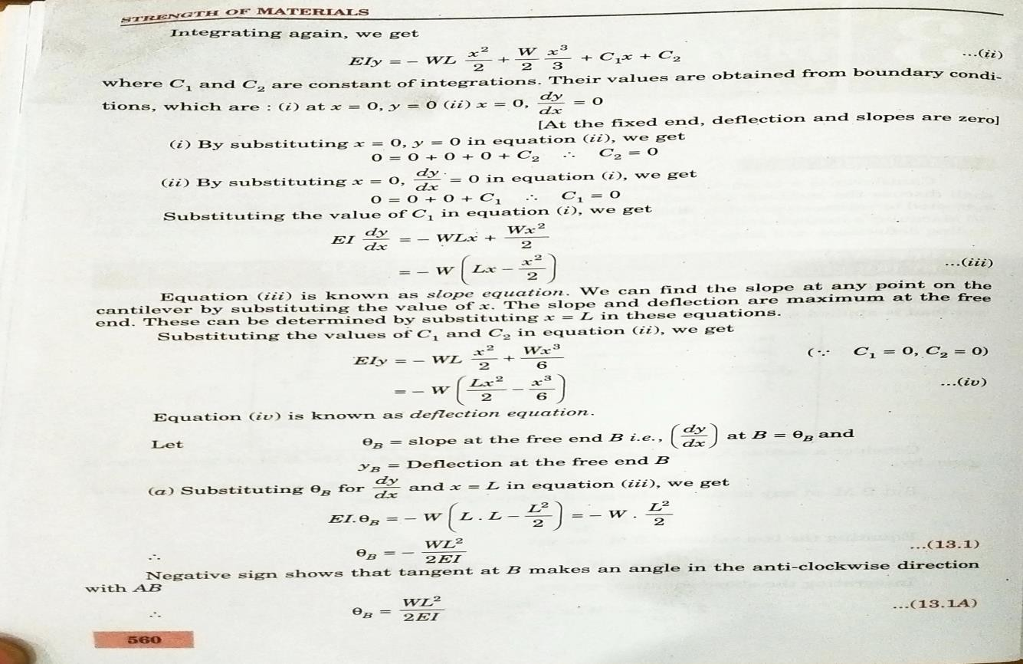

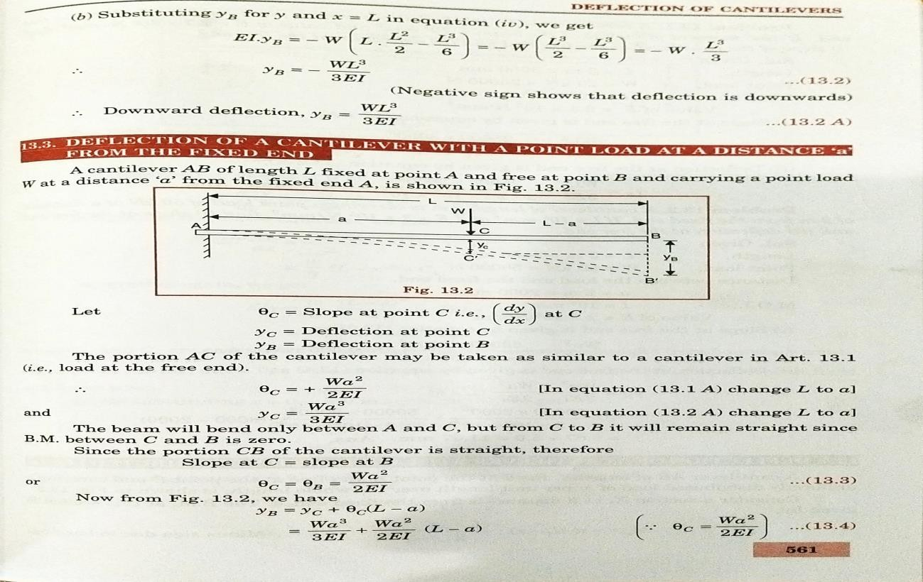

PROBLEMS:
1.A cantilever of length 3 m is carrying a point load of 25 KN at the free end. If I = 108 mm4 and E = 2.1 X 105 N/mm2, find the slope and deflection at the free end.
GIVEN DATA:
L = 3 m = 3000 mm W = 25 KN = 25000 N I = 10⁸ mm⁴
E = 2.1 X 10⁵ N/mm²
SOLUTION:
- SLOPE AT THE FREE END,
ϴB = WL² / 2 EI = 25000 X 3000²
2 X 2.1 X 10⁵ X 10⁸
= 0.005357 radians.
- DEFLECTION AT THE FREE END, yB = W L³/ 3 EI = 25000 X 3000³
3 X 2.1 X 10⁵ X 10⁸
= 10.71 mm

- A cantilever of length 3 m is carrying a point load of 50 KN at a distance of 2 m from the fixed end. If I = 108 mm4 and E = 2 X 105 N/mm2, find the slope and deflection at the free end.
GIVEN DATA:
L = 3 m = 3000 mm W = 50 KN = 50000 N I = 10⁸ mm⁴
E = 2 X 10⁵ N/mm²
SOLUTION:
  - SLOPE AT THE FREE END, ϴB = Wa² / 2 EI
= 50000 X 2000
2 x 2 X 10⁵ x 10⁸
= 0.005 radians
  - DEFLECTION AT THE FREE END, yB = W a³/ 3 EI + W a²/ 2 EI (L – a)
= 50000 X 2000³ + 50000 X 2000³ ( 3000 – 2000 )
3 X 2 X 10⁵ X 10⁸ 3 X 2 X 10⁵ X 10⁸
= 6.67 + 5
= 11.67 mm.
CANTILEVER BEAM WITH A UDL:
- A cantilever beam AB of length L fixed at the point A and free at the point B and carrying a UDL of w per unit length over the whole length.
- Consider a section X, at a distance x from the fixed end A.
- The bending moment at this section is given by, Mx = - w ( L – x ) ( L – x )
2

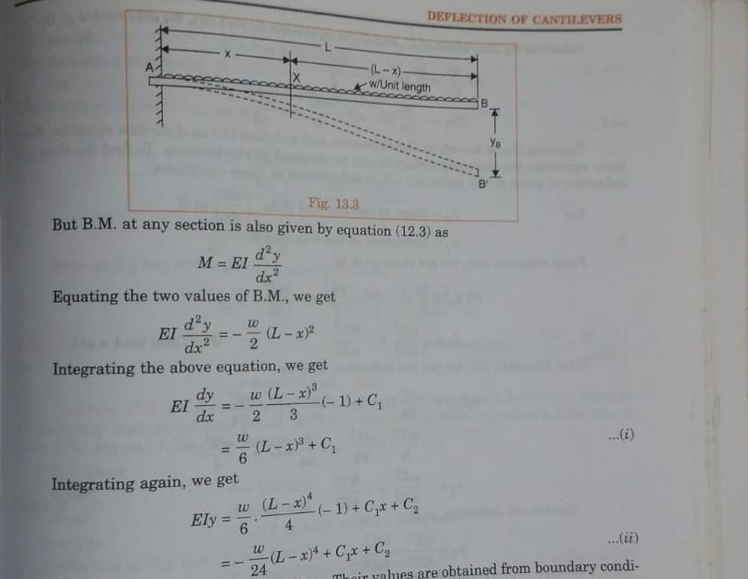

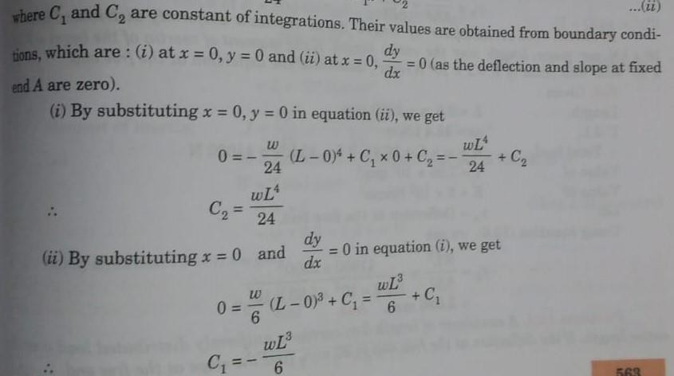

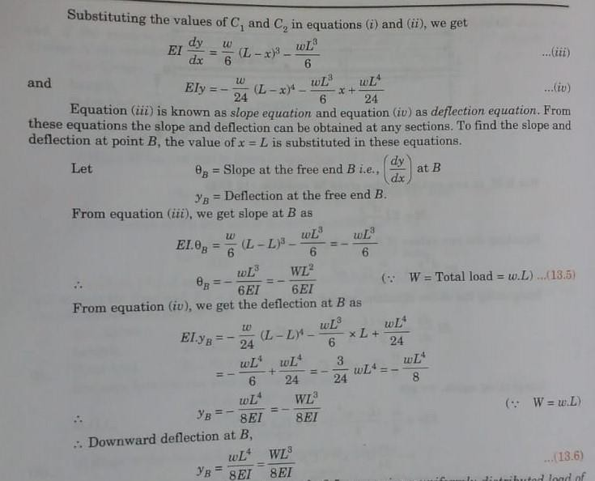

PROBLEMS:
  - A cantilever of length 2.5 m carries a uniformly distributed load of 16.4 KN per metre length. If I = 7.95 X 107 mm4 and E = 2 X 105 N/mm2, determine the deflection at the free end.
GIVEN DATA:
L = 2.5 m = 2500 mm
w = 16.4 KN/m, W = w X L = 16.4 X 2.5 = 41000 N I = 7.95 X 10⁷ mm⁴
E = 2 X 10⁵ N/mm²
SOLUTION:
    - DEFLECTION AT THE FREE END, yB = WL³/8EI = 41000 X 2500³
8 X 2 X 10⁵ X 7.95 X 10⁷
= 5.036 mm.
  - A cantilever of length 3 m carries a uniformly distributed load over the entire length. If the deflection at the free end is 40 mm, find the slope at the free end.

GIVEN DATA:
L = 3 m = 3000 mm
yB = 40 mm
SOLUTION:
    - SLOPE AT THE FREE END, yB = WL³/8EI
40 = WL² X L = WL² X 3000
8 EI 8 EI
WL² = 40 X 8
EI 3000
Slope at the free end,
ϴB = WL² / 6 EI = WL² / EI X (1/6)
= 40 X 8 X (1/6)
3000
= 0.01777 rad.
  - A cantilever 120 mm wide and 200 mm deep is 2.5 m long. What is the uniformly distributed load which the beam can carry in order to produce a deflection of 5 mm at the free end? Take E = 200 GN/m2.
GIVEN DATA:
L = 2.5 m = 2500 mm
E = 200 GN/m² = 2 X 10⁵ N/mm²
b = 120 mm I = bd³/12 = 120 X 200³ / 12
d = 200 mm = 8 X 10⁷ mm⁴
yB = 5 mm
SOLUTION:
    - UDL,
W = w X L = 2.5 X w = 2.5 w N. y = WL³/8EI
5 = 2.5 w X 2500³
8 X 2 X 10⁵ X 8 X 10⁷

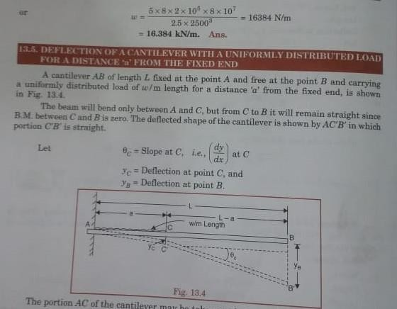
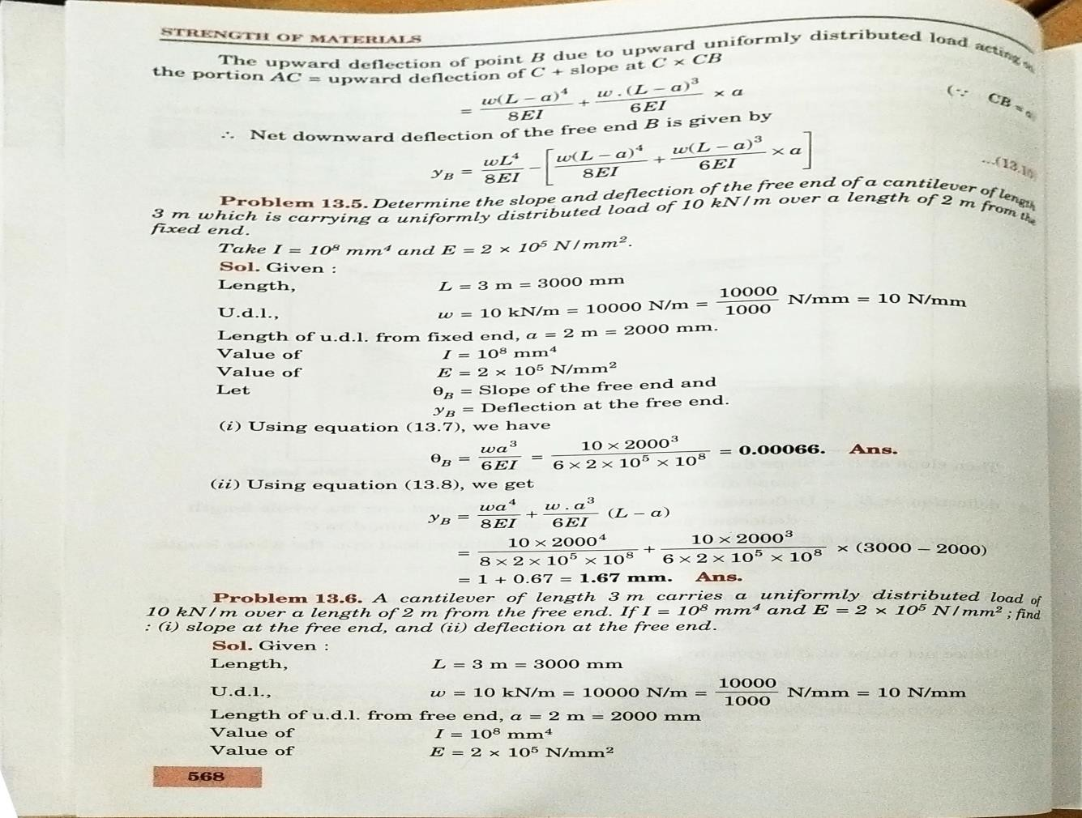

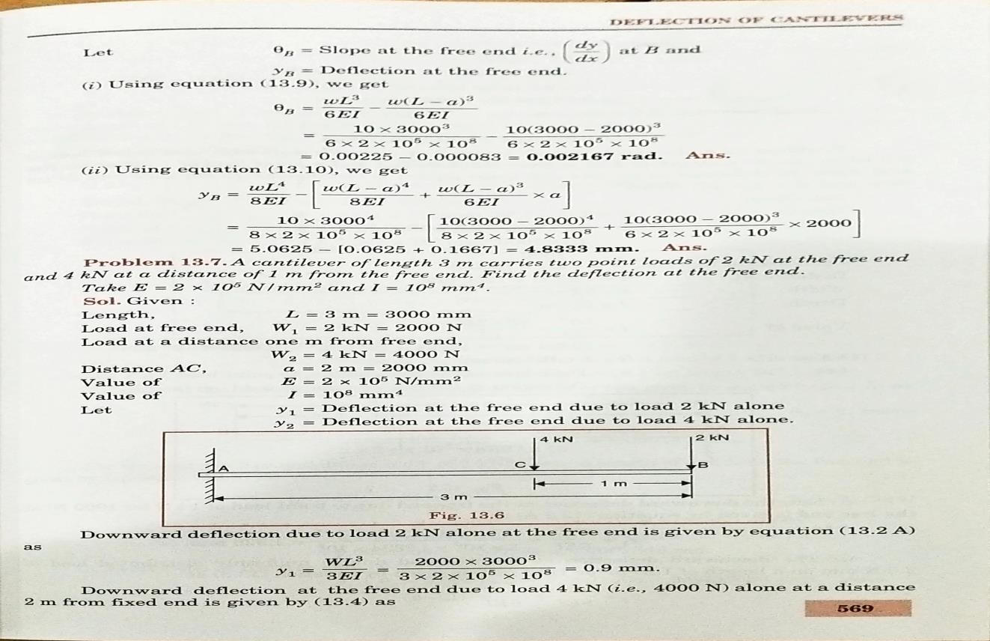
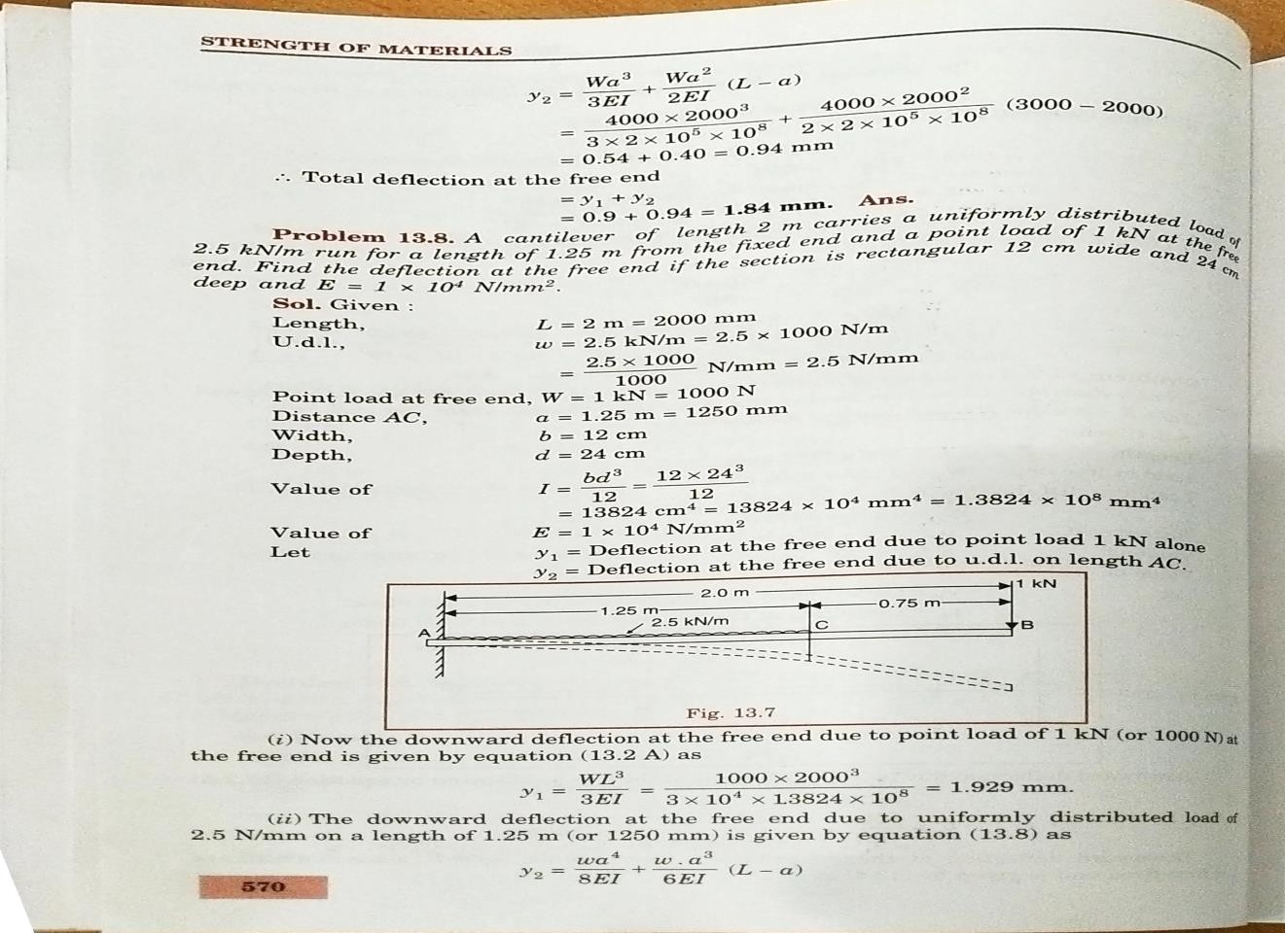

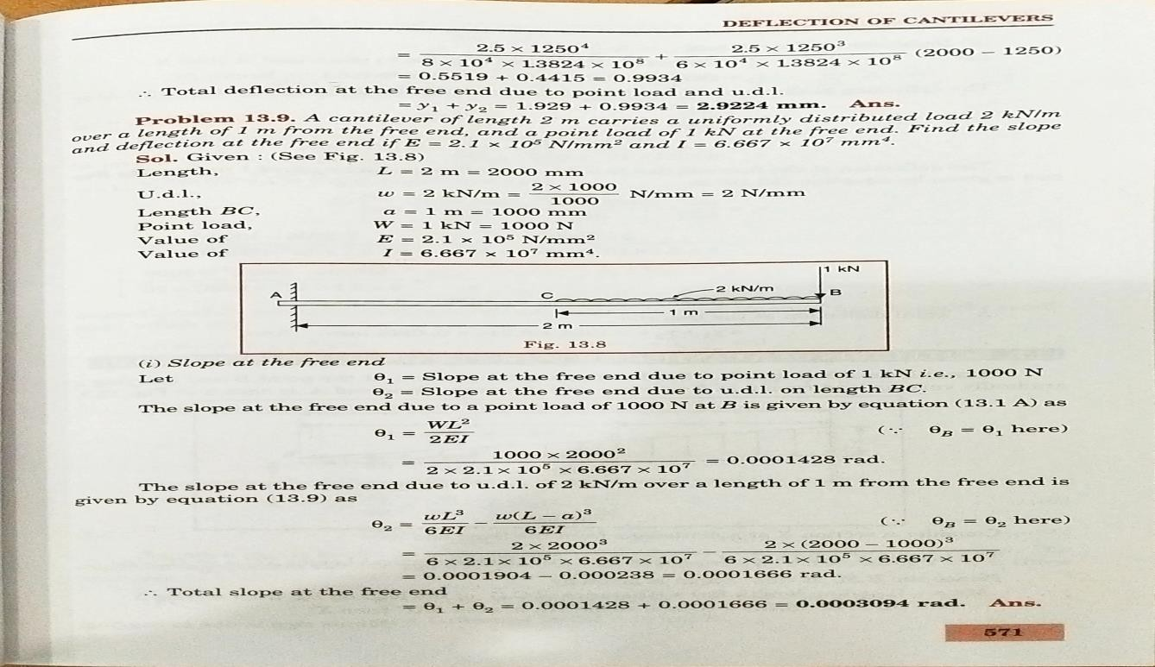
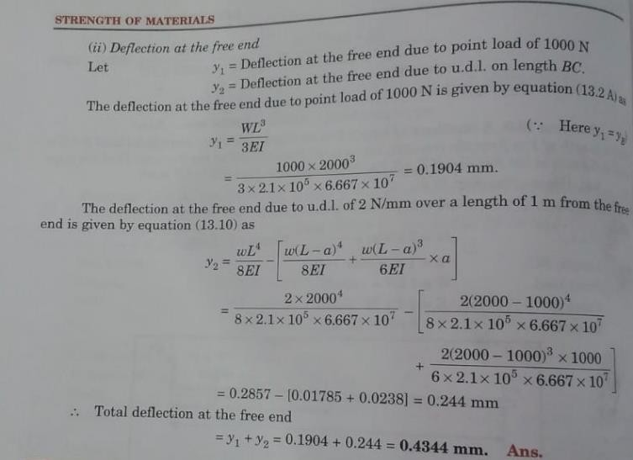

REFERENCE BOOKS:

- Bansal R.K., “Strength of Materials”, 5th Edition, Laxmi Publications, 2013.
- Ramamrutham R., “Strength of Materials”,14th Edition, Dhanpat Rai Publications, 2011.
- Punmia B.C., “Strength of Materials”, Laxmi Publications, 2011.
- Subramanian R., “Strength of Materials - Theory and Problems”, Oxford University Press, 2010.
- Rajput R.K., “Strength of Materials”, S. Chand and Company Ltd., New Delhi, 2007.
- Timoshenko S.P. and Gere J.M., “Mechanics of Materials”, 6th Edition, Tata McGraw Hill.

QUESTION BANK:
  - What are the methods used for determining slope and deflection?
  - What is the slope and deflection equation for simply supported beam carrying UDL through out the length?
  - What is a Macaulay’s method?
  - What is moment area method?
  - Define : Conjugate beam.
  - Find the slope and deflection of a simply supported beam carrying a point load at the centre using moment area method.
  - Distinguish between actual beam and conjugate beam.
  - A beam 4m long, simply supported at its ends, carries a point load W at its centre. If the slope at the ends of the beam is not to exceed 1⁰, find the deflection at the centre of the beam.
  - A cantilever of length 2 m carries a point load of 30 KN at the free end and another load of 30 KN at its centre. If EI = 1013 N.mm2 for the cantilever then determine slope and deflection at the free end by moment area method.
  - Determine slope at the left support, deflection under the load and maximum deflection of a simply supported beam of length 10 m, which is carrying a point load of 10 kN at a distance of 6 m from the left end. Take E = 2 x 105 N/mm2 and I = 1 x 108 mm4.
11.A cantilever of length 3 m is carrying a point load of 25 KN at the free end. If I
= 108 mm4 and E = 2.1 X 105 N/mm2, then determine slope and deflection of the cantilever using conjugate beam method.
12.A simply supported beam of length 5 m carries a point load of 5 kN at a distance of 3m from the left end. If E = 2 x 105 N/mm2 and I = 108 mm4, determine the slope at the left support and deflection under the point load using conjugate beam method.

UNIT – II – STRAIN ENERGY – SCIA1401

SCHOOL OF BUILDING AND ENVIRONMENT DEPARTMENT OF CIVIL ENGINEERING

INTRODUCTION

STRAIN ENERGY:

- Strain energy is defined as the energy stored in a body due to deformation.
- Strain energy is one of fundamental concepts in mechanics and its principles are widely used in practical applications to determine the response of a structure to loads.
- strain energy is equal to the work done by the point load.
- The unit of strain energy is N-m or Joules.
RESILIENCE:

PROOF RESILIENCE:
- Proof resilience is defined as the maximum energy that can be absorbed up to the elastic limit, without creating a permanent distortion.

MODULUS OF RESILIENCE:
- The modulus of resilience is defined as the maximum energy that can be absorbed per unit volume without creating a permanent distortion.
STRAIN ENERGY DUE TO GRADUALLY APPLIED LOAD

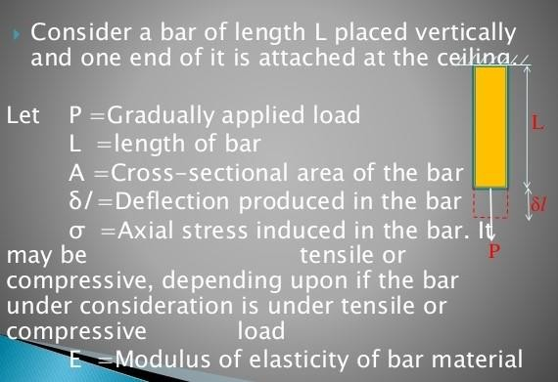

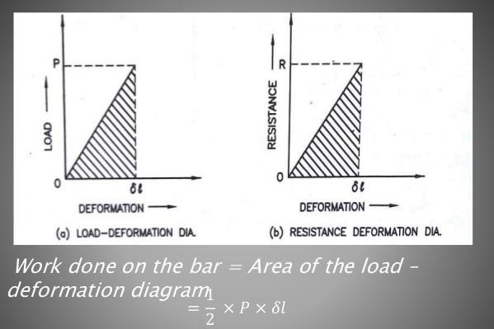
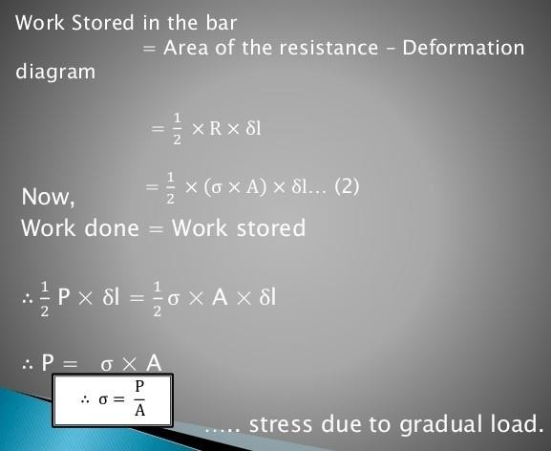

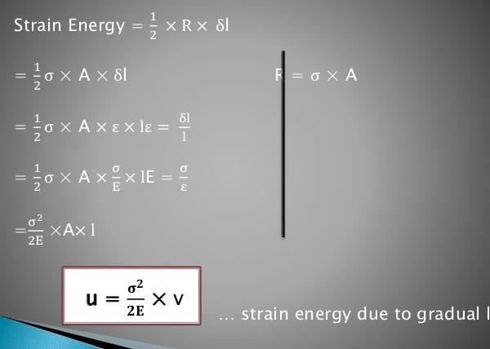

PROBLEMS:

1.A tensile load of 60 KN is gradually applied to a circular bar of 4 cm diameter and 5 m long. If the value of E = 2 X 10⁵ N/mm². Determine stretch in the rod, stress in the rod and strain energy absorbed by the rod.

GIVEN DATA:

Gradually Load, P = 60 KN = 60 X 1000 N Diameter, d = 4 cm = 40 mm.
Length, L = 5 m = 5000 mm E = 2 X 10⁵ N/mm² SOLUTION:
- STRESS IN THE ROD,

σ = P/A = 60000 / 400π A = (π X 40²) /4 = 400π mm²

= 47.746 N/ mm²

- STRETCH IN THE ROD,

x = (σ/E) X L = ( 47.746/ 2 X 10⁵ )/ 5000

= 1.19 mm.

- STRAIN ENERGY ABSORBED BY THE ROD,

U = σ² X V = 47.746² X 2 X 10⁶ π V = A X L = 400π X 5000 2E 2 X 2 X 10⁵ = 2 X 10⁶ π mm³

= 35810 N.mm = 35.81 N.m

STRAIN ENERGY DUE TO SUDDENLY APPLIED LOAD
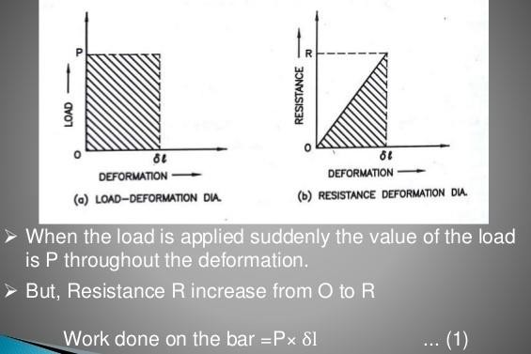

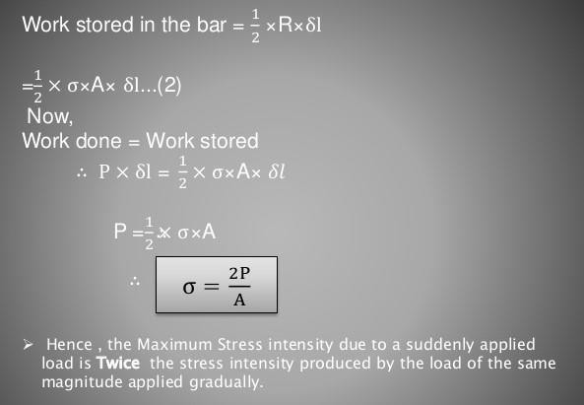

2.Calculate instantaneous stress produced in a bar 10 cm² in area and 3 m long by the sudden application of a tensile load of unknown magnitude, if the extension of the bar due to suddenly applied load is 1.5 mm. Also determine the suddenly applied load. Take E = 2 X 10⁵ N/mm²
GIVEN DATA:

Area, A = 10 cm² = 1000 mm² Length, L = 3 m = 3000 mm Extension, x = 1.5 mm
E = 2 X 10⁵ N/mm²

SOLUTION:

- STRESS IN THE ROD,

x = (σ/E) X L

1.5 = (σ / 2 X 10⁵ )/ 3000

σ = 1.5 X 2 X 10⁵
3000

= 100 N/mm²

- SUDDENLY APPLIED LOAD,

σ = 2 x P/A

100 = 2 x (P/1000)

P = 100 x 1000

2

= 50000 N = 50 KN.

- A steel rod is 2 m long and 50 mm in diameter. An axial pull of 100 KN is suddenly applied to the rod. Calculate the instantaneous stress induced and also the instantaneous elongation produced in the rod. Take E = 200 GN/m²
GIVEN DATA:

Diameter, d = 50 mm Length, L = 2 m = 2000 mm
Pull, P = 100 KN = 100 X 1000 N E = 200 GN/m² = 2 X 10⁵ N/mm² SOLUTION:
  - INSTANTANEOUS STRESS INDUCED,

σ = 2 x P/A A = (π X 50²) /4 = 625 π mm²

= 2 X (100 X 1000/ 625 π)

= 101.86 N/mm²

  - INSTANTANEOUS ELONGATION PRODUCED IN THE ROD,

δL = σ X L
E

= 101.86 X 2000
2 X 10⁵

= 1.0186 mm.
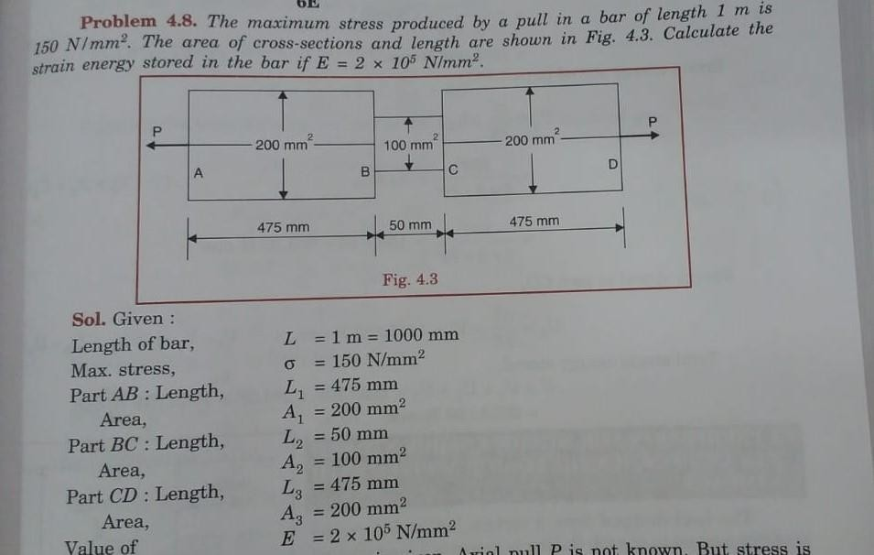

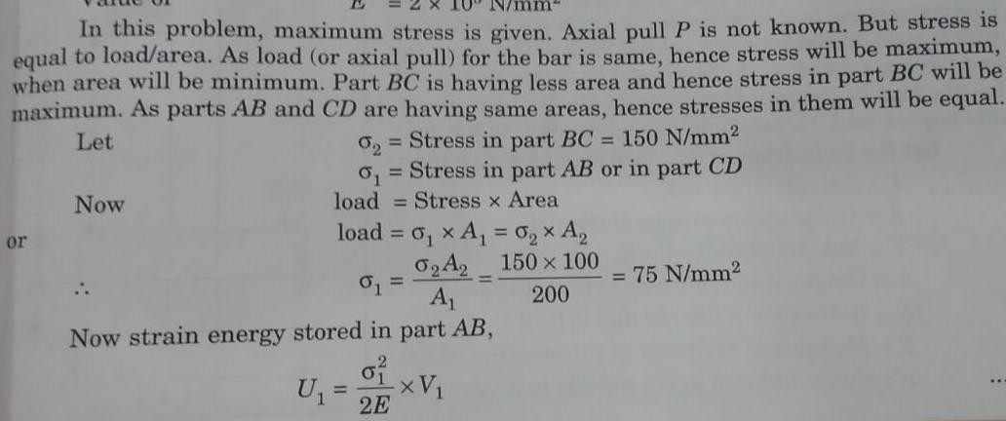

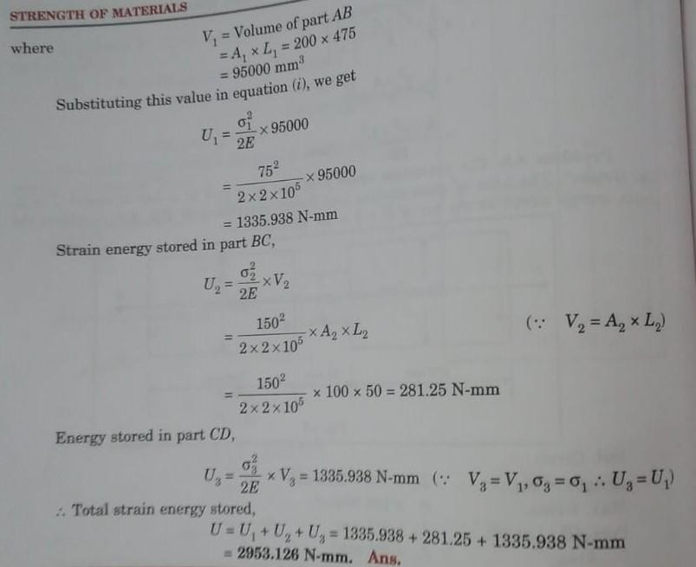

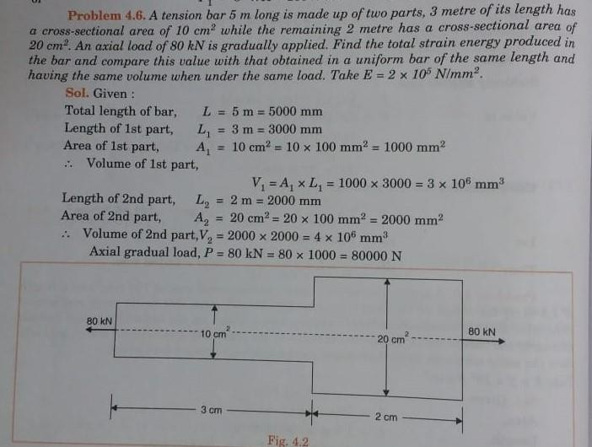

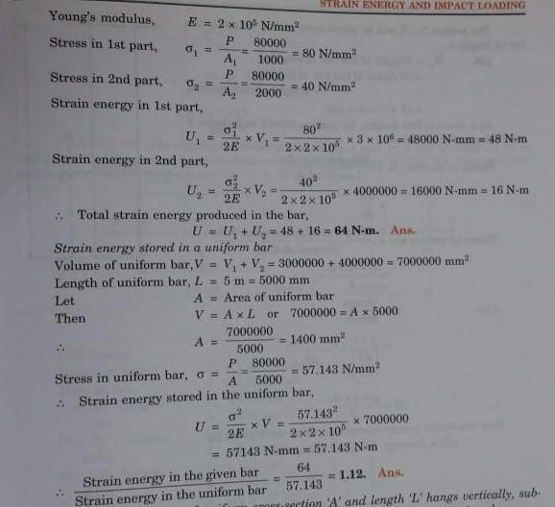

STRAIN ENERGY DUE TO IMPACT LOAD

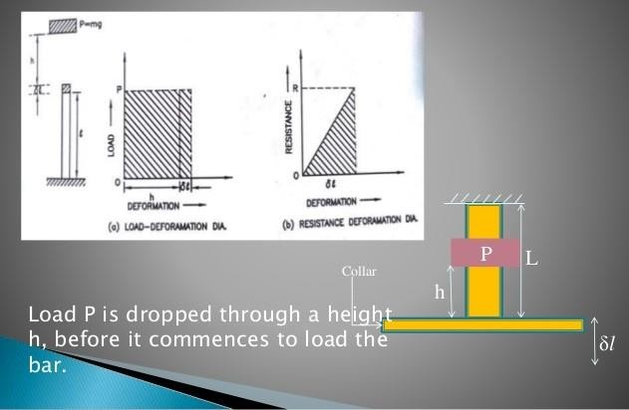

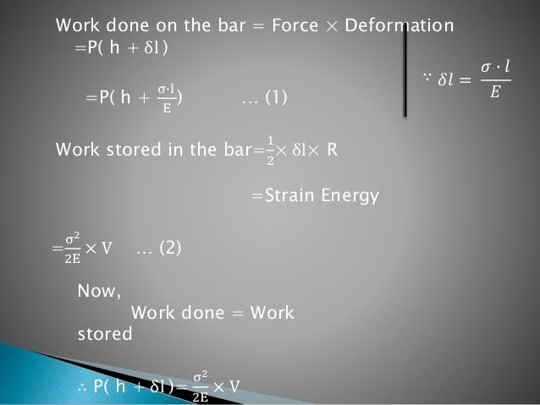

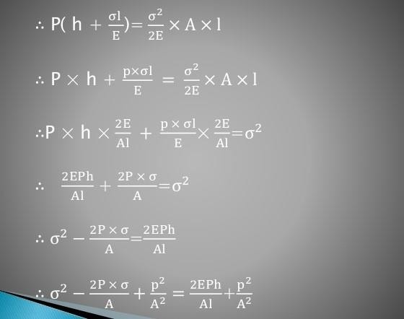

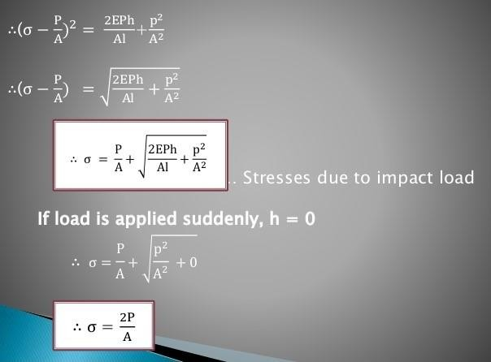

STRESS DUE TO IMPACT LOAD
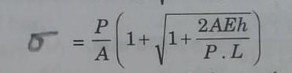

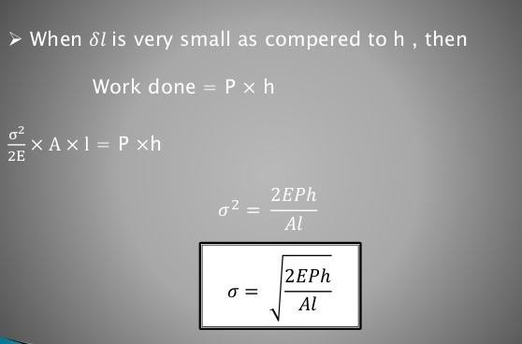

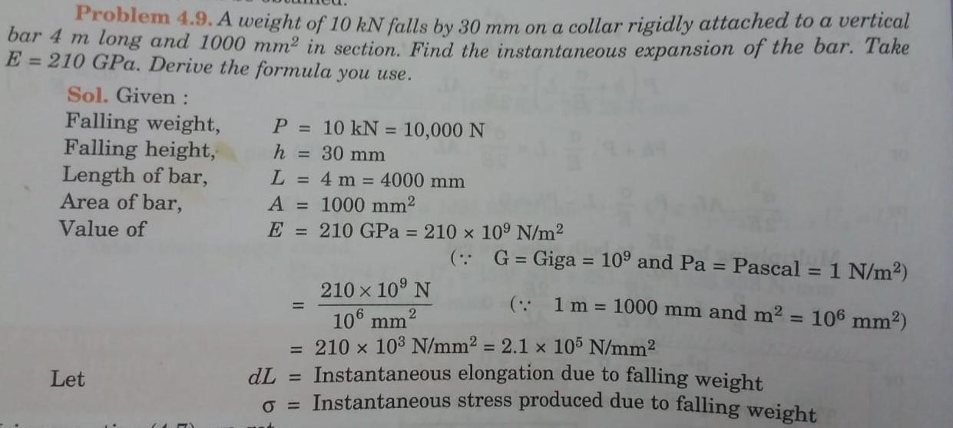

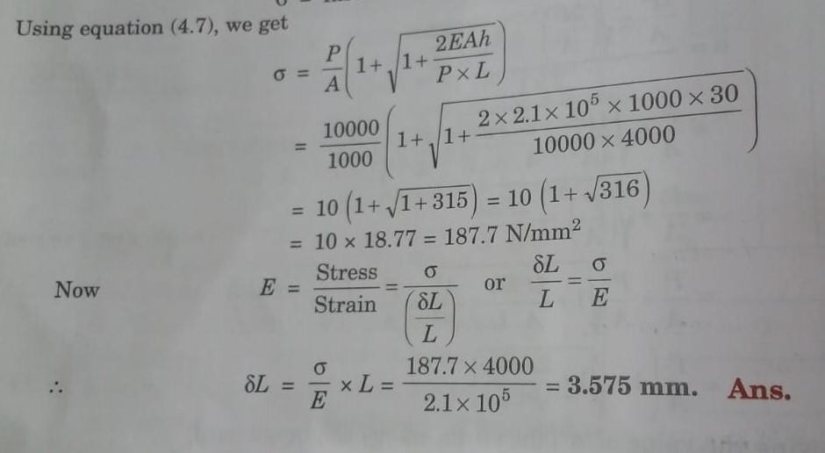

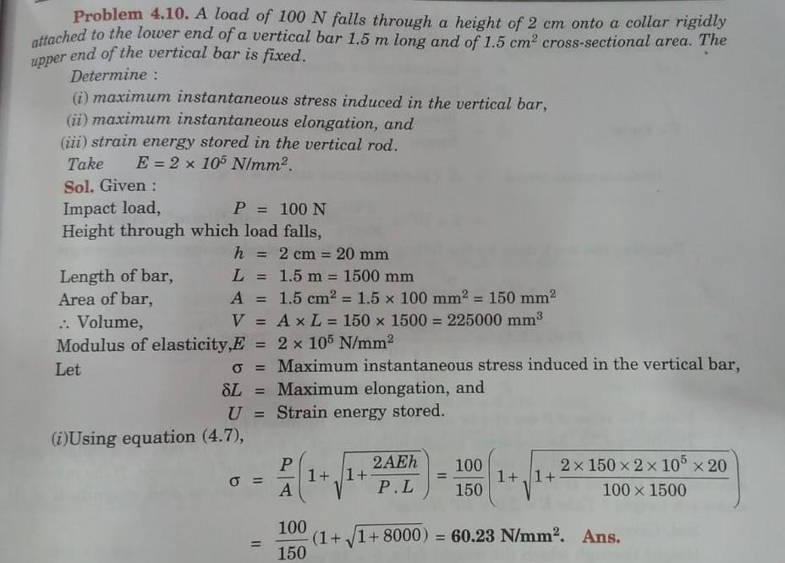
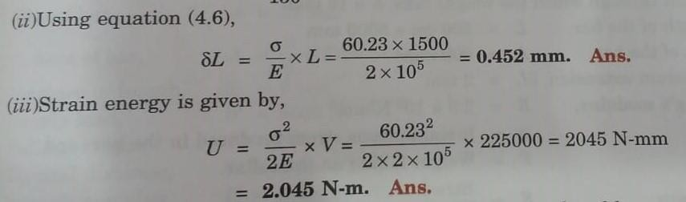

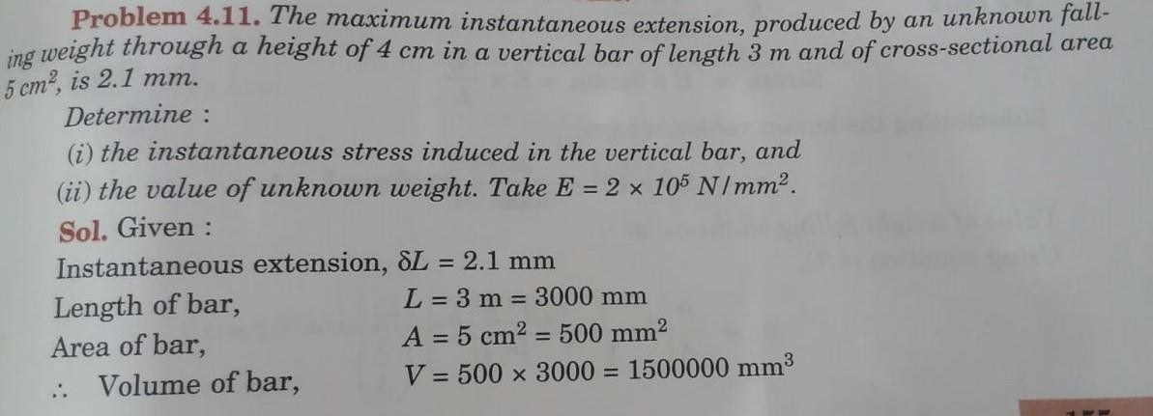
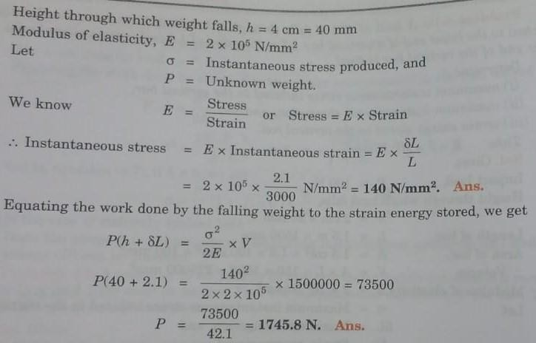

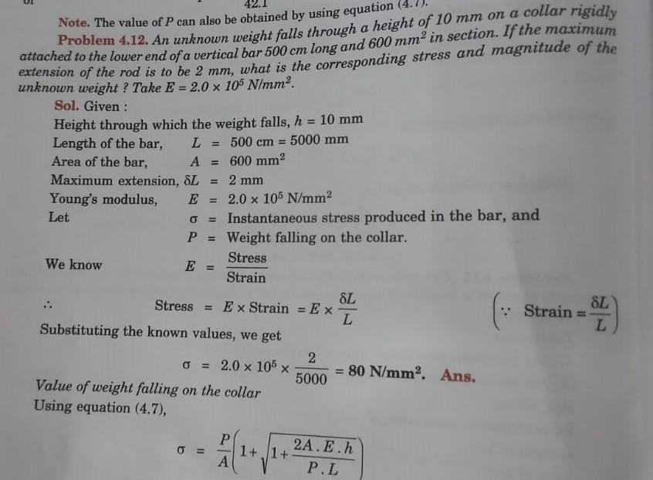

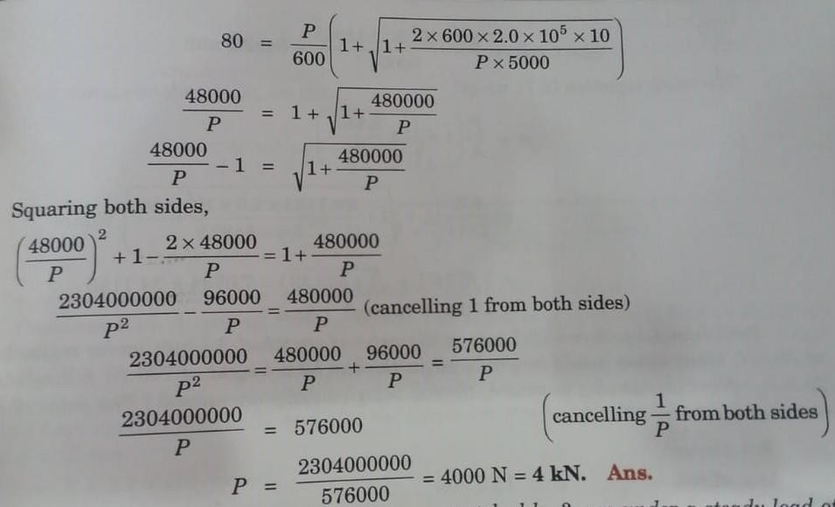

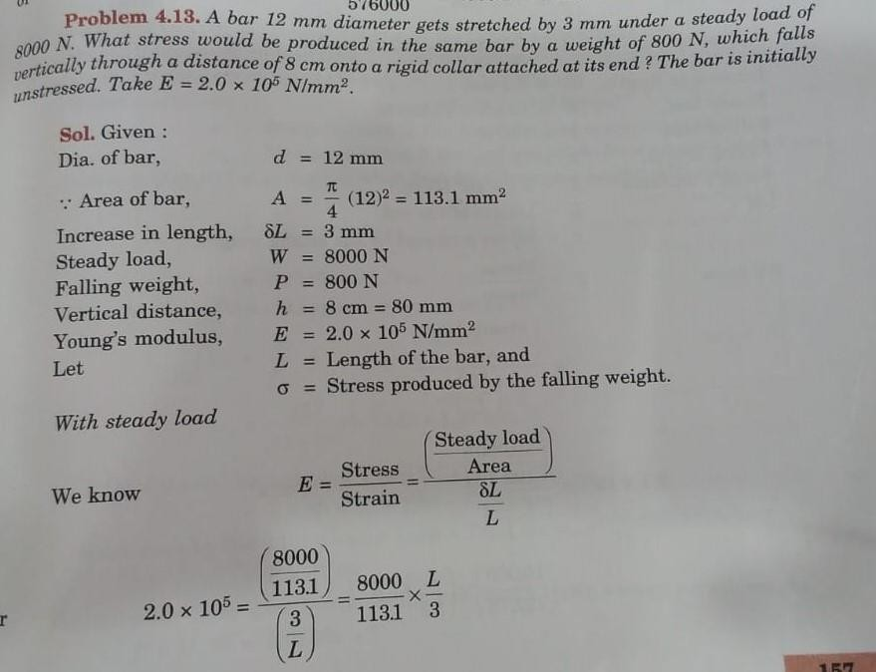

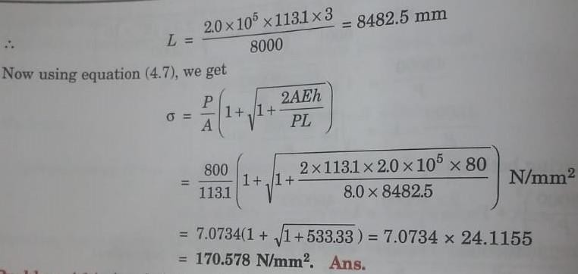

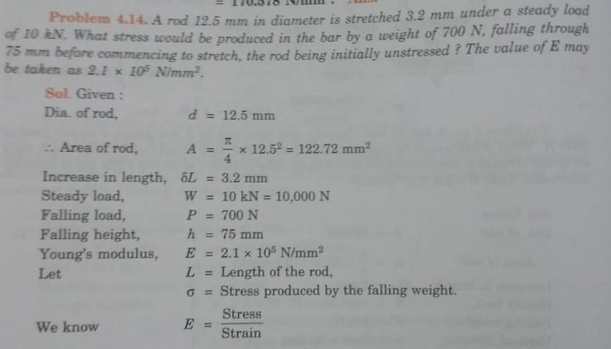
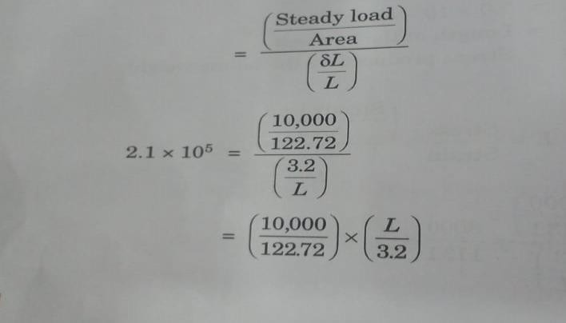
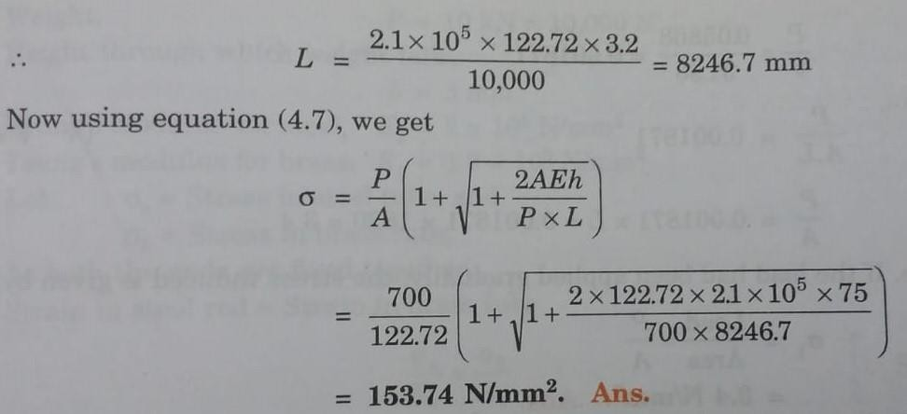

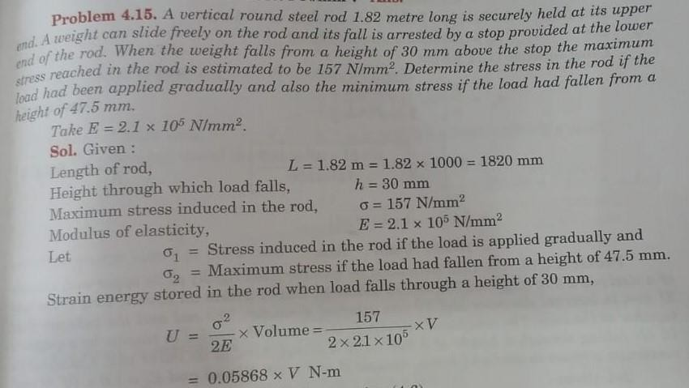
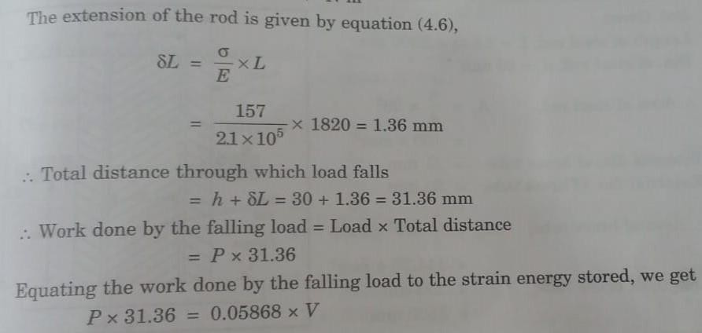

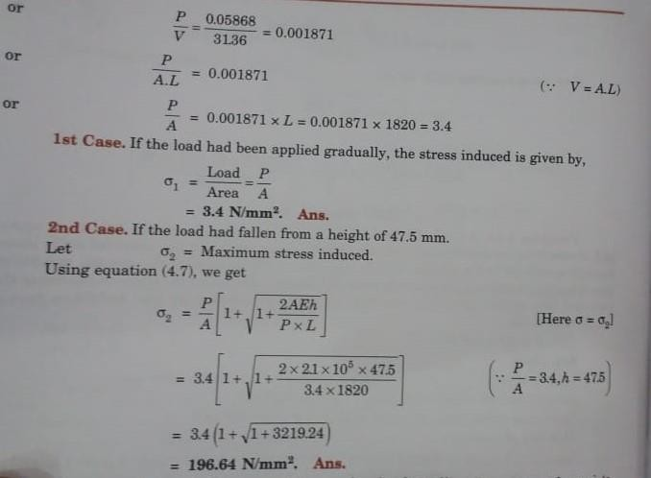

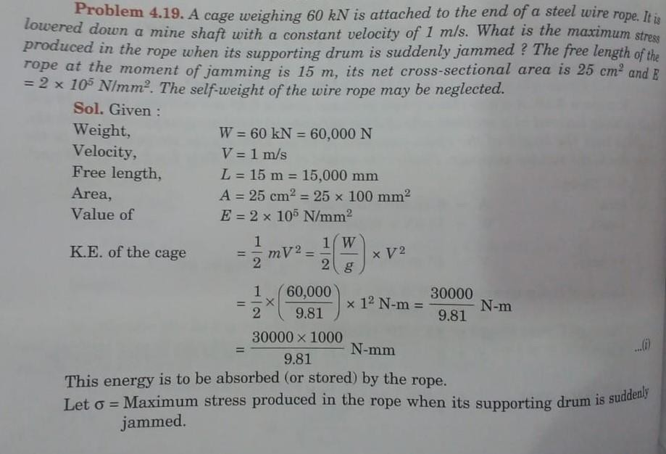

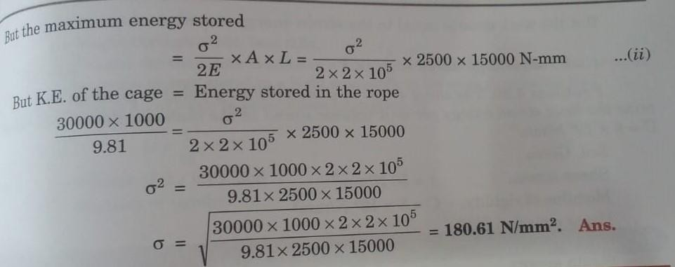

STRAIN ENERGY DUE TO SHEAR STRESS

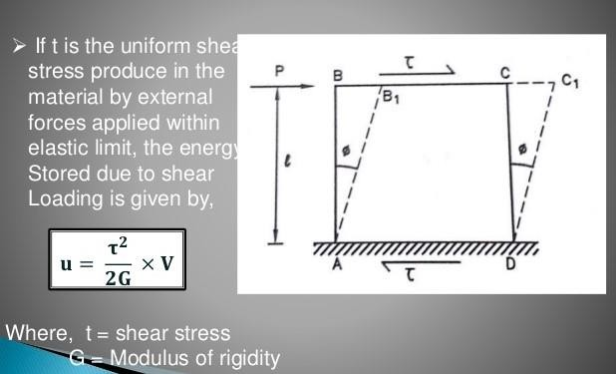

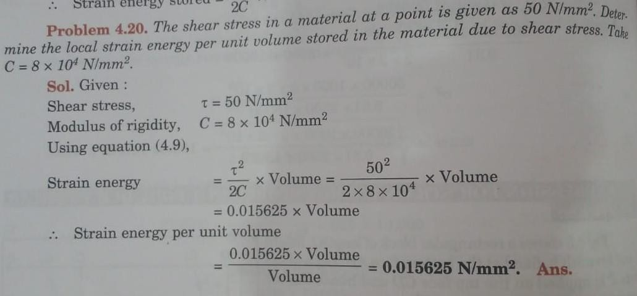

STRAIN ENERGY IN SOLID SHAFT DUE TO TORSION
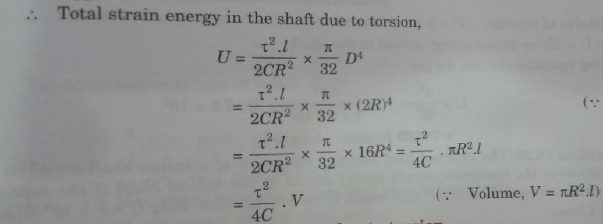

STRAIN ENERGY IN HOLLOW SHAFT DUE TO TORSION
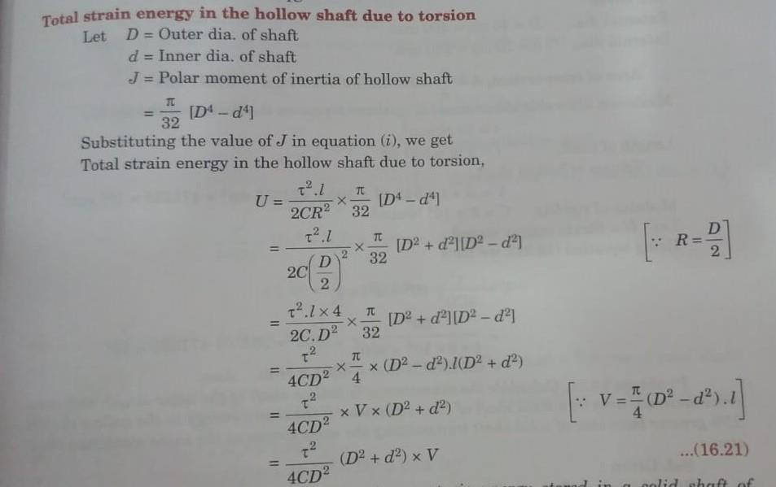
PROBLEMS:
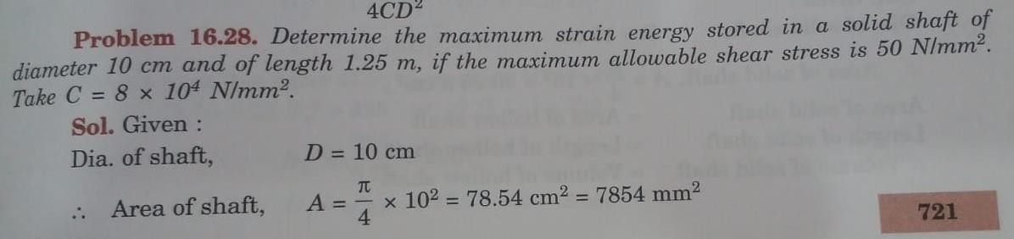

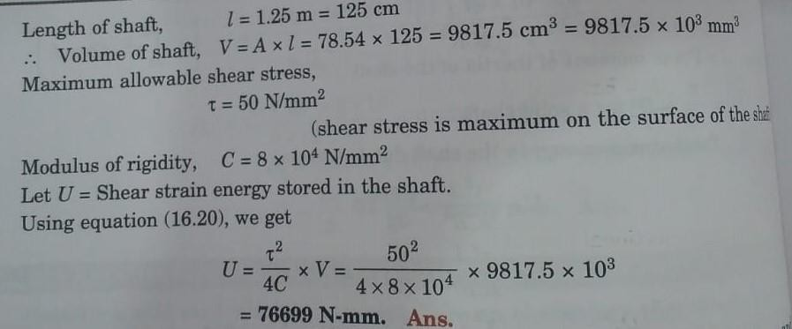

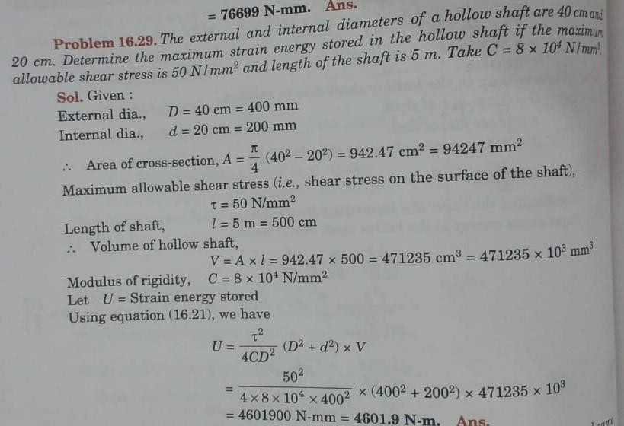

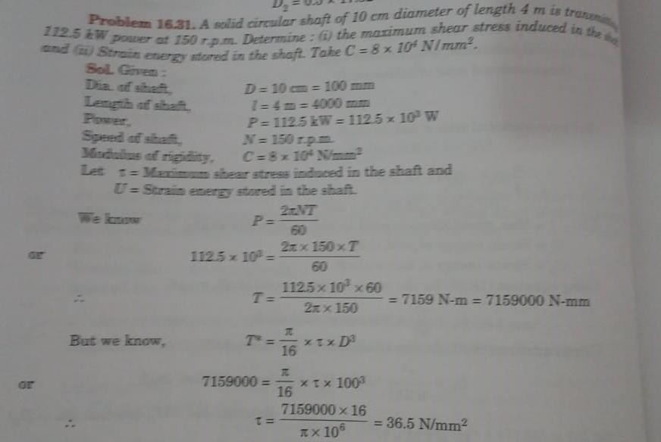

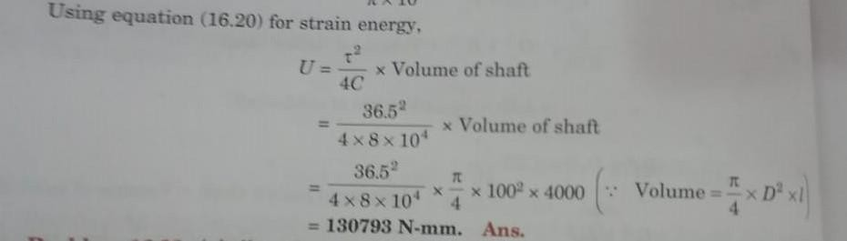

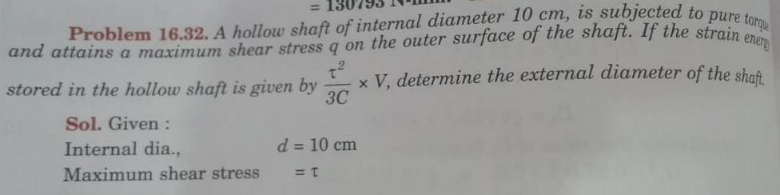

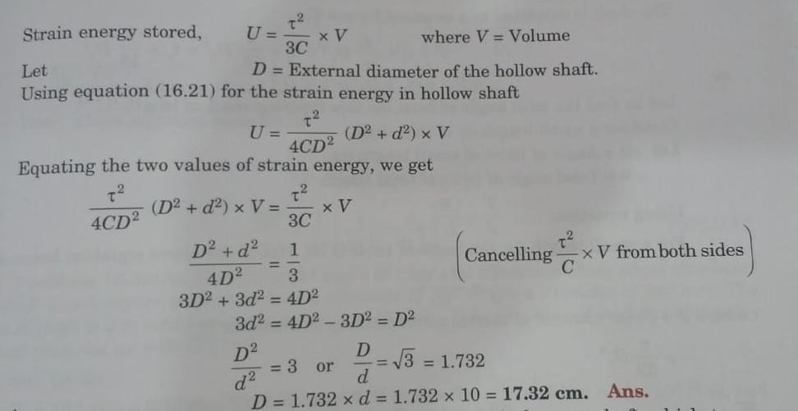

CASTIGLIANO'S FIRST THEOREM:

- Castigliano's first theorem states that the partial derivative of the total strain energy in a structure with respect to a load is equal to the deflection of the point where the load is acting, the deflection being measured in the direction of the load.
- dU = Δ_{i} , dU = ϴ_{j} dP_{i} dM_{j}
Where, U = Total strain energy P_{i} & M_{j} = Loads
Δ_{i} & ϴ_{j} = Deflections.

THEOREM USED IN THE FOLLOWING CASES:

- To determine the displacements of complicated structures.
- To find the deflection of beams due to shearing or bending if the total strain energy due to shearing forces or bending moments is known.
- To find the deflections of curved beams, springs etc.

BETTI'S THEOREM:

- Betti's theorem, also known as Maxwell–Betti reciprocal work theorem, discovered by Enrico Betti in 1872, states that for a linear elastic structure subject to two sets of forces {P_{i}} i=1,2,...,n and {Q_{j}}, j=1,2,...,n, the work done by the set P through the displacements produced by the set Q is equal to the work done by the set Q through the displacements produced by the set P.

MAXWELL’S LAW OF RECIPROCAL DEFLECTION:

- The beam is not just deflected at the centre but all along its length.
- Let the deflection at a point D be δ_{DC}.
- Maxwell's reciprocal theorem says that the deflection at D due to a unit load at C is the same as the deflection at C if a unit load were applied at D.

In our notation, δ_{CD} = δ_{DC}.

REFERENCE BOOKS:

- Bansal R.K., “Strength of Materials”, 5th Edition, Laxmi Publications, 2013.
- Ramamrutham R., “Strength of Materials”,14th Edition, Dhanpat Rai Publications, 2011.
- Punmia B.C., “Strength of Materials”, Laxmi Publications, 2011.
- Subramanian R., “Strength of Materials - Theory and Problems”, Oxford University Press, 2010.
- Rajput R.K., “Strength of Materials”, S. Chand and Company Ltd., New Delhi, 2007.
- Timoshenko S.P. and Gere J.M., “Mechanics of Materials”, 6th Edition, Tata McGraw Hill.

QUESTION BANK:
  - Define: strain energy.
  - Define the terms: Resilience & Modulus of Resilience.
  - Define: Proof resilience.
  - What are the different types of loads?
  - Define: Castigliano’s theorem.
  - Define: maxwell's reciprocal theorem.
  - A steel rod is 2 m long and 50 mm in diameter. An axial pull of 100 KN is suddenly applied to the rod. Find the instantaneous stress induced. Take E = 200 GN/m2
  - The shear stress in a material at a point is given as 50 N/mm2. Find the strain energy per unit volume stored in the material due to shear stress. Take C = 8 X 104 N/mm2.
  - Define: Betties theorem.
10.A tensile load of 50 KN is gradually applied to a circular bar of 5 cm diameter and 4 m long. If E = 2 X 105 N/mm2, determine stretch in the rod, stress in the rod and strain energy absorbed by the rod.
11.A tension bar 5 m long is made up of two parts, 3 m of its length has a cross sectional area of 10 cm2 while the remaining 2 m has a cross sectional ara of 20 cm2. An axial load of 80 KN is gradually applied. Find the total strain energy produced in the bar and compare this value with that obtained in a uniform bar of the same length and having the same volume when under the same load. Take E = 2 X 105 N/mm2.
12.A load of 200 N falls through a height of 2.5 cm on to a collar rigidly attached to the lower end of a vertical bar 2 m long and of 3 cm2 cross sectional area. The upper end of the vertical bar is fixed. Determine maximum instantaneous stress induced in the vertical bar, maximum instantaneous elongation and strain energy stored in the vertical rod. Take E = 2 X 105 N/mm2
13.A rod 12.5 mm in diameter is stretched 3.2 mm under a steady load of 10 KN. Determine the stress would be produced in the bar by a weight of 700 N, falling through 75 mm before commencing to stretch, the rod being initially unstressed? Take E = 2.1 X 105 N/mm2.
14.The maximum instantaneous elongation produced by an unknown falling weight through a height of 4 cm in a vertical bar of length 5 m and of cross- sectional area 5 cm2 is 1.8 mm. Determine the instantaneous stress induced in the vertical bar and the values of unknown weight. Take E = 2 X 106 Kgf/cm2.

UNIT – III – THEORY OF COLUMNS – SCIA1401

SCHOOL OF BUILDING AND ENVIRONMENT DEPARTMENT OF CIVIL ENGINEERING

INTRODUCTION

Any member subjected to axial compressive load is called a column or Strut.

A vertical member subjected to axial compressive load – COLUMN. (Eg: Pillars of a building)

An inclined member subjected to axial compressive load – STRUT. A strut may also be a horizontal member.
Critical or Crippling or Buckling load – Load at which buckling starts.

CLASSIFICATION OF COLUMNS:

According to nature of failure – short, medium and long columns.

Short column – whose length is so related to its c/s area that failure occurs mainly due to direct compressive stress only and the role of bending stress is negligible.

Medium Column - whose length is so related to its c/s area that failure occurs by a combination of direct compressive stress and bending stress.

Long Column - whose length is so related to its c/s area that failure occurs mainly due to bending stress and the role of direct compressive stress is negligible.
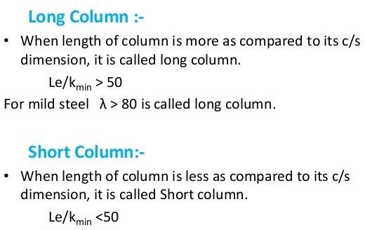

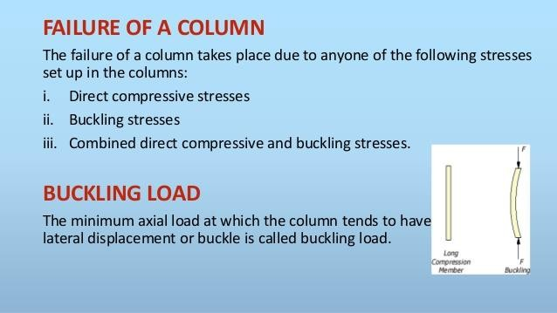
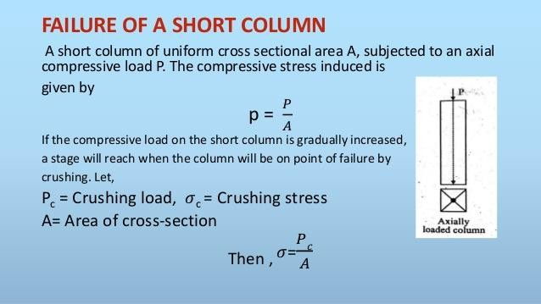

ASSUMPTIONS IN EULER’S COLUMN THEORY:

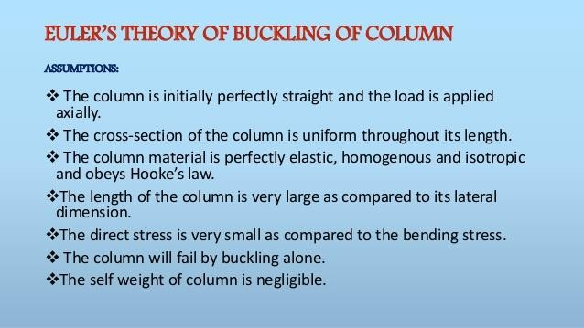

LIMITATIONS OF EULER’S FORMULA:

The general expression of bucking load for the long column as per Euler’s theory is given as,

P = Π ²E I / L²

σ = Π ²E / (Le / k) ²

We know that, Le / k = slenderness ratio. LIMITATION 1:
The above formula is applied only for long columns LIMITATION 2:
As the slenderness ratio decreases the crippling stress increases.

Consequently, if the slenderness ratio reaches to zero, then the crippling stress reaches infinity, practically which is not possible.

LIMITATION 3:

If the slenderness ratio is less than certain limit, then crippling stress is greater than crushing stress, which is not possible practically.

Therefore, up to limiting extent Euler’s formula is applicable with crippling stress equal to crushing stress.

Euler’s formula is applicable when the slenderness ratio is greater than or equal to 80. Euler’s formula is applicable only for long column.
Euler’s formula is thus unsuitable when the slenderness ratio is less than a certain value.

SLENDERNESS RATIO:

Slenderness ratio is the ratio of the actual length of a column and the least radius of gyration of its cross section.

Slenderness Ratio = l/k.

EFFECTIVE LENGTH:

The effective length (Le) of a column is defined as the distance between successive inflection points or points of zero moment.

Effective length is also called equivalent length. Crippling load for any type of end condition is given by,
P = π² EI
Le²

CRIPPLING STRESS IN TERMS OF EFFECTIVE LENGTH AND RADIUS OF GYRATION:

P = π² EI = π² E X A k²

Le² Le²

= π² E X A = π² E X A
Le² / k² (Le/ k)² Crippling stress = Crippling load

Area

= π² E X A = π² E
A (Le/ k)² (Le/ k)²

END CONDITIONS FOR COLUMNS:

- Both ends are hinged or pinned.
- One end is free and the other end is fixed.
- Both ends are fixed.
- One end is fixed and the other end is pinned.

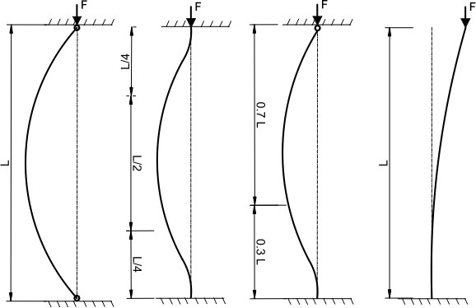

PROBLEMS:

1. A solid round bar 3 m long and 5 cm in diameter is used as a strut. Determine the crippling load for all the end conditions. Take E = 2 X 105 N/mm2.

GIVEN DATA:

Length, L= 3 m = 3000 mm

Diameter, d = 5 cm = 50 mm I = π X d⁴ /64 = π X 50⁴ /64 E = 2 X 10⁵ N/mm². = 30.68 X 104 mm4.
SOLUTION:

- Crippling load for both ends hinged,

P = π² EI = π² X 2 X 10⁵ X 30.68 X 10⁴ = 67288 N = 67.288 KN.
l² 3000²

- Crippling load when one end is fixed and other end is free,

P = π² EI = π² X 2 X 10⁵ X 30.68 X 10⁴ 4l² 4 X 3000²
= 16822 N = 16.822 KN.

- Crippling load when both the ends are fixed,

P = 4π² EI = 4 X π² X 2 X 10⁵ X 30.68 X 10⁴
l² 3000²

= 269152 N = 269.152 KN.

2. Crippling load when one end is fixed and other end is hinged,

P = 2π² EI = 2 X π² X 2 X 10⁵ X 30.68 X 10⁴

l² 3000²

= 134576 N = 134.576 KN.

2. A column of timber section 15 cm X 20 cm is 6 m long both ends being fixed. If E for timber = 17.5 KN/mm2, determine crippling load and safe load for the column if factor of safety = 3.

GIVEN DATA:

Length, L= 6 m = 6000 mm

Dimension of section, = 15 cm X 20 cm E = 17.5 KN/mm².
Factor of safety = 3. SOLUTION:
IXX = 15 X 20³ = 10000 cm⁴ = 10000 X 10⁴ mm⁴.
12

IYY = 20 X 15³ = 5625 cm⁴ = 5625 X 10⁴ mm⁴.
12

Value of I will be the least value of the two moment of inertia.

I = IYY = 5625 cm⁴ = 5625 X 10⁴ mm⁴.

- Crippling load for both ends fixed,

P = 4π² EI = 4 X π² X 17.5 X 10³ X 5625 X 10⁴
l² 6000²

= 1079480 N = 1079.480 KN.

- Safe load for the column,

Safe load = Crippling load / Factor of safety

= 1079.480 / 3

= 359.8 KN.

- A hollow mild steel tube 6 m long 4 cm internal diameter and 5 mm thick is used as a strut with both ends hinged. Find the crippling load and safe load taking factor of safety as 3. Take E = 2 X 105 N/mm2.

GIVEN DATA:

Length, L= 6 m = 6000 mm

Internal diameter, d = 4 cm = 40 mm. Thickness, t = 5 mm.
External diameter, D = d + 2t = 40 + 2 X 5 = 50 mm. E = 2 X 10⁵ N/mm².
Factor of safety = 3.

SOLUTION:

IXX = I = π X (D⁴ - d⁴) = π X (50⁴ – 40⁴) = 18.11 X 10⁴ mm⁴.
64 64

  - Crippling load for both ends hinged,
P = π² EI = π² X 2 X 10⁵ X 18.11 X 10⁴ l² 6000²
= 9929.9 N = 9930 N

  - Safe load for the column,

Safe load = Crippling load / Factor of safety

= 9930 / 3

= 3310 N.

4. A simply supported beam of length 4 m is subjected to a uniformly distributed load of 30 KN/m over the whole span and deflects 15 mm at the centre. Determine the crippling loads when this beam is used as a column with the following conditions:

One end fixed and other end hinged. Both the ends pin jointed.
GIVEN DATA:

Length, L= 4 m = 4000 mm

Uniformly distributed load, w = 30 KN/m = 30 N/mm. Deflection at the centre, δ= 15 mm.
SOLUTION:

For a simply supported beam, carrying UDL over the whole span, the deflection at the centre is given by,

δ = 5 w L⁴
384 EI

15 = 5 X30 X 4000⁴
384 X EI

EI = 0.66 X 1013 N.mm2

- Crippling load when one end is fixed and other end is hinged,

P = 2π² EI = 2 X π² X 0.66 X 10¹³ l² 4000²
= 8224.5 KN.

- Crippling load for both ends hinged,

P = π² EI = π² X 0.66 X 10¹³ l² 4000²
= 4112.25 KN.

5. A solid round bar 4 m long and 5 cm in diameter was found to extend 4.6 mm under a tensile load of 50 KN. This bar is used as a strut with both ends hinged. Determine the buckling load for the bar and also the safe load taking factor of safety as 4.

GIVEN DATA:

Length, L= 4 m = 4000 Diameter, d = 5 cm = 50 mm. Extension of bar, δL= 4.6 mm. Tensile load, W = 50 KN. SOLUTION:
A = π X d² /4 = π X 50²/4 = 625 π mm2.

I = π X d⁴ /64 = π X 50⁴/64 = 30.68 X 104 mm4.

Young’s Modulus, E = Tensile Stress/Tensile Strain

= Tensile Load/Area
Change in length of bar/Original length of bar

= W/A = W X L
δL/L A X δL

= 50000 X 4000 = 2.214 X 104 N/mm2.
625 π X 4.6

- Crippling load for both ends hinged,

P = π² EI = π² X 2.214 X 10⁴ X 30.68 X 10⁴ l² 4000²
= 4189.99 N = 4190 N

- Safe load,

Safe load = Crippling load / Factor of safety

= 4190 / 4

= 1047.5 N.

6. A hollow alloy tube 5 m long with external diameter and internal diameters 40 mm and 25 mm respectively was found to extend 6.4 mm under a tensile load of 60 KN. Find the buckling load for the tube when used as a column with both ends pinned. Also find the safe load for the tube, taking a factor of safety = 4.

GIVEN DATA:

Length, L= 5 m = 5000 mm External diameter, D = 40 mm. Internal diameter, d = 25 mm. Extension of bar, δL= 6.4 mm. Tensile load, W = 60 KN. Factor of safety = 4.
SOLUTION:

A = π X (D² – d²) = π X (40² – 25²) = 766 mm2.
4 4

IXX = I = π X (D⁴ - d⁴) = π X (40⁴ – 25⁴) = 106500 mm⁴.
64 64

Young’s Modulus, E = Tensile Stress/Tensile Strain

= Tensile Load/Area

Change in length of bar/Original length of bar

= W/A = W X L
δL/L A X δL

= 60000 X 5000 = 6.11945 X 104 N/mm2.
766 6.4

- Crippling load for both ends pinned,
P = π² EI = π² X 6.11945 X 10⁴ X 106500 l² 5000²
= 2573 N

- Safe load,

Safe load = Crippling load / Factor of safety

= 2573 / 4

= 643.2 N.

7. Calculate the safe compressive load on a hollow cast iron column (one end fixed and other hinged) of 15 cm external diameter, 10 cm internal diameter and 10 m in length. Use Euler’s formula with a factor of safety of 5 and E = 95 KN/mm2.

GIVEN DATA:

Length, L= 10 m = 10000 mm

External diameter, D = 15 cm = 150 mm Internal diameter, d = 10 cm = 100 mm Factor of safety = 5
E = 95 KN/mm²

SOLUTION:

I = π X (D⁴ - d⁴) = π X (150⁴ – 100⁴) = 1994.175 X 104 mm4.
64 64

- Crippling load for one end fixed and other hinged,

P = 2π² EI = 2 X π² X 95 X 10³ X 1994.175 X 10⁴
l² 10000²

= 373950 N = 373.95 KN.

- Safe load,

Safe load = Crippling load / Factor of safety

= 373.95 / 5

= 74.79 KN.

8. Determine Euler’s crippling load for an I-section joist 40 cm X 20 cm X 1 cm and 5 m long which is used as a strut with both ends fixed. Take E = 2.1 X 105 N/mm2.

GIVEN DATA:

Dimension of I-section = 40 cm X 20 cm X 1 cm Length, l = 5 m = 5000 mm
E = 2.1 X 10⁵ N/mm².

SOLUTION:

Ixx = M.O.I of rectangle (20 X 40) – M.O.I of rectangle [(20 – 1) X (40 – 1 – 1)]

= b d³ - b1 d ³ = 20 X 40³ – 19 X 38³
1
12 12 12 12

= 19786 cm4
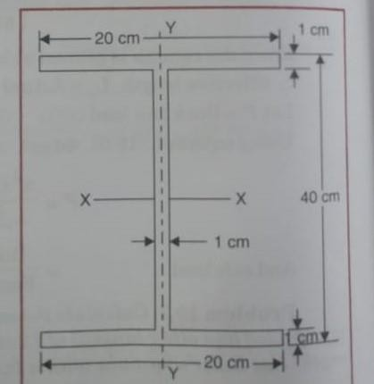
IYY = M.O.I of rectangle (38 X 1) – M.O.I of 2 rectangles (1 X 20)

= d b³ - d1 b ³ = 38 X 1³ – 2 X 1 X 20³
1

12 12 12 12

= 1336.5 cm4

Least value of the moment of inertia is about YY axis. I = IYY = 1336.5 cm⁴ = 1336.5 X 10⁴ mm⁴
1.Euler’s crippling load for both ends fixed,

P = 4π² EI = 4 X π² X 2.1 X 10⁵ X 1336.5 X 10⁴
l² 3000²

= 4432080 N = 4432.08 KN.

- Using Euler’s formula, calculate the critical stresses for a series of struts having slenderness ratio of 40,80,120,160 and 200 under the following conditions:

Both ends hinged

Both ends fixed. Take E = 2.05 X 105 N/mm2. GIVEN DATA:
slenderness ratio, l/k = 40,80,120,160 and 200 E = 2.05 X 10⁵ N/mm².
SOLUTION:

  - Critical stress for both ends hinged,

Critical stress = π² E = π² E
(Le/k)² ( l/k)²

When l/k = 40, critical stress = π² E = π² X 2.05 X 10⁵
( l/k)² 40²

= 1264.54 N/mm2.

When l/k = 80, critical stress = π² E = π² X 2.05 X 10⁵
( l/k)² 80²

= 316.135 N/mm².

When l/k = 120, critical stress = π² E = π² X 2.05 X 10⁵
( l/k)² 120²

= 140.5 N/mm2.

When l/k = 160, critical stress = π² E = π² X 2.05 X 10⁵
( l/k)² 160²
= 79.03 N/mm2.
When l/k = 200, critical stress = π² E = π² X 2.05 X 10⁵
( l/k)² 200²

= 50.58 N/mm2.

  - Critical stress for both ends fixed,

Critical stress = π² E = π² E = 4 π² E
(Le/k)² [ (l/2)/k]² (l/k)²

When l/k = 40, critical stress = π² E = 4 x π² X 2.05 X 10⁵
( l/k)² 40²

= 5058.16 N/mm2.

When l/k = 80, critical stress = π² E = 4 X π² X 2.05 X 10⁵
( l/k)² 80²

= 1264.54 N/mm2.

When l/k = 120, critical stress = π² E = 4 X π² X 2.05 X 10⁵
( l/k)² 120²

= 562.02 N/mm2.

When l/k = 160, critical stress = π² E = 4 X π² X 2.05 X 10⁵
( l/k)² 160²

= 316.135 N/mm2.

When l/k = 200, critical stress = π² E = 4 X π² X 2.05 X 10⁵
( l/k)² 200²

= 202.32 N/mm2.

RANKINE’S FORMULA:

P = σC X A
1 + a (Le/ k)²

Where, σC = Ultimate crushing stress A = Area of cross section
a = Rankine’s constant.

Le = Effective length

k = Least radius of gyration.

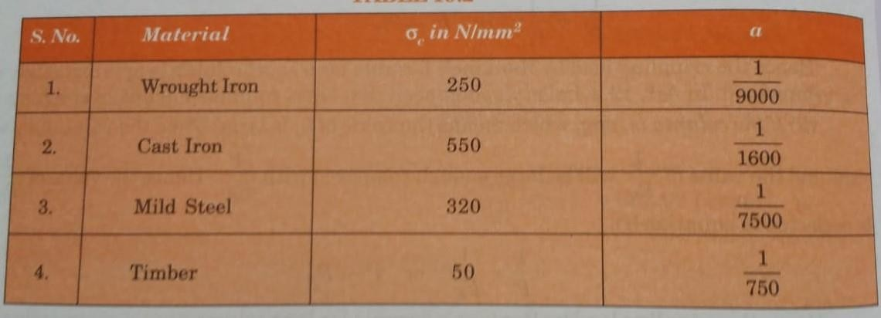

10. The external and internal diameter of a hollow cast iron column are 5 cm and 4 cm respectively. If the length of this column is 3 m and both of its ends are fixed, determine the crippling load using Rankine’s formula. Take σC = 550 N/mm² and a = 1/1600.

GIVEN DATA:

Length, L= 3 m = 3000 mm

External diameter, D = 5 cm = 50 mm. Internal diameter, d = 4 cm = 40 mm. Ultimate crushing stress, σC = 550 N/mm²
Rankine’s constant, a = 1/1600.
16

SOLUTION:

1.Cripling load for both ends fixed,

A = π X (D² – d²) = π X (50² – 40²) = 225 π mm2.
4 4

IXX = I = π X (D⁴ - d⁴) = π X (50⁴ – 40⁴) = 57656 π mm⁴.
64 64

Least radius of gyration, k = I/A = 57656 π / 225 π = 16.007 mm.

For both the ends are fixed, L = l/2 = 3000/2 = 1500 mm.

P = σC X A = 550 X 225 π

1 + a (Le/ k)² 1 + 1/1600 (1500/16.007)²

= 59918.3 N.

- A hollow cylindrical cast iron column is 4 m long with both ends fixed. Determine the minimum diameter of the column if it has to carry a safe load of 250 KN with a factor of safety of 5. Take the internal diameter as 0.8 times the external diameter. Take σC = 550 N/mm² and a
= 1/1600. GIVEN DATA:
Length, L= 4 m = 4000 mm Internal diameter, d = 0.8 X D Safe load = 250 KN
Ultimate crushing stress, σC = 550 N/mm²
Rankine’s constant, a = 1/1600, Factor of safety = 5.

SOLUTION:

Safe load = Crippling load / Factor of safety

Crippling load = Safe load X Factor of safety = 250 X 5 = 1250 KN.

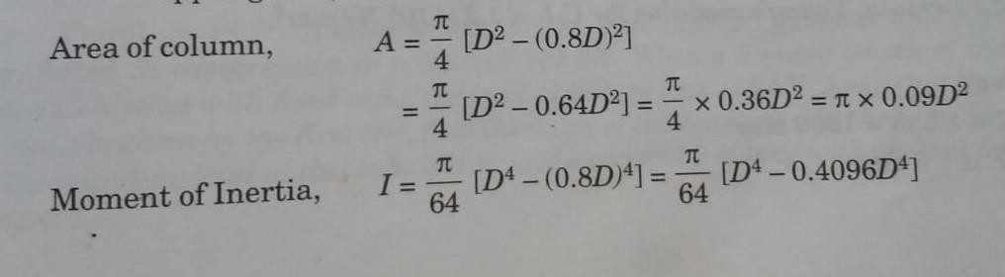

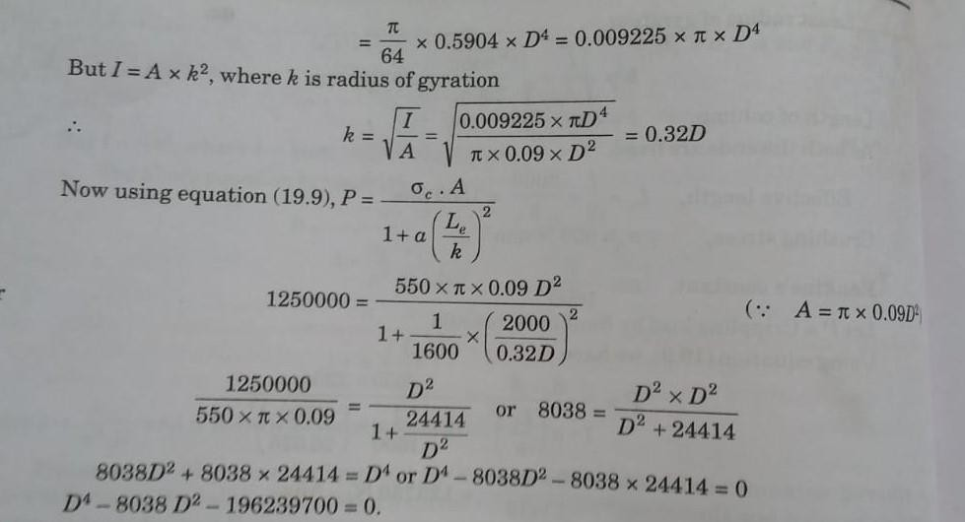
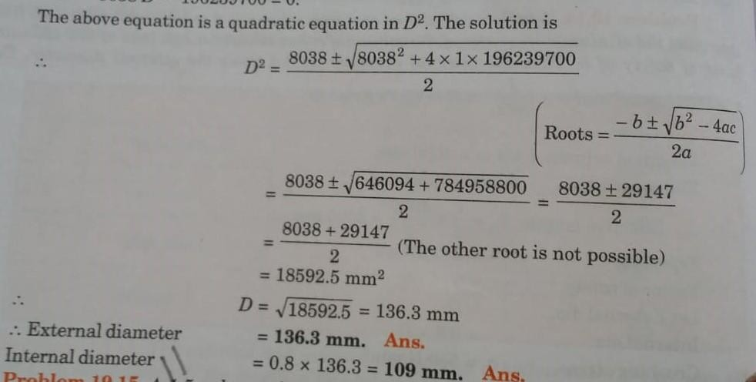

- A 1.5 m long column has a circular cross section of 5 cm diameter. One of the ends of the column is fixed in direction and position and other end is free. Taking factor of safety as 3, calculate the safe load using, Rankine’s formula, take σC = 560 N/mm² and a = 1/1600, Euler’s formula, E = 1.2 X 105 N/mm2.

GIVEN DATA:

Length, L= 1.5 m = 1500 mm Diameter, d = 5 cm
Ultimate crushing stress, σC = 560 N/mm² Rankine’s constant, a = 1/1600.
E = 1.2 X 10⁵ N/mm².

Factor of safety = 3

SOLUTION:

A = π X d² /4 = π X 50²/4 = 1963.5 mm2.

I = π X d⁴ /64 = π X 50⁴/64 = 30.7 X 104 mm4.

Least radius of gyration, k = I/A = 30.7 X 10⁴ / 1963.5 = 12.5 mm.

Le = 2 l = 2 X 1500 = 3000 mm

- Safe load using Rankine’s formula,

P = σC X A = 560 X 1963.5
1 + a (Le/ k)² 1 + 1/1600 (3000/12.5)²

= 29717.8 N.

Safe load = Crippling load / Factor of safety

= 29717.8 / 3

= 9905.9 N.

- Safe load using Euler’s formula,

P = π² EI = π² X 1.2 X 10⁵ X 30.7 X 10⁴ 4l² 4 X 1500²

= 40399.5 N

Safe load = Crippling load / Factor of safety

= 40399.5 / 3

= 13466.5 N.

13. A hollow cast iron column 200 mm outside diameter and 150 mm inside diameter, 8 m long has both ends fixed. It is subjected to an axial compressive load. Taking a factor of safety as 6, σC = 560 N/mm² and a = 1/1600. Determine the safe Rankine load.

GIVEN DATA:

Length, L= 8 m = 8000 mm, Le = l/2 = 8000/2 = 4000 mm. External diameter, D = 200 mm
Internal diameter, d = 150 mm

Ultimate crushing stress, σC = 560 N/mm² Rankine’s constant, a = 1/1600
Factor of safety = 6

SOLUTION:

1.Safe Rankine’s load,

A = π X (D² – d²) = π X (200² – 150²) = 13744 mm2.
4 4

IXX = I = π X (D⁴ - d⁴) = π X (200⁴ – 150⁴) = 53689000 mm⁴.
64 64

Least radius of gyration, k = I/A = 53689000/ 13744 = 62.5 mm.

P = σC X A = 560 X 13744

1 + a (Le/ k)² 1 + 1/1600 (4000/62.5)²

= 2161977 N = 2161.977 KN.

Safe load = Crippling load / Factor of safety

= 2161.977 / 6

= 360.3295 KN.

14. A hollow C.I column whose outside diameter is 200 mm has a thickness of 20 mm. It is 4.5 m long and is fixed at both ends. Calculate the safe load by Rankine’s formula using a factor of safety of 4. Calculate the slenderness ration and the ratio of Euler’s and Rankine’s critical loads. Take σC = 550 N/mm² and a = 1/1600 and E = 9.4 X 10⁴ N/mm².

GIVEN DATA:

Length, L= 4.5 m = 4500 mm, Le = l/2 = 4500/2 = 2250 mm. External diameter, D = 200 mm, Thickness, t = 20 mm.
Internal diameter, d = D – 2 X t = 200 – 2 X 20 = 160 mm Ultimate crushing stress, σC = 550 N/mm²
Rankine’s constant, a = 1/1600

Factor of safety = 4

E = 9.4 X 10⁴ N/mm².

SOLUTION:

A = π X (D² – d²) = π X (200² – 160²) = 11310 mm2.
4 4

IXX = I = π X (D⁴ - d⁴) = π X (200⁴ – 160⁴) = 46370000 mm⁴.

64 64

Least radius of gyration, k = I/A = 46370000 / 11310 = 64 mm.

- Slenderness ratio,

Slenderness ratio = l/k = 4500/64 = 70.30

- Safe load by Rankine’s formula,

P = σC X A = 550 X 11310
1 + a (Le/ k)² 1 + 1/1600 (2250/64)²

= 3511000 N.

Safe load = Crippling load / Factor of safety

= 3511000 / 4

= 877750 N.

- Ratio of Euler’s and Rankine’s critical loads,

Euler’s critical load, P = 4π² EI = 4 X π² X 9.4 X 10⁴ X 46370000
l² 4500²
= 8497700 N.
Euler’s critical load = 8497700 = 2.42
Rankine’s critical load 3511000
I.S CODE FORMULA
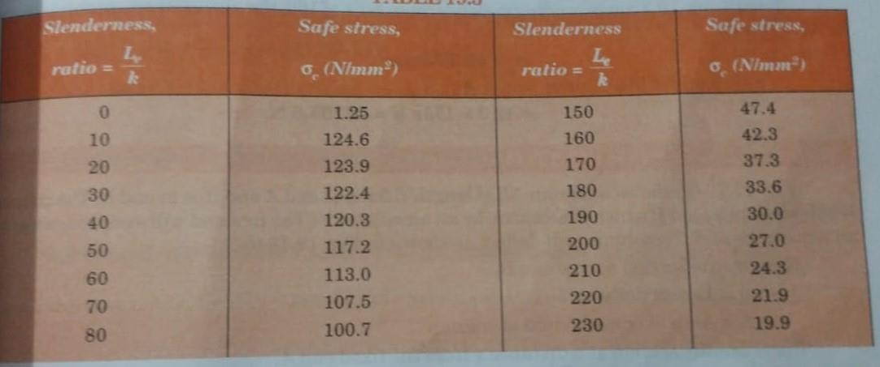
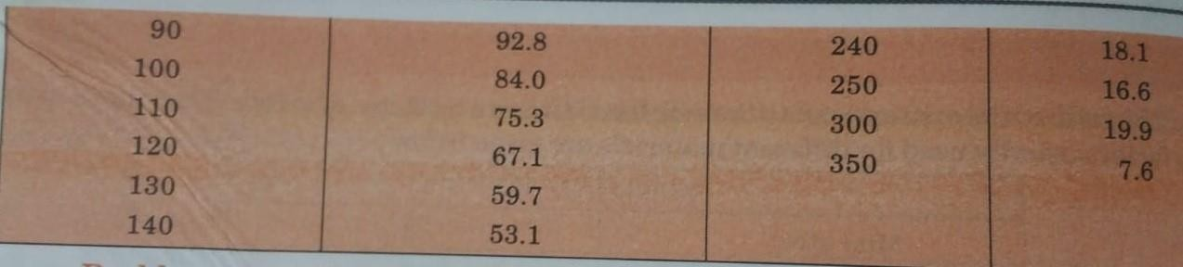

15. Determine the safe load by I.S. code for a hollow cylindrical mild steel tube of 4 cm external diameter and 3 cm internal diameter when the tube is used as a column of length 2.5 m long with both ends hinged.

GIVEN DATA:

External diameter – 4 cm = 40 mm Internal diameter – 3 cm = 30 mm Length – 2.5 m = 2500 mm SOLUTION:
1.Safe load by I.S. CODE formula,

A = π X (D² – d²) = π X (40² – 30²) = 549.77 mm2.

4 4

IXX = I = π X (D⁴ - d⁴) = π X (40⁴ – 30⁴) = 85902.92 mm⁴.

64 64

To determine the safe load by I.S. code formula, first find the value of slenderness ratio. Then according to slenderness ratio, obtain the safe compressive stress from the table.

Now, slenderness ratio = l/k

k = I/A = 85902.92 / 549.77 = 12.5 mm.

slenderness ratio = 2500/12.5 = 200.

From table, corresponding to slenderness ratio of 200, the allowable compressive stress is 27 N/ mm².

σC = 27 N/ mm².

Safe load for the column = σC X A

= 27 X 549.77

= 14843.79 N.

SECANT FORMULA
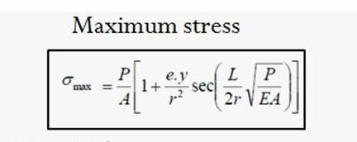

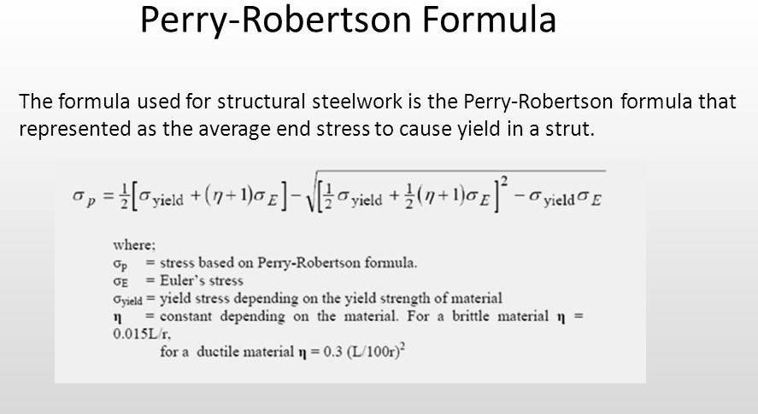

COLUMNS WITH ECCENTRIC LOADING
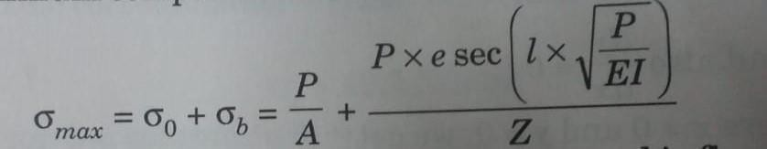

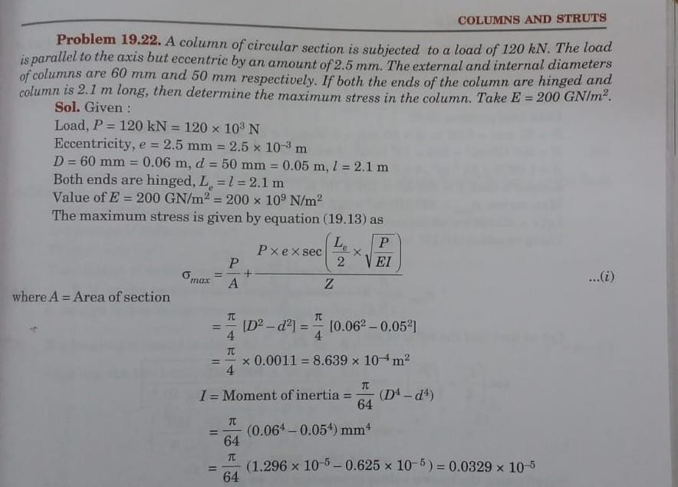

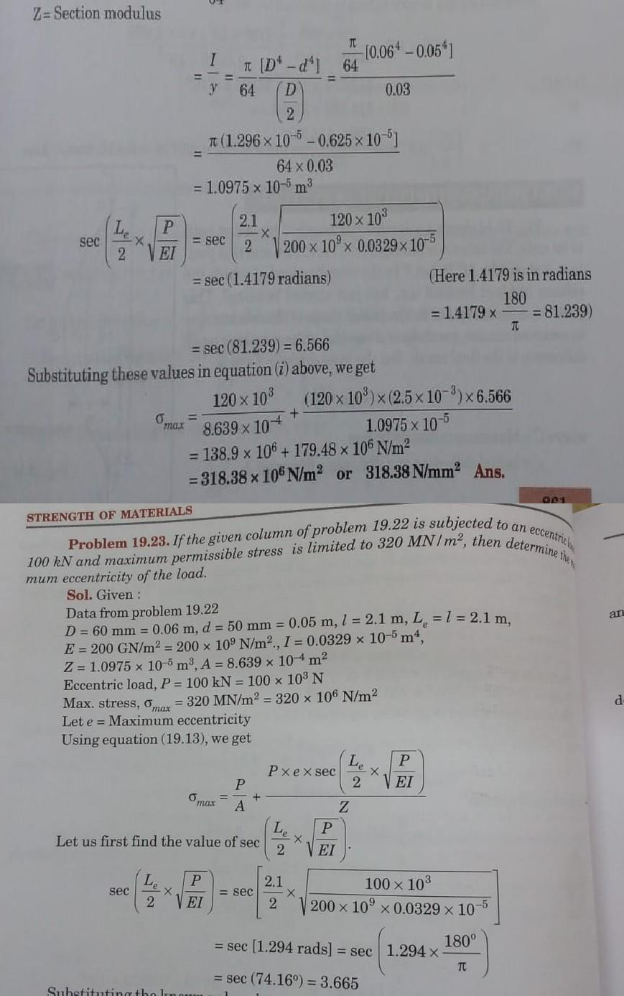

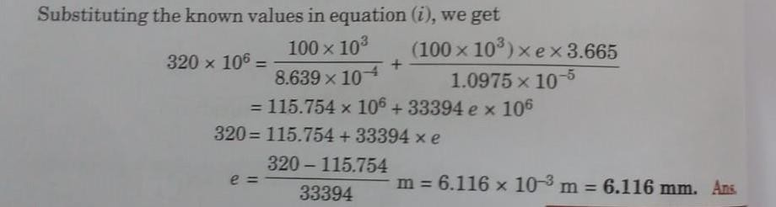

REFERENCE BOOKS:

- Bansal R.K., “Strength of Materials”, 5th Edition, Laxmi Publications, 2013.
- Ramamrutham R., “Strength of Materials”,14th Edition, Dhanpat Rai Publications, 2011.
- Punmia B.C., “Strength of Materials”, Laxmi Publications, 2011.
- Subramanian R., “Strength of Materials - Theory and Problems”, Oxford University Press, 2010.
- Rajput R.K., “Strength of Materials”, S. Chand and Company Ltd., New Delhi, 2007.
- Timoshenko S.P. and Gere J.M., “Mechanics of Materials”, 6th Edition, Tata McGraw Hill.

QUESTION BANK:
  - Distinguish columns & struts.
  - List the assumptions made in Euler’s column theory.
  - What are the different end conditions of a column?
  - Define: slenderness ratio.
  - List the limitations of Euler's formula.
  - Define: Crippling load.
  - What is Equivalent length of a column?
  - What is a Rankine's constant? What is the approximate value of Rankine's constant for cast iron column?
  - Define: Safe load.
10.A column of timber section 10 cm X 15 cm is 5 m long both ends being fixed. If the young's modulus for timber = 17.5 KN/mm2. Determine crippling load and safe load for the column if factor of safety = 3.
11.A hollow mild steel tube 5 m long, 4 cm internal diameter and 5 mm thick is used as a strut with both ends hinged. Determine the crippling load and safe load taking factor of safety as 3.0. Take E = 2 X 105 N/mm2.
- Determine Euler's crippling load for an I - section joist 30 cm X 15 cm X 2 cm and 5 m long which is used as a strut with both ends fixed. Take E = 2 X 105 N/mm2.
- Determine the crippling load for a T - section of dimensions 12 cm X 12 cm X 2 cm and of length 6 cm when it is used as a strut with both of its ends hinged.
Take E = 2 X 105 N/mm2.
- Determine the ratio of buckling strengths of two columns one hollow and the other solid. Both are made of the same material and have the same length, cross sectional area and end conditions. The internal diameter of hollow column is 2/3rd of its external diameter.
  - 2 m long column has a circular cross section of 6 cm diameter. One of the ends of the column is fixed in direction and position and other end is free.
Taking factor of safety as 3, determine the safe load using
    - Rankine's formula taking yield stress = 550 N/mm2 and a = 1/1600 for pinned ends.

UNIT – IV – THIN CYLINDERS AND SPHERES, THICK CYLINDERS – SCIA1401

SCHOOL OF BUILDING AND ENVIRONMENT DEPARTMENT OF CIVIL ENGINEERING

INTRODUCTION

THIN CYLINDER:

- The cylinder which have thickness is less than 1/10 to 1/20 of its Diameter, that cylinder is called as thin cylinder.
- Thin cylinder is only resist to the internal Pressure.
- Thin cylinder failure due to internal fluid pressure by the formation of circumferential stress and longitudinal stress.
- The internal pressure which is acting radially inside the thin cylinder is known as radial pressure in thin cylinder.

STRESSES IN A THIN CYLINDRICAL SHELL:

There will be two types of stresses, which will be developed in the wall of thin cylindrical shell and these stresses are as mentioned here.

CIRCUMFERENTIAL STRESS OR HOOP STRESS:

Stress acting along the circumference of thin cylinder will be termed as circumferential stress or hoop stress.

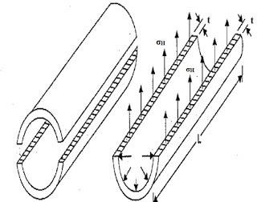If fluid is stored under pressure inside the cylindrical shell, pressure will be acting vertically upward and downward over the cylindrical wall.

LONGITUDINAL STRESS:

- Stress acting along the length of thin cylinder will be termed as longitudinal stress.
- If fluid is stored under pressure inside the cylindrical shell, pressure force will be acting along the length of the cylindrical shell at its two ends.
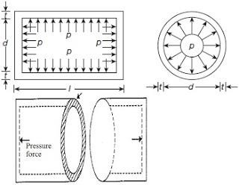

EXPRESSION FOR CIRCUMFERENTIAL or HOOP STRESS:

σ₁ = p d

2 t

Where, p – Internal fluid pressure

d – Internal diameter if the cylinder

t – Thickness of the wall of the cylinder

σ₁ – Circumferential or hoop stress in the material.
EXPRESSION FOR LONGITUDINAL STRESS:

σ₂ = p d

4 t

σ₂ - Longitudinal stress in the material
Longitudinal stress= Half of the circumferential stress.

PROBLEMS

1.A cylindrical pipe of diameter 1.5 m and thickness 1.5 cm is subjected to an internal fluid pressure of 1.2 N/mm2. Determine the longitudinal stress developed in the pipe and circumferential stress developed in the pipe.

GIVEN DATA:

Diameter - 1.5 m

Thickness - 1.5 cm = 0.015 m Internal fluid pressure of 1.2 N/mm² SOLUTION:
- LONGITUDINAL STRESS,

σ2 = p d = 1.2 X 1.5 = 30 N/mm²

4 t 4 X 0.015

- CIRCUMFERENTIAL STRESS,

σ1 = p d = 1.2 X 1.5 = 60 N/mm²
2 t 2 X 0.015

2. A cylinder of internal diameter 2.5 m and of thickness 5 cm contains a gas. If the tensile stress in the material is not to exceed 80 N/mm2, determine the internal pressure of the gas.

GIVEN DATA:

Internal diameter - 2.5 m Thickness - 5 cm = 0.05 m Tensile stress - 80 N/mm²
As tensile stress is given, hence this should be equal to circumferential stress (σ1), σ1 = 80 N/mm²

SOLUTION:

1.INTERNAL PRESSURE OF THE GAS,

σ1 = p d
2 t

p = σ1 X 2 t = 80 X 2 X 0.05 = 3.2 N/mm²
d 2.5

3. A cylinder of internal diameter 0.5 m contains air at a pressure of 7 N/mm2. If the maximum permissible stress induced in the material is 80 N/mm2, find the thickness of the cylinder.

GIVEN DATA:

Internal diameter - 0.5 m Pressure - 7 N/mm²
Maximum permissible stress - 80 N/mm²

As maximum permissible stress is given, hence this should be equal to circumferential stress (σ1). σ1 - 80 N/mm²
SOLUTION:

1.THICKNESS OF THE CYLINDER,

σ1 = p d
2 t

t = p d = 7 X 0.5 2 X σ1 2 X 80
t = 0.021875 m or 2.18 cm.

4. A thin cylinder of internal diameter 1.25 m contains a fluid at an internal pressure of 2 N/mm2. Determine the maximum thickness of the cylinder if i) longitudinal stress is not to exceed 30 N/mm2 ii) circumferential stress is not to exceed 45 N/mm2.

GIVEN DATA:

Internal diameter, d - 1.25 m Internal fluid pressure, p - 2 N/mm² Longitudinal stress, σ2 = 30 N/mm²

circumferential stress, σ1 = 45 N/mm².

SOLUTION:

- MAXIMUM THICKNESS OF THE CYLINDER if σ1 = 45 N/mm²,

σ1 = p d

2 t

t = p d = 2 X 1.25 2 X σ1 2 X 45
t = 0.0277 m or 2.77 cm.

- MAXIMUM THICKNESS OF THE CYLINDER if σ2 = 30 N/mm²,

σ2 = p d

4 t

t = p d = 2 X 1.25 4 X σ1 4 X 30
t = 0.0208 m or 2.08 cm.

The longitudinal or circumferential stresses induced in the material are inversely proportional to the thickness of the cylinder. Hence the stress induced will be less if the value of ‘t’ is more. Hence take the maximum value of ‘t’.

t = 2.77 cm.

5. A water main 80 cm diameter contains water at a pressure head of 100 m. If the weight density of water is 9810 N/m3, find the thickness of the metal required for the water main. Given the permissible stress as 20 N/mm2.

GIVEN DATA:

Diameter of main, d - 1.25 m Pressure head of water, h = 100 m Permissible stress, σ1 = 20 N/mm² SOLUTION:
1.THICKNESS OF THE METAL,

Pressure of water inside the water main, P = w X h = 9810 X 100

= 981000 N/m² = 0.981 N/mm².

σ1 = p d
2 t  t = p d | = | 0.981 X 80 = 2 cm.
2 X σ1 |  | 2 X 20

EFFICIENCY OF A JOINT

The cylindrical shells such as boilers are having two types of joints namely longitudinal joint and circumferential joint.
Ƞl - Efficiency of a longitudinal joint and Ƞc - Efficiency of a circumferential joint. Circumferential stress, σ1 = p d
2 t X Ƞl

Longitudinal stress, σ2 = p d

4 t X Ƞc

Efficiency of a joint means the efficiency of a longitudinal joint.

6. A boiler is subjected to an internal steam pressure of 2 N/mm2. The thickness of boiler plate is 2 cm and permissible tensile stress is 120 N/mm2. Find out the maximum diameter, when efficiency of longitudinal joint is 90 % and that of circumferential joint is 40 %.

GIVEN DATA:

Internal steam pressure, p = 2 N/mm² Thickness of boiler plate, t = 2 cm Permissible tensile stress = 120 N/mm² Ƞl = 90 %
Ƞc = 40 %.

SOLUTION:

In case of a joint, the permissible stress may be circumferential stress or longitudinal stress.

- MAXIMUM DIAMETER FOR CIRCUMFERENTIAL STRESS,

σ1 = p d
2 t X Ƞl

120 = 2 X d
2 X 0.90 X 2

d = 120 X 2 X 0.90 X 2 = 216 cm.
2

- MAXIMUM DIAMETER FOR LONGITUDINAL STRESS,

σ2 = p d
4 t X Ƞc

120 = 2 X d
4 X 0.40 X 2

d = 120 X 4 X 0.40 X 2 = 192 cm.
2

The longitudinal or circumferential stresses induced in the material are directly proportional to diameter. Hence the stress induced will be less if the value of ‘d’ is less. Hence take the minimum value of d.

Maximum diameter of the boiler is equal to the minimum value of diameter. Hence maximum diameter, d = 192 cm.
If d = 216 cm, σ2 will be more than the given permissible stress.

σ2 = p d = 2 X 216 = 135 N/mm²
4 t X Ƞc 4 X 2 X 0.4

- A cylinder of thickness 1.5 cm has to withstand maximum internal pressure of 1.5 N/mm2. If the ultimate tensile stress in the material of the cylinder is 300 N/mm2, factor of safety 3 and joint efficiency 80 %, determine the diameter of the cylinder.

GIVEN DATA:

Thickness of cylinder, t = 1.5 cm Internal pressure, p = 1.5 N/mm² Ultimate tensile stress = 300 N/mm² Factor of safety = 3
Ƞ = 80 %

Joint efficiency means the longitudinal joint efficiency, Ƞl = 80 %

SOLUTION:

Working stress, σ1 = Ultimate tensile stress = 300 = 100 N/mm²
Factor of safety 3

σ1 = p d
2 t X Ƞl

100 = 1.5 X d
2 X 0.80 X 1.5

d = 100 X 2 X 0.80 X 1.5 = 160 cm or 1.6 m.
1.5

EFFECT OF INTERNAL PRESSURE ON THE DIMENSIONS OF A THIN CYLINDRICAL SHELL:

Change in diameter, δd = pd² 1 -
μ

2

2tE

Change in length, δL μ
= pd L 1 -
2tE
2

Volumetric Strain, δV = pd 5 - 2μ
V 2tE 2

Change in volume, δV = V [ 2 e1 + e2]

Change in volume, δV = V 2 δd +
δL

L

d

- Calculate the change in diameter, change in length and change in volume of a thin cylindrical shell 100 cm diameter, 1 cm thick and 5 m long when subjected to internal pressure of 3 N/mm2. Take the value of E = 2 X 105 N/mm2 and poisson’s ratio, μ = 0.3.

GIVEN DATA:

Diameter of shell, d = 100 cm Thickness of shell, t = 1 cm Length of shell, L = 5 m = 500 cm Internal pressure, p = 3 N/mm²
Young’s modulus, E = 2 X 10⁵ N/mm² Poisson’s ratio, μ = 0.3.
SOLUTION:

Change in diameter, δd = pd² 1 - μ
2tE 2

– 0.3

2
1
= 3 X 100²
2 X 1 X 2 X 10⁵
= 0.06375 cm.
Change in length, δL = pd L 1 - μ
2tE 2
= 3 X 100 X 500 1 - 0.3
2 X 1 X 2 X 10⁵ 2
= 0.075 cm.
Change in volume, δV = V +
2 δd

d
δL

L
V = (π d²/4) X L = (π X 100² /4) X 500 = 3926990.817 cm³

δV = 3926990.817 X X 0.06375 +
0.075

500
2
100

= 5595.96 cm3

- A cylindrical thin drum 80 cm in diameter and 3 m long has a shell thickness of 1 cm. If the drum is subjected to an internal pressure of 2.5 N/mm2. Determine the change in diameter, change in length and change in volume. Take the value of E = 2 X 105 N/mm2 and poisson’s ratio, μ = 0.25.

GIVEN DATA:

Diameter of drum, d = 80 cm Thickness of shell, t = 1 cm Length of shell, L = 3 m = 300 cm Internal pressure, p = 2.5 N/mm²
Young’s modulus, E = 2 X 10⁵ N/mm² Poisson’s ratio, μ = 0.25.
SOLUTION:

Change in diameter, δd = pd² 1 -
μ

2

2tE

= 2.5 X 80²
– 0.25

2
1
2 X 1 X 2 X 10⁵

= 0.035 cm.

Change in length, δL - μ
= pd L
1
2tE
2

= 2.5 X 80 X 300 1 - 0.25
2 X 1 X 2 X 10⁵ 2
= 0.0375 cm.

Change in volume, δV = V +
2 δd

d
δL

L

V = (π d²/4) X L = (π X 80² /4) X 300 = 1507964.473 cm³ δV = 1507964.473 X 2 X 0.035 +
0.0375

300
80

= 1507.96 cm3

- A cylindrical vessel whose ends are closed by means of rigid flange plates is made of steel plate 3 mm thick. The length and the internal diameter of the vessel are 50 cm and 25 cm respectively. Determine the longitudinal and circumferential stresses in the cylindrical shell due to an internal fluid pressure of 3 N/mm2. Also calculate the increase in length, diameter and volume of the vessel. Take the value of E = 2 X 105 N/mm2 and poisson’s ratio, μ = 0.3.

GIVEN DATA:

Thickness, t = 3 mm = 0.3 cm

Length of cylindrical vessel, L = 50 cm Internal diameter, d = 25 cm
Internal fluid pressure, p = 3 N/mm² Young’s modulus, E = 2 X 10⁵ N/mm² Poisson’s ratio, μ = 0.25.
SOLUTION:

- CIRCUMFERENTIAL STRESS,

σ1 = p d = 3 x 25 = 125 N/mm²
2 t 2 x 0.3

- LONGITUDINAL STRESS,

σ2 = p d = 3 x 25 = 62.5 N/mm²
Change in diameter, δd = pd² 1 - μ
2tE
2
4 t 4 x 0.3

= 3 X 25²
1 –
2 X 0.3 X 2 X 10⁵
0.3

2
= 0.0133 cm.

Change in length, δL = pd L 1 - μ
2tE 2
= 3 X 25 X 50 1 - 0.3
2 X 0.3 X 2 X 10⁵ 2
= 0.00625 cm.
Change in volume, δV = V +
2 δd

d
δL

L

V = (π d²/4) X L = (π X 25² /4) X 50 = 24543.69 cm³ δV = 24543.69 X 2 X 0.0133 + 0.00625
25 50

= 29.18 cm3

11. A cylindrical vessel is 1.5 m diameter and 4 m long is closed at ends by rigid plates. It is subjected to an internal pressure of 3 N/mm2. If the maximum principal stress is not to exceed 150 N/mm2, find the thickness of the shell. Assume E = 2 X 105 N/mm2 and poisson’s ratio, μ =
0.25. Find the changes in diameter, length and volume of the shell.

GIVEN DATA:

Diameter of vessel, d = 1.5 m = 1500 mm Length of cylindrical vessel, L = 4 m = 4000 mm Internal pressure, p = 3 N/mm²
Maximum principal stress = 150 N/mm² Young’s modulus, E = 2 X 10⁵ N/mm² Poisson’s ratio, μ = 0.25.
SOLUTION:

- THICKNESS OF THE SHELL,

Maximum principal stress means circumferential stress. σ1 = 150 N/mm²
σ1 = p d

2 t

t = p d = 3 X 1500 2 X σ1 2 X 150
t = 15 mm.

- CHANGES IN DIAMETER, LENGTH & VOLUME,

Change in diameter, δd
= pd² 1 -

2tE
μ

2

= 3 X 1500² 1 –
0.25

2
2 X 15 X 2 X 10⁵

= 0.984 mm.

Change in length, δL = pd L μ
1 -

2
2tE

= 3 X 1500 X 4000 1 - 0.25

2 X 15 X 2 X 10⁵ 2

= 0.75 mm.

Volumetric Strain, δV = pd 2μ
5 -

2

V 2tE
Change in volume, δV = pd
5 - 2μ X V
2tE
2
=
3 X 1500
5 - 2 X 0.25 X V
2 X 2 X 10⁵ X 15
2

V = (π d²/4) X L = (π X 1500² /4) X 4000 = 7.0685 X 10⁹ mm³

δV = 3 X 1500 5 - 2 X 0.25 X 7.0685 X 10⁹
2 X 2 X 10⁵ X 15 2

= 10602875 mm3

WIRE WINDING OF THIN CYLINDERS:

  - We know that the hoop stress is two times the longitudinal stress in a thin cylinder, when the cylinder is subjected to internal fluid pressure.
  - Hence the failure of a thin cylinder will be due to hoop stress.
  - Also, the hoop stress which is tensile in nature is directly proportional to the fluid pressure inside the cylinder.
  - In case of cylinders which have to carry high internal fluid pressures, some methods of reducing the hoop stresses have to be devised.
  - One method is to wind strong steel wire under tension on the walls of the cylinder.
  - The effect of the wire is to put the cylinder wall under an initial compressive stress.

THIN SPHERICAL SHELLS:

  - A thin spherical shell of internal diameter ‘d’ and thickness ‘t’ is subjected to an internal fluid pressure ‘p’.
  - The fluid inside the shell has the tendency to split the shell into two hemi spheres along x-x axis.
  - The force P which has a tendency to split the shell.

= p X (π X d²/4)
The area resisting this force, A = π X d X t

Hoop stress induced in the material of the shell is given by, σ₁ = Force (P)
Area resisting this force (A) σ₁ = p X (π X d²/4) = p d
π X d X t 4 t

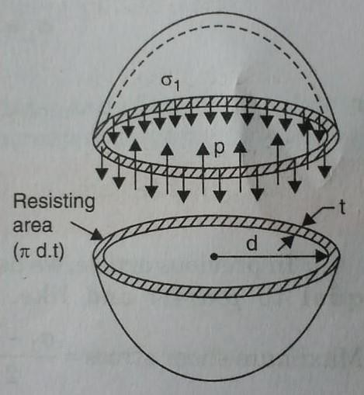

PROBLEMS:

1.A vessel in the shape of a spherical shell of 1.2 m internal diameter and 12 mm shell thickness is subjected to pressure of 1.6 N/mm2 . Determine the stress induced in the material of the vessel.

GIVEN DATA:

Internal diameter of shell, d = 1.2 m = 1200 mm Thickness of shell, t = 12 mm
Pressure, p = 1.6 N/mm²

SOLUTION:

1. STRESS INDUCED IN THE MATERIAL OF THE VESSEL,

σ1 = p d = 1.6 X 1200 = 40 N/mm²
4 t 4 X 12

2.A spherical vessel 1.5 m diameter is subjected to an internal pressure of 2 N/mm2. Find the thickness of the plate required if maximum stress is not to exceed 150 N/mm2 and joint efficiency is 75 %.

GIVEN DATA:

Diameter of spherical vessel, d = 1.5 m = 1500 mm Internal pressure = 2 N/mm²

Maximum stress, σ1 = 150 N/mm² Joint efficiency, Ƞ = 75 %.
SOLUTION:

σ1 = p d
4 t X Ƞ

t = 2 X 1500 = 6.67 mm
4 X 150 X 0.75

CHANGE IN DIMENSIONS OF A THIN SPHERICAL SHELL DUE TO AN INTERNAL PRESSURE:

Strain, δd = pd (1 – μ) d 4tE
Change in diameter, δd = pd (1 – μ) X d
4tE Volumetric strain, δV = 3 X pd (1 – μ)

V 4tE

Change in volume, δV = 3 X pd (1 – μ) X V
4tE

3.A spherical shell of internal diameter 0.9 m and of thickness 10 mm is subjected to an internal pressure of 1.4 N/mm2. Determine the increase in diameter and increase in volume. Take E = 2 X 105 N/mm2 and poisson’s ratio, μ = 1/3.

GIVEN DATA:

Internal diameter of spherical shell, d = 0.9 m = 900 mm Thickness, t = 10 mm
Internal pressure, p = 1.4 N/mm² E = 2 X 10⁵ N/mm²
Poisson’s ratio, μ = 1/3.

SOLUTION:

- INCREASE IN DIAMETER,

Increase in diameter, δd = pd (1 – μ) X d
4tE

Increase in diameter, δd = 1.4 X 900 (1 – (1/3)) X 900
4 X 10 X 2 X 10⁵

= 0.0945 mm.

- INCREASE IN VOLUME,

Change in volume, δV = 3 X pd (1 – μ) X V
4tE

Volume, V = πX d³/6 = πX 900³/6 = 381.7 mm3.

Change in volume, δV = 3 X 1.4 X 900 (1 – (1/3)) X 381.7

4 X 10 X 2 X 10⁵

= 12028.5 mm3.

THICK CYLINDER:

- The cylinder which have Thickness is more than 1/20 of its diameter that Cylinder is called as thick Cylinder.
- If the ratio of thickness to internal diameter is more than 1/20, then cylindrical shell is known as thick cylinders.

STRESSES PRODUCED DUE TO INTERNAL FLUID PRESSURE:

  - Radial pressure p (Compressive)
  - Circumferential stress or Hoop stress σ₁ (Tensile)
  - Longitudinal stress σ₂ (Tensile) Radial Pressure: p_{x} = b - a (1)
x2
Hoop Stress: σ_{x} = b + a (2)
x2

Above 2 equations are called Lame’s equations.

The constants ‘a’ and ‘b’ are obtained from boundary conditions.

- At x = r₁, p_{x} = p₀ or the pressure of fluid inside the cylinder.
- At x = r₂, p_{x} = 0 or atmospheric pressure.
PROBLEMS:

1.Determine the maximum and minimum stress across the section of a pipe of 400 mm internal diameter and 100 mm thick, when the pipe contains a fluid at a pressure of 8 N/mm². Also sketch the radial pressure distribution and hoop stress distribution across the section.

GIVEN DATA:

Internal diameter, d₁ = 400 mm Internal radius, r₁ = 400/2 = 200 mm
External diameter, d₂ = 400 + 2 X 100 = 600 mm External radius, r₂ = 600/2 = 300 mm
Fluid pressure, p₀ = 8 N/mm²
SOLUTION:

1. MAXIMUM AND MINIMUM STRESS,

The radial pressure p_{x} = b - a (1)

x2
Now apply the boundary conditions to the above equation. The boundary conditions are:
1. At x = r₁ = 200 mm, p_{x} = p₀ = 8 N/mm² 2. At x = r₂ = 300 mm, p_{x} = 0.
Substituting these boundary conditions in equation (1), we get 8 = b - a = b - a (2)
200² 40000
19

0 = b - a = b - a (3)

300² 90000
Subtracting equation 3 from equation 2, we get 8 – 0 = b - a - b + a
40000 90000 8 = 9b – 4b = 5 b
360000 360000

b = 360000 X 8 = 576000
5

Substituting this value in equation (3), we get 0 = 576000 – a
90000

a = 576000/90000 = 6.4

The values of ‘a’ and ‘b’ are substituted in the hoop stress.

Hoop Stress: σ_{x} = b + a = 576000 + 6.4
x2 x2
At x = 200 mm, σ₂₀₀ = 576000 + 6.4 = 20.8 N/mm²
200²
At x = 300 mm, σ₃₀₀ = 576000 + 6.4 = 12.8 N/mm²

300²

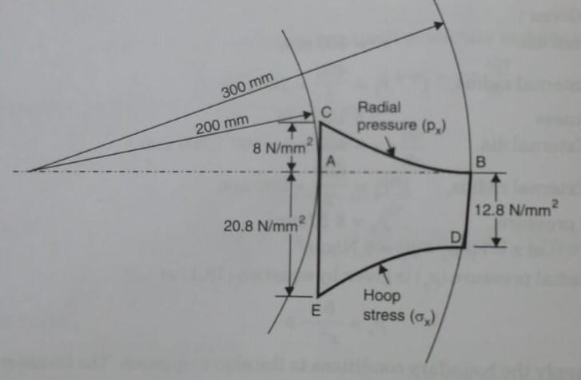

REFERENCE BOOKS:

- Bansal R.K., “Strength of Materials”, 5th Edition, Laxmi Publications, 2013.
- Ramamrutham R., “Strength of Materials”,14th Edition, Dhanpat Rai Publications, 2011.
- Punmia B.C., “Strength of Materials”, Laxmi Publications, 2011.
- Subramanian R., “Strength of Materials - Theory and Problems”, Oxford University Press, 2010.
- Rajput R.K., “Strength of Materials”, S. Chand and Company Ltd., New Delhi, 2007.
- Timoshenko S.P. and Gere J.M., “Mechanics of Materials”, 6th Edition, Tata McGraw Hill.

QUESTION BANK:
  - Distinguish thin and thick cylinder.
  - Name the stresses set up in a thin cylinder subjected to internal fluid pressure.
  - What are circumferential and longitudinal stresses?
  - What do you mean by Lame's equation?
  - Name the stresses set up in a thick cylinder subjected to internal fluid pressure.
  - A cylinder of internal diameter 2.5 m and of thickness 5 cm contains a gas. If the tensile stress in the material is not to exceed 80 N/mm2, find the internal pressure of the gas.
  - A vessel in the shape of a spherical shell of 1.2 m internal diameter and 12 mm shell thickness is subjected to pressure of 1.6 N/mm2. Find the stress induced in the material of the vessel.
  - A spherical vessel 1.5 m diameter is subjected to an internal pressure of 2 N/mm2. Find the thickness of the plate required if maximum stress is not to exceed 150 N/mm2 and joint efficiency is 75 %.
  - A cylinder pipe of diameter 2 m and thickness 2 cm is subjected to an internal fluid pressure of 1.5 N/mm2, find the longitudinal and circumferential stress developed in the pipe material.
  - A thin cylinder of internal diameter 2 m contains a fluid at an internal pressure of 3 N/mm2. Determine the maximum thickness of the cylinder if i)longitudinal stress is not to exceed 30 N/mm2 ii)circumferential stress is not to exceed 40 N/mm2.
  - A thin cylindrical shell of 120 cm diameter, 1.5 cm thick and 6 m long is subjected to internal fluid pressure of 2.5 N/mm2.If E = 2 X105 N/mm2 and poisson's ratio = 0.3, determine i) Change in diameter ii) change in length iii) change in volume.
  - Determine the thickness of metal necessary for a cylindrical shell of internal diameter 150 mm to withstand an internal pressure of 50 N/mm2. The maximum hoop stress in the section is not to exceeed 150 N/mm2.

UNIT – V – THEORIES OF FAILURE – SCIA1401

SCHOOL OF BUILDING AND ENVIRONMENT DEPARTMENT OF CIVIL ENGINEERING

INTRODUCTION

Theories of failure are those theories which help us to determine the safe dimensions of a machine component when it is subjected to combined stresses due to various loads acting on it during its functionality.

IMPORTANT THEORIES OF FAILURE:

Maximum principal stress theory (Rankine's theory) Maximum principal strain theory (St. Venant's theory)
Maximum shear stress theory (Coulomb, Tresca and Guest's theory) Maximum strain energy theory (Haigh's theory)
Maximum shear strain energy theory or Distortion energy theory (Huber von Mises and Hencky's theory)

MAXIMUM PRINCIPAL STRESS THEORY (RANKINE'S THEORY)

According to this theory, the failure of a material will occur when the maximum principal tensile stress (σ₁) in the complex system reaches the value of the maximum stress at the elastic limit in simple tension or the minimum principal stress (maximum principal compressive stress) reaches the value of the maximum stress at the elastic limit in simple compression.

Let in a complex three-dimensional stress system,

σ₁ ,σ₂ and σ₃ = principal stresses at a point in three perpendicular directions. The stresses σ₁ and σ₂ are tensile and σ₃ is compressive.
Also, σ₁ is more than σ₂
σ_{t}* = tensile stress at elastic limit in simple tension.
σ_{c}* = compressive stress at elastic limit in simple compression. σ₁ > σ_{t}* in simple tension.
σ₃ > σ_{c}*in simple compression.
This is the simplest and oldest theory of failure and is known as Rankine’s theory.

If the maximum principal stress σ₁ is the design criterion, then maximum principal stress must not exceed the permissible stress σ_{t} for the given material.
Hence, σ₁ = σ_{t}
Where, σ_{t} = permissible stress and is given by σ_{t} = σ_{t}* / factor of safety.
PROBLEMS:

1.The principal stresses at a point in an elastic material are 100 N/mm² (tensile), 80 N/mm² (tensile) and 50 N/mm² (compressive). If the stress at the elastic limit in simple tension is 200 N/mm² , determine whether the failure of material will occur according to maximum principal stress theory. If not, then determine the factor of safety.

GIVEN DATA:

σ₁ = 100 N/mm² σ₂ = 80 N/mm²
σ₃ = 50 N/mm² = - 50 N/mm² σ_{t}* = 200 N/mm²
SOLUTION:

- TO DETERMINE WHETHER FAILURE OF MATERIAL WILL OCCUR OR NOT:

From the three given stresses, the maximum principal tensile stress is σ₁ = 100 N/mm² And the stress at elastic limit in simple tension is σ_{t}* = 200 N/mm²
As σ1 is less than σ *, the failure will not occur according to maximum principal stress theory.
t

- FACTOR OF SAFETY:

Using equation, σ₁ = σ_{t} σ_{t} = 100 N/mm² σ_{t} = σ_{t}* / factor of safety
Factor of safety = σ_{t}* / σ_{t} = 200/100 = 2.

MAXIMUM PRINCIPAL STRAIN THEORY (ST. VENANT'S THEORY)
4

According to this theory, the failure of a material will occur when the maximum principal strain reaches strain due to yield stress in simple tension or when the minimum principal strain (maximum compressive strain) reaches the strain due to yield stress in simple compression.

Yield stress is the maximum stress at elastic limit. Consider a three-dimensional stress system.
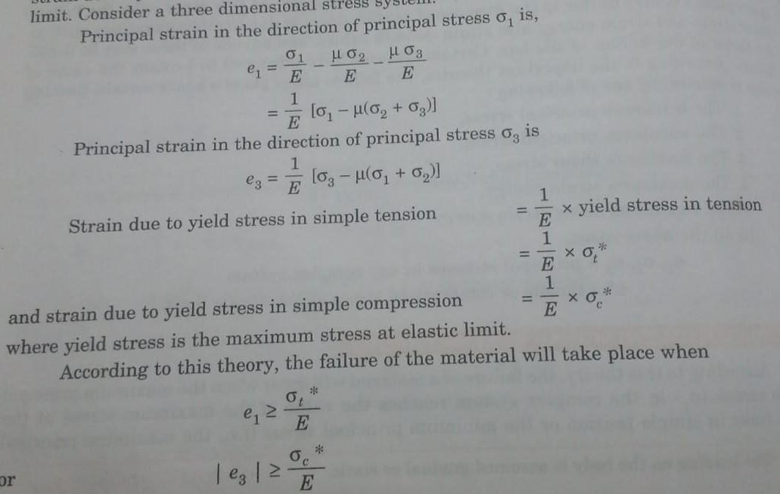
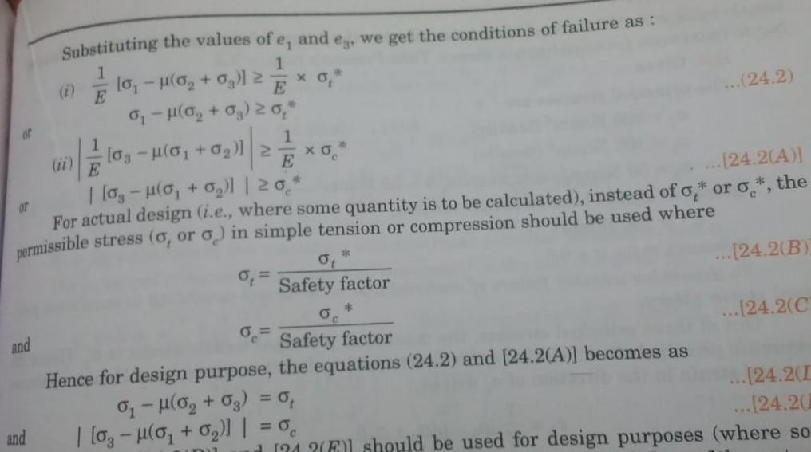

2.The principal stresses at a point in an elastic material are 200 N/mm² (tensile), 100 N/mm² (tensile) and 50 N/mm² (compressive). If the stress at the elastic limit in simple tension is 200 N/mm² , determine whether the failure of material will occur according to maximum principal strain theory. Take Poisson’s ratio = 0.3.

GIVEN DATA:

σ₁ = 200 N/mm² σ₂ = 100 N/mm²
σ₃ = 50 N/mm² = - 50 N/mm² σ_{t}* = 200 N/mm²
Poisson’s ratio = 0.3.

SOLUTION:

1.TO DETERMINE WHETHER FAILURE OF MATERIAL WILL OCCUR OR NOT:
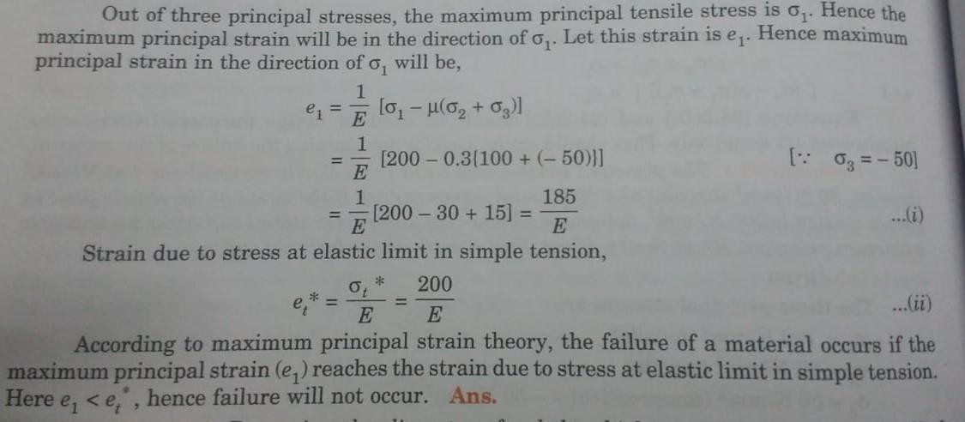

3. Determine the diameter of a bolt which is subjected to an axial pull of 9 KN together with a transverse shear force of 4.5 KN using, i) Maximum principal stress theory and ii) maximum principal strain theory. Given the elastic limit in tension = 225 N/mm² , factor of safety = 3 and Poisson’s ratio = 0.3.
5

GIVEN DATA:

Axial pull, P = 9 KN = 9000 N

Transverse shear force, F = 4.5 KN = 4500 N σ_{t}* = 225 N/mm²
Factor of safety = 3 Poisson’s ratio = 0.3. SOLUTION:
The permissible stress in tension is given by, σ_{t} = σ_{t}* / factor of safety = 225/3 = 75 N/mm²
The axial pull will produce tensile stress whereas transvers shear force will produce shear stress in the bolt.

Let us calculate these stresses.

Now, tensile stress, σ = P = P = 4 P
A πd²/4 πd²

= 4 X 9000 = 11459 N/mm²
πd² d²

Now, shear stress, τ = F = 4F = 4 X 4500 = 5729.5 N/mm²

πd²/4 πd² πd² d²

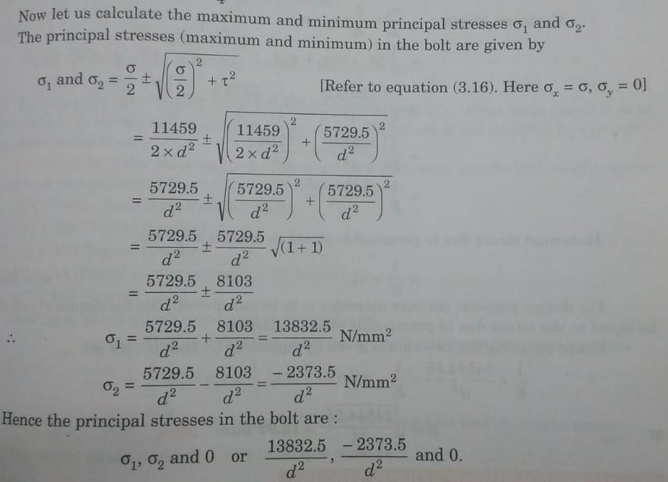

1.DIAMETER OF BOLT ACCORDING TO MAXIMUM PRINCIPAL STRESS THEORY:

Here diameter of the bolt is to be calculated. This becomes the case of design.
For the purpose of design, according to maximum principal stress theory, the maximum principal stress should not exceed the permissible stress σ_{t} in tension.
Here, the maximum principal stress is σ₁
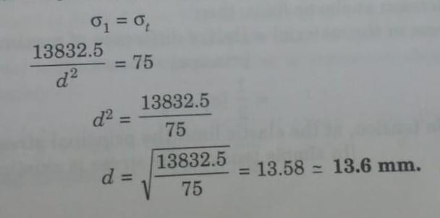

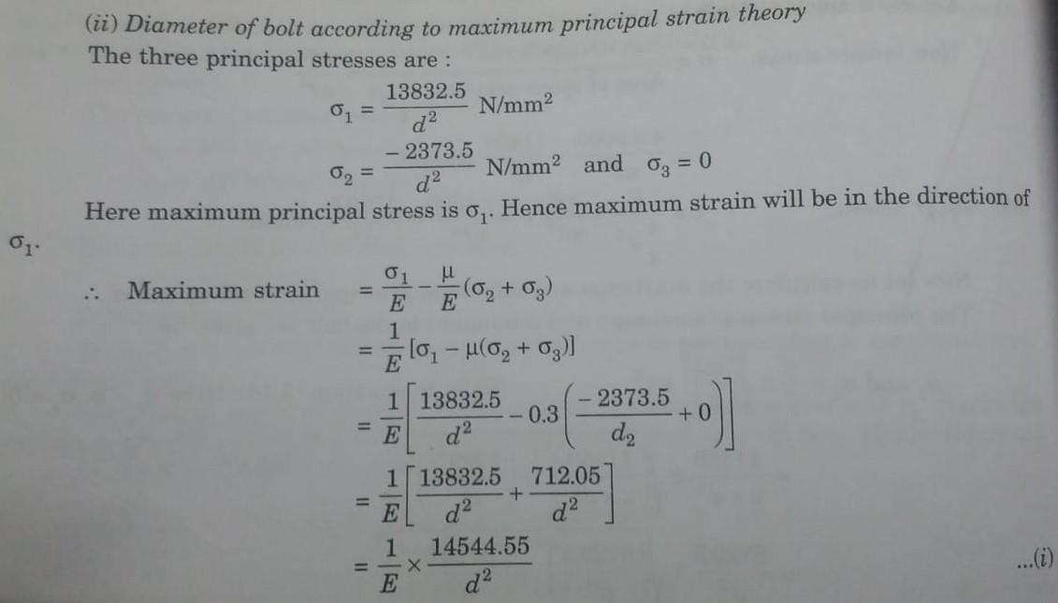
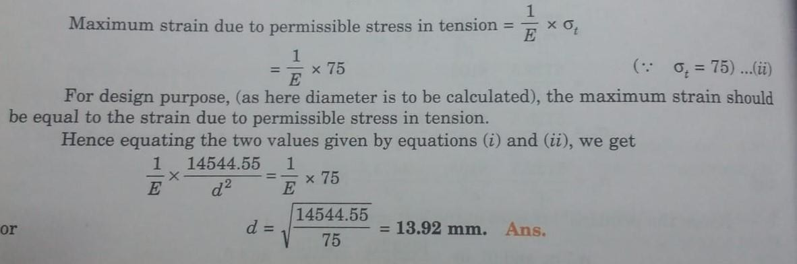

MAXIMUM SHEAR STRESS THEORY (GUEST'S THEORY)

According to this theory, the failure of a material will occur when the maximum shear stress in a material reaches the value of maximum shear stress in simple tension at the elastic limit.

The maximum shear stress in the material is equal to half the difference between maximum and minimum principal stress.

If σ₁ ,σ₂ and σ₃ are principal stresses at a point in a material for which σ_{t}* is the principal stress in simple tension at elastic limit, then

Maximum shear stress in the material = Half of difference of maximum and minimum principal stresses.

= 1 [σ₁ - σ₃] 2
In case of simple tension, at the elastic limit the principal stresses are σ_{t}*, 0, 0. [In simple tension, the stress is existing in one direction only]
- Maximum shear stress in simple tension at elastic limit = Half of difference of maximum and minimum principal stresses.

= 1 [σ_{t}* - 0] = 1 σ_{t}*
2 2

For the failure of material,
1 [σ₁ - σ₃] = 1 σ_{t}* OR [σ₁ - σ₃] > σ_{t}* 2 2
For actual design instead of σ_{t}*, the allowable stress σ_{t} in simple tension should be considered.
σ_{t} = σ_{t}* / factor of safety

Hence for design purpose, the following equation should be used. (σ₁ - σ₃ ) = σ_{t}

The principal stresses at a point in an elastic material are 200 N/mm² (tensile), 100 N/mm² (tensile) and 50 N/mm² (compressive). If the stress at the elastic limit in simple tension is 200 N/mm² , determine whether the failure of material will occur according to maximum shear stress theory.

GIVEN DATA:

σ₁ = 200 N/mm² σ₂ = 100 N/mm²
σ₃ = 50 N/mm² = - 50 N/mm² σ_{t}* = 200 N/mm²
SOLUTION:

Maximum shear stress in the material = Half of difference of maximum and minimum principal stresses.

= 1 [σ₁ - σ₃] = 1 [ 200 – (-50)] = 250/2 = 125 N/mm²

2 2

Maximum shear stress in simple tension at elastic limit = Half of difference of maximum and minimum principal stresses.

= 1 x σ_{t}* = 1 x 200 = 100 N/mm²
2 2

As maximum shear stress developed in the material is 125 N/mm² is more than the maximum shear stress at the elastic limit in simple tension is 100 N/mm² , hence failure will occur.

According to the theory of maximum shear stress, determine the diameter of a bolt which is subjected to an axial pull of 9 KN together with a transverse shear

force of 4.5 KN. Elastic limit in tension = 225 N/mm² , factor of safety = 3 and Poisson’s ratio = 0.3.

GIVEN DATA:

Axial pull, P = 9 KN = 9000 N

Transverse shear force, F = 4.5 KN = 4500 N σ_{t}* = 225 N/mm²
Factor of safety = 3 Poisson’s ratio = 0.3. SOLUTION:
1.DIAMETER OF BOLT ACCORDING TO MAXIMUM PRINCIPAL STRESS THEORY:

Permissible simple stress in tension, σ_{t} = σ * /3 = 225/3 = 75 N/mm²
t

The axial pull will produce tensile stress whereas transvers shear force will produce shear stress in the bolt.

Let us calculate these stresses.

Now, tensile stress, σ = P = P = 4 P
A πd²/4 πd²

= 4 X 9000 = 11459 N/mm²
πd² d²

Now, shear stress, τ = F = 4F = 4 X 4500 = 5729.5 N/mm²

πd²/4 πd² πd² d²

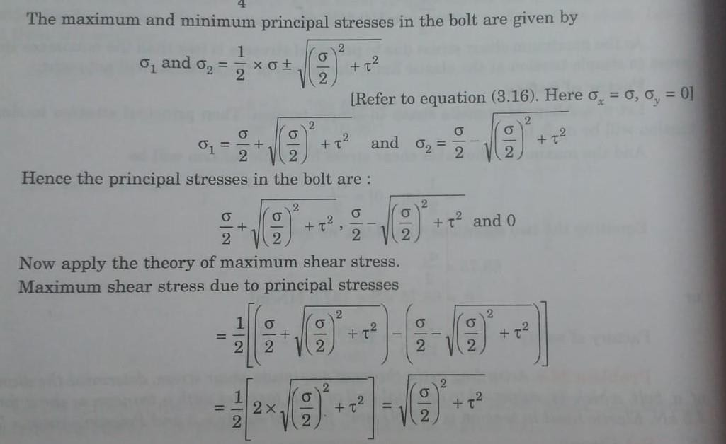

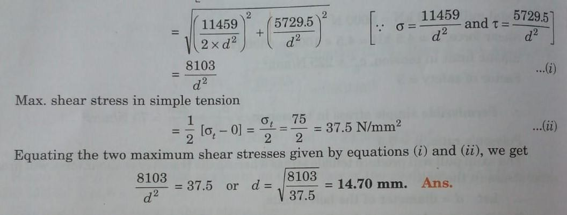

MAXIMUM STRAIN ENERGY THEORY (HAIGH'S THEORY)

According to this theory, the failure of a material will occur when the total strain energy per unit volume in the material reaches the strain energy per unit volume of the material at the elastic limit in simple tension.

Strain energy in a body is equal to work done by the load in straining the material and is equal to ½ X P X δL.
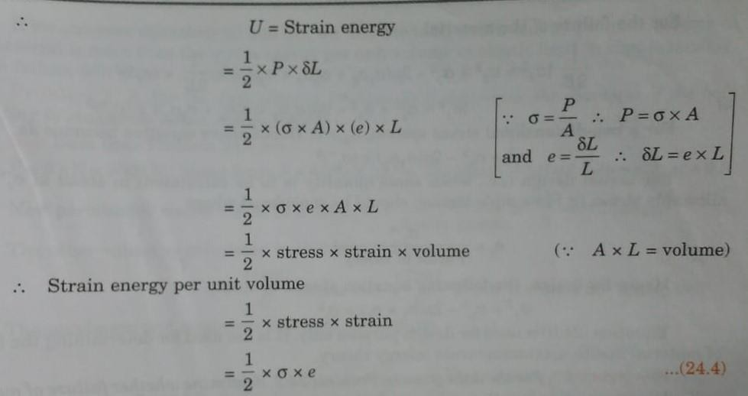
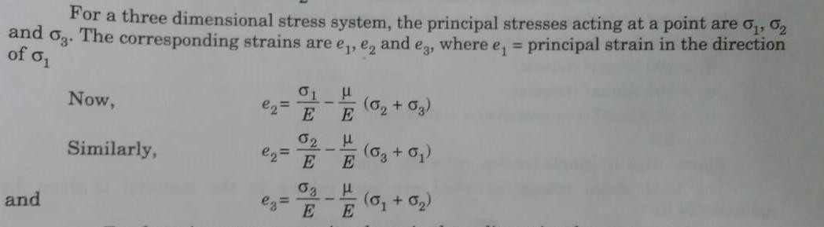

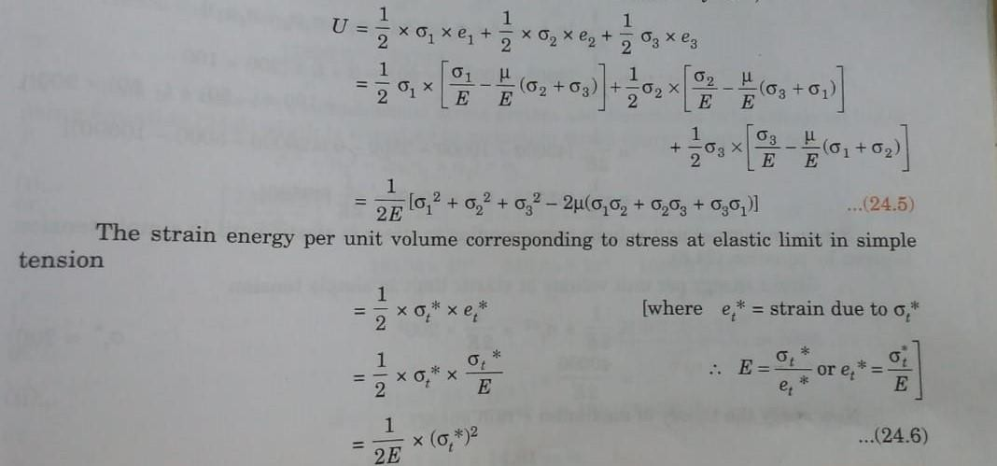
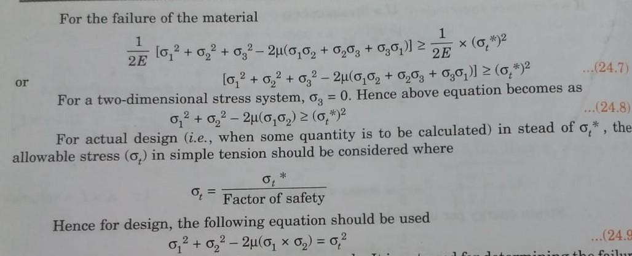

6. The principal stresses at a point in an elastic material are 200 N/mm² (tensile), 100 N/mm² (tensile) and 50 N/mm² (compressive). If the stress at the elastic limit in simple tension is 200 N/mm² , determine whether the failure of material will occur according to maximum principal strain theory. Take Poisson’s ratio = 0.3.

GIVEN DATA:

σ₁ = 200 N/mm² σ₂ = 100 N/mm²
σ₃ = 50 N/mm² = - 50 N/mm² σ_{t}* = 200 N/mm²
Poisson’s ratio = 0.3.

SOLUTION:

1.TO DETERMINE WHETHER FAILURE OF MATERIAL WILL OCCUR OR NOT:

Total strain energy per unit volume in the material, 1 [σ₁ + σ₁ + σ₁ – 2 ( σ₁ σ₂ + σ₂ σ₃ + σ₃ σ₁ ) ]
2E

= 1 [ 200² + 100² +(-50)² – 2 x 0.3 {200 x 100 + 100 x (-50) + (- 50) x 200}] 2E
= 1 [49500] 2E
strain energy per unit volume of the material at the elastic limit in simple tension

1 X σ_{t}^{*2} 2E

= 1 X 200² = 40000 2E 2E
We find the total strain energy per unit volume in the material is more than the strain energy per unit volume at elastic limit in simple tension. Hence failure will occur.

7. According to maximum strain energy theory, determine the diameter of a bolt which is subjected to an axial pull of 9 KN together with a transverse shear force of 4.5 KN. Elastic limit in tension = 225 N/mm² , factor of safety = 3 and Poisson’s ratio = 0.3.

GIVEN DATA:

Axial pull, P = 9 KN = 9000 N

Transverse shear force, F = 4.5 KN = 4500 N σ_{t}* = 225 N/mm²
Factor of safety = 3 Poisson’s ratio = 0.3. SOLUTION:
- DIAMETER OF BOLT ACCORDING TO MAXIMUM STRAIN ENERGY THEORY:

Permissible simple stress in tension, σ_{t} = σ * /3 = 225/3 = 75 N/mm²
t

The axial pull will produce tensile stress whereas transvers shear force will produce shear stress in the bolt.

Let us calculate these stresses.

Now, tensile stress, σ = P = P = 4 P

A πd²/4 πd²

= 4 X 9000 = 11459 N/mm²

πd² d²
16

Now, shear stress, τ = F = 4F = 4 X 4500 = 5729.5 N/mm²
πd²/4 πd² πd² d²

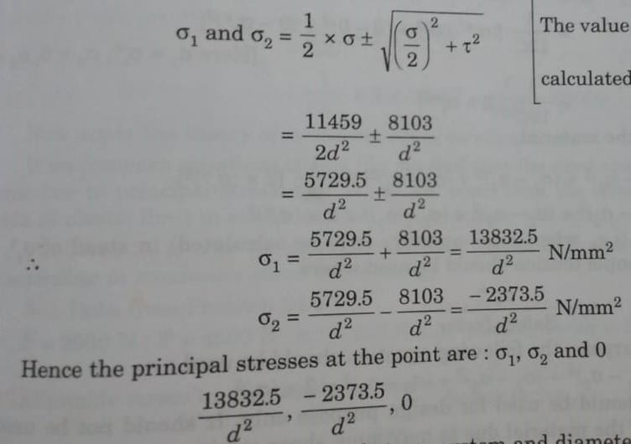

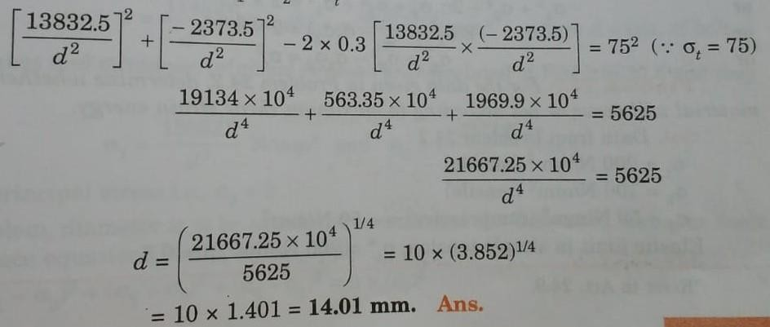

MAXIMUM SHEAR STRAIN ENERGY THEORY (MISES-HENKY THEORY)

  - According to this theory, the failure of a material will occur when the total shear strain energy per unit volume in the material reaches the value of shear strain energy per unit volume at the elastic limit in the simple tension.
  - The total shear strain energy per unit volume due to principal stresses σ₁ ,σ₂ and σ₃ in a stressed material is given as,
1 [ (σ₁ – σ₂ ) ² + (σ₂ – σ₃ ) ² + (σ₃ - σ₁ ) ² ]

2C

The simple tension test is a uniaxial stress system which means the principal stresses are σ₁ ,0,0.
At the elastic limit the tensile stress in simple tension is σ_{t}*

Hence at the elastic limit in simple tension test, the principal stresses are σ_{t}* ,0,0. The shear strain energy per unit volume at the elastic limit in simple tension will be.
1 [ (σ_{t}* – 0 ) ² + (0 – 0 ) ² + (0 - σ_{t}* ) ² ]
12C

1 [ 2 X σ_{t}^{*2} ]
12C

For the failure of the material,

1 [ (σ₁ – σ₂ ) ² + (σ₂ – σ₃ ) ² + (σ₃ - σ₁ ) ² ] > 1 [ 2 X σ_{t}^{*2} ]
12C 12C

(σ₁ – σ₂ ) ² + (σ₂ – σ₃ ) ² + (σ₃ - σ₁ ) ² > 2 X σ_{t}^{*2}

For actual design instead of σ_{t}*, the allowable stress σ_{t} in simple tension should be considered.

σ_{t} = σ_{t}* / factor of safety

Hence for design purpose, the following equation should be used. (σ₁ – σ₂ ) ² + (σ₂ – σ₃ ) ² + (σ₃ - σ₁ ) ² = 2 X σ_{t}²

8. The principal stresses at a point in an elastic material are 200 N/mm² (tensile), 100 N/mm² (tensile) and 50 N/mm² (compressive). If the stress at the elastic limit in simple tension is 200 N/mm² , determine whether the failure of material will occur according to maximum shear strain energy theory. Take Poisson’s ratio = 0.3.

GIVEN DATA:

σ₁ = 200 N/mm² σ₂ = 100 N/mm²
σ₃ = 50 N/mm² = - 50 N/mm² σ_{t}* = 200 N/mm²
Poisson’s ratio = 0.3.

SOLUTION:

1.TO DETERMINE WHETHER FAILURE OF MATERIAL WILL OCCUR OR NOT:

The total shear strain energy per unit volume due to principal stresses σ₁ ,σ₂ and σ₃ in a stressed material is given by,

1 [ (σ₁ – σ₂ ) ² + (σ₂ – σ₃ ) ² + (σ₃ - σ₁ ) ² ]
12C

= 1 [ (200 – 100)² + {100 – (-50)} ² + {(-50) -200} ²] 12C

= 1 X 95000 12C

The shear strain energy per unit volume at the elastic limit in simple tension will be,

1 [ 2 X σ_{t}^{*2} ] = 1 [ 2 X 200² ] = 1 X 80000

12C 12C 12C

We find that total shear strain energy per unit volume due to principal stresses σ₁ ,σ₂ and σ₃ are more than the shear strain energy per unit volume at the elastic limit in simple tension.

Hence failure will occur.

9. According to maximum shear strain energy theory, determine the diameter of a bolt which is subjected to an axial pull of 9 KN together with a transverse shear force of 4.5 KN. Elastic limit in tension = 225 N/mm² , factor of safety = 3 and Poisson’s ratio = 0.3.

GIVEN DATA:

Axial pull, P = 9 KN = 9000 N

Transverse shear force, F = 4.5 KN = 4500 N σ_{t}* = 225 N/mm²
Factor of safety = 3 Poisson’s ratio = 0.3. SOLUTION:
1.DIAMETER OF BOLT ACCORDING TO MAXIMUM SHEAR STRAIN ENERGY THEORY:

Permissible simple stress in tension,σ_{t} = σ * /3 = 225/3 = 75 N/mm²
t

The axial pull will produce tensile stress whereas transvers shear force will produce shear stress in the bolt.

Let us calculate these stresses.

Now, tensile stress, σ = P = P = 4 P
A πd²/4 πd²

= 4 X 9000 = 11459 N/mm²
πd² d²

Now, shear stress, τ = F = 4F = 4 X 4500 = 5729.5 N/mm²
πd²/4 πd² πd² d²

In this problem, diameter is to be calculated according to the maximum shear strain energy theory.

Hence the following equation is to be used. (σ₁ – σ₂ ) ² + (σ₂ – σ₃ ) ² + (σ₃ - σ₁ ) ² = 2 X σ_{t}²

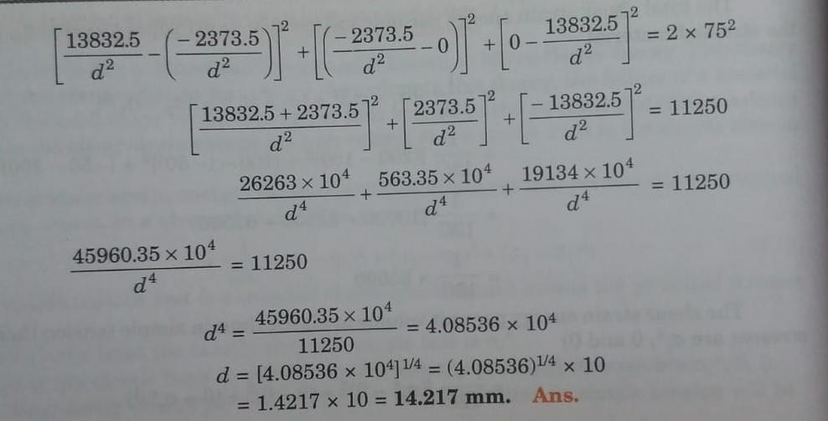

REFERENCE BOOKS:

- Bansal R.K., “Strength of Materials”, 5th Edition, Laxmi Publications, 2013.
- Ramamrutham R., “Strength of Materials”,14th Edition, Dhanpat Rai Publications, 2011.
- Punmia B.C., “Strength of Materials”, Laxmi Publications, 2011.
- Subramanian R., “Strength of Materials - Theory and Problems”, Oxford University Press, 2010.
- Rajput R.K., “Strength of Materials”, S. Chand and Company Ltd., New Delhi, 2007.
- Timoshenko S.P. and Gere J.M., “Mechanics of Materials”, 6th Edition, Tata McGraw Hill.

QUESTION BANK:
- Name the important theories of failure.
- Define: Maximum principal stress theory.
- Define: Maximum principal strain theory.
- Define: Maximum shear stress theory.
- Define: Maximum strain energy theory.
- Define: Maximum shear strain energy theory.
- The principal stresses at a point in an elastic material are 22 N/mm2 tensile, 110 N/mm2 (tensile) and 55 N/mm2 (compressive). If the stress at the elastic limit in simple tension is 200 N/mm2, determine whether the failure of material will occur according to maximum principal stress theory. If not, then determine the factor of safety.
- Determine the diameter of a bolt which is subjected to an axial pull of 9 kN together with a transverse shear force of 4.5 kN using Maximum principal strain theory. Given the elastic limit in tension = 225 N/mm2, factor of safety = 3 and Poisson’s ratio = 0.3.
- At a section of mild steel shaft, the maximum torque is 8437.5 Nm and maximum bending moment is 5062.5Nm. The diameter of shaft is 90 mm and the stress at the elastic limit in simple tension for the material of the shaft is 220 N/mm2.Determine whether the failure of the material will occur or not according to maximum shear stress theory. If not, then find the factor of safety.
- According to the theory of maximum shear stress, determine the diameter of a bolt which is subjected to an axial pull of 9 kN together with a transverse shear force of 4.5 kN. Elastic limit in tension is 225 N/mm2, factor of safety = 3 and poisson’s ratio = o.3.
- The principal stresses at a point in an elastic material are 22 N/mm2 tensile, 110 N/mm2 (tensile) and 55 N/mm2 (compressive). If the stress at the elastic limit in simple tension is 220 N/mm2 and poisson's ratio = 0.3, determine whether the failure of material will occur or not according to maximum strain energy theory.
- A cylindrical shell made of mild steel plate and 1.2 m in diameter is to be subjected to an internal pressure of 1.5 MN/m2. If the material yields at 200 MN/m2, calculate the thickness of the plate on the basis of the following three theories, assuming a factor of safety 3 in each case: (i) maximum principal stress theory, (ii) maximum shear stress theory, and (iii) maximum shear strain energy theory.

