UNIT I
Fundamental of basic electronics: Component identification, Component symbols & their footprints, understand schematic, Creating new PCB, Browsing footprints libraries, Setting up the PCB layers, Design rule checking, Track width selection, Component selection, Routing and completion of the design

What's a PCB?
Printed circuit board is the most common name but may also be called "printed wiring boards" or "printed wiring cards". Before the advent of the PCB circuits were constructed through a laborious process of point-to-point wiring. This led to frequent failures at wire junctions and short circuits when wire insulation began to age and crack.
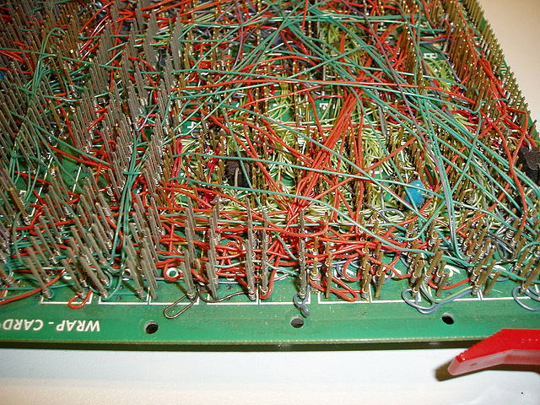
A significant advance was the development of wire wrapping, where a small gauge wire is literally wrapped around a post at each connection point, creating a gas-tight connection which is highly durable and easily changeable.
As electronics moved from vacuum tubes and relays to silicon and integrated circuits, the size and cost of electronic components began to decrease. Electronics became more prevalent in consumer goods, and the pressure to reduce the size and manufacturing costs of electronic products drove manufacturers to look for better solutions. Thus was born the PCB.
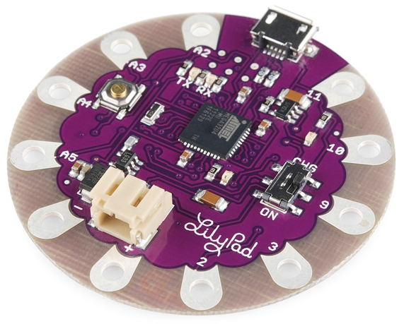
PCB is an acronym for printed circuit board. It is a board that has lines and pads that connect various points together. In the picture above, there are traces that electrically connect the various connectors and components to each other. A PCB allows signals and power to be routed between physical devices. Solder is the metal that makes the electrical connections between the surface of the PCB and the electronic components. Being metal, solder also serves as a strong mechanical adhesive.

Composition
A PCB is sort of like a layer cake or lasagna- there are alternating layers of different materials which are laminated together with heat and adhesive such that the result is a single object.
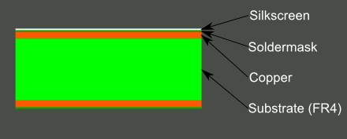
Let's start in the middle and work our way out.

The base material, or substrate, is usually fiberglass. Historically, the most common designator for this fiberglass is "FR4". This solid core gives the PCB its rigidity and thickness. There are also flexible PCBs built on flexible high-temperature plastic (Kapton or the equivalent).
You will find many different thickness PCBs; the most common thickness for SparkFun products is 1.6mm (0.063"). Some of our products- LilyPad boards and Arudino Pro Micro boards- use a 0.8mm thick board.
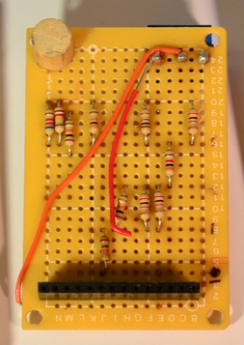
Cheaper PCBs and perf boards (shown above) will be made with other materials such as epoxies or phenolics which lack the durability of FR4 but are much less expensive. You will know you are working with this type of PCB when you solder to it - they have a very distictive bad smell. These types of substrates are also typically found in low-end consumer electronics. Phenolics have a low thermal decomposition temperature which causes them to delaminate, smoke and char when the soldering iron is held too long on the board.

Copper
The next layer is a thin copper foil, which is laminated to the board with heat and adhesive. On common, double sided PCBs, copper is applied to both sides of the substrate. In lower cost electronic gadgets the PCB may have copper on only one side. When we refer to a double sided or 2-layer board we are referring to the number of copper layers (2) in our lasagna. This can be as few as 1 layer or as many as 16 layers or more.
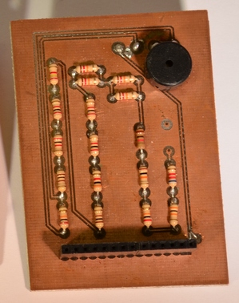
PCB with copper exposed, no solder mask or silkscreen.
The copper thickness can vary and is specified by weight, in ounces per square foot. The vast majority of PCBs have 1 ounce of copper per square foot but some PCBs that handle very high power may use 2 or 3 ounce copper. Each ounce per square translates to about 35 micrometers or 1.4 thousandths of an inch of thickness of copper.

Soldermask
The layer on top of the copper foil is called the soldermask layer. This layer gives the PCB its green (or, at SparkFun, red) color. It is overlaid onto the copper layer to insulate the copper traces from accidental contact with other metal, solder, or conductive bits. This layer helps the user to solder to the correct places and prevent solder jumpers.
In the example below, the green solder mask is applied to the majority of the PCB, covering up the small traces but leaving the silver rings and SMD pads exposed so they can be soldered to.
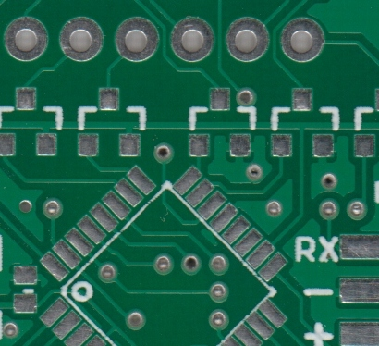
Soldermask is most commonly green in color but nearly any color is possible. We use red for almost all the SparkFun boards, white for the IOIO board, and purple for the LilyPad boards.

Silkscreen
The white silkscreen layer is applied on top of the soldermask layer. The silkscreen adds letters, numbers, and symbols to the PCB that allow for easier assembly and indicators for humans to better understand the board. We often use silkscreen labels to indicate what the function of each pin or LED.
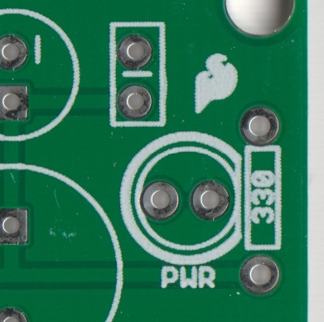
Silkscreen is most commonly white but any ink color can be used. Black, gray, red, and even yellow silkscreen colors are widely available; it is, however, uncommon to see more than one color on a single board.

Terminology
Now that you've got an idea of what a PCB structure is, let's define some terms that you may hear when dealing with PCBs:
Annular ring - the ring of copper around a plated through hole in a PCB.
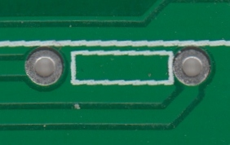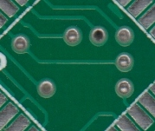
Examples of annular rings.
- DRC - design rule check. A software check of your design to make sure the design does not contain errors such as traces that incorrectly touch, traces too skinny, or drill holes that are too small.
- Drill hit - places on a design where a hole should be drilled, or where they actually were drilled on the board. Inaccurate drill hits caused by dull bits are a common manufacturing issue.
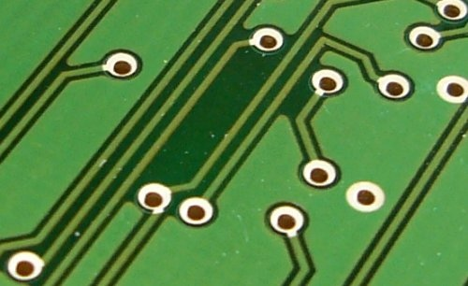

- Finger - exposed metal pads along the edge of a board, used to create a connection between two circuit boards. Common examples are along the edges of computer expansion or memory boards and older cartridge-based video games.
- Mouse bites - an alternative to v-score for separating boards from panels. A number of drill hits are clustered close together, creating a weak spot where the board can be broken easily after the fact. See the SparkFun Protosnap boards for a good example.
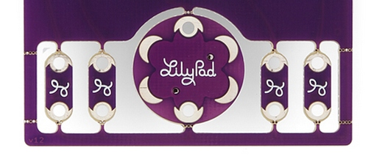
Pad - a portion of exposed metal on the surface of a board to which a component is soldered.
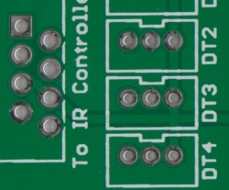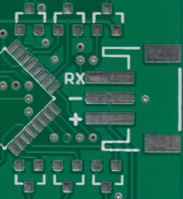
PTH (plated through-hole) pads on the left, SMD (surface mount device) pads on the right.
- Panel - a larger circuit board composed of many smaller boards which will be broken apart before use. Automated circuit board handling equipment frequently has trouble with smaller boards, and by aggregating several boards together at once, the process can be sped up significantly.
- Paste stencil - a thin, metal (or sometimes plastic) stencil which lies over the board, allowing solder paste to be deposited in specific areas during assembly.
Abe does a quick demonstration of how to line up a paste stencil and apply solder paste.
- Pick-and-place - the machine or process by which components are placed on a circuit board.
- Plane - a continuous block of copper on a circuit board, define by borders rather than by a path. Also commonly called a "pour".
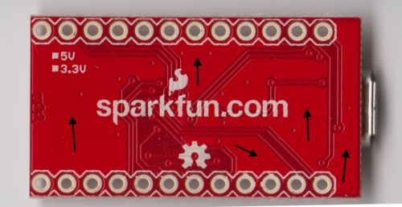
Various portions of the PCB that have no traces but has a ground pour instead.
- Plated through hole - a hole on a board which has an annular ring and which is plated all the way through the board. May be a connection point for a through hole component, a via to pass a signal through, or a mounting hole.
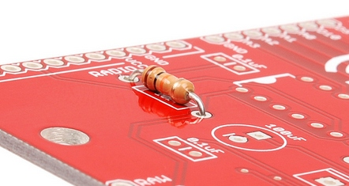
A PTH resistor inserted into the FabFM PCB, ready to be soldered. The legs of the resistor go through the holes. The plated holes can have traces connected to them on the front of the PCB and the rear of the PCB.
- Pogo pin - spring-loaded contact used to make a temporary connection for test or programming purposes.
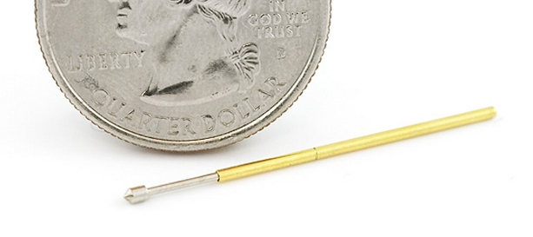
The popular pogo pin with pointed tip. We use tons of these on our test beds.
- Reflow - melting the solder to create joints between pads and component leads.
- Silkscreen - the letters, number, symbols, and imagery on a circuit board. Usually only one color is available, and resolution is usually fairly low.
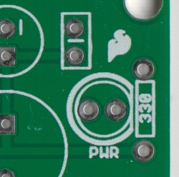
Silkscreen identifying this LED as the power LED.
- Slot - any hole in a board which is not round. Slots may or may not be plated. Slots sometimes add to add cost to the board because they require extra cut-out time.
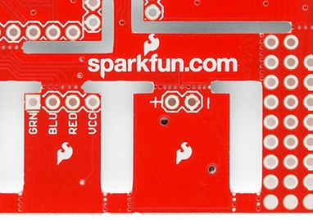
- Solder paste - small balls of solder suspended in a gel medium which, with the aid of a paste stencil, are applied to the surface mount pads on a PCB before the components are placed. During reflow, the solder in the paste melts, creating electrical and mechanical joints between the pads and the component.
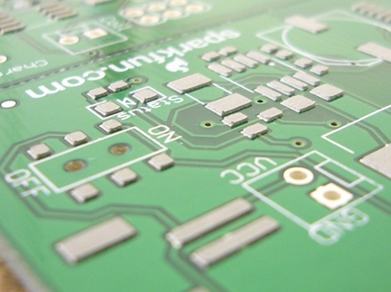
Solder paste on a PCB shortly before the components are placed. Be sure to read about *paste stencil above as well.*
- Solder pot - a pot used to quickly hand solder boards with through hole components. Usually contains a small amount of molten solder into which the board is quickly dipped, leaving solder joints on all exposed pads.
- Soldermask - a layer of protective material laid over the metal to prevent short circuits, corrosion, and other problems. Frequently green, although other colors (SparkFun red, Arduino blue, or Apple black) are possible. Occasionally referred to as "resist".
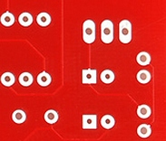
Solder mask covers up the signal traces but leaves the pads to solder to.
- Solder jumper - a small, blob of solder connecting two adjacent pins on a component on a circuit board. Depending on the design, a solder jumper can be used to connect two pads or pins together. It can also cause unwanted shorts.
- Surface mount - construction method which allows components to be simply set on a board, not requiring that leads pass through holes in the board. This is the dominant method of assembly in use today, and allows boards to be populated quickly and easily.
- Thermal - a small trace used to connect a pad to a plane. If a pad is not thermally relieved, it becomes difficult to get the pad to a high enough temperature to create a good solder joint. An improperly thermally relieved pad will feel "sticky" when you attempt to solder to it, and will take an abnormally long time to reflow.
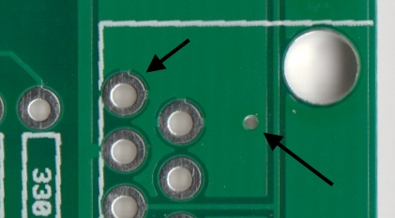
- Thieving - hatching, gridlines, or dots of copper left in areas of a board where no plane or traces exist. Reduces difficulty of etching because less time in the bath is required to remove unneeded copper.
- Trace - a continuous path of copper on a circuit board.
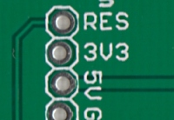
- V-score- a partial cut through a board, allowing the board to be easily snapped along a line.
- Via - a hole in a board used to pass a signal from one layer to another. Tented vias are covered by soldermask to protect them from being soldered to. Vias where connectors and components are to be attached are often untented (uncovered) so that they can be easily soldered.
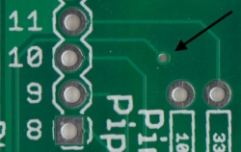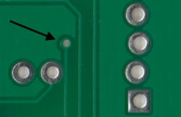
Front and back of the same PCB showing a tented via. This via brings the signal from the front side of the PCB, through the middle of the board, to the back side.
- Wave solder - a method of soldering used on boards with through-hole components where the board is passed over a standing wave of molten solder, which adheres to exposed pads and component leads.

Designing Your Own!
How do you go about designing your own PCB? The ins and outs of PCB design are way too in depth to get into here, but if you really want to get started, here are some pointers:
- Find a CAD package: there are a lot of low-cost or free options out there on the market for PCB design. Things to consider when choosing a package:
  - Community support: are there a lot of people using the package? The more people using it, the more likely you are to find ready-made libraries with the parts you need.
  - Ease-of-use: if it's painful to use it, you won't.
  - Capability: some programs place limitations on your design- number of layers, number of components, size of board, etc. Most of them allow you to pay for a license to upgrade their capability.
  - Portability: some free programs do not allow you to export or convert your designs, locking you in to one supplier only. Maybe that's a fair price to pay for convenience and price, maybe not.
- Look at other people's layouts to see what they have done. Open Source Hardware makes this easier than ever.
- Practice, practice, practice.
- Maintain low expectations. Your first board design will have lots of problems. Your 20th board design will have fewer, but will still have some. You'll never get rid of them all.
- Schematics are important. Trying to design a board without a good schematic in place first is an exercise in futility.
Finally, a few words on the utility of designing your own circuit boards. If you plan on making more than one or two of a given project, the payback on designing a board is pretty good- point-to-point wiring circuits on a protoboard is a hassle, and they tend to be less robust than purpose-designed boards. It also allows you to sell your design if it turns out to be popular.
Circuit layouts and schematic diagrams are a simple and effective way of showing pictorially the electrical connections, components and operation of a particular electrical circuit or system. Basic electrical and electronic graphical symbols called Schematic Symbols are commonly used within circuit diagrams, schematics and computer aided drawing packages to identify the position of individual components and elements within a circuit.
Graphical symbols not only identify a components position but the type of electrical element too, whether its resistive, inductive, capacitive, mechanical, etc. Thus in circuit diagrams and schematics, graphical symbols identify and represent electrical and electronic devices and show how they are electrically connected together while drawing lines between them represents the wires or component leads.
A the connecting leads or pins of a component in a schematic diagram can be identified using letters or abreviations. For example, the connecting leads of a bipolar junction transistor, (BJT) are identified as E (emitter), B (base), and C (collector). Arrows are also used within schematic symbols to indicate the direction of convertional current flow around a circuit or through a component, or are used as part of their graphical symbol to show that the components has a variable or adjustable value. For example, a potentiometer or rheostat.
Although electrical components are represented by universally accepted schematic symbols, there are a number of variants and alternative symbols used throughout the world to represent the same electrical component or device. For example, the IEC (International Electrotechnical Commission) have one set of symbols, while the IEEE (Institute of Electrical and Electronics Engineers) have an alternative set of symbols for the same component.
The basic electrical and electronic graphical symbols presented here are the more generally accepted graphical symbols because of their common usage across a range of electrical and electronic fields. The individual graphical symbols below are given along with a brief description and explanation.

Power Supply Schematic Symbols
Schematic  Symbol | Symbol Identification | Description of Symbol
 | Single Cell | A single DC battery cell of 0.5V
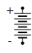 | DC Battery Supply | A collection of single cells forming a DC battery supply
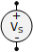 | DC Voltage Source | A constant DC voltage supply of a fixed value
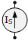 | DC Current Source | A constant DC current supply of a fixed value
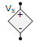 | Controlled Voltage Source | A dependent voltage source controlled by an external voltage or current
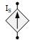 | Controlled Current Source | A dependent current source controlled by an external voltage or current
 | AC Voltage Source | A sinusoidal voltage source or generator

Electrical Grounding Schematic Symbols
Schematic  Symbol | Symbol Identification | Description of Symbol
 | Earth Ground | Earth ground referencing a common zero potential point
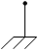 | Chassis Ground | Chassis ground connected to the power supplies earthing pin
 | Digital Ground | A common digital logic circuit ground line

Resistor Schematic Symbols
Schematic  Symbol | Symbol Identification | Description of Symbol
 | Fixed Resistor (IEEE Design) | A fixed value resistor whose resistive value is indicated next to its schematic symbol
 | Fixed Resistor (IEC Design)
 | Potentiometer (IEEE Design) | Three terminal variable resistance whose resistive value is adjustable from zero to its maximum value
 | Potentiometer (IEC Design)
 | Rheostat (IEEE Design) | Two terminal fully adjustable rheostat whose resistive value varies from zero to a maximum value
 | Rheostat (IEC Design)
 | Trimmer Resistor | Small variable resistors for mounting onto pcb’s
 | Thermistor (IEEE Design) | Thermal resistor whose resistive value changes with changes in surrounding temperature
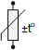 | Thermistor (IEC Design)

Capacitor Schematic Symbols
Schematic  Symbol | Symbol Identification | Description of Symbol
 | Fixed Value Capacitor | A fixed value parallel plate non-polarised AC capacitor whose capacitive value is indicated next to its schematic symbol
 | Fixed Value Capacitor
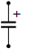 | Polarized Capacitor | A fixed value polarised DC capacitor usually an electrolytic capacitor which must be connected to the supply as indicated
 | Variable Capacitor | An adjustable capacitor whose capacitance value can be varied by means of adjustable plates

Inductor and Coil Schematic Symbols
Schematic  Symbol | Symbol Identification | Description of Symbol
 | Open Inductor | An open inductor, coil or solenoid that generates a magnetic field around itself when energised
 | Iron Core Inductor | An inductor formed by winding the coil around a solid laminated iron core indicated by solid lines
 | Ferrite Core Inductor | An inductor formed by winding the coil around a non-solid ferrite core indicated by dashed lines

Switch and Contact Symbols
Schematic  Symbol | Symbol Identification | Description of Symbol
 | SPST Toggle Switch | Single-pole single-throw toggle switch used for making (ON) or breaking (OFF) a circuits current
 | SPDT Changeover Switch | Single-pole double-throw changeover switch used for changing the direction of current flow from one terminal to another
 | Pushbutton Switch (N.O) | Normally open contacts pushbutton switch – push to close, release to open
 | Pushbutton Switch (N.C) | Normally closed contacts pushbutton switch – push to open, release to close
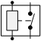 | SPST Relay Contacts | Electromechanical relay with internal single-pole single-throw toggle contacts
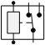 | SPDT Relay Contacts | Electromechanical relay with internal single-pole double-throw changeover contacts
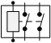 | DPST Relay Contacts | Electromechanical relay with internal double-pole single-throw toggle contacts
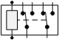 | DPDT Relay Contacts | Electromechanical relay with internal double-pole double-throw changeover contacts
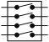 | DIP Switch Assembly | PCB mounted DIP switch with 1-to-10 toggle switches either single-pole, double-pole, rotary or with a common terminal

Semiconductor Diode Symbols
Schematic  Symbol | Symbol Identification | Description of Symbol
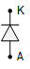 | Semiconductor Diode | Semiconductor pn-junction diode used for rectification and high current applications
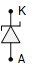 | Zener Diode | Zener diode used in its reverse voltage breakdown region for voltage limiting and regulation applications
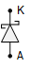 | Schottky Diode | Schottky diode consisting of an n-type semiconductor and metal electrode junction for low voltage applications

Transistor Symbols
Schematic  Symbol | Symbol Identification | Description of Symbol
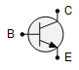 | NPN Bipolar Transistor | Characterised as being a lightly doped p-type base region between two n-type emitter and collector regions with the arrow indicating direction of conventional current flow out.
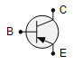 | PNP Bipolar Transistor | Characterised as being a lightly doped n-type base region between two p-type emitter and collector regions. Arrow indicates direction of conventional current flow in.
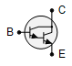 | Darlington Pair Transistor | Two bipolar transistor npn or pnp connected in a series common collector configuration to increase current gain
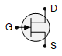 | N-JFET Transistor | N-channel junction field effect transistor having an n-type semiconductive channel between source and drain with the arrow indicating direction of conventional current flow
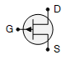 | P-JFET Transistor | P-channel junction field effect transistor having a p-type semiconductive channel between source and drain with the arrow indicating direction of conventional current flow
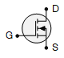 | N-MOSFET Transistor | N-channel metal-oxide semiconductor field effect transistor with an insulated gate terminal which can be operated in depletion or enhancement mode
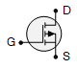 | P-MOSFET Transistor | P-channel metal-oxide semiconductor field effect transistor with an insulated gate terminal which can be operated in depletion or enhancement mode

Photodevice Schematic Symbols
Schematic  Symbol | Symbol Identification | Description of Symbol
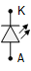 | Light Emitting Diode (LED) | A semiconductor diode which emits coloured light from its junction when forward biased
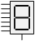 | 7-segment Display | A 7-segment display used common cathode (CC) or common anode (CA) for displaying single numbers and letters
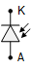 | Photodiode | A semiconductor device which allows current to flow when exposed to incident light energy
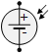 | Solar Cell | P–N junction photovoltaic cell transducer which converts light intentsity directly into electrical energy
 | Photoresistor | Light dependent resistor (LDR) which changes its resistive value with changes in light intensity
 | Indicator Lamp or Light Bulb | A filament lamp, indicator or other which emits visible light when a current flows through it
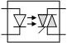 | Opto-isolator or Optocoupler | An Opto-isolator or Optocoupler which uses photo-sensitive devices to isolate its input and output connections

Digital Logic Symbols
Schematic  Symbol | Symbol Identification | Description of Symbol
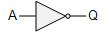 | NOT Gate | Logic gate with only one input and one output and outputs a logic 1 (HIGH) when input is 0 (LOW) and outputs a 0 when input is 1 (Inverter)
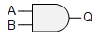 | AND Gate | Logic gate with two or more inputs which outputs a logic 1 (HIGH) when ALL of its inputs are at logic 1 (HIGH)
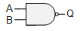 | NAND Gate | Logic gate with two or more inputs that outputs a logic 0 (LOW) when ALL of its inputs are HIGH at logic 1 (Equivalent to NOT + AND)
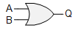 | OR Gate | Logic gate with two or more inputs which outputs a logic 1 (HIGH) when ANY (or both) of its inputs are at logic 1 (HIGH)
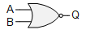 | NOR Gate | Logic gate with two or more inputs that outputs a logic 0 (LOW) when ANY (or both) of its inputs are HIGH at logic 1 (Equivalent to NOT + OR)
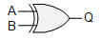 | XOR Gate | Exclusive-OR gate with two inputs that outputs a logic 1 (HIGH) whenever its two inputs are DIFFERENT
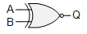 | XNOR Gate | Exclusive-NOR gate with two inputs that outputs a logic 1 (HIGH) whenever its two inputs are the SAME (NOT + XOR)
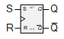 | SR Flip-Flop | Set-Reset Flip-flop is a bistable device used to store one bit of data on its two complementary outputs
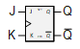 | JK Flip-Flop | JK (Jack Kilby) Flip-flop has the letter J for Set and the letter K for Reset (Clear) with internal feedback
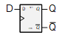 | D-type Flip-Flop | D (Delay or Data) Flip-flop is a single input flip-flop which toggles between its two complementary outputs
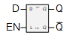 | Data Latch | Data latch stores one data bit on its single input when EN enable pin is LOW and outputs the data bit transparently when the EN enable pin is HIGH
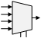 | 4-to-1 Multiplexer | A Multiplexer passes the data on one of its inputs pins to a single output line
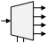 | 1-to-4 Demultiplexer | A Demultiplexer passes the data on its single input pin to one of several output lines
Here we have seen a number of basic electrical and electronics schematic symbols in graphical form used by engineers to show how a particular circuit is connected together and operates by the types of symbols used within it so that other engineers may understand.

PCB Footprints First Start With a Padstack
Before we look at ways to create and load PCB footprints into Allegro, we have to first start with the padstack that will make up the foundation of the footprint. As with many of the design elements used in PCB layout, the padstack can either be imported or built. For our purposes, we are going to look at the process of building it in Allegro’s Padstack Editor. But before we start that, we need to ensure that the right library paths are set up within the Allegro PCB Editor for the work that we are going to do.
In the picture below, you can see the Setup > User Preferences pulldown menu. This menu is used for multiple settings, but the ones we are interested in here are the library paths. Within the library category of the path settings are two paths that need to be set for the libraries to work: the “padpath” and the “psmpath.” By saving or placing the pads and package symbols in the directories that these paths point to, you will have access to them within the PCB editor.
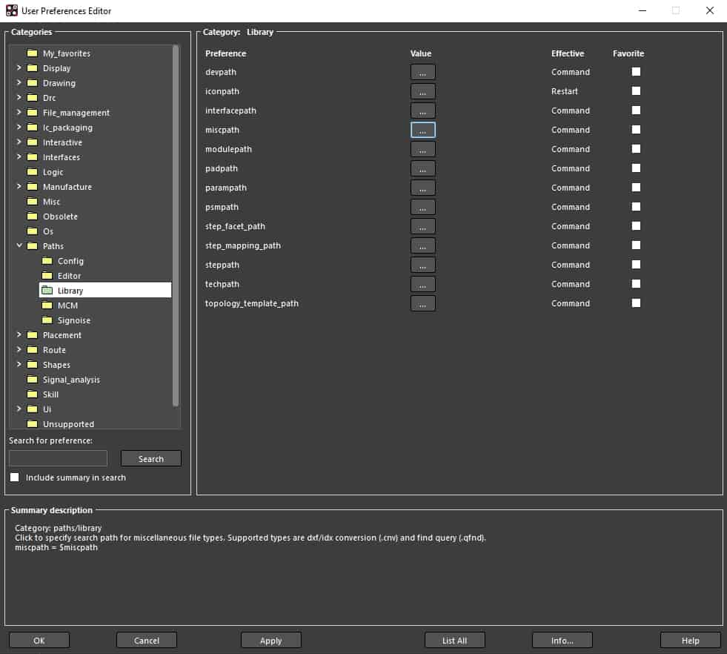
The Library Paths category in the Users Preferences Editor
With our paths correctly set, the next step is to open the padstack editor. Cadence’s Padstack Editor is a standalone tool, and although it can be opened from within the Allegro PCB Editor, it is simpler to use the Windows Start button to invoke it from the Cadence PCB Utilities. Once the padstack editor is open, set the units, decimal places, and what type of padstack that you are going to build. For our example, we are building a 75 mil by 25 mil rectangle to use with a surface mount footprint.
As you can see below, we are working in the Design Layers tab of the editor, and we have already input the values for our rectangular SMD pad on the “BEGIN LAYER.” Since this is a surface mount pad, we won’t be setting up any drill sizes or symbols, but we will add solder and paste mask layer data in the appropriate tab. Also, note that we have specified oversized thermal and antipad values along with the regular pad values. This instructs Allegro to increase the clearance around the pad when the footprint is surrounded by a solid metal plane.
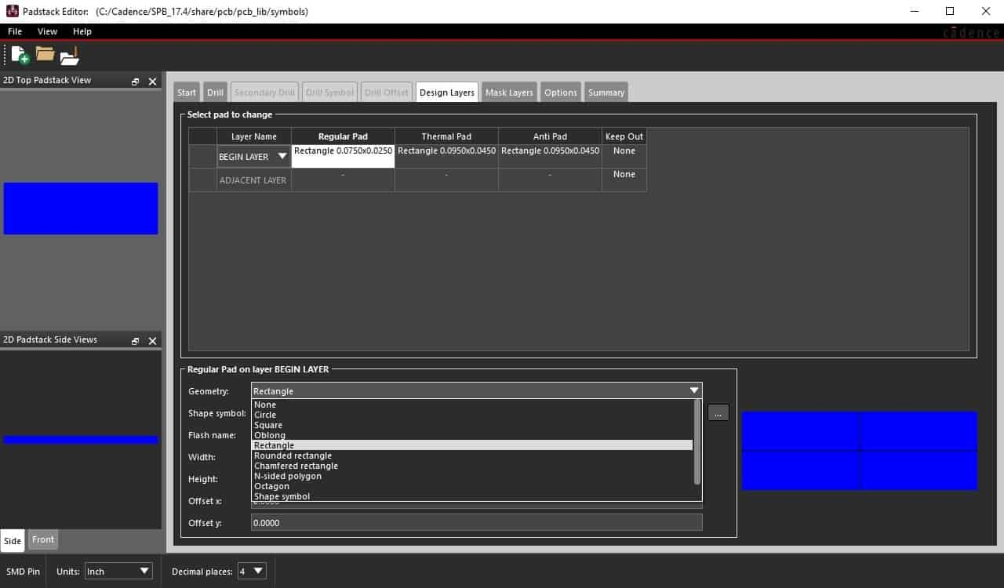
Cadence’s Padstack Editor being used to build a rectangular SMD pad
To finish the pad, go to File > Save As, and save it out to the location that you previously set up for your library padpath. Now you are ready to use this pad when building a PCB footprint.

Building PCB Footprints to Load Into Your Layout
To create a footprint using the pad that we just created, open up the Allegro PCB Editor and go to File > New. In the New Drawing pop-up menu, select Package Symbol as the drawing type, and since we are going to create a simple fourteen pin IC, give it a drawing name of SOIC-14. Once you’ve OK’ed the dialog box, it will open a new window for creating the footprint. Before you start creating the part however, make sure that your parameters are set up the way you want by going to the Setup > Design Parameters menu. In the design tab are the settings for sizes and extents that you may want to adjust. You also have the choice of using the Design Workflow window to access the setups, and in this case, we will click on Grids to adjust their size and enable their display.
Now we will add some pins by going to the Layout > Pins pulldown menu. In the options window, make sure that the pin type is set to Connect, and click on the 3 dot browser button to select a padstack to use. Since our padpath was only set up for the directory that we saved our 75x25_smd pad in, that is the only padstack displayed in the pop-up browser. Double click on the padstack that you want to use, and continue to set up the remainder of the options. In our case, we want to place seven pins going down with a spacing of 0.050 inches between them. Now you can move your cursor into the correct location for the first pin, and click the mouse button to place all seven pins.
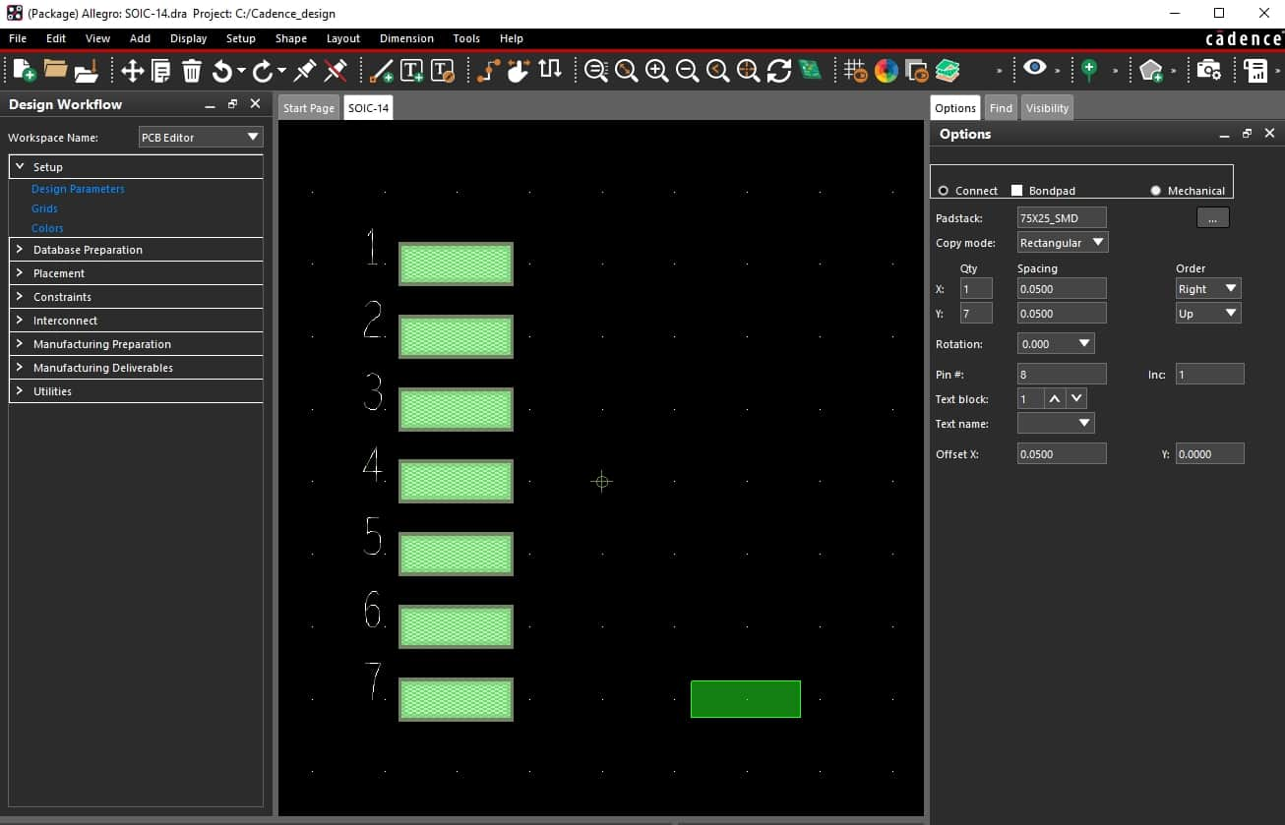
Placing pins in a surface mount footprint
In the picture above, you can see the first seven pins that have been placed, and the next row of pins is ready to be placed in the lower right corner. With the pin order in the options changed from down to up and the pin number starting at 8, all we have to do is to click the mouse button to place the next column of pins.
As with any footprint you will want to add various graphics and attributes. These can include silkscreen and assembly drawing shapes, pin 1 indicators, and component minimum and maximum heights to name a few. You do need to add a boundary outline for the part, however, and at least one of the layers needs to have a reference designator on it. Once all of this is completed, you can save the part. Remember, like the padstack, you will want this package symbol or footprint, to be saved into the directory that is specified by your “psmpath” so that the Allegro PCB Editor can find it later.

Loading PCB Footprints From Your CAD Libraries
With our footprint now created, we can load it into the PCB editor. In Allegro this is done by going to the Place > Manually pulldown menu. If you are working on a layout that already has other footprints in it, you will see them all in the Package symbols list of the Placement pop-up menu. Click on the Advanced Settings tab and disable the display of the database symbols, and then click back into the Placement List tab. Now you will only see the footprints saved to the library directory that you have specified in your library path, just as we have done in the picture below.
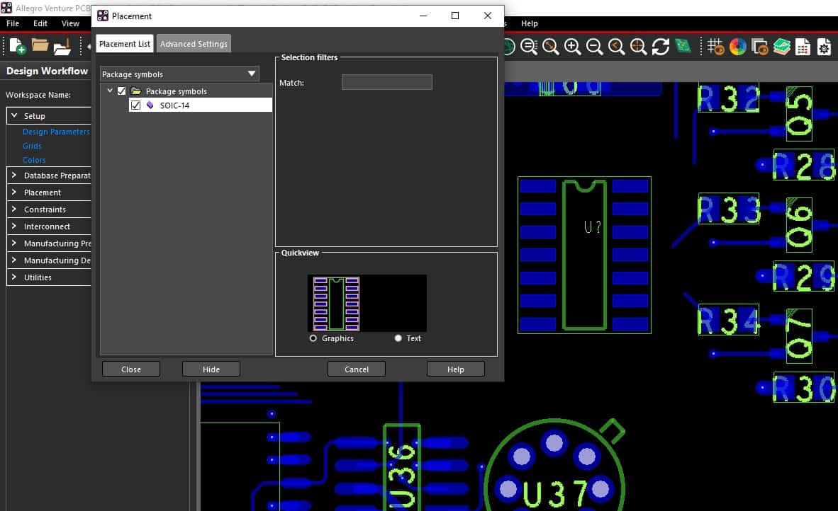
Using the Placement menu in Allegro PCB Editor to place the SOIC-14 footprint we just created
In the picture above we have selected our SOIC-14 from the placement menu to demonstrate how a footprint is loaded into the PCB editor. You can see the new part just to the right of the pop-up menu. If we had created additional parts, they would have been listed here in the placement menu along with the SOIC-14. Together with the library path setups, this system of footprint creation gives you precise control over your library as well as the footprints that you load into the layout tools. But manually building padstacks and symbol packages isn’t the only way to load new footprints into Allegro. There are some other options as well, which we’ll explore in the next section.

Footprint Building Tools and Resources
When we created our new footprint, we used the Package Symbol option in the New Drawing pop-up menu. If we had selected the Package Symbol (wizard) option instead, Allegro would have built the new footprint for us. The wizard provides an interface for you to specify the required PCB component package style as well as the desired padstack names, layer preferences, and unique dimensions. Once all of the information is entered into the interface, Allegro will create the part for you, saving a lot of time and effort.
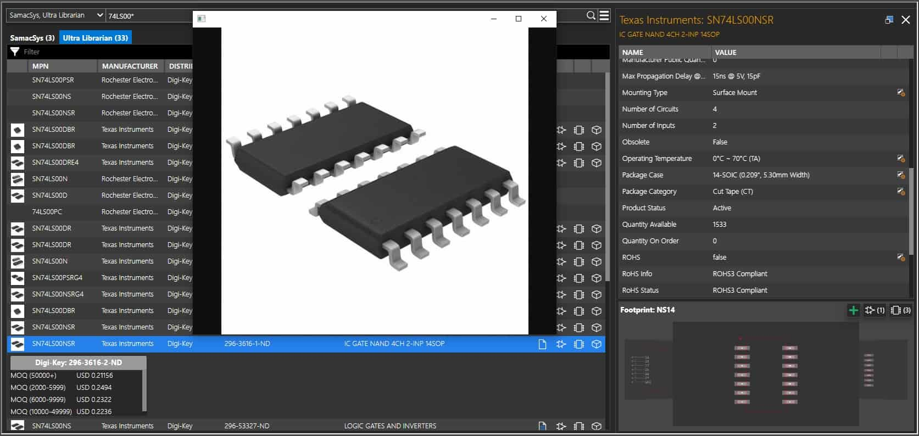
The Unified Parts Search menu in Allegro’s schematic capture tools
Another option is to use the unified part search utility in the schematic editor. This feature allows you to search for parts based on their names, types, package styles, or any number of other identifying attributes. Once found, the browser will display all of the part data that it has including values, tolerances, manufacturing information, life cycle status, and even package illustrations as you can see in the picture above. It will also allow you to immediately add the part to your schematic while at the same time downloading the accompanying PCB footprint into your library.
Design rule checking, Track width selection, Component selection
Design Rules for PCB Layout Using Altium Designer Summer 09

- Introduction

The Department currently has an in-house facility for making PCBs which permits boards to be made relatively quickly at low cost. This facility does have some limitations, though, which in turn places some constraints upon PCB layout. These constraints can be easily satisfied by altering some of the default design rules in PROTEL. This document outlines these constraints and how to implement them. It also discusses how to check your work, how to save it, as well as what you need to do in order to have your PCB design made.

Before discussing these, though, a few aspects need to be clarified. Firstly, the Department’s in-house facility can make single-sided PCBs as well as double-sided (using both Top layer & Bottom layer tracks). But it currently does not have the capability to do plated through holes (PTH). Secondly, for double-sided boards this means that any required connection between a bottom-layer track and a top-layer track happens by means of either a wire or a component lead soldered on both the top & bottom layers. In the latter case, one needs to ensure that soldering on the top layer is actually possible. This is not the case for many components, including connectors & electrolytic capacitors. So it is important to ensure that any component that cannot be soldered on the top layer does not have a top layer track connected to it. Thirdly, the Department does not have the facility to automatically drill your board once it has been made. You will need to do this yourself using drilling facilities available in the Department.

Subsequent sections of this document discuss the following aspects:

- Minimum Clearance between all tracks, PADs and components.
- Interactive Routing Track width & via sizes
- Track Widths for different nets (supply nets, signal nets etc)
- Routing Via Style
- Polygon Properties if using a polygon plane
- Component PAD sizes
- PCB Outline, Mounting Requirement s and Identification
- Design Rule Checking
- Saving Your work
- Submitting your design

- Minimum Clearance between all tracks, PADs and components.

In the PCB editor window select Design >> Rules & then double click on Electrical category to expand it). Then double click on Clearance type - see Figure 1.
If using metric units, Minimum Clearance should be 0.5 mm.
If using Imperial units, Minimum Clearance should be 20 mil.
Change the minimum clearance value accordingly.

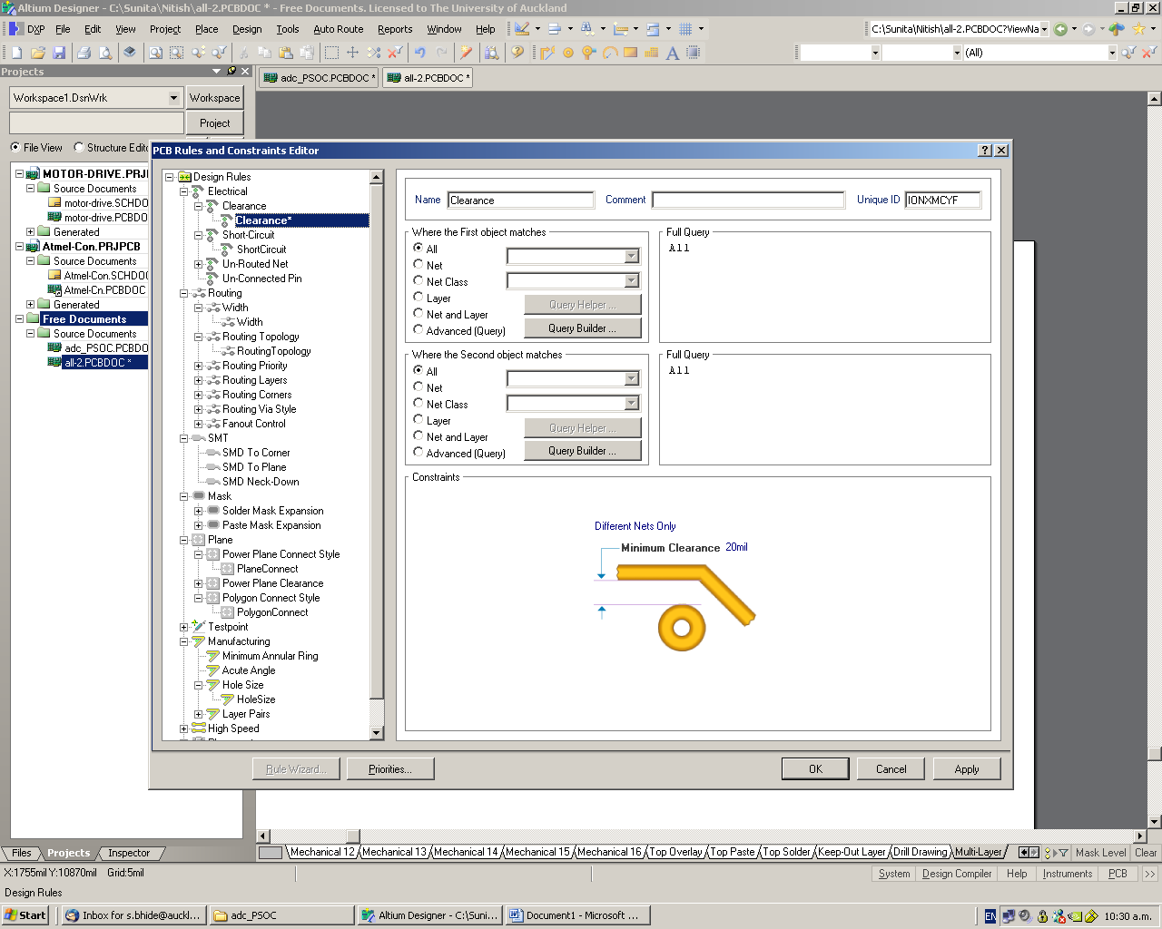

Figure 1 Setting the Minimum Clearance value
- Track Widths for different nets (e.g., supply nets, signal nets)

Select Design >> Rules & then double click on Routing category. Then double click on Width to display width rules - see Figure 2.
If using metric units set minimum track width to 0.3mm & preferred & maximum width to whatever you want (may be 0.6 & 0.7mm, respectively)
If using imperial units set minimum track width to 12 mil & preferred & maximum width to whatever you want (may be 25 & 30 mil, respectively)
You can select different track widths for different nets (e.g. you could make supply tracks large & all others set to the minimum width). More information can be found in the Protel help files.

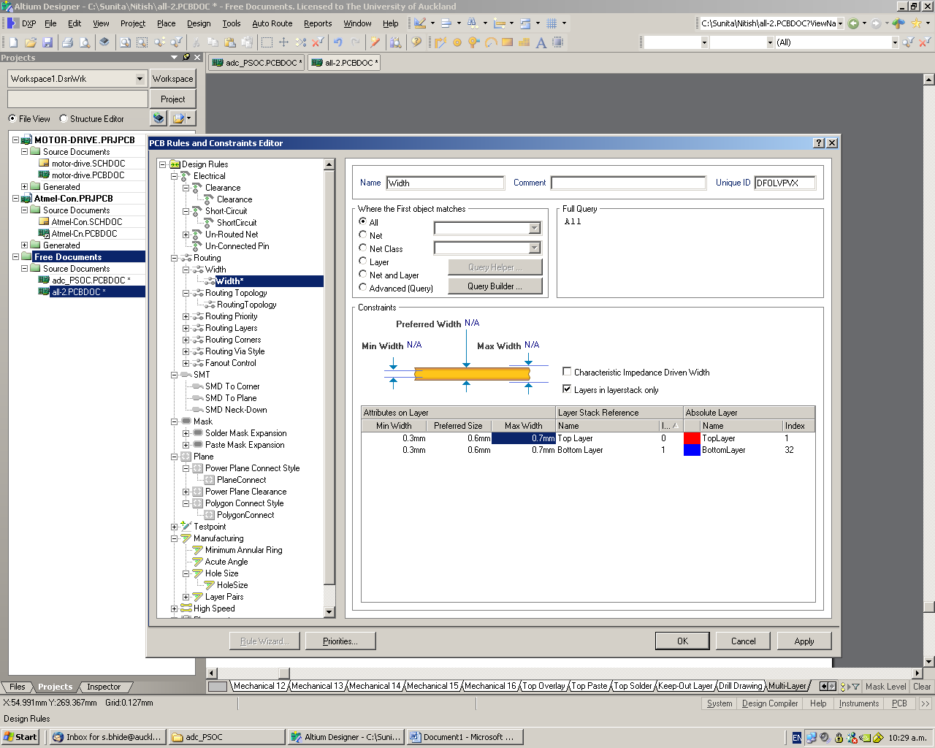

Figure 2 Setting track widths

- Default track width mode & via size mode

In the PCB editor window select DXP >> Preferences & then click on Interactive routing. See Figure 1. Click Track width Mode & set it to Rule Preferred. Click the Via Size Mode & again select Rule Preferred.

Because of this setting your default track width will be always same as your preferred Track width. Otherwise by default the track width is the minimum Track width & this may not be preferred in most of the cases.

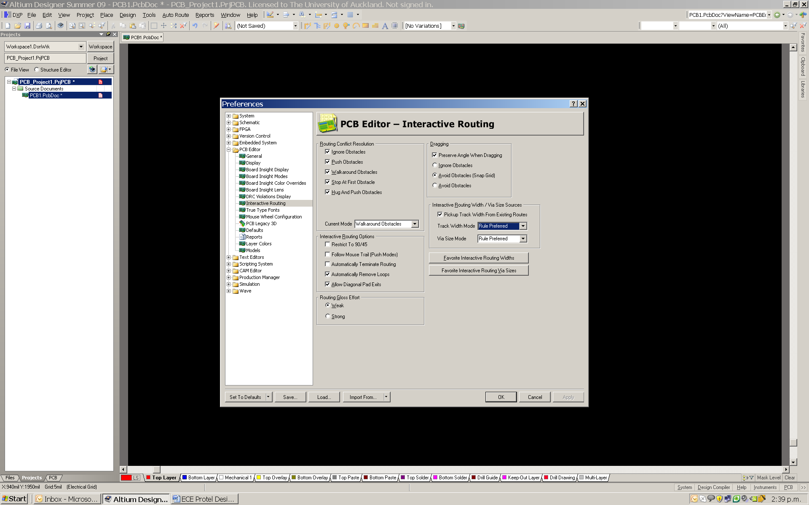

Figure 1 changing the default setting for interactive routing

- Routing Via Style

Select Design >> Rules & then double click on Routing category. Then double click on routing via style & the routing via see Figure 3.
Set the minimum via diameter to 1.6mm & preferred & maximum diameter to whatever 1.7mm
Set the via hole size to 0.7mm.

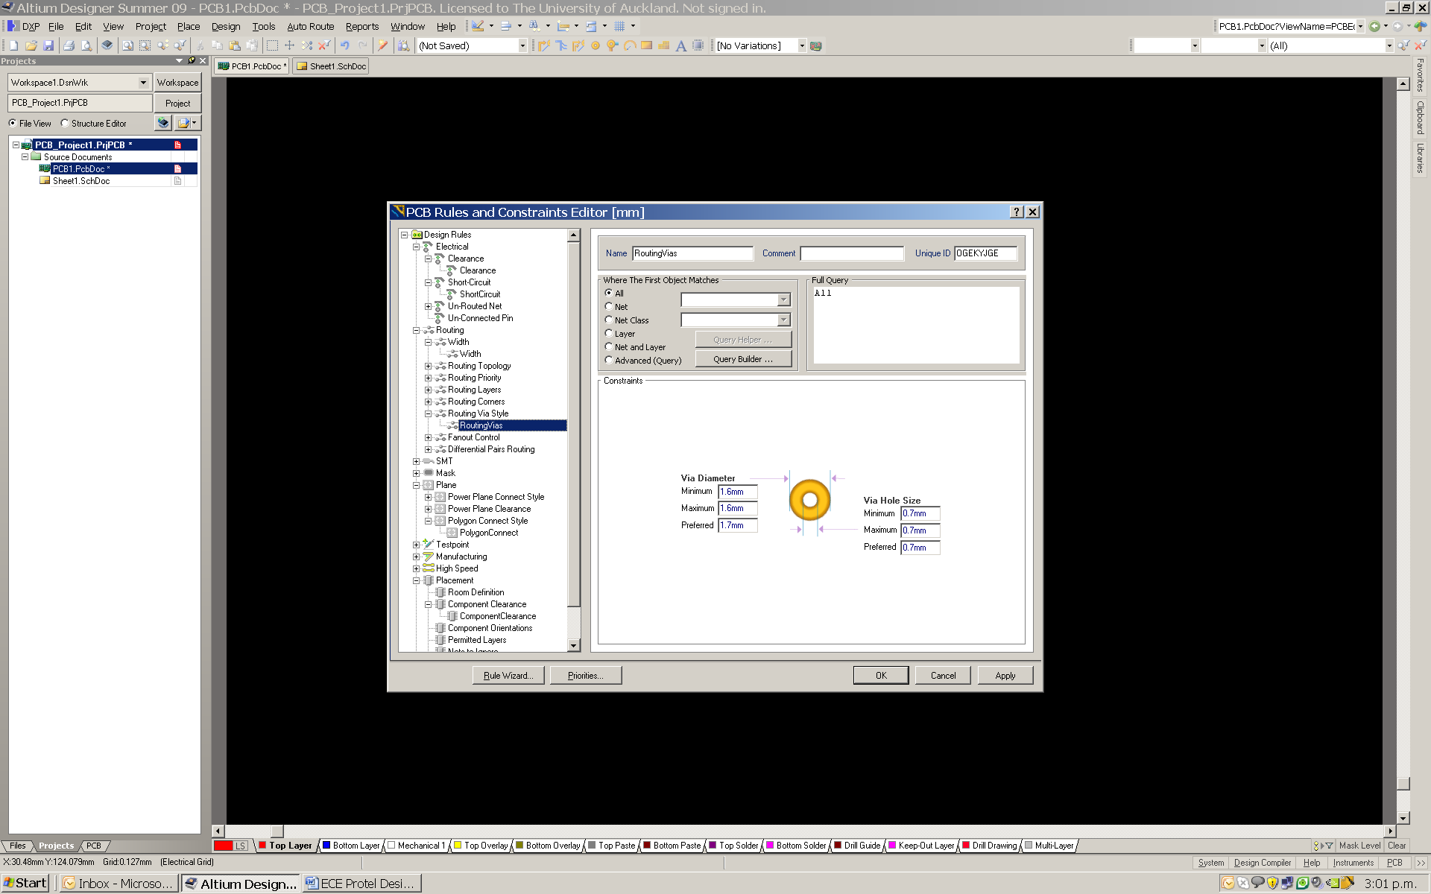

Figure 2 Setting via size

- Polygon Properties if using a polygon plane

Select Design >> Rules & then double click on Polygon Connect Style category. Then double click on Polygon Connect.

In this menu change conductor width to 12mil (0.3048 mm) - see Figure 3.

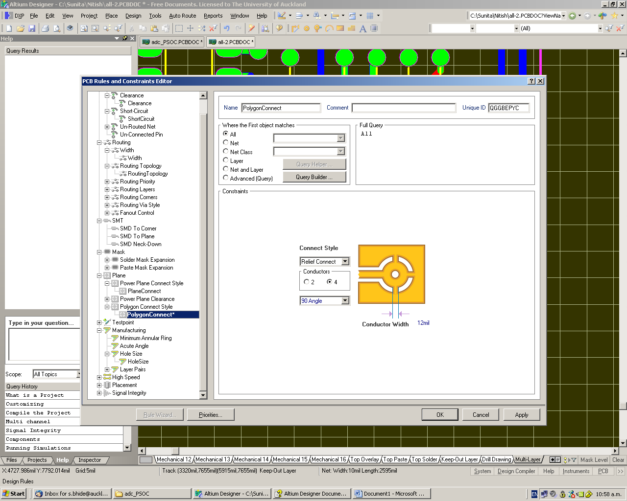

Figure 3 Setting Polygon properties

- Component Pad Sizes

Generally you need to make sure that PAD sizes are as large as possible. This is important when it comes to drilling the PCB once it has made as well as when the board is being soldered. Make use of the following guidelines for selecting PAD sizes:

- If using axial resistors with a 0.8 mm drill hole, then the PAD diameter should be at least 1.6mm or more.
- if using a connector with a lead diameter of 0.9 mm, you will need a drill hole size of 0.9mm and a PAD diameter of at least 1.7mm (i.e., if using circular pads). Or you can select the PAD shape to suit your design.
- for a hole size larger than 1mm, use a PAD diameter of 2mm.
- for ICs, the hole size is normally 0.8 mm, but because the pins of an IC are adjacent to each other, in order to get maximum clearance between PADs, use oval shaped PADs rather than round. This can be achieved by setting the X size dimension of a PAD to be larger than the Y size. For example, for a 14 pin DIP package, use PAD X size = 2mm and PAD Y seize = 1.5mm, with a hole dimension = 0.8mm.
- for other components which are placed very close to each other, you should also select oval PADs in order to ensure maximum clearance between pads

If you are using components from the Protel Library, make sure that the PAD sizes are modified to suit the above guidelines. In order to change the PAD parameters, double click on the PAD you want to change and then change the parameters accordingly - see Figure 4.

You can change multiple PADs at the same time using the Inspector Panel. For further details, use Protel help on Inspector panel.

- PCB Outline, Mounting Requirements and Identification

The following precautions should be taken when designing a PCB.

PCB Outline
Make sure that this is well defined and drawn in the Keep Out layer

PCB Mounting Requirements
You need to give careful thought as to how your PCB will be mounted and factor this into your design. This may be by way of mounting holes (use sizes of 3mm or 4mm typically). But other methods of PCB mounting are also acceptable.

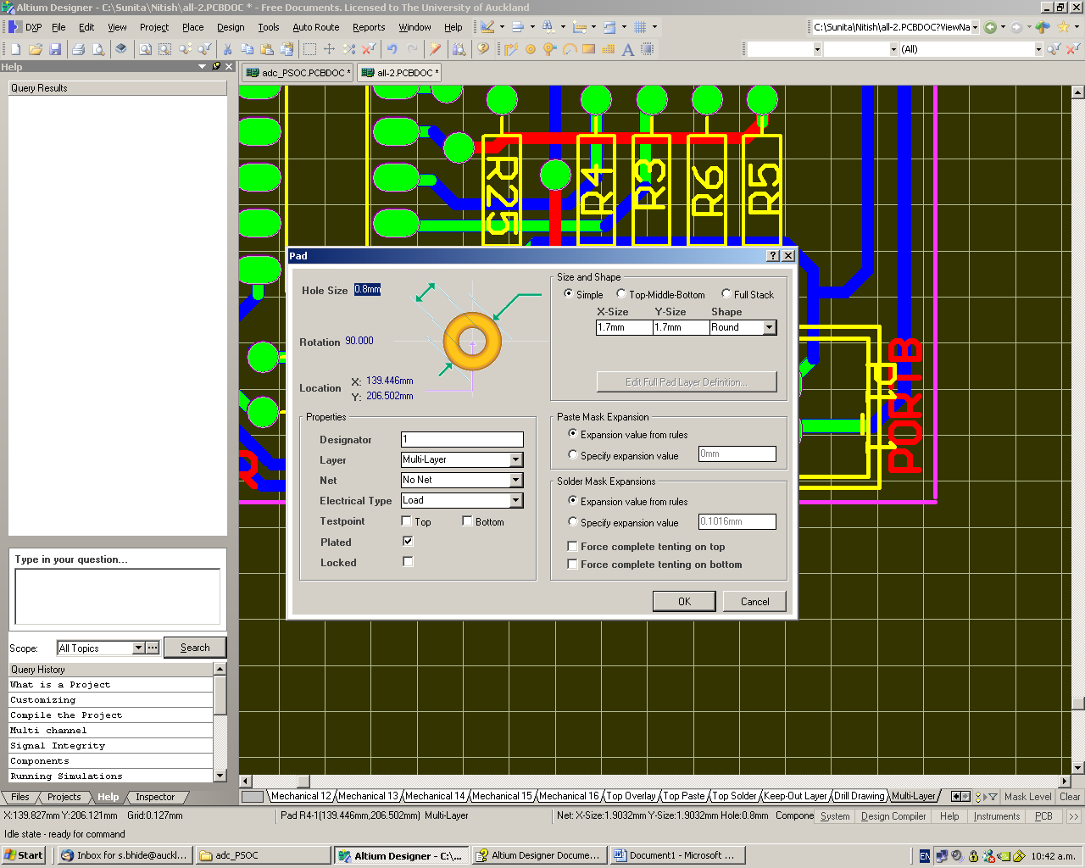

Figure 4 Changing the parameters of a PAD

PCB Identification
To facilitate in identifying & distributing PCBs once they are made, make sure that your PCB is identified in the following manner:

- Part IV project students: Course Number / Project No.
  - examples: EE 401 / Prj 95, CS 401 / Prj 83, SE 401 / Prj 16
- Part III design students: Course No. / Group No.
  - examples: EE 310 / Grp 12, CS 301 / Grp 5
- All others: write their UPI or PCB title (whichever is convenient)

The text used for identification can be placed either on the top or bottom layers. If placed on the Bottom layer, it should be mirrored, but if on the Top layer, it should not.

- Design Rule Checking

Once you have completed your PCB design, you need to verify that it complies with the design rules. Do this as follows:

Choose Tools >> Design Rule Check & then click on Run Design Rule Check

Design Rule check highlights any design violations in your design. If you have complied with all the design rules, there should be no rule violations. However, if in your design you have run tracks through the adjacent pins of an IC, then the Minimum Clearance of 0.5mm (20mil) won’t be met and a violation will be highlighted. In this situation you can add a new Clearance Design Rule just for the footprint of the component in question (in this case and IC).

For more details on how to add a clearance rule, read the Getting Started With PCB Design. This is a PDF document and can be found in Protel help.

- Submitting Your Design for Manufacture

Before submitting your design for manufacture, you should complete the check list contained in Appendix A.

Once you have completed your PCB design, you need to send the PCB file (.pcbdoc) to the project technician so that your PCB can be made.

Design Check List
Make sure that you have ticked each item in the following check list before you submit the PCB. If your PCB does not comply with any of these requirements it will not be accepted for manufacturing.
Clearance (set to 0.5mm or 20mil)

Track width set to minimum of 12mil or more

Interactive Track width & via size set up
Polygon Setting (if used)

Component PAD sizes used as per the guide

PCB Outline done

PCB Mounting Method

PCB Identification

Design Rule checked

UNIT II
Introduction to PCB: Definition and Need/Relevance of PCB, Background and History of PCB, Types of PCB, Classes of PCB Design, Terminology in PCB Design, Different Electronic design automation (EDA)tools and comparison.
Printed Circuit Boards (PCBs) can be defined as rugged nonconductive boards built on substrate-based structure as shown in Fig. 4.1. The PCBs are mainly used to provide electrical connection and mechanical support to the electrical components of a circuit. They are prevalent in electronic devices and can be easily identified as the green-colored board in most cases. Based on the design specifications and requirements, many active (for example, operational amplifiers and batteries) and passive components (such as inductors, resistors, and capacitors) are mounted on the PCBs to match the form factor of the final design. Form factor can be defined as a feature of any hardware design that specifies the size, shape, and other relevant physical properties of the PCB in its entirety. While determining a form factor of a PCB design, aspects such as chassis, mounting schemes, and board configurations are taken into consideration. The connection among the components on a PCB are established with copper interconnects (routes), which act as the pathway for the electrical signals.
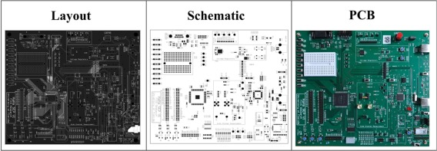
Figure Modern PCBs are very complex with multiple layers and several components arranged in a compact manner to minimize the overall size. A modern PCB in different forms, such as layout, schematic, and its final output is shown in this figure.
An Austrian engineer named Paul Eisler was the first to develop PCBs during the time of World War II. His patented methodologies for PCB etching process, various mechanisms of interconnect routing, and employment of electrical conduit in the boards are put to practice for decades [6]. Since its first development, PCB designs have significantly evolved over time. Modern-day PCBs largely vary in complexity, starting from single layer PCBs to complex designs with as many as 20 to 30 layers with hidden vias and embedded components [18]. PCB vias can be defined as vertical interconnect accesses for establishing the electrical connection through one or more adjacent layers of the circuit board.
PCBs play a vital role in area, power, performance, reliability, and security of a computing system. The PCB design and test process should consider these parameters. This chapter provides an overview of the PCBs with a highlight on current practices of design and test. It discusses the electrical components used in a PCB and different types of boards available. It also presents a brief history of PCB evolution highlighting the changes in PCB design with technological progress. The complete life cycle of modern PCB design is also depicted in the chapter with an illustrative description of the steps and parties involved in these steps.

Evolution of PCBs
Over time, PCBs have evolved as an easy tool for optimizing the manufacturing of electronics products. What was once assembled easily by human hands soon gave the way to microscopic components which required the precision and efficiency of machinery. Consider the two circuit boards shown below. One is an older board for a calculator made within the 1960s. While the other is a typical high-density motherboard that you’ll see in today’s computers.
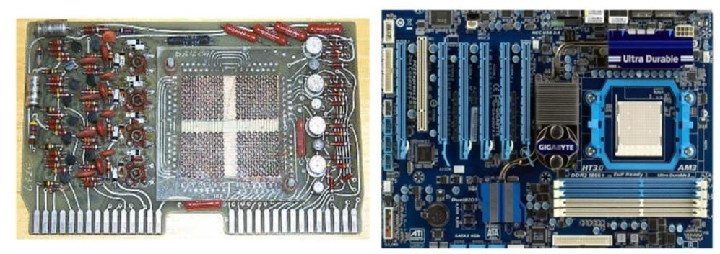PCB comparison between an old calculator & today’s modern motherboards
In the calculator, probably we can see 30+ transistors, but on a single chip motherboard, you can find millions of transistors. Actually, the rate at which technology and PCB design itself are advancing is really impressive. Everything that we saw on the PCB of the calculator can now fit into a single chip on today’s modern designs. Thus, huge noticeable trends are in the actions in the manufacturing of PCBs.
Let us go through the History of the Printed Circuit Board PCB Timeline from the 1880s to present-day PCB manufacturing and the changes that took place in between these years.

From 1880 to 1900
This was the time when electricity was brought into households, first starting in cities, then getting into the rural areas. Finally, Electricity was now an alternative to coal, wood, and oil. Electricity changed all of this. During this era major Inventions on electromagnetic & Motors took place.
Actually, this age was the period of genius inventors. Because it still has an impact on the electronics of today.
1. Thomas Alva Edison invented the lightbulb in 1879, known as America’s greatest inventor.
2. Nikola Tesla invented the motor in 1888 and AC power in 1895.
3. Alexander Graham Bell invented the telephone in 1876.
4. George Eastman’s Kodak invented the first consumer camera in 1884.
5. Herman Hollerith invented the tabulator in 1890 and would go on to found IBM.
One of the greatest Conflicts during this Age of innovation was between AC and DC. Nikola Tesla’s AC ended up winning out as only the method of transporting electricity over long distances. However, the interesting thing to note is how we’re still dealing with AC-DC conversion issues today.
Note: Actually, the beginning ideas for the PCB weren’t invented during this era. However, without the manufacturing progress of The Gilded Age, and also the spreading influence of electricity, the PCB would never be what it’s today.

From 1890 to 1920
This is the time that shows the primary patent for a PCB. In 1903, one of the famous German Inventor Albert Hanson filed a British patent for a device described as a flat, foil conductor on an insulating board having multiple layers.
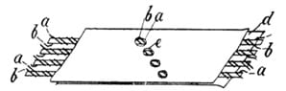The First Albert Hanson PCB patent drawing
Albert Hanson also described the whole concept hole application in his patent. He showed that we can punch a hole into the two layers and had perpendicular wires to establish electrical connectivity. The progressive Age marked the first World War. This conflict was purely focused on mechanical devices and the trench world war. Actually, the basic electronics, and even PCB concept, still hadn’t come into use in military applications, but they were evolving soon.

During 1920s
It was also during this time that we saw the invention of the trendy appliances we still rely on today like washing machines, vacuums, and refrigerators. But where are our PCBs? We’re still not seeing them utilized in any of the appliances or automobiles introduced during this age.
However, in 1925 Charles Ducas invented a patent that describes the way for adding conductive inks to an insulating material. this might later give birth to the printed wiring board (PWB). Actually, this patent was the first real application to relate a PCB. But was only used as a flat heating coil. We still haven’t got the actual electrical connectivity between board and components, but we’re getting closer to it.
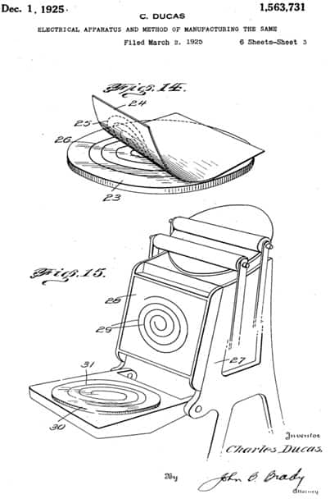Charles Ducas patent drawing

During 1930-1945
This was the year noted as the most significant year in the History of Printed Circuit Board PCB. The second warfare is underway, and therefore the US enters the fray in 1942 after the bombing of Pearl Harbor. It was also during warfare 2 that we saw the first use of a PCB as we all know it today in the proximity fuse.
This device was used for high-velocity artillery shells, which needed to fireside precisely over massive distances in either sky or land. The proximity fuse was first Invented by the British to combat the push of Hitler’s Army.
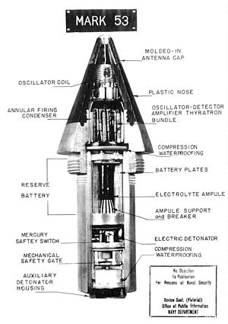Proximity fuse was the first military application to use a PCB
During this time we even have Paul Eisler, an Austrian living within the UK, file a patent for copper foil on a non-conductive base of a glass. Sound familiar? This is often the concept we still use today for manufacturing PCBs with an insulating layer and copper on the top/bottom. Eisler took this concept one step further by making a radio along with his PCB in 1943, which might pave the way for future military applications.
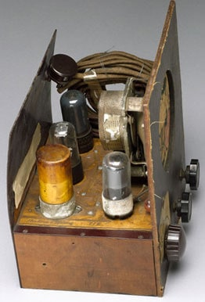A radio made by Paul Eisler that uses first printed circuit board (PCB)

During 1940s
Let’s see the history of Printed Circuit Board PCB during the 1940s. We see a lot of improvements to existing appliances like vacuum cleaners, washing machines, televisions, and radios. What we’re still not seeing though are consumer-level PCBs. Where is Paul Eisler’s work? Let’s have a look at this old television below, and you’ll see all of the components but no underlying PCB foundation.
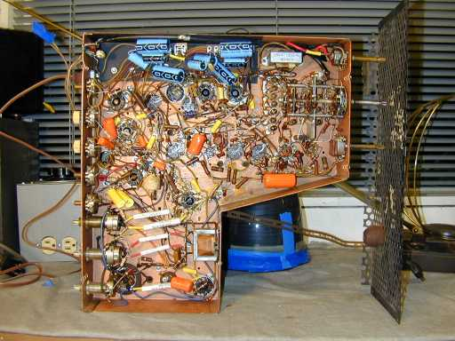
An old Motorola television from without PCB in 1948
Despite the shortage of PCBs, we did see the arrival of the transistor at Bell Labs in 1947.
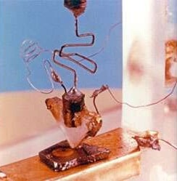The first transistor of the world, born in Bell Labs in 1947

From 1947 to 1970
Let’s move down to History of Printed Circuit Board PCB from 1947 to 1970. It’s the ERA where we see PCBs being used to their full potential. In 1956 the US Army released its patent for the “Processing of Assembling Electrical Circuits.” Now manufacturers had a technique to both hold electronics and establish connectivity between components with copper traces.
As PCBs start to take off in the manufacturing realm, we discover ourselves in the world’s first Space Race between the USA & Russia.
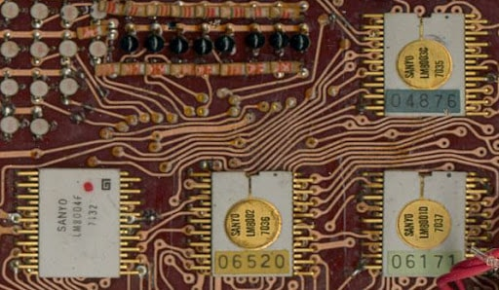
Back to PCBs, in 1963 we’ve Hazeltine Corporation filing a patent for the first plated through-hole technology. This is able to allow components to be closely spaced together on a PCB without concern about crossover connections. Actually, we also have seen the invention Surface Mount Technology (SMT) developed by IBM. These densely packed components found their first practical use in the Saturn rocket boosters.
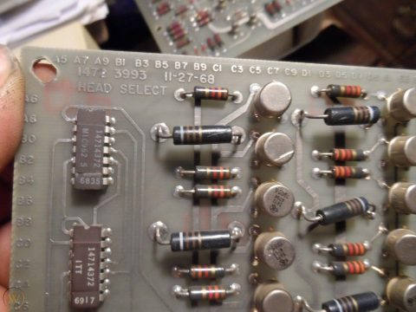PCBS 1970s

The 1970s – The Dawn of the Microprocessor
The 70s brought us the first microprocessor within the sort of an integrated circuit (IC). This was firstly developed in 1958 by Jack Kilby at Texas Instruments.
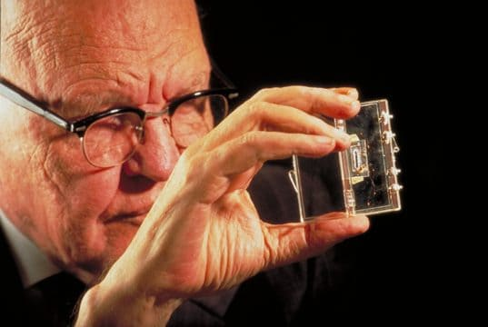
Jack Kilby is holding the first integrated circuit
It’s in the 1970s where we see ICs first being used within the manufacturing of electronics. Hence, from this time if you were not using a PCB board for connectivity you were in big trouble.

The 1980s – The Dawn of the Digital Age
The Digital Age brings about massive changes in how we consume media with the introduction of personal devices just like the CD, VHS, camera, gaming consoles, walkmans, etc.
It’s important to know that PCBs were still being drawn by hand with a light-weight board and stencils, then again computers and EDA arrived. Now we can see EDA software like Protel and EAGLE. It is completely changing how we design and manufacture electronics. Rather than photographs of PCBs, we’re now ready to save our designs as Gerber text files whose coordinates can easily be fed into manufacturing machinery to prepare a PCB.

The 1990s – The Internet Age
In the 90s we saw the utilization of silicon come with a full swing with the introduction of BGAs. Now we are able to fit more gates onto a single chip and begin to embed memories and Systems on Chip (SoC) together. This can be also a period of intense miniaturization in electronics. We don’t see any new features added to PCBs, but the whole design process is beginning to change and evolve, shifting to the IC.
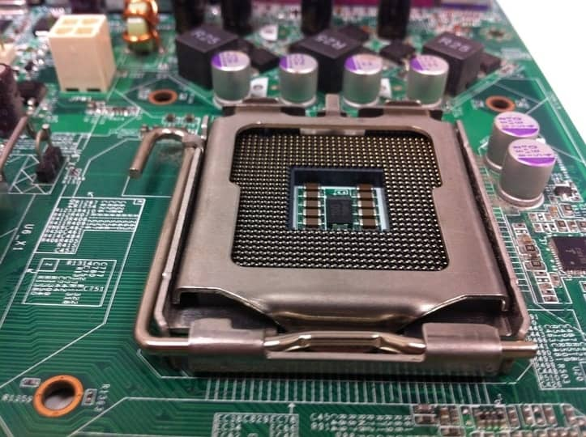
Now designers need to implement Design for Test (DFT) strategies into their layouts. It’s not as easy as you think to pop off a component and add a blue wire. Engineers need to design their layouts from the perspective of future rework in mind. Are all of those components placed in a proper way that they can be easily removed? This is an enormous concern.
This is also a time where smaller component packages like 0402 make the hand soldering of boards nearly impossible. The designer now lives in his EDA software, and therefore the manufacturer handles the physical production and assembly.
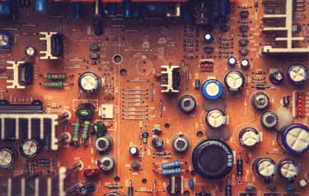Old TV PCBs 1990

The 2000s & Beyond – The Hybrid Age
We’re in an age of consolidation of devices, but what’s coming next? PCBs are established, we’ve processes and procedures for nearly everything. High-speed applications are getting the norm. We’re also seeing only 25% of PCB designers under the age of 45, and 75% are preparing to retire. The industry seems to be in an exceedingly period of crisis.
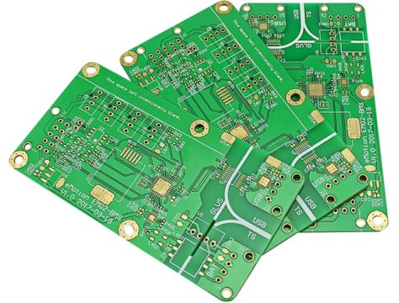Modern Days PCB from NextPCB 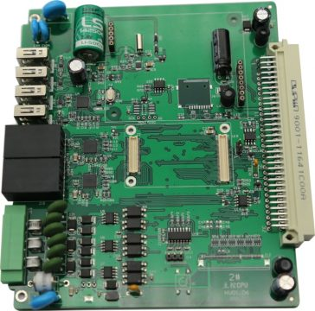Modern Days PCB from NextPCB
What is the future of PCB design in robotics? Maybe in wearables with flexible circuitry? Or perhaps we’d see protons replacing electrons with Photonics. As for the physical PCBs that we’ve come to know, even those might change within the future. rather than needing a physical medium for connectivity between components, there’s the potential for wave technology. This might allow parts to send signals wirelessly without having copper. That’s all from History of Printed Circuit Board PCB.
Modern Locket made with PCB from NextPCB

Modern Day PCB Manufacturing by NEXTPCB

About NEXTPCB
NextPCB is one of the most experienced PCB manufacturers in China, has specialized in the PCB and assembly industry for over 15 years, providing some of the most innovative printed circuit board with assembly technologies in terms of the highest quality standards, fastest delivery turnaround as fast as 24hours, lowest manufacturer direct prices, and the most dedicated customer service in the industry. You can count on NextPCB to meet your needs, from the simplest boards to the most complex designs for small quantity and large-scale production.
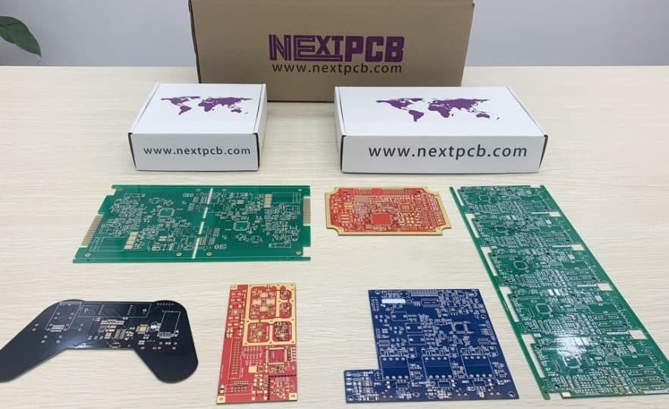

Services Provided by NEXTPCB
NextPCB provides the following services including sourcing components, PCB prototyping, PCB manufacturing, PCB assembly, quality testing, and the final shipment.
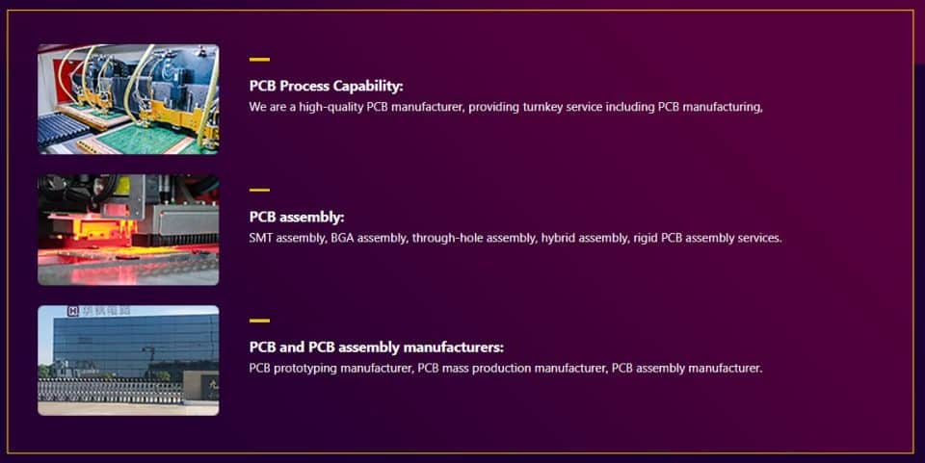
.

PCB Manufacturing Process by NEXTPCB
The PCB manufacturing process is a very long process and requires a lot of time. But NextPCB has all the latest modern machinery and tools that will make the prototype ready in 24 hours. The PCB manufacturing includes the following steps.
1. Pre-Product Engineering
2. Board Cutting
3. Drilling
4. Deburr
5. Electroless Copper Deposition
6. Copper Plate Making
7. Image Expose
8. Image Develop
9. Inner Layer Etch
10. Automatic Optical Inspection (AOI)
11. Solder Mask Applications
12. Bake
13. Rescue Solder Pad
14. Legend
15. Surface Finish
16. Electrical Test
17. Outline Process – Rout, v-scoring
18. Wash Boards
19. Final Inspection
Once the PCB manufacturing process is completed, the assembly services need to be done. The PCBA services include the following process.
1. Components Checking
2. Solder Paste Printing
3. Pick & Place SMD Parts
4. Reflow Soldering
5. Flipping
6. THT Component Placement
7. Wave Soldering (hand soldering)
8. AOI Checking/ X-Ray
9. Visual Inspection (Repairing)
10. Quality Control/Packaging
11. Delivery.

The complete PCB Manufacturing Process is explained in the video below.
How PCB is Made in China - NextPCB Factory Visit || PCB Manufacturing & Assembly Process

How to place a PCB/PCBA order from NextPCB?
If you want to order the PCB and PCBA services from the NEXTPCB, you can follow the video below.
How to place a PCB & PCBA order on NextPCB website！

PCB Samples and Assembled Boards
I have added few samples of PCB and assembled boards from NextPCB. The PCB quality is brilliant and superb. The services and facilities provided by them are up to the mark and best. Compared to all other PCB manufactures, I will personally recommend NextPCB to all the project lovers and industrialist.

The History of Printed Circuit Board PCB from timeline 1880 to Present is very interesting as you read above. From the old PCB designing methods back in 1960 to modern-day EDA tools for PCB Designing with NextPCB took so many inventions and technology setup.

UNIT III
PCB Design Process: PCB Design Flow, Placement and routing, Steps involved in layout design, Artwork generation Methods - manual and CAD, General design factors for digital and analogue circuits, Layout and Artwork making for Single-side, double-side and Multilayer Boards, Design for manufacturability, Design-specification standards
PCB Design Process and Fabrication Challenges
Virtually every electronic product is constructed with one or more printed-circuit boards (PCBs). The PCBs hold the ICs and other components and implement the interconnections between them. PCBs are

What is Design for Manufacturing or DFM?
Design for Manufacturing (DFM) is the process of designing parts, components or products for ease of manufacturing with an end goal of making a better product at a lower cost. This is done by simplifying, optimizing and refining the product design. The acronym DFMA (Design for Manufacturing and Assembly) is sometimes used interchangeably with DFM.
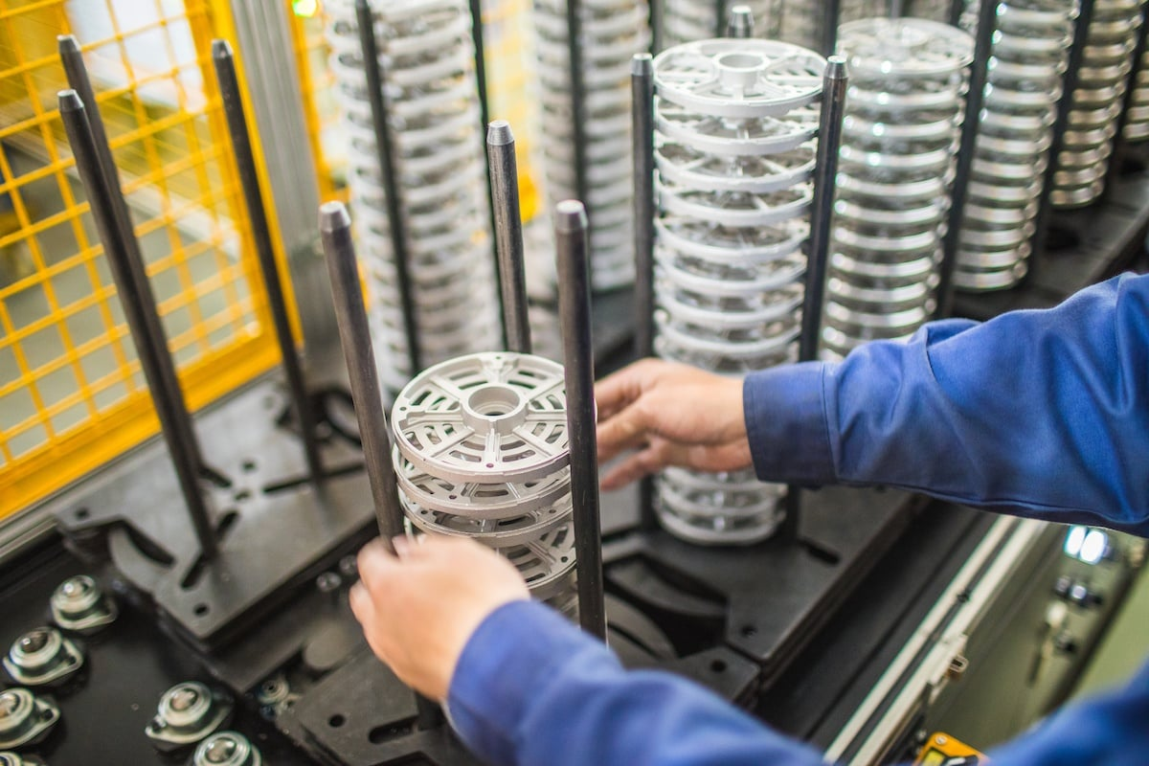
Five principles are examined during a DFM. They are:
- Process
- Design
- Material
- Environment
- Compliance/Testiing
Ideally, DFM needs to occur early in the design process, well before tooling has begun. In addition, properly-executed DFM needs to include all the stakeholders — engineers, designers, contract manufacturer, moldbuilder and material supplier. The intent of this “cross-functional” DFM is to challenge the design — to look at the design at all levels: component, sub-system, system, and holistic levels — to ensure the design is optimized and does not have unnecessary cost embedded in it.
The following chart offers an excellent visual representation of the effect of an early DFM. As the design progresses through the product life cycle, changes become more expensive, as well as more difficult to implement. Early DFM allows design changes to be executed quickly, at the least expensive location.
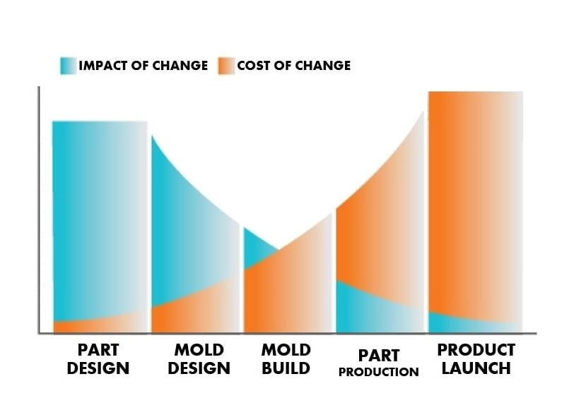
Pulling stakeholders together early in the design process is easier if you're developing a new product, but even if you're dealing with an established product, challenging the original design is a necessary element of a thorough DFM. Too often, mistakes in a design are repeated by replicating a previous design. Question every aspect of your design.
- Look at the original drawings.
- Tear down the product.
- Look at competitive and near-neighbor products, as well as lead users such as medical and automotive.
- Talk to your contract manufacturer — who may have solved the problem with a different customer?
- Has someone else solved this problem a different way?
- Is there a way to make it better?
A lot of thought, time and effort go into a DFM. Jeff Tadin, our senior product development engineer, has almost 30 years of experience with product development, design and manufacturing. Today, he’s going to walk us through a hypothetical DFM process using a basic computer mouse (this mouse was not produced by East West Manufacturing.)

5 PRINCIPLES OF DFM: A CLOSER LOOK

1 | PROCESS
The manufacturing process chosen must be the correct one for the part or product. You wouldn't want to use highly-capitalized process like injection molding which involves building of tools and dies to make a low-volume part that could have been manufactured using a lower-capitalized method, such as thermoforming. That would be equivalent to using a tank to squash an anthill — a classic case of overkill. Let's see what Jeff has to say about selecting the right manufacturing process:

2 | DESIGN
Design is essential. The actual drawing of the part or product has to conform to good manufacturing principles for the manufacturing process you’ve chosen. Here's Jeff, talking about design of the mouse:
In the case of plastic injection molding, for example, the following principles would apply:
- Constant wall thickness, which allows for consistent and quick part cooling
- Appropriate draft (1 - 2 degree is usually acceptable)
- Texture - need 1 degree for every 0.001” of texture depth on texture side walls
- Ribs = 60 percent of nominal wall, as a rule of thumb
- Simple transitions from thick to thin features
- Wall thickness not too small - this increases injection pressure
- No undercuts or features that require side action - all features “in line of pull/mold opening”
- Spec the loosest tolerances that allow a good product - and consult the trade organization for your manufacturing process on what is reasonable for that process
Be sure to discuss the design with your contract manufacturer, who can ensure that your design conforms to good manufacturing principles for the selected process.

3 | MATERIAL
It's important to select the correct material for your part/product. In this video, Jeff talks about some of the criteria that go into that decision:

Some material properties to consider during DFM include:
- Mechanical properties - How strong does the material need to be?
- Optical properties - Does the material to be reflective or transparent?
- Thermal properties - How heat resistant does it need to be?
- Color - What color does the part need to be?
- Electrical properties - Does the material need to act as a dielectric (act as an insulator rather than a conductor)?
- Flammability - How flame/burn resistant does the material need to be?
Again, be sure to discuss the material with your contract manufacturer, who might have access to existing materials in their portfolio which would allow you to secure lower material pricing.

4 | ENVIRONMENT
Your part/product must be designed to withstand the environment it will be subjected to. All the form in the world won’t matter if the part can’t function properly under its normal operating conditions:

5 | COMPLIANCE/TESTING
All products must comply with safety and quality standards. Sometimes these are industry standards, others are third-party standards and some are internal, company-specific standards.

FACTORS THAT AFFECT DFM
The goal of DFM is to reduce manufacturing costs without reducing performance. In addition to the principles of DFM, here are five factors that can affect design for manufacturing and design for assembly:

1 | Minimize Part Count
Reducing the number of parts in a product is the quickest way to reduce cost because you are reducing the amount of material required, the amount of engineering, production, labor, all the way down to shipping costs.

2 | Standaradize Parts and Materials
Personalization and customization are expensive and time-consuming. Using quality standardized parts can shorten time to production as such parts are typically available and you can be more certain of their consistency.
Material is based on the planned use of the product and it's function. Consider:
- How should it feel? Hard? Soft?
- Does it need to withstand pressure?
- Will your part or product need to conduct heat, electricity?

3 | Create Modular Assemblies
Using non-customized modules/modular assemblies in your design allows you to modify the product without losing its overall functionality. A simple example is a basic automobile that allows you to add in extras by putting in a modular upgrade.

4 | Design for Efficient Joining
Can the parts interlock or clip together? Look for ways to join parts without the use of screws, fasteners or adhesives. If you must use fasteners, here are a few tips:
- Keep the number, size and variation of fasteners to a minimum
- Use standard fasteners as much as possible.
- Use self-tapping and chamfered screws for better placement.
- Stay away from screws that are too long or too short, separate washers, tapped holes, round heads and flatheads.

5 | Minimize Reorientation of Parts During Assembly & Machining
Parts should be designed so that a minimum of manual interaction is necessary during production and assembly.

6 | Streamline Number of Manufacturing Operations/Processes
The more complex the process of making your product, is the more variables for error are introduced. Remember what Jeff said: All processes have limitations and capabilities. Only include those operations that are essential to the function of the design.

7 | Define "Acceptable" Surface Finishes
Unless it must be trade show grade, go with function rather than flashy for your surface finish.

The Gerber file set is PCB jargon for the output files of the layout that are
used by PCB manufacturers to create the PCB. A complete set of Gerber files includes output files
generated from the board layout file:
• Silkscreen top and bottom
• Solder mask top and bottom
• All metal layers
• Paste mask top and bottom
• Component map (X-Y coordinates)
• Assembly drawing top and bottom
• Drill file
• Drill legend
• FAB outline (dimensions, special features)
• Netlist file
• Gentle Learning Curve
• Intuitive GUI
• Routine Tasks Performed By Easy To remember Hotkeys
• Comprehensive Constraint Manager handling High-Speed Signal Integrity and Easy to Grapple
• Manageable File Structure
• Easy to Create and Manage Library Manager
• Intuitive 3D Visualization Engine
• Decent Auto-Routing capability
• Connect Seamlessly to Its Schematic Tool For Easier ECOs
• Allow Manageable Exports of Manufacturing Outputs
• Handle Large Number of Copper Shapes
• Allow Designer to Easily Manage Large Number of Layers
• Embedded CAM Engine That Follows CAD Tool’s GUI
• Not Too Overpriced

Single-Sided Boards
A single-side PCB, also known as a single-layer PCB, is simple and affordable to produce. The manufacturer begins with a base core material, such as fiberglass (FR4), which the core has a layer of copper on it. This copper material makes the board conductive and allows electricity to flow through. Then, they add a solder mask that insulates the conductive copper sheet below. Finally, they cover the rest of the layers with a silkscreen print that indicates the location for each part. When creating a single-sided board, the manufacturer adds these layers to one side only.
Single-sided boards may not have the same complexity as their counterparts, but they power a wide range of everyday electronics. Since they cost so little to make, you can find them in bulk-manufactured devices like:
- Cameras
- Audio equipment
- Power supplies
- Calculators
- Solid state drives
- Printers

Double-Sided PCBs
Making double-sided PCBs involves the same kinds of layers as a single-sided board. The difference between double-sided and single-sided PCBs is that instead of using a single-sided copper core, the manufacture will start a core with copper on both sides. During production, they also drill holes called vias that they can plate or fill with a conductive, or non conductive material. The electrical current travels from one side of the board to the other through these vias. Double-sided PCBs have a higher cost than single-sided boards, but they provide twice as much space for components.
Electronics that need an intermediate level of circuit complexity use double-sided PCBs to operate. Double-sided boards power more complicated devices than single-sided PCBs, but they can’t handle advanced applications like computers or smartphones. They appear in electronics such as:
- LED lighting
- Vending machines
- Car dashboards
- Phone systems
- Industrial controls

Multilayer Printed Circuit Boards
Multilayer PCBs can support a high level of circuit complexity because they consist of three or more copper layers laminated together. The manufacturer starts a core that has the same materials as a typical single-sided or double-sided PCB. After etching the inner core, they add layers of prepreg, a soft fiberglass. This material keeps the layers together and becomes hard fiberglass after the board goes through a hot press. As a result of the curing process, multilayer PCBs are tough and durable. If the manufacture is building a 4 Layer pcb they typically will use one core, prepreg and they copper foil for the top and bottom layers.
We have complex technology like computers and data servers thanks to the high capacity of multilayer PCBs. Other examples of devices powered by multilayer PCBs include:
- Fiber optics
- Smartphones
- GPS systems
- Scientific and space equipment
- Heart monitors
- Atomic accelerators

