MANAGERIAL ECONOMICS AND FINANCIAL ANALYSIS
(20A52301)

LECTURE NOTES
II - B.TECH& I- SEM
Prepared by:

Mr. K.M. KIRAN KUMAR,

Associate Professor

VEMU INSTITUTE OF TECHNOLOGY
(Approved By AICTE, New Delhi and Affiliated to JNTUA, Ananthapuramu)
Accredited By NAAC, NBA(EEE, ECE & CSE)& ISO: 9001-2015 Certified Institution
Near Pakala, P.Kothakota, Chittoor- Tirupathi Highway
Chittoor, Andhra Pradesh-517 112
Web Site: www.vemu.org

R 20 Regulations
JAWAHARLAL NEHRU TECHNOLOGICAL UNIVERSITY ANANTAPUR
(Established by Govt. of A.P., ACT No.30 of 2008) ANANTHAPURAMU – 515 002 (A.P) INDIA
CIVILENGINEERING

Course Code | MANAGERIAL ECONOMICS AND FINANCIAL  ANALYSIS |  | L | T | P | C
20A52301 |  |  | 3 | 0 | 0 | 3
 | (Common to All branches of Engineering)
Pre-requisite | NIL | Semester | III
Course Objectives:
- To inculcate the basic knowledge of micro economics and financialaccounting
- To make the students learn how demand is estimated for different products, input-output relationship for optimizing production andcost
- To Know the Various types of market structure and pricing methods andstrategy
- Togiveanoverviewoninvestmentappraisalmethodstopromotethestudentstolearnhowto plan long-term investmentdecisions.
- To provide fundamental skills on accounting and to explain the process of preparingfinancial statements
Course Outcomes (CO):
- Define the concepts related to Managerial Economics, financial accounting andmanagement.
- Understandthe fundamentals of Economics viz., Demand, Production, cost, revenue and markets
- Apply the Concept of Production cost and revenues for effective Businessdecision
- Analyze how to invest their capital and maximizereturns
- Evaluate the capital budgetingtechniques
- Develop the accounting statements and evaluate the financial performance of businessentity.
UNIT – I | Managerial Economics
Introduction – Nature, meaning, significance, functions, and advantages. Demand-Concept, Function, LawofDemand-DemandElasticity-Types–Measurement.DemandForecasting-Factorsgoverning Forecasting, Methods. Managerial Economics and Financial Accounting andManagement.
UNIT – II | Production and Cost Analysis
Introduction – Nature, meaning, significance, functions and advantages. Production Function– Least- cost combination– Short run and Long run Production Function- Isoquants and Isocosts, MRTS - Cobb-DouglasProductionFunction-LawsofReturns-InternalandExternalEconomiesofscale.Cost & Break-Even Analysis - Cost concepts and Cost behavior- Break-Even Analysis (BEA) - Determination of Break-Even Point (Simple Problems)-Managerial significance and limitations of Break-EvenAnalysis.
UNIT - III | Business Organizations and Markets
Introduction – Nature, meaning, significance, functions and advantages. Forms of Business Organizations- Sole Proprietary - Partnership - Joint Stock Companies - Public Sector Enterprises. Types of Markets - Perfect and Imperfect Competition - Features of Perfect Competition Monopoly- Monopolistic Competition–Oligopoly-Price-Output Determination - Pricing Methods and Strategies
UNIT - IV | Capital Budgeting
Introduction – Nature, meaning, significance, functions and advantages. Types of Working Capital, Components, Sources of Short-term and Long-term Capital, Estimating Working capital requirements. Capital Budgeting– Features, Proposals, Methods and Evaluation. Projects – Pay Back Method, Accounting Rate of Return (ARR) Net Present Value (NPV) Internal Rate Return (IRR) Method (sample problems)
UNIT – V | Financial Accounting and Analysis
Introduction – Nature, meaning, significance, functions and advantages. Concepts and Conventions- Double-EntryBookKeeping,Journal,Ledger,TrialBalance-FinalAccounts(TradingAccount,Profit and Loss Account and Balance Sheet with simple adjustments). Financial Analysis - Analysis and Interpretation of Liquidity Ratios, Activity Ratios, and Capital structure Ratios andProfitability.
Textbooks:
- Varshney&Maheswari: Managerial Economics, Sultan Chand,2013.
- Aryasri: Business Economics and Financial Analysis, 4/e, MGH,2019
Reference Books:
- Ahuja Hl Managerial economicsSchand,3/e,2013
- S.A. Siddiqui and A.S. Siddiqui: Managerial Economics and Financial Analysis, New Age International,2013.
- Joseph G. Nellis and David Parker: Principles of Business Economics, Pearson, 2/e, New Delhi.
- Domnick Salvatore: Managerial Economics in a Global Economy,Cengage, 2013.

UNIT – I
INTRODUCTION TO MANAGERIAL ECONOMICS

- Define Managerial Economics. Explain its nature andscope. Meaning &Definition:
Managerial Economics refers to the firm’s decision-making process. It could be also interpreted as “Economics of Management”. Managerial Economics is also called as “Industrial Economics” or “Business Economics”.
In the words of E.F.Brigham and J.L. Pappas Managerial Economics is “the applications of economics theory and methodology to business administration practice”.
  - Savage&T.R.Small therefore believes that managerial economics “is concerned with businessefficiency”

Nature of Managerial Economics:
    - Close tomicroeconomics
    - Operates against the back drop ofmacroeconomics
    - Normative statements
    - Prescriptive actions
    - Applied innature
    - Offers scope to evaluate eachalternative
    - Interdisciplinary
    - Assumptions andlimitations

Scope of Managerial Economics:
The scope of managerial economics covers two areas of decision making

Operational or Internalissues
      - Environmental or Externalissues A. Operationalissues:
Operational issues refer to those, which wise within the business organization and they are under the control of the management. Thoseare:
        - Theory of demand and DemandForecasting
        - Pricing and Competitivestrategy
        - Production costanalysis
        - Resourceallocation
        - Profitanalysis
        - Capital or Investmentanalysis
        - Strategic planning

B. Environmental or External Issues:
An environmental issue in managerial economics refers to the general business environment in which the firm operates. They refer to general economic, social and political atmosphere with in which the firm operates. A study of economic environment should include:
- The type of economic system in thecountry.

- The general trends in production, employment, income, prices, saving andinvestment.
- Trends in the working of financial institutions like banks, financial corporations, insurance companies
- Magnitude and trends in foreigntrade;
- Trends In Labour and capitalmarkets;
- Government’s economic policies viz. industrial policy monetary policy, fiscal policy, price policyetc.

- Enumerate the relationship of financial accounting and management with Managerial Economics?
Managerial Economics refers to the firm’s decision-makingprocess. It could be also interpreted as “Economics of Management”. The economic analysis also a part of human analysis or mind analysis, so it does totally inter related each other. The major objective of the managerial economics is profitmaximization.

Relation with Financial Accounting:
  - CapitalBudgeting
  - Budgetarycontrol
  - Cost andrevenue
  - Financial analysis andinformation
  - Generation and interpretation of accountingdata

Relationship with Management:
- Assumptions
- Decisionmaking
- Allocation ofresources
- Planning andcontrolling
- Organizing anddirecting

DEMAND ANALYSIS AND LAW OF DEMAND
- Define demand function and explain the determinants ofdemand.
There are factors on which the demand for a commodity depends. These factors are economic, social as well as political factors. The effect of all the factors on the amount demanded for the commodity is called Demand Function.

Mathematically the demand function for a product can be expressed –
Qd=f(P,I,T,PR, EP, EI,SP,DC,A,O)
Determinants of demand:
  - Price of the product(P)
  - Income level of the consumer(I)
  - Tastes and preferences of the consumer(T)
  - Prices of related goods which may be substitute(PR)
  - Expectations about the prices in future(EP)

  - Expectations about the incomes in future(EI)
  - Size of the population(SP)
  - Distribution of the consumers over different regions(DC)
  - Advertising efforts(A)
  - Any other factor capable of effecting the demand(O)

Define law of demand with itsexceptions?
Law of demand shows the relation between price and quantity demanded of a commodity in the market. In the words of Marshall, “the amount demand increases with a fall in price and diminishes with a rise in price”.

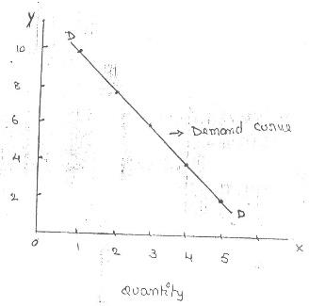
Assumptions:
Law of demand is based on certain assumptions:
- This is no change in consumers taste andpreferences.
- Income should remainconstant price
- Prices of other goods should notchange.
- There should be no substitute for thecommodity
- The commodity should not confer at anydistinction
- The demand for the commodity should becontinuous
- People should not expect any change in the price of thecommodity

Law of demand slopes downwards when the demand curve inverse relation between price and quantity demand.

The reasons for exceptional demand curve slope every time upward areas follows.
- Giffenparadox
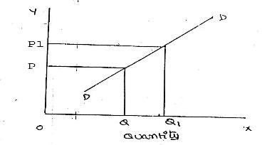
- Veblen or Demonstrationeffect
- Ignorance
- Speculative effectprice
- Fear ofshortage
- Necessaries

What is meant by elasticity of demand and types of elasticity ofdemand?
Elasticity of demand explains the relationship between a change in price and consequent change in Amount demanded. “Marshall” introduced the concept of elasticity of demand. Elasticity of demand shows the extent of change in quantity demanded to a change in price.
In the words of “Marshall”, “The elasticity of demand in a market is great or small according as the Amount demanded increases much or little for a given fall in the price and diminishes much or little for a given rise in Price”
Elastic demand: A small change in price may lead to a great change in quantity demanded. In this case, demand is elastic.
In-elastic demand: If a big change in price is followed by a small change in demanded then the demand in “inelastic”.

TYPE OF ELASTISITY OF DEMAND
- Price elasticity of demand
Proportionate change in the quantity demand of commodityX Price elasticity=------------------------------------------------------------------
Proportionate change in the price of commodityX

  - Elastic price demand-E>1
  - Inelastic price Demand-E<1
  - Unit price elasticity -E=1

Income elasticity ofdemand
Proportionate change in the quantity demand of commodity X Income Elasticity= ------------------------------------------------------------------
Proportionate change in the income of people

  - Zero income elasticity -Ey=0
  - Negative Income elasticity -Ey<0
  - Unit income elasticity -Ey=1
  - Income elasticity greater than unity -Ey>1
  - Income elasticity less than unity –Ey<1

Cross elasticity of demand
Proportionate change in the quantity demand of commodity “X” Cross elasticity= -----------------------------------------------------------------------
Proportionate change in the price of commodity “Y”

  - In case of substitutes, cross elasticity of demand ispositive
  - In case of compliments, cross elasticity isnegative
  - In case of unrelated commodities, cross elasticity of demanded iszero

Advertising elasticity of demand – is alwaysPOSITIVE
Proportionate change in the quantity demand of commodity X Advertising elasticity= -----------------------------------------------------------------------
Proportionate change in the advertisement cost

- Explain how do you measure elasticity of demand? Explain different types of price elasticity of demand?
Measure of elasticity of demand:
  - Perfectly elastic demand-E=∞
  - Perfectly Inelastic Demand-E=0
  - Relatively elastic demand-E>1
  - Relatively in- elastic demand -E<1
  - Unit elasticity of demand-E=1

Types of Price elasticity of demand
- Elastic price demand-E>1
- Inelastic price Demand-E<1
- Unit price elasticity -E=1

Explain the significance of elasticity and the factors influencingelasticity Significance of Elasticity ofdemand:

- Pricefixation
- Production
- Distribution
- InternationalTrade
- Public Finance
- Nationalization

Factors influencing the elasticity of demand:
Elasticity of demand depends on many factors.
  - Nature ofcommodity
  - Availability ofsubstitutes
  - Variety ofuses
  - Postponement of demand
  - Amount of moneyspent
  - Time
  - Range ofPrices

What is the contemporary importance of managerialeconomics?
Managerial economics decides the business is going towards profit or loss. That’s why it has its own priority on optimization of resources. Means to decrease the cost and increase the profit.
  - Useful in business organization andpolicies
  - Profit Planning andcontrolling
  - Creates demand forcasting
  - Price determination
  - Demandforecasting
  - Solutions fortaxation
  - Understanding the mechanism of economicsystem
  - Analysis of effects of governmentpolicies
  - Supporting themanufacture
  - Gives in right directions (decisionmaking)
  - Maintaining and distribution ofprofit
  - Measurement of the efficiency of thefirm

What are the needs for demand forecasting? Explain the factors governing of demand forecasting?
Need for demand forecasting
  - Estimate & Assessment of futuredemand
  - Businessdecision-making
  - Productionplanning
  - Estimating of revenue andexpenditures
  - Distinguish between forecast of demand andsales
  - Time and reliability offorecast

Factors governing Demand Forecasting
- Functional nature ofdemand
- Forecastinglevels
- Types offorecasting
- Degree oforientation
- Established or newproducts
- Nature ofgoods
- Degree ofcompetition
- Marketdemand
- Functional nature of marketdemand

What do you understand by demand forecasting? Explain different methods of demand forecasting?
The information about the future is essential for both new firms and those planning to expand the scale of their production. Demand forecasting refers to an estimate of future demand for the product.
Based on the time span and planning requirements of business firms, demand forecasting can be classified into 1. Short-term demand forecasting and 2. Long–term demand forecasting.
  - Estimate & Assessment of futuredemand
  - Businessdecision-making
  - Productionplanning
  - Estimating of revenue andexpenditures
  - Distinguish between forecast of demand andsales
  - Time and reliability offorecast

Methods of forecasting:
Several methods are employed for forecasting demand. All these methods can be grouped under Survey method and statistical method. Survey methods and statistical methods are further subdivided into different categories.

SurveyMethod:
  - Opinion survey method- This method is also known as sales- force composite method (or) collective opinion method. The salesmen are more knowledge. They can be important source of information. They arecooperative.
  - Expert opinion method- Firms in advanced countries make use of outside experts for estimating futuredemand.
  - Delphi Method- A variant of the survey method is Delphimethod.
  - This method has been used in the area of technologicalforecasting.
  - Consumer’s interview method- contacted personally to know about their plans and preference regarding the consumption of the product. This method seems to be the most ideal method for forecastingdemand

StatisticalMethods:
  - Time series analysis or trend projection methods- presented either in a tabular form or a graph.
    - Trend line by observation 2. Least square method 3. Moving averages methods4.
Exponential smoothing
  - Barometric Technique- (1) Construction Contracts awarded for building Materials (2) Personalincome(3)AgriculturalIncome (4)Employment(5)Grossnationalincome(6)
Industrial Production (7) Bank Deposits
  - Regression and correlation method- provides the values of the independent variables from within the modelitself

UNIT – II
THEORY OF PRODUCTION AND COST ANALYSIS

PRODUCTION FUNCTION
- Define production function. Explain Isocosts andIsoquants.
The production function expresses a functional relationship between physical inputs and physical outputs of a firm at any particular time period. The output is thus a function of inputs. Mathematically production function can be written as
Q= f (A, B, C, D)
Where “Q” stands for the quantity of output and A, B, C, D are various input factors such as Land, Labour, Capital and Organization. Here output is the function of inputs. Hence output becomes the dependent variable and inputs are the independent variables.

ISOCOSTS:
The term Isocosts is derived from the words ‘iso’ and ‘cost’ – ‘Iso’ means equal and ‘cost’ implies cost. Isocost therefore, means equal costs. Isocosts that refers to that cost curve that represents the combination of inputs that will cost the producer the same amount of money. If the level of production changes the cost changes and thus the Isocost curve move to upward and viceversa.

ISOQUANTS:
The term Isoquants is derived from the words ‘iso’ and ‘quant’ – ‘Iso’ means equal and ‘quant’ implies quantity. Isoquant therefore, means equal quantity. A family of iso-product curves or isoquants or production difference curves can represent a production function with two variable inputs, which are substitutable for one another within limits.The curve of Isoquant also called as the product indifference curve. For a given output level firm’s production become,

Q= f (L, K)
Where ‘Q’, the units of output is a function of the quantity of two inputs ‘L’ and ‘K’.

Assumptions:
  - There are only two factors of production, viz. Labour and Capital.
  - The two factors can substitute each other up to certainlimit
  - The shape of the isoquant depends upon the extent of substitutability of the twoinputs.
  - The technology is given over aperiod.

Features of ISO quants:
- Downwardsloping
- Convex toorigin
- Do notinterest
- Do not touch axis

A)MRTS
Marginal rate of Technical Substitution
The MRTS refers to the rate at which one input factor is substituted with the other to attain a given level of output.
5 units of decrease in labor and compensated by an increase in one unit of capital, resulting in MRTS 5:1
Change inoneinput K MRTS= =-
Change in another input L

Least cotcombination
The manufacturer has to produce at lower costs to attain higher profits. The Isocosts and ISOquants can be used to determine the input usage that minimizes the cost of production.

Cobb Douglas production function
Production function of the linear homogenous type is invested by Juntwicksell and first tested by C. W. Cobb and P. H. Dougles in 1928. This famous statistical production function is known as Cobb-Douglas production function. Originally the function is applied on the empirical study of the American manufacturing industry. Cabb – Douglas production function takes the following mathematical form.
WhereY= (AK^{X} L^{1-x})
Y=output K=Capital L=Labour
A, ∞=positive constant

Explain the law of returns withdiagram.
The law of returns to scale explains the behavior of the total output in response to change in the scale of the firm, i.e., in response to a simultaneous to changes in the scale of the firm, i.e., in response to a simultaneous and proportional increase in all the inputs. More precisely, the Law of returns to scale explains how a simultaneous and proportionate increase in all the inputs affects the total output at its variouslevels.
When a firm expands, its scale increases all its inputs proportionally, then technically there are three possibilities.
  - The total output may increaseproportionately
  - The total output may increase more thanproportionately
  - The total output may increase less thanproportionately.

- Explain internal and external economies ofscale?
Production may be carried on a small scale or o a large scale by a firm. When a firm expands its size of production by increasing all the factors, it secures certain advantages known as economies of production. Marshall has classified these economies of large-scale production into internal economies and externaleconomies.

Causes of internal economies:
Internal economies are generally caused by two factors
- Indivisibilities 2.Specialization.

Internal Economies:
Internal economies may be of the following types.
  - TechnicalEconomies.
  - ManagerialEconomies:
  - MarketingEconomies:
  - FinancialEconomies:
  - Risk bearingEconomies:
  - Economies ofResearch:
  - Economies ofwelfare:

External Economies.
Business firm enjoys a number of external economies, which are discussed below:
    - Economies ofConcentration:
    - Economies ofInformation
    - Economies ofWelfare:
    - Economies ofDisintegration:
Thus, internal economies depend upon the size of the firm and external economies depend upon the size of the industry.

Explain the economies of large scale ofproduction.
Internal and external diseconomies are the limits to large-scale production. It is possible that expansion of a firm’s output may lead to rise in costs and thus result diseconomies instead of economies. When a firm expands beyond proper limits, it is beyond the capacity of the manager to manage it efficiently. This is an example of an internal diseconomy. In the same manner, the expansion of an industry may result in diseconomies, which may be called external diseconomies. Employment of additional factors of production becomes less efficient and they are obtained at a higher cost. It is in this way that external diseconomies result as an industry expands.

The major diseconomies of large-scale production are discussed below:

Internal Diseconomies:
- FinancialDiseconomies
- Managerialdiseconomies
- MarketingDiseconomies
- TechnicalDiseconomies
- Diseconomies ofRisk-taking

External Diseconomies:
When many firm get located at a particular place, the costs of transportation increase due to congestion. The firms have to face considerable delays in getting raw materials and sending finished products to the marketing centers. The localization of industries may lead to scarcity of raw material, shortage of various factors of production like Labour and Capital, shortage of power, finance and equipment’s. All such external diseconomies tend to raise cost per unit.

COST ANALYSIS
- What is cost analysis? Explain the concept ofcost?
Profit is the ultimate aim of any business and the long-run prosperity of a firm depends upon its ability to earn sustained profits. Profits are the difference between selling price and cost of production. In general, the selling price is not within the control of a firm but many costs are under its control. The firm should therefore aim at controlling and minimizing cost.
A managerial economist must have a clear understanding of the different cost concepts for clear business thinking and properapplication.
- Opportunity costs and outlaycosts
- Explicit and implicitcosts
- Historical and Replacementcosts
- Short – run and long – runcosts
- Out-of pocket and bookscosts
- Fixed and variablecosts
- Post and Futurecosts
- Traceable and commoncosts
- Avoidable and unavoidablecosts
- Controllable and uncontrollablecosts
- Incremental and sunkcosts
- Total, average and marginalcosts
- Accounting and Economicscosts

COST-OUTPUT RELATIONSHIP
A proper understanding of the nature and behavior of costs is a must for regulation and control of cost of production. The cost of production depends on money forces and an understanding of the functional relationship of cost to various forces will help us to take various decisions. Output is an important factor, which influences the cost.
The cost-output relationship plays an important role in determining the optimum level of production. Knowledge of the cost-output relation helps the manager in cost control, profit prediction, pricing, promotion etc. The relation between cost and its determinants is technically described as the cost function.

Where:

C= f (S, O, P, T ….)

C= Cost (Unit or total cost)
S= Size of plant/scale of production O= Output level
P= Prices of inputs

(a) Cost-Output Relation in the short-run:

The cost concepts made use of in the cost behavior are total cost, Average cost, and Marginal cost, Total cost is the actual money spent to produce a particular quantity of output. Total cost is the summation of fixed and variable costs.

TC=TFC+TVC
Up to a certain level of production total fixed cost i.e., the cost of plant, building, equipment etc., remains fixed. But the total variable cost i.e., the cost of Labour, Raw Materials etc., Vary with the variation in output. Average cost is the total cost per unit. It can be found out asfollows.

AC= TC/Q
The total of average fixed cost (TFC/Q) keep coming down as the production is increased and average variable cost (TVC/Q) will remain constant at any level of output.

Marginal cost is the addition to the total cost due to the production of an additional unit of product. It can be arrived at by dividing the change in total cost by the change in total output.
In the short-run there will not be any change in total fixed cost. Hence change in total cost implies change in total variable costonly.

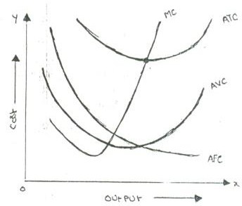

b. Cost-Output Relationship in the long-run:
Long run is a period, during which all inputs are variable including the one, which are fixes in the short-run. In the long run a firm can change its output according to its demand. Over a long period, the size of the plant can be changed, unwanted buildings can be sold staff can be increased or reduced. The long run enables the firms to expand and scale of their operation by bringing or purchasing larger quantities of all the inputs. Thus, in the long run all factors become variable.
The long-run cost-output relations therefore imply the relationship between the total cost and the total output. In the long-run cost-output relationship is influenced by the law of returns to scale.
In the long run a firm has a number of alternatives in regards to the scale of operations. For each scale of production or plant size, the firm has an appropriate short-run average cost curve. The short-run average cost (SAC) curve applies to only one plant whereas the long-run average cost (LAC) curve takes in to consideration many plants.

The long-run cost-output relationship is shown graphically with the help of “LCA’ curve.

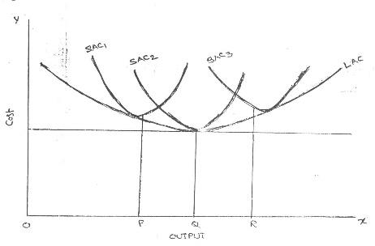

7. Explain the Break-Even Point?

Break – Even- Point: If we divide the term into three words, then it does not require further explanation.
Break-Divide Even-Equal
Point-Place or Position
Break Even Point refers to the point where total cost is equal to total revenue. It is a point of no profit, no loss. This is also a minimum point of no profit, no loss. This is also a minimum point of production where total costs are recovered. If sales go up beyond the Brea Even Point, organization makes a profit. If they come down, a loss is incurred.
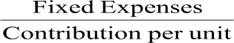
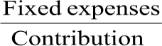
- Break Even point (Units)=

- Break Even point (InRupees)= Xsales

Important:
  - Profit and LossAccount
  - Relationship between cost, volume andprofit
  - Long termplanning
  - Useful forforecasting
  - Serves as a tool of costcontrol

What is break-even analysis? State its merits anddemerits?
The study of cost-volume-profit relationship is often referred as BEA. The term BEA is interpreted in two senses. In its narrow sense, it is concerned with finding out BEP; BEP is the point at which total revenue is equal to total cost. It is the point of no profit, no loss. In its broad determine the probable profit at any level of production.

Merits:
  - Information provided by the Break-Even Chart can be understood more easily than those contained in the profit and Loss Account and the coststatement.
  - Break Even Chart discloses the relationship between cost, volume and profit. It reveals how changes in profit. So, it helps management indecision-making.
  - It is very useful for forecasting costs and profits long term planning andgrowth
  - The chart discloses profits at various levels ofproduction.
  - It serves as a useful tool for costcontrol.
  - It can also be used to study the comparative plant efficiencies of theindustry.
  - Analytical Break-even chart present the different elements, in the costs – direct Material, direct Labour, Fixed and VariableOverheads.

Demerits:
- Break-even chart presents only cost volume profits. It ignores other considerations such as capital amount, marketing aspects and effect of government policy etc., which are necessary in decisionmaking.
- It is assumed that sales, total cost and fixed cost can be represented as straight lines. In actual practice, this may not beso.
- It assumes that profit is a function of output. This is not always true. The firm may increase the profit without increasing itsoutput.
- A major drawback of BEC is its inability to handle production and sale of multiple products.
- It is difficult to handle selling costs such as advertisement and sale promotion in BEC.
- It ignores economics of scale inproduction.
- Fixed costs do not remain constant in the longrun.
- Semi-variable costs are completelyignored.
- It assumes production is equal to sale. It is not always true because generally there may be openingstock.
- When production increases variable cost per unit may not remain constant but may reduce on account of bulk buyingetc.
- The assumption of static nature of business and economic activities is a well-known defect of BEC.

Explain in details the concepts of BEA?
The concept of Break-Even analysis is -
- Fixedcost
- Variable cost
- Contribution
- Margin ofsafety
- Angle ofincidence
- Profit volumeratio
- Break-Even-Point

UNIT – III
MARKETS AND NEW ECONOMIC ENVIRONMENT

Define markets and explain how markets areclassified?
A market may be also defined as the demand made by a certain group of potential buyers for a good or service. The former one is a narrow concept and later one, a broader concept.
Economists describe a market as a collection of buyers and sellers who transact over a particular product or product class (the housing market, the clothing market, the grain market etc.).
For business purpose we define a market as people or organizations with wants (needs) tosatisfy, money to spend, and the willingness to spendit.
Market structure describes the competitive environment in the market for any good or service. A market consists of all firms and individuals who are willing and able to buy or sell a particular product. This includes firms and individuals currently engaged in buying and selling a particular product, as well as potential entrants.

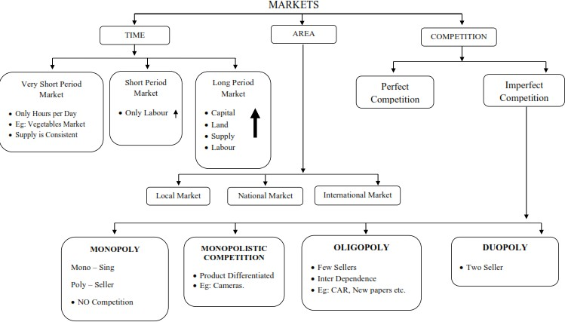

What is a perfect and imperfect market? Describe itsfeatures.

Perfect competition refers to a market structure where competition among the sellers and buyers prevails in its most perfect form. In a perfectly competitive market, a single market price prevails for the commodity, which is determined by the forces of total demand and total supply in themarket.

Features of Perfect Competition

The following features characterize a perfectly competitive market:

  - A large number of buyers and sellers
  - Homogeneousproduct
  - Free entry andexit
  - Perfectknowledge
  - Indifference
  - Non-existence of transportcosts
  - Perfect mobility of factors ofproduction

Features of Imperfect Competition
- Monopoly
- Monopolistic Competition
- Oligopoly
- Duopoly

Features of monopoly
The following are the features of monopoly:
- Single person or afirm
- No closesubstitute
- Large number ofBuyers
- Price Maker
- Supply andPrice
- Downward Sloping DemandCurve

Features of Monopolistic Competition
The important features of monopolistic competition are:
- Existence of Manyfirms
- ProductDifferentiation
- Large Number ofBuyers
- Free Entry and Exist ofFirms
- Sellingcosts
- ImperfectKnowledge

Features of Oligopoly
The main features of oligopoly are the term oligopoly is derived from two Greek words, oligos meaning a few, and pollen meaning to sell. Oligopoly is the form of imperfect competition where there are a few firms in the market, producing either a homogeneous product or producing products, which are close but not perfect substitute of each other.
  - Few Firms
  - Interdependence
  - Indeterminate DemandCurve
  - Advertising and sellingcosts
  - Price Rigidity
- Explain features of monopolistic competition. How price and out-put is determined?
Perfect competition and pure monopoly are rate phenomena in the real world. Instead, almost every market seems to exhibit characteristics of both perfect competition and monopoly. Hence in the real world it is the state of imperfect competition lying between these two extreme limits that work. Edward. H. Chamberlain developed the theory of monopolistic competition, which presents a more realistic picture of the actual market structure and the nature of competition.Features of MonopolisticCompetition
The important features of monopolistic competition are:
  - Existence of Manyfirms
  - ProductDifferentiation
  - Large Number ofBuyers
  - Free Entry and Exist ofFirms
  - Sellingcosts
  - ImperfectKnowledge

Price – Output Determination under Monopolistic Competition
Since under monopolistic competition different firms produce different varieties of products, different prices for them will be determined in the market depending upon the demand and cost conditions. Each firm will set the price and output of its own product. Here also the profit will be maximized when marginal revenue is equal to marginal cost.

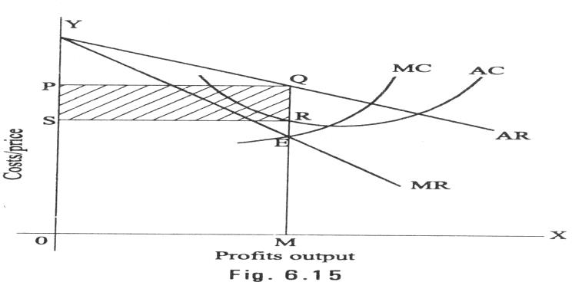
Short-run equilibrium of the firm

If the demand and cost conditions are less favorable the monopolistically competitive firm may incur loss in the short-run
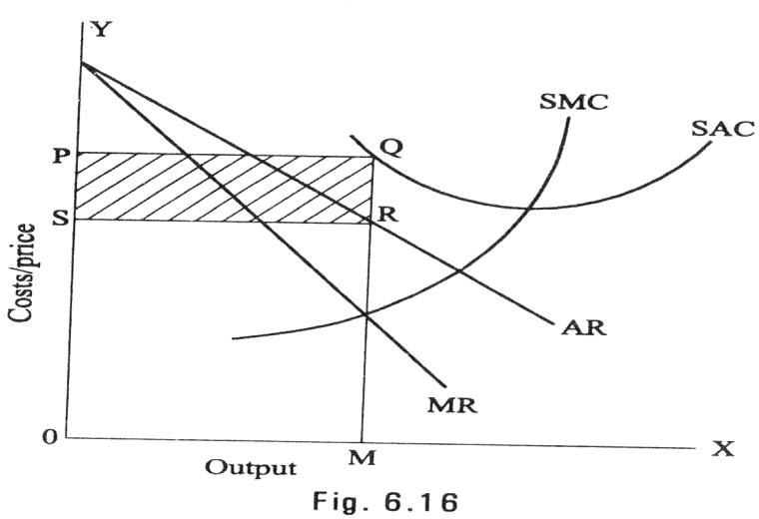

Long – Run Equilibrium of the Firm:
A monopolistically competitive firm will be long – run equilibrium at the output level where marginal cost equal to marginal revenue. Monopolistically competitive firm in thelong run attains equilibrium where MC=MR and AC=AR Fig 6.17 shows thistrend.
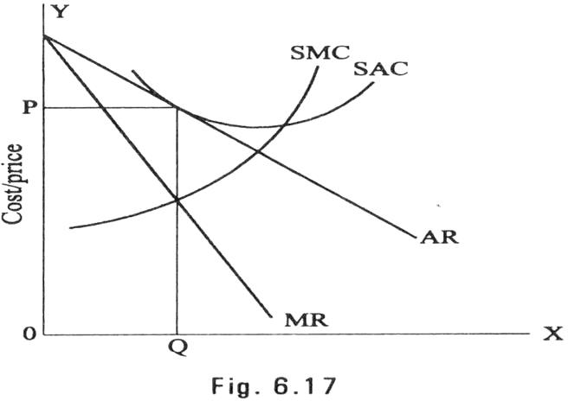

Price determinants – Demand and supply
The price of a product is determined by the demand for and supply of that product. According to Marshall the role of these two determinants is like that of a pair of scissors in cutting cloth. It is possible that at times, while one pair is held fixed, the other is moving to cut the cloth. Similarly, it is conceivable that there could be situations under which either demand or supply is playing a passive role, and the other, which is active, alone appear to be determining the price. However, just as one pair of scissors alone can never cut a cloth, demand or supply alone is insufficient to determine theprice.

Equilibrium Price
The price at which demand and supply of a commodity is equal known as equilibrium price.

Price output determination under MONOPOLY (EquilibriumPoint)
The monopolistic firm attains equilibrium when its marginal cost becomes equal to the marginal revenue. The monopolist always desires to make maximum profits. He makes maximum profits when MC=MR. He does not increasing his output if his revenue exceeds his costs. But when the costs exceed the revenue, the monopolist firm incur loses. Hence the monopolist curtails his production. He produces up to that point where additional cost is equal to the additional revenue (MR=MC). Thus, point is called equilibriumpoint.
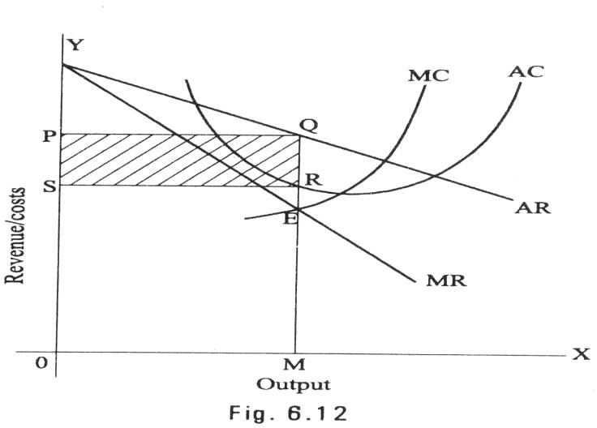

The above diagram (Average revenue) = MQ or OP Average cost = MR
Profit per unit = Average Revenue-Average cost=MQ-MR=QR Total Profit = QRXSR=PQRS
The area PQRS resents the maximum profit earned by the monopoly firm.
But it is not always possible for a monopolist to earn super-normal profits. If the demand and cost situations are not favorable, the monopolist may realize short run losses

Explain various pricing methods followed by businessorganizations?
The micro – economic principle of profit maximization suggests pricing by the marginal analysis. That is by equating MR to MC. However, the pricing methods followed by the firms in practice around the world rarely follow this procedure. This is for two reasons; uncertainty with regard to demand and cost function and the deviation from the objective of short run profit maximization.

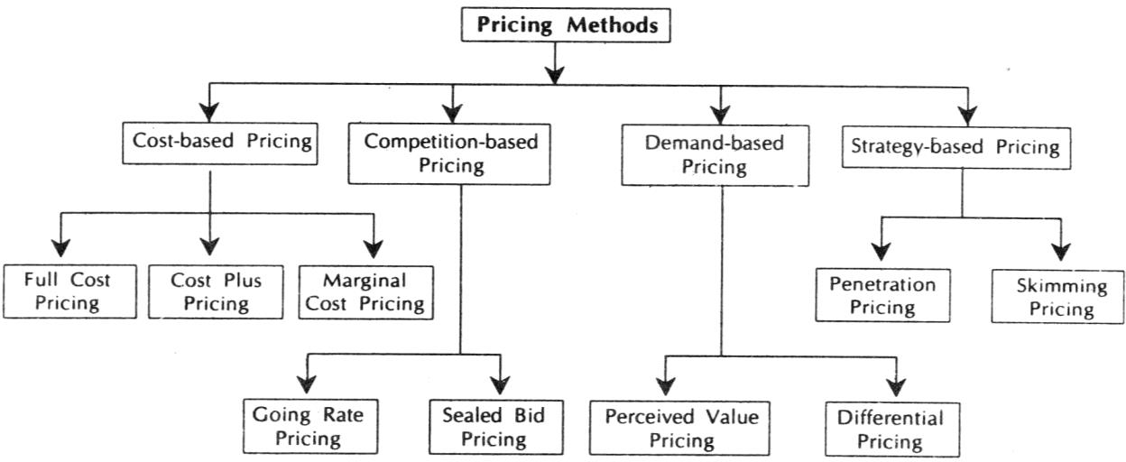

PRICING OBJECTIVES:
- Monitory pricingobjectives:
  - To achieve a targeted return oninvestment
  - To maximize theprofits
  - To increase salesvolume
  - Pricingstabilization

Non-monitory pricingobjectives
  - Society orientedobjectives
  - Maximize marketshare
  - Operation orientedobjectives
  - Patronase orientedobjectives

PRICING POLICY:the pricing policy of a company sends out signals about the company philosophies. It helps in creating that perception in customer’s mind.
    - Negotiations
    - Quality
    - Discounts

BUSINESS FEATURES AND EVALUATION OF DIFFERENT FORMS OF BUSINESSORGANIZATION
- Explain the features of sole trade organization. Discuss the merits and demerits ofsole trade form oforganization.
The sole trader is the simplest, oldest and natural form of business organization. It is also called sole proprietorship. ‘Sole’ means one. ‘Sole trader’ implies that there is only one trader who is the owner of the business. It is a one-man form of organization wherein the trader assumes all the risk of ownership carrying out the business with his own capital, skilland
intelligence. He is the boss for himself. He has total operational freedom. He is the owner, Manager and controller.

Features:

- It is easy to start a business under this form and also easy toclose.
- He introduces his own capital. Sometimes, he may borrow, ifnecessary
- He enjoys all the profits and in case of loss, he lonesuffers.
- He has unlimited liability which implies that his liability extends to his personal properties in case of loss.
- He has a high degree of flexibility to shift from one business to the other.
- Business secretes can be guardedwell
- There is no continuity. The business comes to a close with the death, illness or insanity of the sole trader. Unless, the legal heirs show interest to continue the business, the business cannot berestored.
- He has total operational freedom. He is the owner, manager andcontroller.
- He can be directly in touch with thecustomers.
- He can take decisions very fast and implement thempromptly.
- Rates of tax, for example, income tax and so on are comparatively verylow.

Merits
The following are the merits of the sole trader from of business organization:

  - Easy to start and easy toclose
  - Personal contact with customersdirectly
  - Promptdecision-making
  - High degree offlexibility
  - Secrecy
  - Low rate oftaxation
  - Directmotivation
  - TotalControl
  - Minimum interference fromgovernment
  - Transferability

Demerits
The following are the demerits of sole trader form:
- Unlimitedliability
- Limited amounts ofcapital
- No division ofLabour
- Uncertainty
- Inadequate for growth andexpansion
- Lack ofspecialization
- More competition
- Low bargainingpower

Explain the features, merits and limitations of Joint StockCompany?
The joint stock company emerges from the limitations of partnership such as joint and several liability, unlimited liability, limited resources and uncertain duration and so on. Normally, to take part in a business, it may need large money and we cannot foretell the fate of business. It is not literally possible to get into business with little money. Against this background, it is interesting to study the functioning of a joint stock company. The main principle of the joint stock company from is to provide opportunity to take part in business with a low investment as possible say Rs.1000. Joint Stock Company has been a boon for investors with moderate funds toinvest.

The word ‘company’ has a Latin origin, com means ‘come together’, pany means ‘bread’, joint stock company means, people come together to earn their livelihood by investing in the stock of company jointly.

Features
This definition brings out the following features of the company:
  - Artificialperson
  - Separate legalexistence
  - Voluntary association ofpersons
  - LimitedLiability
  - Capital is divided intoshares
  - Transferability ofshares
  - CommonSeal
  - Perpetualsuccession
  - Ownership and Managementseparated
  - Windingup
  - The name of the company ends with‘limited’

Advantages:
The following are the advantages of a joint Stock Company
    - Mobilization of largerresources
    - Separate legalentity
    - Limitedliability
    - Transferability ofshares
    - Liquidity ofinvestment
    - Inculcates the habit of savings andinvestments
    - Democracy inmanagement
    - Economics of large-scale production
    - Continuedexistence
    - Institutionalconfidence
    - Professionalmanagement
    - Growth andExpansion

Disadvantages
- Formation of company is a long-drawnprocedure
- High degree of governmentinterference
- Inordinate delays indecision-making
- Lack orinitiative
- Lack of responsibility andcommitment
- Lack of responsibility andcommitment

Explain features of partnership with its merits anddemerits.
Partnership is an improved from of sole trader in certain respects. Where there are like- minded persons with resources, they can come together to do the business and share the profits/losses of the business in an agreed ratio. Persons who have entered into such an agreement are individually called ‘partners’ and collectively called ‘firm’. The relationship among partners is called apartnership.
Indian Partnership Act, 1932 defines partnership as the relationship between two or more persons who agree to share the profits of the business carried on by all or any one of them acting for all.

Features
- Relationship
- Two or morepersons
- There should be abusiness
- Agreement
- Carried on by all or any one of them acting forall

The following are the other features:
  - Unlimitedliability
  - Number ofpartners
  - 10 partners iscase of bankingbusiness
  - 20 in case of non-bankingbusiness
  - Division ofLabour
  - Personal contact withcustomers
  - Flexibility

Advantages:
The following are the advantages of the partnership from:
- Easy toform
- Availability of larger amount ofcapital
- Division ofLabour
- Flexibility
- Personal contact withcustomers
- Quick decisions and promptaction
- The positive impact of unlimitedliability

Disadvantages:
The following are the disadvantages of partnership:
- Formation of partnership isdifficult
- Liability:
- Lack of harmony or cohesiveness
- Limitedgrowth
- Instability
- Lack of Publicconfidence

Explain different types of public sectorenterprises?
Public enterprises occupy an important position in the Indian economy. Today, public enterprises provide the substance and heart of the economy. Its investment of over Rs.10,000crore is in heavy and basic industry, and infrastructure like power, transport and communications. The concept of public enterprise in Indian dates back to the era of pre- independence.

Features:
  - Under the control of a governmentdepartment
  - More financialfreedom
  - Like any other governmentdepartment
  - Budget, accounting and auditcontrols
  - More a government organization, less a businessorganization

Advantages
- Effective control
- Responsible Executives
- Less scope for mystification offunds
- Adds to Governmentrevenue

Disadvantages:
- Decisionsdelayed
- No incentive to maximizeearnings
- Slow response to marketconditions
- Redtapism andbureaucracy
- Incidence of more taxes

UNIT – IV
FINANCIAL ACCOUNTING AND FINANCIAL ANALYSIS
Introduction:
As you are aware, every trader generally starts business for purpose of earning profit. While establishing business, he brings own capital, borrows money from relatives, friends, outsiders or financial institutions. Then he purchases machinery, plant, furniture, raw materials and other assets. He starts buying and selling of goods, paying for salaries, rent and other expenses, depositing and withdrawing cash from bank. Like this he undertakes innumerable transactions in business.

Meaning ofAccounting:
Thus, book-keeping is an art of recording the business transactions in the books of original entry and the ledges. Accountancy begins where Book-keeping ends. Accountancy means the compilation of accounts in such a way that one is in a position to know the state of affairs of the business. The work of an accountant is to analyze, interpret and review the accounts and draw conclusion with a view to guide the management in chalking out the future policy of the business.

Definition ofAccounting:

American Institute of Certified Public Accountants (AICPA): “The art of recording, classifying and summarizing in a significant manner and in terms of money transactions and events, which are in part at least, of a financial character and interpreting the results thereof.”

Smith and Ashburne: “Accounting is a means of measuring and reporting the results of economicactivities.”

R.N. Anthony: “Accounting system is a means of collecting summarizing, analyzing and reporting in monetary terms, the information about thebusiness.

Thus, accounting is an art of identifying, recording, summarizing and interpreting business transactions of financial nature. Hence accounting is the Language of Business.

Branches ofAccounting:
The important branches of accounting are:
    - Financial Accounting: The purpose of accounting is to ascertain thefinancial results
i.e.profit or loss in the operations during a specific period. It is also aimed at knowing the financial position, i.e.assets, liabilities and equity position at the end ofthe period. It
also provides other relevant information to the management as a basic for decision- making for planning and controlling the operations of the business.
    - Cost Accounting: The purpose of this branch of accounting is to ascertain the cost of a product / operation / project and the costs incurred for carrying out various activities. It also assists the management in controlling the costs. The necessary data and information are gatherr4ed form financial and other sources.
    - Management Accounting: Its aim to assist the management in taking correct policy decision and to evaluate the impact of its decisions and actions. The data required for this purpose are drawn accounting andcost-accounting.
    - Inflation Accounting: It is concerned with the adjustment in the values of assest and of profit in light of changes in the price level. In a way it is concerned with the overcoming of limitations that arise in financial statements on account of the cost assumption (i.e recording of the assets at their historical or original cost) and the assumption of stable monetaryunit.
    - Human Resource Accounting: It is a branch of accounting which seeks to report and emphasize the importance of human resources in a company’s earning process and total assets. It is concerned with the process of identifying and measuring data about human resources and communicating this information to interested parties. In simple words, it is accounting for people as organizationalresources.

FUNCTIONS OF ANACCOUNTANT:

The job of an accountant involves the following types of accounting works:
- Designing Work: It includes the designing of the accounting system, basis for identification and classification of financial transactions and events, forms, methods, procedures,etc.
- Recording Work: The financial transactions are identified, classified and recorded in appropriate books of accounts according to principles. This is “Book Keeping”. The recording of transactions tends to be mechanical andrepetitive.
- Summarizing Work: The recorded transactions are summarized into significant form according to generally accepted accounting principles. The work includes the preparation of profit and loss account, balance sheet. This phase is called preparation of final accounts
- Analysis and Interpretation Work: The financial statements are analyzed by using ratio analysis, break-even analysis, funds flow and cash flowanalysis.
- Reporting Work: The summarized statements along with analysis and interpretation are communicated to the interested parties or whoever has the right to receive them. For Ex. Shareholders. In addition, the accou8nting departments have to prepare and send regular reports so as to assist the management in decision making. This isReporting.
- Preparation of Budget: The management must be able to reasonably estimate the future requirements and opportunities. As an aid to this process, the accountant has to prepare budgets, like cash budget, capital budget, purchase budget, sales budget etc. this isBudgeting.
- Taxation Work: The accountant has to prepare various statements and returns pertaining to income-tax, sales-tax, excise or customs duties etc., and file the returns with the authoritiesconcerned.
- Auditing: It involves a critical review and verification of the books of accounts statements and reports with a view to verifying their accuracy. This is auditing this is what the accountant or the accounting department does. A person may be placed in any part of Accounting Department or MIS (Management Information System) Department or in small organization; the same person may have to attend to all thiswork.

USERS OF ACCOUNTING INFORMATION
Different categories of users need different kinds of information for making decisions.
The users of accounting can be divided in two board groups (1). Internal users and
(2). External users.

Internal Users:
Managers: These are the persons who manage the business, i.e. management at
- TopLevel,
- Middle Leveland
- Lowerlevels.

External Users:
- Investors
- Creditors
- Workers
- Customers
- Government
- Public
- Researchers

BASIC ACCOUNTING CONCEPTS
Accounting is a system evolved to achieve a set of objectives. In order to achieve the goals, we need a set of rules or guidelines. These guidelines are termed here as “BASIC ACCOUNTING ONCEPTS”. The term concept means an idea or thought. Basic accounting concepts are the fundamental ideas or basic assumptions underlying the theory and profit of FINANCIAL ACCOUNTING. These concepts help in bringing about uniformity in the practice of accounting. In accountancy following concepts are quite popular.

- Business Entity Concept: In this concept “Business is treated as separate from the proprietor”. All the Transactions recorded in the book of Business and not in the books of proprietor. The proprietor is also treated as a creditor for the Business.

- Going Concern Concept: This concept relates with the long life of Business. The assumption is that business will continue to exist for unlimited period unless it is dissolved due to some reasons or theother.

- Money Measurement Concept: In this concept “Only those transactions are recorded in accounting which can be expressed in terms of money, those transactions which cannot be expressed in terms of money are not recorded in the books ofaccounting”.

- Cost Concept: Accounting to this concept, can asset isrecorded at its cost in the books of account. i.e., the price, which is paid at the time of acquiring it. In balance sheet, these assets appear not at cost price every year, but depreciation is deducted and they appear at the amount, which is cost, lessclassification.

- Accounting Period Concept: every Businessman wants to know the result of his investment and efforts after a certain period. Usually one-year period is regarded as an ideal for this purpose. This period is called Accounting Period. It depends on the nature of the business and object of the proprietor ofbusiness.

- Dual Accept Concept: According to this concept “Every business transaction has two aspects”, one is the receiving benefit aspect another one is giving benefit aspect. The receiving benefit aspect is termed as “DEBIT”, whereas the giving benefit aspect is termed as “CREDIT”. Therefore, for every debit, there will be correspondingcredit.

- Matching Cost Concept: According to this concept “The expenses incurred during an accounting period, e.g., if revenue is recognized on all goods sold during a period, cost of those good sole should also Be charged to thatperiod.

- Realization Concept: According to this concept revenue is recognized when a sale is made. Sale is Considered to be made at the point when the property in goods possess to the buyer and he becomes legally liable topay.

ACCOUNTING CONVENTIONS
Accounting is based on some customs or usages. Naturally accountants here to adopt that usage or custom. They are termed as convert conventions in accounting. The following are some of the important accounting conventions.
- Full Disclosure: According to this convention accounting reports should disclose fully and fairly the information. They purport to represent. They should be prepared honestly and sufficiently disclose information which is if material interest to proprietors, present and potential creditors and investors. The companies ACT, 1956 makes it compulsory to provide all the information in the prescribedform.
- Materiality: Under this convention the trader records important factor about the commercial activities. In the form of financial statements if any unimportant information is to be given for the sake of clarity it will be given asfootnotes.
- Consistency: It means that accounting method adopted should not be changed from year to year. It means that there should be consistent in the methods or principles followed. Or else the results of a year cannot be conveniently compared with that ofanother.
- Conservatism: This convention warns the trader not to take unrealized income in to account. That is why the practice of valuing stock at cost or market price, whichever is lower is in vague. This is the policy of “playing safe”; it takes in to consideration all prospective losses but leaves all prospectiveprofits.
The following three different rules have been laid down for the three classes of accounts:

- Personal Accounts: The account of the person receiving benefit (receiver) is to be debited and the account of the person giving the benefit (given) is to be credited.
Rule: “Debit TheReceiver
Credit TheGiver”
- Real Accounts: When an asset is coming into the business, account of that asset is tobe debited
.When an asset is going out of the business; the account of that asset is to be credited.
Rule: “Debit What comesin
Credit What goesout”
- Nominal Accounts: When an expense is incurred or loss encountered, the account representing the expense or loss is to be debited. When any income is earned or gain made, the account representing the income of gain is to becredited.
Rule: “Debit All expenses andlosses
Credit All incomes andgains”
The perform of Journal is given below:
Date | Particulars | LF | Dr.  (Amount Rs.) | Cr.  (Amount Rs.)

LEDGER:
All the transactions in a journal are recorded in a chronological order. After a certain period, if we want to know whether a particular account is showing a debit or credit balance it becomes very difficult. So, the ledger is designed to accommodate the various accounts maintained the trader. It contains the final or permanent record of all the transactions in duly classified form. “A ledger is a book which contains various accounts.” The process of transferring entries from journal to ledger is called“POSTING”.
Posting is the process of entering in the ledger the entries given in the journal. Posting into ledger is done periodically, may be weekly or fortnightly as per the convenience of thebusiness.

The following are the guidelines for posting transactions in the ledger.
- After the completion of Journal entries only posting is to be made in theledger.
- For each item in the Journal a separate account is to be opened. Further, for each new item a new account is to beopened.
- Depending upon the number of transactions space for each account is to be determined in the ledger.
- For each account there must be a name. This should be written in the top of the table. At the end of the name, the word “Account” is to beadded.
- The debit side of the Journal entry is to be posted on the debit side of the account, by starting with“TO”.
- The credit side of the Journal entry is to be posted on the debit side of the account, by starting with“BY”.

Performa for ledger: LEDGER BOOK:

Dr. Cr.
Date | Particulars | JF | Amount Rs. |  | Date | Particulars | JF | Amount Rs.
SUBSIDIARY BOOKS:
In a small business concern, the numbers of transactions are limited. These transactions are first recorded in the journal as and when they take place. Subsequently, these transactions are posted in the appropriate accounts of the ledger. Therefore, the journal is known as “Book of Original Entry” or “Book of Prime Entry” while the ledger is known as main book ofaccounts.
On the other hand, the transactions in big concern are numerous and sometimes even run into thousands and lakhs. It is inconvenient and time-wasting process if all the transactions are going to be managed with ajournal.
Therefore, a convenient device is made. Smaller account books known as subsidiary books or subsidiary journals are disturbed to various sections of the business house. As and when transactions take place, they are recorded in these subsidiary books simultaneously without delay. The original journal (which is known as Journal Proper) is used only occasionally to record those transactions which cannot be recorded in any of the subsidiary books.

TYPES OF SUBSIDIARY BOOKS: -- Subsidiary books are divided into eight types. They are,
  - Purchases Book: - This book records all credit purchases only. Purchase of goods for cash and purchase of assets for cash. Credit will not be recorded in this book. Purchases book is otherwise called Purchases Day Book, Purchases Journal or PurchasesRegister.
  - Sales Book: - This book is used to record credit sales only. Goods are sold for cash and sale of assets for cash or credit will not be recorded in this book. This book is otherwise called Sales Day Book, Sales Journal or Sales Register.
  - Purchase Returns Book: - This book is used to record the particulars of goods returned to the suppliers. This book is otherwise called Returns OutwardBook.
  - Sales Returns Book: - This book is used to record the particulars of goods returned by the customers. This book is otherwise called Returns InwardBook.
  - Cash Book: - All cash transactions, receipts and payments are recorded in this book. Cash includes cheques, money ordersetc.
  - Bills Receivables Book: - This book is used to record all the bills and promissory notes are received from thecustomers.
  - Bills Payable Book: - This book is used to record all the bills or promissory notes accepted to thesuppliers.
  - Journal Proper: - This is used to record all the transactions that cannot be recorded in any of the above-mentioned subsidiarybooks.

TRAIL BALANCE:
The first step in the preparation of final accounts is the preparation of trail balance. Inthe double entry system of book keeping, there will be credit for every debit and there will not be any debit without credit. When this principle is followed in writing journal entries, the total amount of all debits is equal to the total amount allcredits.
A trail balance is a statement of debit and credit balances. It is prepared on a particular date with the object of checking the accuracy of the books of accounts. It indicates that all the transactions for a particular period have been duly entered in the book, properly posted and balanced. The trail balance doesn’t include stock in hand at the end of the period. All adjustments required to be done at the end of the period including closing stock are generally given under the trailbalance.

DEFINITIONS: SPICER AND POGLAR: A trail balance is a list of all the balances standing on the ledger accounts and cash book of a concern at any given date.
    - ATLIBOI: A trail balance is a statement of debit and credit balances extracted from the ledger
with a view to test the arithmetical accuracy of thebooks.
Thus, a trail balance is a list of balances of the ledger accounts and cash book of a business concern at any given date.
PROFORMA FOR TRAIL BALANCE:

Trail balance for the Year Ending Mr.…………………………………… as on …………
Particulars | Debit Balances  Rs | Credit Balances  Rs
Debit Balances:  - Debtors  - Assets suchas  Plant and Machinery Land and Buildings Furniture  - Expenses such as Rent  Insurance Office expenses  - Losses Suchas  Stock destroyed by fire Loss on sale of Assets  - Purchase |  | XXX
- Sales Returns
- Drawings
Credit Balance:
- Creditors
- Liabilities Such as Capital Debentures Long termLoan
- Incomes
- Gains
- Profit
- BankOverdraft
- PurchaseReturns
- Sales account
- Provision account such as Provision for DoubtfulDebts
Provision for discount on debtors
- Reserves andSurplus

Final Accounts:
The process of preparing final accounts is two stages:
      - Trading and Profit and Loss accountand
      - Balance sheet

TRADING ACCOUNT:

The first step in the preparation of final account is the preparation of trading account. The main purpose of preparing the trading account is to ascertain gross profit or gross loss as a result of buying and selling the goods.

Trading account of MR……………………. for the year ended ……………………

Particulars | Amount | Particulars | Amount
To opening stock To purchases xxxxLess:returns xx | Xxxx  Xxxx | By sales xxxx Less: returns xxx By closing stock | XxxxXxxx
To carriage inwards Towages  Tofreight  To customs duty | XxxxXxxxXxxxXxxx
To gas, fuel, coal, Water | Xxxx
To factory expenses  To other man. Expenses To productive expenses | XxxxXxxxXxxx
To gross profit c/d | Xxxx
 | Xxxx |  | Xxxx

PROFIT AND LOSS ACCOUNT

The business man is always interested in knowing his net income or net profit. Net profit represents the excess of gross profit plus the other revenue incomes over administrative, sales, Financial and other expenses. The debit side of profit and Credit side of loss account. shows the expenses in debit side and the incomes in credit side. If the total of the credit side is more, it will be the net profit. And if the debit side is more, it will be net loss.

PROFIT AND LOSS A/C OF MR…………………….FOR THE YEAR ENDED…………
PARTICULARS | AMOUNT | PARTICULARS | AMOUNT
TO office salaries TOrent,rates,taxes  TO Printing and stationery TO Legalcharges  Audit fee  TOInsurance  TO General expenses TO Advertisements TO Baddebts  TO Carriage outwards TO Repairs  TO Depreciation TO interestpaid  TO Interest on capital TO Interest on loans TO Discount allowed TO Commission  TONet profit →  (transferred to capital a/c) | XxxxxxXxxxxXxxxx  XxxxXxxxXxxxXxxxxXxxxXxxxXxxxXxxxxXxxxxXxxxxXxxxXxxxxXxxxxXxxxx | By Gross profit b/d By Interest received By Discount received  By Commission received  By Income from investments By Dividend on shares  By Miscellaneous investments By Rent received | XxxxxXxxxxXxxxXxxxx  XxxxXxxxXxxx  Xxxx
 | Xxxxx |  | Xxxx

BALANCE SHEET

The second point of final accounts is the preparation of balance sheet. It is prepared often in the trading and profit; loss accounts have been compiled and closed. A balance sheet may be considered as a statement of the financial position of the concern at a given date.

DEFINITION: A balance sheet is an item wise list of assets, liabilities and proprietorship of a business at a certain state.

J.R.botliboi: A balance sheet is a statement with a view to measure exact financial position of a business at a particular date.
On the left-hand side of this statement, the liabilities and the capital are shown. On the right-hand side all the assets are shown. Therefore, the two sides of the balance sheet should be equal. Otherwise, there is an error somewhere.

BALANCE SHEET OF ………………………… AS ON …………………………………….
Liabilities and capital | Amount | Assets | Amount
Creditors Bills payable  Outstanding Expenses Bank overdraft  Loans Mortgage  Reserve& Surplus fund  Capital xxxxxx  Add:  NetProfit xxxx  -------  xxxxxxx  --------  Less:  Drawings xxxx  - | XxxxXxxxXxxxXxxxXxxxXxxx  Xxxxxxx | Cash in hand Cash at bank Bills receivable Debtors Closing stock Investments  Furniture and fittings Plats&machinery Land & buildings Patents,Trade Mark copyrights  Goodwill Prepaidexpenses  Outstanding incomes | XxxxXxxxXxxxXxxxXxxxXxxxXxxx  XxxxXxxxXxxx  XxxxXxxxXxxx
 | XXXX |  | XXXX

FINAL ACCOUNTS – ADJUSTMENTS:

1.CLOSING STOCK:-
- If closing stock is given in Trail Balance: It should be shown only in the balance sheet “Assets Side”.
- If closing stock is given asadjustment:
  - First, it should be posted at the credit side of “TradingAccount”.
  - Next, shown at the asset side of the “BalanceSheet”.

2.OUTSTANDING EXPENSES:-
- If outstanding expenses given in Trail Balance: It shouldbeonly on the liability side of Balance Sheet.
- If outstanding expenses given as adjustment:
  - First, it should be added to the concerned expense at the debit side of profit and loss account or TradingAccount.
  - Next, it should be added at the liabilities side ofthe Balance Sheet.

  - PREAPID EXPENSES:-
- If prepaid expenses given in Trial Balance: It should be shown only in assets side of the Balance Sheet.
- If prepaid expense givenasadjustment :
  - First, it should be deducted from the concerned expenses at the debit side of profit and loss account or TradingAccount.
  - Next, it should be shown at the assets side of the BalanceSheet.

4.INCOME EARNED BUT NOT RECEIVED [OR] OUTSTANDING INCOME [OR] ACCURED INCOME:-
- If incomes given in Trial Balance: It should be shown only on the assets side of the Balance Sheet.
- If incomes outstanding given asadjustment:
  - First, it should be added to the concerned income at the credit side of profit and loss account.
  - Next, it should be shown at the assets side of the Balancesheet.

5. INCOME RECEIVED IN ADVANCE: UNEARNED INCOME:-
- If unearned incomes given in Trail Balance: It should be shown only on the liabilities side of the BalanceSheet.

- If unearned income givenasadjustment :
  - First, it should be deducted from the concerned income in the credit side of the profit and lossaccount.
  - Secondly, it should be shown in the liabilities side of the Balance Sheet.

6.DEPRECIATION:-
- If Depreciation given in Trail Balance: It should be shown only on the debit side of the profit and lossaccount.
- If Depreciation given asadjustment
  - First, it should be shown on the debit side of the profit and lossaccount.
  - Secondly, it should be deduced from the concerned asset in the Balance sheet assetsside.

7.INTEREST ON LOAN [OR] CAPITAL: -

- If interest on loan (or) capital given in Trail balance: It should be shown only on debit side of the profit and lossaccount.
- If interest on loan (or)capital given as adjustment:

  - First, it should be shown on debit side of the profit and lossaccount.
  - Secondly, it should add to the loan or capital in the liabilities side of the BalanceSheet.

8.BAD DEBTS: -
- If bad debts given in Trail balance: It should be shown on the debit side of the profit and loss account.
- If bad debts given asadjustment:
  - First, it should be shown on the debit side of the profit and lossaccount.
  - Secondly, it should be deducted from debtors in the assets side of the BalanceSheet.

9.INTEREST ON DRAWINGS:-
- If interest on drawings given in Trail balance: It should be shown on the credit side of the profit and lossaccount.
- If interest on drawings given as adjustments:
  - First, it should be shown on the credit side of the profit and lossaccount.
  - Secondly, it should be deducted from capital on liabilities side of the BalanceSheet.

10.INTEREST ON INVESTMENTS:-
- If interest on the investments given in Trail balance: It should be shown on the credit side of the profitandloss account.
- If interest on investments givenasadjustments:

  - First, it should be shown on the credit side of the profit and lossaccount.
  - Secondly, it should be added to the investments on assets side of the BalanceSheet.

RATIO ANALYSIS

Introduction: Ratio analysis is a commonly used tool of financial statement analysis. Ratio is a mathematical relationship between one number to another number. Ratio is used as an index for evaluating the financial performance of the business concern. An accounting ratio shows the mathematical relationship between two figures, which have meaningful relation with each other.
Ratio can be classified into various types. Classification from the point of view of financial management is as follows:
- LiquidityRatio
- ActivityRatio
- SolvencyRatio
- ProfitabilityRatio

Objectives of Ratio Analysis:
- To determine liquidity (Short teamsolvency)
- To determine long termSolvency.
- To determine operatingefficiently.
- To determine profitability with respect to revenues from operations andInvestments.
- To compare intra firmposition
  - Evaluating the financialposition
  - Performance of the enterprise in the industry over a period attime.
  - Identify strong and weak areas for theenterprise.
  - To compare inter firm position within particularindustry.

Managerial Uses:
- It is useful to takedecisions
- Financialforecasting
- Helps incommunications
- Helps in Co –ordinations
- Useful toshareholders
- Useful tocreditor
- Useful toemployees
- Useful toGovt.

Classification of Ratio Analysis:
- LiquidityRatio
- ActivityRatio
- SolvencyRatio
- ProfitabilityRatio

Liquidity Ratio
It is also called as short-term ratio. This ratio helps to understand the liquidity in a business which is the potential ability to meet current obligations. This ratio expresses the relationship between current assets and current assets of the business concern during a particular period.
The following are the major liquidity ratio:
- CurrentRatio
- Quick Ratio (or) Liquid Ratio (or) Acid testRatio.
- Absolute Liquidity or Cash Ratio

Activity / Turnover Ratio:
It is also called as turnover ratio. This ratio measures the efficiency of the current assets and liabilities in the business concern during a particular period. This ratio is helpful to understand the performance of the business concern. Some of the activity ratios are givenbelow:

- Finished Goods or Stock TurnoverRatio
- Debtors TurnoverRatio
- Creditors Turnover Ratio
- Working Capital T/ORatio
- Fixed Assets T/ORatio
- Capital TurnoverRatio

Leverage or Capital Structure Ratio
It is also called as leverage ratio, which measures the long-term obligation of the business concern. This ratio helps to understand, how the long-term funds are used in the business concern. Some of the solvency ratios are givenbelow:

- Debt to Total FundsRatio
- Equity to Total FundsRatio
- Debt – Equity Ratio
- Capital GearingRatio
- ProprietaryRatio
- Fixed Assets to Long Term FundsRatio
- Debt Service CoverageRatio
- Interest coverageRatio
- Preference Dividend CoverageRatio

Profitability Ratio
Profitability ratio helps to measure the profitability position of the business concern. Some of the major profitability ratios are given below.

- Gross ProfitRatio
- Operating ProfitRatio
- Net ProfitRatio
- ContributionSales
- Ratio (or) Profit VolumeRatio
- Return on Investment (or) Return on Capital Employed(ROCE)
- Return on Equity (ROE) (or) Return on Net Worth(RONW)
- Return onAssets
- Earnings Per Share(ESP)
- Dividend Per Share(DPS)
- Price Earnings Ratio (PERatio)
- Dividend Yield(%)
- Book Value PerShare
- Market Value to BookValue

Introduction:
UNIT- V
CAPITAL AND CAPITAL BUDGETING

Finance is the prerequisite to commence and vary on business. It is rightly said to be the lifeblood of the business. No growth and expansion of business can take place without sufficient finance. It shows that no business activity is possible without finance. This is why; every business has to make plans regarding acquisition and utilization offunds.

However efficient a firm may be in terms of production as well as marketing if it ignores the proper management of flow of funds it certainly lands in financial crunch and the very survival of the firm would be at a stake.

Explain the different sources of raising finance for corporatesector?
In case of proprietorship business, the individual proprietor generally invests his own savings to start with, and may borrow money on his personal security or the security of his assets from others. Similarly, the capital of a partnership from consists partly of funds contributed by the partners and partly of borrowed funds. But the company from of organization enables the promoters to raise necessary funds from the public who may contribute capital and become members (shareholders) of the company. In course of its business, the company can raise loans directly from banks and financial institutions or by issue of securities (debentures) to the public. Besides, profits earned may also be reinvested instead of being distributed as dividend to the shareholders.

Source of Company Finance
Based upon the time, the financial resources may be classified into
  - Sources of longterm
  - Sources of short – termfinance.
  - Some of these sources also serve the purpose of medium – termfinance.

The Source of Long – Term FinanceAre:
  - Issue ofshares
  - Issue debentures
  - Loan from financialinstitutions
  - Retained profitsand
  - Public deposits

Sources of Short-term Financeare:
  - Trade credit
  - Bank loans and advancesand
  - Short-term loans from financecompanies.

Whatisworkingcapital?Explainthefactorsgoverningworkingcapitalrequirements.
Illustrate: Finance is required for two purposes viz. for itestablishment and to carry out the day-to- day operations of a business. Funds are required to purchase the fixed assets such as plant, machinery, land, building, furniture, etc., on long-term basis. Investments in these assets represent that part of firm’s capital, which is blocked on a permanent of fixed basis and is called fixed capital. Funds are also needed for short-term purposes such as the purchase of raw materials, payment of wages and other day-to-day expenses, etc. and these funds are known as workingcapital.

Factors Determining the Working Capital Requirements:
There are a large number of factors such as the nature and size of business, the character of their operations, the length of production cycle, the rate of stock turnover and the state of economic situation etc. that decode requirement of working capital. These factors have different importance and influence on firm differently. In general, following factors generally influence the working capital requirements.
  - Nature or character ofbusiness
  - Size of business or scale of operations
  - Productionpolicy
  - Manufacturing process/Length of productioncycle
  - Seasonalvariations
  - Working capitalcycle
  - Creditpolicy
  - Businesscycles
  - Rate of growth ofbusiness

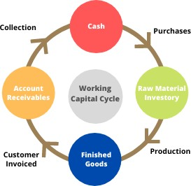

Working capital cycle= inventory days+ Receivable days –payable days

There are two components of working capital:
- Gross working capital- gross working capital refers to the capital invested in total current assets of the enterprise. in the broader sense, the term working capital refers to the gross working capital. The notion of the gross working capital refers to the capital invested in total current assets of the enterprise. Current assets are those assets, which in the ordinary course of business, can be converted into cash within a short period, normally one accountingyear.

Examples of current assets:
  - Cash in hand and bankbalance
  - Bills receivables or AccountsReceivables
  - Sundry Debtors (less provision for baddebts)
  - Short-term loans andadvances.
  - Inventories of stocks, suchas:
    - Rawmaterials
    - Work – inprocess
    - Stores andspares
    - Finishedgoods
  - Temporary Investments of surplusfunds.
  - PrepaidExpenses
  - Accrued Incomesetc.

- Net Working Capital- Networking capital represents the excess of current assets over current liabilities. in a narrow sense, the term working capital refers to the net working capital. Networking capital represents the excess of current assets over currentliabilities.
Current liabilities are those liabilities, which are intend to be paid in the ordinary course of business within a short period, normally one accounting year out of the current assets or the income of the business. Net working capital may be positive or negative. When the current assets exceed the current liabilities net working capital is positive and the negative net working capital results when the liabilities are more than the currentassets.

Examples of current liabilities:
  - Billspayable
  - Sundry Creditors or AccountsPayable.
  - Accrued or OutstandingExpanses.
  - Short term loans, advances anddeposits.
  - Dividendspayable
  - Bankoverdraft
  - Provision for taxationetc.,

Importance of Working Capital:
Working capital is refereed to be the lifeblood and nerve center of a business. Working capital is as essential to maintain the smooth functioning of a business as blood circulation in a human body. No business can run successfully without an adequate amount of working capital.

The main advantages of maintaining adequate amount of working capital are as follows:

- Solvency of the business: Adequate working capital helps in maintaining solvency of the business by providing uninterrupted flow ofproduction.
- Good will: Sufficient working capital enables a business concern to make prompt payment and hence helps in creating and maintaining goodwill.
- Easy loans: A concern having adequate working capital, high solvency and good credit standing can arrange loans from banks and others on easy and favorableterms.
- Cash Discounts: Adequate working capital also enables a concern to avail cash discounts on the purchases and hence it reducescosts.
- Regular supply of raw materials: Sufficient working capital ensures regular supply of raw materials and continuousproduction.
- Regular payments of salaries wages and other day to day commitments: A company which has ample working capital can make regular payment of salaries, wages and other day to day commitments which raises the morale of its employees, increases their efficiency, reduces wastage and cost and enhances production andprofits.
- Exploitation of favorable market conditions: The concerns with adequate working capital only can exploit favorable market conditions such as purchasing its requirements in bulk when the prices arelower.
- Ability to face crisis: Adequate working capital enables a concern to face business crisis inemergencies.
- Quick and regular return on Investments: Every investor wants a quick and regular return on his investment. Sufficiency of working capital enables a concern to pay quick and regular dividends to its investors, as there may not be much pressure to plough back profits. This gains the confidence of its investors and creates a favorable market to raise additional funds in thefuture.
- High morale: Adequacy of working capital creates an environment of security, confidence, and high morale and creates overall efficiency in a business. Every business concern should have adequate working capital to run its businessoperations.

The Need or Objectives of Working Capital:
The need for working capital arises mainly due to the time gap between production and realization of cash. The process of production and sale cannot be done instantaneously and hence the firm needs to hold the current assets to fill-up the time gaps. There are time gaps in purchase of raw materials and production; production and sales: and sales and realization of cash. The working capital is needed mainly for the following purposes:

- For the purchase of rawmaterials.
- To pay wages, salaries and other day-to-day expenses and overhead cost such as fuel, power and office expenses,etc.
- To meet the selling expenses such as packing, advertising,etc.
- To provide credit facilities to the customersand
- To maintain the inventories of raw materials, work-in-progress, stores and spares and finishes stocketc.

Factors determining the working capital requirements:
There are a large number of factors such as the nature and size of business, the character of their operations, the length of production cycle, the rate of stock turnover and the state of economic situation etc. that decode requirement of working capital. These factors have different importance and influence on firm differently. In general, following factors generally influence the working capital requirements.

- Nature or character of business: The working capital requirements of a firm basically depend upon the nature of its business. Public utility undertakings like electricity, water supply and railways need very limited working capital as their sales are on cash and are engaged in provision of services only. On the other hand, trading firms require more investment in inventories, receivables and cash and such they need large amount of working capital. The manufacturing undertakings also require sizable workingcapital.
- Size of business or scale of operations: The working capital requirements of a concern are directly influenced by the size of its business, which may be measured in terms of scale of operations. Greater the size of a business unit, generally, larger will bethe requirements of working capital. However, in some cases, even a smaller concern may need more working capital due to high overhead charges, inefficient use of available resources and other economic disadvantages of small size.
- Production policy: If the demand for a given product is subject to wide fluctuations due to seasonal variations, the requirements of working capital, in such cases, depend upon the production policy. The production could be kept either steady by accumulating inventories during stack periods with a view to meet high demand during the peak season or the production could be curtailed during the slack season and increased during the peak season. If the policy is to keep the production steady by accumulating inventories it will require higher workingcapital.
- Manufacturing process/Length of production cycle: In manufacturing business, the requirements of working capital will be in direct proportion to the length of manufacturing process. Longer the process period of manufacture, larger is the amount of working capital required, as the raw materials and other supplies have to be carried for a longerperiod.
- Seasonal variations: If the raw material availability is seasonal, they have to be bought in bulk during the season to ensure an uninterrupted material for the production. A huge amount is, thus, blocked in the form of material, inventories during such season, which give rise to more working capital requirements. Generally, during the busy season, a firm requires larger working capital then in the slackseason.
- Working capital cycle: In a manufacturing concern, the working capital cycle starts with the purchase of raw material and ends with the realization of cash from the sale of finished products. This cycle involves purchase of raw materials and stores, its conversion into stocks of finished goods through work–in progress with progressive increment of labour and service costs, conversion of finished stock into sales, debtors and receivables and ultimately realization of cash. This cycle continues again from cash to purchase of raw materials and so on. In general, the longer the operating cycle, the larger the requirement of workingcapital.
- Credit policy: The credit policy of a concern in its dealings with debtors and creditors influences considerably the requirements of working capital. A concern that purchases its requirements on credit requires lesser amount of working capital compared to the firm, which buys on cash. On the other hand, a concern allowing credit to its customers shall need larger amount of working capital compared to a firm selling only oncash.
- Business cycles: Business cycle refers to alternate expansion and contraction in general business activity. In a period of boom, i.e., when the business is prosperous, there is a need for larger amount of working capital due to increase in sales. On the contrary, in the times of depression, i.e., when there is a down swing of the cycle, the business contracts, sales decline, difficulties are faced in collection from debtors and firms may have to hold large amount of workingcapital.

- Rate of growth of business: The working capital requirements of a concern increase with the growth and expansion of its business activities. The retained profits may provide for a part of working capital but the fast-growing concerns need larger amount of working capital than the number of undistributedprofits.

Capital Budgeting Techniques:
The capital budgeting appraisal methods are techniques of evaluation of investment proposal will help the company to decide upon the desirability of an investment proposal depending upon their; relative income generating capacity and rank them in order of their desirability. These methods provide the company a set of norms on the basis of which either it has to accept or reject the investment proposal. The most widely accepted techniques used in estimating the cost-returns of investment projects can be grouped under two categories.
- Traditionalmethods
- Discounted Cash flowmethods
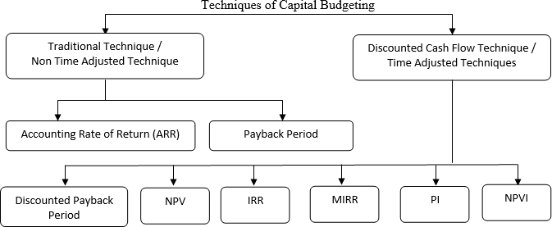

I. TRADITIONAL METHODS:
These methods are based on the principles to determine the desirability of an investment project on the basis of its useful life and expected returns. These methods depend upon the accounting information available from the books of accounts of the company. These will not take into account the concept of ‘time value of money’, which is a significant factor to determine the desirability of a project in terms of present value.

Payback period method:
It is the most popular and widely recognized traditional method of evaluating the investment proposals. It can be defined, as ‘the number of years required to recover the original cash out lay invested in a project’.

According to Weston & Brigham, “The payback period is the number of years it takes the firm to recover its original investment by net returns before depreciation, but after taxes”.
According to James. C. Vanhorne, “The payback period is the number of years required to recover initial cashinvestment.
The payback period is also called payout or payoff period. This period is calculated by dividing the cost of the project by the annual earnings after tax but before depreciation under this method the projects are ranked on the basis of the length of the payback period. A project with the shortest payback period will be given the highest rank and taken as the best investment. The shorter the payback period, the less risky the investment is the formula for payback period is

Cash outlay (or) original cost ofproject Pay-backperiod= -------------------------------------------
Annual cash inflow

Merits:
  - It is one of the earliest methods of evaluating the investmentprojects.
  - It is simple to understand and tocompute.
  - It does not involve any cost for computation of the paybackperiod
  - It is one of the widely used methods in small scale industrysector
  - It can be computed on the basis of accounting information available from thebooks.

Demerits:
  - This method fails to take into account the cash flows received by the company after the paybackperiod.
  - It doesn’t take into account the interest factor involved in an investmentoutlay.
  - It doesn’t take into account the interest factor involved in an investmentoutlay.
  - It is not consistent with the objective of maximizing the market value of the company’s share.
  - It fails to consider the pattern of cash inflows i. e., the magnitude and timing of cash inflows.
- Accounting (or) Average Rate of Return Method (ARR): It is an accounting method, which uses the accounting information repeated by the financial statements to measure the probability of an investment proposal. It can be determined by dividing the average income after taxes by the average investment i.e., the average book value afterdepreciation.
According to ‘Soloman’, accounting rate of return on an investment can be calculated as the ratio of accounting net income to the initial investment, i.e.,
Average net income after taxes
ARR= X100
Average Investment

Total Income after Taxes Average net income after taxes = -----------------------------
No. ofYears

Total Investment Averageinvestment= ----------------------
2
On the basis of this method, the company can select all those projects who’s ARR is higher than the minimum rate established by the company. It can reject the projects with an ARR lower than the expected rate of return. This method can also help the management to rank the proposal on the basis of ARR. A highest rank will be given to a project with highest ARR, where as a lowest rank to a project with lowest ARR.

Merits:
It is very simple to understand and calculate.
  - It can be readily computed with the help of the available accountingdata.
  - It uses the entire stream of earning to calculate theARR.

Demerits:
  - It is not based on cash flows generated by aproject.
  - This method does not consider the objective of wealthmaximization
  - IT ignores the length of the project’s usefullife.
  - It does not take into account the fact that the profits can bere-invested.

II: DISCOUNTED CASH FLOW METHODS:
The traditional method does not take into consideration the time value of money. They give equal weight age to the present and future flow of incomes. The DCF methods are based on the concept that a rupee earned today is more worth than a rupee earned tomorrow. These methods take into consideration the profitability and also time value of money.

Net present value method(NPV)
The NPV takes into consideration the time value of money. The cash flows of different years and valued differently and made comparable in terms of present values for this the net cash inflows of various period are discounted using required rate of return which is predetermined.
According to Ezra Solomon, “It is a present value of future returns, discounted at the required rate of return minus the present value of the cost of the investment.”
According the NPV technique, only one project will be selected whose NPV is positive or above zero. If a project(s) NPV is less than ‘Zero’. It gives negative NPV hence. It must be rejected. If there are more than one project with positive NPV’s the project is selected whose NPV is thehighest.

The formula for NPV is
NPV= Present value of cash inflows – investment.
C1 C2 C3 Cn
NPV= + + +
(1+K)
Co- investment
C1, C2, C3… Cn= cash inflows indifferentyears. K= Cost of the Capital (or) Discounting rate D=Years.

Merits:
  - It recognizes the time value of money.
  - It is based on the entire cash flows generated during the useful life of theasset.
  - It is consistent with the objective of maximization of wealth of theowners.
  - The ranking of projects is independent of the discount rate used for determining the presentvalue.

Demerits:
- It is different to understand anduse.
- The NPV is calculated by using the cost of capital as a discount rate. But the concept of cost of capital. If self is difficult to understood anddetermine.
- It does not give solutions when the comparable projects are involved in different amounts ofinvestment.
- It does not give correct answer to a question whether alternative projects or limited funds are available with unequal lines.

Internal Rate of Return Method(IRR)
The IRR for an investment proposal is that discount rate which equates the present value of cash inflows with the present value of cash out flows of an investment. The IRR is also known as cutoff or handle rate. It is usually the concern’s cost of capital.

According to Weston and Brigham “The internal rate is the interest rate that equates the present value of the expected future receipts to the cost of the investmentoutlay.

When compared the IRR with the required rate of return (RRR), if the IRR is more than RRR then the project is accepted else rejected. In case of more than one project with IRR more than RRR, the one, which gives the highest IRR, is selected.
The IRR is not a predetermine rate, rather it is to be trial and error method. It implies that one has to start with a discounting rate to calculate the present value of cash inflows. If the obtained present value is higher than the initial cost of the project one has to try with a higher rate. Likewise if the present value of expected cash inflows obtained is lower than the present value of cash flow. Lower rate is to be taken up. The process is continued till the net present value becomes Zero. As this discount rate is determined internally, this method is called internal rate of returnmethod.

P1 - Q
IRR=L+ XD
P1 –P2
Where:
L- Lower discount rate
P1 - Present value of cash inflows at lower rate. P2 - Present value of cash inflows at higher rate. Q- Actual investment
D- Difference in Discount rates.
Merits:
- It considers the time value ofmoney
- It takes into account the cash flows over the entire useful life of theasset.
- It has a psychological appear to the user because when the highest rate of return projects is selected, it satisfies the investors in terms of the rate of return ancapital
- It always suggests accepting to projects with maximum rate ofreturn.
- It is inconformity with the firm’s objective of maximum owner’swelfare.

Demerits:
- It is very difficult to understand anduse.
- It involves a very complicated computationalwork.
- It may not give unique answer in allsituations.

Probability Index Method (PI)
The method is also called benefit cost ration. This method is obtained cloth a slight modification of the NPV method. In case of NPV the present value of cash out flows are profitability index (PI), the present value of cash inflows is divided by the present value of cash out flows, while NPV is a absolute measure, the PI is a relative measure.
It the PI is more than one (>1), the proposal is accepted else rejected. If there are more than one investment proposal with the more than one PI the one with the highest PI will be selected. This method is more useful in case of projects with different cash outlays cash outlays and hence is superior to the NPV method.

