FINITE ELEMENT METHODS
19A03704a

IV-B.Tech & I-SEM

Department of Civil Engineering
VEMU INSTITUTE OF TECHNOLOGY::P.KOTHAKOTA
Chittoor – Tirupathi National Highway, Near Pakala, Chittoor(Dt.), AP – 517112
(Accredited by NAAC & NBA (CSE, ECE, EEE))
(Approved by AICTE, New Delhi & Permanently Affiliated to JNTUA, Anantapuramu)

B. Tech IV-I Sem. (C.E) L T P C
3 10 3
19A03704a FINITE ELEMENT METHODS

(19A03704a) FINITE ELEMENT METHODS OPEN ELECTIVE-III Course

Objectives:
- Familiarize basic principles of finite element analysis procedure.
- Explain theory and characteristics of finite elements that represent engineering structures.
- Apply finite element solutions to structural, thermal, dynamic problem.
- Learn to model complex geometry problems and solution techniques.

UNIT – I
Introduction to finite element methods for solving field problems, Stress and equilibrium, Boundary conditions, Strain-Displacement relations, Stress- strain relations for 2D and 3D Elastic problems. Potential energy and equilibrium, The Rayleigh-Ritz method, Formulation of Finite Element Equations. One dimensional problems: Finite element modeling coordinates and shape functions. Assembly of global stiffness matrix and load vector. Finite element equations, Treatment of boundary conditions, Quadratic shape functions.

Learning Outcomes:
At the end of the unit, the student will be able to
- Understand the concept of nodes and elements.(l2)
- Understand the general steps of finite element methods.(l2)
- Understand the role and significance of shape functions in finite element formulations (l2)
- Formulate and solve axially loaded bar problems. (l6)

UNIT - II
Analysis of trusses: Stiffness Matrix for plane truss element. Stress Calculations and Problems.
Analysis of beams: Element Stiffness Matrix for two noded, two degrees of freedom per node beam element and simple problems.

Learning Outcomes:
At the end of the unit, the student will be able to
- Explain the use of the basic finite elements for structural applications using truss and beam. (l2)
- Formulate and analyze truss and beam problems. (l6)

UNIT - III
Finite element modeling of two dimensional stress analysis - constant strain trianglesquadrilateral element-treatment of boundary conditions. Estimation of load Vector, Stresses.Finite element modeling of Axi-symmetric solids subjected to axi-symmetric loading with triangular elements.Two dimensional four nodedIsoparametric elements and problems.

Learning Outcomes:
- At the end of the unit, the student will be able to •
- Explain the formulation of two – dimensional elements (Triangular and Quadrilateral Elements). (L2)
- Apply the formulation techniques to solve two – dimensional problems using triangle and quadrilateral elements. (L3)
- Formulate and solve axisymmetric problems. (L6)

UNIT - IV
Steady state heat transfer analysis: One dimensional analysis of slab and fin, two dimensional analysis of thin plate. Analysis of a uniform shaft subjected to torsion loading.
Learning Outcomes:
- At the end of the unit, the student will be able to
- Explain the application and use of the Finite Element Methods for heat transfer problems. (L2)
- Formulate and solve heat transfer problems. (L6)

UNIT V
Dynamic analysis:
Formulation of finite element model,element –mass matrices,evaluation of Eigen values and Eigen vectors for a stepped bar truss. 3D Problems: Finite Element formulation- Tetrahedron element-Stiffness matrix.
Learning Outcomes:
At the end of the unit, the student will be able to
- Understand problems involving dynamics using Finite Element Methods.
- Evaluate the Eigen values and Eigen Vectors for steeped bar.
- Develop the stiffness matrix for tetrahedron element.

Course Outcomes:

Upon successful completion of this course you should be able to
- Understand the concepts behind variational methods and weighted residual methods in FEM.
- Identify the application and characteristics of FEA elements such as bars, beams, and isoparametric elements, and 3-D element.
- Develop element characteristic equation procedure and generation of global stiffness equation will be applied.
- Able to apply Suitable boundary conditions to a global structural equation, and reduce it to a solvable form.
- • Able to identify how the finite element method expands beyond the structural domain, for problems involving dynamics, heat transfer and fluid flow.

TEXT BOOKS:
T1 | Chandraputla, Ashok &Belegundu, “Introduction to Finite Element in Engineering”, Prentice Hall.
T2 | S.S.Rao, “The Finite Element Methods in Engineering”,2nd Edition,Elsevier Butterworth - Heinemann 2011.
REFERENCE BOOKS:
R1 | J N Reddy, “An introduction to the Finite Element Method”, McGraw – Hill, New York, 1993.
R2 | R D Cook, D S Malkus and M E Plesha, “Concepts and Applications of Finite Element Analysis”, 3rd Edition, John Wiley, New York, 1989
R3 | K J Bathe, “Finite Element Procedures in Engineering Analysis”, Prentice-Hall, Englewood Cliffs,1982.
R4 | T J R Hughes, “the Finite Element Method, Prentice”, Hall, Englewood Cliffs, NJ, 1986.
R5 | C Zienkiewicz and R L Taylor, “the Finite Element Method”, 3rd Edition. McGrawHill, 1989.
WEB REFERENCES
W1 | https://nptel.ac.in/courses/105/105/105105041/
W2 | https://nptel.ac.in/courses/105/106/105106051/

INTRODUCTION

BasicConcepts
The finite element method (FEM), or finite element analysis(FEA), is based on the idea of building a complicated object withsimple blocks, or, dividing a complicated object into small andmanageable pieces.Application of this simple idea can be foundeverywherein everyday life, as wellas inengineering.

Examples:
  - Lego (kids’ play)
  - Buildings
  - Approximation of the area of a circle:

“Element”Si θi
R

Why Finite Element Method?
  - Design analysis: hand calculations, experiments, andcomputer simulations

  - FEM/FEA is the most widely applied computer simulation method in engineering
  - Closely integrated with CAD/CAM applications
A Brief History of the FEM

 | 1943 | ----- | Courant (Variational methods)
 | 1956 | ----- | Turner,Clough,MartinandTopp(Stiffness)
 | 1960 | ----- | Clough(“FiniteElement”,planeproblems)
  - 1970s Applicationsonmainframecomputers
  - 1980s Microcomputers,pre-andpostprocessors
• 1990s Analysisoflargestructuralsystems

What is FEM ?
- Many physical phenomena in engineering and science can be described in terms of partial differential equations.
- In general, solving these equations by classical analytical methods for arbitrary shapes is almost impossible.
- The finite element method (FEM) is a numerical approach by which these partial differential equations can be solved approximately.
- From an engineering standpoint, the FEM is a method for solving engineering problems such as stress analysis, heat transfer, fluid flow and electromagnetics by computer simulation.
- Millions of engineers and scientists worldwide use the FEM to predict the behaviour of structural, mechanical, thermal, electrical and chemical systems for both design and performance analyses.
BASIC STEPS OF FEM
- Discretization of the structure
- Identify primary unknown quantity 3 Selection of Displacement function
4 Formation of the element stiffness matrix and load vector 5 Formation of Global stiffness matrix and load vector
6 Incorporation of Boundary conditions 7 Solution of Simultaneous equations
8 Calculation of element strains and stresses 9 Interpretation of the result obtained.

Step1: Discretization of or structure – (Establish the FE mesh)
- The continuum is divided into a number of elements by imaginary lines or surfaces.
- The interconnected elements may have different sizes and shapes.
- Establish the FE mesh with set coordinates, element numbers and node numbers
- The discretized FE model must be situated with a coordinate system
- Elements and nodes in the discretized FE model need to be identified by “element numbers” and “nodal numbers.”
- Nodes are identified by the assigned node numbers and their corresponding coordinates
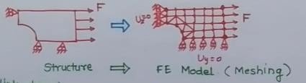

Step2: Identify primary unknown quantity

- Primary unknown quantity - The first and principal unknown quantity to be obtained by the FEM
Eg: Stress analysis: Displacement {u} at nodes
- In stress analysis, The primary unknowns are nodal displacements, but secondary unknown quantities include: strains in elements can be obtained by the “strain-displacement relations,” and the unknown stresses in the elements by the stress-strain relations (the Hooke’s law).

Step 3: Choice of approximating functions
- Displacement function is the starting point of the mathematical analysis.
- This represents the variation of the displacement within the element.
- The displacement function may be approximated in the form a linear function or a higher-order function.
- A convenient way to express it is by polynomial expressions.
- Shape or geometry of the element may also be approximated.
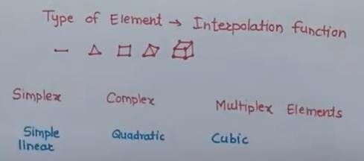

Step 4: Formation of the element stiffness matrix & load vector
- After continuum is discretized with desired element shapes, the individual element stiffness matrix is formulated.
- Basically it is a minimization procedure whatever may be the approach adopted.
- For certain elements, the form involves a great deal of sophistication.
- The geometry of the element is defined in reference to the global frame.
- Coordinate transformation must be done for elements where it is necessary.
{F}e= {K}e * {q}e

Step 5: Formation of overall stiffness matrix & load vector
- After the element stiffness matrices in global coordinates are formed, they are assembled to form the overall stiffness matrix.
- The assembly is done through the nodes which are common to adjacent elements.
- The overall stiffness matrix is symmetric and banded.
{F}G= {K} G * {q} G

Step6 : Incorporation of boundary conditions
- The boundary restraint conditions are to be imposed in the stiffness matrix.
- There are various techniques available to satisfy the boundary conditions.
• One is the size of the stiffness matrix may be reduced or condensed in its final

form.
- To ease computer programming aspect and to elegantly incorporate the boundary conditions, the size of overall matrix is kept the same.

Step7: Solution of simultaneous equations
- The unknown nodal displacements are calculated by the multiplication of force vector with the inverse of stiffness matrix.
- [δ]=inverse of [k].[F]

Step8: Calculation of stresses or stress-resultants
- Nodal displacements are utilized for the calculation of stresses or stress- resultants.
- This may be done for all elements of the continuum or it may be limited to some predetermined elements.

Step9: Display and Interpretation of Results
- Results may also be obtained by graphical means.
- It may desirable to plot the contours of the deformed shape of the continuum.
- Tabulation of results
- Graphic displays: (1) Static with contours. (2) Animations
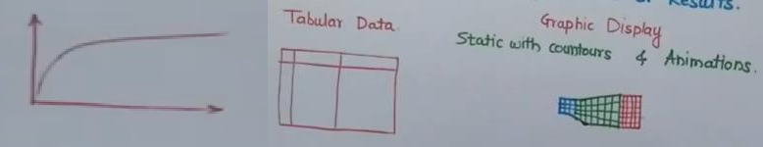

Advantages of Finite Element Method
- Modeling of complex geometries and irregular shapes are easier as varieties of finite elements are available for discretization of domain.
- Boundary conditions can be easily incorporated in FEM.
- Different types of material properties can be easily accommodated in modeling from element to element or even within an element.
- Higher order elements may be implemented.
- FEM is simple, compact and result-oriented and hence widely popular among engineering community.
- Availability of large number of computer software packages and literature makes FEM a versatile and powerful numerical method.

Disadvantages of Finite Element Method
- Large amount of data is required as input for the mesh used in terms of nodal connectivity and other parameters depending on the problem.
- It requires a digital computer and fairly extensive
- It requires longer execution time compared with FEM.
- Output result will vary considerably.

Limitations of FEA

- Proper engineering judgment is to be exercised to interpret results.
- It requires large computer memory and computational time to obtain intend results.
- There are certain categories of problems where other methods are more effective, e.g., fluid problems having boundaries at infinity are better treated by the boundary element method.
- For some problems, there may be a considerable amount of input data. Errors may creep up in their preparation and the results thus obtained may also appear to be acceptable which indicates deceptive state of affairs. It is always desirable to make a visual check of the input data.
- In the FEM, many problems lead to round-off errors. Computer works with a limited number of digits and solving the problem with restricted number of digits may not yield the desired degree of accuracy or it may give total erroneous results in some cases. For many problems the increase in the number of digits for the purpose of calculation improves the accuracy.

Applications of FEM
- Mechanical engineering: In mechanical engineering, FEM applications include steady and transient thermal analysis in solids and fluids, stress analysis in solids, automotive design and analysis and manufacturing process simulation.
- Geotechnical engineering: FEM applications include stress analysis, slope stability analysis, soil structure interactions, seepage of fluids in soils and rocks, analysis of dams, tunnels, bore holes, propagation of stress waves and dynamic soil structure interaction.
- Aerospace engineering: FEM is used for several purposes such as structural analysis for natural frequencies, modes shapes, response analysis and aerodynamics.
- Nuclear engineering: FEM applications include steady and dynamic analysis of reactor containment structures, thermo-viscoelastic analysis of reactor components, steady and transient temperature-distribution analysis of reactors and related structures.
- Electrical and electronics engineering: FEM applications include electrical network analysis, electromagnetics, insulation design analysis in high-voltage equipments, dynamic analysis of motors and heat analysis in electrical and electronic equipments.
- Metallurgical, chemical engineering: In metallurgical engineering, FEM is used for the metallurgical process simulation, moulding and casting. In chemical engineering, FEM can be used in the simulation of chemical processes, transport processes and chemical reaction simulations.
- Meteorology and bio-engineering: In the recent times, FEM is used in climate predictions, monsoon prediction and wind predictions. FEM is also used in bio-engineering for the simulation of various human organs, blood circulation prediction and even total synthesis of human body.
8 Civil Engineering Structure: Finite element analysis (FEA) is an extremely useful tool in the field of civil engineering for numerically approximating physical structures that are too complex for regular analytical solutions. Consider a concrete beam with support at both ends, facing a concentrated load on its center span. The deflection at the center span can be determined mathematically in a relatively simple way, as the initial and boundary conditions are finite and in control. However, once you transport the same beam into a practical application, such as within a bridge, the forces at play become much more difficult to analyze with simple mathematics.

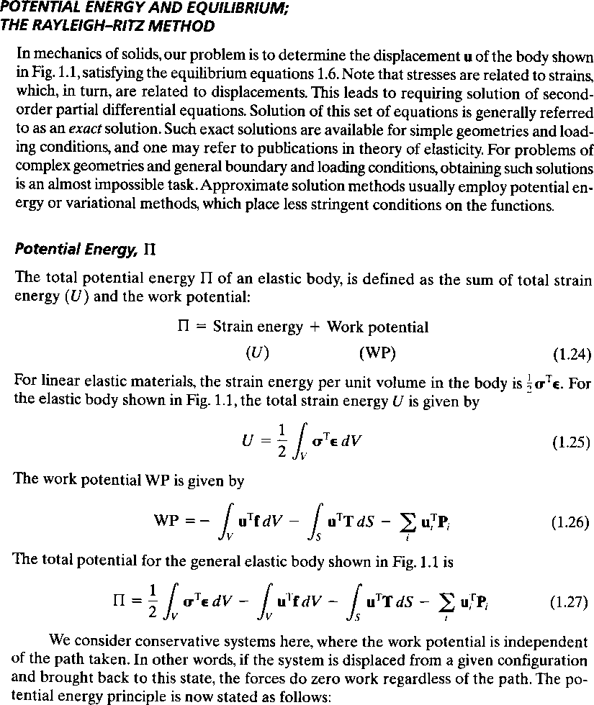
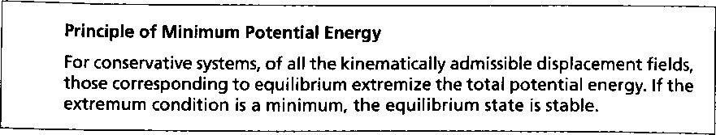
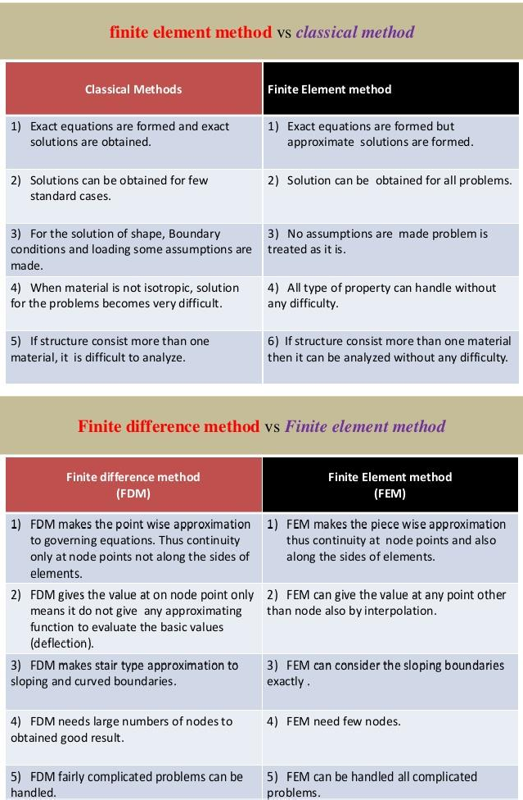

VEMU Institute of Technology
Department of CE
Page 8

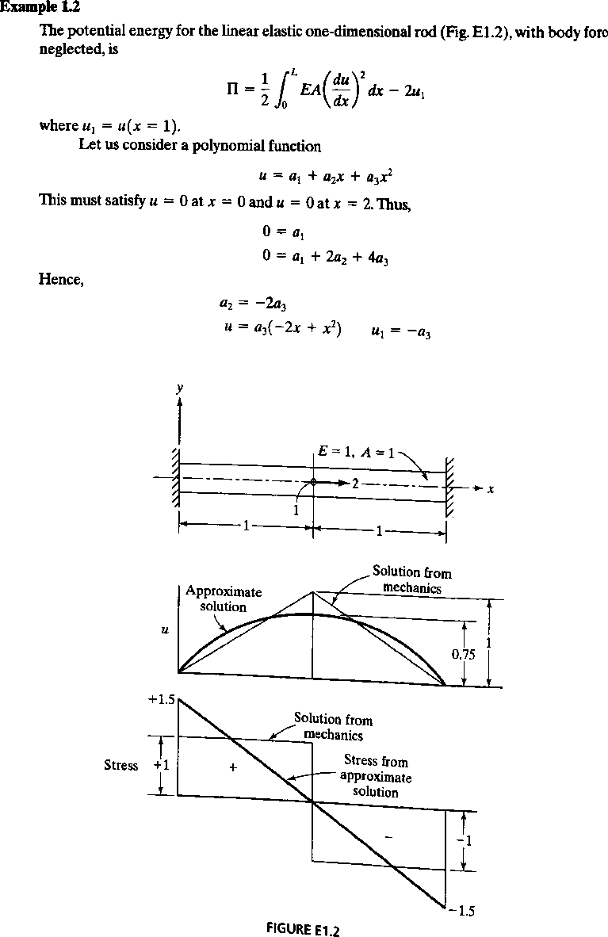

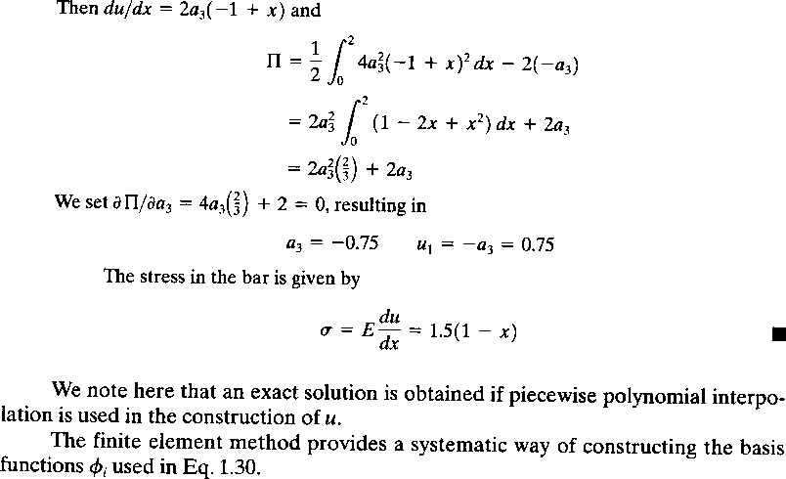
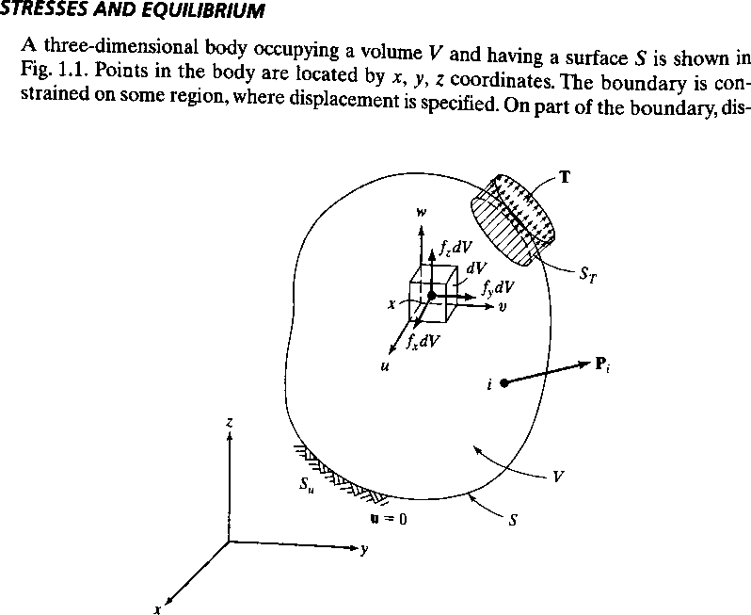

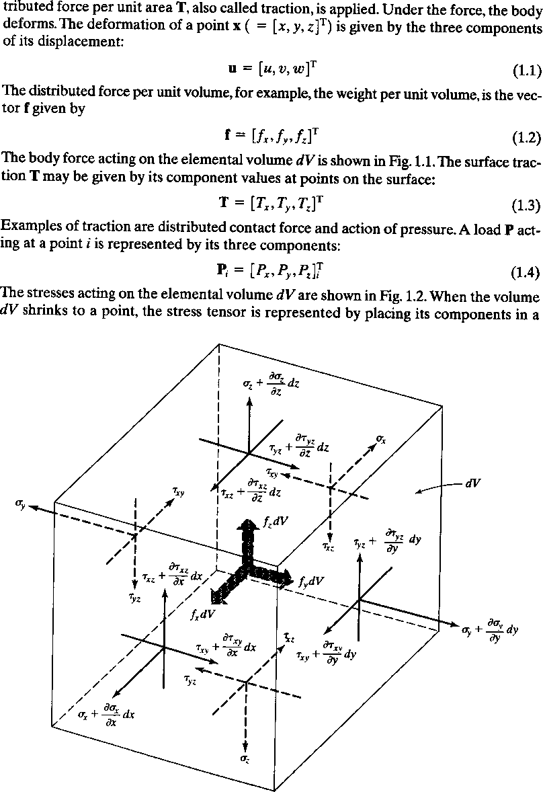

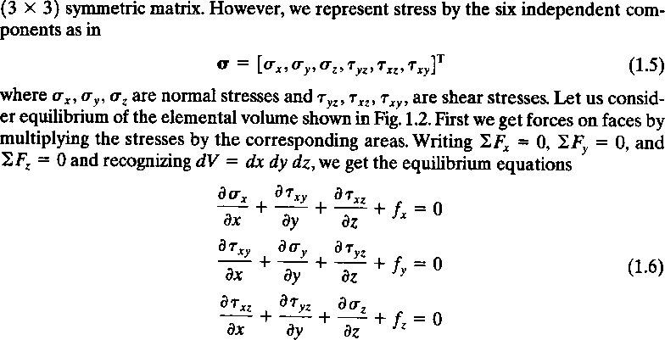

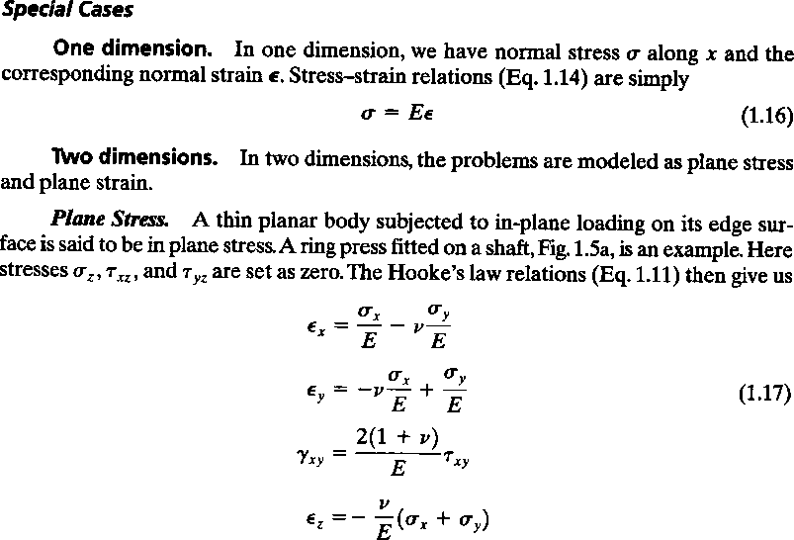

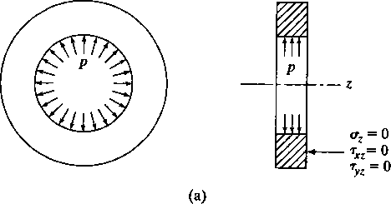

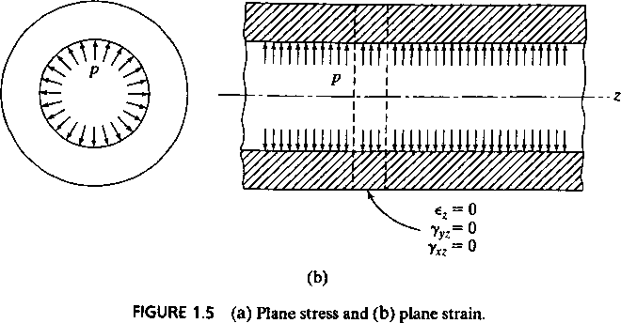

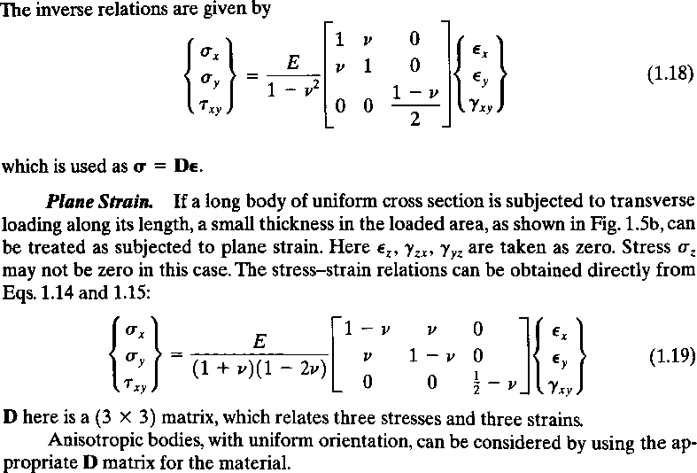

Strain Displacement Relationship for Axisymmentric element:
Consider an axisymmetric ring element and its cross section to represent the general state of strain for an axisymmetric problem. The displacements can be expressed for element ABCD in the plane of a cross-section in cylindrical coordinates. We then let u and w denote the displacements in the radial and longitudinal directions, respectively. The side AB of the element is displaced an amount u, and side CD is then displaced an amount u + in the radial direction.

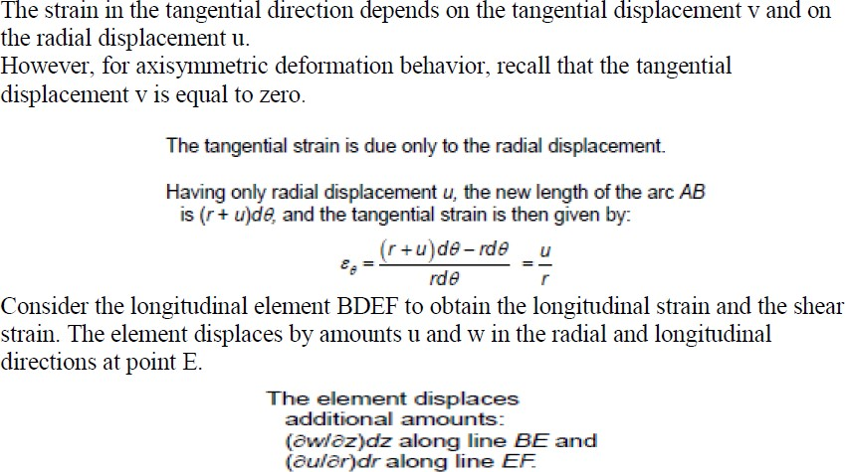
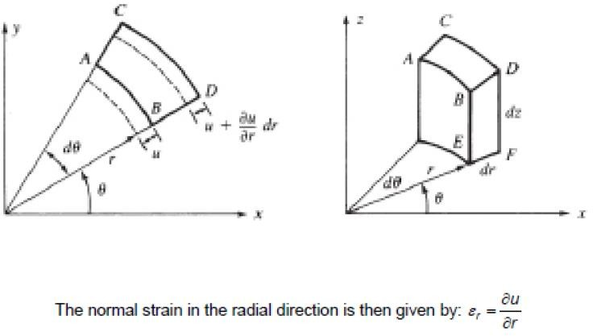
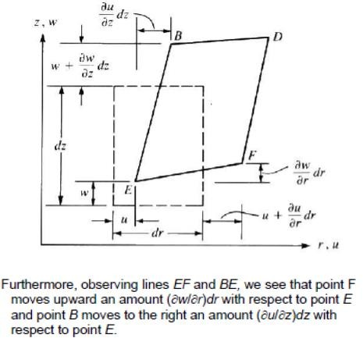

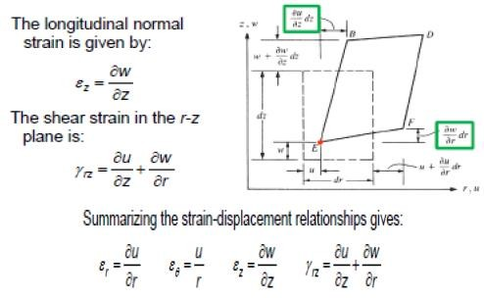

UNIT –II
ONE DIMENSIONAL & TWO DIMENSIONAL ELEMENTS
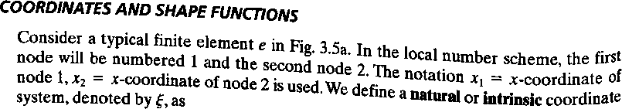
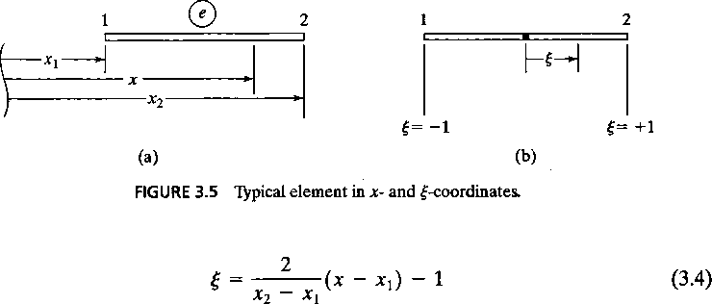
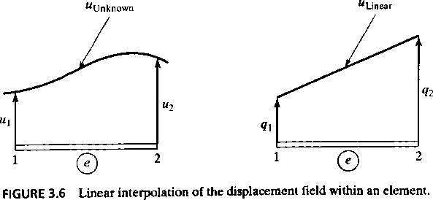
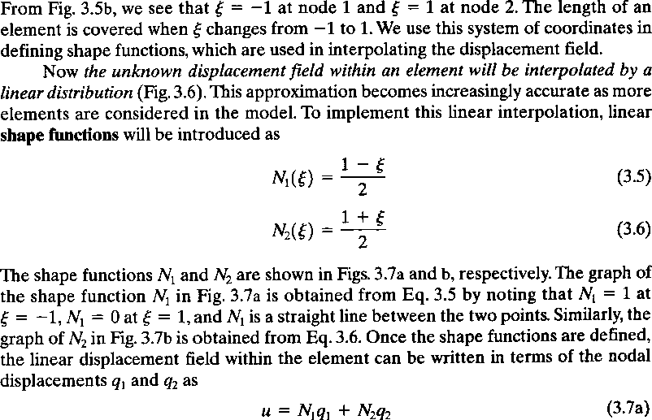

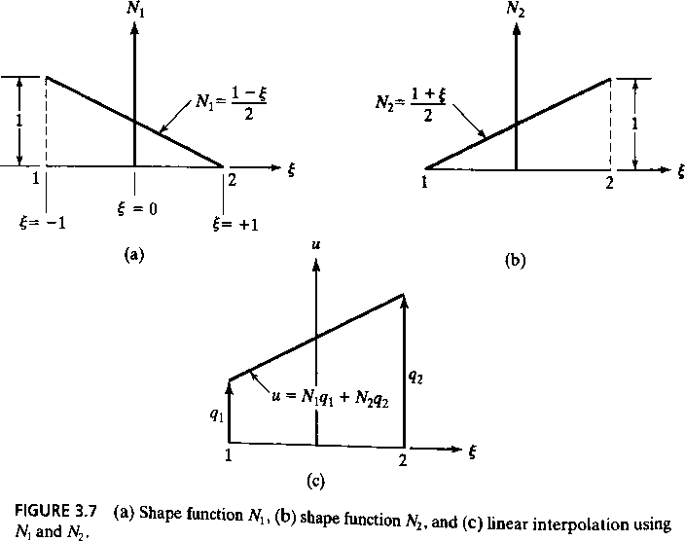
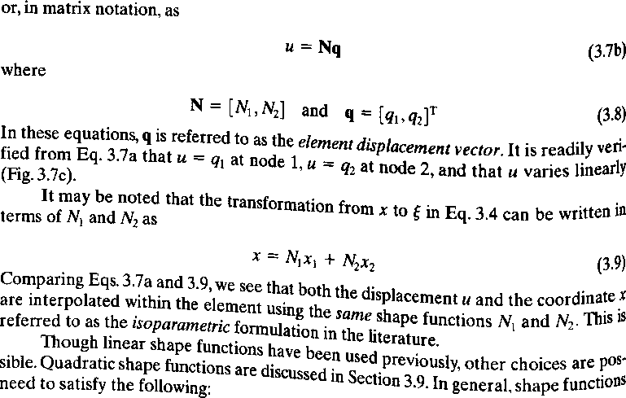

Degrees of Freedom in FEA:
- Degree of Freedom (DoF) is a “possibility” to move in a defined direction. There are 6 DoF in a 3D space: you can move or rotate along axis x, y or z. Together, those components describe a motion in 3D. DoF in FEA also do other things: they control supports, information about stresses and more.
- Degree of freedom or DOF means the number of independent coordinates a structure can move. There are 6 DOF possible for a structure. They are movement on x,y and z axis and rotation about these axis.
- Whatever be the field, degree of freedom, dof in short, represents the minimum number of independent coordinates required to specify the position of every mass in the system uniquely.
- eg. A simple spring mass system as shown in Fig. which is constrained to move only in the vertical direction requires the displacement x only to specify the position of the mass m. Hence it has one degree of freedom.
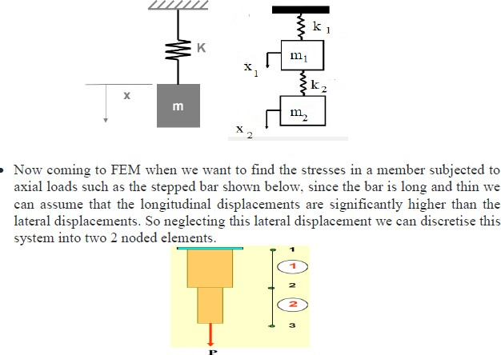
- If we attach another spring and another mass below the first mass then each mass will undergo different displacement and hence we need to specify x1 and x2 which are the displacements of masses 1 and 2 respectively. Hence this has 2 dof.

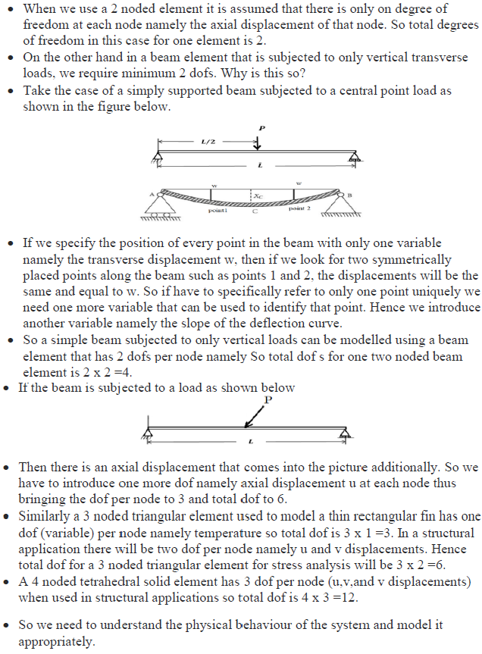

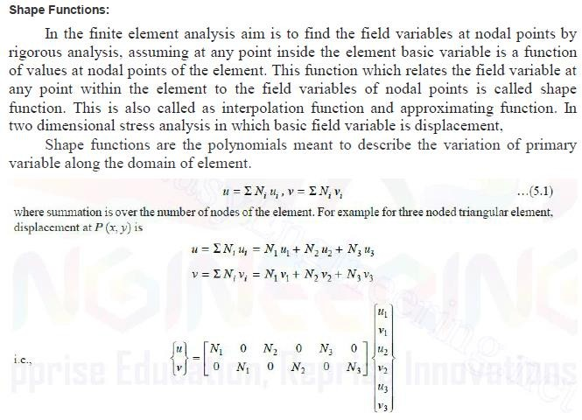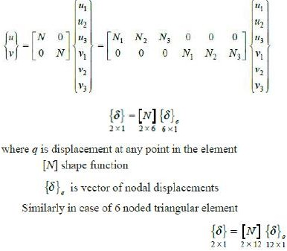

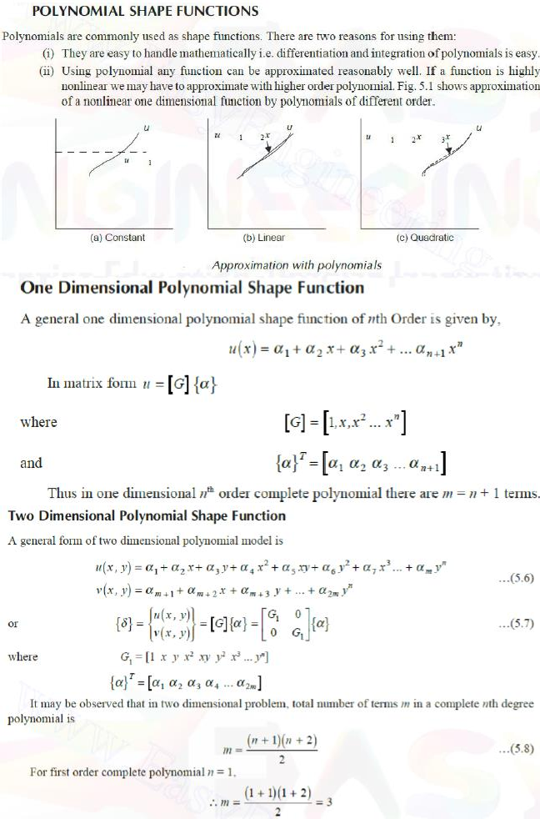

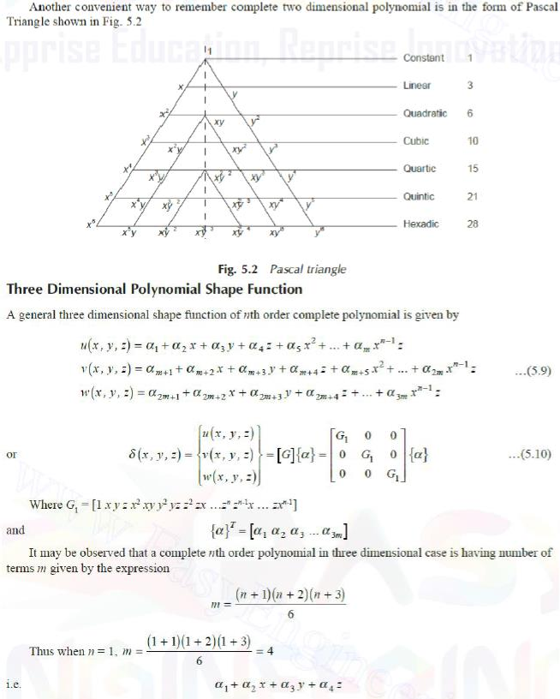

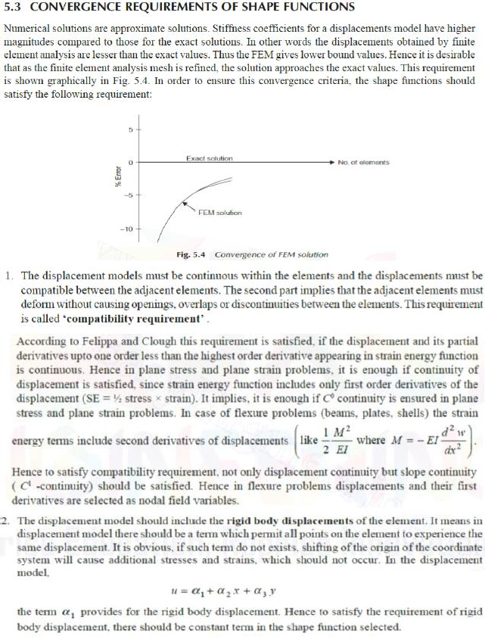

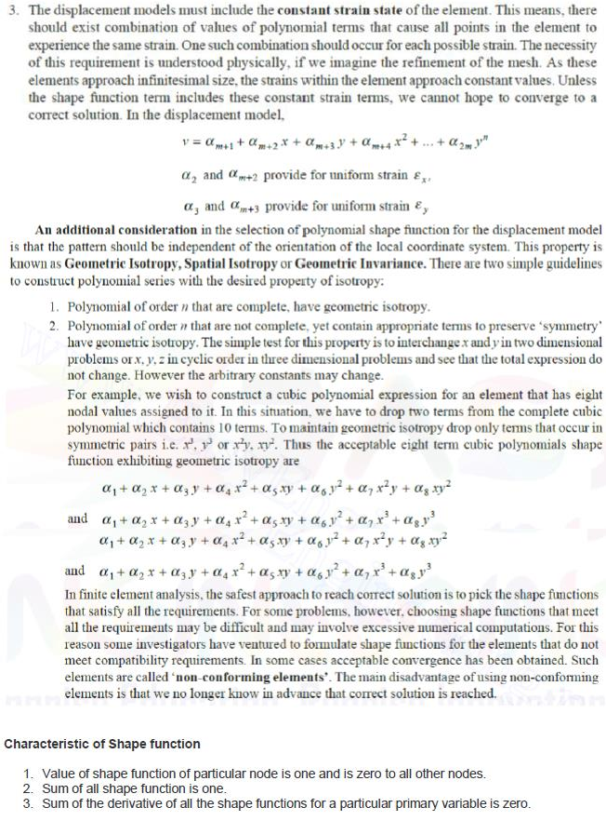

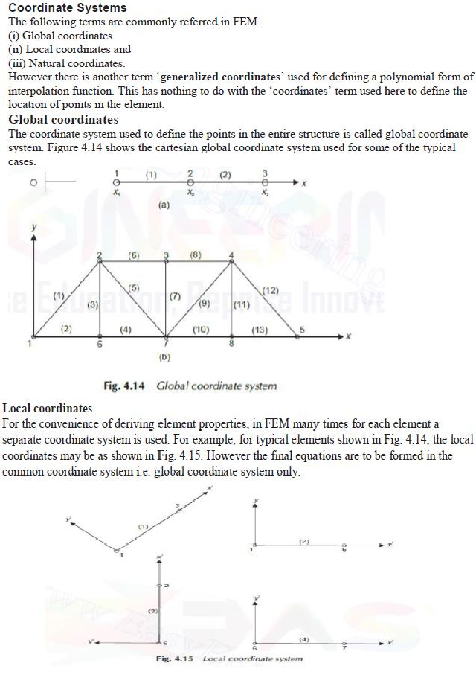

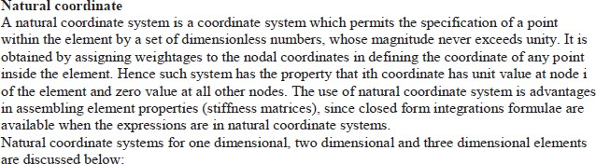

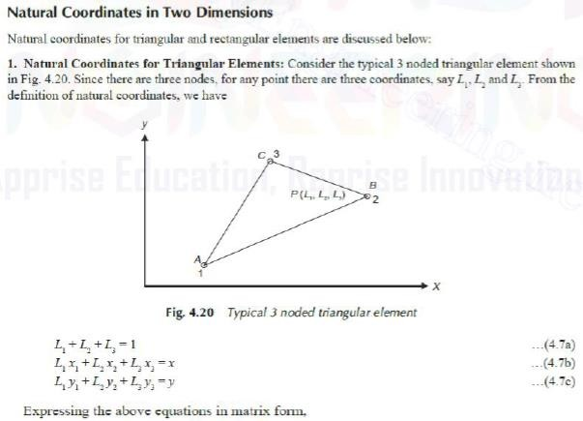
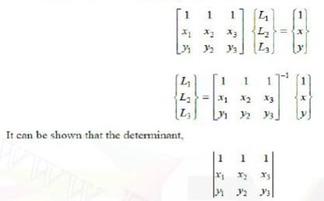

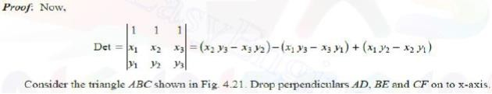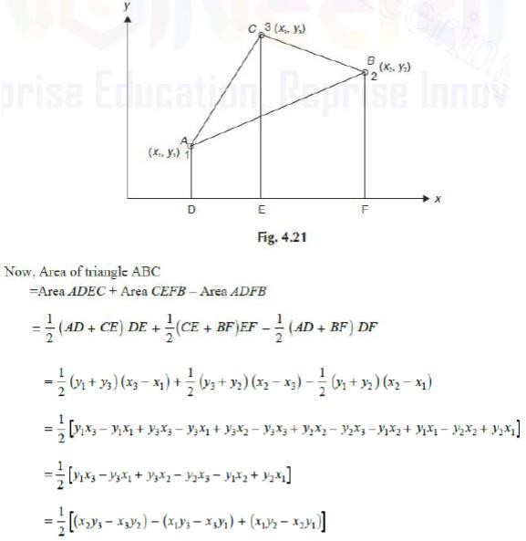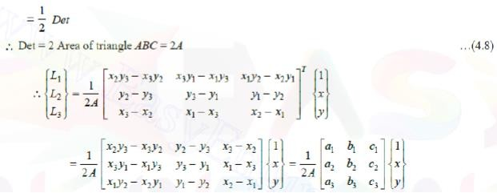

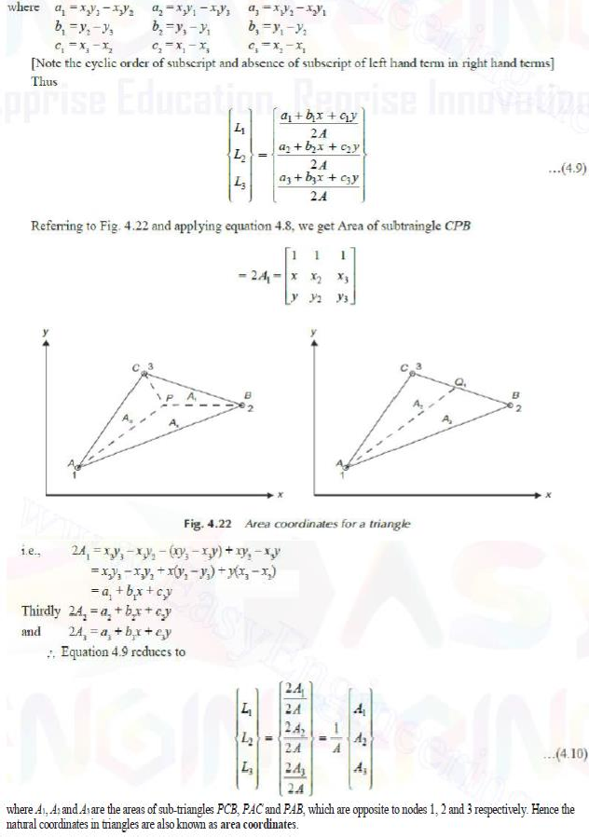

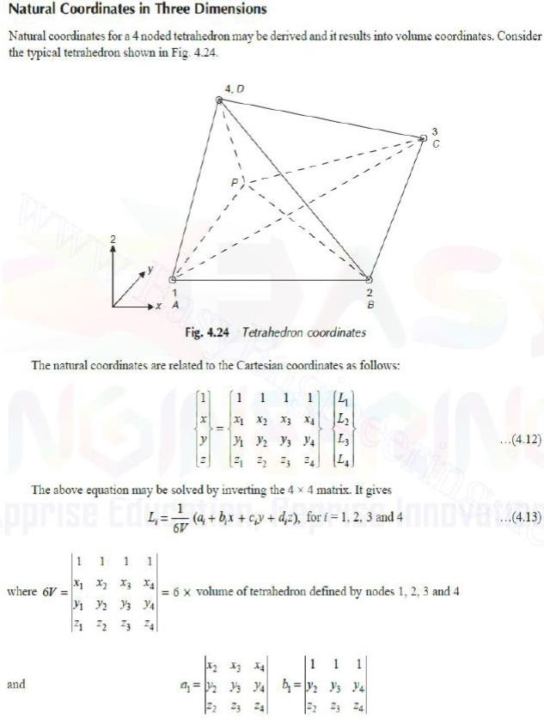

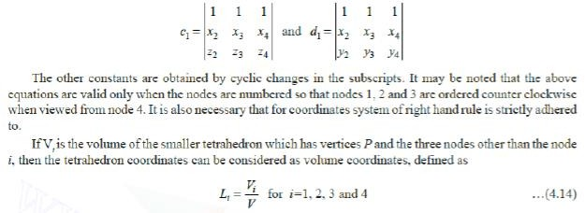

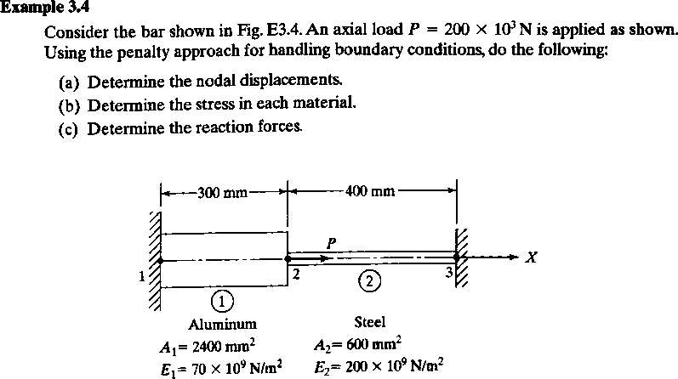

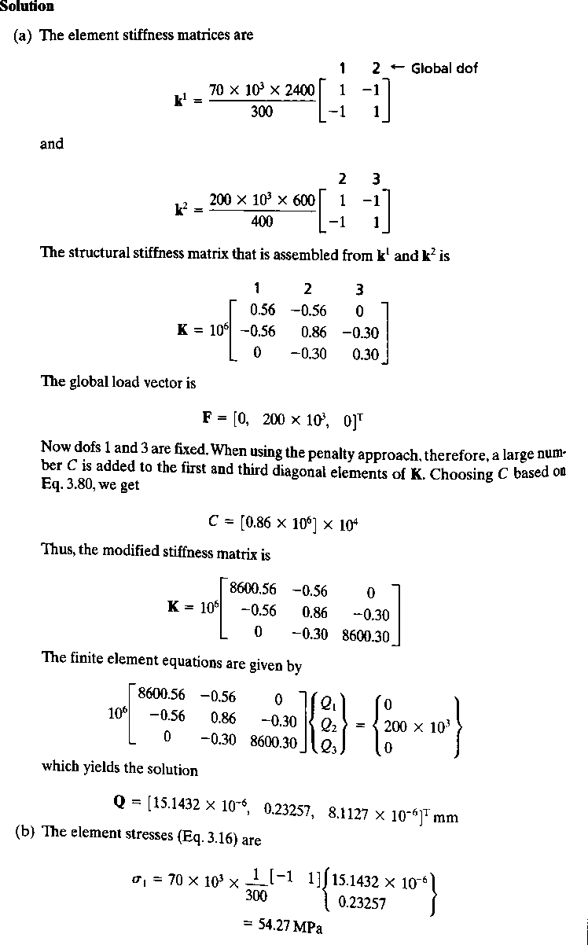

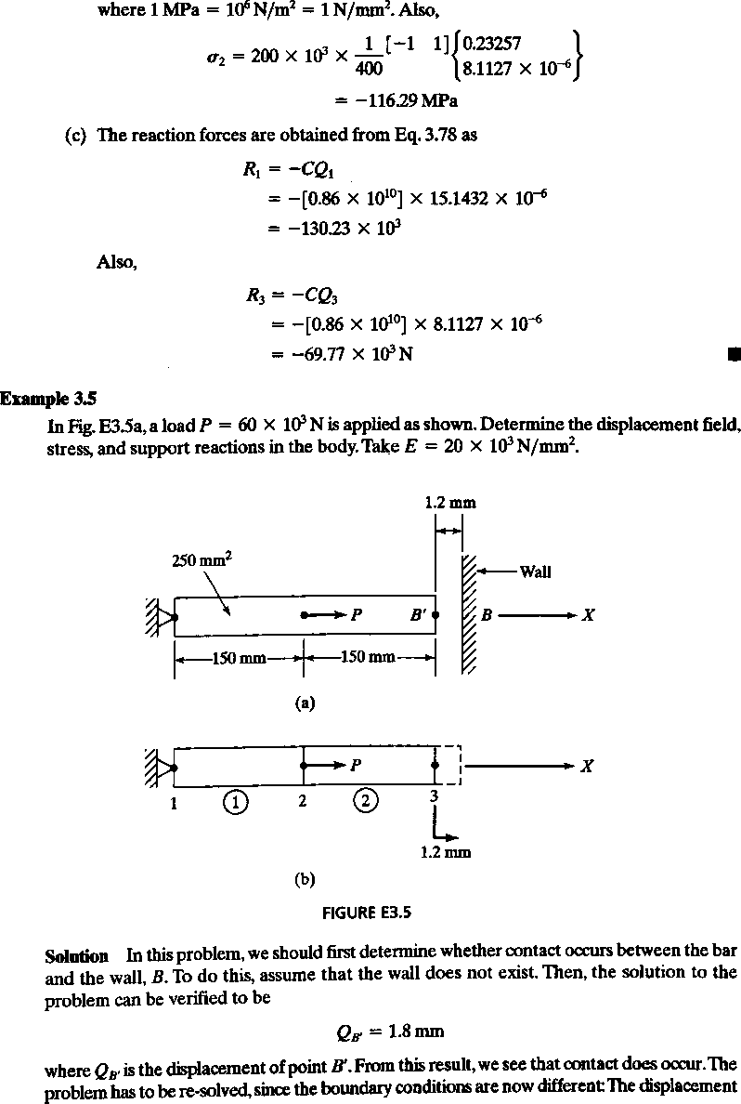

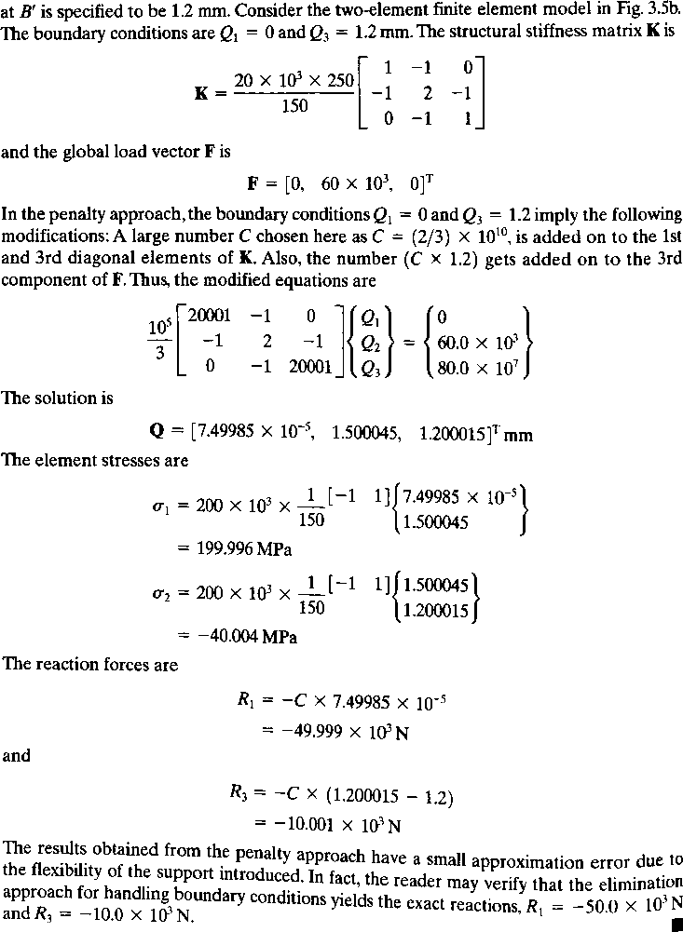

Truss
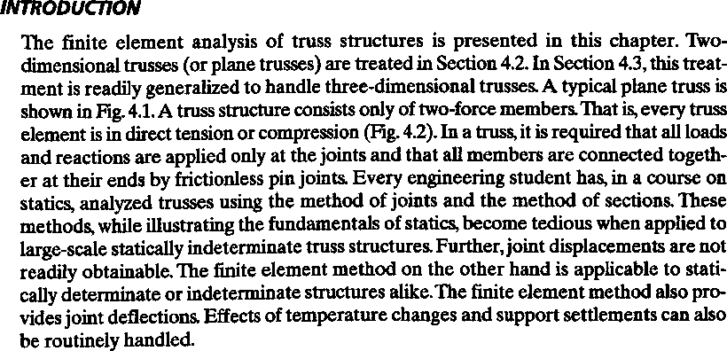
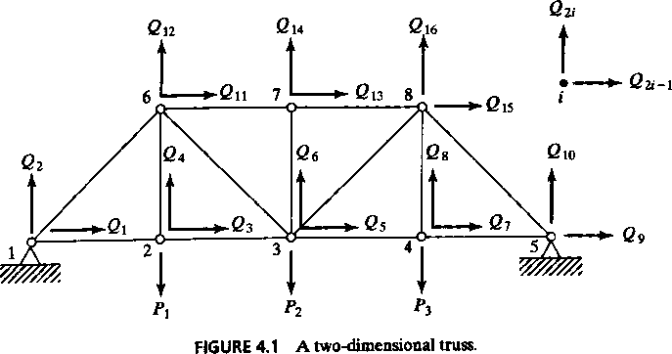

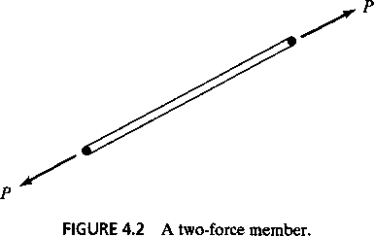

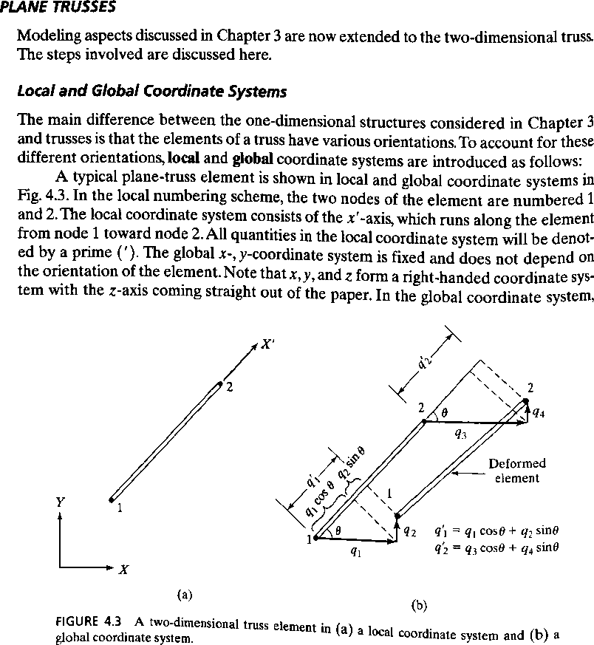

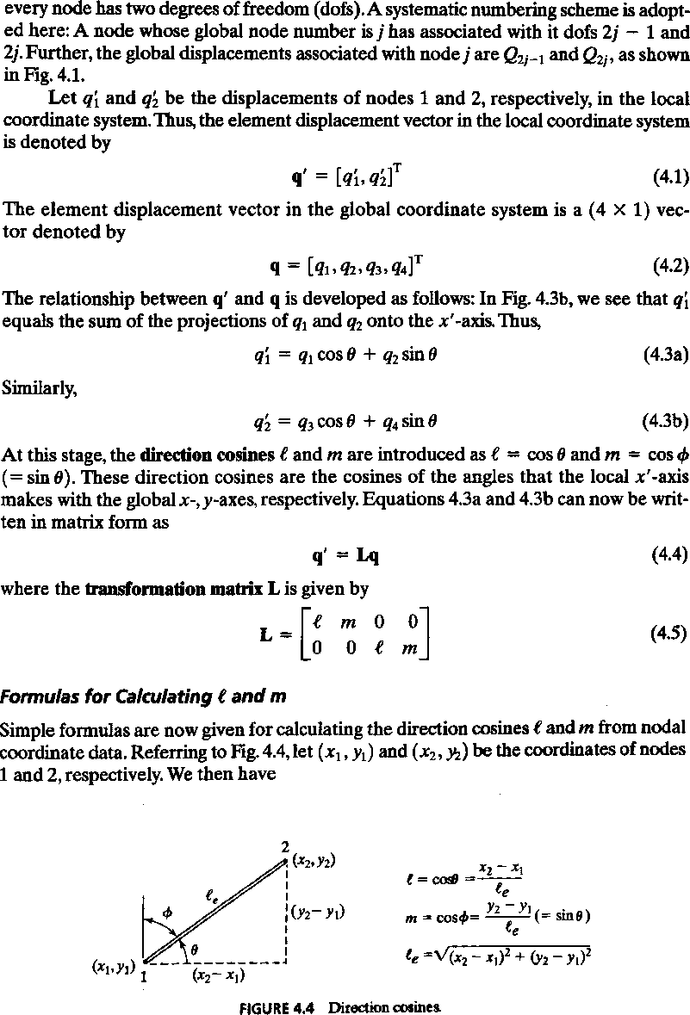

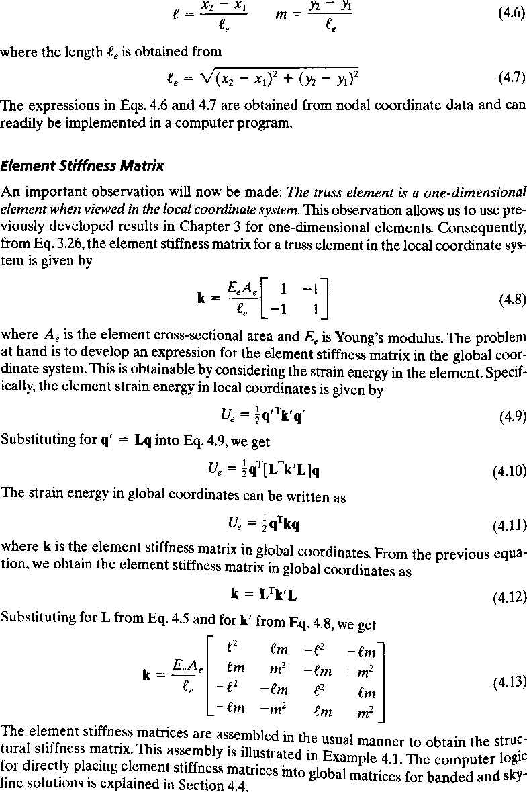

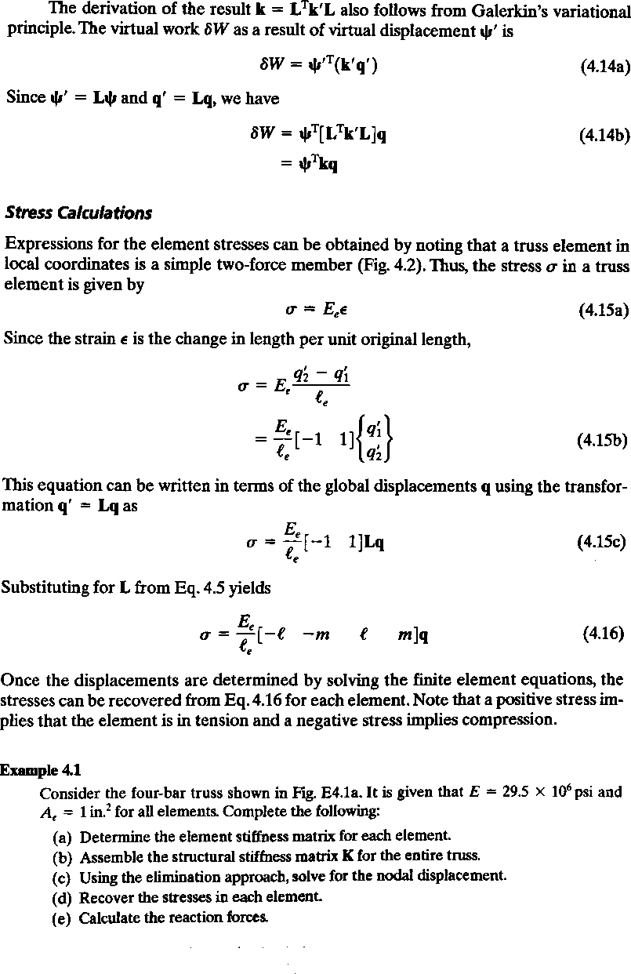

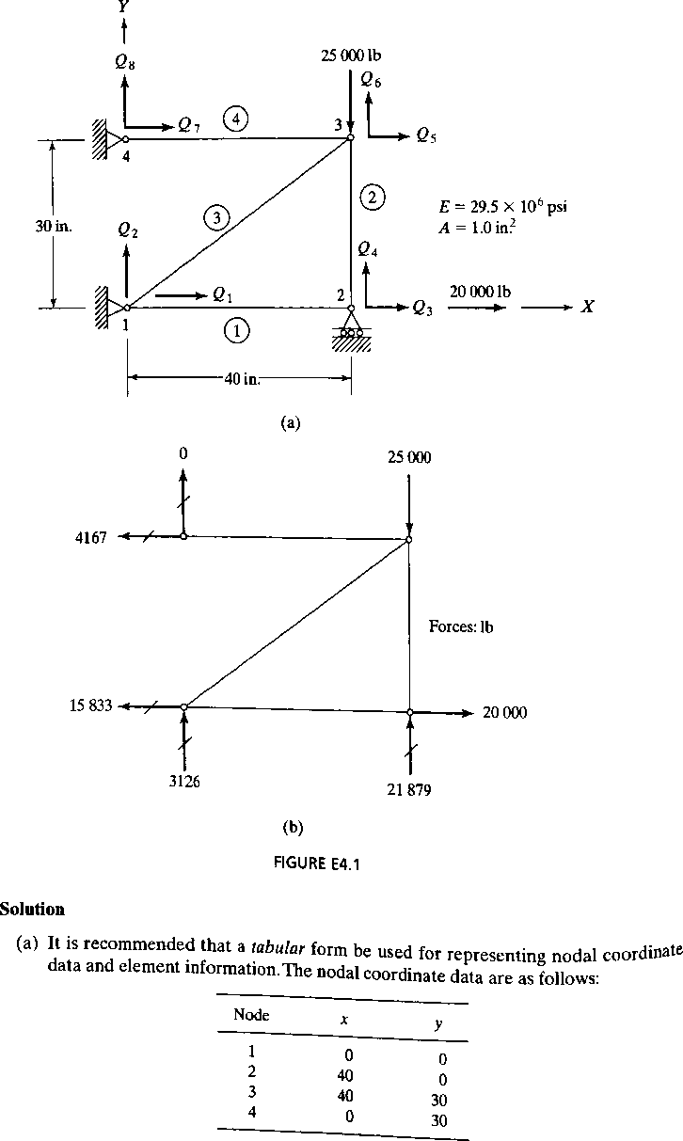

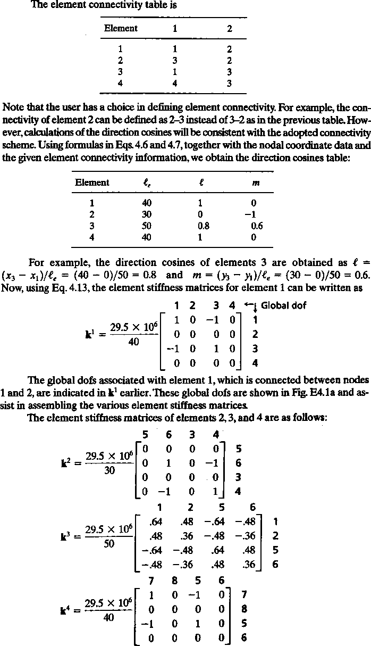

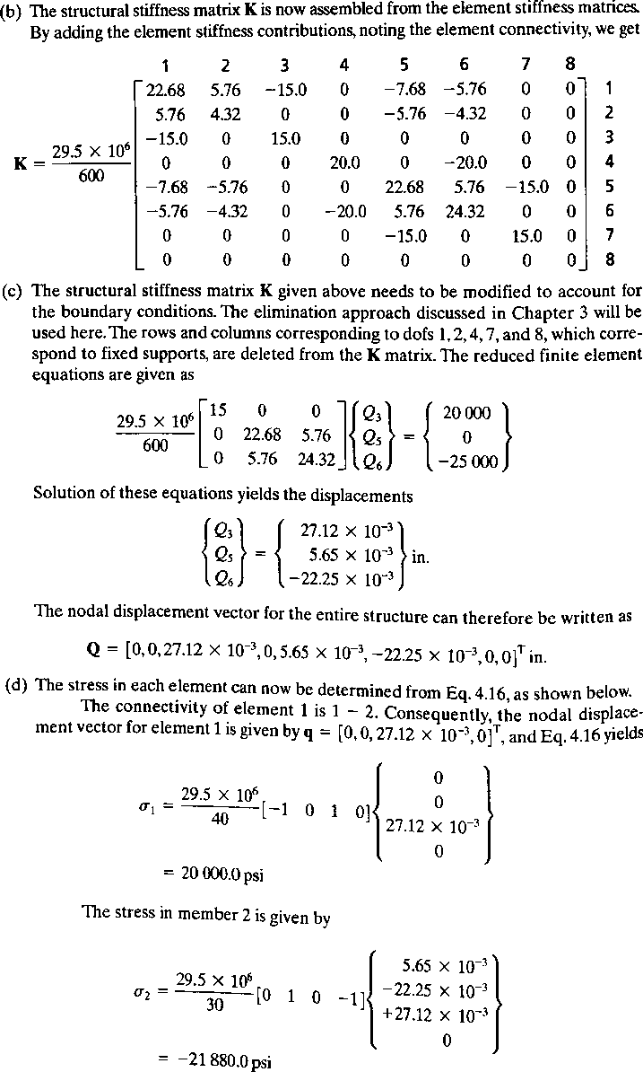

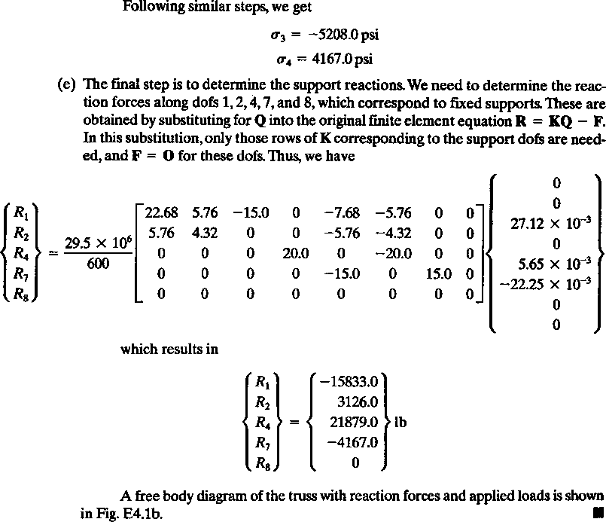

UNIT –III GENERATION OF ELEMENT
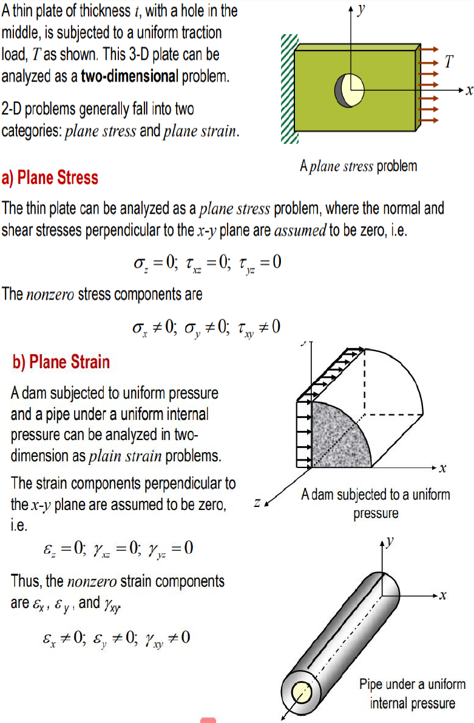

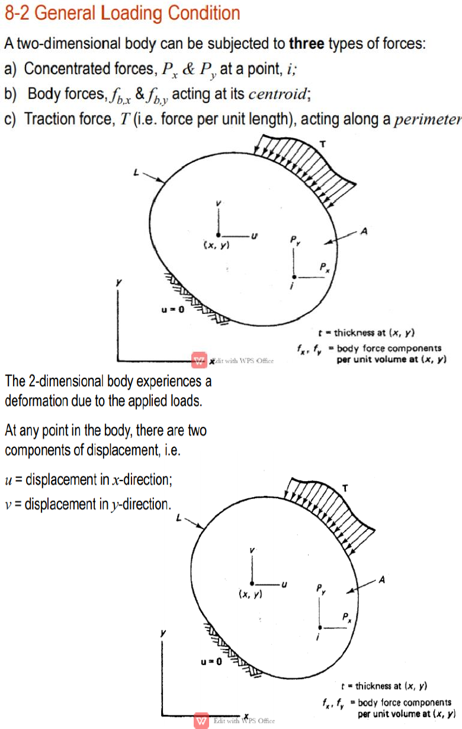

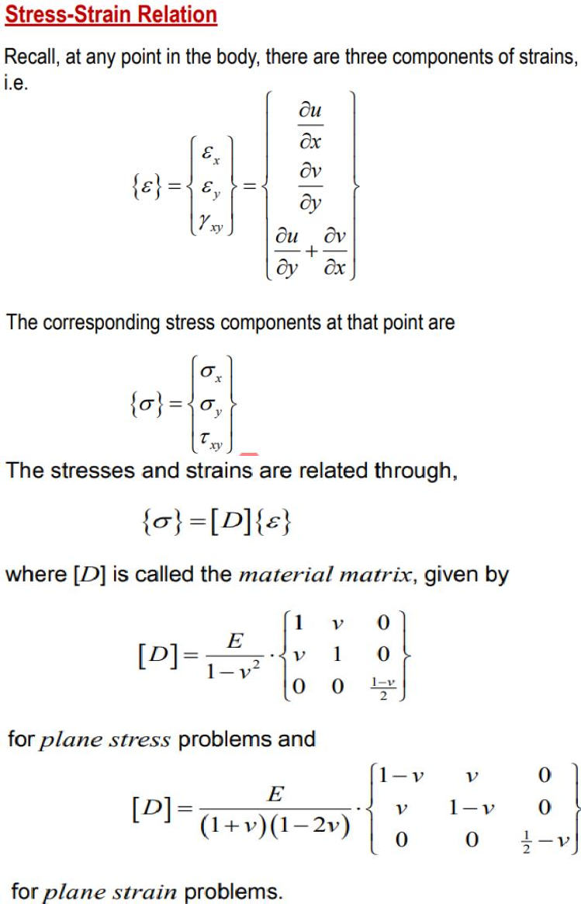

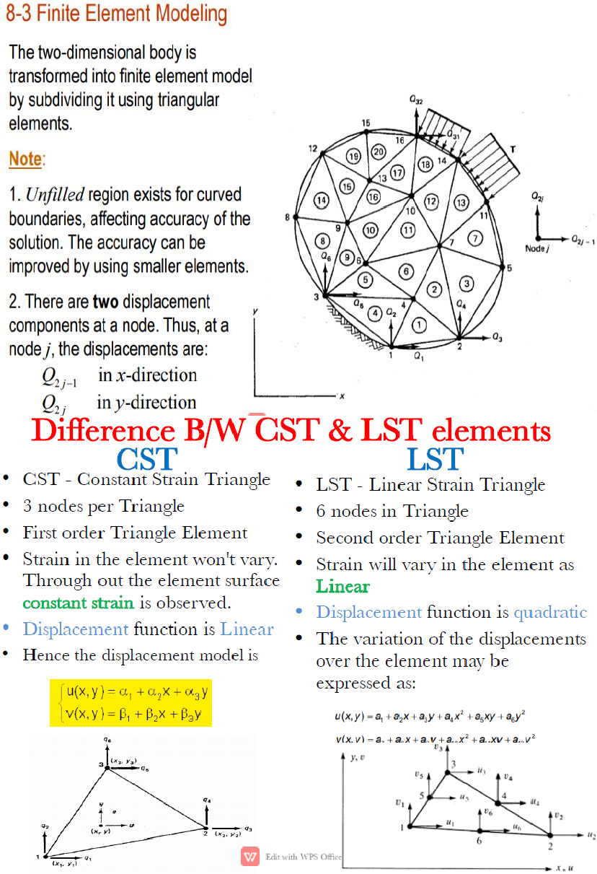

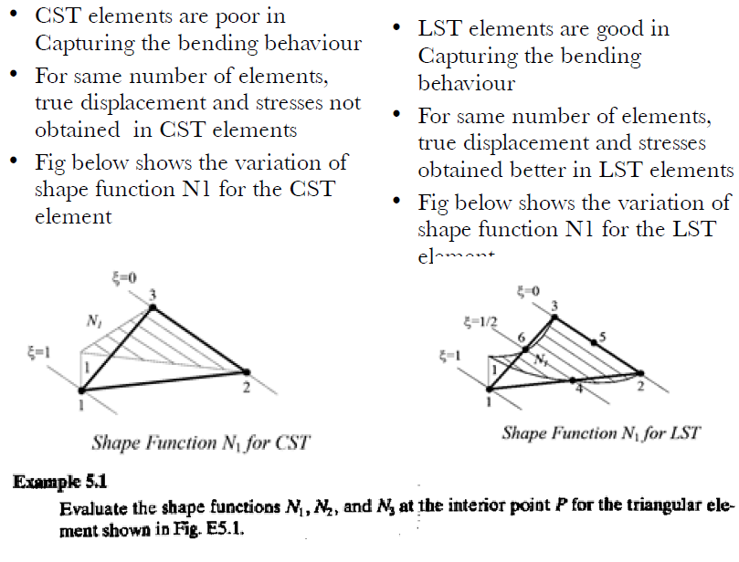
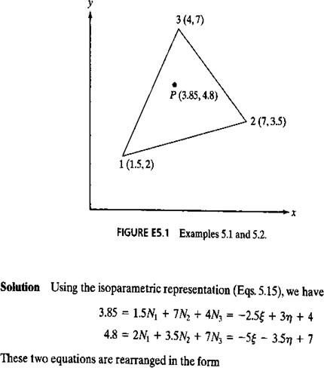

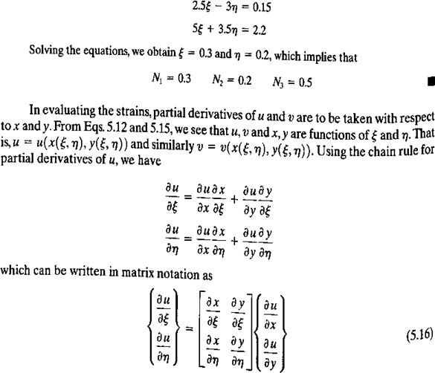

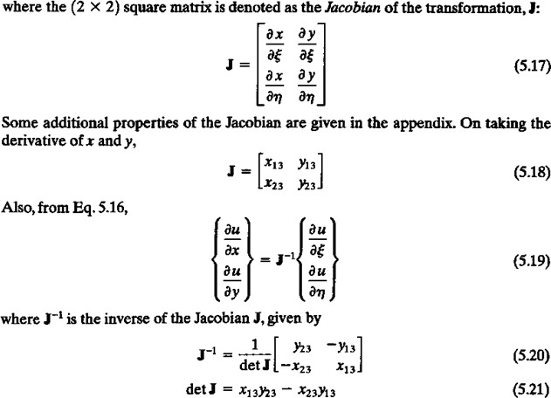

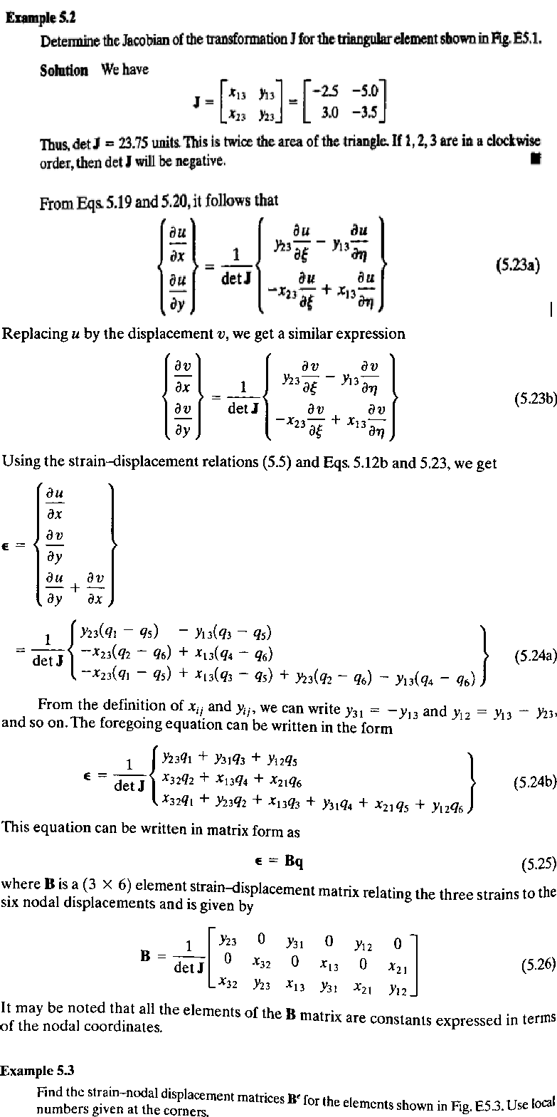

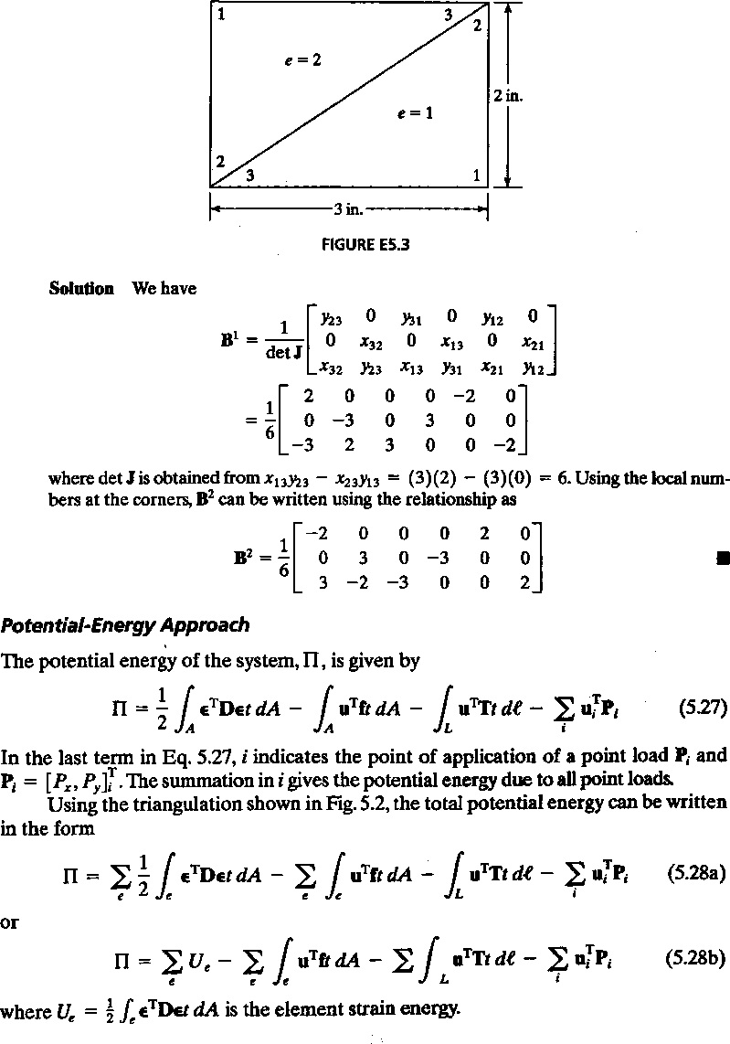

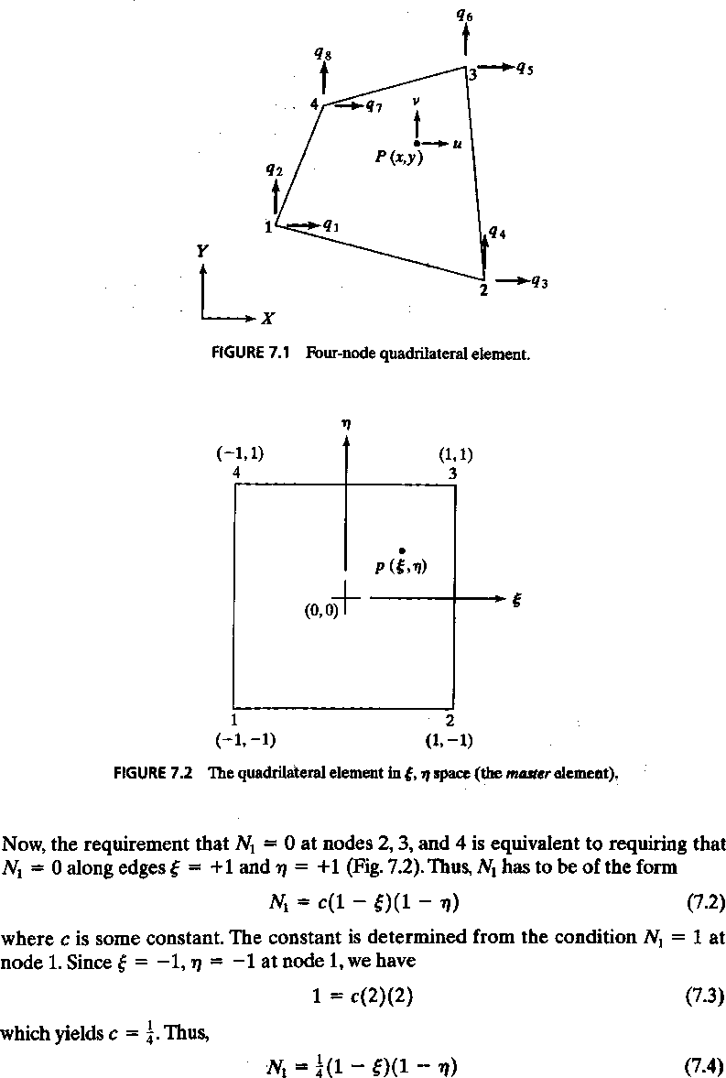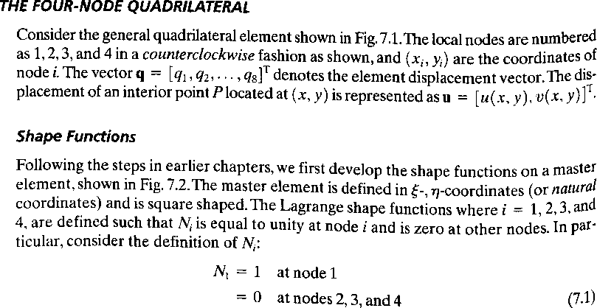

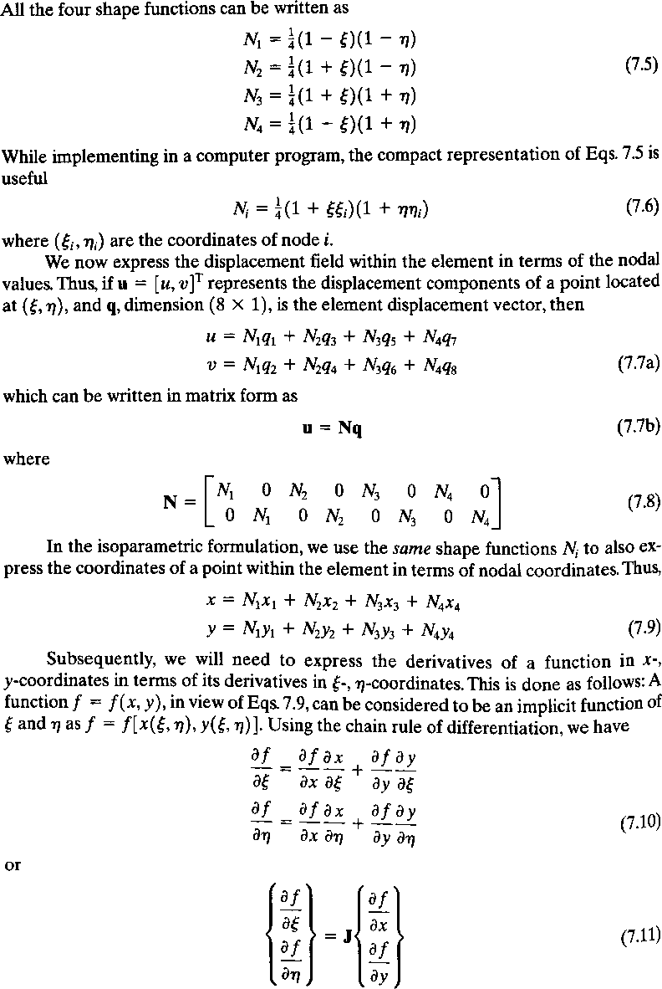

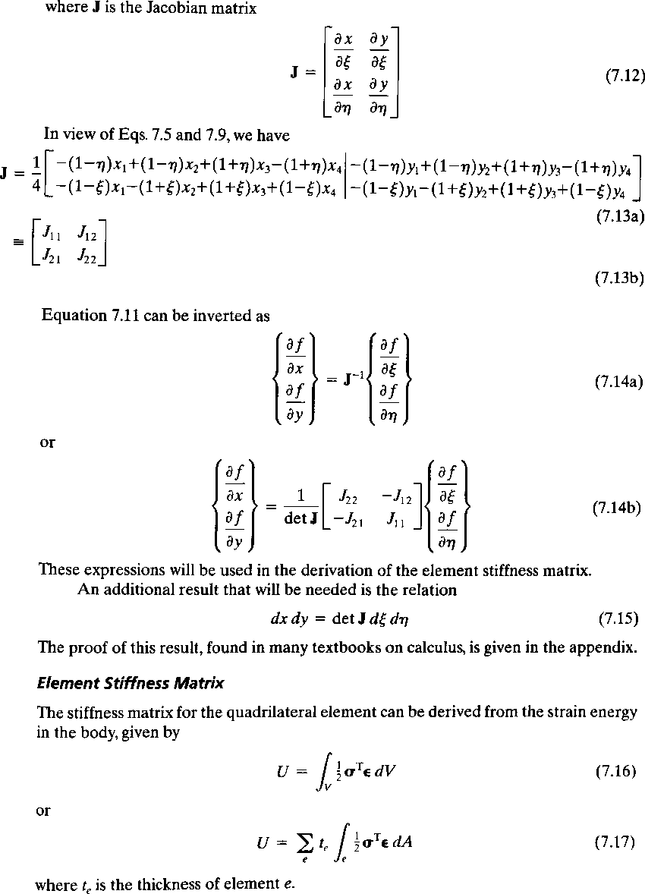

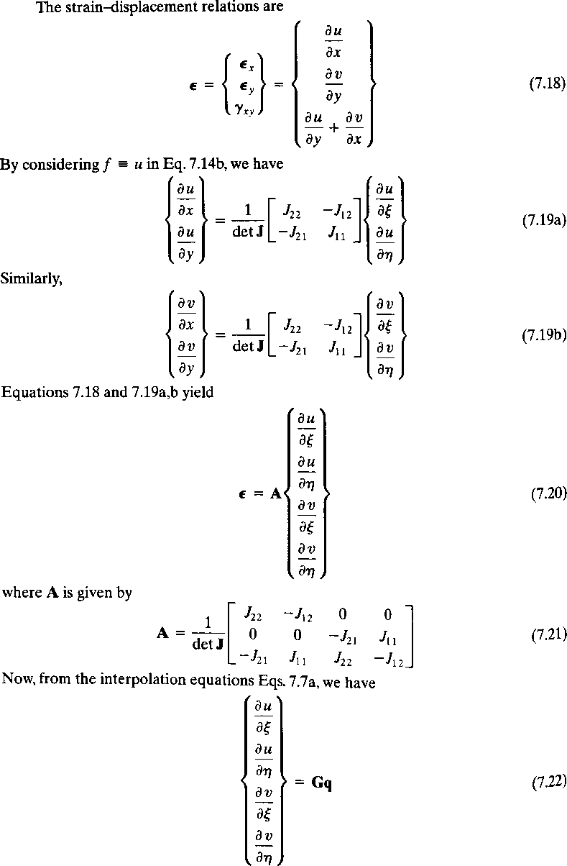

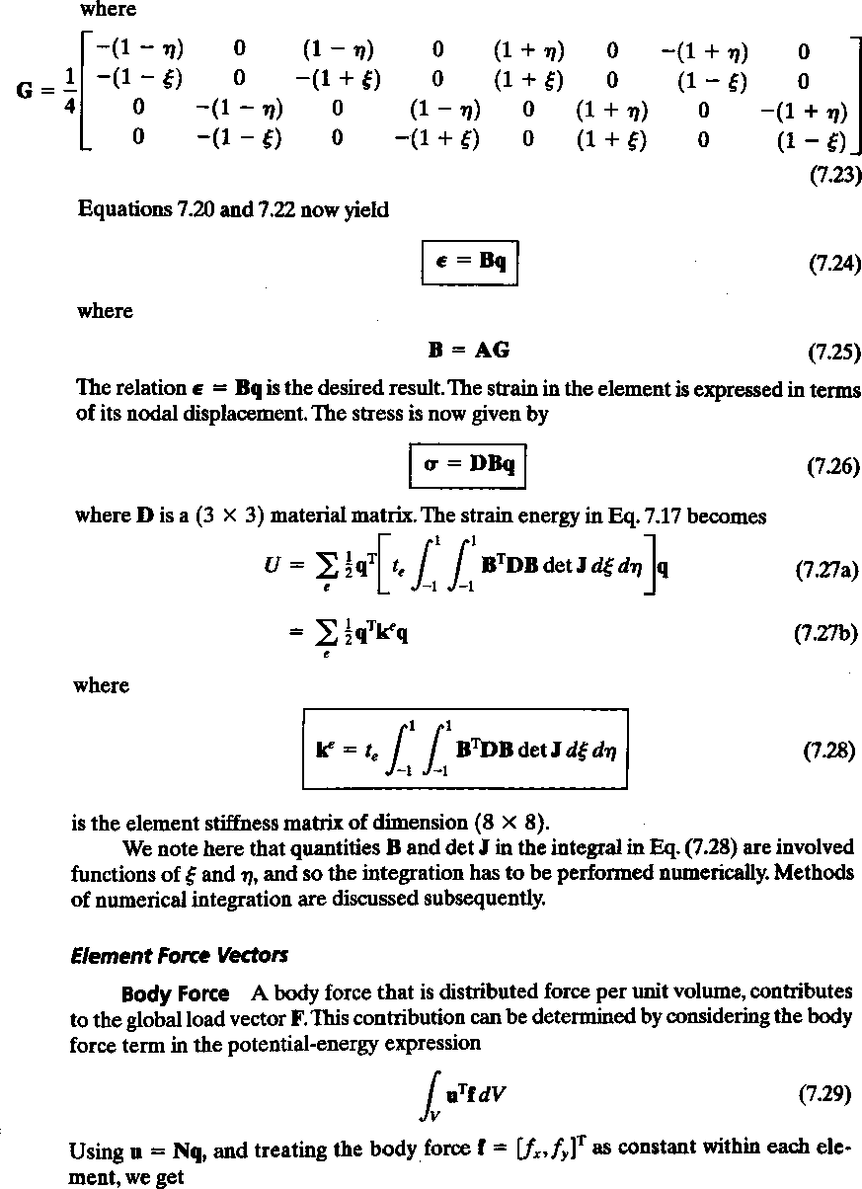

UNIT –IV ISOPARAMETRIC FORMULATION
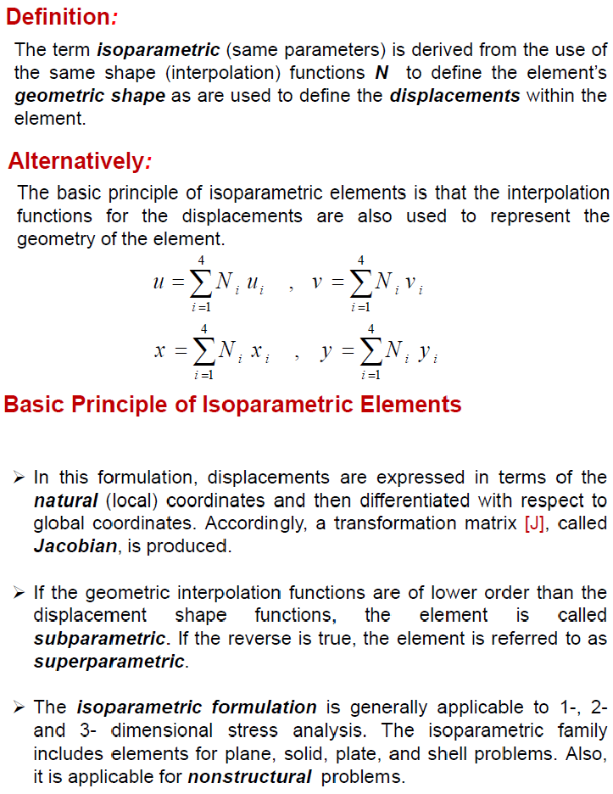

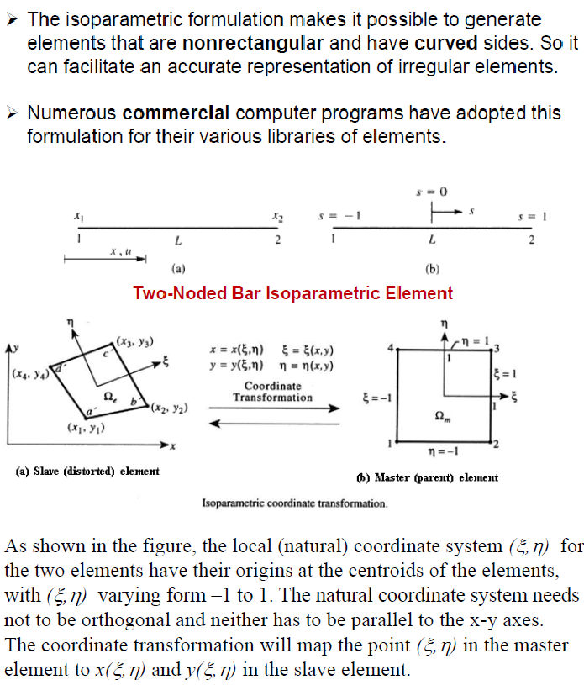

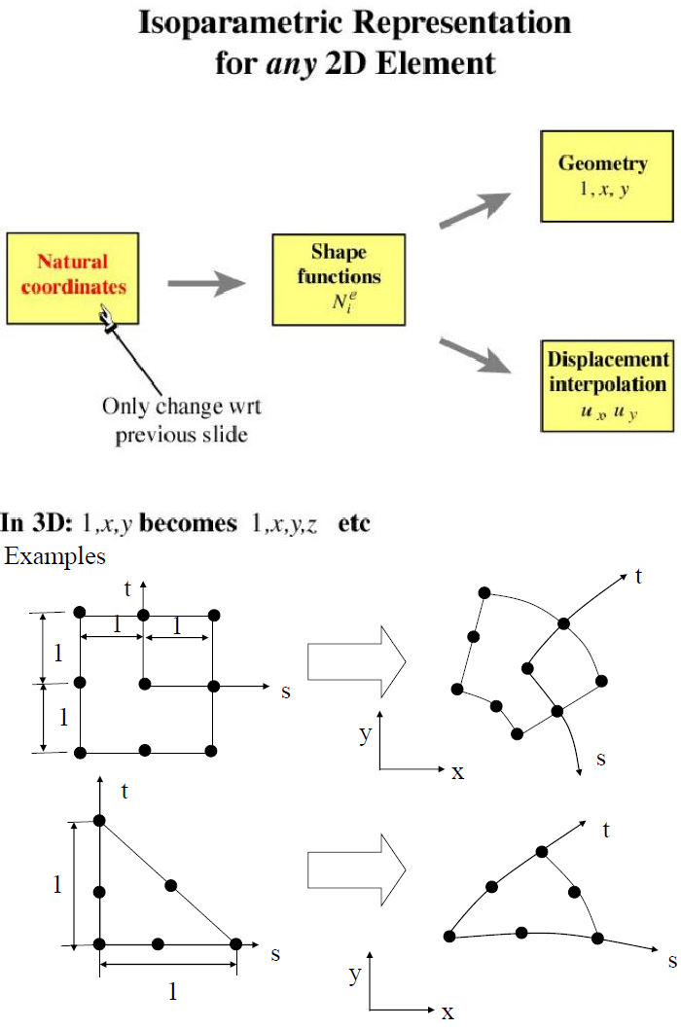

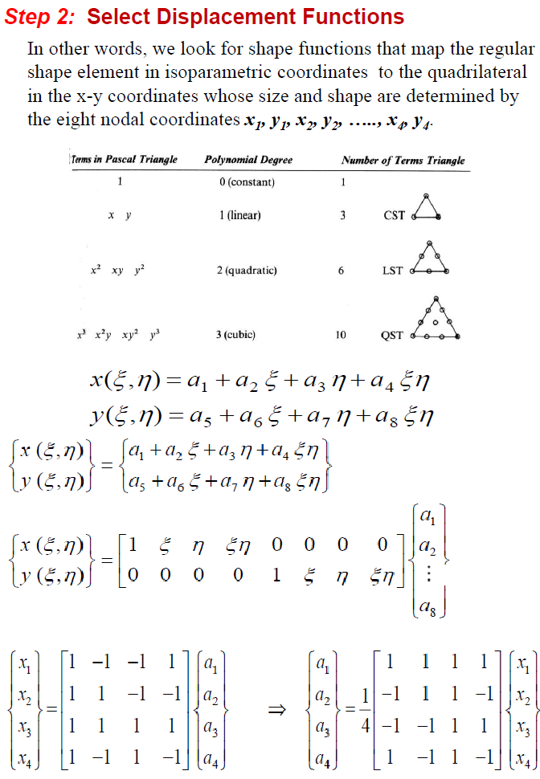

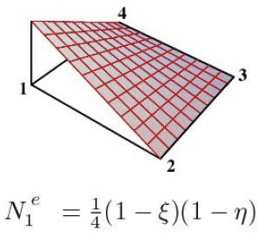
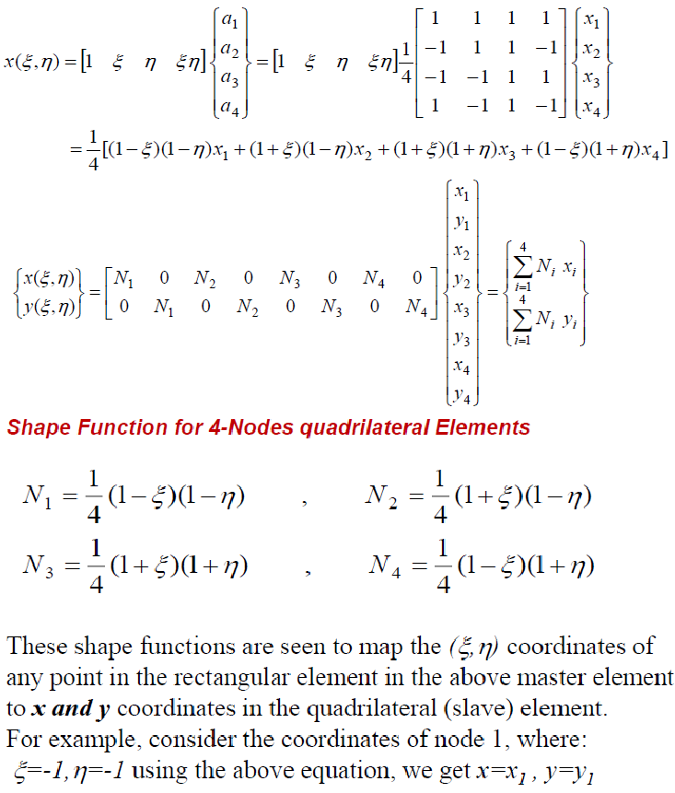

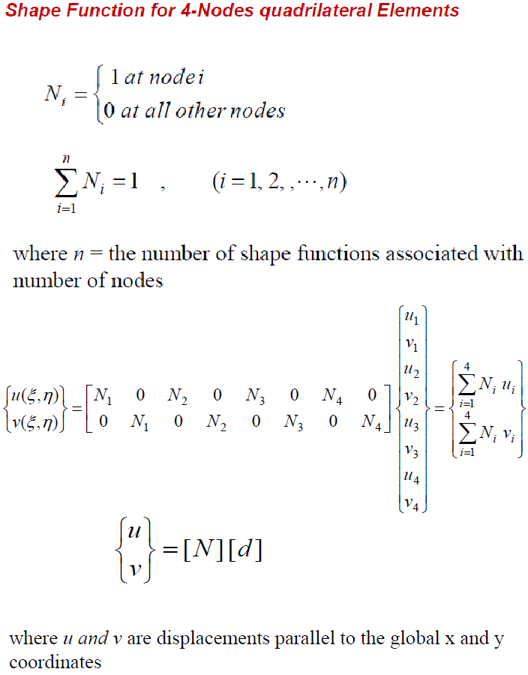

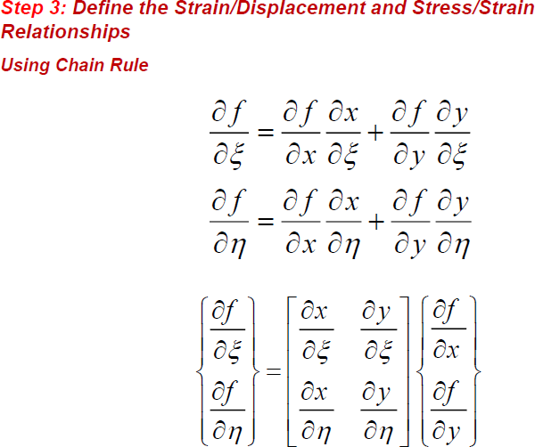

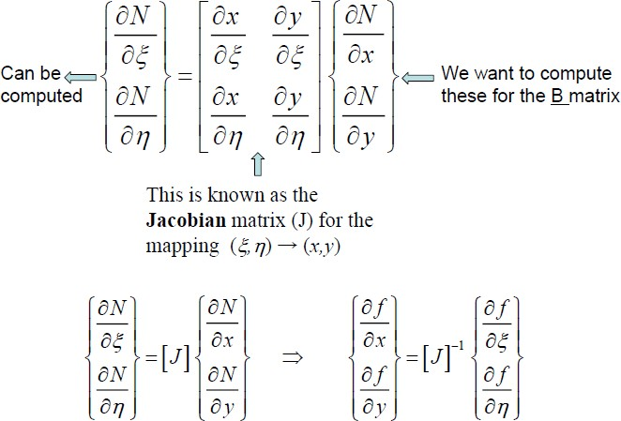

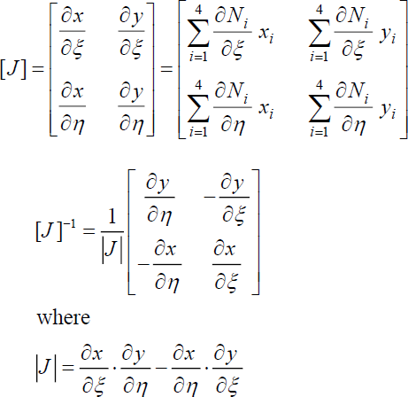
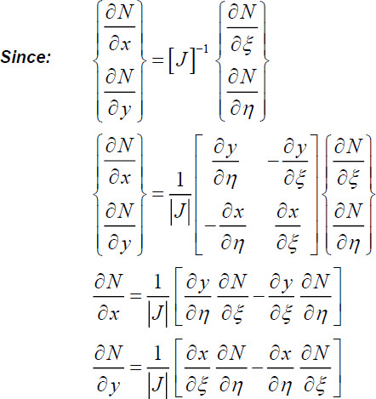

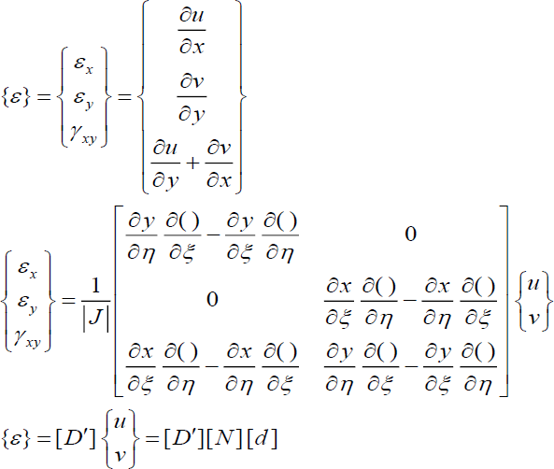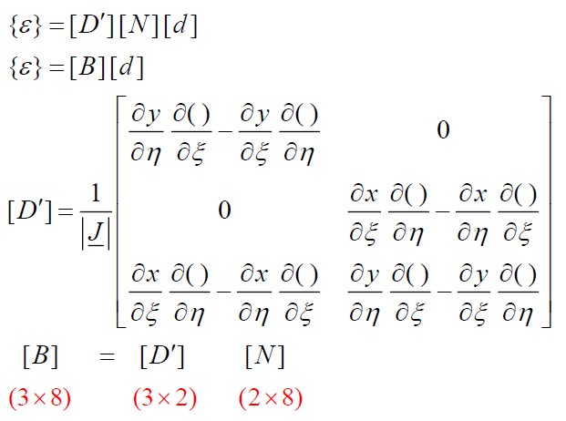

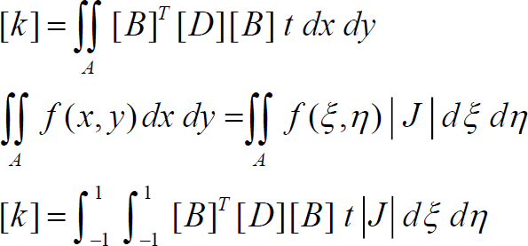
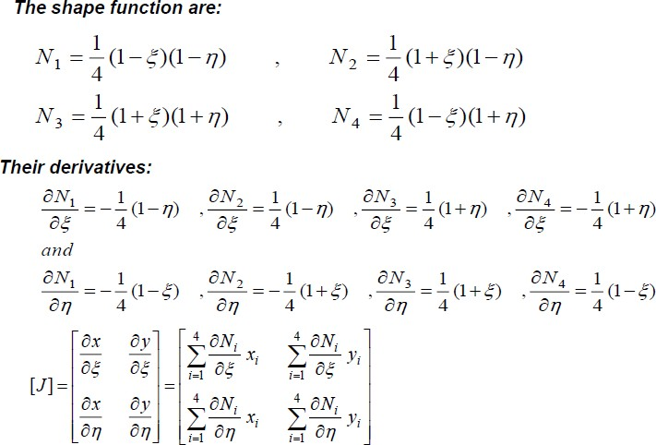
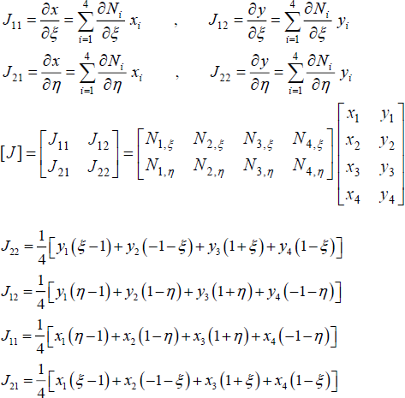

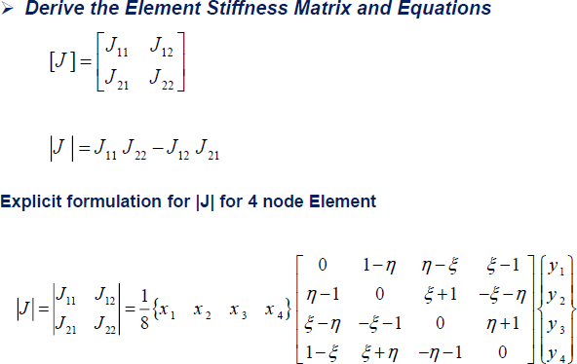
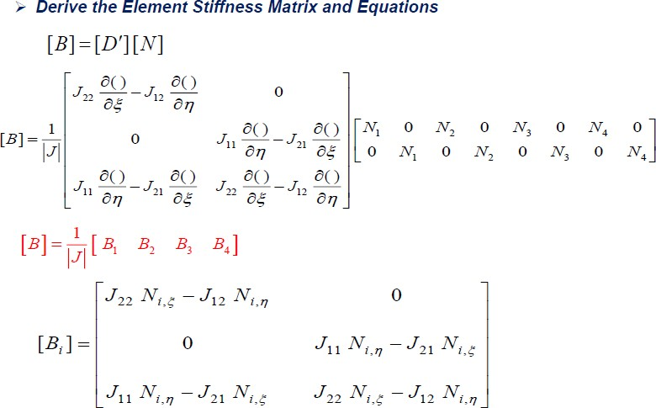

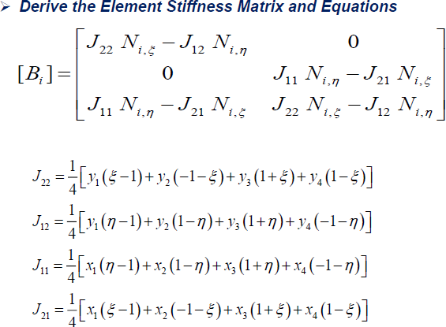
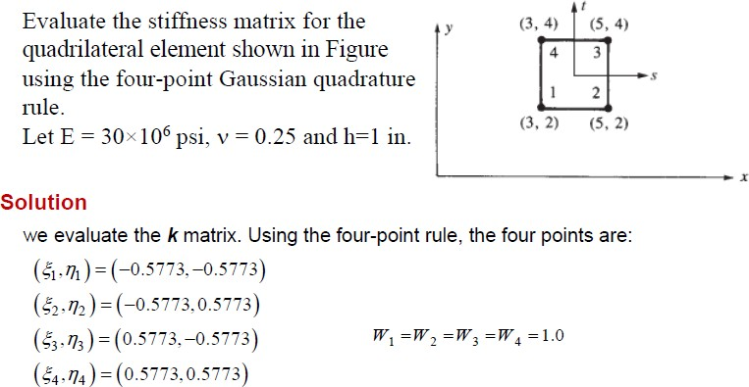

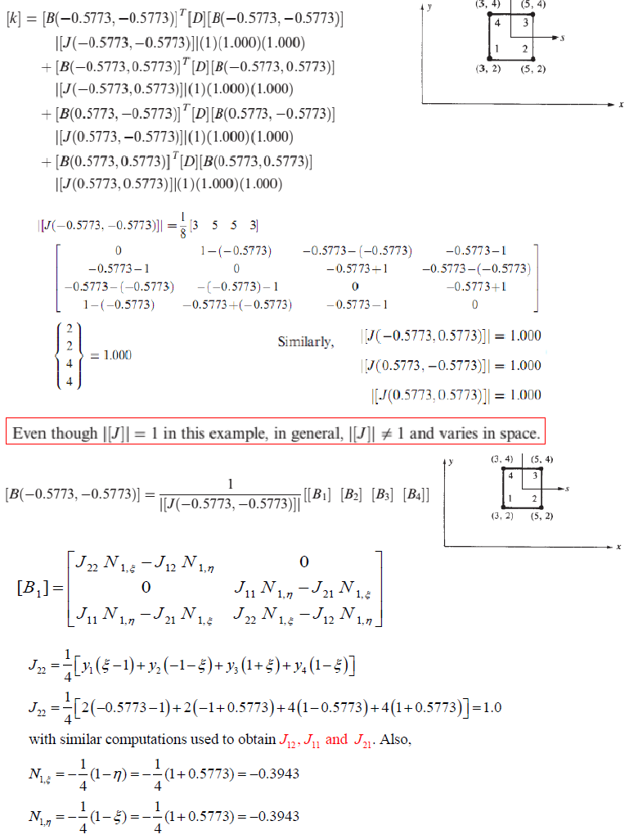

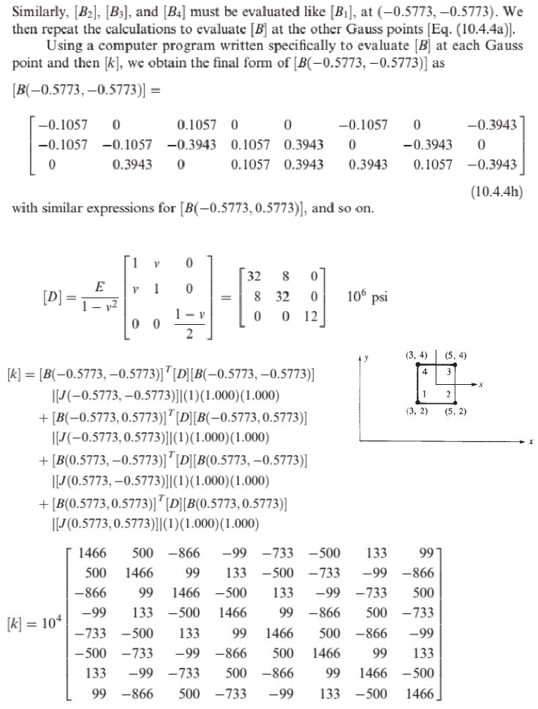

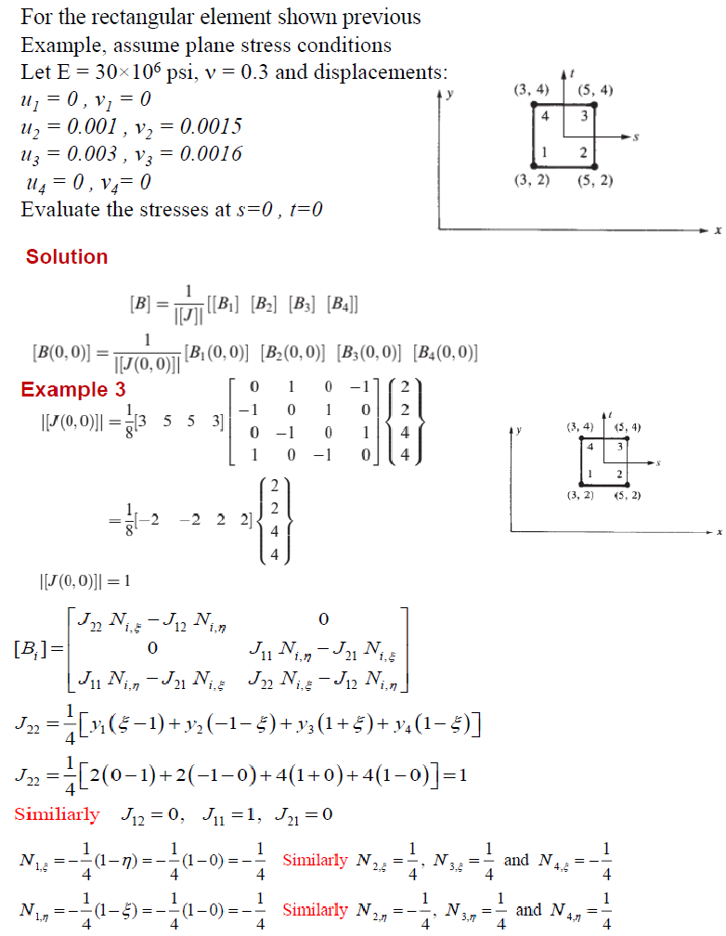

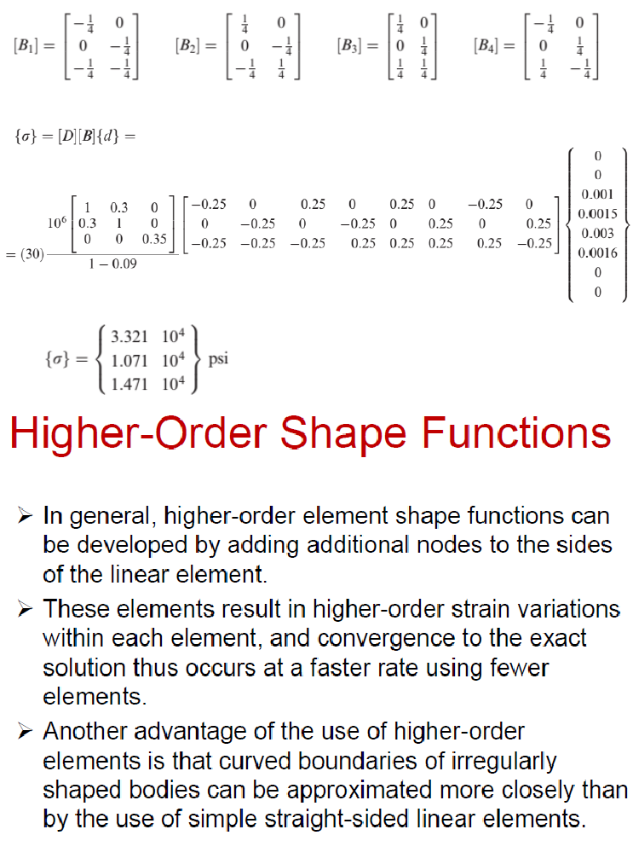

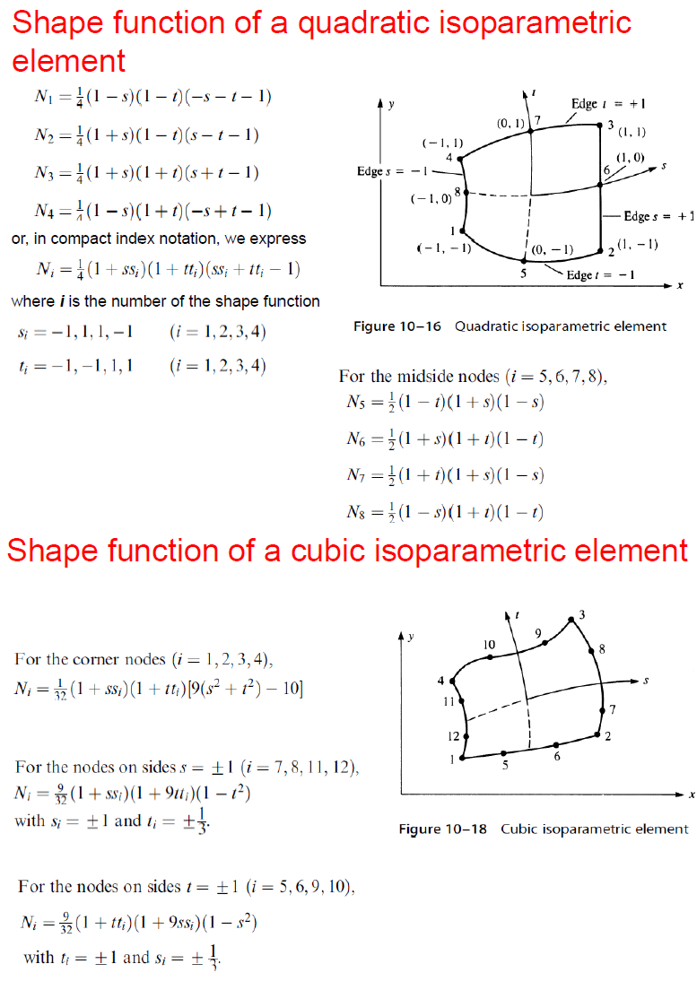

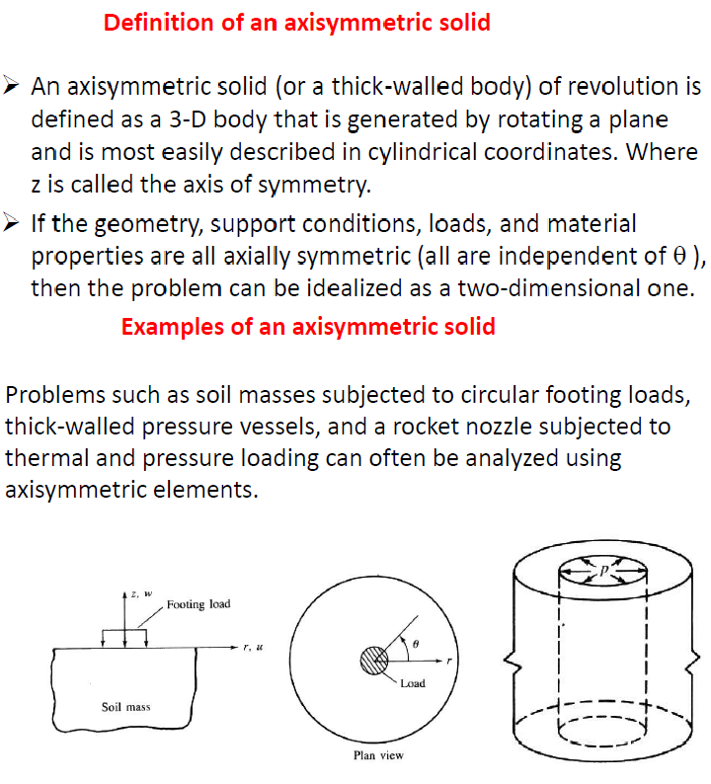

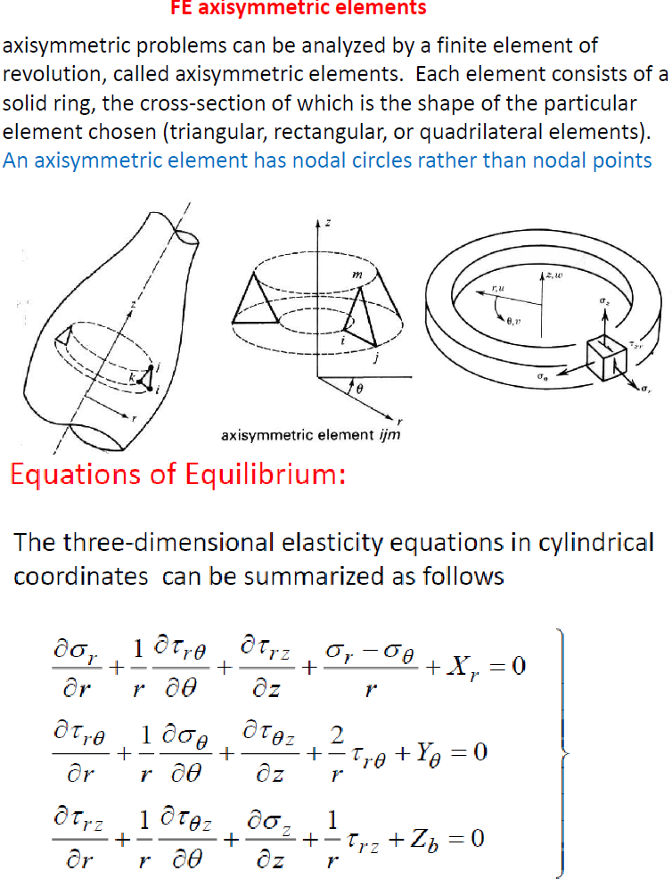

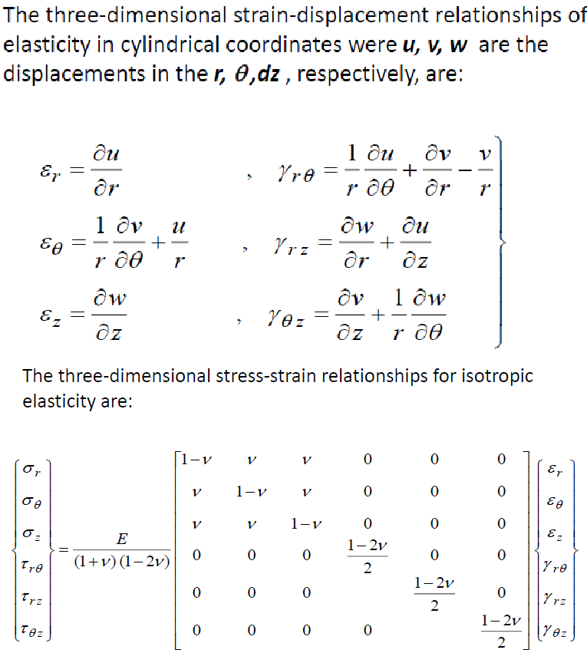

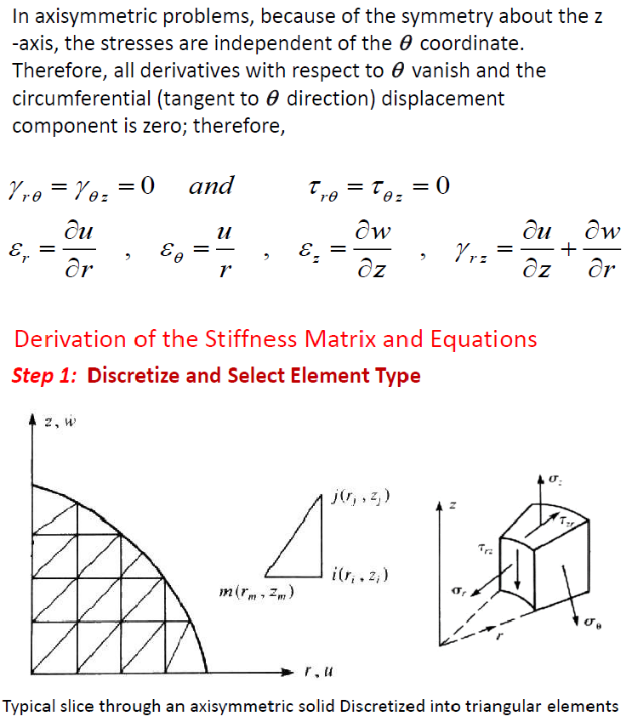

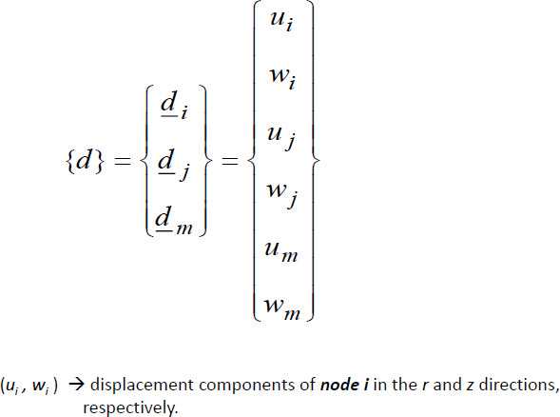
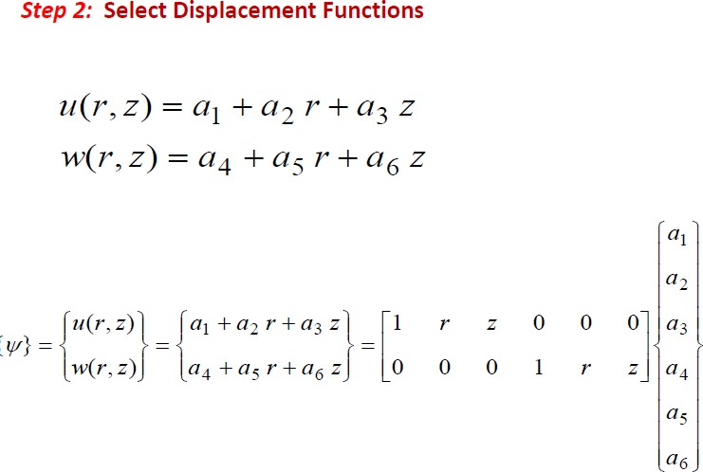

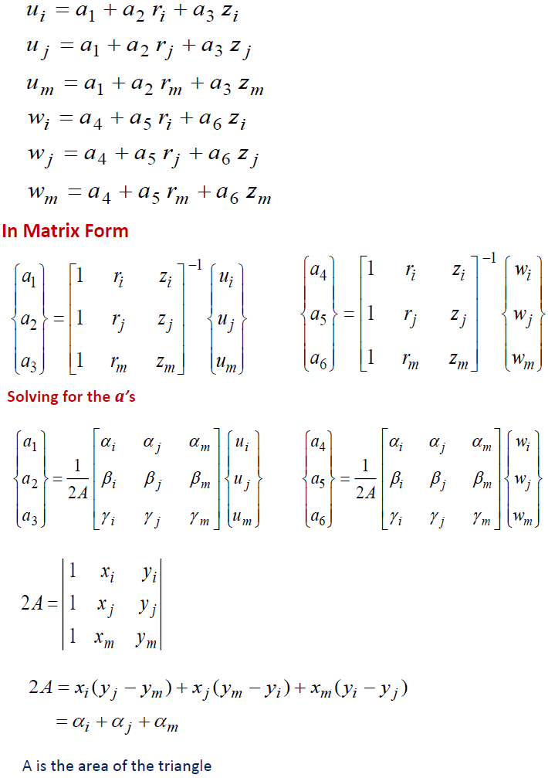

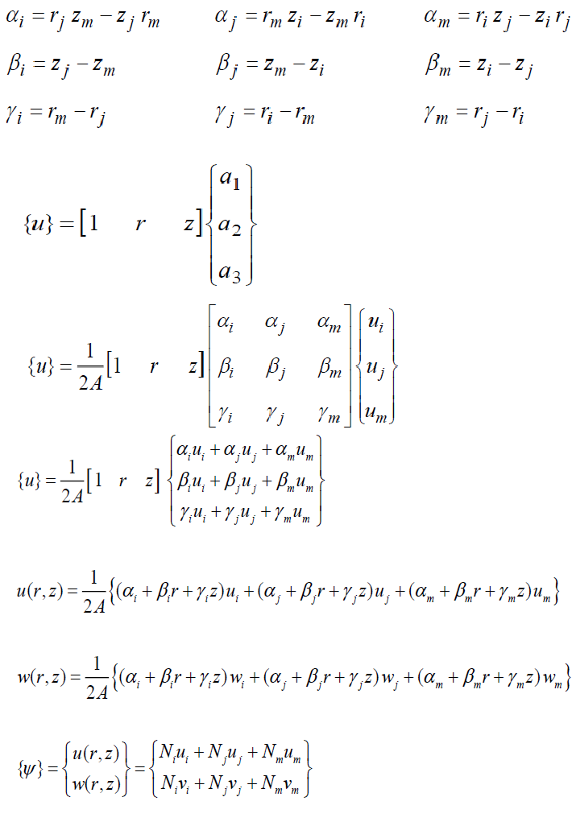

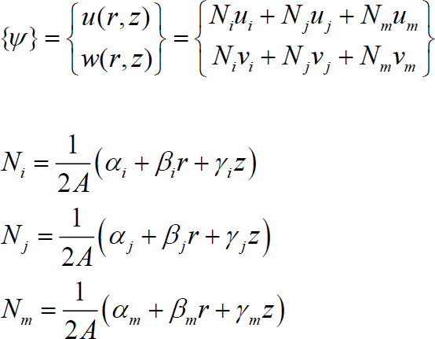

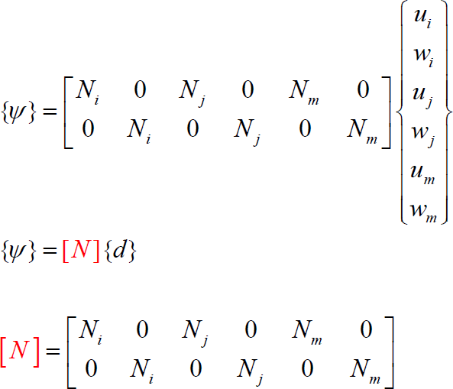

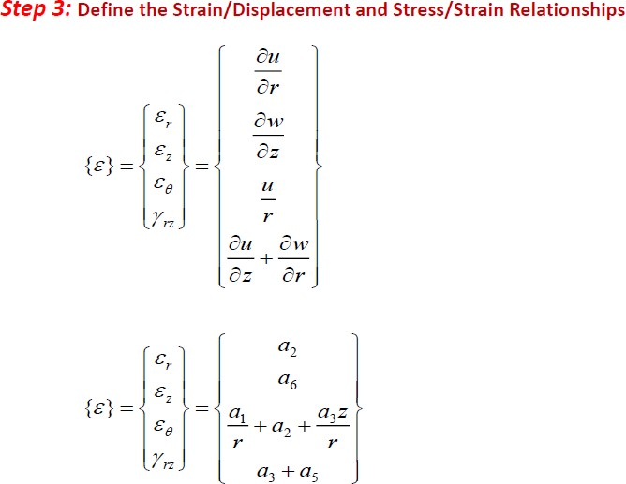

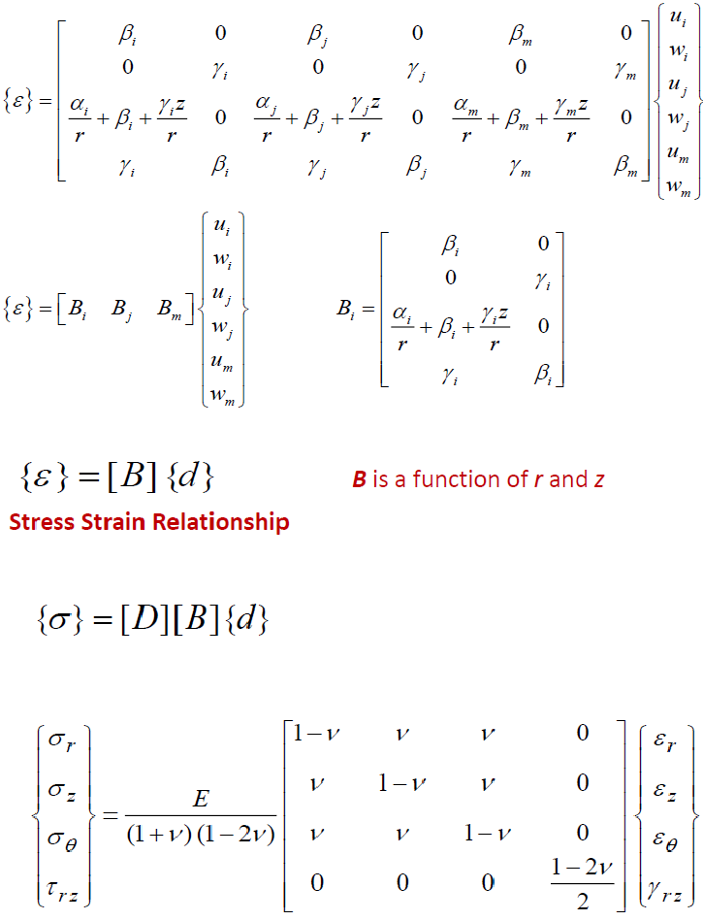

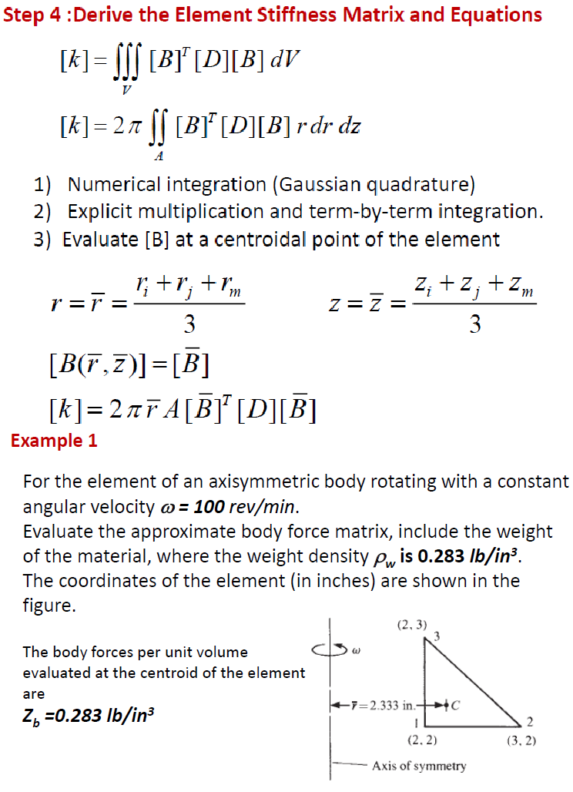

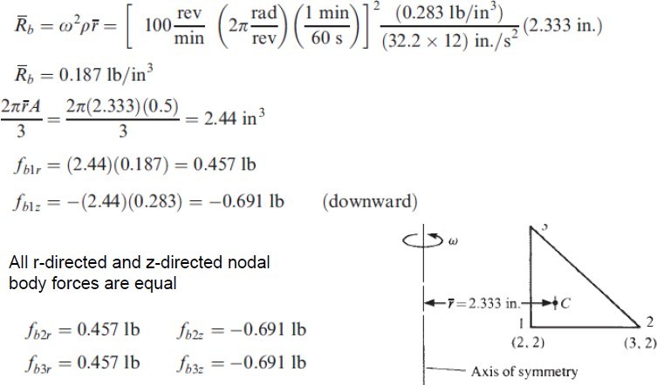

UNIT-V

DYNAMIC ANALYSIS

