Structural Analysis-I (20A01402)

LECTURE NOTES II-B.TECH & II-SEM
Prepared by:
Mr. B. RAMU, Assistant Professor

Department of Civil Engineering

VEMU INSTITUTE OF TECHNOLOGY

(Approved By AICTE, New Delhi and Affiliated to JNTUA, Ananthapuramu) Accredited By NAAC, NBA( EEE, ECE & CSE) & ISO: 9001-2015 Certified Institution Near Pakala, P.Kothakota, Chittoor- Tirupathi Highway
Chittoor, Andhra Pradesh-517 112 Web Site: www.vemu.org

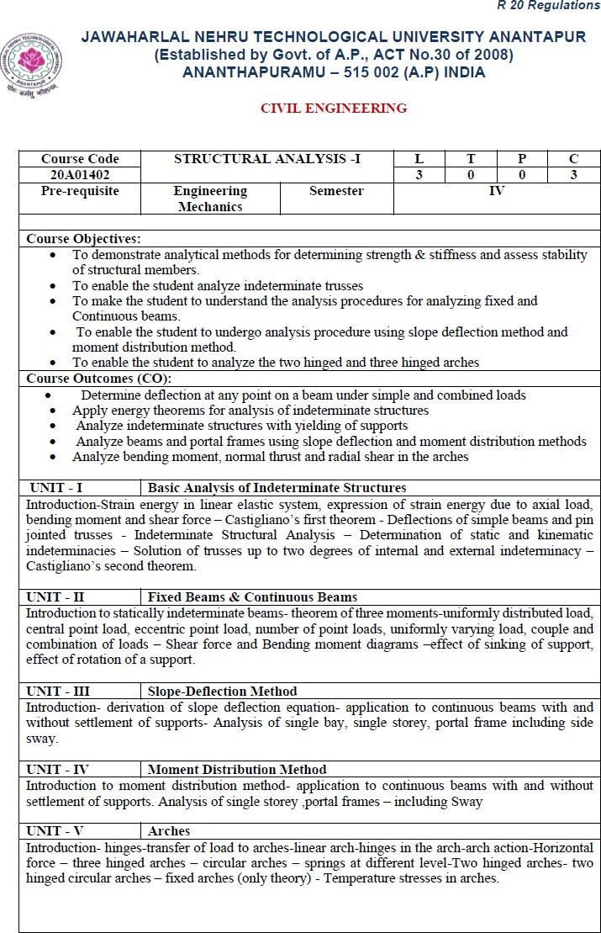

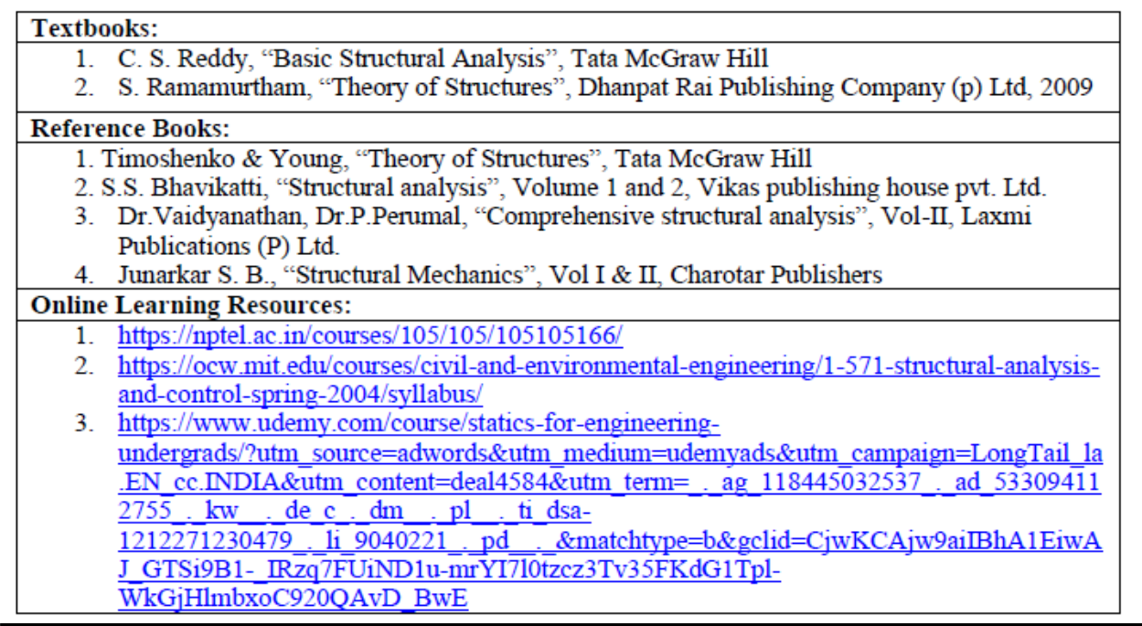

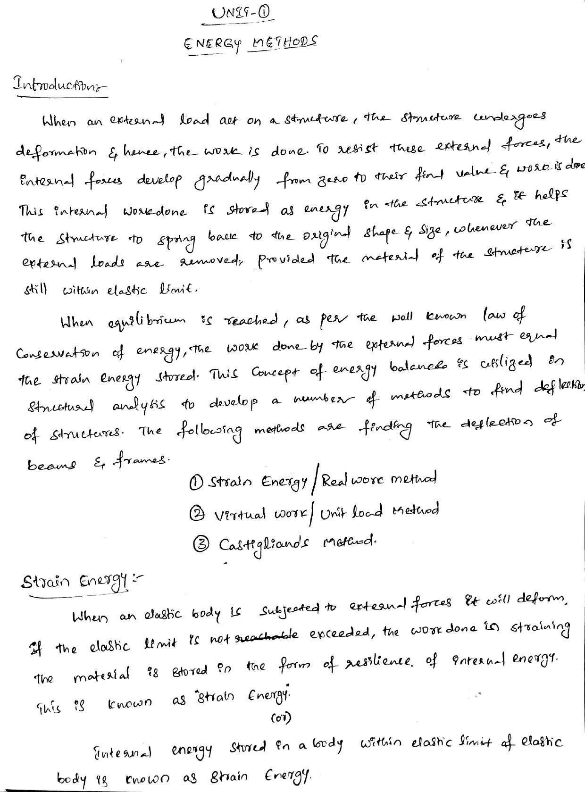

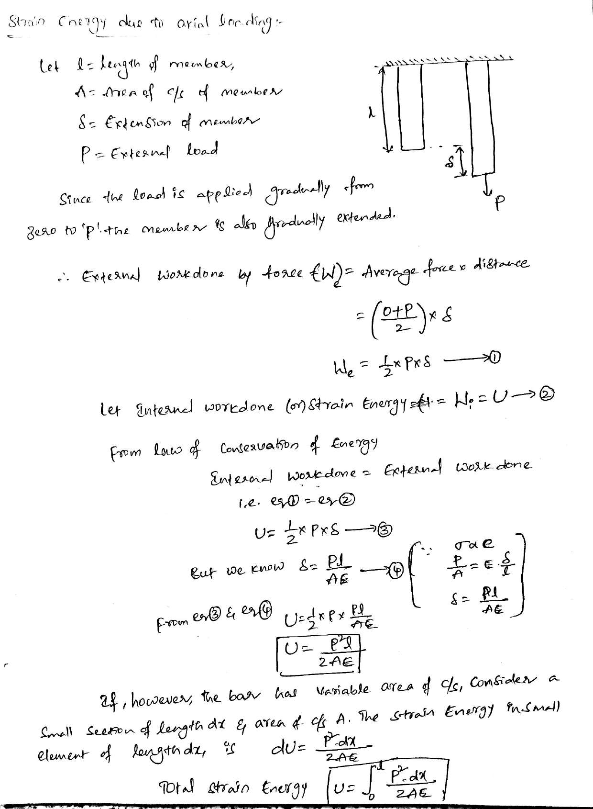

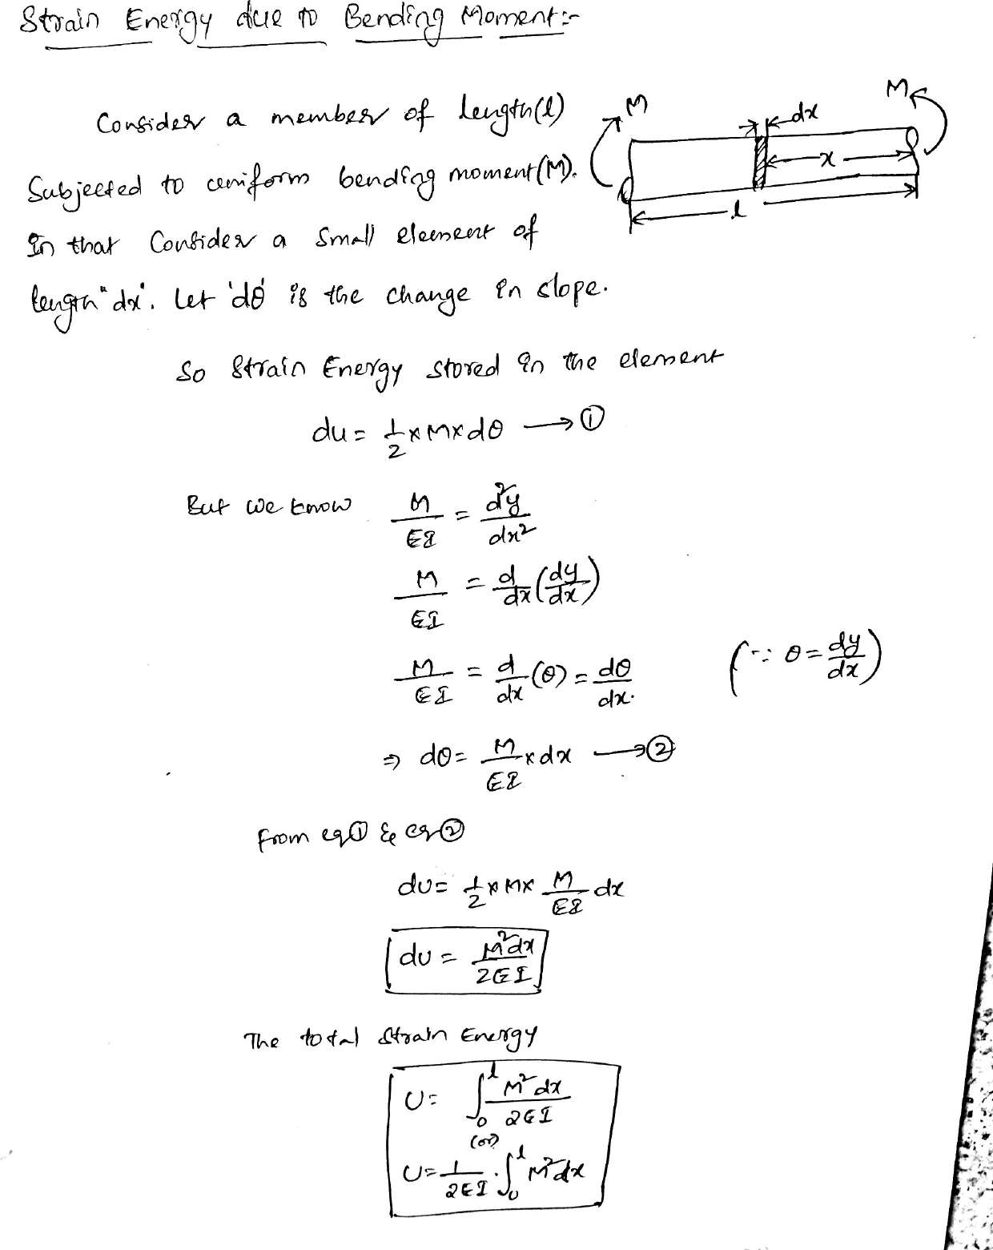

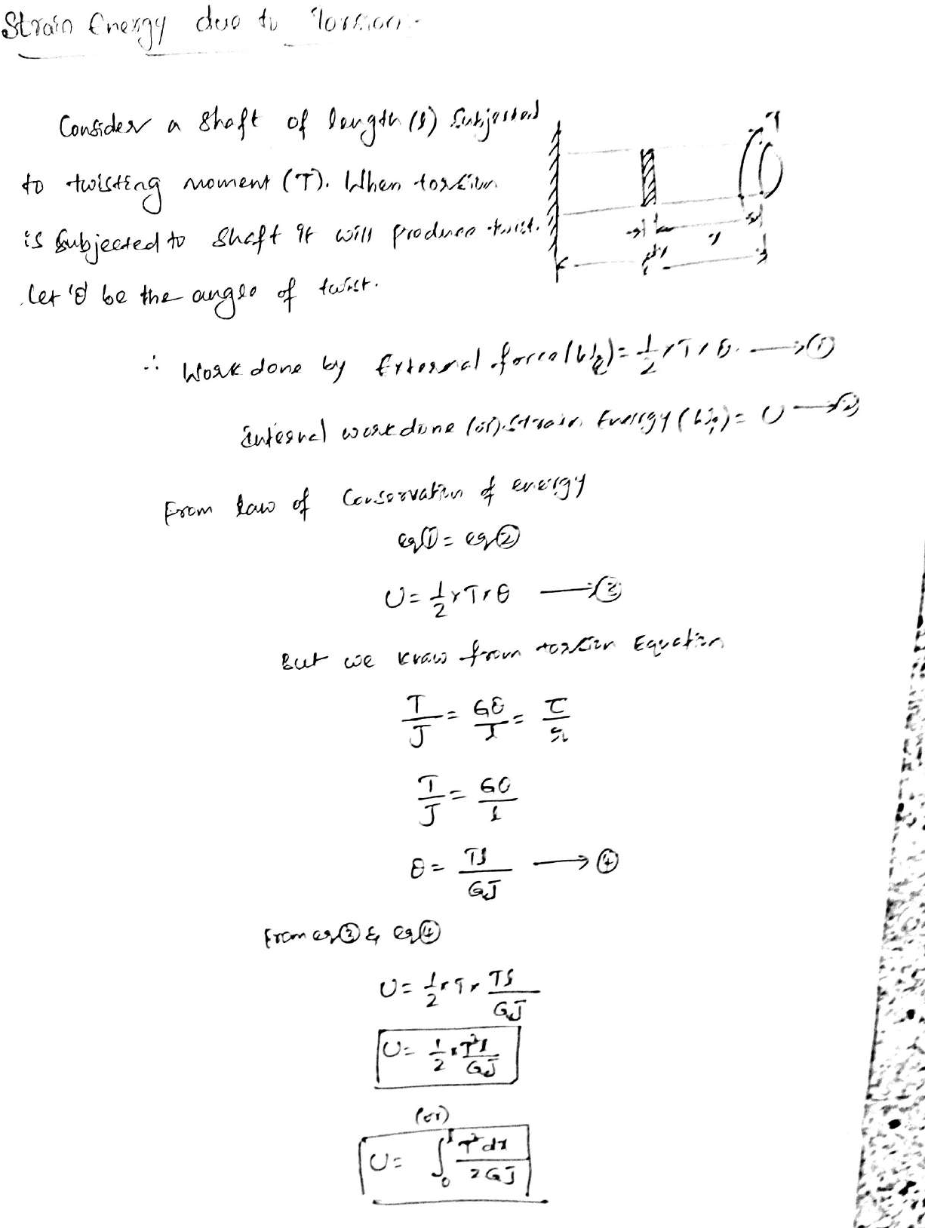

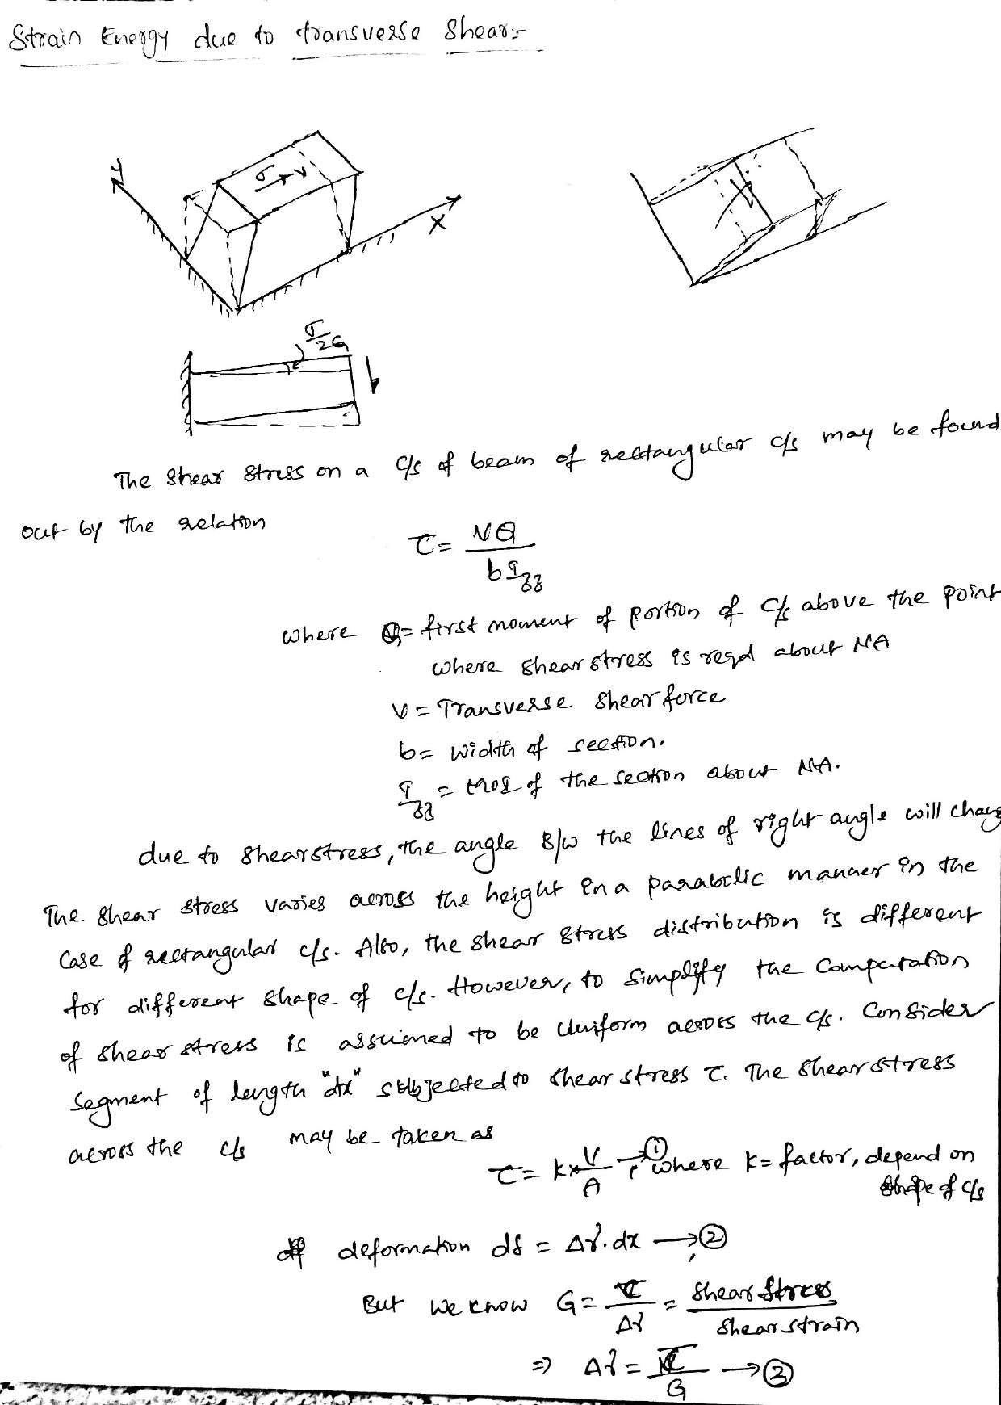

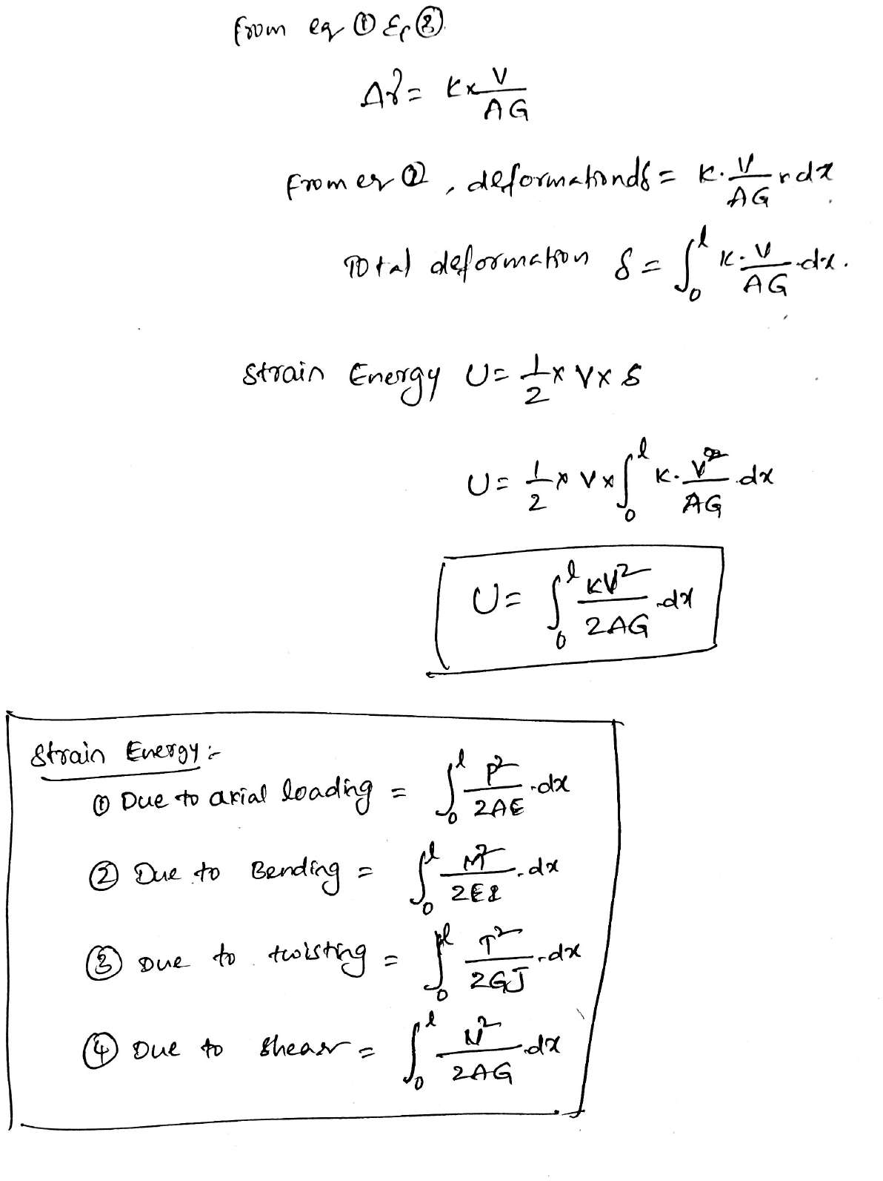

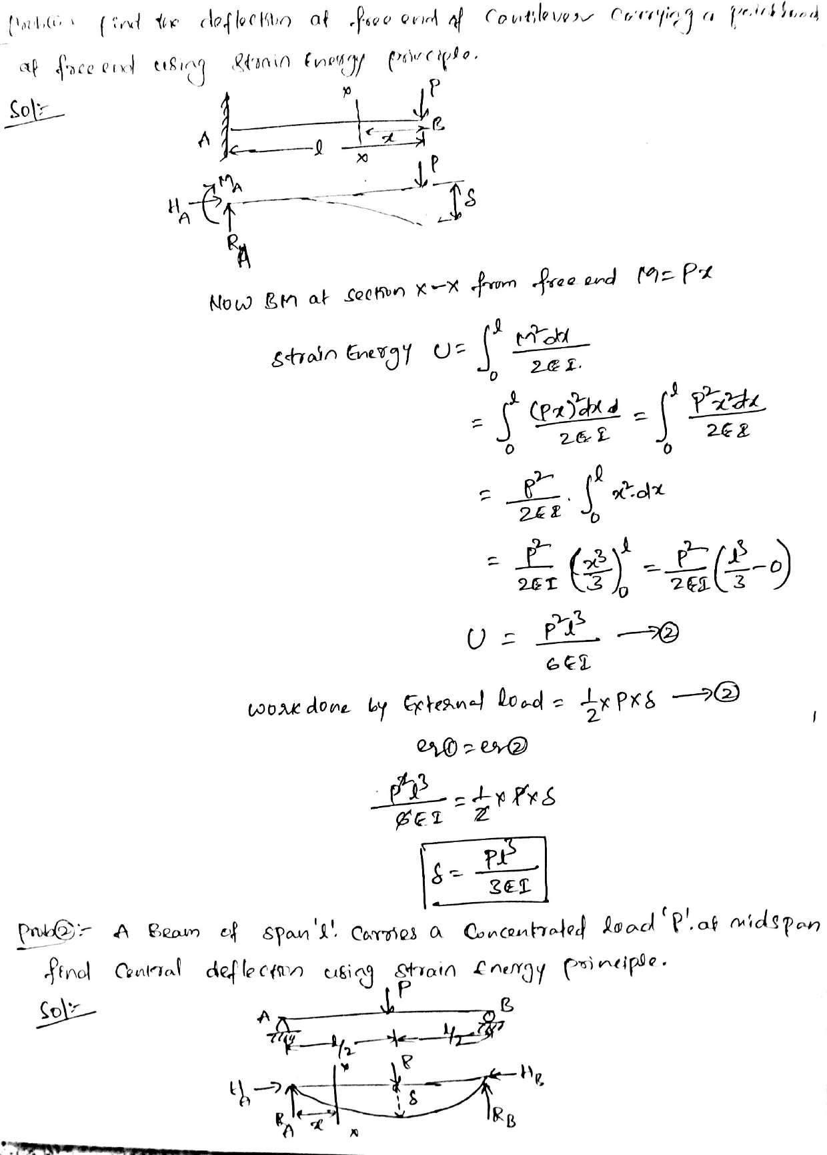

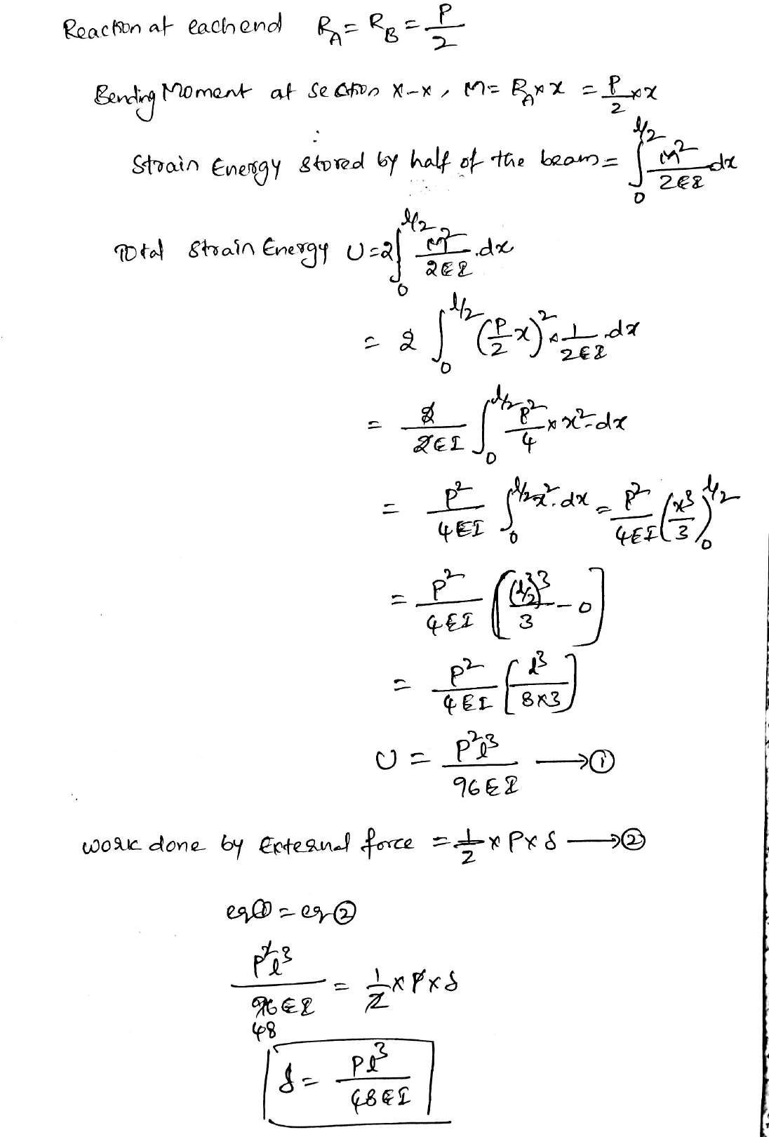

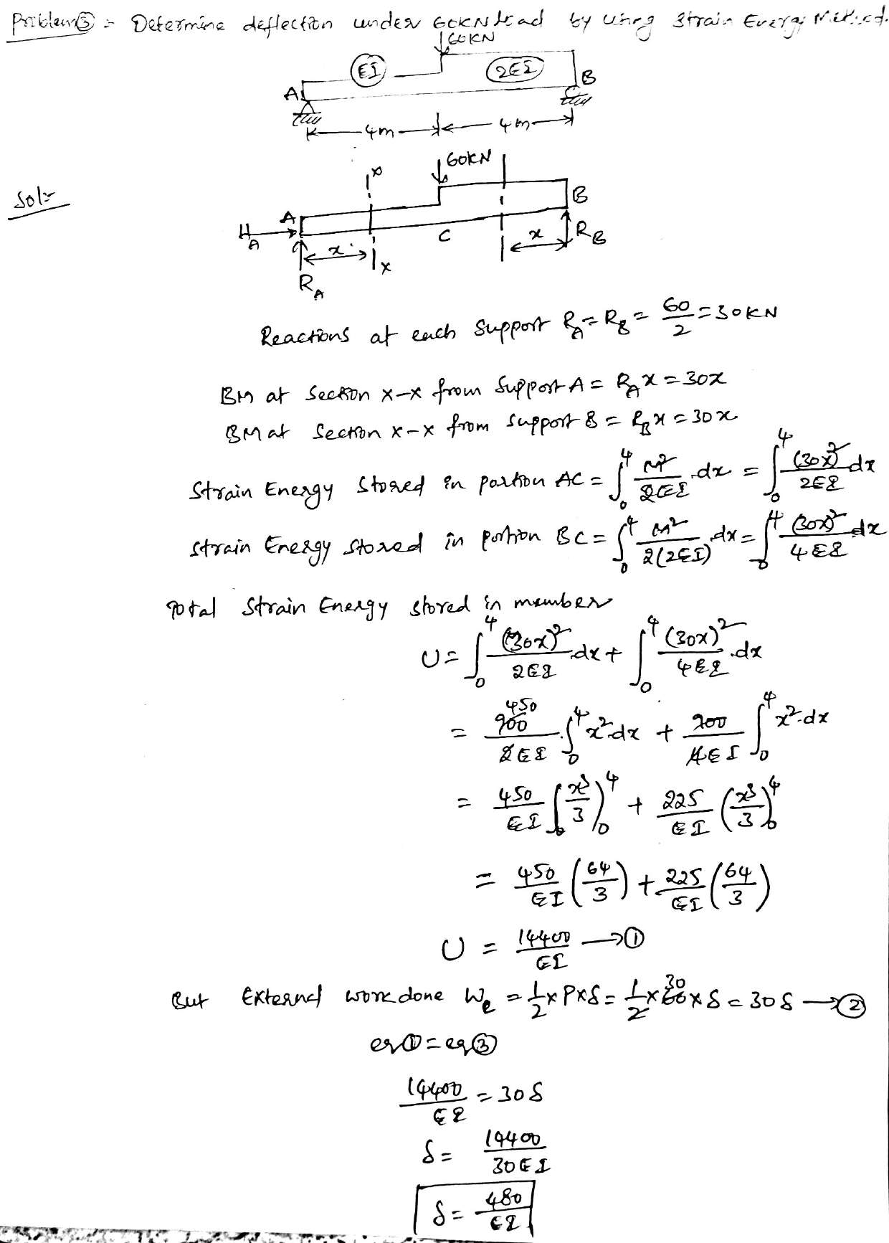

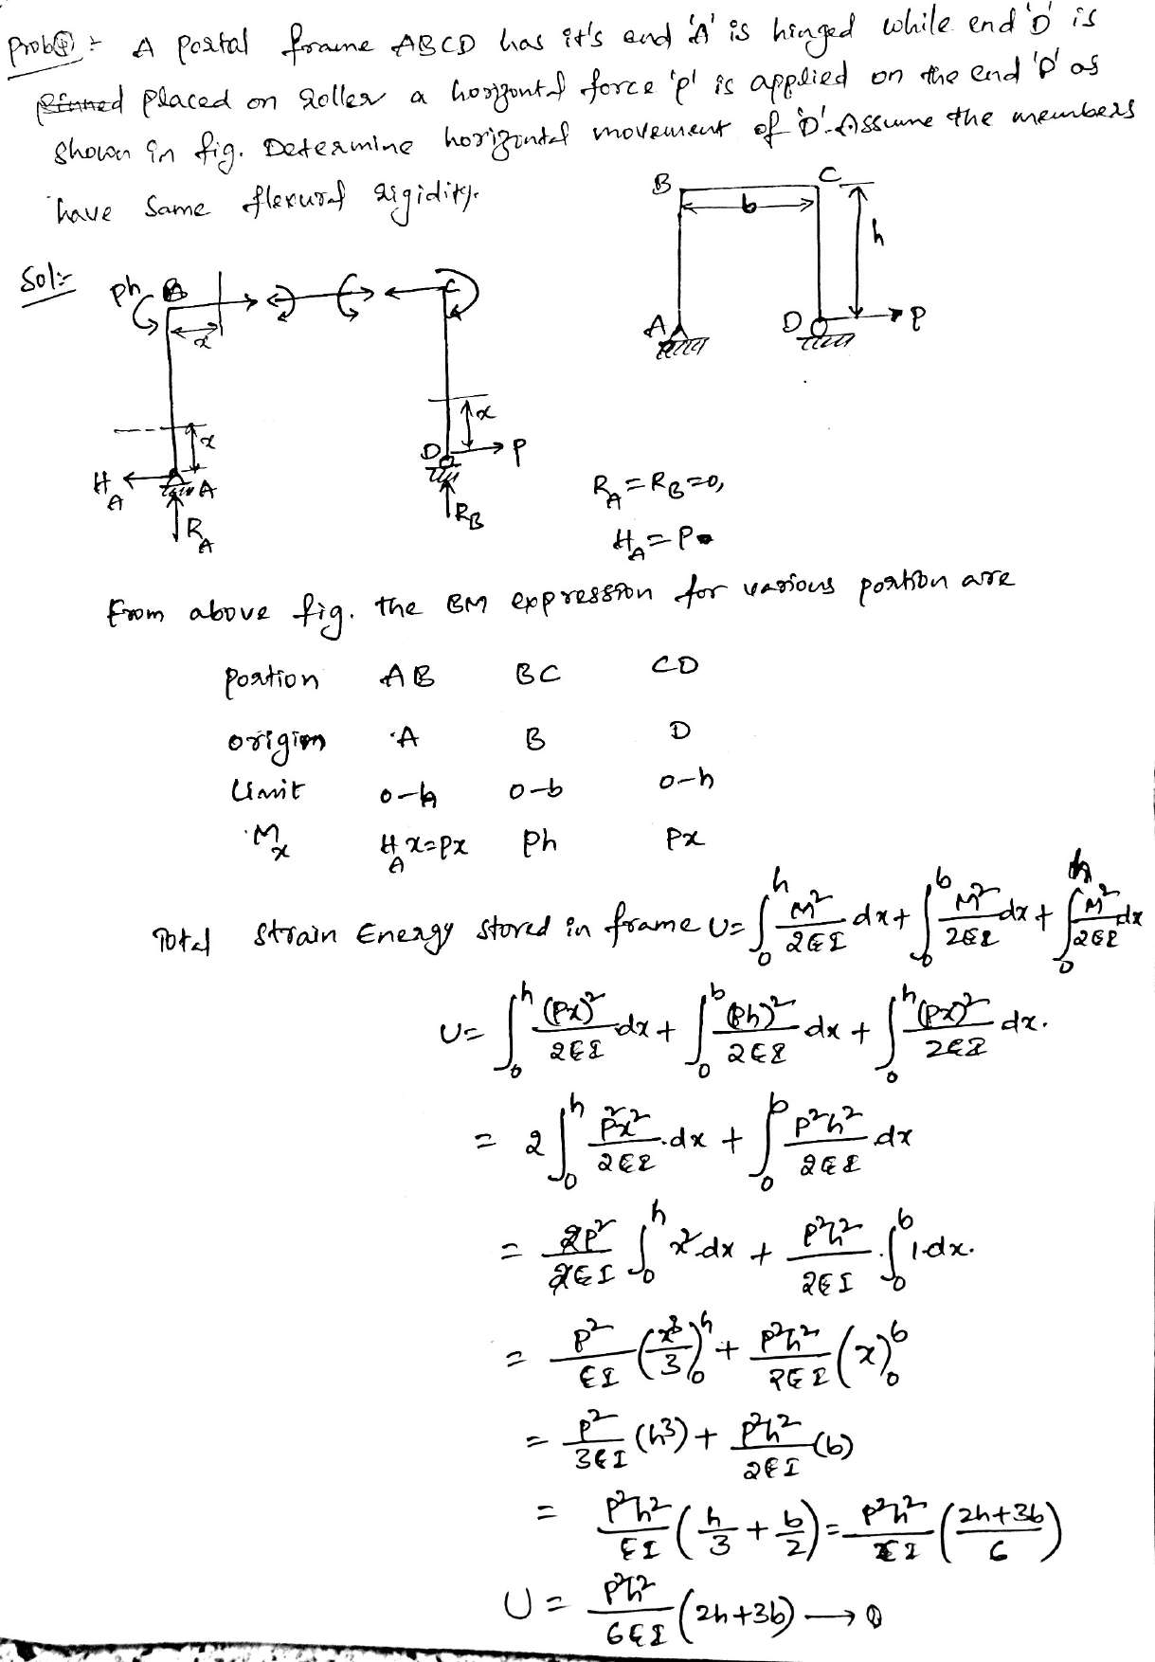

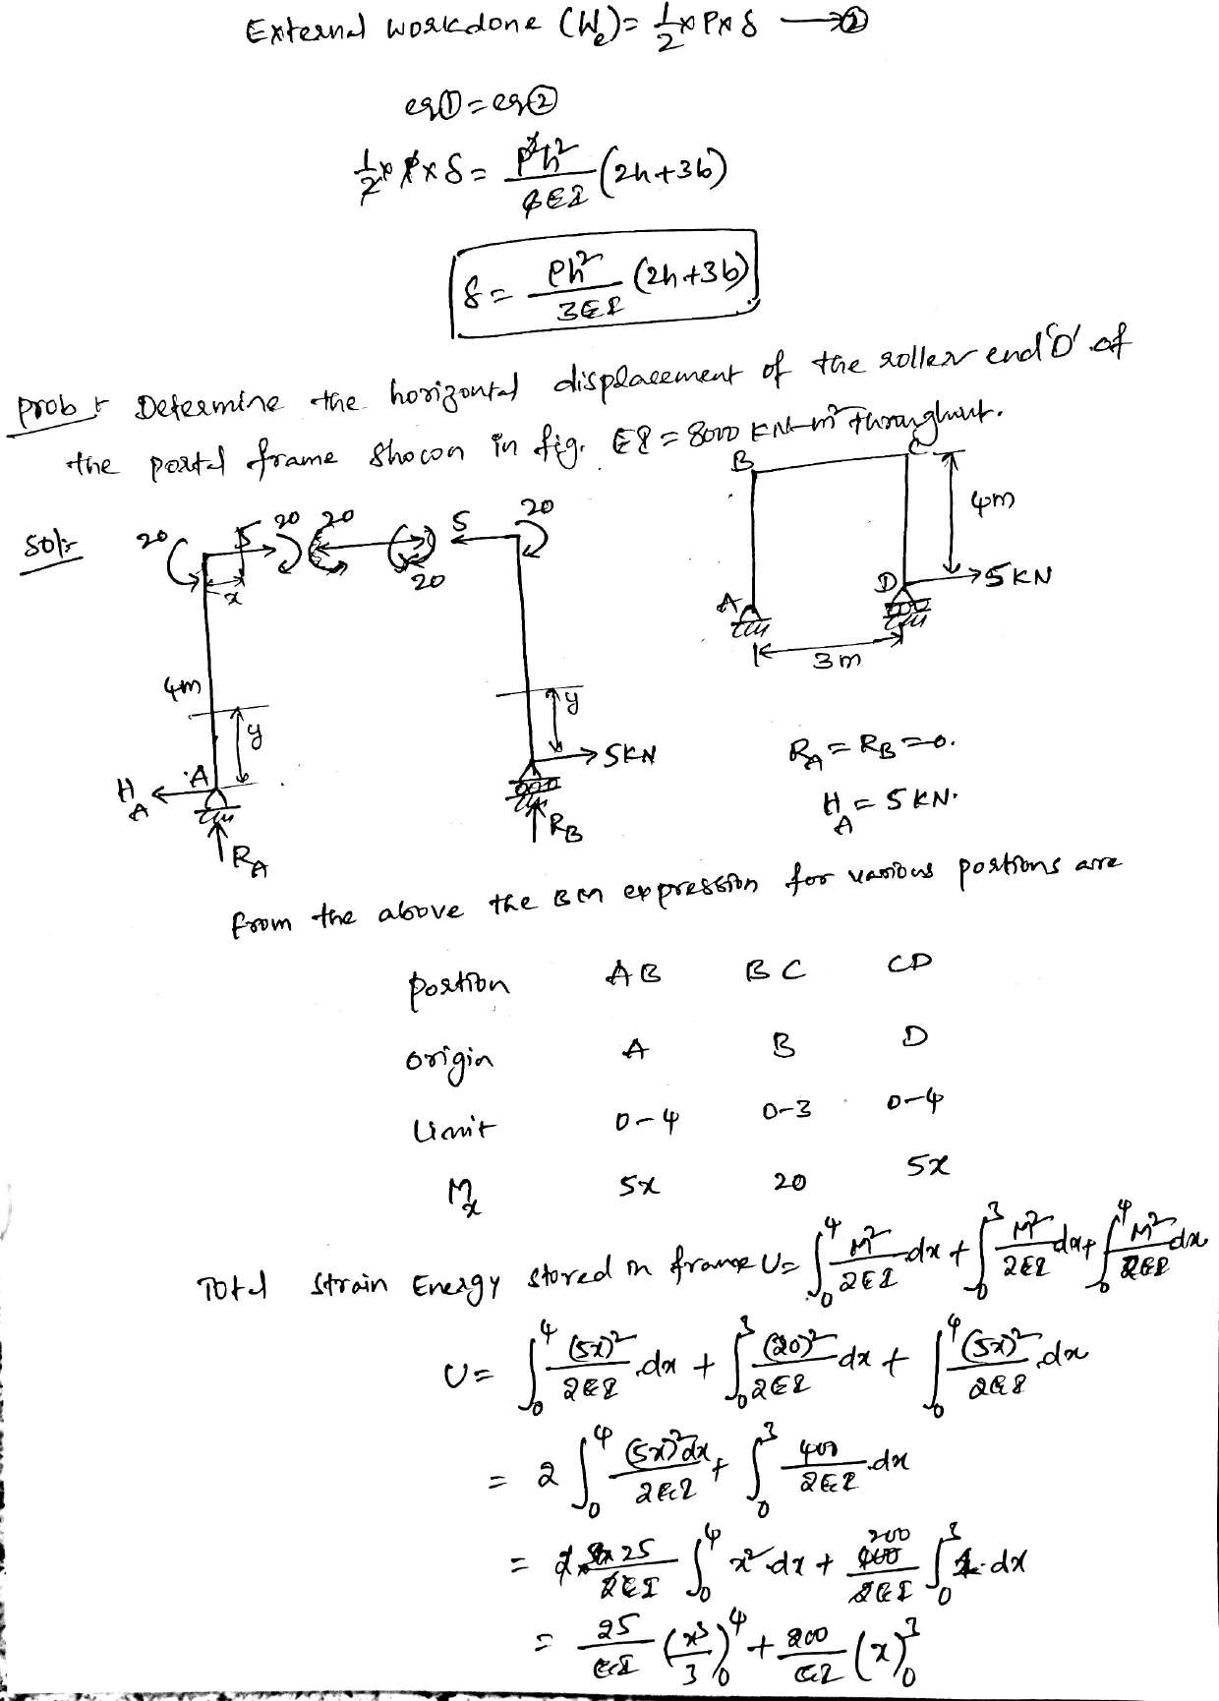

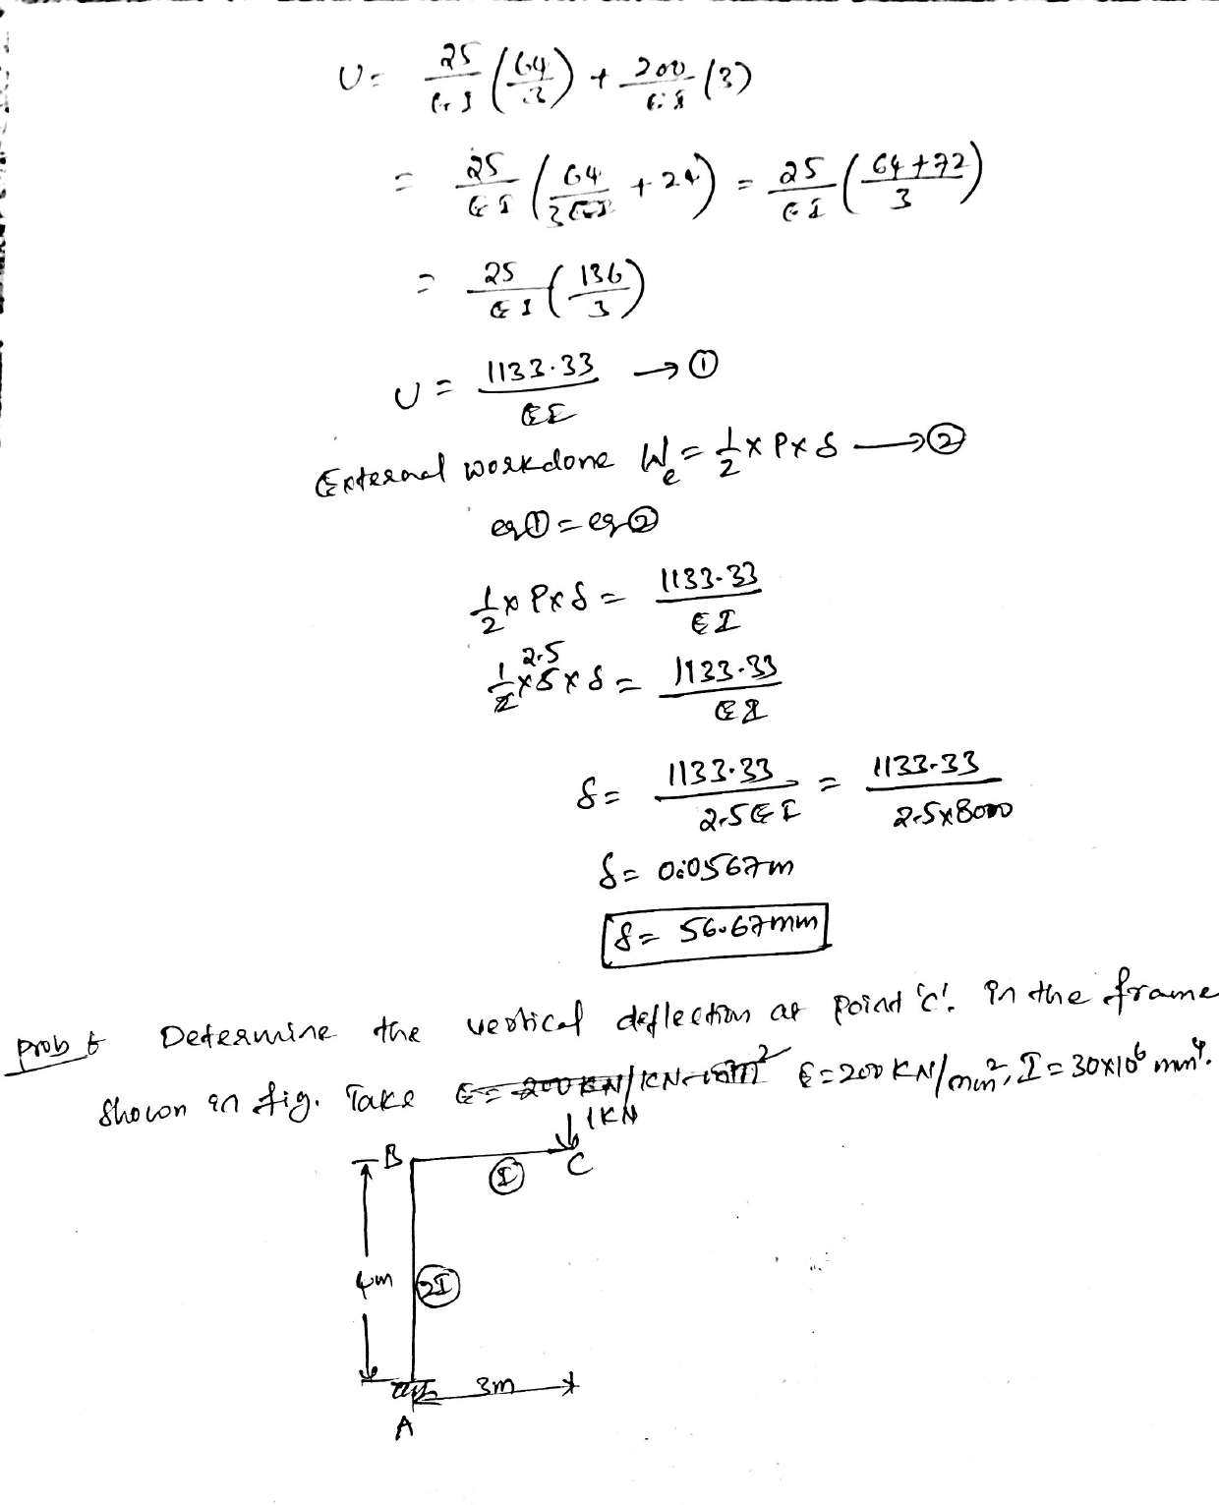

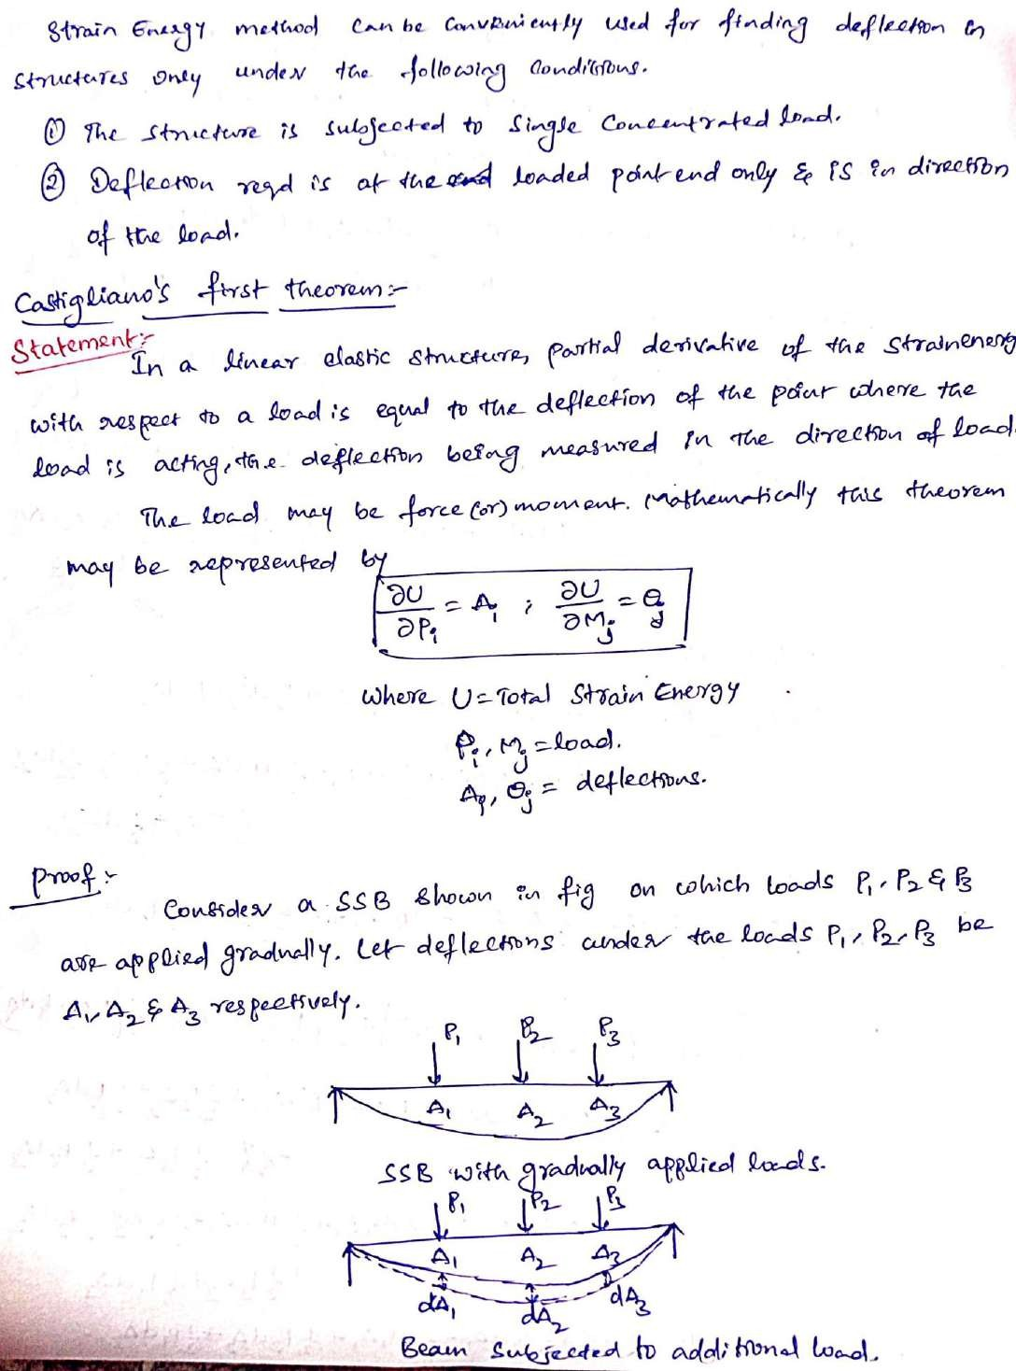

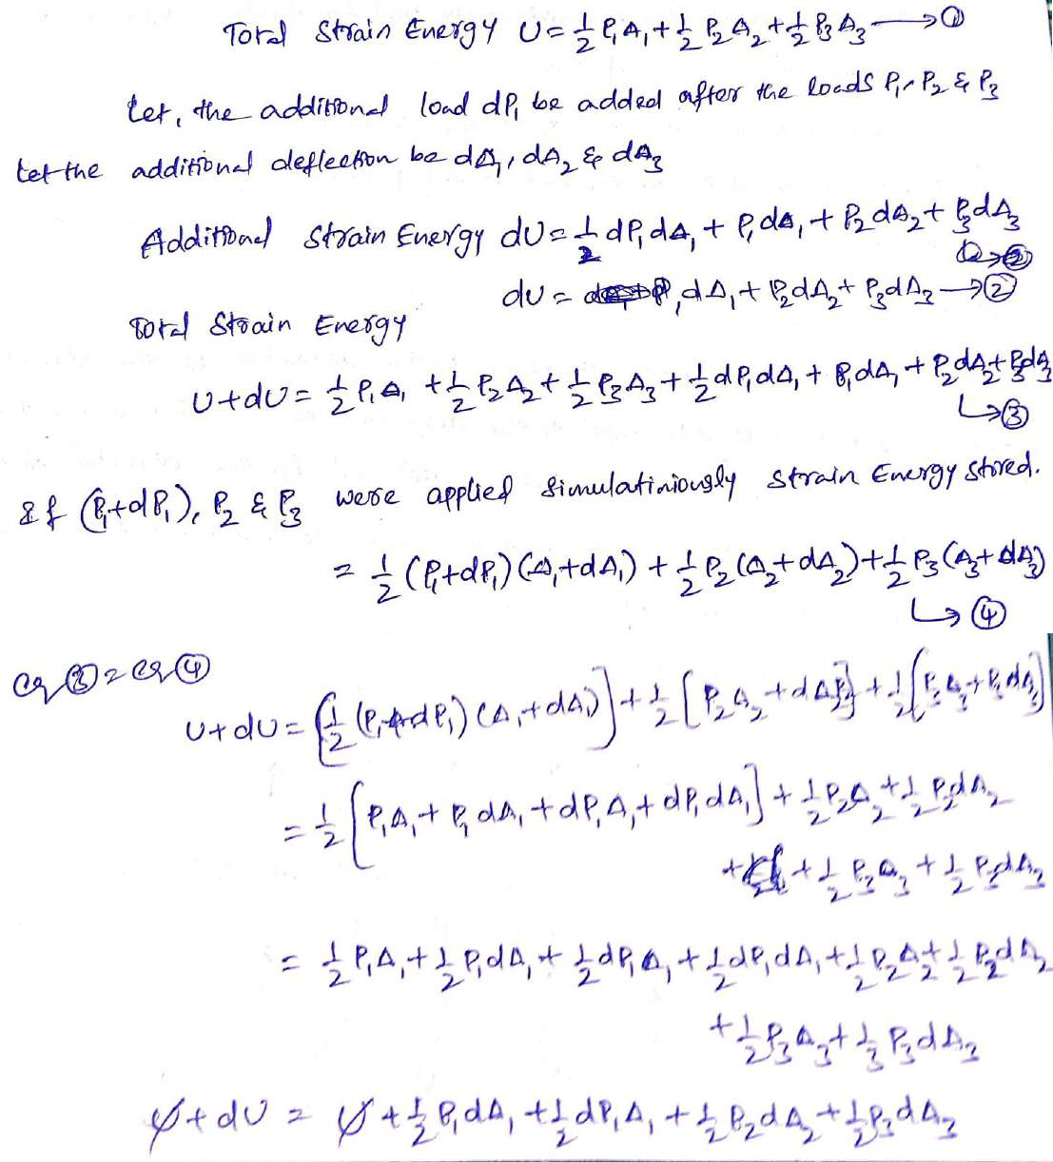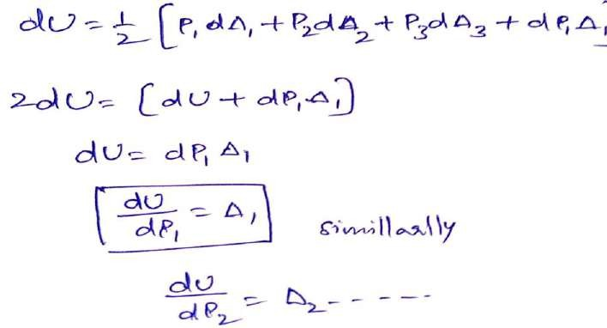

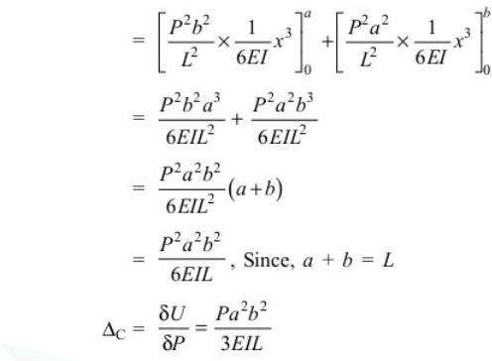
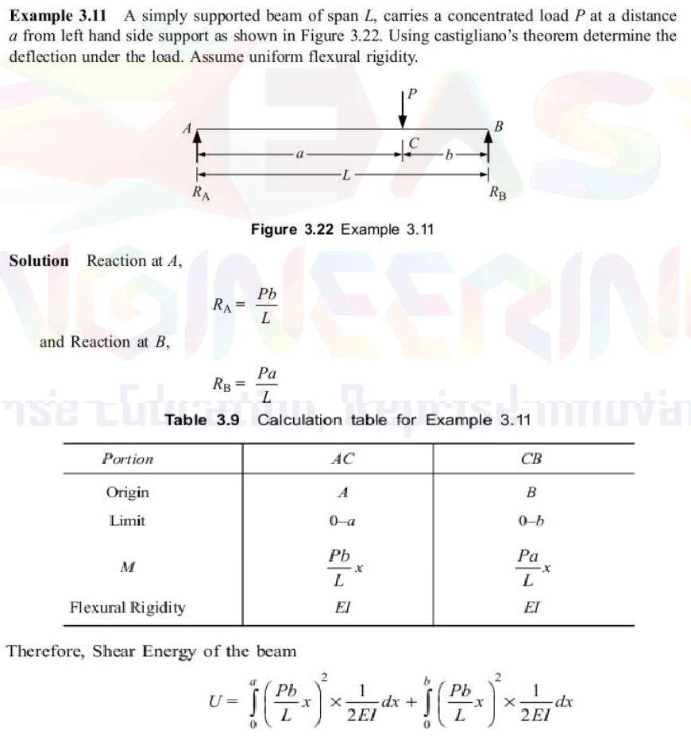

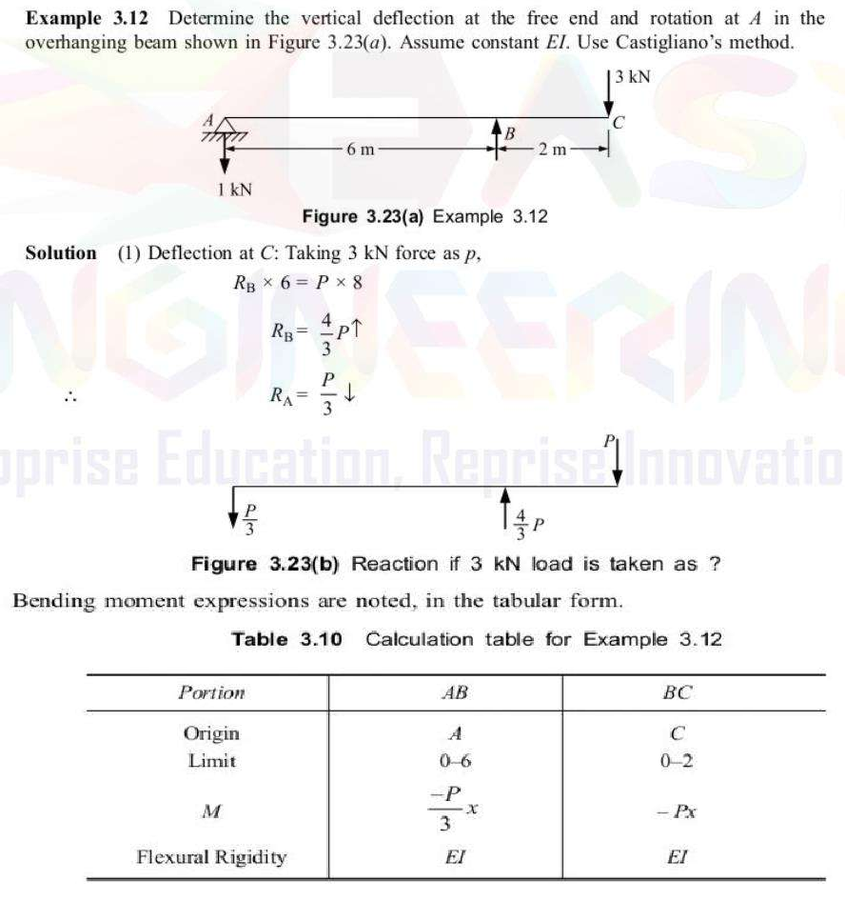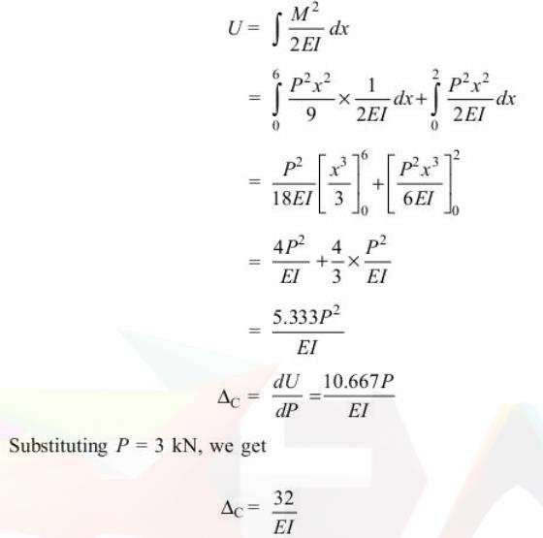

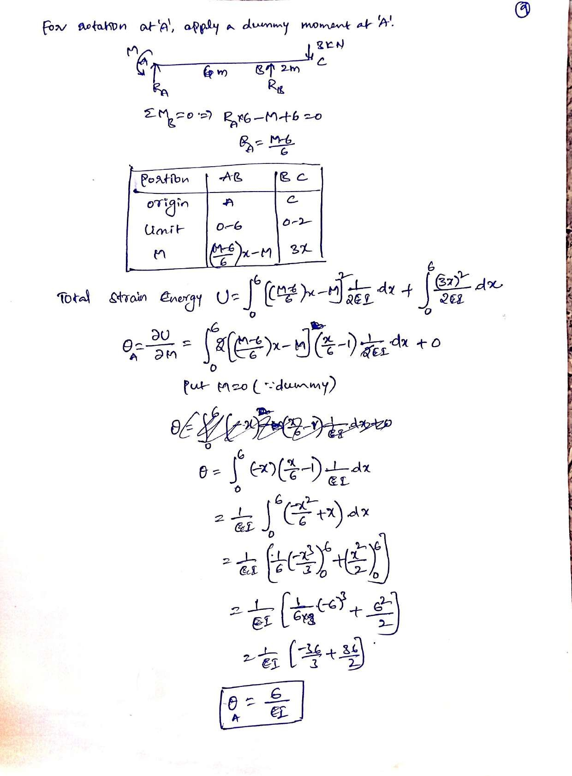

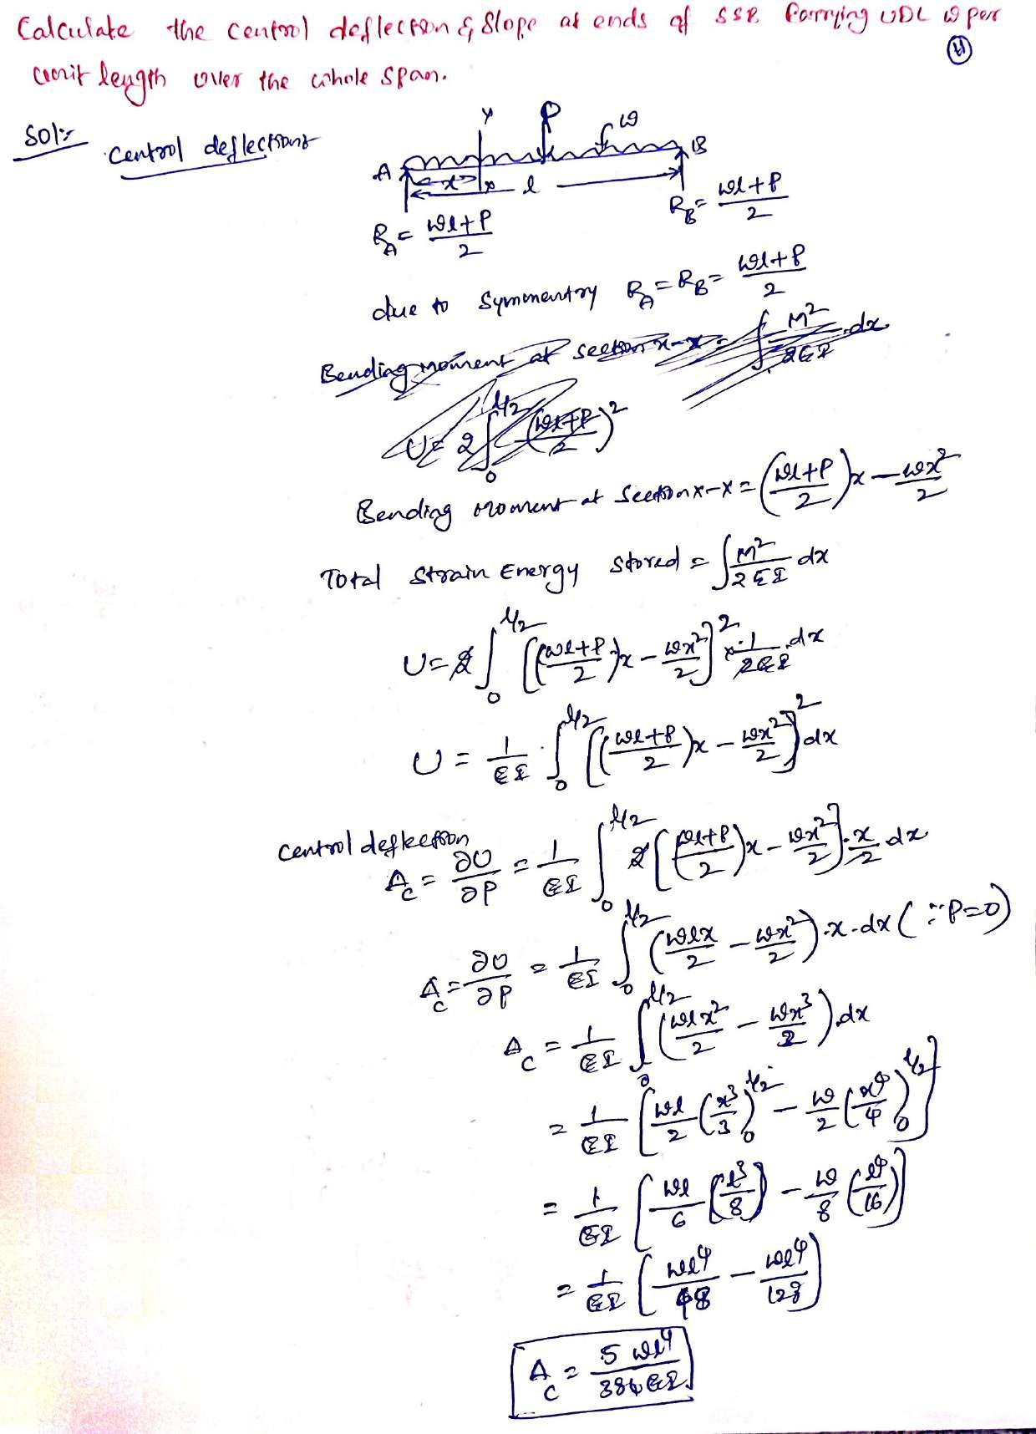

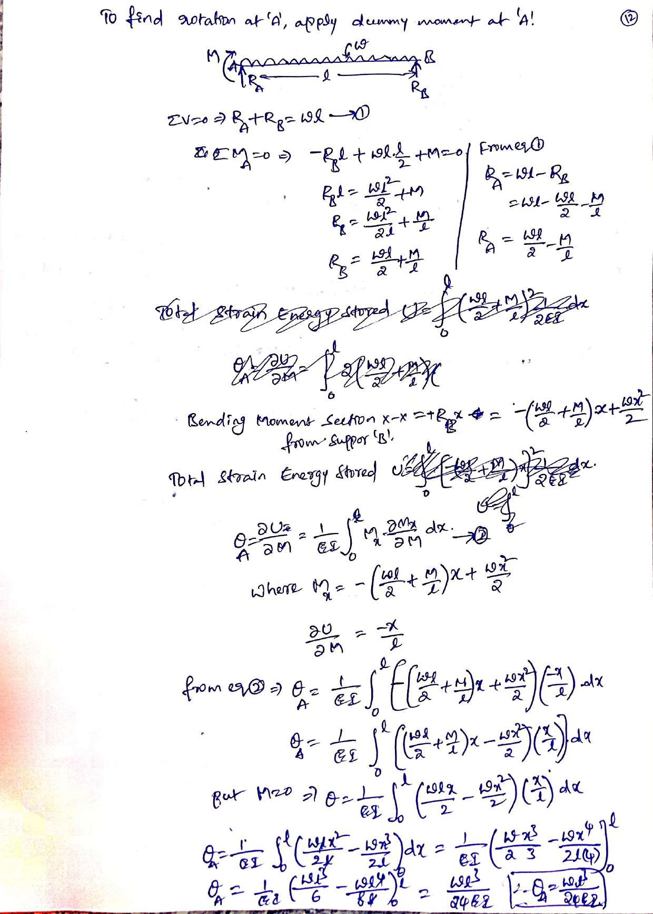

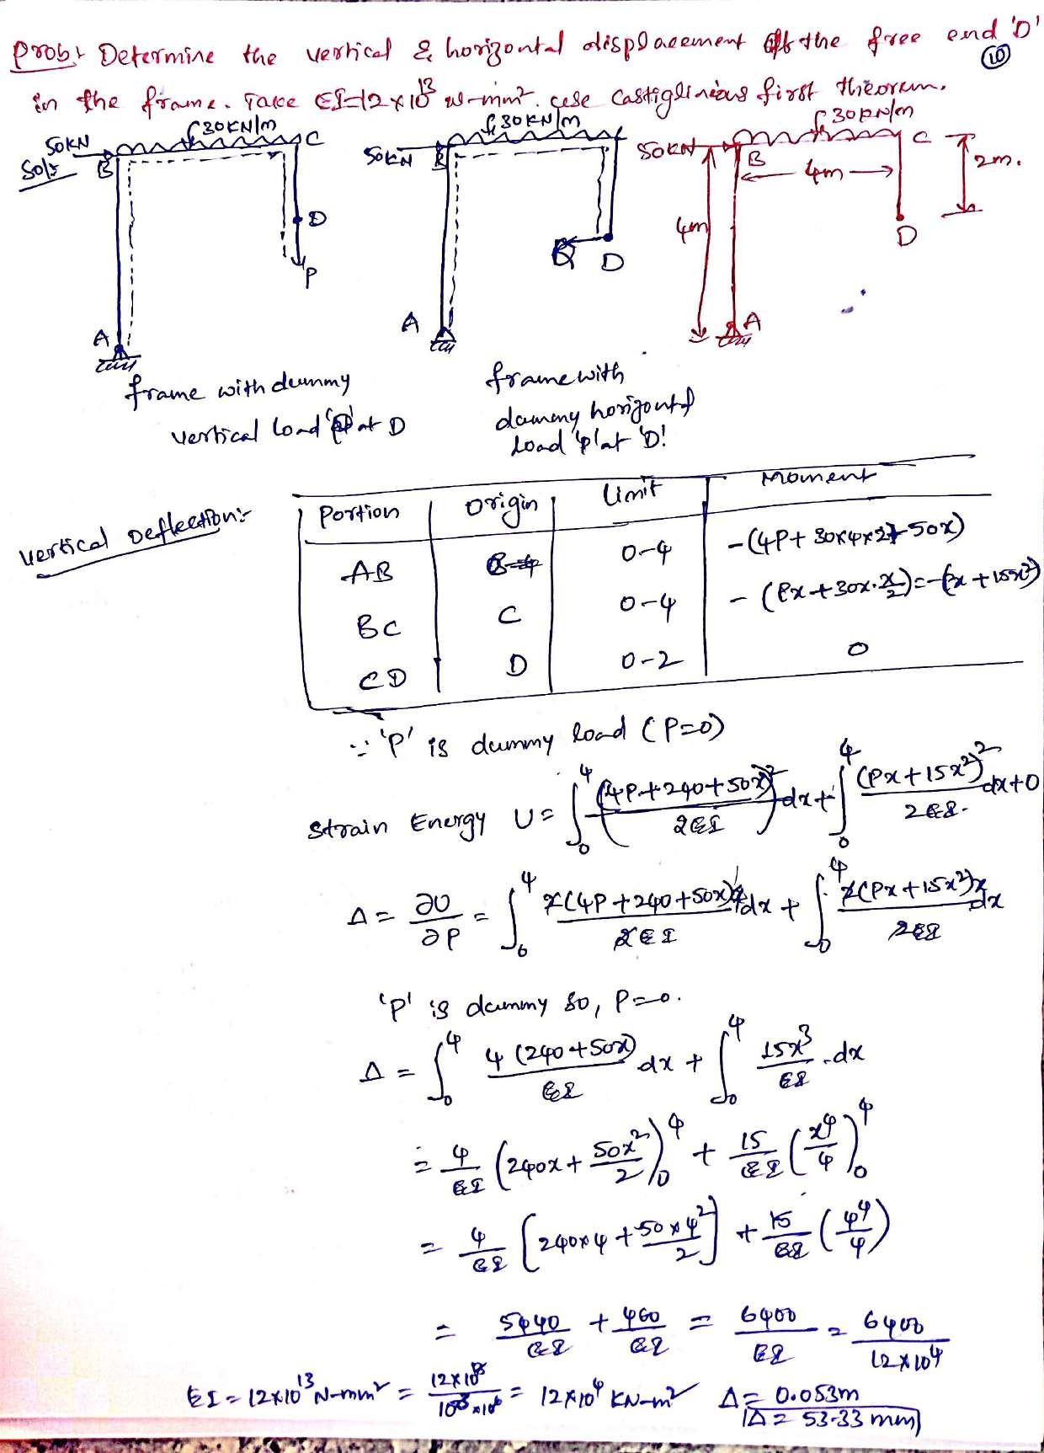

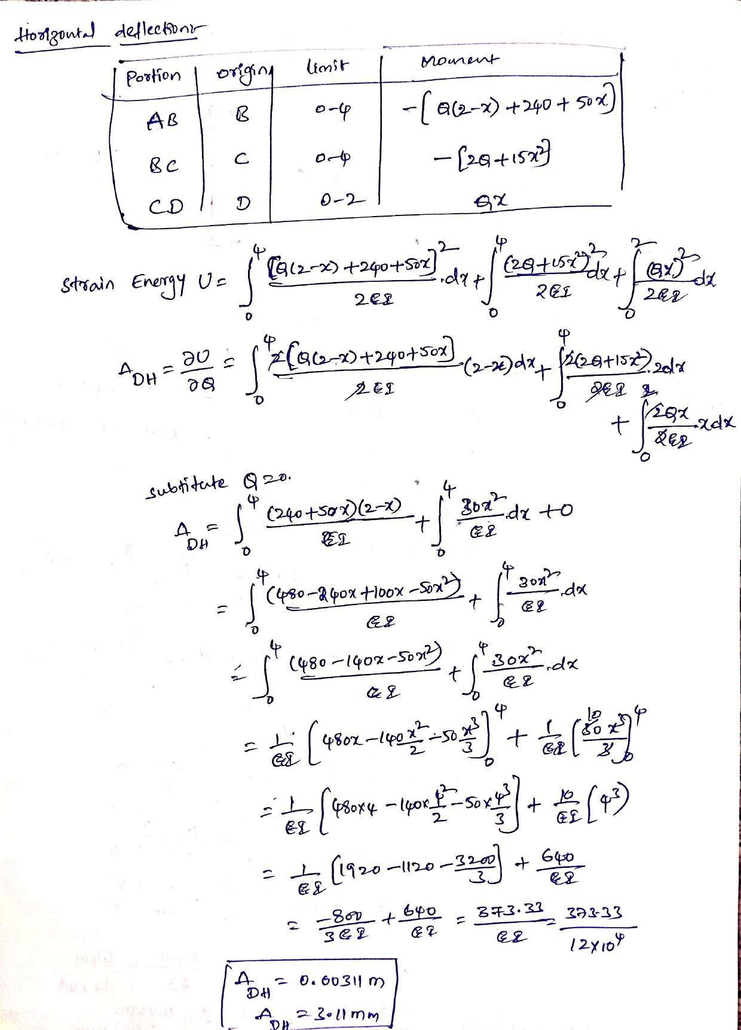

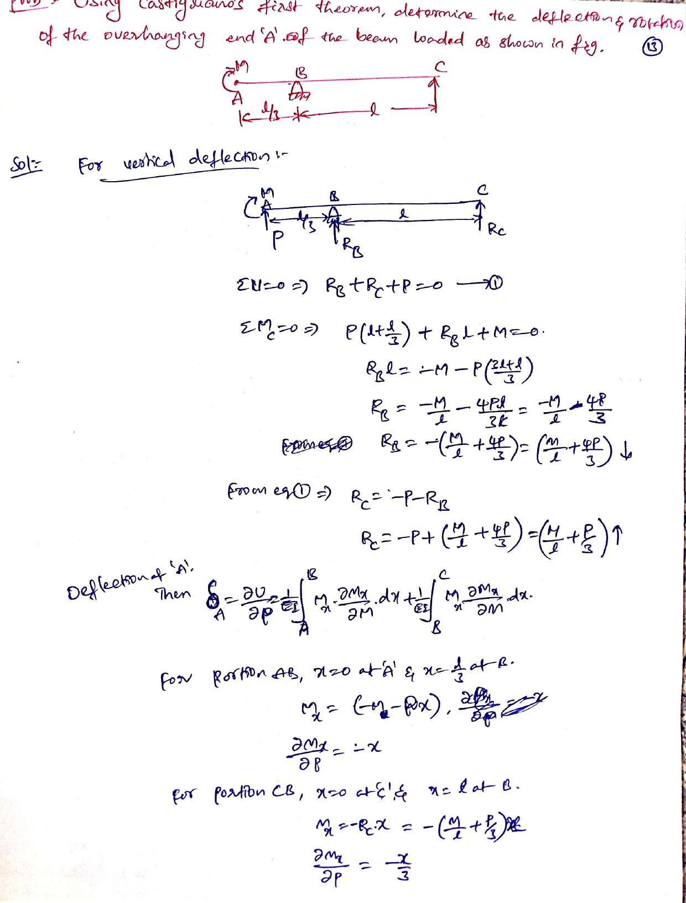

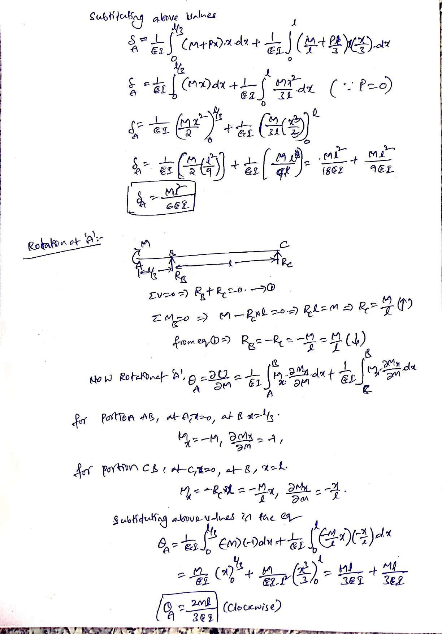

Castigliano’s Theorems:
The theorem of least work derives from what is known as Castigliano’s second theorem. So, let’s first state the two theorems of Carlo Alberto Castigliano (1847-1884) who was an Italian railroad engineer. In 1879, Castigliano published two theorems.

Castigliano’s first theorem
The first partial derivative of the total internal energy (strain energy) in a structure with respect to any particular deflection component at a point is equal to the force applied at that point and in the direction corresponding to that deflection component.

This first theorem is applicable to linearly or nonlinearly elastic structures in which the temperature is constant and the supports are unyielding.
Castigliano’s second theorem
The first partial derivative of the total internal energy in a structure with respect to the force applied at any point is equal to the deflection at the point of application of that force in the direction of its line of action.

The second theorem of Castigliano is applicable to linearly elastic (Hookean material) structures with constant temperature and unyielding supports.

Note that in the above statements, force may mean point force or couple (moment) and displacement may mean translation or angular rotation. Proofs of Castigliano’s theorems are given at the end of this document.

Without further due, here is the theorem of least work, a.k.a. Castigliano’s theorem of least work:

The redundant reaction components of a statically indeterminate structure are such that they make the internal work (strain energy) a minimum.
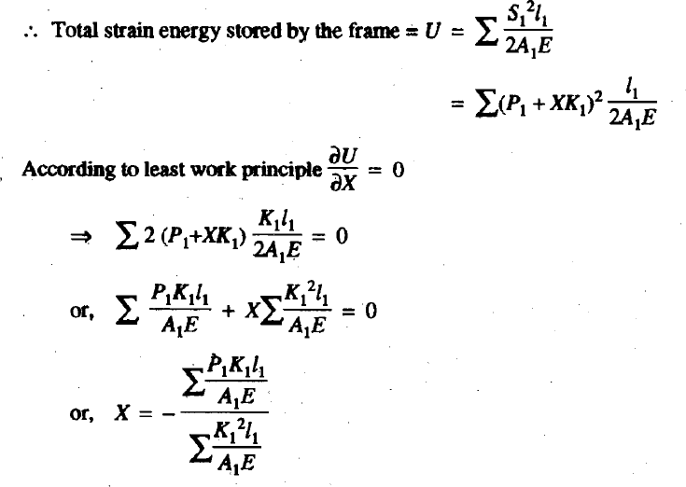

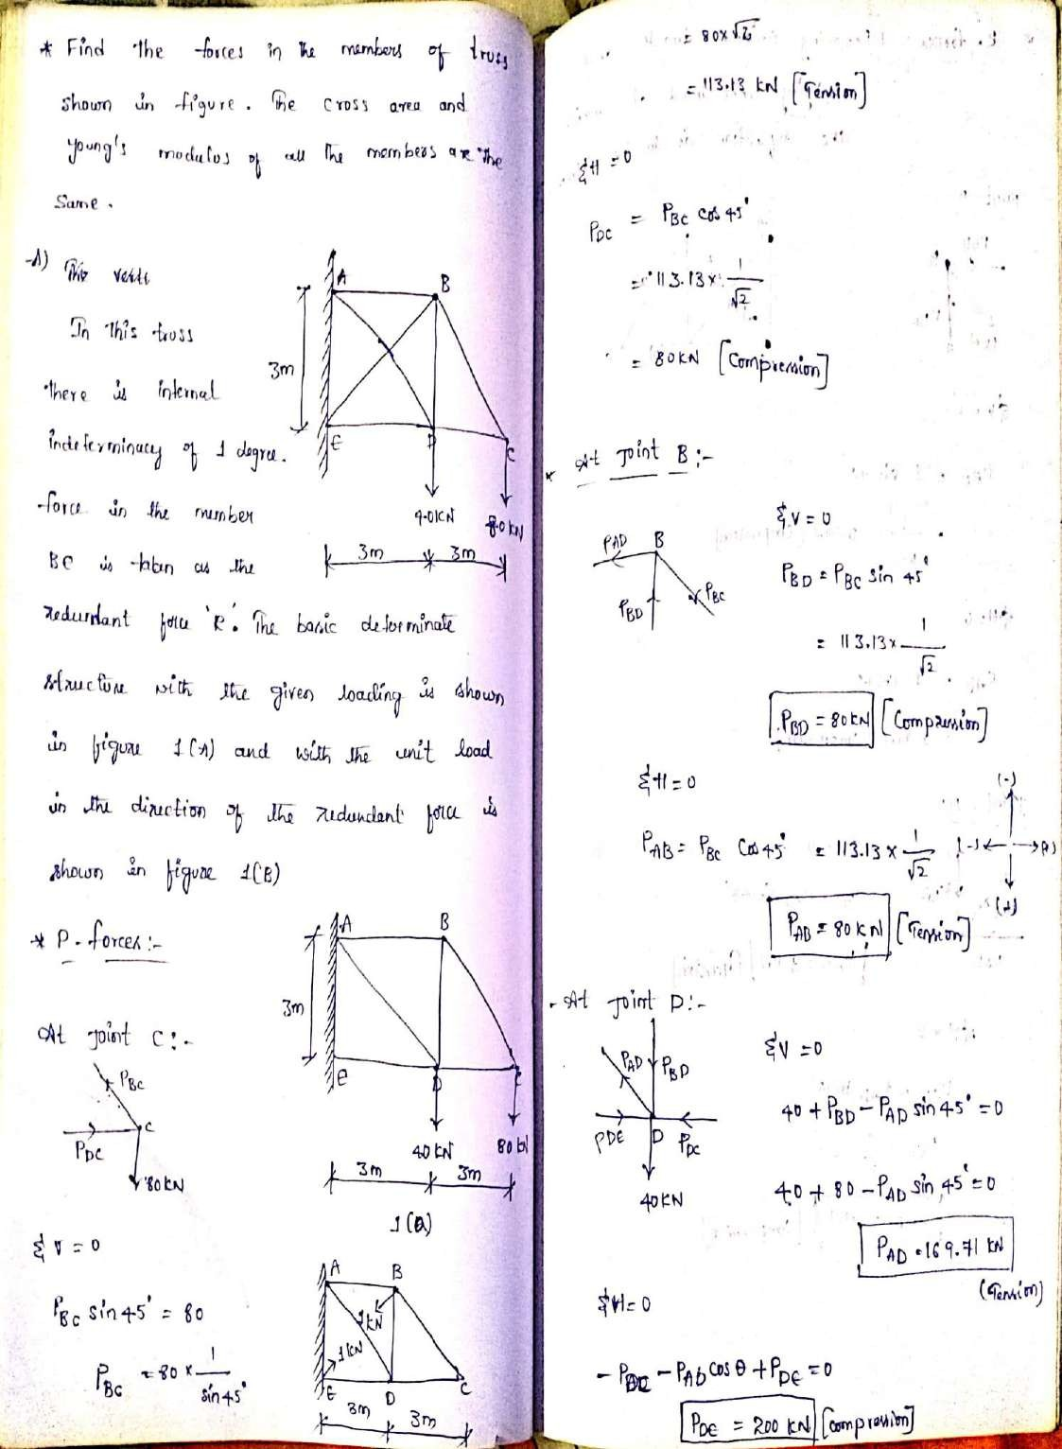

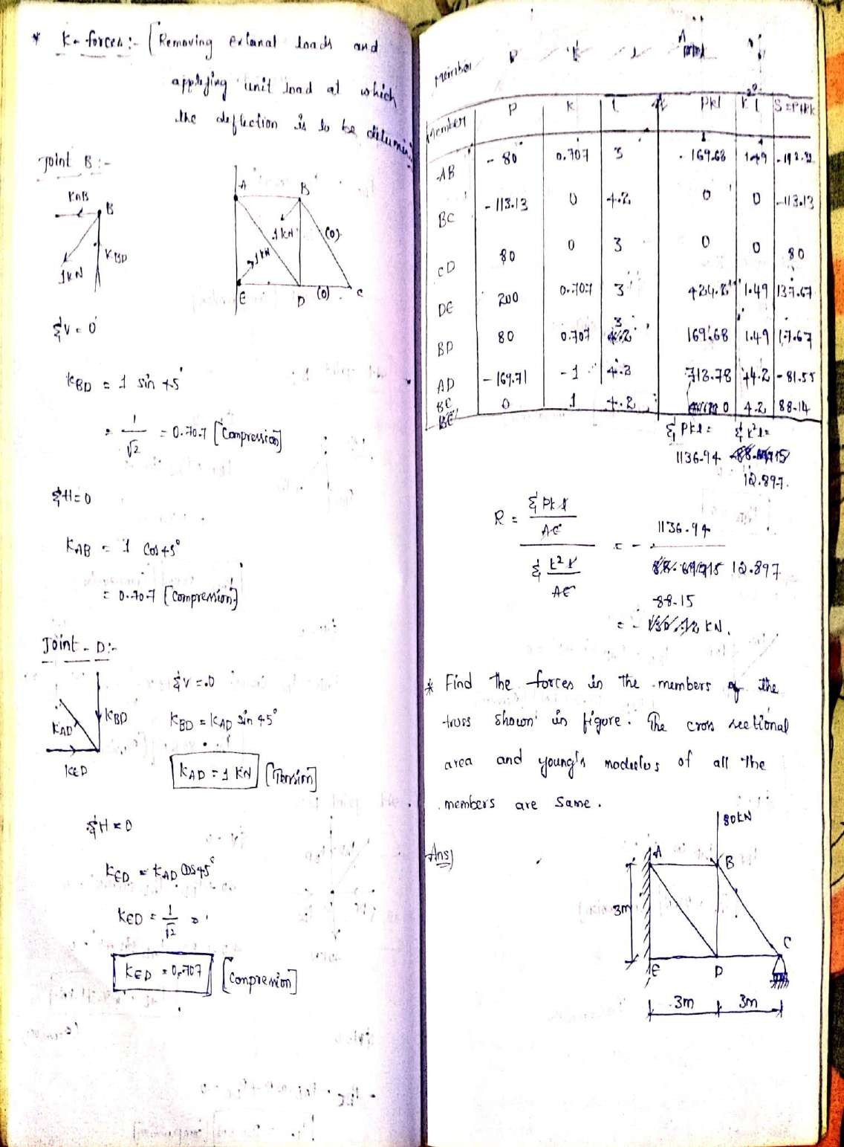

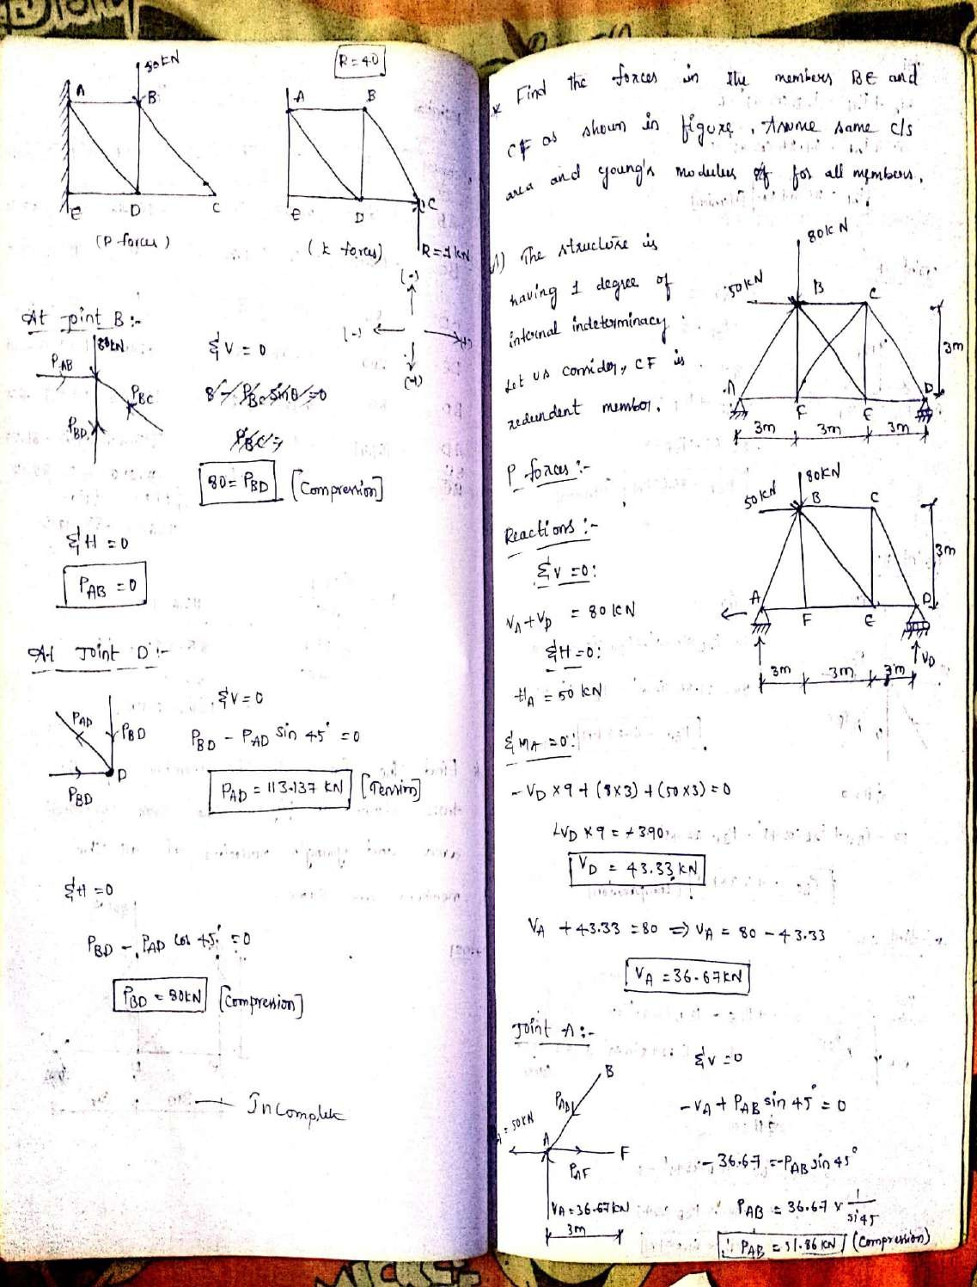

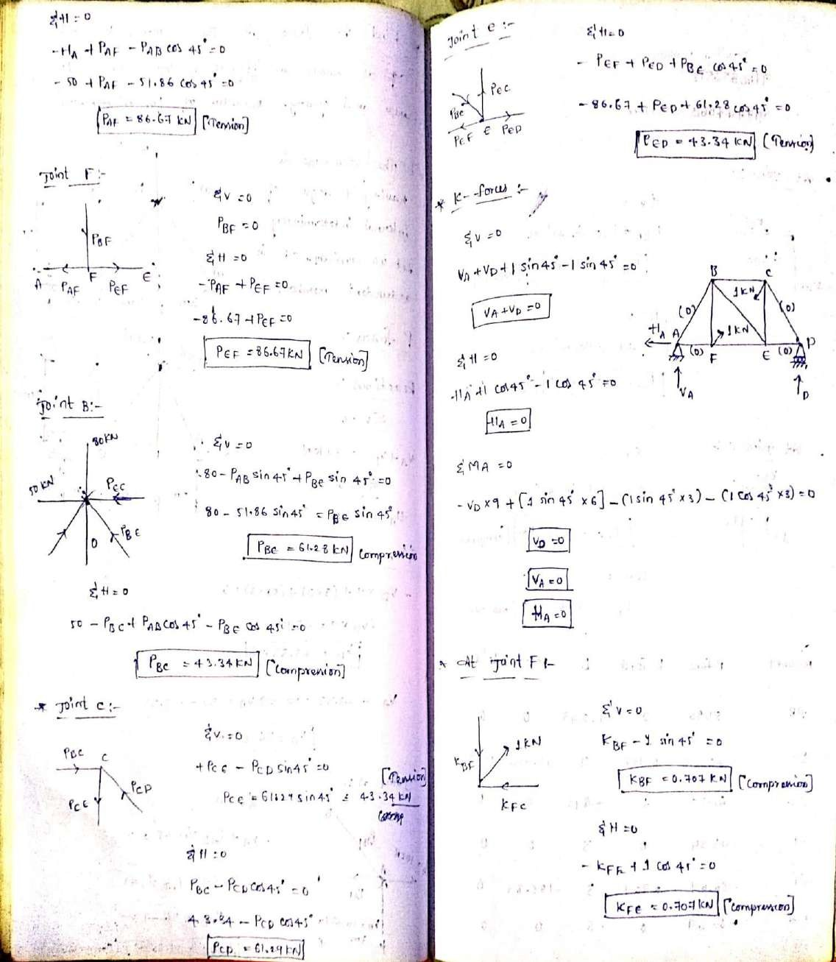

FIXED BEAMS

FIXED BEAMS
- A beam whose both ends are ﬁxed is known as a ﬁxed beam. Fixed beam is also called as built-in or encaster beam.
- 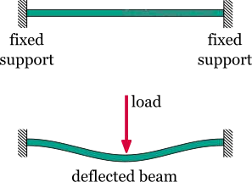Incase of ﬁxed beam both its ends are rigidly ﬁxed and the slope and deﬂection at the ﬁxed ends are zero

Advantages of ﬁxed beams
  - For the same loading, the maximum deﬂection of a ﬁxed beam is less than that of a simply supported beam.
  - For the same loading, the ﬁxed beam is subjected to lesser maximum bending moment.
  - The slope at both ends of a ﬁxed beam is zero.
  - The beam is more stable and stronger.

(i)

(ii)

(iii)

(iv)

Disadvantages of a ﬁxed beam
Large stresses are set up by temperature changes.
Special care has to be taken in aligning supports accurately at the same level.
Large stresses are set if a little sinking of one support takes place.
Frequent ﬂuctuations in loading render the degree of ﬁxity at the ends very uncertain

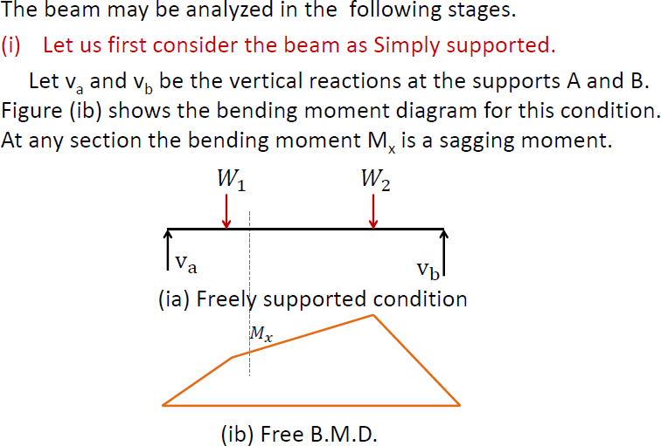

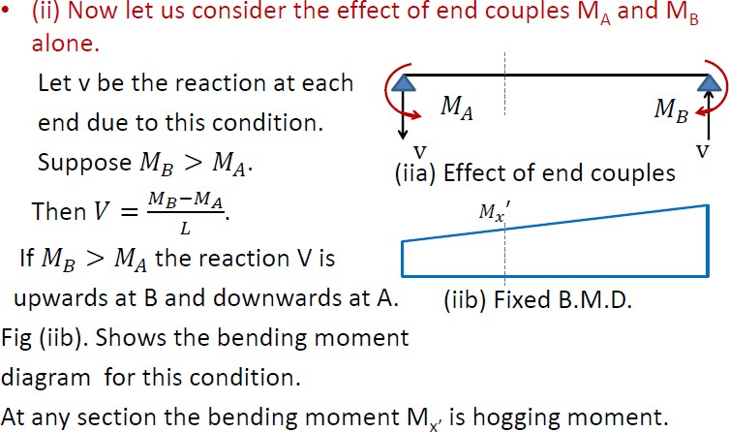

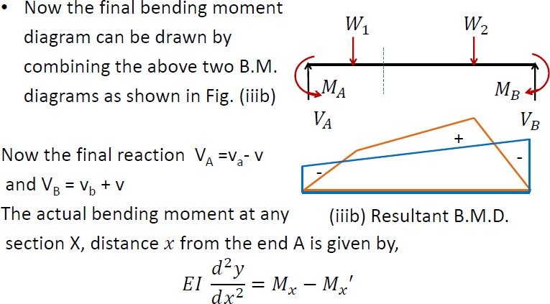

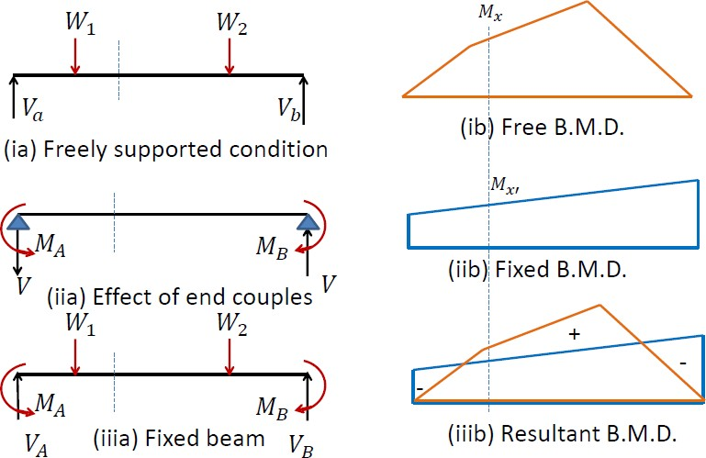

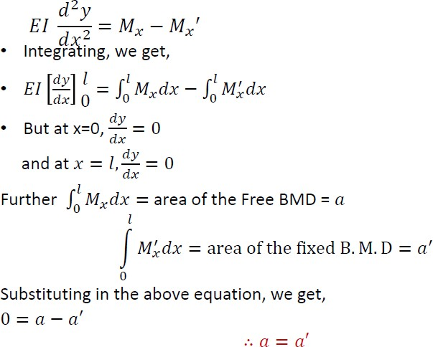

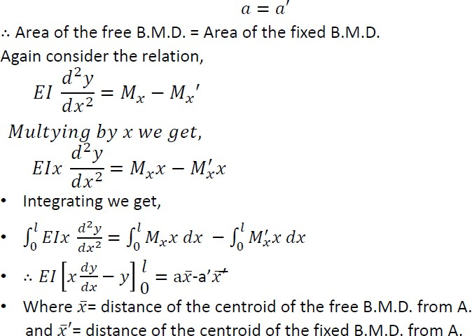

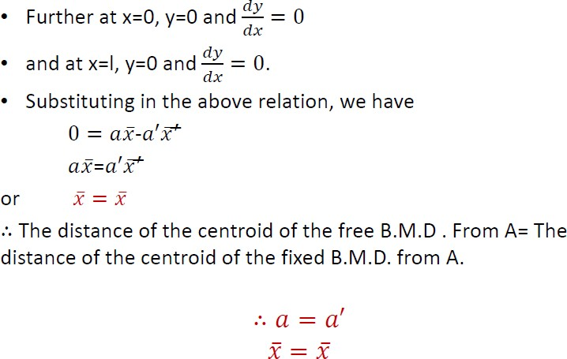

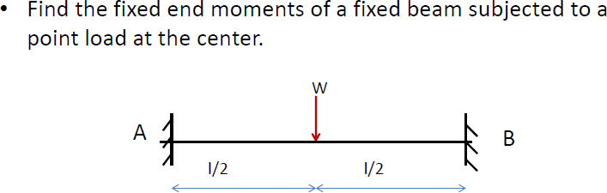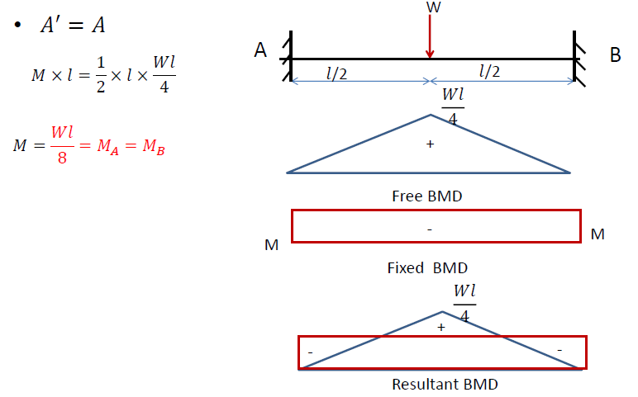

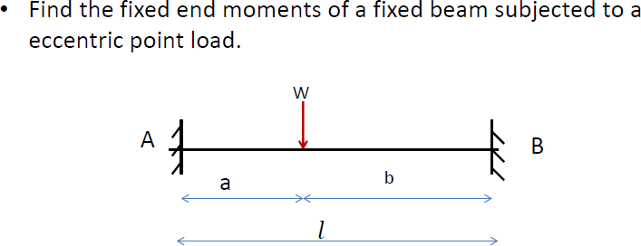
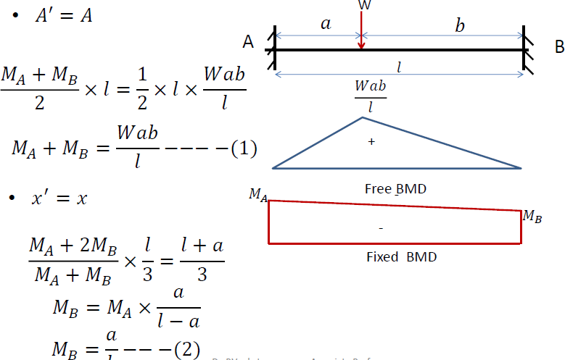

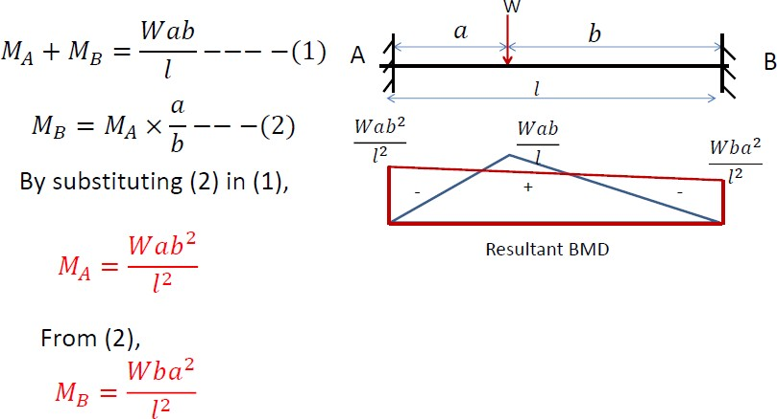

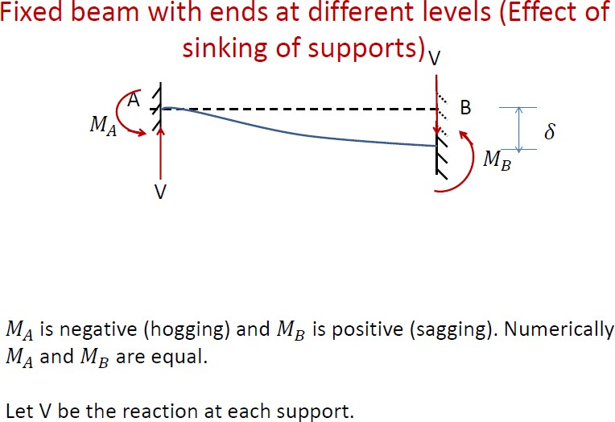

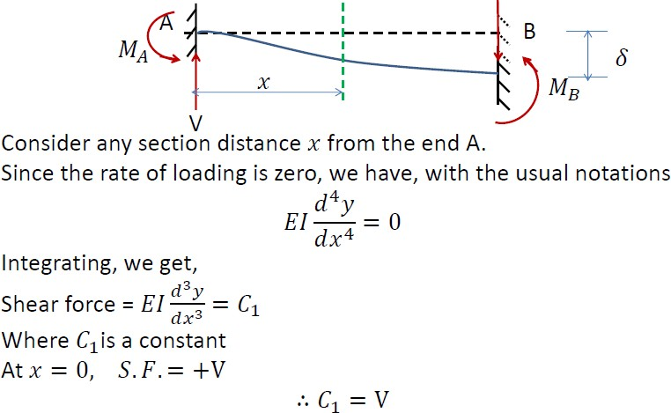

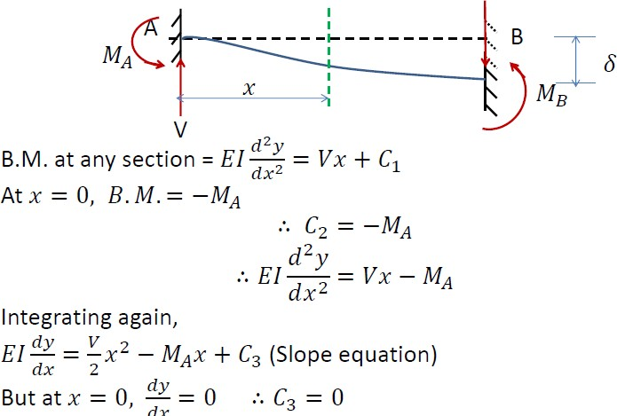

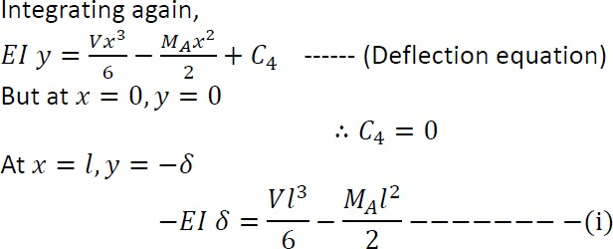
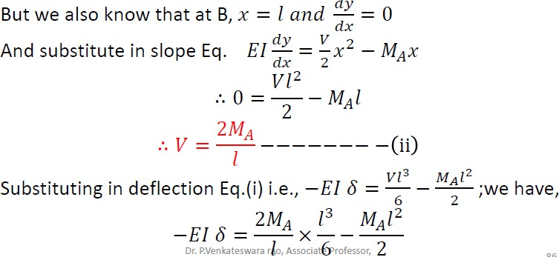

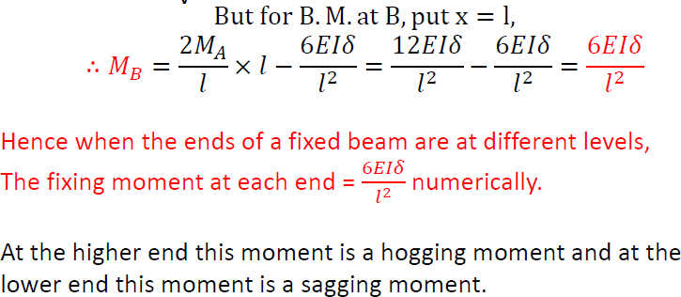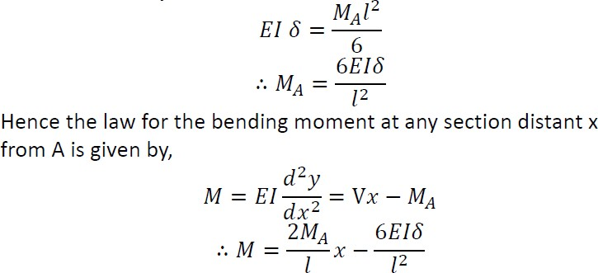

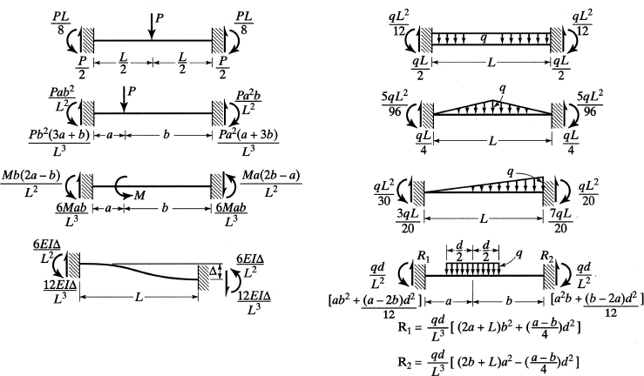

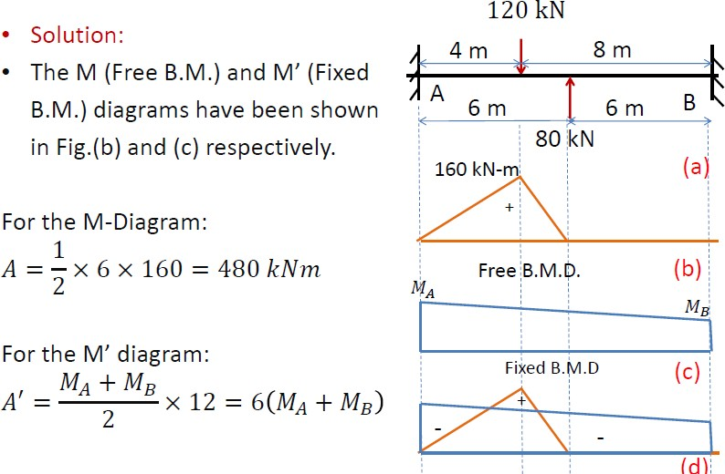

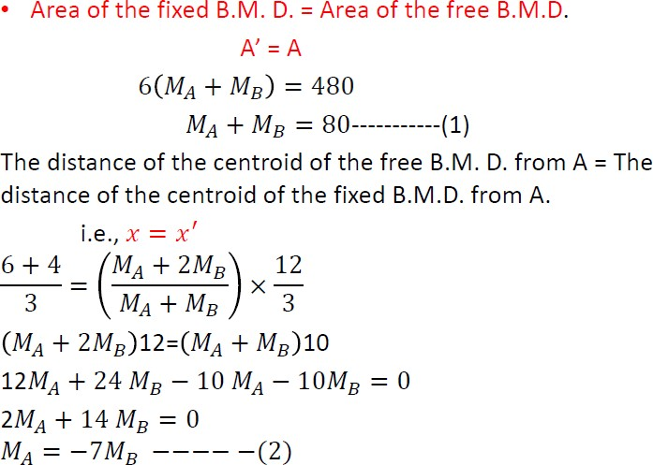

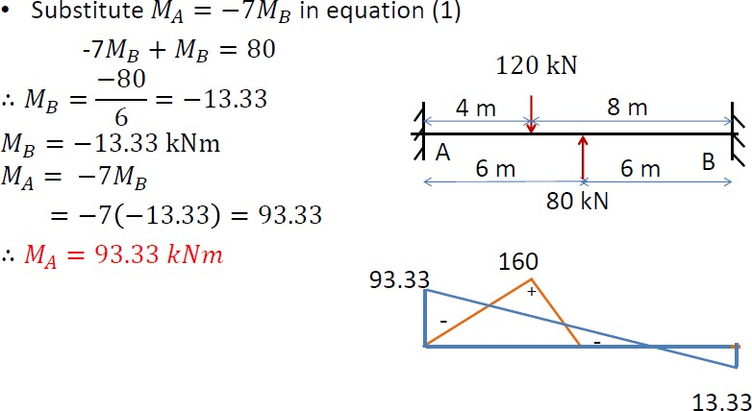

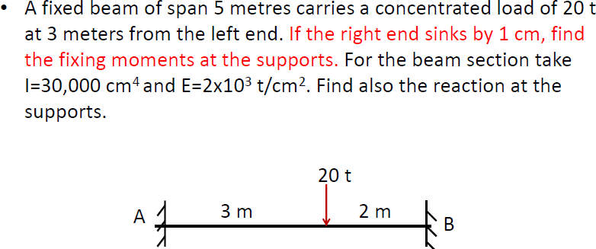

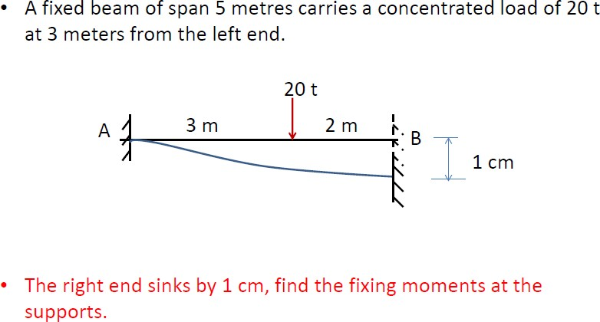

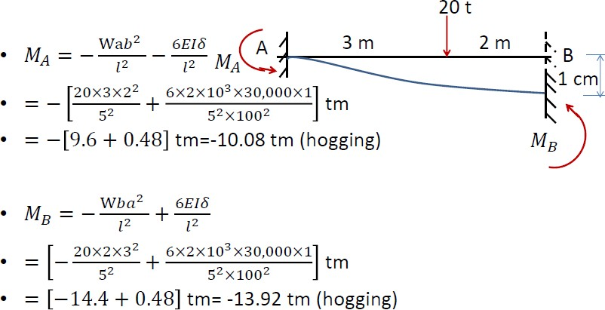

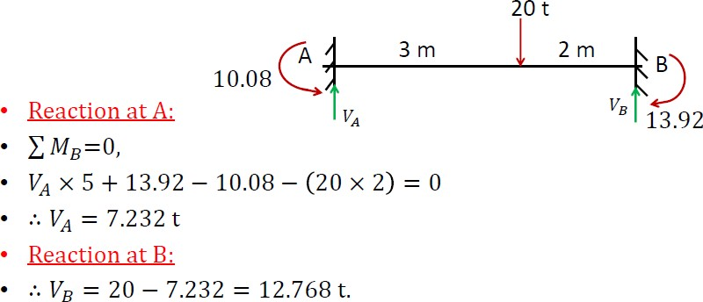

Continuous Beams

Introduction:

Beams are made continuous over the supports to increase structural integrity.
A continuous beam provides an alternate load path in the case of failure at a section.

In regions with high seismic risk, continuous beams and frames are preferred in buildings and bridges.
A continuous beam is a statically indeterminate structure.
•

The advantages of a continuous beam as compared to a simply supported beam are as follows

- For the same span and section, vertical load capacity is more.
- Mid span deﬂection is less.
- The depth at a section can be less than a simply supported beam for the same span. Else, for the same depth the span can be more than a simply supported beam.
⇒ The continuous beam is economical in material.
- There is redundancy in load path.
⇒ Possibility of formation of hinges in case of an extreme event.
- Requires less number of anchorages of tendons.
- For bridges, the number of deck joints and bearings are reduced.
⇒ Reduced maintenance

There are of course several disadvantages of a continuous beam as compared to a simply supported beam.
- Diﬃcult analysis and design procedures.
- Diﬃculties in construction, especially for precast members.
- Increased frictional loss due to changes of curvature in the tendon proﬁle.
- Increased shortening of beam, leading to lateral force on the supporting columns.
- Secondary stresses develop due to time dependent eﬀects like creep and shrinkage, settlement of support and variation of temperature.
- The concurrence of maximum moment and shear near the supports needs proper detailing of reinforcement.
- Reversal of moments due to seismic force requires proper analysis and design.

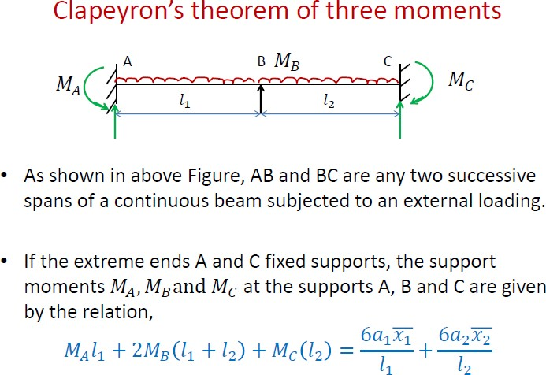

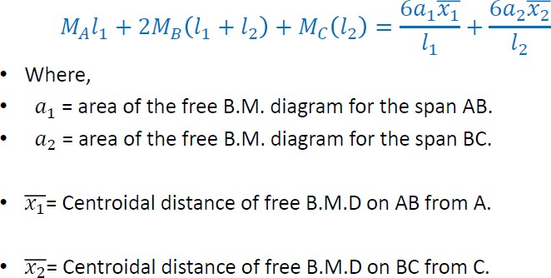

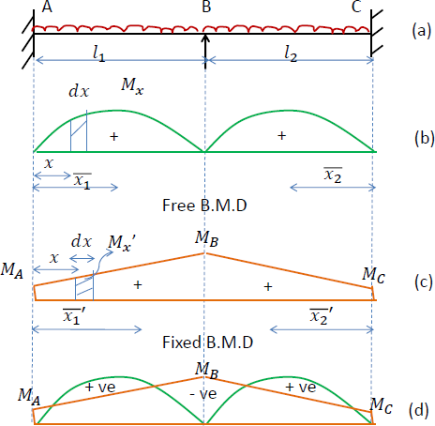

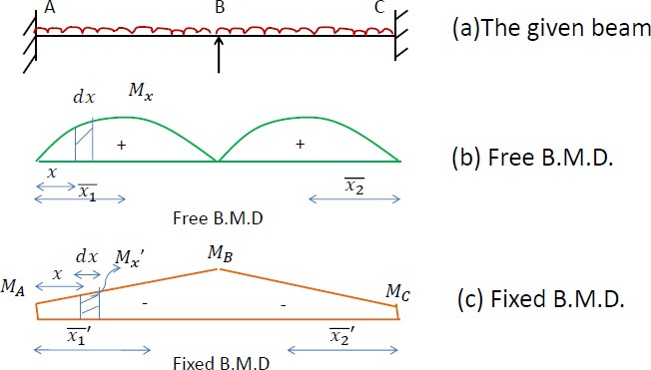

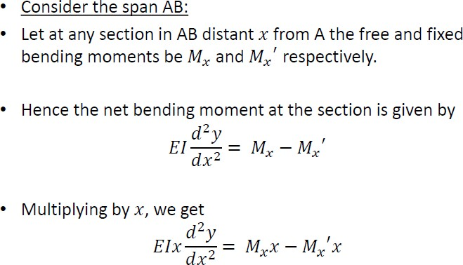

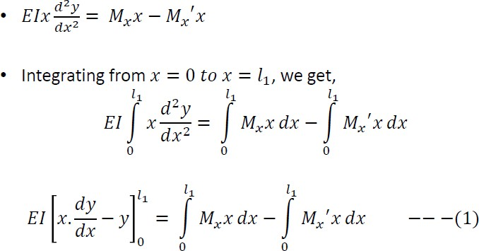

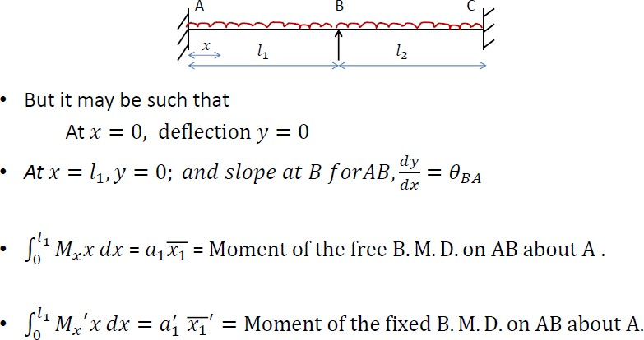

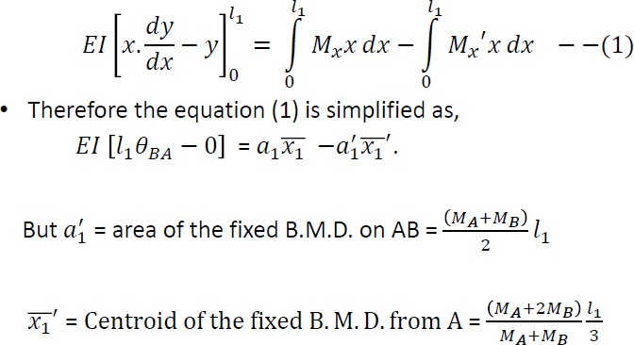

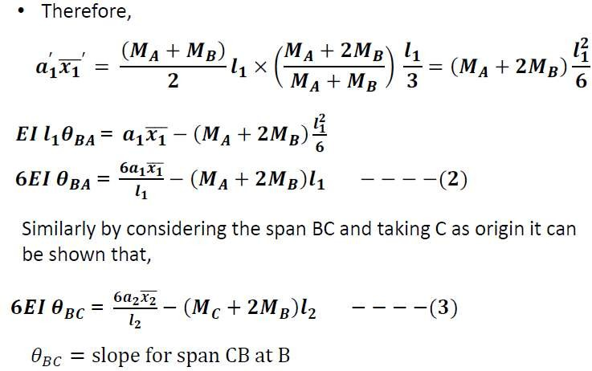

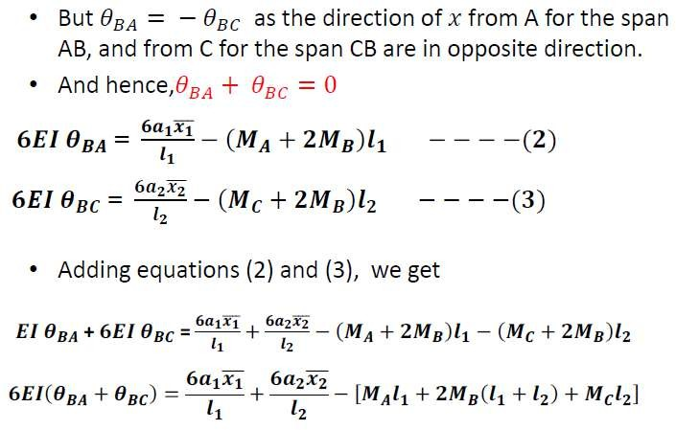
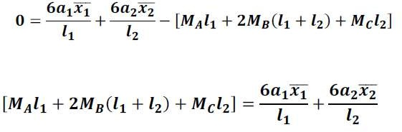

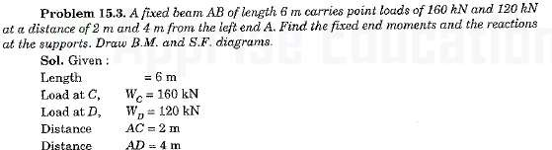
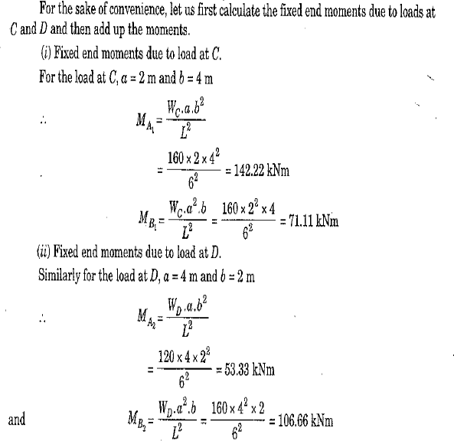
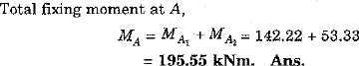
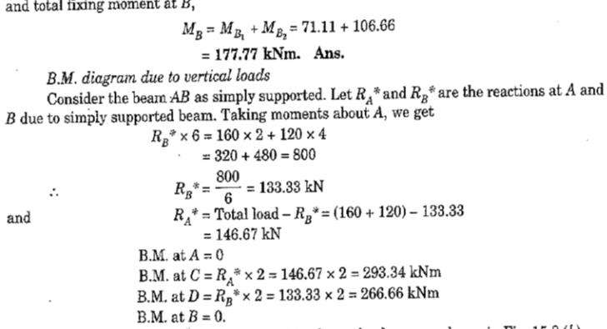

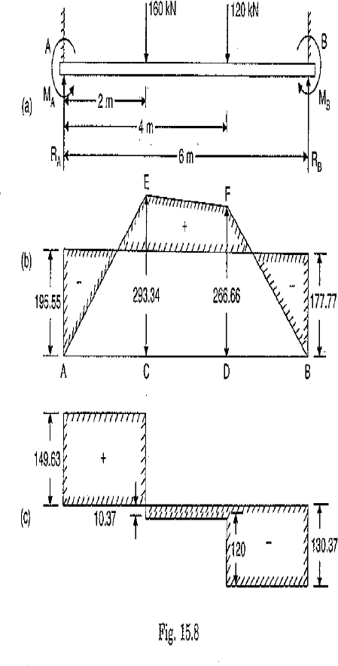
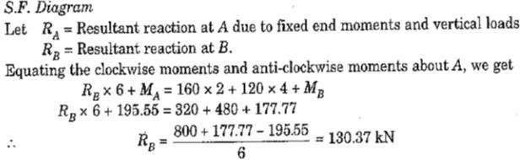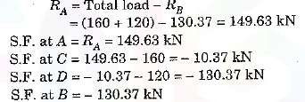

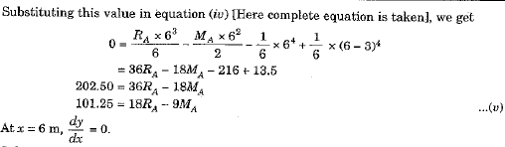
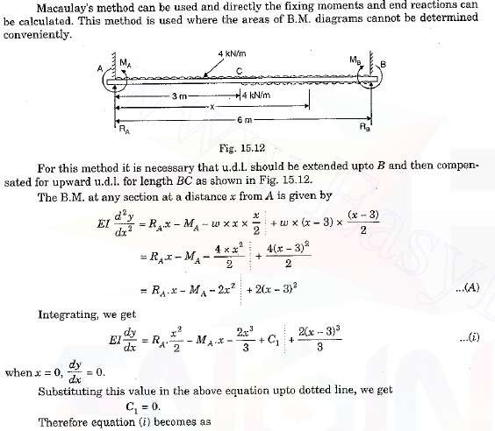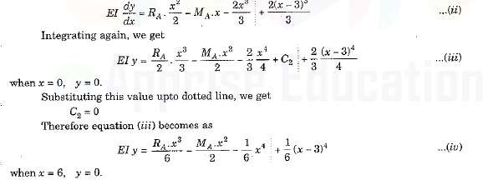

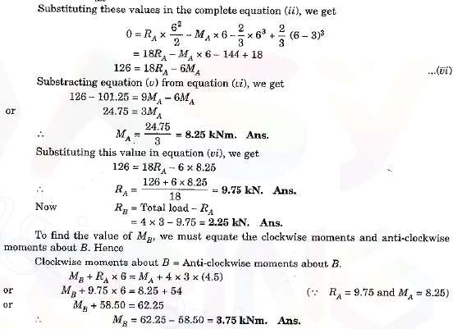

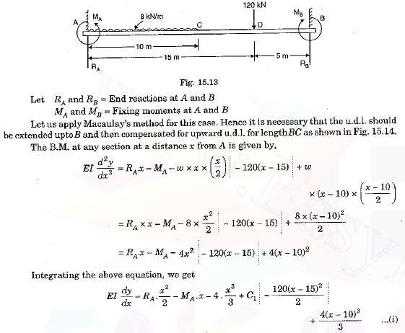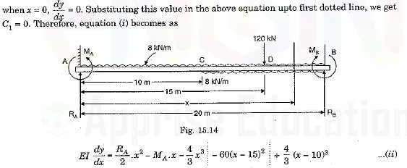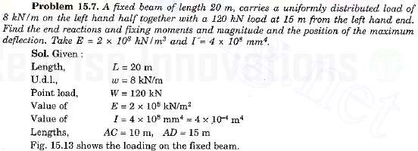

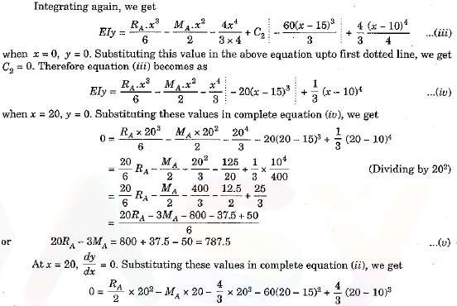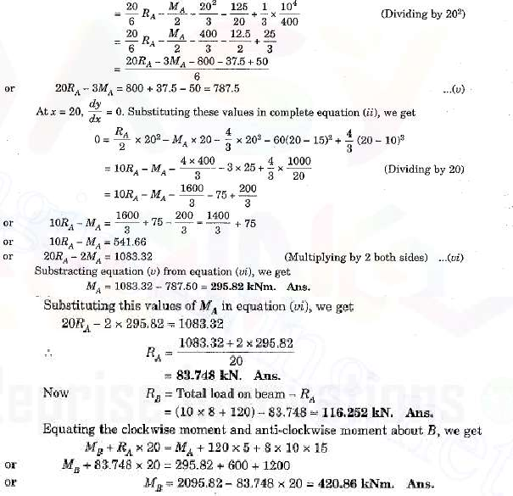

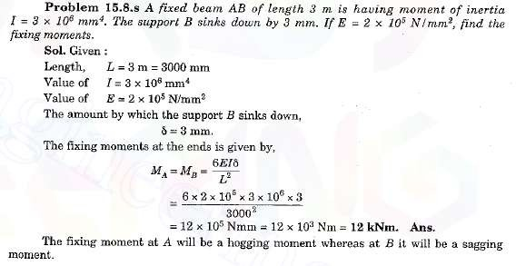

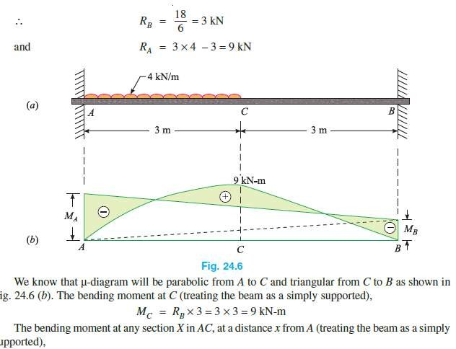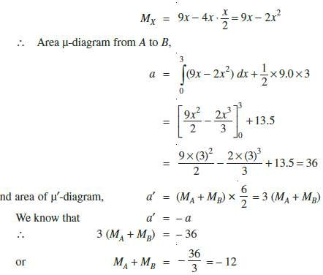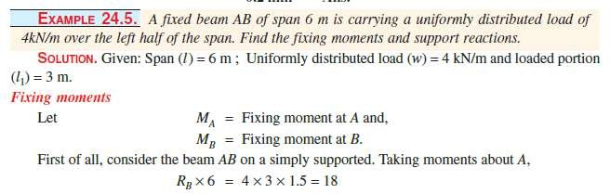

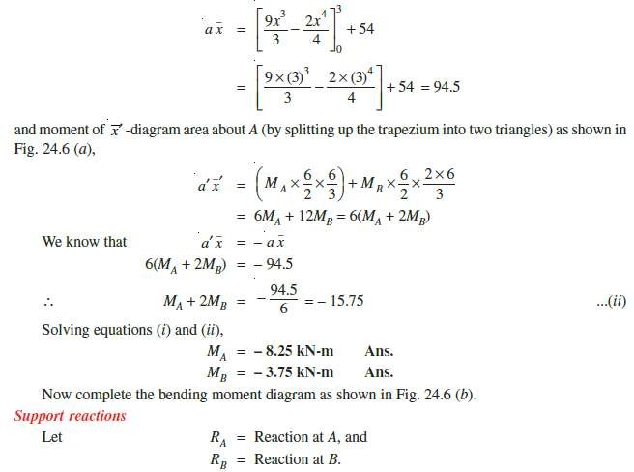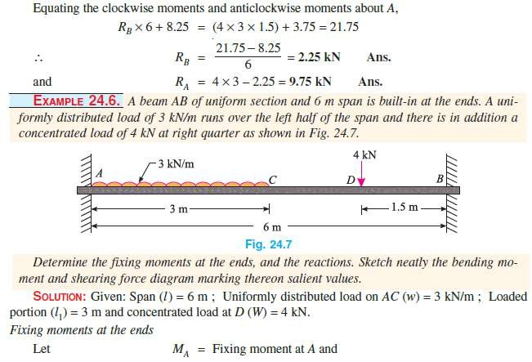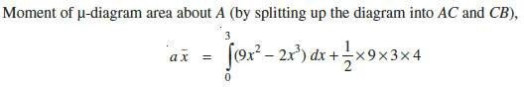

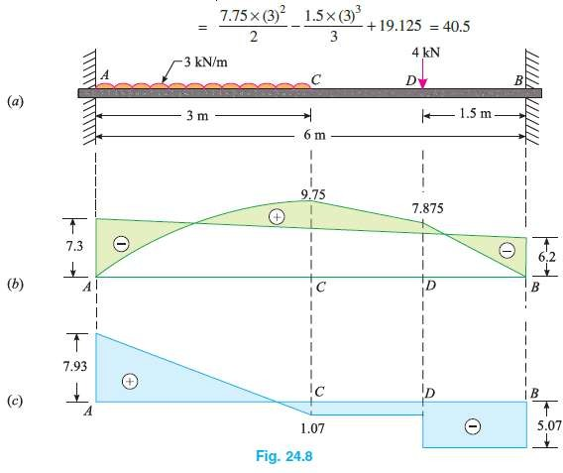
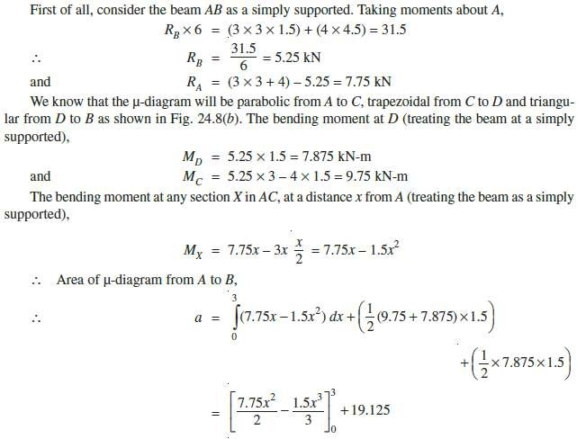

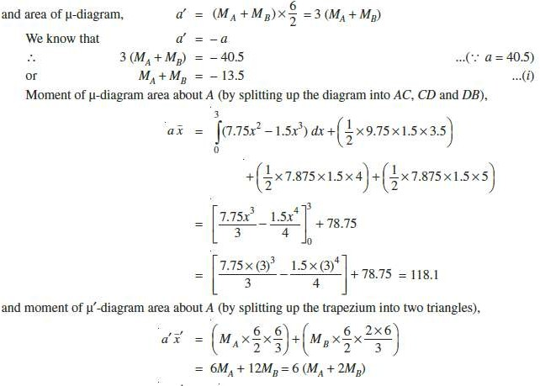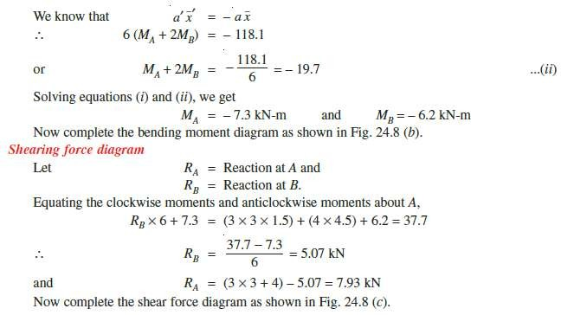

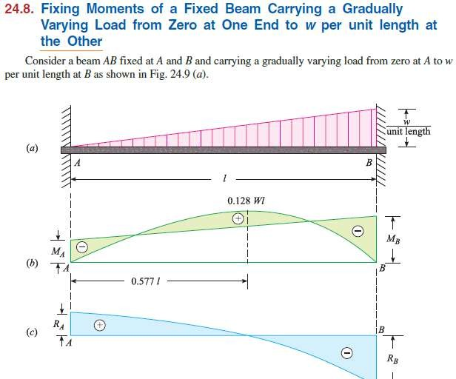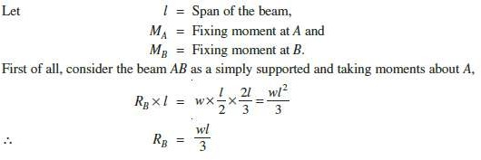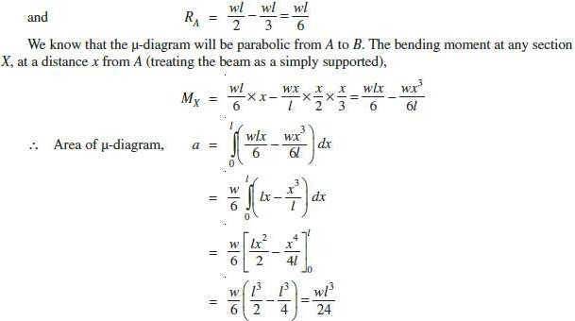

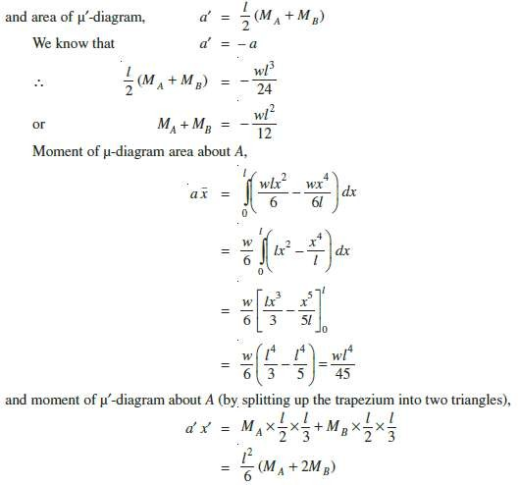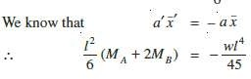
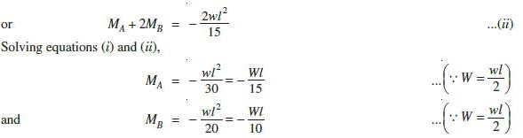

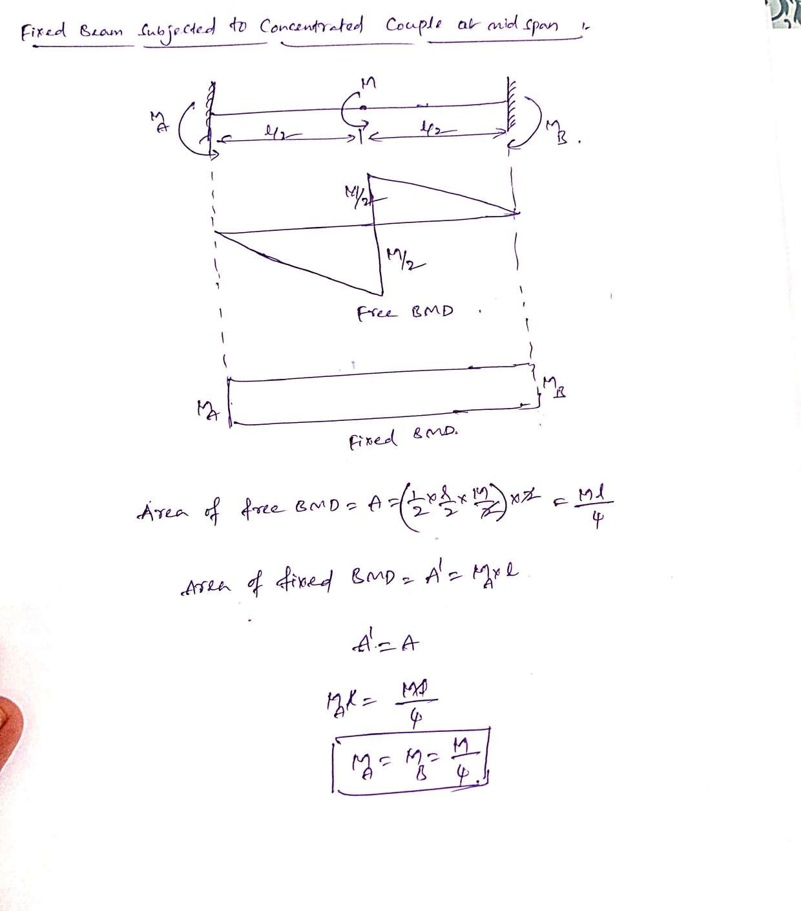

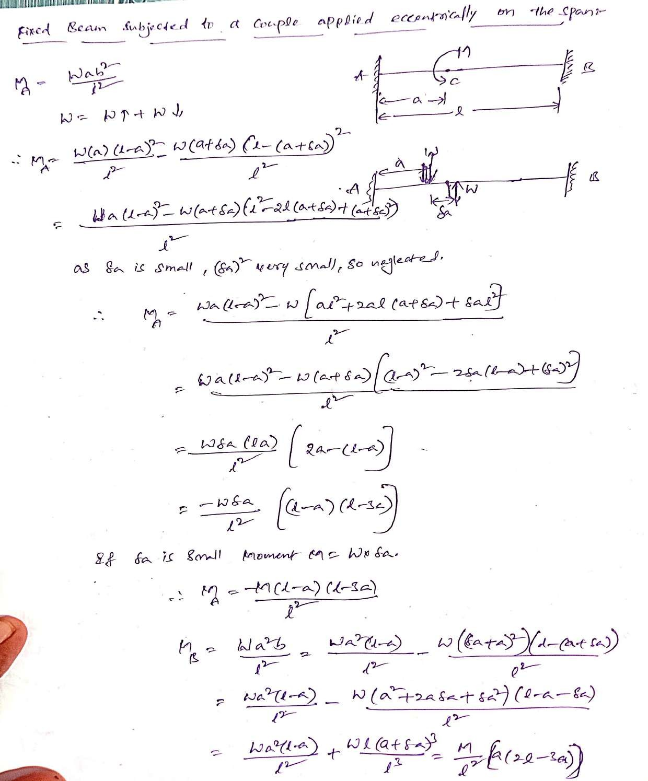

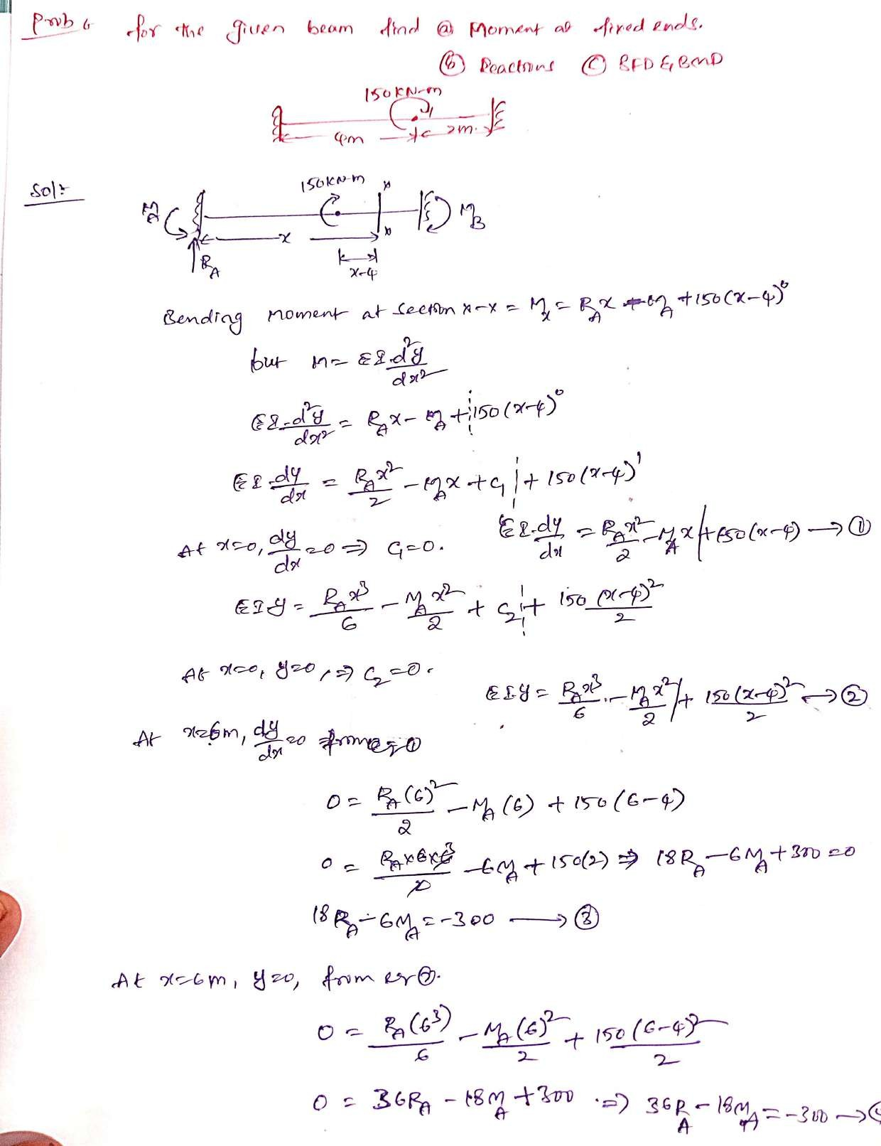

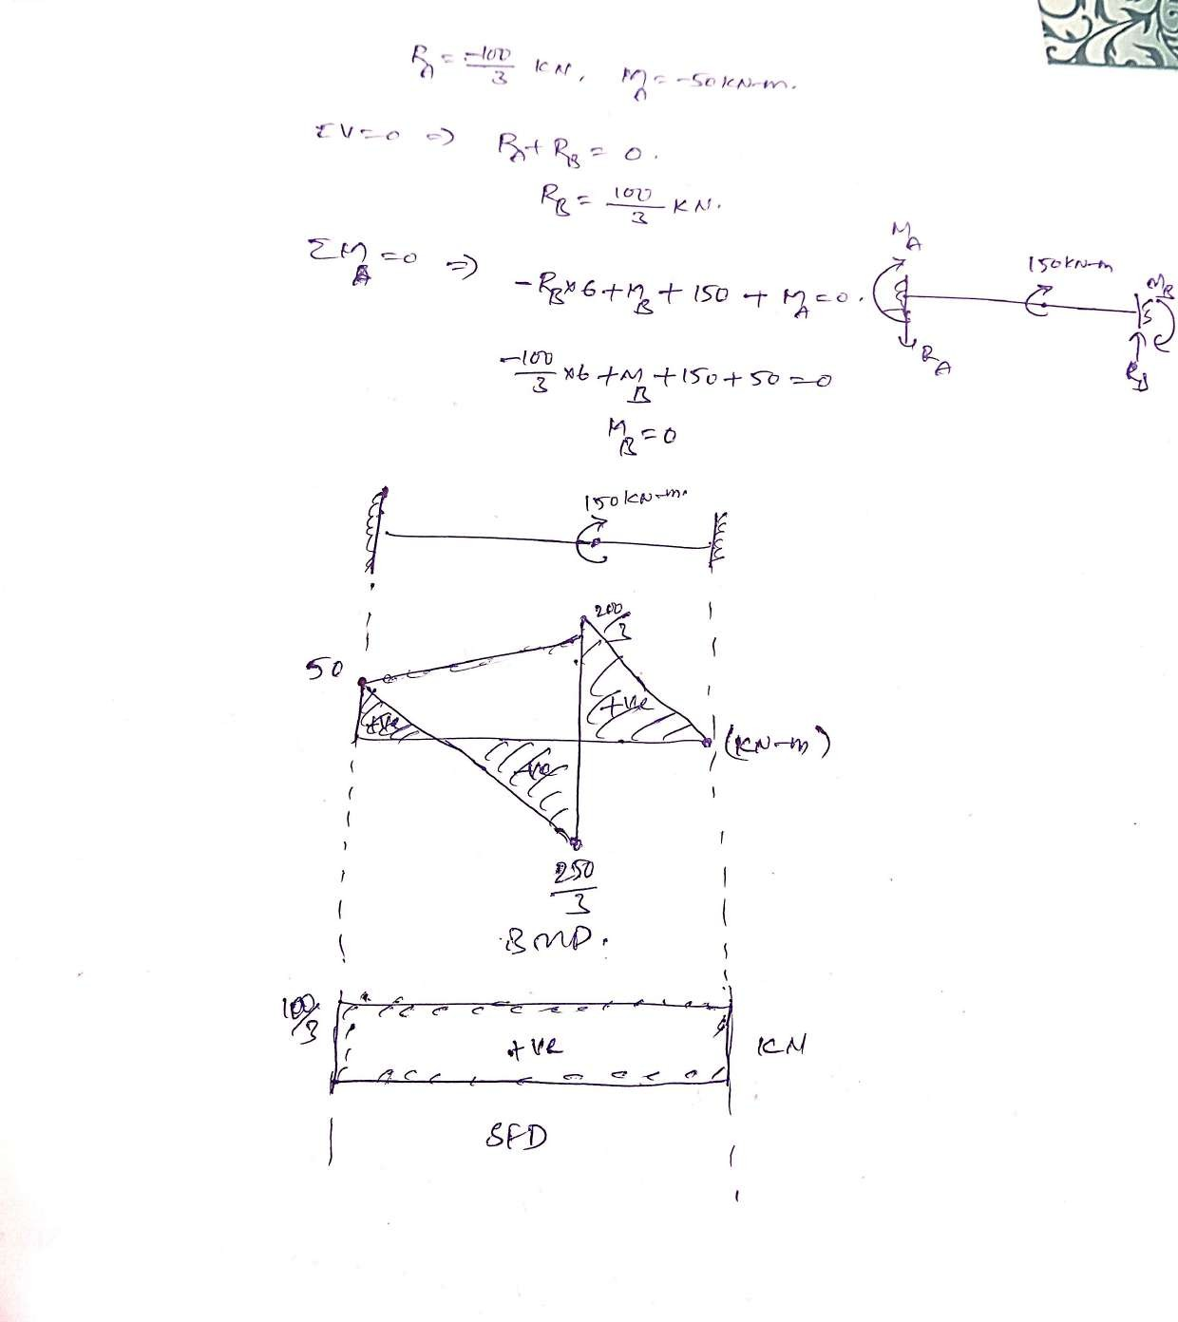

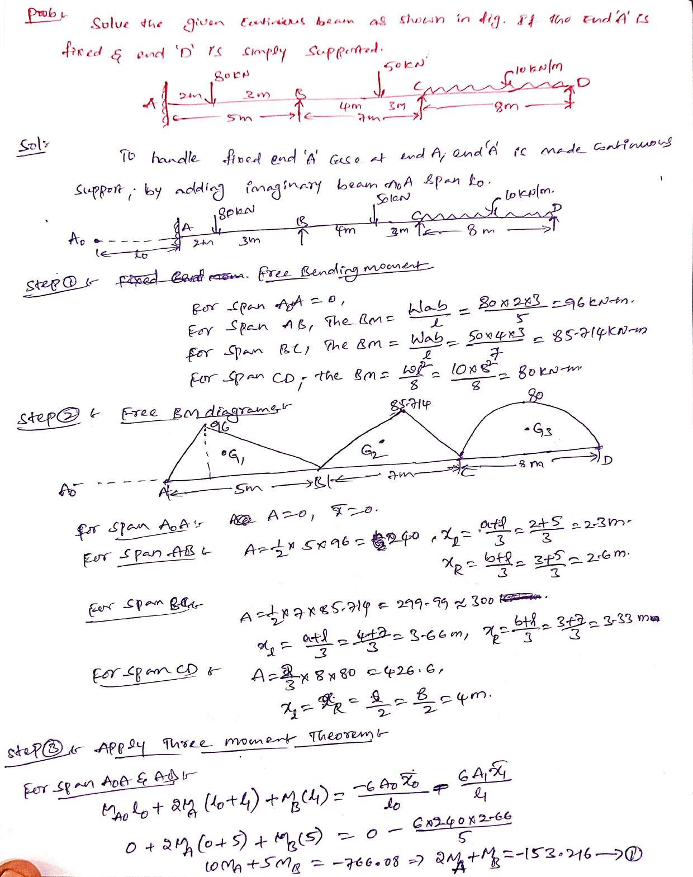

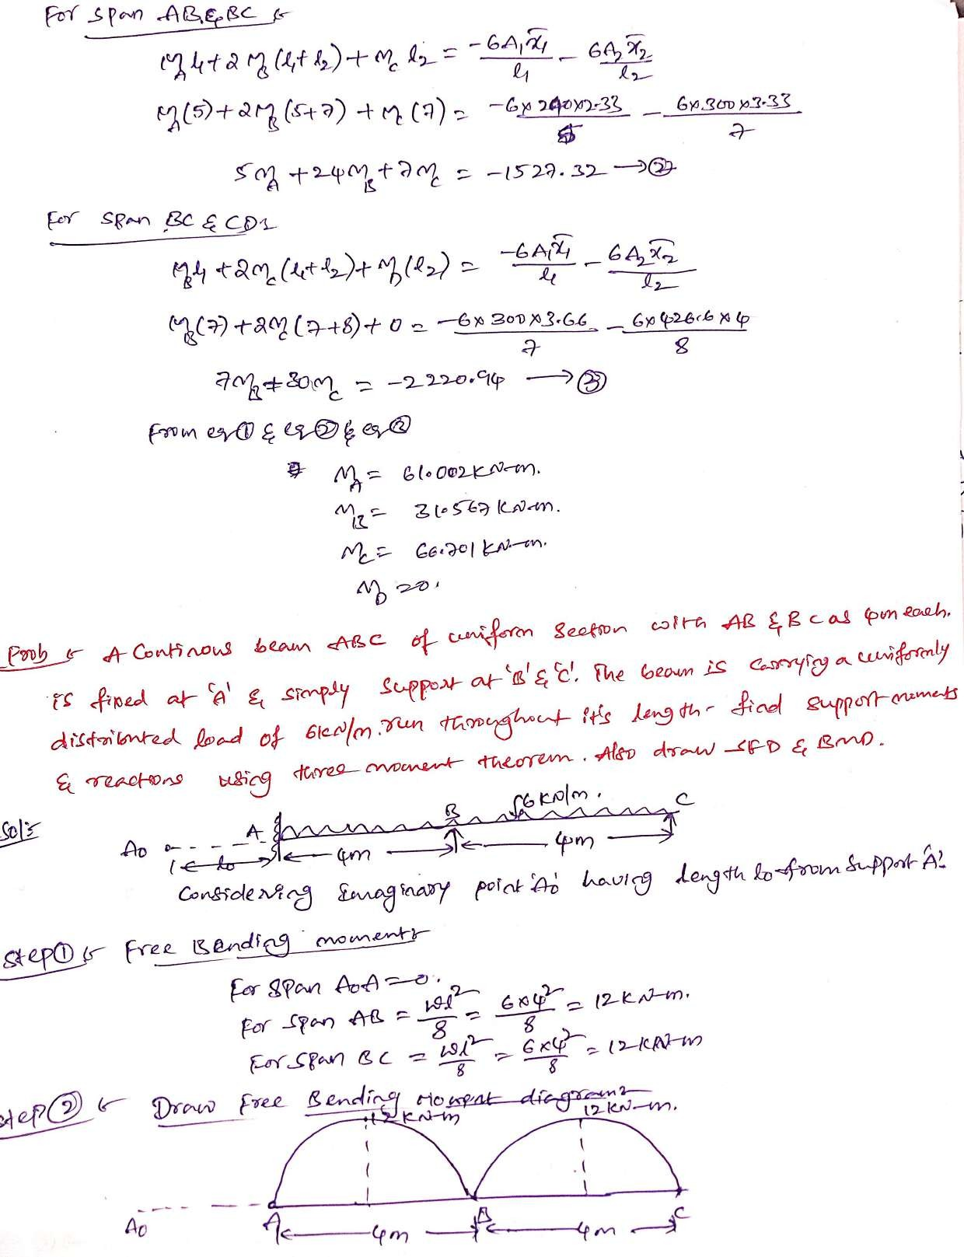

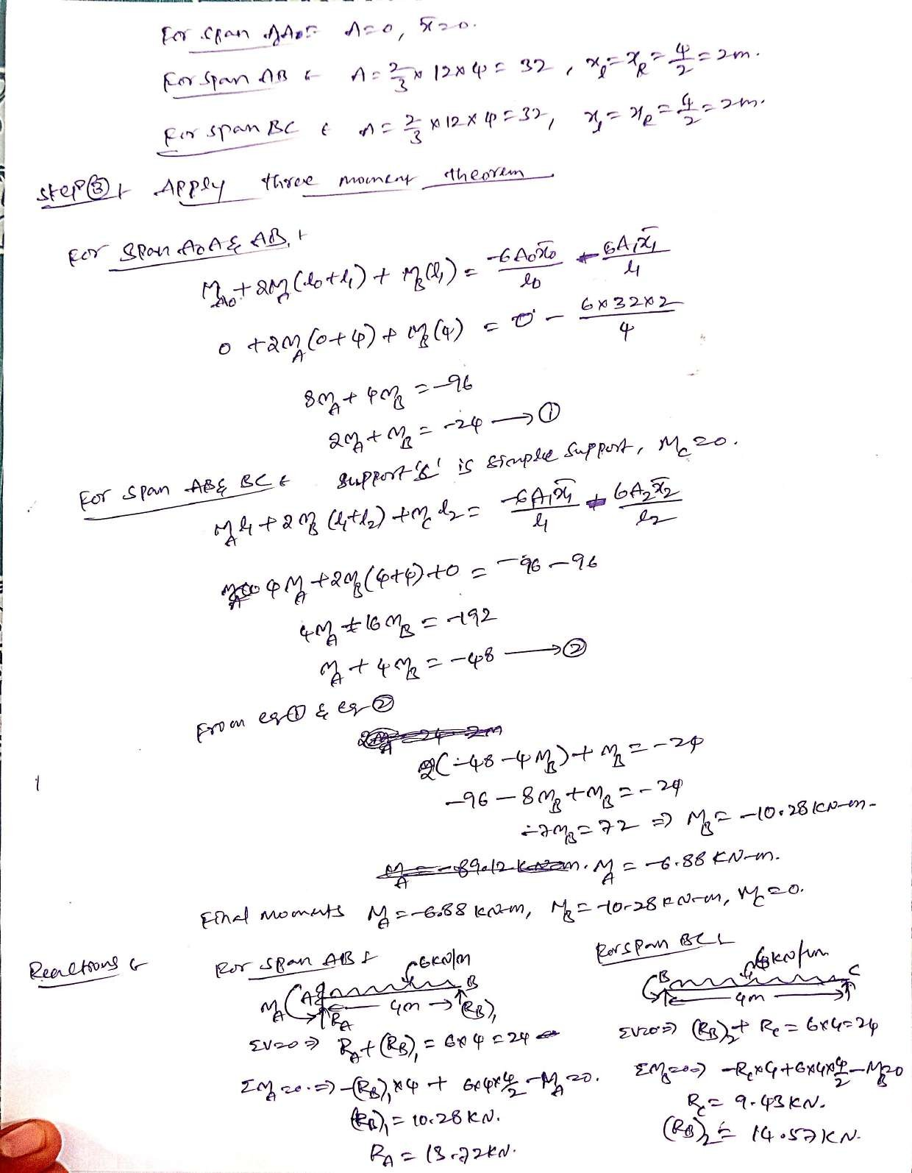

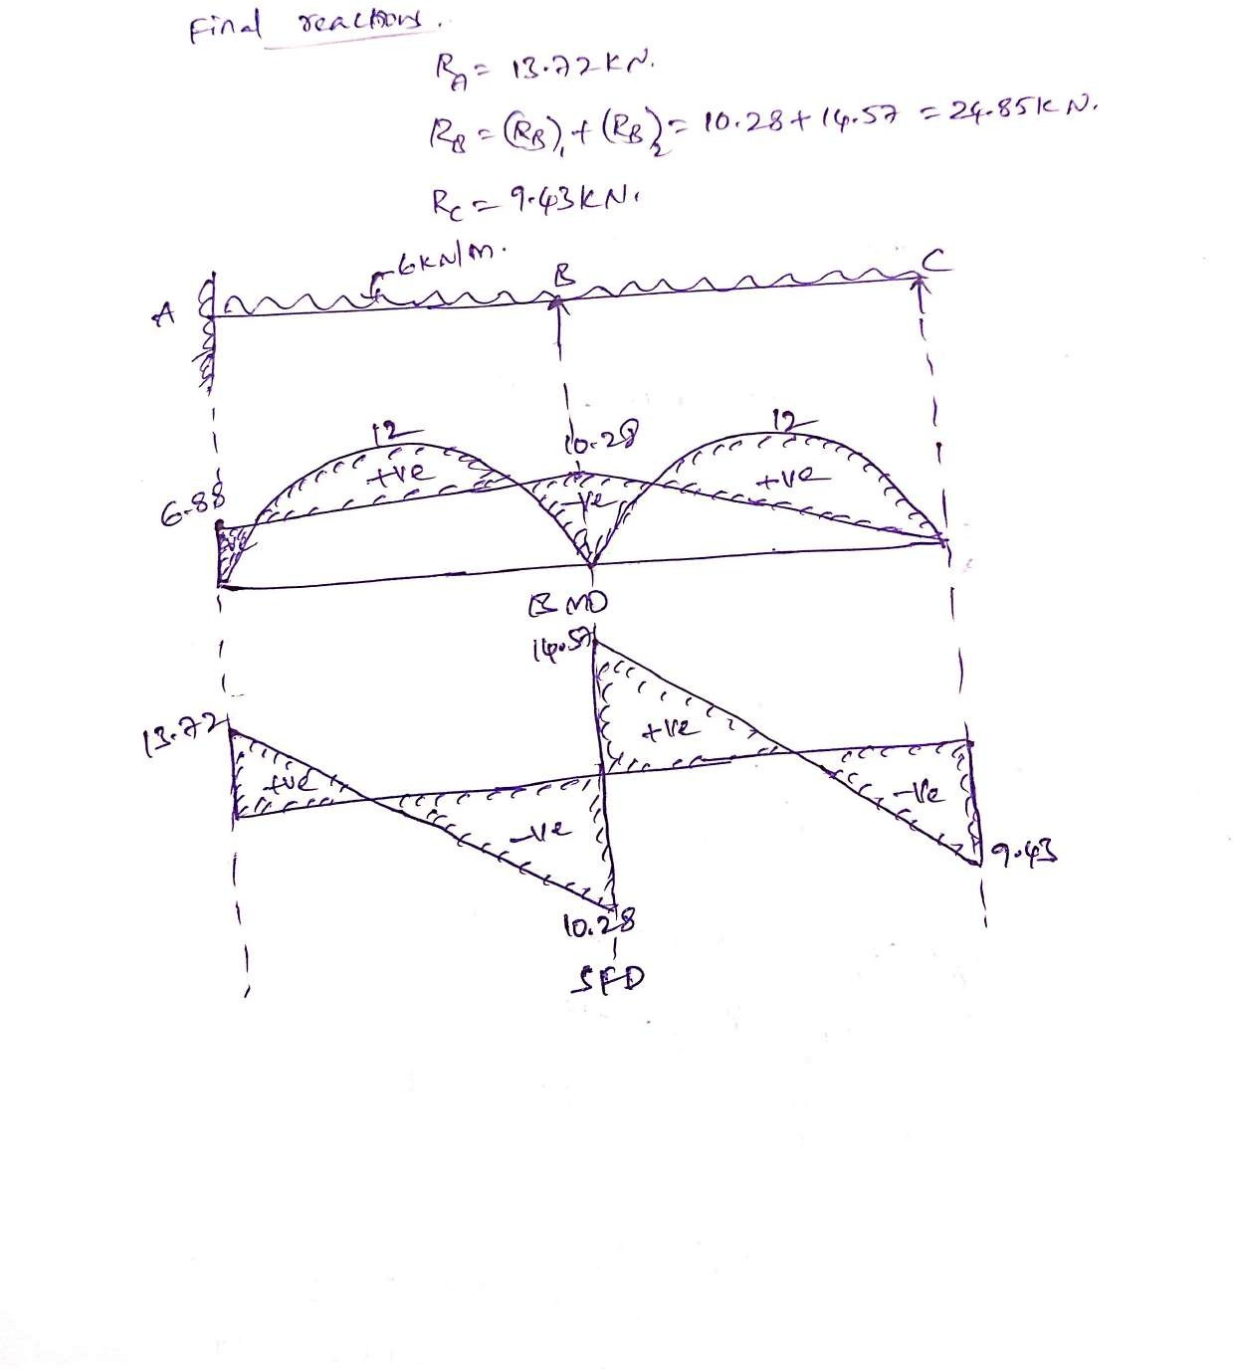

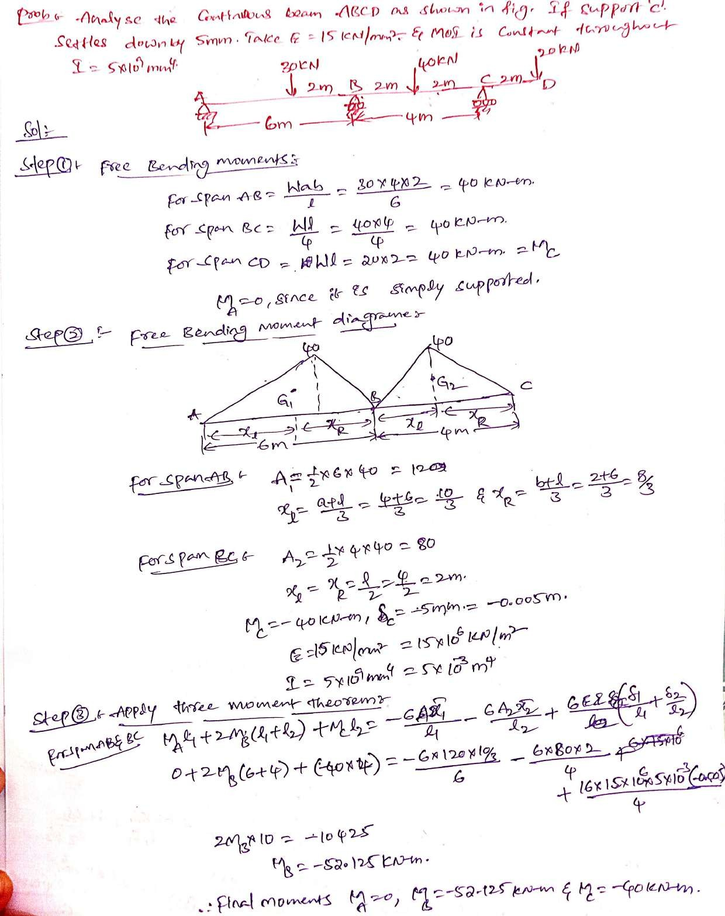

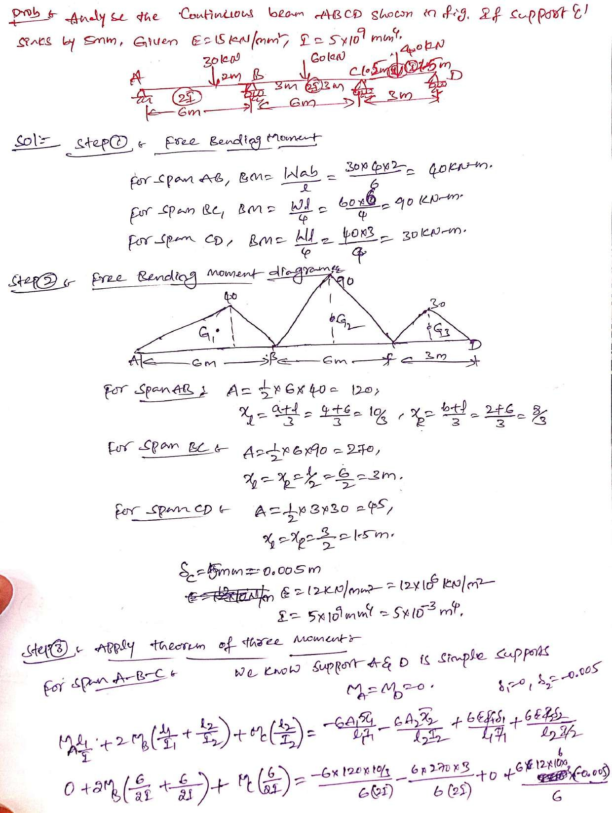

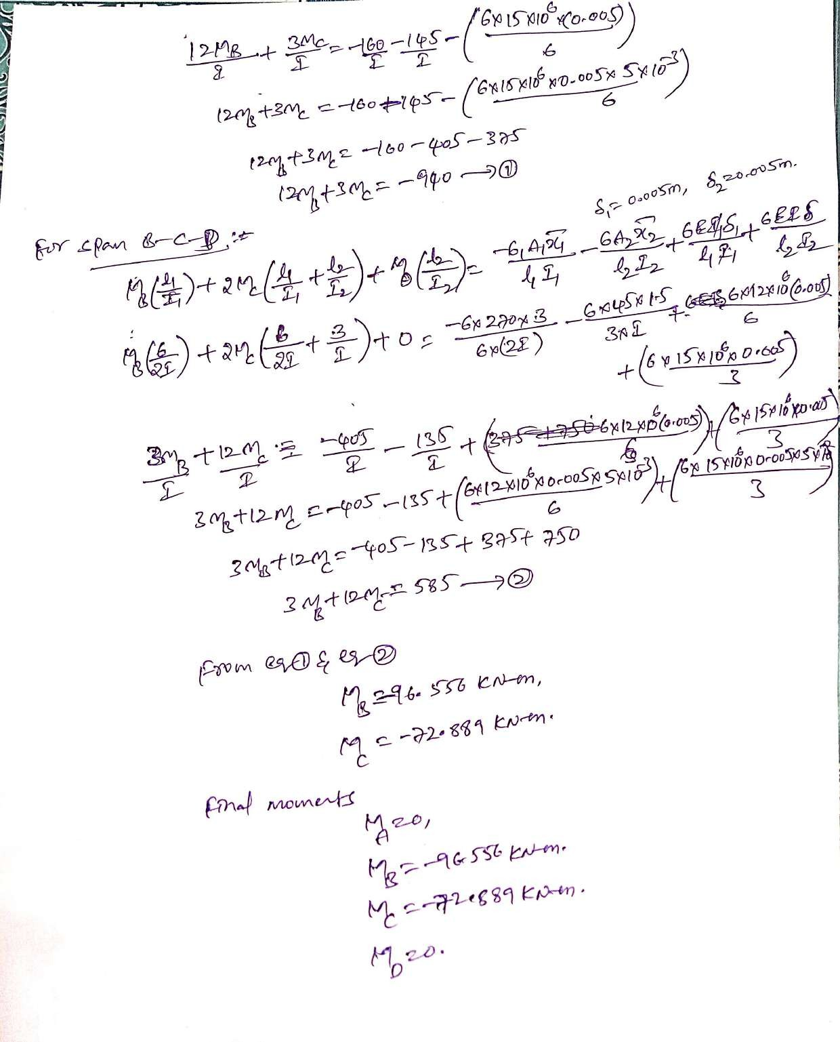

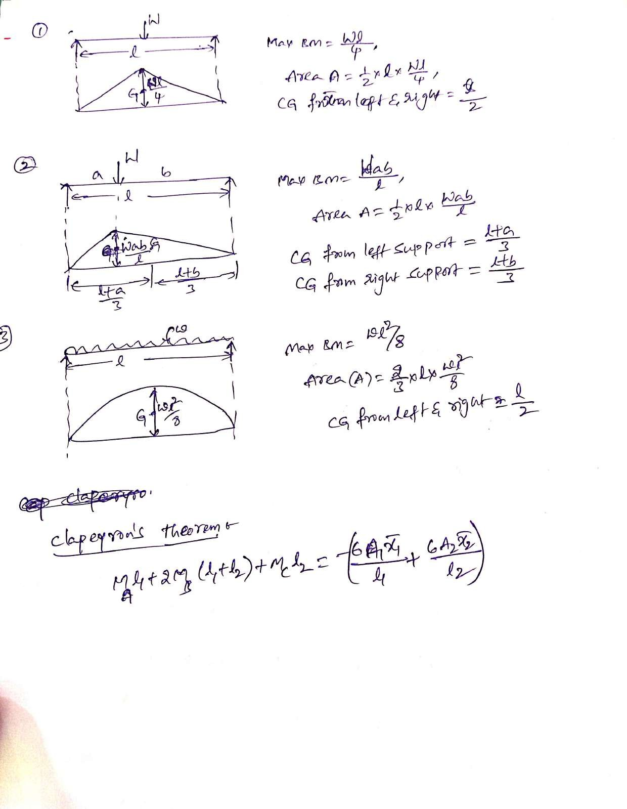

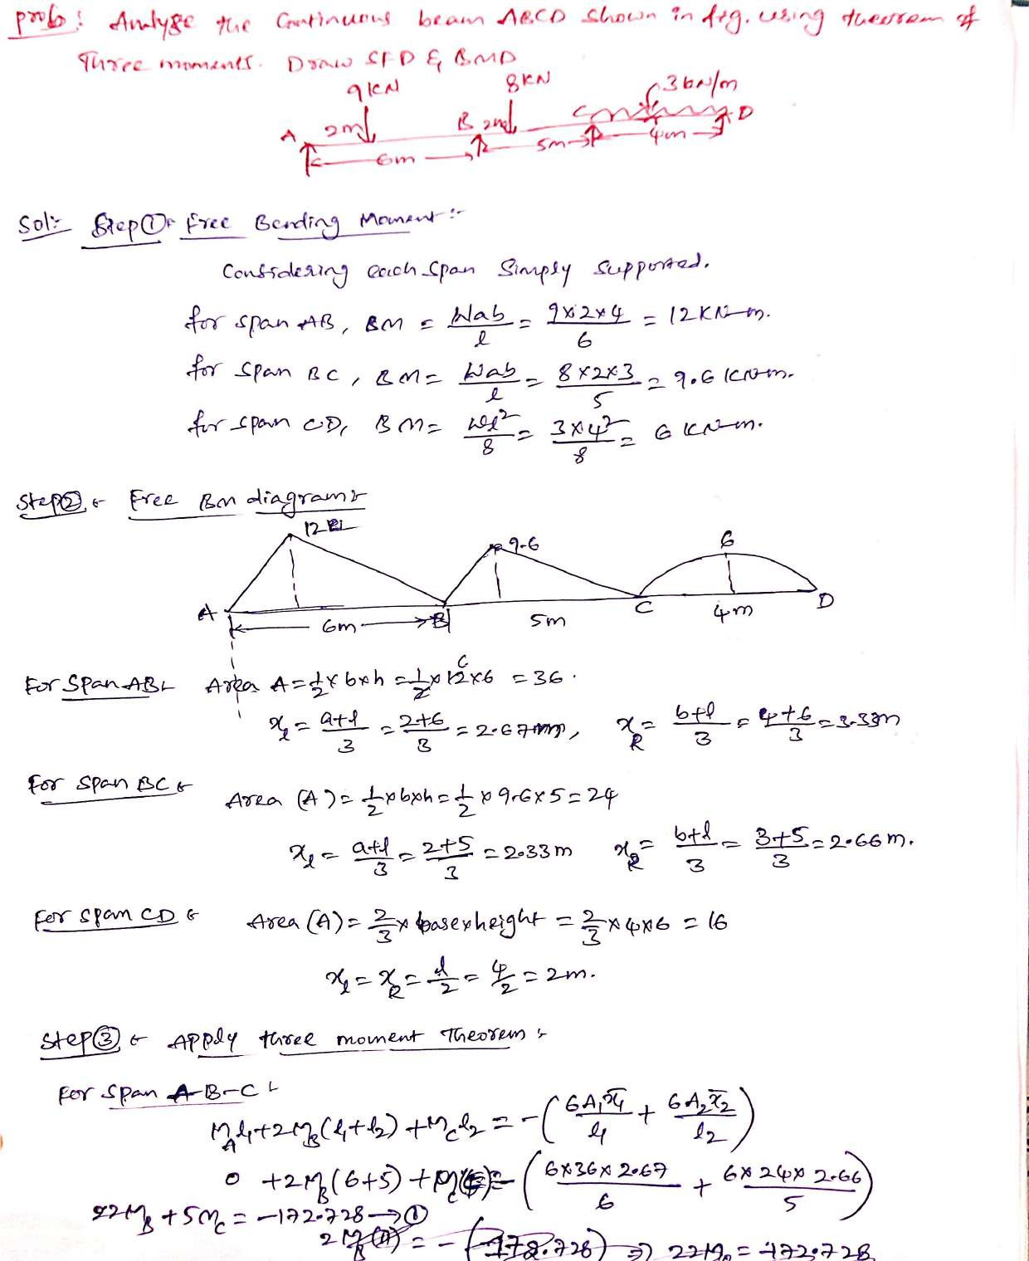

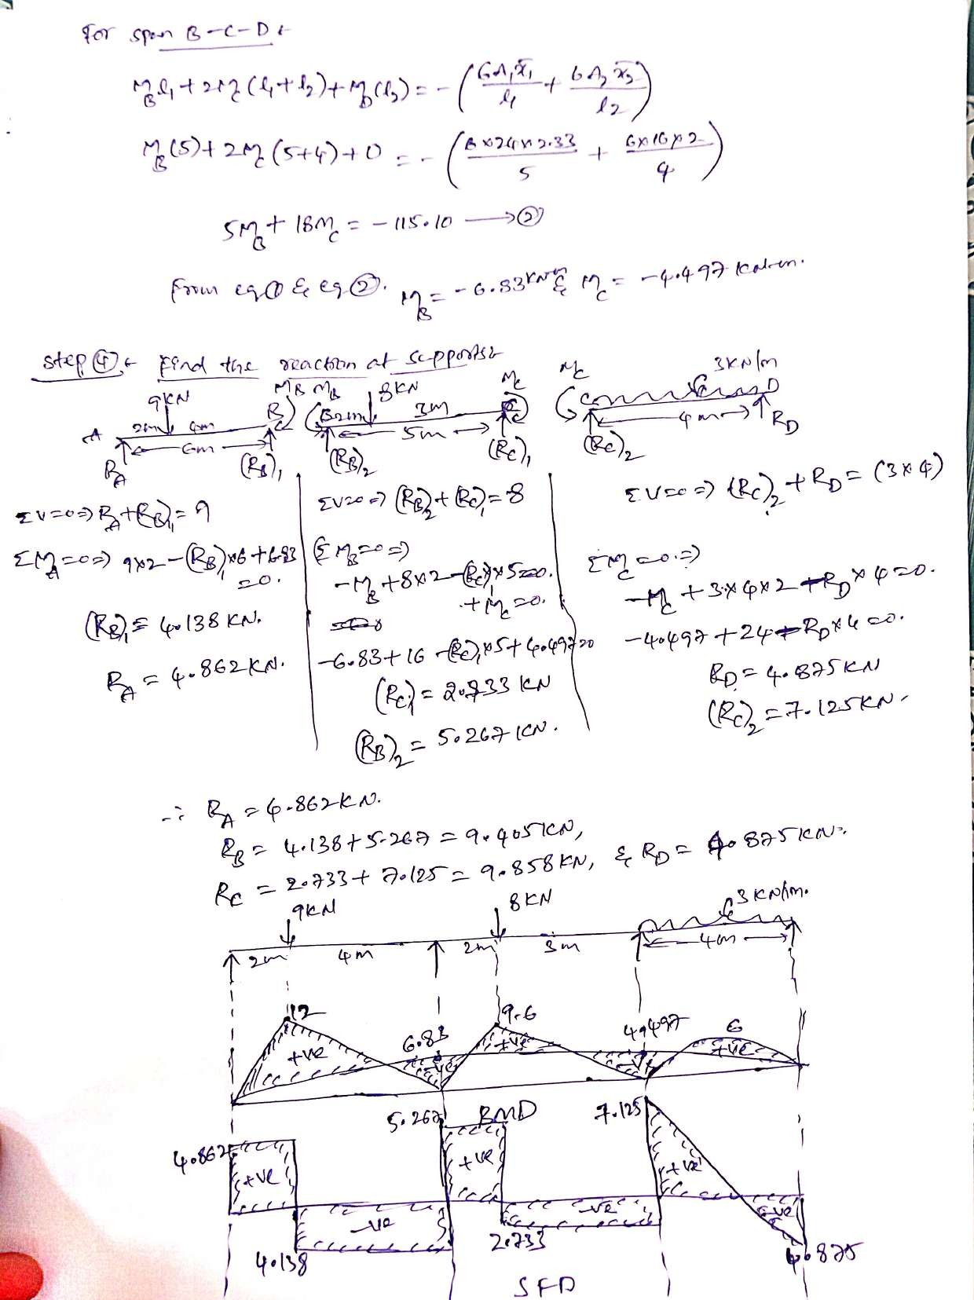

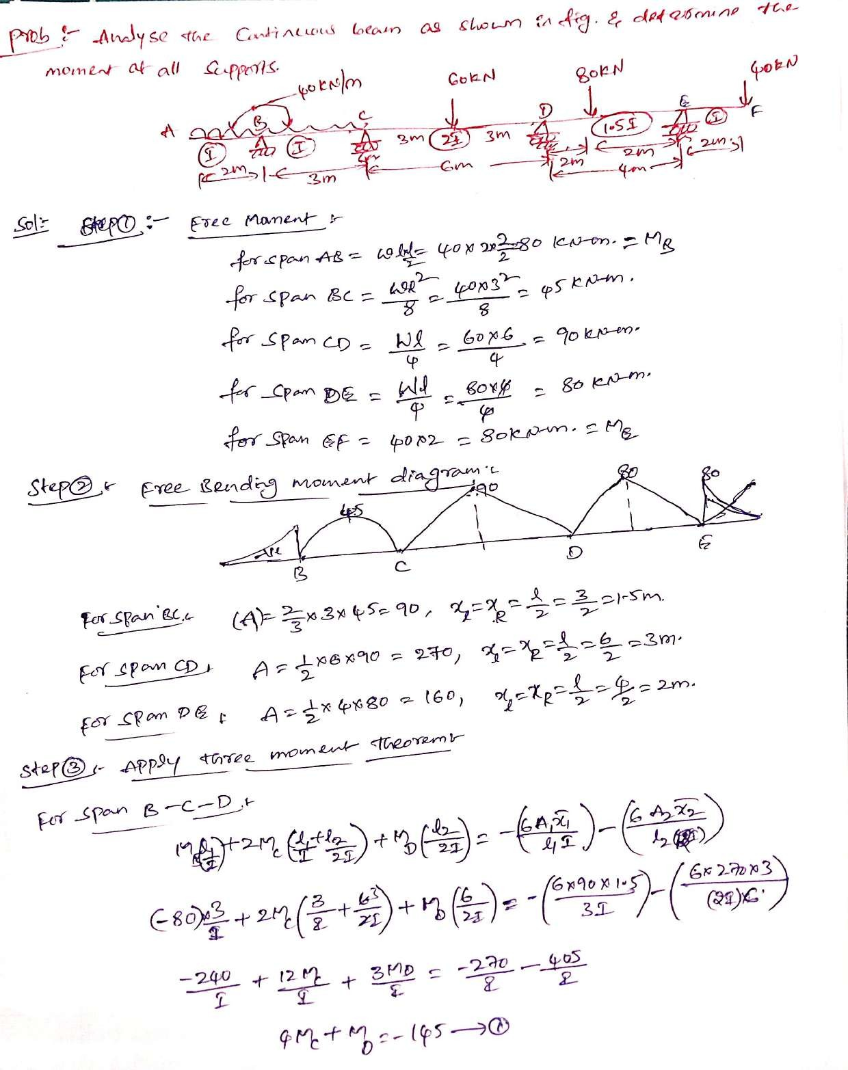

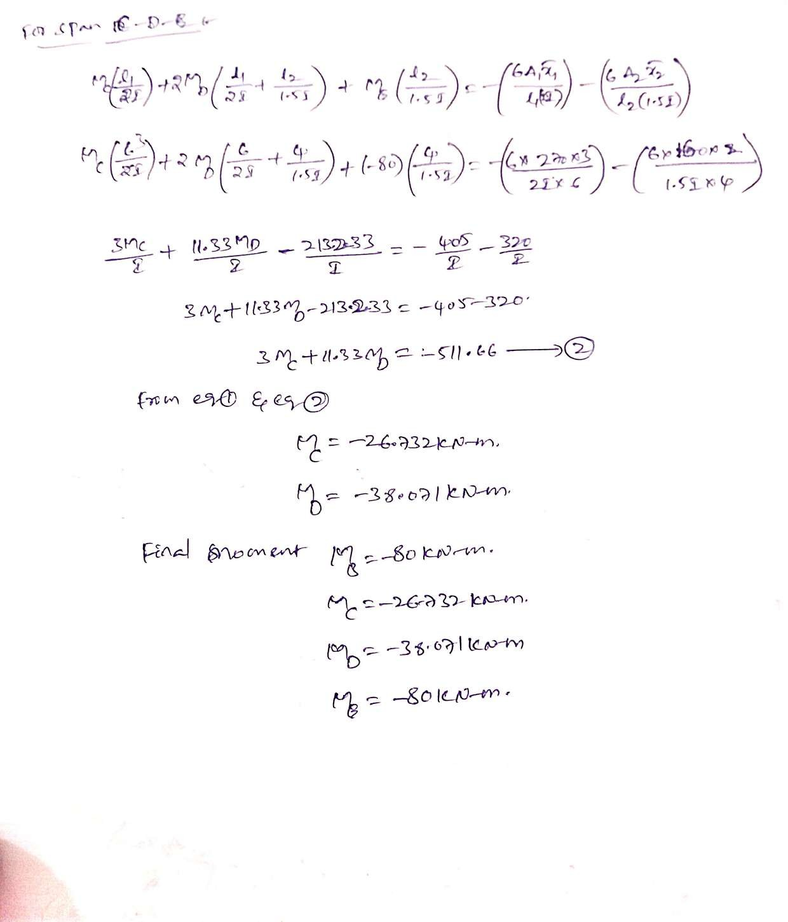

UNIT-IV
SLOPE DEFLECTION METHOD
Continuous beams and rigid frames (with and without sway) – Symmetry and antisymmetry – Simplification for hinged end – Support displacements

Introduction:
- This method was first proposed by Prof. George A. Maney in 1915.
- It is ideally suited to the analysis of continuous beams and rigid jointed frames.
- Basic unknowns like slopes and deflections of joints are found out.
- Moments at the ends of a member is first written down in terms of unknown slopes and deflections of end joints.
- Considering the joint equilibrium conditions, a set of equations are formed and solutions of these simultaneous equations gives unknown slopes and deflections.
- Then end moments of individual members are determined.
- It involves solutions of simultaneous equations; a problem with more than three unknowns is considered a difficult problem for hand calculations. Hence this method was sidelined by moment distribution method with the help of computers; solutions for any number of simultaneous equations can be obtained early.
- The development of this method in the matrix form is “Stiffness Matrix Method” (it is commonly used for the analysis of large structures with the help of computers.
Assumptions made in slope-deflection method
- All joints are rigid.
- The rotations of joints are treated as unknowns.
- Between each pair of the supports the beam section is constant.
- The joint in structure may rotate or deflect as a whole, but the angles between the members meeting at that joint remain the same.
- Distortions due to axial deformations are neglected.
- Shear deformations are neglected.
Sign Conventions:
Moments:
- Clockwise moments = (+)^{ive}
- Anti-clockwise moments = (-)^{ive}

Rotations:
- Clockwise rotations = (+)^{ive}
- Anti-clockwise rotations = (-)^{ive}
Settlements:
- Right side support is below left side support = (+)^{ive}
- Left side support is below right side support = (-)^{ive}
Applications of Slope Deflection Equations:
- Rigid jointed structures can be analyzed.
- Continuous Beams
- Frames without side sway (Non-Sway)
- Frames with side sway (Sway)
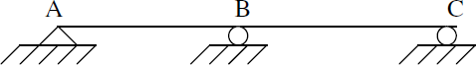
The beam shown in Fig. is to be analyzed by slope-deflection method. What are the unknowns and, to determine them, what are the conditions used?
Unknowns: Ɵ_{A}, Ɵ_{B}, Ɵ_{C}
Equilibrium equations used: (i) MAB = 0 (ii) MBA + MBC = 0 (iii) MCB = 0
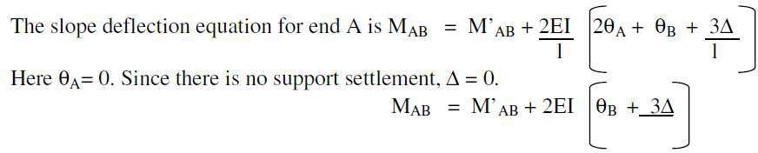
Write down the slope deflection equation for a fixed end support.

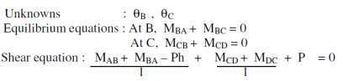
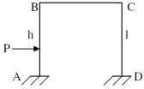
Write down the equilibrium equations for the frame shown in Fig.
Limitations of slope deflection method
- It is not easy to account for varying member sections
- It becomes very cumbersome when the unknown displacements are large in number.

Why slope-deflection method is called a ‘displacement method’?
- In slope-deflection method, displacements (like slopes and displacements) are treated as unknowns and hence the method is a „displacement method‟.
Degrees of freedom
- In a structure, the numbers of independent joint displacements that the structure can undergoes are known as degrees of freedom.
Write the fixed end moments for a beam carrying a central clockwise moment.
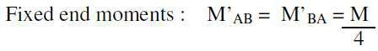
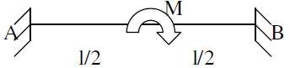
Problems:
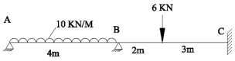
- Analyse the continuous beam given in figure by slope deflection method and draw the B.M.D&S.F.D.

Step 1: Fixed end moments
MFAB
= | -WL²/12 | = | -10×4²/12 | = | -13.33 KNM
= | WL²/12 | = | 10×4²/12 | = | -13.33 KNM
= | - Wab²/L² | = | -6×2×3²/5² | = | -4.32 KNM
= | Wa²b/L² | = | 6×2²×3/5² | = | 2.88 KNM

F
M
BA
F
M
BC
F
M
CB
Step 2: Slope deflection equation
M_{AB} = M^{F}_{AB}+2EI/L (2θ_{A}+θ_{B})
M_{AB} = -13.33+EIθ_{A} + 0.5EIθ_{B} 1

M_{BA} = M^{F}
BA
+2EI/L (2θ +θ )

M_{BA} = 13.33+0.5EIθ_{A} + EI θ_{B} 2
B
A
M_{BC} = M^{F} +2EI/L (2θ +θ )
BC B C
MBC | = | -4.32+0.8EI θ_{B} | --------3
MCB | = | 2.88+0.4EI θ_{B} | --------4

Apply equilibrium conditions M_{AB} = 0
EI θ_{A} + 0.5EI θ_{B} | = | 13.33 | --------5
MBA + MBC | = | 0

13.33 + 0.5EI θ_{A} +EI θ_{B} - 4.32 + 0.8EI θ_{B} = 0
0.5EI θ_{A} +1.8EI θ_{B} = -9.01 6
Solve eqn 5 & 6, we get

EIθ_{A} | = | 18.39
EIθ_{B} | = | -10.11
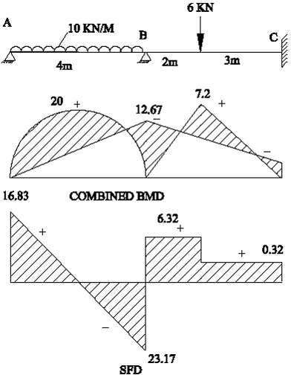
This values sub in eqn 1 to 4

MAB  MBA | =  = | 0 KNM  12.67 KNM
MBC | = | -12.67 KNM
MCB | = | -1.16 KNM
Step 3: Find the Reactions Span AB
R_{A} | = | 16.83 KN
RB1 | = | 23.17 KN
RB2 | = | 6.312 KN
R_{C} | = | -0.312 KN

- 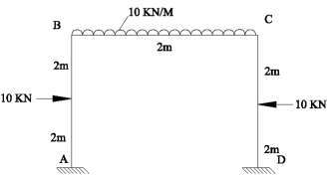Analyze the frame given in figure by slope deflection method and draw the B.M.D & S.F.D.
𝑤

Step 1: fixed end moments
MFAB MFBA MFBC MFCB MFCD MFDC
= | -WL/8 | = | - 10×4/8 | = | -5 KNM
= | WL/8 | = | 10×4/8 | = | 5 KNM
= | -WL²/12 | = | - 10×2²/12 | = | - 3.33 KNM
= | WL²/12 | = | 10×2²/12 | = | 3.33 KNM
= | -WL/8 | = | - 10×4/8 | = | -5 KNM
= | WL/8 | = | 10×4/8 | = | 5 KNM

Step 2: Slope deflection equation M_{AB}=M^{F}AB+2EI/L(2θA+θB) M_{AB}=-5 +0.5EIθB 1

M_{BA} = M^{F}
BA
+2EI/L (2θ +θ )

M_{BA} = 5+EIθ_{B} 2
B
A
M_{BC} = M^{F} +2EI/L (2θ +θ )
BC B C
M_{BC} = -3.33+2EIθ_{B} + EIθ_{C} 3
M_{CB} = M^{F} +2EI/L (2θ +θ )
CB C B
M_{CB} = 3.33+2EIθ_{C} +EIθ_{B} 4
M_{CD} = M^{F} +2EI/L (2θ +θ )
CD C D
M_{CD} = -5+EIθ_{C} 5
M_{DC} = M^{F} +2EI/L (2θ +θ )
DC D C
M_{DC} = 5+0.5EIθ_{C} 6
Apply equilibrium conditions M_{BA}+M_{BC} = 0
5+EIθ_{B}-3.33+2EIθ_{B} +EIθ_{C}  M_{CB}+M_{CD} = 0 | = | 0 | ----------7
3.33+2EIθ_{C} +EIθ_{B}-5+EIθ_{C} | = | 0 | ---------8
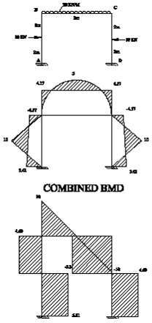
Solve eqn 7 & 8 we get

EIθ_{B} | = | -0.835
EIθ_{C} | = | 0.835
Sub this values eqn 1 to 6

MAB | = | -5.42 KNM
MBA | = | 4.17 KNM
MBC | = | -4.17 KNM
MCB | = | 4.17 KNM
MCD | = | -4.17 KNM
MDC | = | 5.42 KNM
Step 3: find reactions Span AB:
R_{A} | = | 5.31 KN
RB1 | = | 4.69 KN
Span BC:

RB2 | = | 10 KN
RC1 | = | 10 KN

Span CD:

RC2 | = | 4.69 KN
R_{D} | = | 5.31 KN

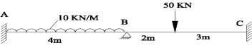
- Draw the SFD&BMD for th continuous beam shown in fig. Take E=2×10⁵ N/mm²,I=3×10⁶ mm⁴ .The support B sinks by 30 mm. Using slope deflection method.
Step 1: fixed end moments
MFAB MFBA MFBC MFCB
= | -WL²/12 | = | - 10×4²/12 | = | -13.33 KNM
= | WL²/12 | = | 10×4²/12 | = | -13.33 KNM
= | - Wab²/L² | = | -50×2×3²/5² | = | -36 KNM
= | Wa²b/L² | = | 50×2²×3/5² | = | 24 KNM

Step 2: Slope deflection equation
M_{AB} = M^{F}_{AB} + 2EI/L (2θ_{A}+θ_{B}) – 6EI∆/l²
M_{AB} = EIθ_{B} - 20 1
M_{BA} = M^{F}_{BA} + 2EI/L (2θ_{B}+θ_{A}) – 6EI∆/l²
M_{BA} = EIθ_{B} + 6.58 2
M_{BC} = M^{F}_{BC} + 2EI/L (2θ_{B}+θ_{C}) + 6EI∆/l²
M_{BC} = 0.8EIθ_{B} -31.68 3
M_{CB} = M^{F}_{CB} + 2EI/L (2θC+θ_{B}) + 6EI∆/l²
M_{CB} = 28.32 + 0.4EIθ_{B} 4
Applying equilibrium conditions
M_{BA} + M_{BC} = 0
EIθ_{B} + 6.58 + 0.8EIθ_{B} - 31.68 = 0
EIθ_{B} = 13.94
This values sub in eqn 1 to 4

MAB  MBA | =  = | -13.03 KNM  20.52 KNM
MBC | = | -20.52 KNM
MCB | = | 33.89KNM

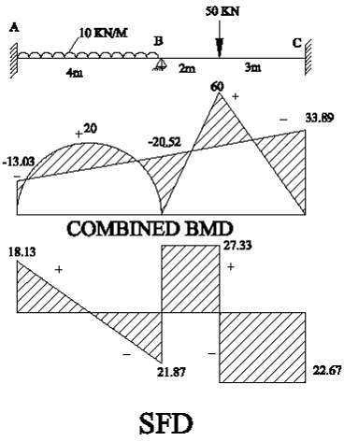
Step 3: Find the reactions
Span AB

R_{A} | = | 18.13 KN
RB1 | = | 21.87 KN
Span BC

RB2 | = | 27.33 KN
R_{C} | = | 22.67 KN

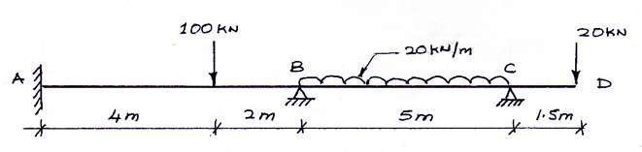
- Analyze continuous beam ABCD by slope deflection method and then draw bending moment and SF diagram. Take EI constant.

Solution: FEM

FAB= −

Wab²
L2

= − 100× 4 × 2² =
62

- 44.44

KN M

FBA = +
Wa ²b L2
wL2
= + 100× 4² × 2 =
62
20 × 52
+ 88.88
KNM

FBC = −
FCB = +
12
wL2

12
= − =

12
= + 20 × 52 =

12
- 41.67

+ 41.67
KNM

KNM

FCD = −20×1.5 =
- 30
KN M

Slope deflection equations:

M =F + 2EI (2θ +θ ) = −44.44 + 1 EIθ

- - - - - - - -- > (1)

AB AB L A B 3 B

M =F + 2EI (2θ +θ ) = +88.89 + 2 EIθ

- - - - - - - -- > (2)

BA BA L B A 3 B

M =F + 2EI (2θ +θ ) = −41.67 + 4 EIθ + 2 EIθ

- - - - - - - - > (3)

BC BC L B C 5 B 5 C

M =F + 2EI (2θ +θ ) = +41.67 + 4 EIθ + 2 EIθ

- - - - - - - - > (4)

CB CB L C B 5 C 5 B
MCD = −30 KNM

Now, M +M
= 88.89 + 2 EIθ −41.67 + 4 EIθ + 2 EIθ


BA BC
:
- B 5 B 5 C

= 47.22 + 22 EIθ + 2 EIθ = 0

- - - - - - - - > (5)

15 ^{B} 5 ^{C}

And, M +M
= +41.67 + 4 EIθ + 2 EIθ


−30

CB CD
5 C 5 B

= 11.67 + 2 EIθ + 4 EIθ

− − − − − − > (6)

5 B 5 C

EIθB = −32.67 EIθC = +1.75
Rotation@ Rotation @
B anticlockwise B clockwise

MAB

MBA
= −44.44 + 1 (− 32.67) = −61.00
2
= +88.89 + 2 (− 32.67) = +67.11
3
KNM

KNM

M = −41.67 + 4 (− 32.67) = + 2 (1.75) = −67.11

KNM

BC 5 5

M = +41.67 + 4 (1.75)+ 2 (− 32.67) = +30.00

KNM

CB

MCD = −30
5 5
KNM

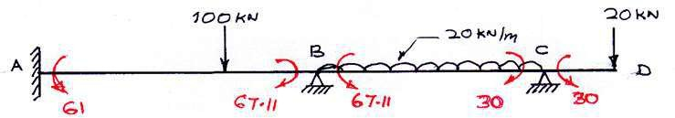

Reactions: Consider free body diagram of beam AB, BC and CD as shown
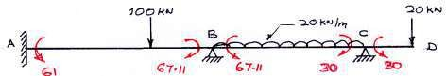

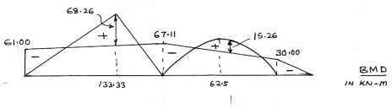
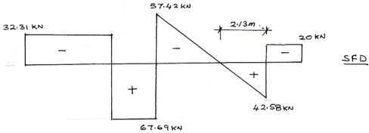

Span AB

RB ×6 = 100× 4 + 67.11− 61

RB = 67.69 KN
RA = 100 −RB = 32.31 KN

Span BC

R ×5 = 20 × 5 × 5 + 30 − 67.11
C 2

RC = 42.58 KN
RB = 20 × 5 −RB = 57.42 KN

Maximum Bending Moments:
Max = 133.33 − 61− ⎛ 67.11− 61× 4 = 68.26 KN ⎞
⎜
M⎟
⎝ 6 ⎠
SpanBC: where SF=0, consider SF equation with C as reference

SX = 42.58 − 20x = 0

x = 42.58 = 2.13
20
∴
m

2.13²

Mmax = 42.58× 2.13 − 20 × 2
− 30 = 15.26
KN M

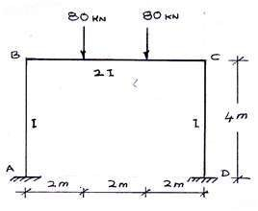
- Analyse the portal frame shown in figure and also drawn bending moment and shear force diagram

Solution: FEM
W ab² W cd²
FBC= − 1 − 2
L2 L2
= 80 × 2 × 4² − 80 × 4 × 2² =

62
Wa ²b
62
W c²d
- 106.67
KNM

FCB = + L2
+ ² = +106.67
L2
KNM

Slope deflection equations:

M =F + 2EI (2θ +θ ) = 0 + 2EI (0 +θ ) = 1 EIθ

- - - - - - - - > (1)

AB AB L A B 4 B 2 B

M =F
+ 2EI (2θ +θ ) = 0 + 2EI (2θ +0) = EIθ

- - - - - -- > (2)

BA BA L B A 4 B B
M =F + 2EI (2θ +θ )

BC BC L B C

= −106.67 + 2E2I (2θ +θ

) = −106.67 + 4 EIθ + 2 EIθ

- - - - - - > (3)

6 B C
M =F + 2EI (2θ +θ )

3 B 3 C

CB CB L C B

= +106.67 + 2E2I (2θ +θ ) = +106.67 + 4 EIθ

- 2 EIθ

- - - - - - > (4)

6 C B
M =F + 2EI (2θ +θ )

3 C 3 B

CD CD L C D

= 0 + 2EI (2θ +0) = EIθ

- - - - - -- > (5)

4 C C

M =F + 2EI (2θ +θ )

DC DC L D C

= 0 + 2EI (0 +θ ) = 1 EIθ

- - - - - -- > (6)

4 C 2 C

Now M +M
= −106.67 + 7 EIθ + 2 EIθ = 0

- - - - - -- > (7)

BA BC
3 B 3 C

− 746.69 + 49 EIθ

+ 14 EIθ

= 0⎫

+ 213.34 +
3
- EIθ

B 3 C
+ 14 EIθ = 0

⎪
⎬ subtracts
⎪

3 ^{B} 3 ^{C} ⎪⎭

- 960.03 + 45 EIθ = 0

3 B
EIθ = + 960.03 × 3 = + 64

Clockwise

^{B} 45
Using equation (7)

EIθ
= − 3 ⎡− 106.67 + 7 EIθ ⎤



C 2 ⎢⎣ 3 B ⎥⎦

= - 3 ⎡− 106.67 + 7 × ⎤ = − 64

Anticlo ckwise

2 ⎢⎣ 3 64
⎥
⎦
∴ Final moments are

MAB
= + 64 = +32
2

KNM

MBA = 64
KNM

M = −106.67 + 4 64 + 2 (− 64) = − 64

KNM

BC 3 3

M = +106.67 + 4 (− 64) + 2 (64) = + 64

KNM

CB

MCD = − 64
3 3
KNM

MDC = −
1 64 = -32
2
KNM

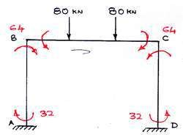
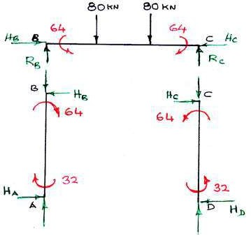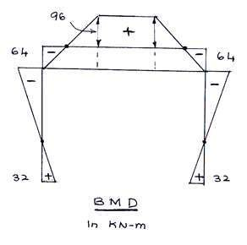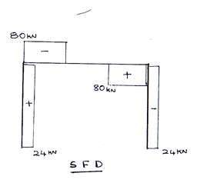Consider free body diagrams of beam and columns as shown

By symmetrical we can write

RA = RB = 60
RD = RC = 80

∑ MB = 0
KNM KNM

HA × 4 = 64 + 32
∴ HA = 24 KN

Apply

∑ MC = 0
HA × 4 = 64 + 32

∴ HD = 24 KN

6 )Analyse the portal frame and then draw the bending moment diagram
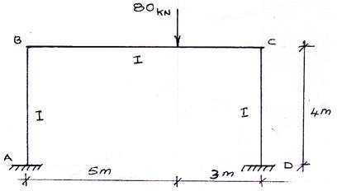

Solution:

Assume sway to right.
Here θ_{A} = 0,θ_{D} = 0,θ_{B} ≠ 0,θ_{D} = 0

FEMS:

FBC= −

FCB = +

Wab²

L2
Wa ²b L2

= − 80 × 5 × 3²
82
= + 80 × 5² × 3
82

= −56.25

= +93.75

KNM KNM

Slope deflection equations

M =F
+ 2EI ⎛ 2θ

+θ − 3δ ⎞

AB AB
L ⎜ _{A} _{B} L ⎟

= 0 + 2EI ⎛0 +θ − 3δ ⎞ = 1 EIθ − 3 EIδ
⎝
⎠


- - - - - - - - > (1)

4 ⎜ B 4 ⎟ 2 ^{B} 8
⎝
⎠

M =F
+ 2EI ⎛ 2θ +θ

− 3δ ⎞

BA BA
L ⎜ _{B} _{A} L ⎟

= 0 + 2EI ⎛ 2θ +0 − 3δ ⎞ = EIθ − 3 EIδ
⎝
⎠


- - - - - - - - > (2)

4 ⎜ B 4 ⎟ B 8
⎝
⎠

M =F + 2EI (2θ +θ )

BC BC L B C

= −56.25 + 2EI (2θ +θ

) = −56.25 + 1 EIθ + 1 EIθ

- - - - - - - -- > (3)

8 B C
M =F + 2EI (2θ +θ )

2 B 4 C

CB CB L C B

= +93.75 + 2EI (2θ +θ ) = 93.75 + 1 EIθ + 1 EIθ

- - - - - - - -- > (4)

8 C B 2 C 4 B

M =F
+ 2EI ⎛ 2θ

+θ − 3δ ⎞

CD CD
L ⎜ _{C} _{D} L ⎟

= 0 + 2EI ⎛ 2θ +0 − 3δ ⎞ = EIθ − 3 EIδ
⎝
⎠


- - - - - - - -- > (5)

4 ⎜ C 4 ⎟ C 8
⎝
⎠

M =F
+ 2EI ⎛ 2θ +θ

− 3δ ⎞

DC DC
L ⎜ _{D} _{C} L ⎟

= 0 + 2EI ⎛0 +θ − 3δ ⎞ = 1 EIθ − 3 EIδ
⎝
⎠


- - - - - - - -- > (6)

4 ⎜ C 4 ⎟ 2 ^{C} 8
⎝
⎠

MBA +MBC = 0 MCB +MCD = 0
HA +HD + ∑PH = 0
- − > Jo int conditions

- - - > Shear condition

- e,
MAB +MBA + MCD +MDC = 0

4 4
∴ MAB +MBA +MCD +MDC = 0
Now, M +M = EIθ − 3 EIδ − 56.25 + 1 EIθ + 1 EIθ = 0

BA BC B 8 2 B 4 C

= −56.25 + 3 EIθ + 1 EIθ − 3 EIδ = 0

− − − − − − > (7)

2 ^{B} 4 ^{C} 8

And, M +M
= 93.75 + 1 EIθ + 1 EIθ +EIθ − 3 EIδ = 0

CB CD
2 C 4 B C 8

= 93.75 + 1 EIθ + 3 EIθ − 3 EIδ = 0

− − − − − −− > (8)

4 ^{B} 2 ^{C} 8

And, M +M +M
+M = 1 EIθ − 3 EIδ + EIθ − 3 EIδ + EIθ − 3 EIδ


AB BA CD
DC 2 B 8 B 8 C 8

= 3 EIθ

- 3 EIθ

  - 1 EIθ
2 C
− 3 EIδ = 0

- 3 EIδ 8`
− − − − − −− > (9)

2 ^{B} 2 ^{C} 2

From (9)
EIδ = EIθB +EIθC

Substitute in
(7) &
(8)

Eqn(7)

− 56.25 + 3 EIθ + 1 EIθ − 3 [EIθ +EIθ


] = 0

2 B 4 C 8 B C

− 56.25 + 9 EIθ − 1 EIθ = 0

− − - - - - - -- > (10)

Eqn(8)
8 B 8 C

+ 93.75 + 1 EIθ

+ 3 EIθ − 3 [EIθ +EIθ

] = 0

4 B 2 C 8 B C
+ 93.75 − 1 EIθ + 9 EIθ = 0

- - - - - - - - - - > (11)

8 B 8 C

Solving equations (10) & (11) we get EIθ_{B} = 41.25

By Equation (10)
EIθ

= 8 ⎡− 56.25 + 9 EIθ ⎤

C ⎢⎣ 8 B ⎥⎦
= 8 ⎡− 56.25 + 9 ⎤ = −78.75
⎦

⎣⎢ 8 41.25⎥

Hence
∴EIδ = EIθB +EIθC = 41.25 − 78.75 = −37.5

EIθB = 41.25,
EIθC = −78.75,
EIδ = −37.5

M = 1 (41.25) − 3 (− 37.5) = +34.69 KNM

AB 2 8

MBA
M
= 41.25 − 3 (− 37.5) = +55.31KNM 8
= −56.25 + 1 (41.25) + 1 (− 78.75) = −55.31KNM

BC 2 4
M = 93.75 + 1 (− 78.75) + 1 (41.75) = +64.69 KNM

CB 2 4

MCD
= −78.75 − 3 (− 37.5) = −64.69 KNM
8

M = 1 (− 78.75) − 3 (− 37.5) = −25.31KNM

DC 2 8

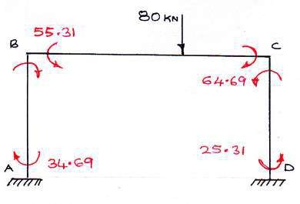

Reactions

SpanBC:
RB
= 55.31− 64.69 + 80 × 3 = 28.83 KN
8

∴ RC = 80 − RB = 51.17

Column CD:
H = 64.69 + 25.31 = 22.5
D 4

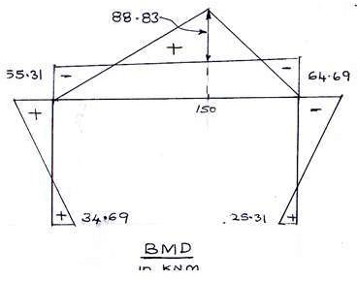

7) Frame ABCD is subjected to a horizontal force of 20 KN at joint C as shown in figure. Analyse and draw bending moment diagram.
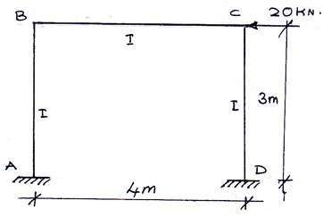
Solution:

Frame is Symmetrical and unsymmetrical loaded hence there is a sway. Assume sway towards right
FEM
FAB = FBA = FBC = FCB = FCD = FDC = 0

Slope deflection equations are

M =F
+ 2EI ⎛ 2θ

+θ − 3δ ⎞

AB AB
L ⎜ _{A} _{B} L ⎟

= 2EI ⎛θ − 3δ ⎞
⎝
⎠
⎝
⎠

3 ⎜ _{B} 3 ⎟

= 2 EIθ − 2 EIδ

- - - - - - - -- > (1)

3 ^{B} 3

M =F
+ 2EI ⎛ 2θ +θ

− 3δ ⎞

BA BA
L ⎜ _{B} _{A} L ⎟

= 2EI ⎛ 2θ − 3δ ⎞
⎝
⎠
⎝
⎠

3 ⎜ _{B} 3 ⎟

= 4 EIθ − 2 EIδ

− − − − − − > (2)

3 ^{B} 3

M = F + 2EI (2θ +θ )

BC BC L B C
= 2EI (2θ +θ )

4 B C

= EIθB +0.5 EIθC
- - - - - - - - > (3)

MCB
=FCB
+ 2EI (2θ
L C
+θB )

= 2EI (2θ
4 C
+θB )

= EIθC +0.5 EIθB
- - - - - - - - > (4)

M =F
+ 2EI ⎛ 2θ

+θ − 3δ ⎞

CD CD
- ⎜ _{C} _{D} L ⎟

= 2EI ⎡2θ − 3δ⎤
⎝
⎠

3 ⎢⎣ C
3 ⎥⎦

= 4 EIθ
3 C
- 2 EIδ
3
− − − − − − > (5)

M =F
+ 2EI ⎡2θ +θ

− 3δ⎤

DC DC
L ⎢⎣ D
C L ⎥⎦

= 2 EI ⎡θ − 3δ⎤

3 ⎢⎣ c
3 ⎥⎦

I.
I I.
= 2 EIθ
3 C

MBA +MBC = 0 MCB +MCD = 0
- 2 EIδ
3
- - - - - - - -- > (6)

III.

- e,
HA +HD −20 = 0
MAB +MBA + MCD +MDC − 20 = 0

3 3
MAB +MBA +MCD +MDC −60 = 0
Now M +M = 4 EIθ − 2 EIδ + EIθ +0.5EIθ

BA BC 3 B 3 B C

= 7 EIθ +0.5EIθ − 2 EIδ = 0

− − − − − − > (7)

3 B C 3

and M +M = EIθ
+0.5EIθ + 4 EIθ − 2 EIδ


CB CD C
B 3 C 3

= 0.5EIθ + 7 EIθ − 2 EIδ = 0

− − − − − − > (8)

B 3 C 3

and M
+M +M
+M −60 = 2 EIθ

− 2 EIδ + 4 EIθ

− 2 EIδ + 4 EIθ


AB BA CD DC
3 ^{B} 3
3 ^{B} 3 3 ^{C}

− 2 EIδ + 2 EIθ − 2 EIδ − 60

3 3 ^{C} 3

EIθB = −8.18, EIθC = −8.18, EIδ = −34.77
= 2EIθB
+2EIθC
− 8 EIδ − 60 = 0 − − − − − − − (9)
3

M = 2 (− 8.18)− 2 (− 34.77) = +17.73 KNM

AB 3 3
M = 4 (− 8.18)− 2 (− 34.77) = +12.27 KNM

BA 3 3

MBC = 0 − 8.18 + 0.5 (− 8.18) = −12.27 MCB = 0.5 (− 8.18)− 8.18 = −12.27
KNM KNM

M = 4 (− 8.18)− 2 (− 34.77) = +12.27 KNM

CD 3 3
M = 2 (− 8.18)− 2 (− 34.77) = +17.73 KNM

DC 3 3

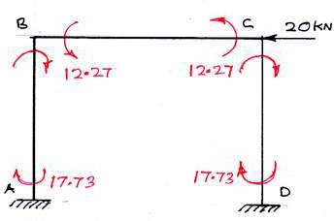

Reactions: Consider the free body diagram of the members

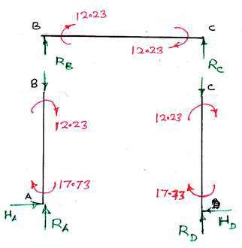

Member AB:
H = 17.73 + 12.27 = 10 KN
A 3
MemberBC:
R = 12.27 + 12.27 = 6.135 KN
C 4

∴RB = −RC = −6.135 KN
Member CD:
- ve
sign indicates direction of
RB downwards

H = −17.73 −12.27 = −10 KN
D 3
- ve
sign indicates the direction of
HD is left to right

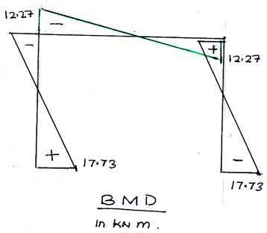

UNIT-V
MOMENT DISTRIBUTION METHOD

Distribution and carryover of moments – Stiffness and carry over factors – Analysis of continuous beams – Plane rigid frames with and without sway – Neylor‟s simplification.
Hardy Cross (1885-1959)
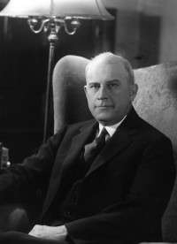
- Moment Distribution is an iterative method of solving an
indeterminate Structure.
- Moment distribution method was first introduced by Hardy Cross in 1932.
- Moment distribution is suitable for analysis of all types of indeterminate beams and rigid frames.
- It is also called a ‘relaxation method’ and it consists of successive approximations using a series of cycles, each converging towards final result.
- It is comparatively easier than slope deflection method. It involves solving number of simultaneous equations with several unknowns, but in this method does not involve any simultaneous equations.
- It is very easily remembered and extremely useful for checking computer output of
highly indeterminate structures.
- It is widely used in the analysis of all types of indeterminate beams and rigid frames.
- The moment-distribution method was very popular among engineers.
- It is very simple and is being used even today for preliminary analysis of small structures.
- The primary concept used in this methods are,
  - Fixed End Moments
  - Relative or Beam Stiffness or Stiffness factor
  - Distribution factor
  - Carry over moment or Carry over factor

Basic Concepts
- In moment-distribution method, counterclockwise beam end moments are taken as positive.
- The counterclockwise beam end moments produce clockwise moments on the joint.
- Note the sign convention:
Anti-clockwise is positive Clockwise is negative

Assumptions in moment distribution method
- All the members of the structures are assumed to be fixed and fixed end moments due to external loads are obtained.
- All the hinged joints are released by applying an equal and opposite moment.
- The joints are allowed to deflect (rotate) one after the other by releasing them successively.
- The unbalanced moment at the joint is shared by the members connected at the joint when it is released.
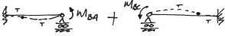
- 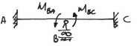The unbalanced moment at a joint is distributed in to the two spans with their distribution factor.

- Hardy cross method makes use of the ability of various structural members at a joint to sustain moments in proportional to their relative stiffness.
Fixed End Moments
- All members of a given frame are initially assumed fixed at both ends.
- The loads acting on these fixed beams produce fixed end moments at the ends.
- FEM are the moments exerted by the supports on the beam ends.
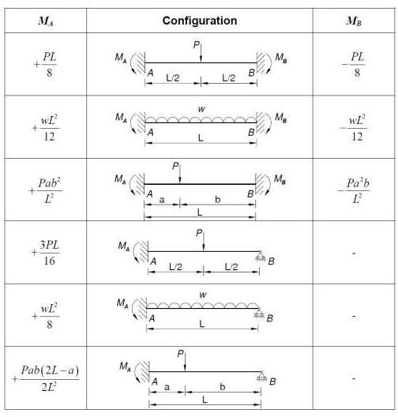
- These (non-existent) moments keep the rotations at the ends of each member zero.

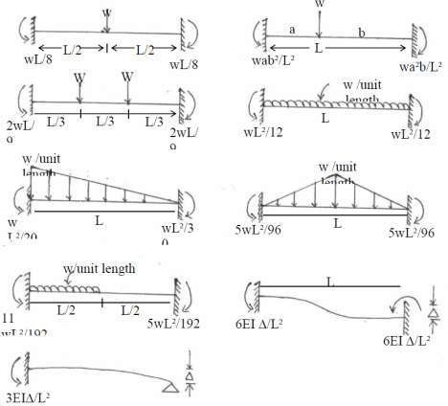
Relative or Beam Stiffness or Stiffness factor
- When a structural member of uniform section is subjected to a moment at one end, then the moment required so as to rotate that end to produce unit slope is called the stiffness of the member.
- Stiffness is the member of force required to produce unit deflection.
- It is also the moment required to produce unit rotation at a specified joint in a beam or a structure. It can be extended to denote the torque needed to produce unit twist.
- It is the moment required to rotate the end while acting on it through a unit rotation, without translation of the far end being
  - Beam is hinged or simply supported at both ends k = 3 EI / L
  - Beam is hinged or simply supported at one end and fixed at other end k = 4 EI / L
  - Stiffness of members in continuous beams and rigid frames
    - Stiffness of all intermediate members k = 4 EI / L
    - Stiffness of edge members,
      - If edge support is fixed k = 4 EI / L
      - If edge support is hinged or roller k = 3 EI / L

- Where, | E | = | Young‟s modulus of the beam material
 | I | = | Moment of inertia of the beam
 | L | = | Beam‟s span length

Distribution factor
- When several members meet at a joint and a moment is applied at the joint to produce rotation without translation of the members, the moment is distributed among all the members meeting at that joint proportionate to their stiffness.
- Distribution factor = Relative stiffness / Sum of relative stiffness at the joint
- If there is 3 members,
Distribution factors = k1 / (k1+k2+k3), k2/ (k1+k2+k3), k₃/ (k1+k2+k3)
Carry over moment
- Carry over moment: It is defined as the moment induced at the fixed end of the beam by the action of a moment applied at the other end, which is hinged.
- Carry over moment is the same nature of the applied moment.
Carry over factor (C.O):
- A moment applied at the hinged end B “carries over” to the fixed end „ A‟,
a moment equal to half the amount of applied moment and of the same rotational sense. C.O =0.5
Problem:
- Find the distribution factor for the given beam.

A L B L C L D

Joint | Member | Relative stiffness | Sum of Relative stiffness | Distribution factor
A | AB | 4EI / L | 4EI / L | (4EI / L) / (4EI / L) = 1
B | BA  BC | 3EI /L  4EI / L | 3EI /L + 4EI / L = 7EI / L | (3EI / L) / (7EI / L )= 3/7  (4EI / L) / (7EI / L) = 4/7
C | CB  CD | 4EI / L  4EI / L | 4EI / L + 4EI / L =8EI / L | (4EI / L) / (8EI / L) =4/8  (4EI / L) / (8EI / L)= 4/8
D | DC | 4EI / L | 4EI / L | (4EI / L)/ (4EI / L) = 1

- Find the distribution factor for the given beam.
(3I) |  |  | (I)
A | L | B | L

C

Joint | Member | Relative stiffness | Sum of Relative stiffness | Distribution factor
A | AB | 4E (3I ) / L | 12EI / L | (12EI / L) / (12EI / L) = 1
B | BA  BC | 4E( 3I) /L  4EI / L | 12EI /L + 4EI / L = 16EI / L | (12EI / L) / (16EI / L )= 3/4  (4EI / L) / (16EI / L) = 1/4
C | CB | 4EI / L | 4EI / L | (4EI / L) / (4EI / L) =1

- Find the distribution factor for the given beam.
A
B
C
D
L

Joint | Member | Relative stiffness | Sum of Relative | Distribution factor
B | BA BC | 0 (no support)  3EI / L | 3EI / L | 0  (3EI / L ) / ( 3EI / L) =1
C | CB  CD | 3EI / L  4EI / L | 3EI /L + 4EI / L  = 7EI / L | (3EI / L) / (7EI / L )= 3 / 7  (4EI / L) / (7EI / L) = 4 / 7
D | DC | 4EI / L | 4EI / L | (4EI / L) / (4EI / L) =1

Flexural Rigidity of Beams:
  - The product of young‟s modulus (E) and moment of inertia (I) is called Flexural Rigidity (EI) of Beams. The unit is N.mm².
Constant strength beam:
  - If the flexural Rigidity (EI) is constant over the uniform section, it is called Constant strength beam.
Sway:
  - Sway is the lateral movement of joints in a portal frame due to the unsymmetrical dimensions, loads, moments of inertia, end conditions, etc.
What are the situations where in sway will occur in portal frames?
  - Eccentric or unsymmetrical loading
  - Unsymmetrical geometry
  - Different end conditions of the columns
  - Non-uniform section of the members
  - Unsymmetrical settlement of supports
  - A combination of the above
What are symmetric and antisymmetric quantities in structural behaviour?
  - When a symmetrical structure is loaded with symmetrical loading, the bending moment and deflected shape will be symmetrical about the same axis.
  - Bending moment and deflection are symmetrical quantities
Steps involved in Moment Distribution Method:
- Calculate fixed end moments due to applied loads following the same sign convention and procedure, which was adopted in the slope-deflection method.
- Calculate relative stiffness.
- Determine the distribution factors for various members framing into a particular joint.

- Distribute the net fixed end moments at the joints to various members by multiplying the net moment by their respective distribution factors in the first cycle.
- In the second and subsequent cycles, carry-over moments from the far ends of the same member (carry-over moment will be half of the distributed moment).
- Consider this carry-over moment as a fixed end moment and determine the balancing moment. This procedure is repeated from second cycle onwards till convergence
Advantages of Fixed Ends or Fixed Supports
- Slope at the ends is zero.
- Fixed beams are stiffer, stronger and more stable than SSB.
- In case of fixed beams, fixed end moments will reduce the BM in each section.
- The maximum defection is reduced.
Problem:
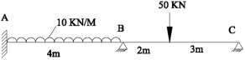
- Analyse the frame given in figure by moment distribution method and draw the B.M.D & S.F.D

Step: 1 - Fixed end moment
MFAB
= | -WL²/12 | = | - 10×4²/12 | = | -13.33 KNM
= | WL²/12 | = | 10×4²/12 | = | -13.33 KNM
= | - Wab²/L² | = | -50×2×3²/5² | = | -36 KNM
= | Wa²b/L² | = | 50×2²×3/5² | = | 24 KNM

F
M
BA
F
M
BC
F
M
CB
Step: 2 - Stiffness

KAB | = | KBA | = | 4EI/L | = | EI
KBC | = | KCB | = | 3EI/L | = | 0.6EI
Step: 3 - Distribution factor Joint B
D^{F} = K /(K +K ) = 0.63
BA BA BA BC
D^{F} = K /(K +K ) = 0.37
BC BC BA BC
Step: 4 - Moment distribution

MEMBER | AB | B |  | CB
 |  | BA | BC
DF | 0 | 0.67 | 0.33 | 0
FEM | -13.33 | +13.33 | -36 | +24
BALANCING | 0 | 0 | 0 | -24
CF | 0 | 0 | -12 | 0
M | -13.33 | +13.33 | -48 | 0
BALANCING | 0 | 21.84 | 12.83 | 0
CF | 10.92 | 0 | 0 | 0
M-FINAL | -2.4 | 35.17 | -35.17 | 0

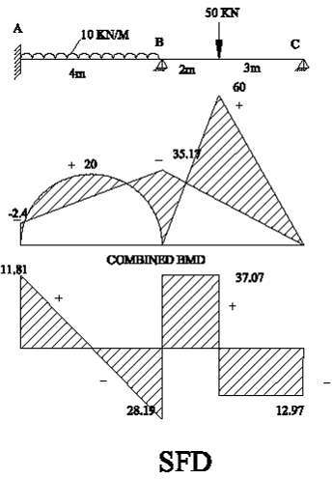
Step: 5 - Reactions Span AB:
R_{A} | = | 11.81 KN
RB1 | = | 28.19 KN
Span BC:

RB2 | = | 37.03 KN
R_{C} | = | 12.97 KN

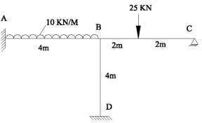
- Analyse the frame given in figure by moment distribution method and draw the B.M.D&S.F.D

Step: 1 - Fixed end moment
MFAB
=  =  = | -WL²/12 WL²/12  - WL/8 | =  =  = | - 10×4²/12 10×4²/12  -25×4/8 | =  =  = | -13.33 KNM  -13.33 KNM  -12.5 KNM
= | WL/8 | = | 25×4/8 | = | 12.5 KNM
= | 0
= | 0

F
M
BA
F
M
BC
F
M
CB
F
M
BD
F
M
DB

Step: 2 - Stiffness

KAB | = | KBA | = | 4EI/L | = | EI
KBC | = | KCB | = | 3EI/L | = | 0.75EI
KBD | = | KDB | = | 4EI/L | = | EI
Step: 3 - Distribution factor Joint B

D^{F} = K / (K +K +K
) = 0.36

BA BA BA BC BD

D^{F} = K / (K
+K +K
) = 0.28

BC BC BA BC BD

D^{F} = K / (K +K +K

) = 0.36

BD BD BA BC BD

Step: 4 - Moment distribution

MEMBER | AB | B |  |  | DB | CB
 |  | BA | BC | BD
DF | 0 | 0.36 | 0.28 | 0.36 | 0
FEM | -13.33 | +13.33 | -12.5 | 0 | 0 | +12.5
CF | 0 | 0 | -6.25 | 0 | 0 | -12.5
M(initial) | -13.33 | +13.33 | -18.75 | 0 | 0 | 0
BALANCING | 0 | +1.95 | 1.52 | 1.95 | 0 | 0
MF | 0.98 | 0 | 0 | 0 | 0.98 | 0
M-FINAL | -12.35 | 15.28 | -17.23 | 1.95 | 0.98 | 0

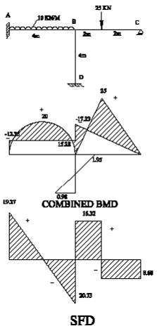
Step: 5 - Find reactions: Span AB:
R_{A} | = | 19.27 KN
RB1  Span BC: | = | 20.73 KN
RB2 | = | 16.32 KN
R_{C} | = | 8.68 KN
Span BD:
RB3 | = | -0.73 KN
R_{D} | = | 0.73 KN

- The continuous beam ABCD, subjected to the given loads, as shown in Figure below. Assume that only rotation of joints occurs at B, C and D, and that no support displacements occur at B, C and D. Due to the applied loads in spans AB, BC and CD, rotations occur at B, C and D using moment distribution method.
150KN
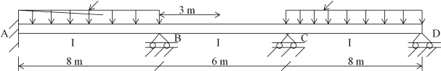

Step: 1 - Fixed end moments
wl ²
M AB = −M BA = − 12 = −

(15)(8)²
12

= −80 kN.m

M = −M
= − wl = − (150)(6) = −112.5 kN.m

BC CB
8 8
wl ² (10)(8)²

MCD = −M DC = − 12 = − 12
= −53.333 kN.m

Step: 2 - Stiffness Factors (Unmodified Stiffness)

K AB

KBC

= KBA

= KCB
= 4EI
L
= 4EI
L
= (4)(EI ) = 0.5EI 8
= (4)(EI ) = 0.667EI 6

K = ⎡ 4EI ⎤ = 4 EI

= 0.5EI

CD ⎢⎣ 8 ⎥⎦ 8

KDC
= 4EI
8

= 0.5EI

Step: 3 - Distribution Factors

DFAB
=
KBA
KBA
- K

wall
= 0.5EI
  - + ∞ (wall stiffness )
= 0.0

DFBA

DF
= KBA
KBA + KBC
= KBC
K
= 0.5EI 0.5EI + 0.667EI
= 0.667EI
= 0.4284

= 0.5716

BC
BA
- KBC

0.5EI + 0.667EI

DFCB

DF
= KCB
KCB + KCD
= KCD
K
= 0.667EI 0.667EI + 0.500EI
= 0.500EI
= 0.5716

= 0.4284

CD
CB
- KCD

0.667EI + 0.500EI

DFDC
= KDC
K
= 1.00

DC

Step: 4 - Moment Distribution

Joint | A | B |  | C |  | D
Member | AB | BA | BC | CB | CD | DC
DF | 0 | 0.4284 | 0.5716 | 0.64 | 0.36 | 1
FEM | -80 | 80 | -112.50 | 112.50 | -53.33 | 53.33
Ist Distribution |  | 13.923 | 18.577 | -37.87 | -21.3 | -53.33
Carry over Moment | 6.962 |  | -18.93 | 9.289 | -26.67 | -10.65
2nd Distribution |  | 8.111 | 10.823 | 11.122 | 6.256 | 10.65
Carry over Moment | 4.056 |  | 5.561 | 5.412 | 5.325 | 3.128
3rd Distribution |  | -2.382 | -3.179 | -6.872 | -3.865 | -3.128
Carry over Moment | -1.191 |  | -3.436 | -1.59 | -1.564 | -1.933
4th Distribution |  | 1.472 | 1.964 | 2.019 | 1.135 | 1.933
Carry over Moment | 0.736 |  | 1.01 | 0.982 | 0.967 | 0.568
5th Distribution |  | -0.433 | -0.577 | -1.247 | -0.702 | -0.568
Carry over Moment
M-FINAL | -69.44 | 100.69 | -100.7 | -93.748 | 93.75 | 0

Step: 5 - Computation of Shear Forces
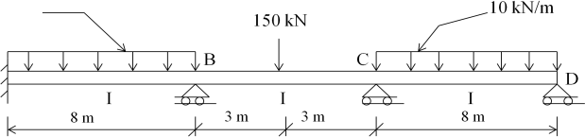

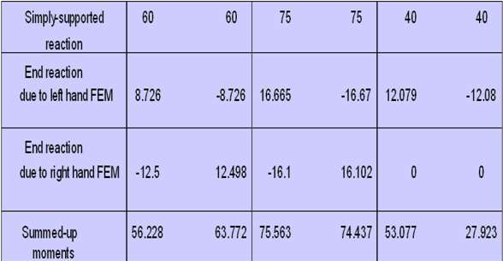

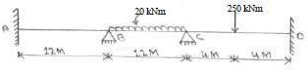
5. Analyse the beam as shown in figure by moment distribution method and draw the BMD. Assume EI is constant

Step: 1 - Fixed end moments
M^{F}_{AB} = 0 M^{F} = 0
BA
M^{F} = -WL²/12 = - 20×12²/12 = -240 KNM M^{F} = WL²/12 = - 20×12²/12 = 240 KNM M^{F} = - WL/8 = -250×8/8 = -250 KNM M^{F} = WL/8 = 250×8/8 = 250 KNM
BC
CB
CD
DC
Step:2 - Distribution factor

Joint | Member | Relative Stiffness (K) | ΣK | D.F = (K / ΣK)
B | BA | I / L = (I /12) | I / 6 | 0.50
 | BC | I / L = (I /12) |  | 0.50
C | CB | I / L = (I /12) | 5I / 24 | 0.40
 | CD | I / L = (I /8) |  | 0.60

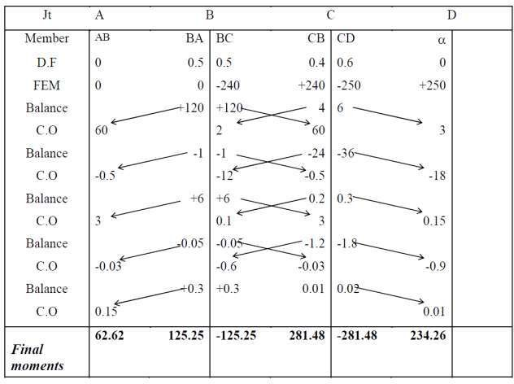
Step:3 – Moment Distribution

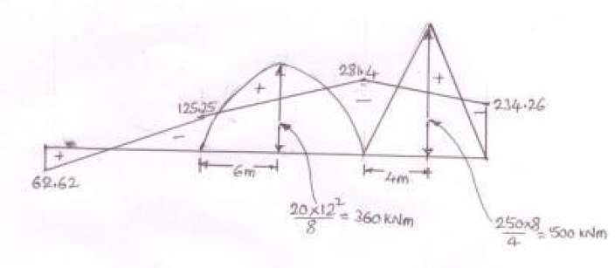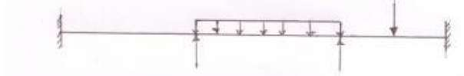

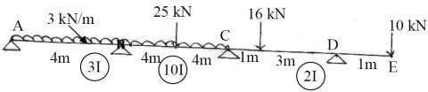
- Analyze the continuous beam as shown in fig by moment distribution method and draw BMD & SFD

Step: 1 - Fixed end moments
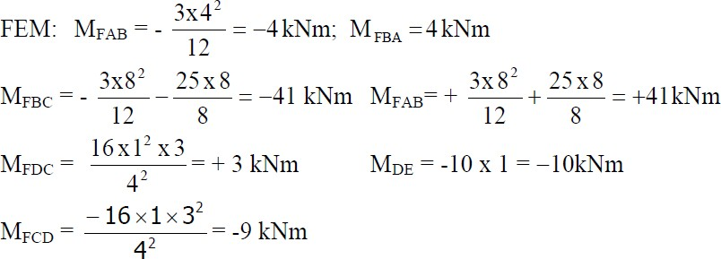

Step:2 - Distribution factor
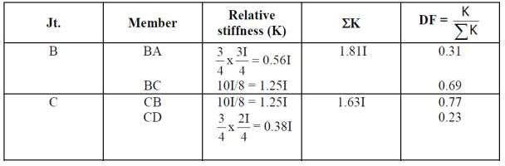

Step: 3 - Moment Distribution
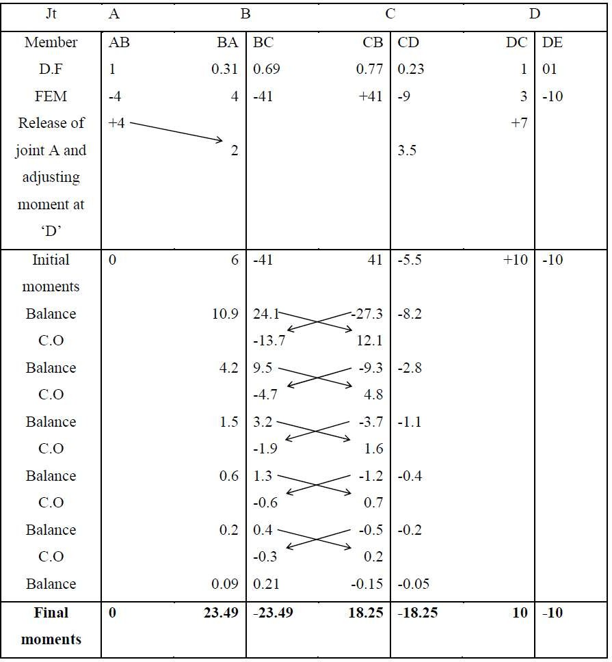
Step: 4 – BMD & SFD
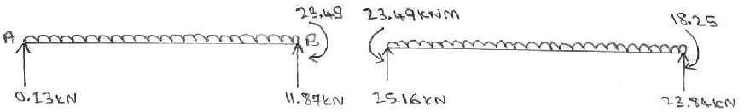
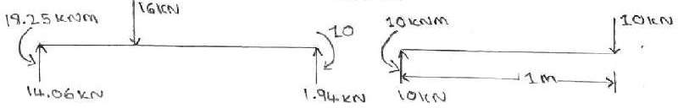

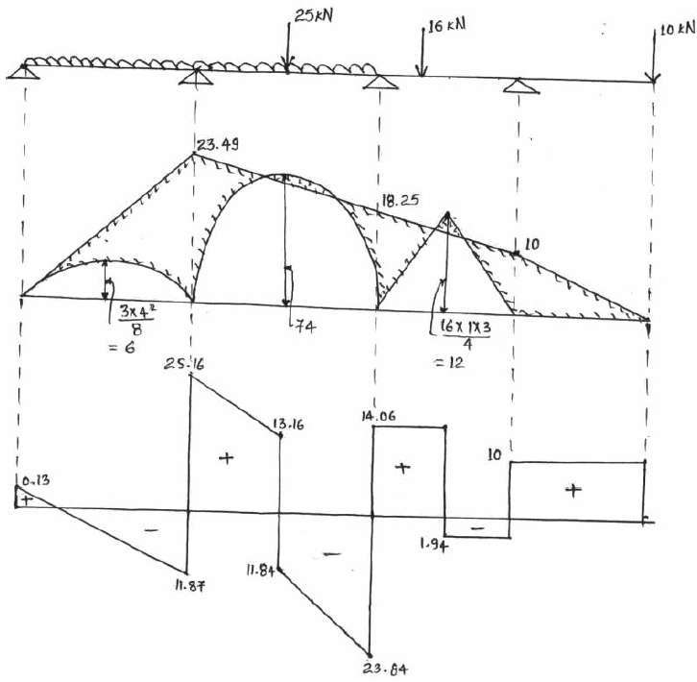

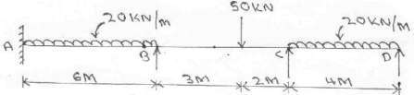
- Analyze the continues beam as shown in figure by moment distribution method and draw the
B.M. diagrams

Support B sinks by 10mm, and take E = 2 x 10⁵ N/mm², I = 1.2 x 10⁻⁴ m⁴
Step: 1 - Fixed end moments
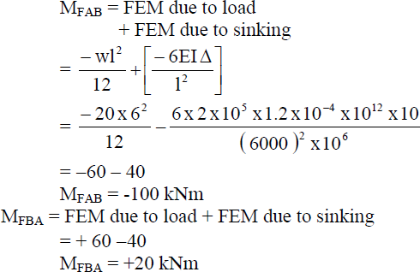
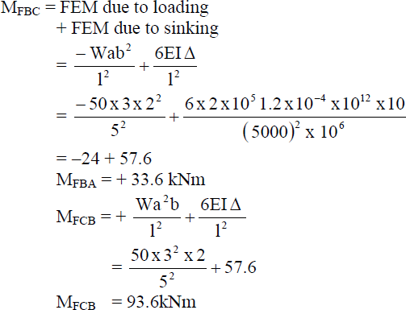
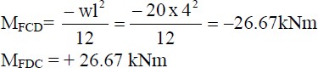

Step:2 - Distribution factor
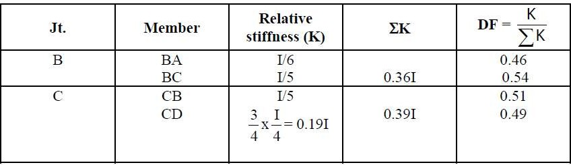

Step: 3 - Moment Distribution
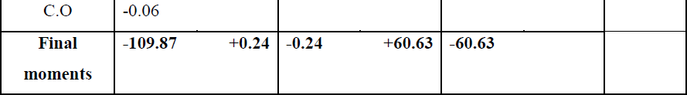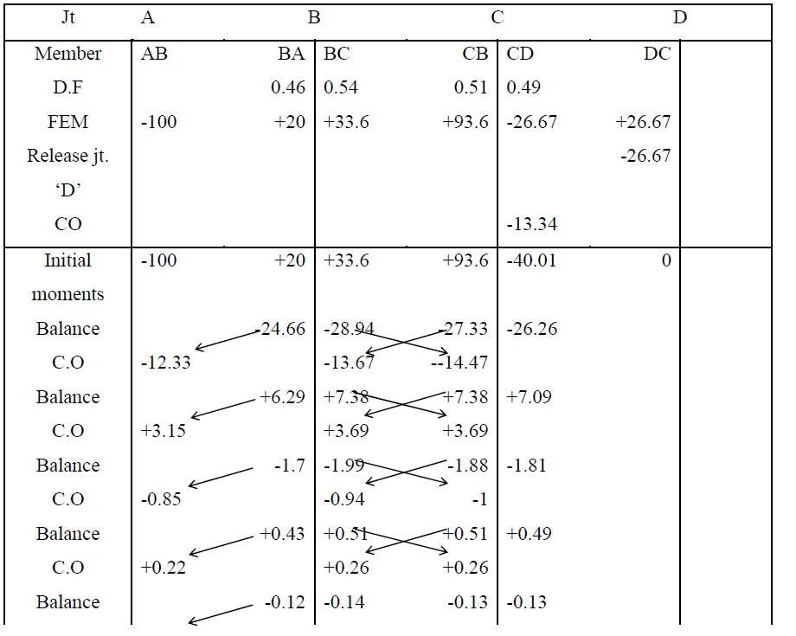

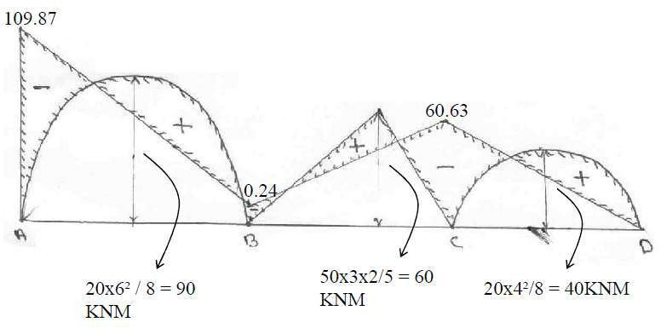
Step: 4 – BMD

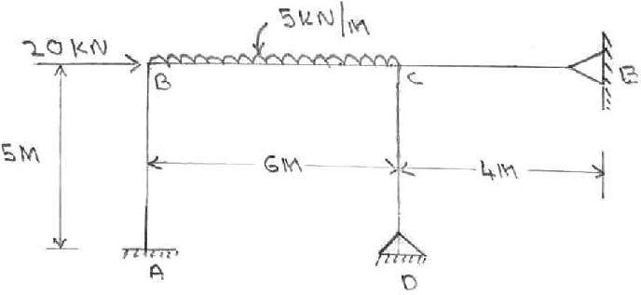
6. Analysis the frame shown in figure by moment distribution method and draw BMD. Assume EI is constant

Step: 1 - Fixed end moments
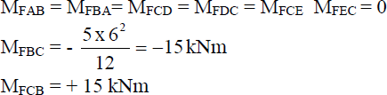

Step:2 - Distribution factor
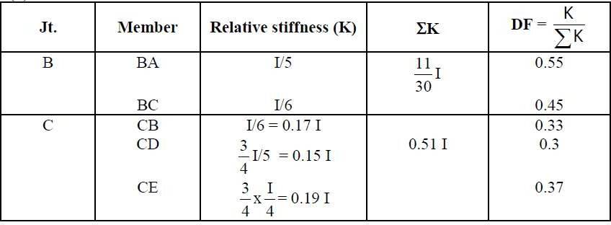

Step: 3 - Moment Distribution
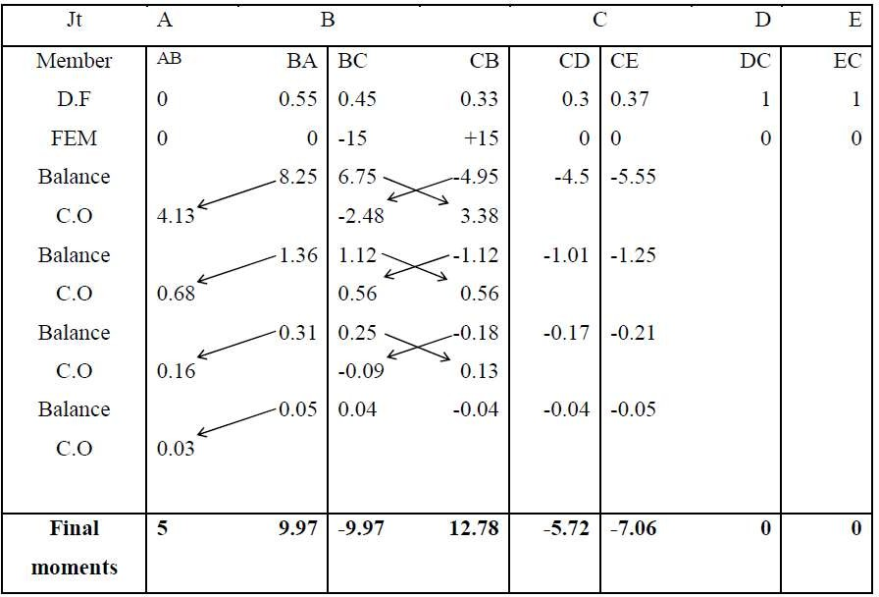
Step: 4 – BMD
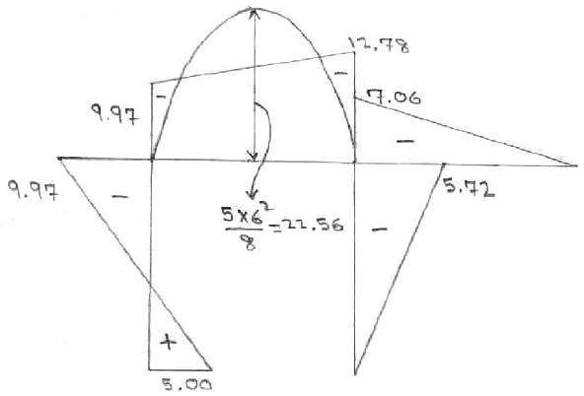

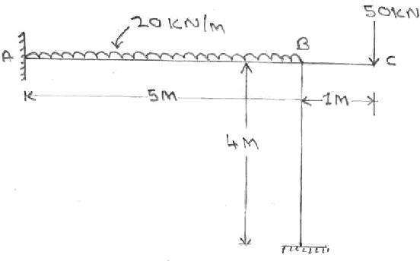
- Analyze the frame shown in figure by moment distribution method and draw BMD and SFD

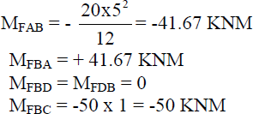
Step: 1 - Fixed end moments
Step:2 - Distribution factor
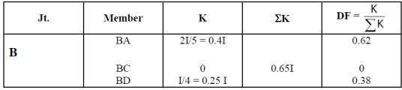
Step: 3 - Moment Distribution
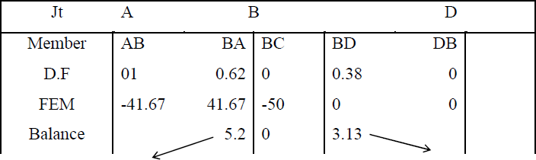

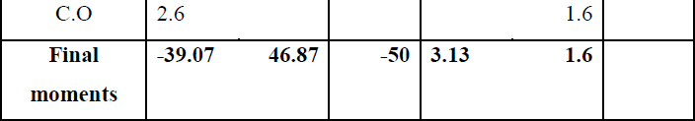

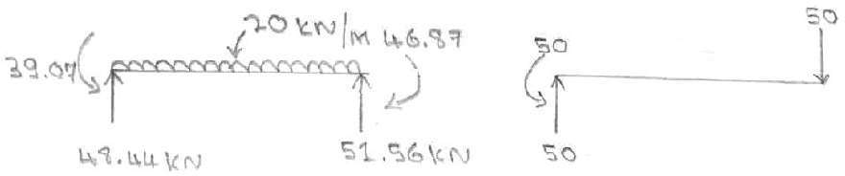
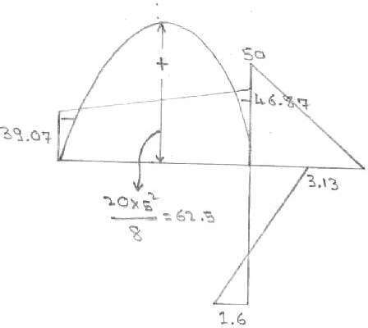
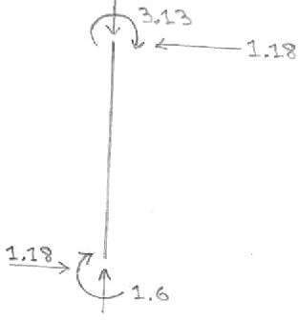

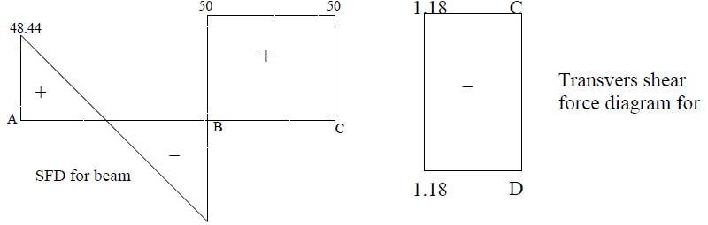

Moment distribution method for frames with side sway:
  - 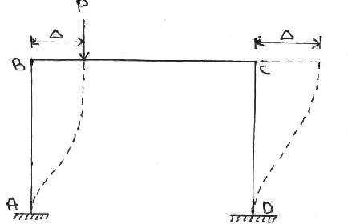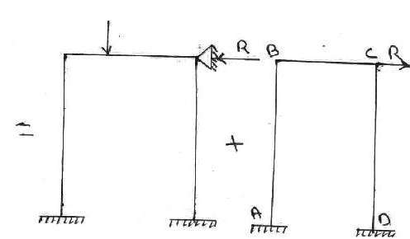Frames that are non symmetrical with reference to material property or geometry (different lengths and I values of column) or support condition or subjected to nonsymmetrical loading have a tendency to side sway.

- Analyze the frame shown in figure by moment distribution method. Assume EI is constant.
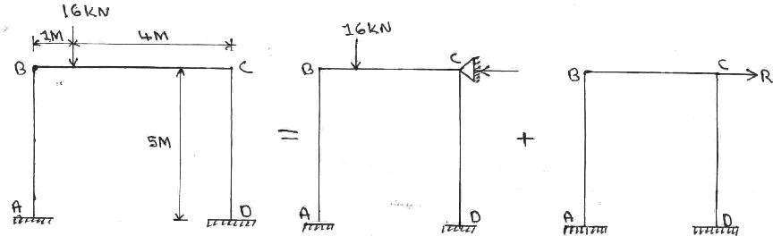
Non Sway Analysis:
  - First consider the frame held from side sway as shown in figure.
Step: 1 - Fixed end moments
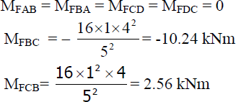
Step:2 - Distribution factor
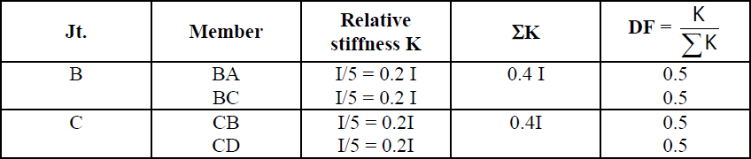

Step: 3 - Moment Distribution
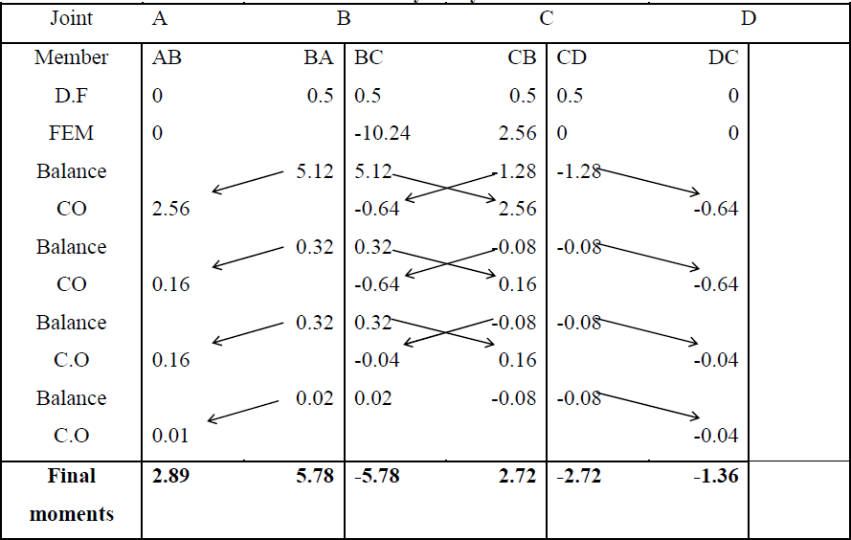

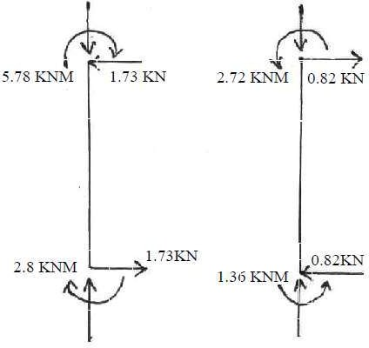
FBD of columns:

By seeing of the FBD of columns
R = 1.73 – 0.82
(Using ΣF_{x} = 0 for entire frame) = 0.91 KN (←) Now apply
R = 0.91 kN acting opposite as shown in figure
for the sway analysis.

- Sway analysis:
  - For this we will assume a force R′ is applied at C causing the frame to deflect Δ‟ as shown
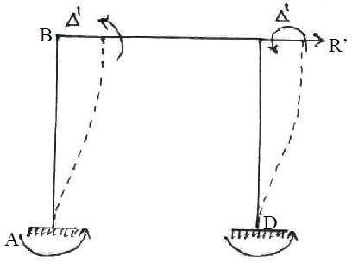
in figure

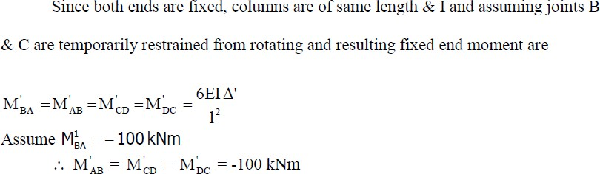

Moment distribution table for sway analysis:
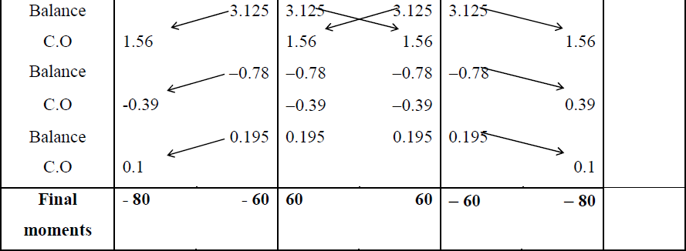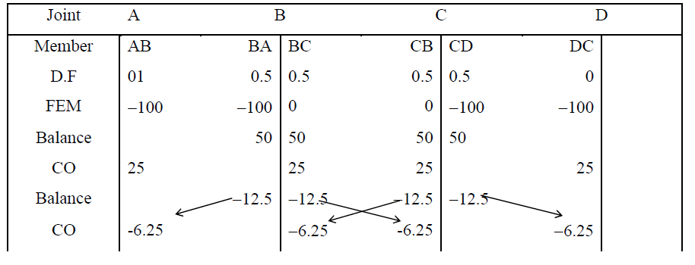

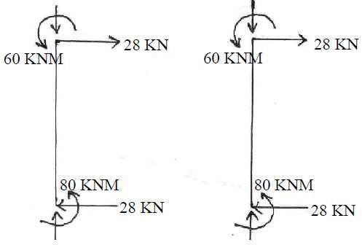
FBD of columns:
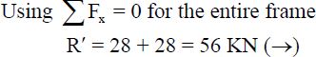

  - Hence R‟ = 56KN creates the sway moments shown in above moment distribution table. Corresponding moments caused by R = 0.91KN can be determined by proportion.
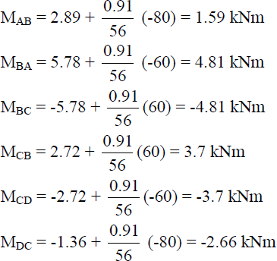
  - Thus final moments are calculated by adding non sway moments and sway moments calculated for R = 0.91KN, as shown below
BMD:
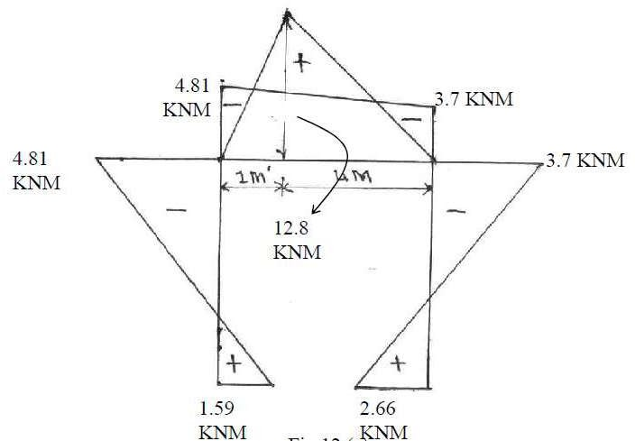

Moment distribution method for frames with side sway:
1. Analysis the rigid frame shown in figure by moment distribution method and draw BMD
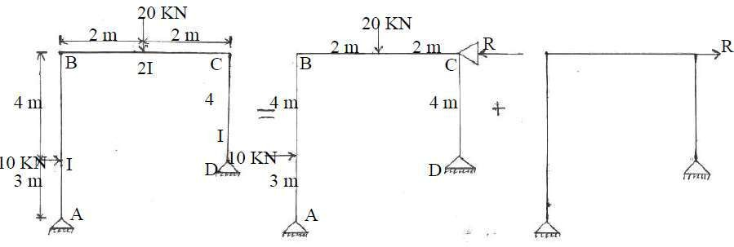
- Non Sway Analysis:
First consider the frame held from side sway as shown in figure 2
FEM calculation:
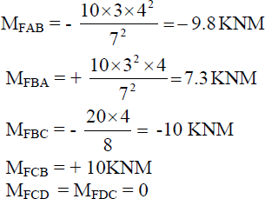

Distribution Factor:
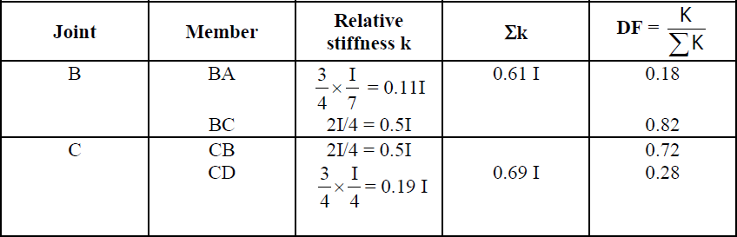

Moment distribution for non sway analysis:
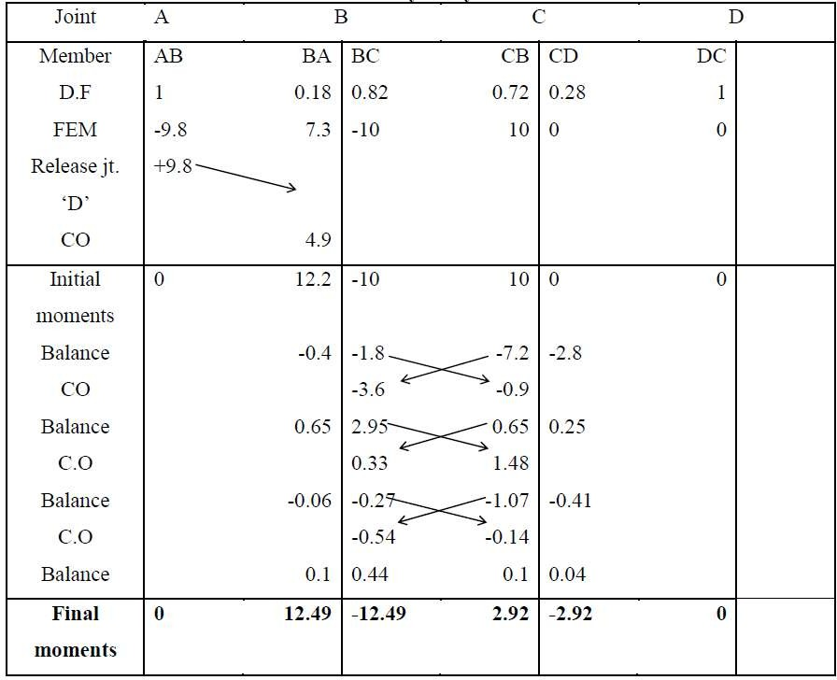
FBD of columns:
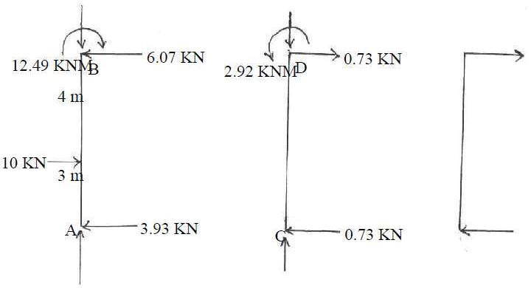
  - FBD of columns AB & CD for non-sway analysis is shown in figure

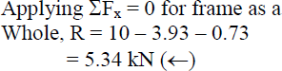
  - Now apply R = 5.34KN acting opposite as shown in figure for sway analysis

- Sway analysis:
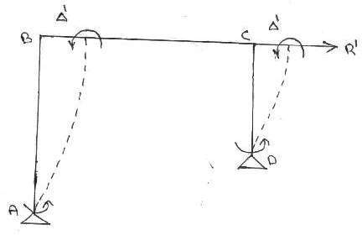
  - For this we will assume a force R′ is applied at C causing the frame to deflect Δ′ as shown in figure.

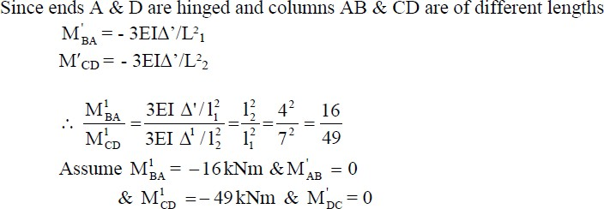

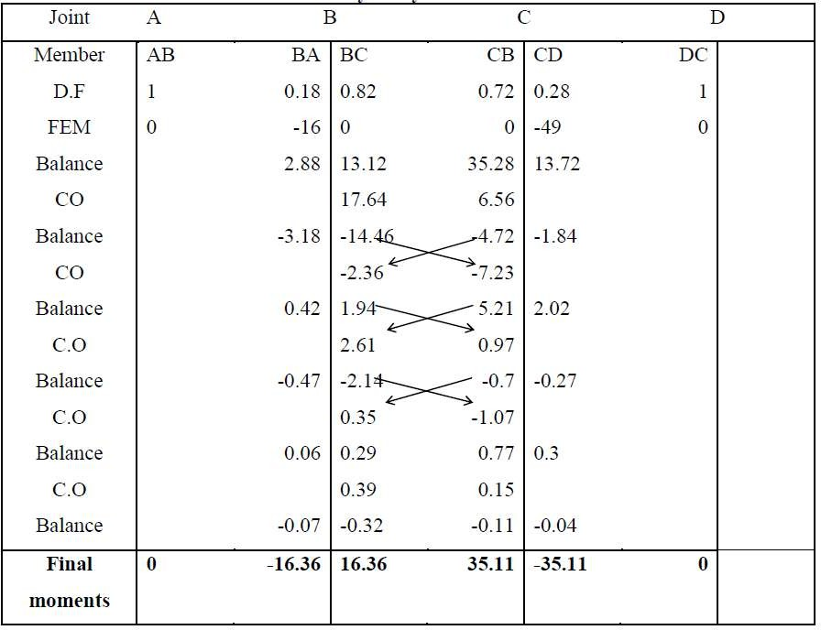
Moment distribution table for sway analysis:

FBD of columns AB & CD for sway analysis moments is shown in fig.
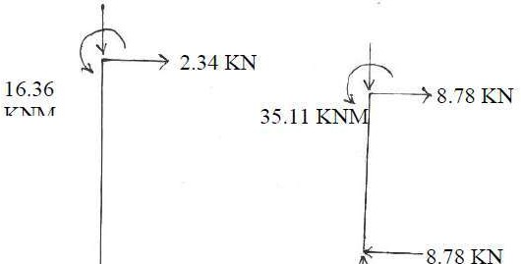
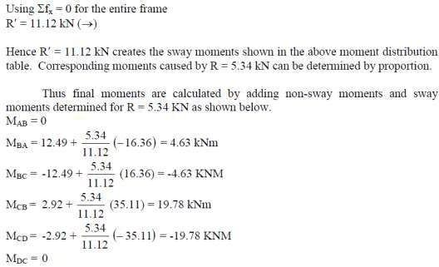
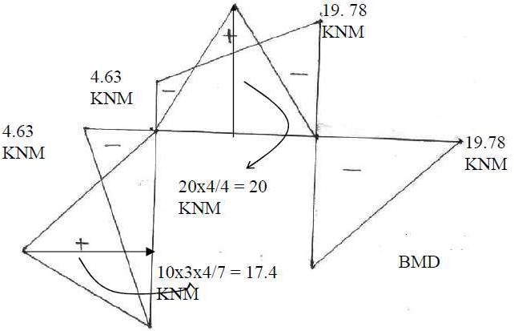

UNIT-III ARCHES
Arches as structural forms – Examples of arch structures – Types of arches – Analysis of three hinged, two hinged and fixed arches, parabolic and circular arches – Settlement and temperature effects.
Introduction:
  - Mainly three types of arches are used in practice: three-hinged, two-hinged and hingeless arches.
  - In 19th century, three-hinged arches were commonly used for the long span structures.
  - Then development in structural analysis, for long span structures starting from late nineteenth century engineers adopted two-hinged and hingeless arches.
  - Two-hinged arch is the statically indeterminate structure to degree one.
  - Usually, the horizontal reaction is treated as the redundant and is evaluated by the method of least work.
Arch:
  - An arch is a curved beam or structure in vertical plane and subjected to transverse loads which act on the convex side of the curve and re-sights the external loads by virtue of thrust.
  - It is subjected to three restraining forces i.e.,
    - Thrust
    - Shear force
    - Bending Moment
What is an arch? Explain.
  - An arch is defined as a curved girder, having convexity upwards and supported at its ends.
  - The supports must effectively arrest displacements in the vertical and horizontal directions.
  - Only then there will be arch action.
What is a linear arch?
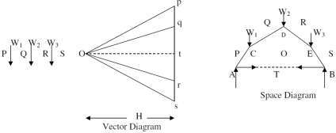
  - If an arch is to take loads, say W1, W2, and W3 (fig) and a Vector diagram and funicular polygon are plotted as shown, the funicular polygon is known as the linear arch or theoretical arch.

  - The polar distance „ot‟ represents the horizontal thrust.
  - The links AC, CD, DE, and EB will be under compression and there will be no bending moment.
  - If an arch of this shape ACDEB is provided, there will be no bending moment.
  - For a given set of vertical loads W1, W2…..etc., we can have any number of linear arches depending on where we choose „O‟ or how much horizontal thrust (or) we choose to introduce.
State Eddy’s theorem.
  - Eddy‟s theorem states that “The bending moment at any section of an arch is proportional to the vertical intercept between the linear arch (or theoretical arch) and the centre line of the actual arch.”
  - BM_{x} = Ordinate O₂O₃ x scale factor
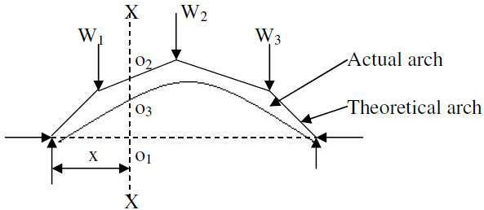
What is the degree of static indeterminacy of a three hinged parabolic arch?
  - For a three hinged parabolic arch, the degree of static indeterminancy is zero.
  - It is statically determinate.
Explain with the aid of a sketch, the normal thrust and radial shear in an arch rib.
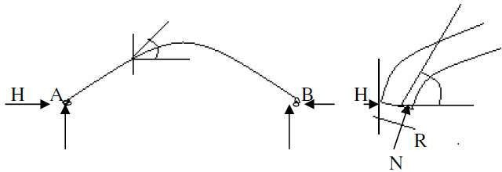
  - Let us take a section X of an arch. (fig (a) ).
  - Let q be the inclination of the tangent at X.
  - If H is the horizontal thrust and V the vertical shear at X, from the free body of the RHS of the arch, it is clear that V and H will have normal and radial components given by,
N = H cosƟ + V sinƟ R = V cosƟ - H sinƟ

Difference between the basic action of an arch and a suspension cable
  - An arch is essentially a compression member which can also take bending moments and shears.
  - Bending moments and shears will be absent if the arch is parabolic and the loading uniformly distributed.
  - A cable can take only tension. A suspension bridge will therefore have a cable and a stiffening girder.
  - The girder will take the bending moment and shears in the bridge and the cable, only tension.
  - Because of the thrusts in the cables and arches, the bending moments are considerably reduced.
  - If the load on the girder is uniform, the bridge will have only cable tension and no bending moment on the girder.
Distinguish between two hinged and three hinged arches

Sl. No | Two hinged arches | Three hinged arches
1 | Statically indeterminate to first  degree | Statically determinate
2 | Might develop temperature  stresses | Increase in temperature causes increase in  Central rise. No stresses.
3 | Structurally more efficient | Easy to analyse.  But in costruction, the central hinge may involve additional expenditure.
4 | Will develop stresses due to  sinking of supports | Since this is determinate, no stresses due  to support sinking.
Types of Arches
- According to the support conditions (structural behaviour arches) or hinges
  - Three hinged arch
    - Hinged at the supports and the crown
    - 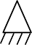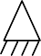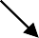A 3-hinged arch is a statically determinate structure.
Hinged at the
crown
Rise
Springing
Hinged at the
Support

  - Two hinged arch
    - Hinged only at the support
    - It is an indeterminate structure of degree of indeterminacy equal to 1

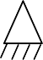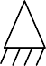Rise
Rib of the arch

Span

Hinges at the support
  - Single hinged arch
  - Fixed arch (or) hingeless arch
    - The supports are fixed
    - It is a statically indeterminate structure.
    - The degree of indeterminancy is 3
- , According to their shapes
  - Circular or curved or segmental arch
  - Parabolic arch
  - Elliptical arch
  - Polygonal arch
- , According to their basis of materials
  - Steel arches,
  - Reinforced concrete arches,
  - Masonry arches (Brick or Stone) etc.,
- , According to their space between the loaded area and the rib arches
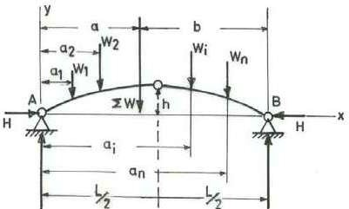
  - Open arch
  - Closed arch (solid arch).
Three Hinged Arch
- Three hinged arch is statically determinate.
- Third hinge at crown and the other two hinges at each abutments
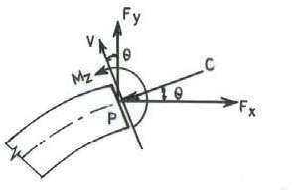
- Mostly used for long span bridges
Analysis of three Hinged Parabolic Arch
- Bending moment at the crown hinge is zero
- Arch have two reaction at support (One horizontal & one vertical)
- Need for four equation to solve and find the unknown reaction.

- We can use three static equilibrium conditions and in addition to that the B.M. at the crown hinge is equal to zero.
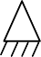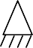
Crown
Rise
Springing
Hinged at the
Support

For Symmetric Parabolic Arch:
- Rise:
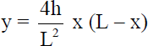
Where,
y_{c} = r = Radius (or) Rise of arch L = Length of Arch or Span
- Internal forces (Fx, Fy & Mz)
  - Normal Thrust (N_{x})
N_{x} = V_{x} SinƟ + H CosƟ
  - Radial Shear (R_{x})
R_{x} = V_{x} SinƟ - H CosƟ
  - Slope of arch (Ɵ)
θ = tan⁻¹ [(4h/L²) (L – 2x)
  - Resultant (R)
R_{A} = √(V_{A}² + H_{A}²)

Where,
F_{x} or R_{x} | = | shear force in the arch
F_{y} or N_{x} | = | thrust in the arch
θ | = | Slope of arch axis at P.
V | = | Shear at P
C | = | Thrust at P
M | = | Bending moment at P

- A three hinged parabolic arch of 20 m span and 4 m central rise as shown in figure carries a point load of 40 kN at 4 m horizontally from left support. Compute BM, SF and AF at load point. Also determine maximum positive and negative bending moments in the arch
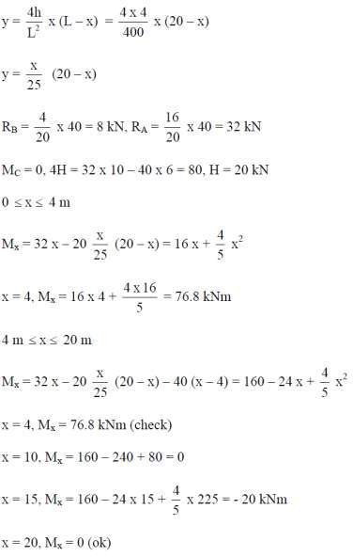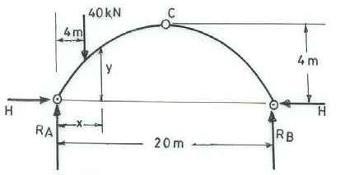
and plot the bending moment diagram.

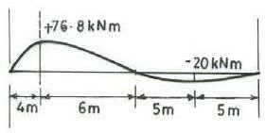
B.M.D

Analysis of two-hinged arch
  - A typical two-hinged arch is having four unknown reactions, but there are only three equations of equilibrium available.
  - Hence, the degree of statically indeterminacy is one for two-hinged arch.
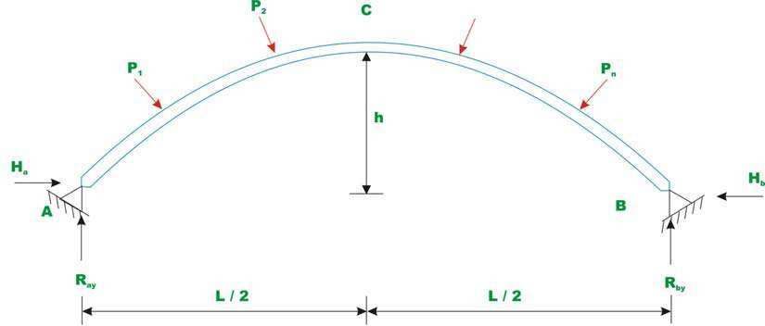
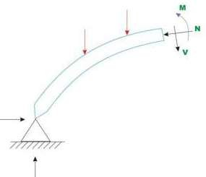

Rib-shortening in the case of arches.
  - In a two hinged arch, the normal thrust which is a compressive force along the axis of the arch will shorten the rib of the arch.
  - This in turn will release part of the horizontal thrust.
  - Normally, this effect is not considered in the analysis (in the case of two hinged arches).
  - Depending upon the importance of the work we can either take into account or omit the effect of rib shortening.
  - This will be done by considering (or omitting) strain energy due to axial compression along with the strain energy due to bending in evaluating H.

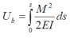
Strain energy due to bending (U_{b})

Where,
M | = | Bending moment
E | = | Young’s modulus of the arch material
I | = | Moment of inertia of the arch cross section
s | = | Length of the centreline of the arch
Strain energy due to axial compression (U_{a})

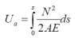
Where,
M = Bending moment
N = Axial compression.
A = Cross sectional area of the arch
E = Young’s modulus of the arch material
s = Length of the centreline of the arch
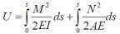
Total strain energy of the arch

Symmetrical two hinged arch
  - Consider a symmetrical two-hinged arch as shown in figure.
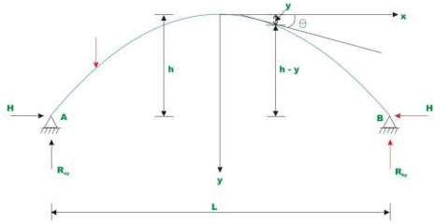
  - Let „C‟ at crown be the origin of co-ordinate axes.
  - Now, replace hinge at ‘B’ with a roller support.
  - Then we get a simply supported curved beam figure as shown in below.
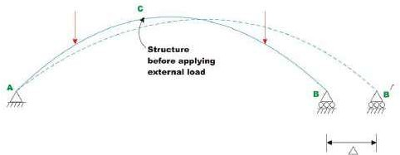

  - Since the curved beam is free to move horizontally, it will do so as shown by dotted lines.
  - Let M_{o} and N_{o} be the bending moment and axial force at any cross section of the simply supported curved beam.
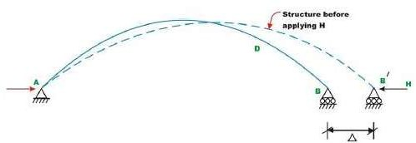
  - Since, in the original arch structure, there is no horizontal displacement, now apply a horizontal force „H’ as shown in figure.

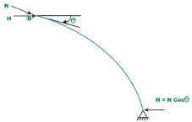
  - The horizontal force „H’ should be of such magnitude, that the displacement at „B’ must vanish.

Bending moment at any cross section of the arch | M | = | M_{o} – H (h-y)
The axial compressive force at any cross section | N | = | N_{o} + H cosƟ
Where,
θ the angle made by the tangent at D with horizontal
Substituting the value of M and N in the equation
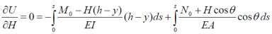
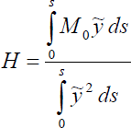

Temperature effect
  - Consider an unloaded two-hinged arch of span L.
  - When the arch undergoes a uniform temperature change of T °C, then its span would increase by α L T if it were allowed to expand freely.
  - α is the co-efficient of thermal expansion of the arch material.

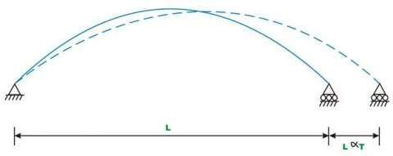
  - Since the arch is restrained from the horizontal movement, a horizontal force is induced at the support as the temperature is increased.

Analysis of 3-hinged arches
  - It is the process of determining external reactions at the support and internal quantities such as normal thrust, shear and bending moment at any section in the arch.
Procedure to find reactions at the supports
  - Sketch the arch with the loads and reactions at the support.

  - Apply equilibrium conditions namely
∑ Fx = 0,
∑Fy = 0
and ∑M= 0

  - Apply the condition that BM about the hinge at the crown is zero (Moment of all the forces either to the left or to the right of the crown).
  - Solve for unknown quantities.
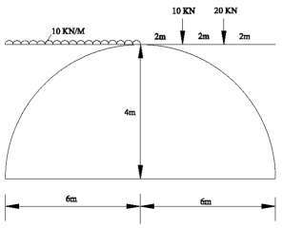
- Find the BM,RS,NT catch 4m from left hand side,2m from right hand side of the three hinged parabolic arch shown in fig.

Step1: Find V_{A}, V_{B}, H_{A}, H_{B}
Take M @ B = 0

V_{A}×12+H_{A}×0-10×16(6/2+6)-20×4+20×2  V_{A} = 55 KN | = | 0
Take M @ A = 0  -V_{B}×12+H_{B}×0+20×0+20×8+ (10×6²/2) | = | 0
V_{B} = 45 KN
H_{A} (LHS)
V_{A}×6-(H_{A}×4)- (10×6²/2)=0
H_{A} = 37.5 KN

H_{B} (RHS)
-V_{B}×6+H_{B}×4-20×4+20×2 = 0
H_{B} = 37.5 KN
(i) BM, RS, NT (4m from LHS)

Y_{D}  Y_{D}  Bending moment |  | =  =  = | 4r/L²(Lx-x²)  4×4/12²(12×4-4²)  3.56 m
M@D |  | = | (V_{A}×4)-(H_{A}×3.56)-(10×4²/2)
M_{D}  Normal thrust |  | = | 6.5 KNm
 | NT | = | V_{x}Sinθ + HCosθ
 | V_{x} | = | V_{A}-(10×4)
 |  | = | 55-40
 |  | = | 15 KN
 | θ | = | 4r/L² (L-2x)
 |  | = | 25.46
 | NT | = | 15×cos 25.46-37.5×sin 25.46
 |  | = | 40.3 KN
Radial shear
 | RS | = | V_{x}cosθ - Hsinθ
 |  | = | 15×cos 25.46 – 37.5 × sin 25.46
 |  | = | 2.58 KN
(ii) BM, RS, NT (2m from RHS)
Y_{E} |  | = | 2.22 m
V_{X} |  | = | 25 KN
Bending moment
M@E |  | = | (-V_{B}×2) + H_{B}×2.22
M@E |  | = | -6.75KNm
Normal thrust
NT | = |  | V_{x}Sinθ + HCosθ
V_{x} | = |  | V_{B}-20
 | = |  | 45-20
 | = |  | 25 KN
θ | = |  | 4r/L² (L-2x) = 50.92

NT | = | 25×cos 55.92-37.5×sin 55.92
 | = | 43KN
Radial shear
RS | =  = | V_{x} cosθ - Hsinθ  25×cos 55.92 – 37.5 × sin 55.92
 | = | -13.33 KN

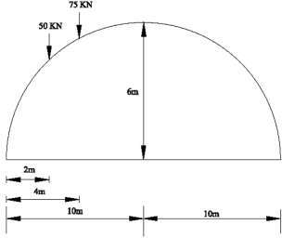
- Three hinged circular arch, a find support reaction, BM, RS, NT at 4m from L.H.S and 5m from R.H.S.

Solution: Find V_{A}, V_{B}, H_{A}, H_{B}

Take M @ B | = | 0
V_{A}×20-50×18-75×16 | = | 0
V_{A} | = | 105 KN
Take M @ A=0
V_{B} | = | 20 KN
H_{A}(LHS)
V_{A}×10-(H_{A}×6)- (50×8) - (75×6) = 0
H_{A} | = | 33.33 KN
H_{B} (RHS)
H_{B} | = | 33.33 KN
Find Y_{D}  r (2R-r) | = | L²/4
L | = | 20m, r = 6m
6(2R-r) | = | 20²/4
R | = | 11.33 m
R² = x′²+(R-r+Y_{D})² x′=6m
11.33² = 6²+(11-6+ Y_{D})²
9.61 = 5.33+ Y_{D}
Y_{D}=4.28 m
θ = sin⁻¹(x′/R)
= sin⁻¹(6/11.33)
= 31.98̊

(i) BM, RS, NT (4m from LHS)
Bending moment

M@D | = | (V_{A}×4)-(50×2)-(H_{A}×Y_{D})
 | = | 117.35 KNm
Normal thrust
NT | = | V_{x}Sinθ + HCosθ
V_{x} | = | V_{A}-(75+50)
 | = | 20 KN
NT | = | 20Sin31.98 + 33.33Cos31.98
 | = | 17.98 KN
Radial shear
RS | = | V_{x} cosθ – H sinθ
 | = | 20×cos 31.98 – 33.33× sin31.98
 | = | - 34.61 KN
(ii) BM,RS,NT(6m from RHS)
x′ | = | 5 m
θ | = | 26.18
Bending moment
Y_{E} | = | 4.83
M@E | = | (VB×5)+(H_{B}×Y_{E})
 | = | (20×5) + (33.33×4.83)
 | = | 60.98 KNm
Normal thrust
NT | = | V_{x} Sinθ + H Cosθ
V_{x} | = | 20 KN
NT | = | 20 Sin26.18 + 33.33 Cos26.18
 | = | 38.73 KN
Radial shear
RS | = | V_{x} cosθ – H sinθ
 | = | 20×cos 26.18 – 33.33× sin26.18
 | = | - 3 KN

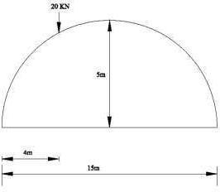
- A two hinged parabolic arch of span 15m and a point load of 20 KN at a distance of 4m from L.H.S. Find the BM, RS, NT 4m from L.H.S and 3m from R.H.S. since r = 5m.
Solution: Find V_{A},V_{B}

Take | M@B = |  |  | 0
 | V_{A}×15-20×11 = |  |  | 0
 | V_{A} = |  |  | 14.67 KN
Take | M@A = |  |  | 0
 | -V_{B}×15+20×4 = |  |  | 0
 | V_{B} = |  |  | 5.3 KN
H |  | = | ₀∫^{l} (μ y dx)/(18r²L/15)
μ₁ |  | = | 14.67 x₁
μ₂ |  | = | -5.33x₂+80
Substitute the μ₂,μ₁ values to above equation and we get H = 11.8 KN
(i) BM,RS,NT(4m from LHS)
Bending moment

Y_{D}  M@D | =  = | 3.9 m  (V_{A}×4)-(20×0)-(H_{A}×Y_{D})
 | = | 12.62 KNm
Normal thrust
NT | = | V_{x}Sinθ + HCosθ
V_{x} | = | V_{A}- 20
 | = | -5.33 KN
θ | = | 35.65
NT  Radial shear | = | -5.33Sin35.65 + 11.81Cos35.65 = 6.5 KN
RS | = | V_{x} cosθ – H sinθ
 | = | -5.33×cos 35.65 – 11.81× sin35.65
 | = | - 11.2 KN
(ii) BM, RS, NT (5m from RHS)
x | = | 5 m
θ | = | 28.65
Bending moment
Y_{E} = 3.75
M@E = 0

Normal thrust

NT | = | V_{x}Sinθ + HCosθ
V_{x} | = | 25 KN
NT | = | 25Sin28.65+50Cos28.65
 | = | 55.87 KN
Radial shear  RS | = | V_{x}cosθ - Hsinθ = 25×cos 28.65 – 50× sin28.65
 | = | - 2.04 KN

- A 3-hinged arch has a span of 30m and a rise of 10m. The arch carries UDL of 0.6 kN/m on the left half of the span. It also carries 2 concentrated loads of 1.6 kN and 1 kN at 5 m and 10 m from the ‘rt’ end. Determine the reactions at the support. (sketch not given).

  - 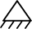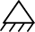kN/m
C
1 kN 1.6 kN

H_{B} = 4.275 A B H_{B} = 4.275
5 m 5 m

h = 10m

∑ Fx = 0
V_{A} = 7.35
L = 30m
V_{B} = 4.25

H − H = 0
A B

H = H
B
A

------ (1)

To find vertical reaction.

∑ Fy
= 0
VA + VB = 0.6 x15 +1+1.6
= 11.6

(2)

∑MA
= 0
− VB x 30 + 1.6 x 25 +1x 20 + (0.6 x15) 7.5 = 0 V B= 4.25 kN
VA = 4.25 = 11.6 AA = 7.35 kN

To find horizontal reaction.

= 0
C
−1x5 −1.6x10 + 4.25x15 − H x10 = 0 H = 4.275kN
B
B

HA

MC = 0

= 4.275kN
OR

7.375x15 − HA x10 − (0.6x15)7.5 HA = 4.275kN
HB = 4.275kN
To find total reaction
R_{B}

V_{A} = 7.35 kN
R_{A}
α_{A}
V_{B} = 4.25 kN

A

R A =

H_{A} = 4.275 kN

H
A
2 = V 2
A
A H_{B} = 4.275 kN

4.275² + 7.35²

= 8.5kN

−1 ⎛ VA ⎞ 0

αA = tan
⎜ ⎟ = 59 .82
⎝ HA ⎠

R B =
H ² + V ² = 6.02kN
B
B

₋₁⎛ VB ⎞

αB = tan
⎜ ⎟ = 44.83
⎝ HB ⎠

- A 3-hinged parabolic arch of span 50m and rise 15m carries a load of 10kN at quarter span as shown in figure. Calculate total reaction at the hinges.
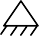
10 kN
C
15 m
H_{A} A
B H_{B}
V_{A}
12.5 m
50 m
V_{B}

∑ Fx
= 0

H = H
B
A

To find vertical reaction:
∑ Fy = 0
VA +VB = 10

------ (1)

∑MA = 0

− VB x 50 + 10 x12.5 = 0
VB = 2.5 kN
To find Horizontal reaction
MC = 0

VA = 7.5 kN

V × 25 −H ×15 = 0
B
B

To find total reaction.

V_{A} = 7.5
R_{A}
α_{A}

V_{B} = 4.25
R_{B}

A H_{A} = 4.17

H_{B} = 4.17

HB = 4.17 kN = HA

R A =
4.17² + 7.5²
R A = 8.581kN

−1 ⎛ VA ⎞ 0

αA = tan
⎜ ⎟ = 60 .92
⎝ HA ⎠

R B =
H
A
2 + V 2
B

R B = 4.861kN
−1 ⎛ VB ⎞ 0

αB = tan
⎜ ⎟ = 30 .94
⎝ HB ⎠

Problem: Determine the reaction components at supports A and B for 3-hinged arch shown in fig.

10 kN/m
C

2.5 m
180 kN

H_{A} A V_{A}

10 m

2 .4 m

B H_{B}

8 m 6 m
V_{B}

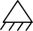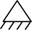To find Horizontal reaction

∑ Fx
= 0

H − H = 0
A B

H = H
B
A

------ (1)

To find vertical reaction.

∑ Fy
= 0

V + V
B
A
V + V
B
A

= 180 + 10 x10
= 280

(2)

∑MA
= 0
− VB x24 + HB x 2.4 + 180 x18 + 10 x 10 x

5 = 0

2.4HB − 24VB
= − 3740
------ (3)

HB −10VB
MC = 0
= −1558.33

− 180 x 8 − VB x14 − HB x 4.9 = 0

HB x 4.9 −VB 14 = −1440
------ (4)

− HB + 2.857VB = +293.87
Adding 2 and 3
− 10VB + 2.857VB = −1558.33 + 293.87

VB =177kN VA = 103kN
HB −10 x177 = −1558.33 HB = 211.67kN = HA

A symmetrical 3-hinged parabolic arch has a span of 20m. It carries UDL of intensity 10 kNm over the entire span and 2 point loads of 40 kN each at 2m and 5m from left support. Compute the reactions. Also find BM, radial shear and normal thrust at a section 4m from left end take central rise as 4m.

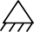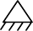40 kN
40 kN

10 kN/m

M
C
4 m

∑ Fx = 0
HA

  - HB = 0

2 m 3m
20 m

(1)

HA = HB
∑ Fy = 0
VA + VB − 40 − 40 −10 x 20 = 0 VA + VB = 280

(2)

∑MA = 0

+ 40 x 2 + 40 x 5 + (10 x 20)10 − V
B

x 20 = 0

V =114 kN V =166 kN
B
A

Mc = 0

− (10 x10) 5 − HB x 4 +114 x10 = 0

HB =160 kN

HA =160 kN

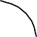VERTICAL

10 kN/m
40 kN

64.35
NORMAL

M
160 kN
φ = 25.64
HORIZONTAL

BM at M

160 kN

4
2 m
166 kN
y = 2.56
86 kN
REDIAL
m

= - 160 x 2.56
+ 166 x 4 – 40 x 2
- (10 x 4)2
= + 94.4 kNm

y = 4hx (L − x) L2
= 4 x 4 x 4 (20 − 4)
202

y = 2.56m

tanφ= 4h
L2

4 x 4
(L − 2x)

= (20 − 2 x 4) 202

φ = 25⁰.64

Normal thrust = N = + 160 Cos 25.64 + 86 Cos 64.36

 | = | 181.46 kN
S | = | 160 Sin 25.64 | - 86 x Sin 64.36
S | = | - 8.29 kN

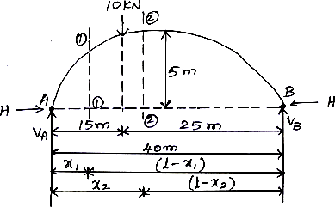
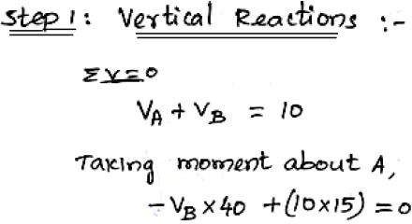
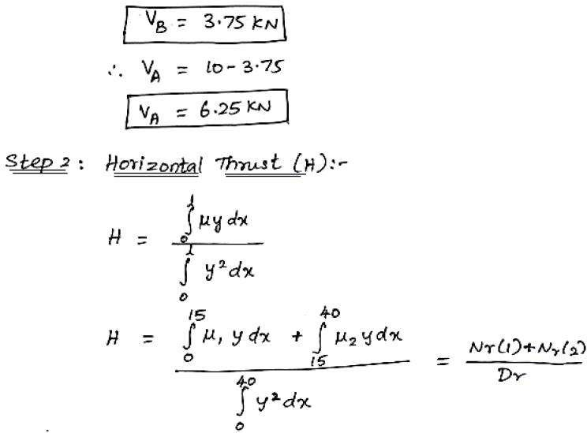
- A parabolic two hinged arch has a span of 40 m and a rise of 5 m. a concentrated load 10 kN acts at 15 m from the left support. The second moment of area varies as the secant of the inclination of the arch axis. Calculate the horizontal thrust and reactions at the hinge. Also calculate maximum bending moment at the section.

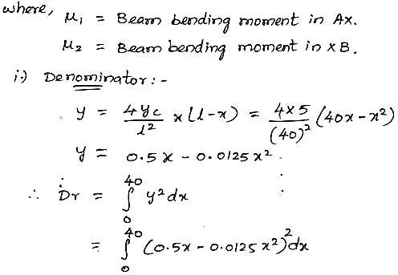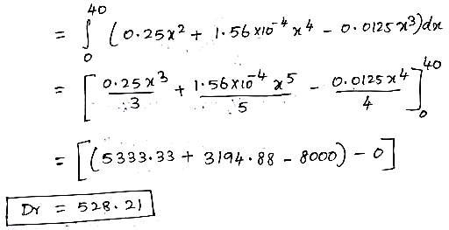
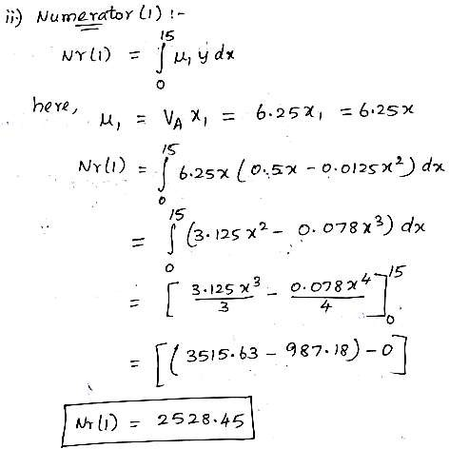

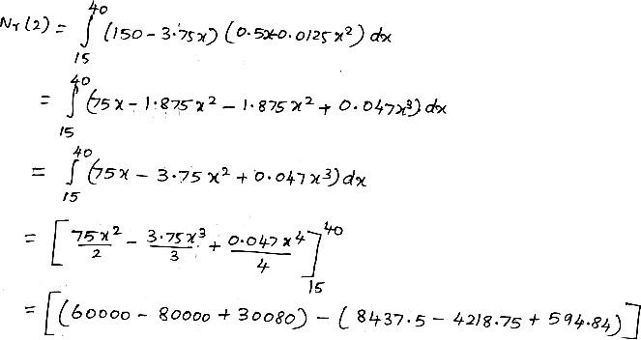
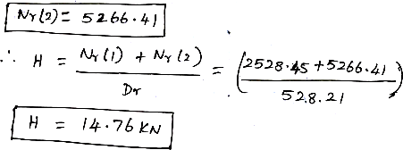
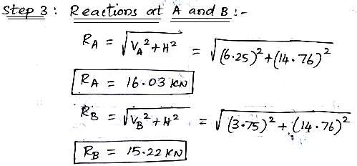
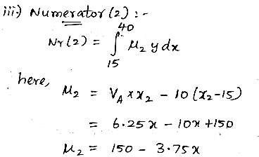

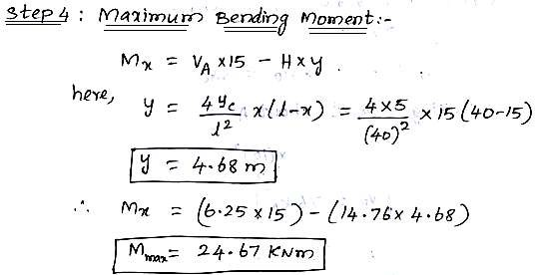

- A two hinged parabolic arch of span 25 m and rise 5 m carries an udl of 38 kN/m covering a distance of 10 m from left end. Find the horizontal thrust, the reactions at the hinges and the maximum negative moment.
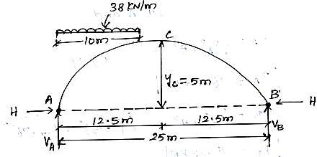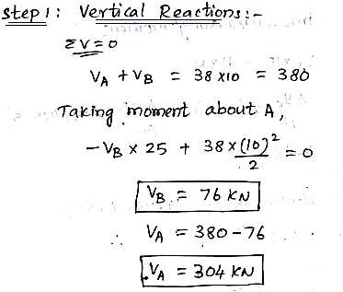

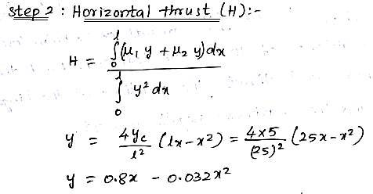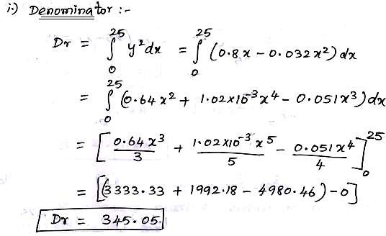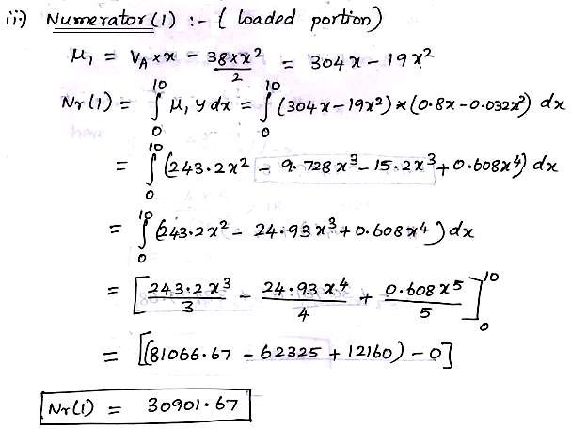

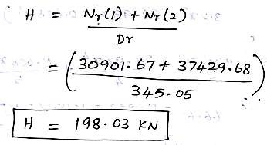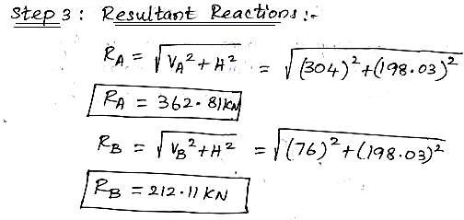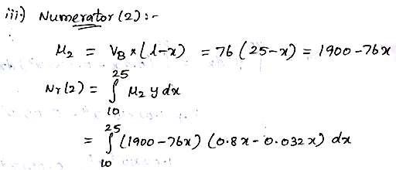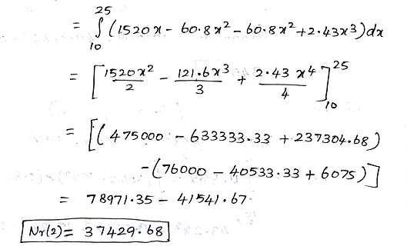

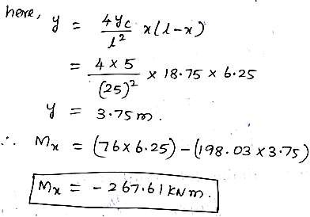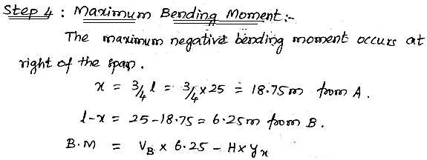

- A parabolic two hinged arch of span 60 m and central rise of 6 m is subjected to a crown load of 40 kN. Allowing rib shortening and temperature rise of 20o C, determine horizontal thrust, H. IC = 6x105 cm4, AC = 1000 cm2, E = 1x104 MPa,

α = 11x10⁻⁶/o C, I = IC sec θ.
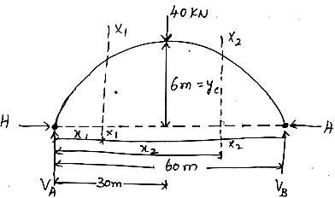

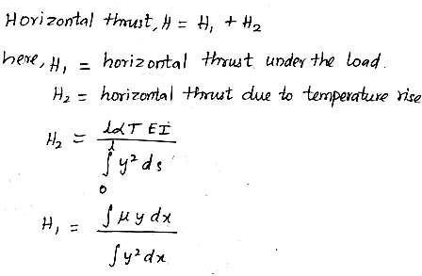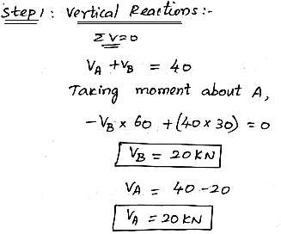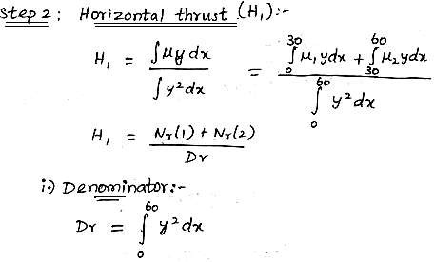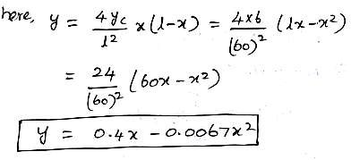

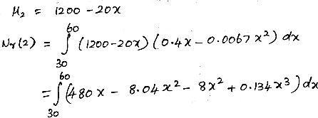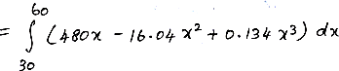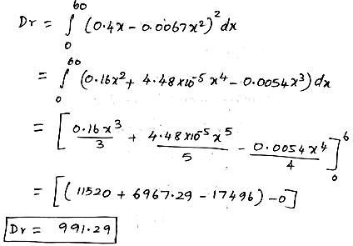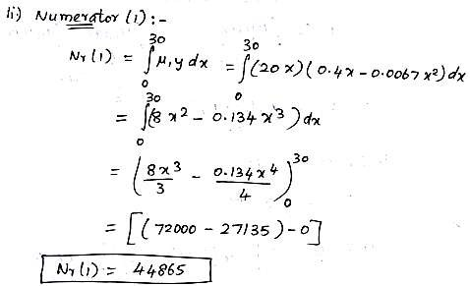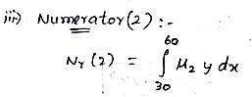

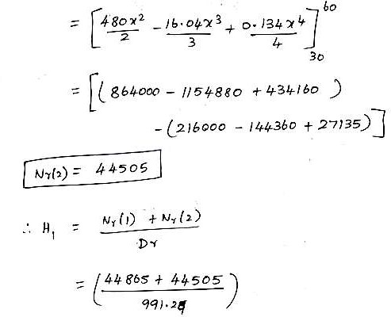
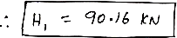
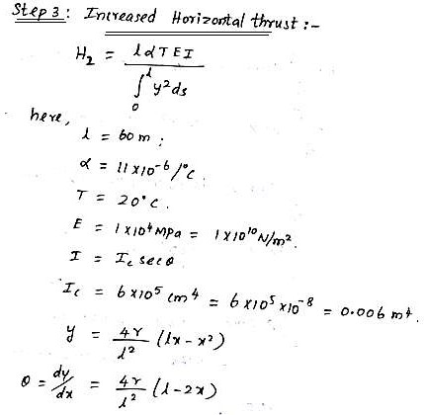

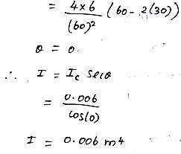
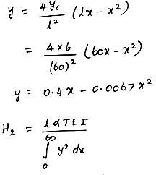

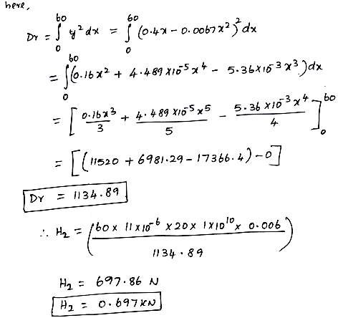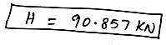

What is a linear arch?
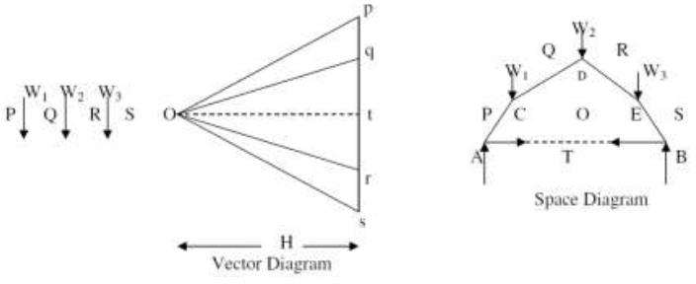
If an arch is to take loads, say W1, W2, and W3 (fig) and a Vector diagram and funicular polygon are plotted as shown, the funicular polygon is known as the linear arch or theoretical arch.
  - The polar distance „ot‟ represents the horizontal thrust.
  - The links AC, CD, DE, and EB will be under compression and there will be no bending moment.
  - If an arch of this shape ACDEB is provided, there will be no bending moment.
  - For a given set of vertical loads W1, W2…..etc., we can have any number of linear arches depending on where we choose „O‟ or how much horizontal thrust (or) we choose to introduce.

State Eddy’s theorem.
  - Eddy‟s theorem states that “The bending moment at any section of an arch is proportional to the
vertical intercept between the linear arch (or theoretical arch) and the centre line of the actual arch.”
  - BMx = Ordinate O2O3 x scale factor
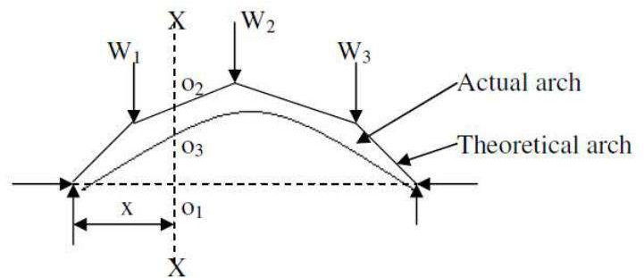
Distinguish between two hinged and three hinged arches
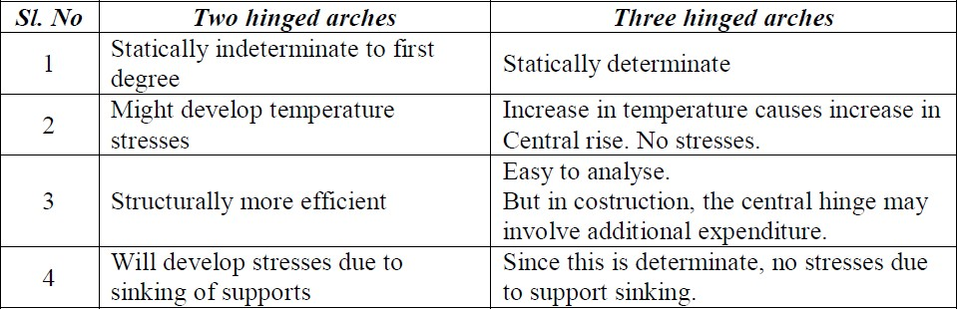

Rib-shortening in the case of arches.
  - In a two hinged arch, the normal thrust which is a compressive force along the axis of the arch will shorten the rib of the arch.
  - This in turn will release part of the horizontal thrust.
  - Normally, this effect is not considered in the analysis (in the case of two hinged arches).
  - Depending upon the importance of the work we can either take into account or omit the effect of rib shortening.
  - This will be done by considering (or omitting) strain energy due to axial compression along with the strain energy due to bending in evaluating H.
