GEOTCHNICAL ENGINEERING LABORATOTY MANUAL
(20A01502P)

NAMEOF STUDENT : ______________________________________________________
ROLL NO : ________________________________________________________________
BRANCH : _________________________________________________________________
YEAR/SEMESTER : _________________________________________________________

Department of Civil Engineering
VEMU INSTITUTE OF TECHNOLOGY::P.KOTHAKOTA
Chittoor – Tirupathi National Highway, Near Pakala, Chittoor(Dt.), AP – 517112
(Accredited by NAAC & NBA (CSE, ECE, EEE))
(Approved by AICTE, New Delhi & Permanently Affiliated to JNTUA, Anantapuramu)

JAWAHARLAL NEHRU TECHNOLOGICAL UNIVERSITY – ANANTAPUR
III B.Tech I Semester R 20 Regulation
Geotechnical Engineering Laboratory
(20A01502P)
List of Experiments
1. Specific gravity
2. Atterberg’s limits
3. Field density – Core cutter method and Sand replacement method
4. Grain size analysis by sieving
5. Hydrometer analysis test
6. Permeability of soil – Constant head test and Variable head test
7. Compaction test
8. Consolidation test (to be demonstration)
9. Direct shear test
10. Triaxial compression test (UU test)
11. Unconfined compression test
12. Vane shear test
13. Differential free swell (DFS)
14. CBR test
List of Equipments
1). Specific gravity bottle
2). Liquid limit, Plastic limit and Shrinkage limit apparatus
3). Set of standard IS sieves with sieve shaker
4). Core cutter and Sand replacement cylinder
5). Hydrometer
6). Constant head and Falling head permeability apparatus
7). Standard Procter’s test apparatus
8). Consolidation test apparatus
9). Direct shear test apparatus
10). Triaxial test apparatus
11). Unconfined compression test apparatus
12). Vane shear test apparatus
13). CBR test apparatus

S.No | Name of Experiment | Page No
1 | Specific gravity, G | 1 – 3
2 | Atterberg’s limits | 4 – 10
3 | Field density-Core cutter method and Sand replacement method. | 11 – 14
4 | Grain size analysis by sieving. | 15 - 18
5 | Hydrometer analysis test. | 19 – 22
6 | Permeability of soil – Constant head test and Variable head test | 23 – 27
7 | Compaction test | 28 – 31
8 | Consolidation test (to be demonstrated) | 32 – 35
9 | Direct shear test | 36 – 39
10 | Triaxial compression test (UU test) | 40 – 42
11 | Unconfined compression test | 43 – 45
12 | Vane shear test | 46 – 48
13 | Differential free swell (DFS) | 49 – 51
14 | CBR Test | 52 – 54
ADDITIONAL EXPERIMENTS
15 | Liquid Limit by Cone Penetration Method | 55-57
16 | Relative Density of Soil | 58-61
CONTENTS
GEOTECHNICAL ENGINEERING LABORATORY

GENERAL INSTRUCTIONS FOR LABORATORY CLASSES

DO s :
1. Maintain proper dress code and Discipline in the lab.
2. Clean all the equipment after completion of experiment.
3. Learn the lab procedure and know about the equipment before starting the experiment.
4. Handle the equipment with care.
5. Switch off the electrical equipment after completion of the experiment.
6. Wear gloves while doing the experiment.
7. Handle the glassware equipment carefully.

Don’ts :
1. Never operate the equipment on your own.
2. Never be in a hurry to do the experiment.
3. Never disturb the in-situ soil while doing the experiment.
4. Never place hands in the oven without knowing the temperature in the oven.
5. Never place the hands and legs near the mould while doing compaction.

SCHEME OF EVALUATION
S.No | Name of Experiment | Date | Marks Awarded |  |  |  |  | Total  30 M
 |  |  | Record  (10 M) | Observation  (10 M) |  | Viva Voce  (10 M) | Attendance  (10 M)
1 | Specific gravity, G
2 | Atterberg’s Limits
3 | Field density-Core cutter and Sand replacement methods.
4 | Grain size analysis by sieving.
5 | Hydrometer Analysis test.
6 | Permeability of soil - constant and variable head tests
7 | Compaction test
8 | Consolidation test (to be demonstrated)
9 | Direct Shear test
10 | Triaxial Compression test (UU test)
11 | Unconfined Compression test
12 | Vane Shear test
13 | Differential free swell (DFS)
`14 | CBR Test
15 | Liquid Limit by Cone Penetration Method
16 | Relative Density of Soil

Signature of Lab Incharge

VEMU INSTITUTE OF TECHNOLOGY::P.KOTHAKOTA
Chittoor – Tirupathi National Highway, Near Pakala, Chittoor(Dt.), AP – 517112
(Accredited by NAAC & NBA (CSE, ECE, EEE))
(Approved by AICTE, New Delhi & Permanently Affiliated to JNTUA, Anantapuramu)

VISION & MISSION OF THE INSTITUTE
Institute Vision
- To be a premier institute for professional education producing dynamic and vibrant force of technocrats with competent skills, innovative ideas and leadership qualities to serve the society with ethical and benevolent approach.
Institute Mission
- To create a learning environment with state-of-the art infrastructure, well equipped laboratories, research facilities and qualified senior faculty to impart high quality technical education.
- To facilitate the learners to foster innovative ideas, inculcate competent research and consultancy skills through Industry-Institute Interaction.
- To develop hard work, honesty, leadership qualities and sense of direction in rural youth by providing value based education.

VEMU INSTITUTE OF TECHNOLOGY::P.KOTHAKOTA
Chittoor – Tirupathi National Highway, Near Pakala, Chittoor(Dt.), AP – 517112
(Accredited by NAAC & NBA (CSE, ECE, EEE))
(Approved by AICTE, New Delhi & Permanently Affiliated to JNTUA, Anantapuramu)

Department Vision
To become a premier center of excellence in Civil Engineering producing dynamic and energetic force of Civil Engineers with competent skills, innovative ideas and leadership qualities to serve the society with quality education, strong ethical values and research.
Department Mission
- To impart high quality technical education in Civil Engineering by providing state – of – the – art infrastructure, well equipped laboratories, research facilities and the qualified senior faculty.
- To foster and inculcate innovative ideas, competent skills and consultancy services in learners through institute-industry interaction.
- To develop necessary leadership qualities, ethical values and communication skills in graduates by providing the value based education.

VEMU INSTITUTE OF TECHNOLOGY::P.KOTHAKOTA
Chittoor – Tirupathi National Highway, Near Pakala, Chittoor(Dt.), AP – 517112
(Accredited by NAAC & NBA (CSE, ECE, EEE))
(Approved by AICTE, New Delhi & Permanently Affiliated to JNTUA, Anantapuramu)

Ptogramme Educational Objectives (PEO’S)

S.No | After few years of graduation the Civil Engineering student will be
PEO_1 | To excel in the field of Civil Engineering by applying the fundamentals of mathematics, basic sciences and engineering concepts to solve the real world problems.
PEO_2 | To compete professionally with design competence and multidisciplinary approach by applying suitable modern technological, research and consultancy skills in Civil Engineering and allied areas.
PEO_3 | To exhibit strong leadership qualities, ethical, environmental and professional values, communication skills and also lifelong learning for sustainable development of society and nation

Ptogramme Specific Outcomes (PSO’S)

After the graduation the Civil Engineering student will be
PSO_1 | Higher Education: Qualify in competitive examinations for pursuing higher education by applying the fundamental concepts of Civil Engineering domains such as Structural Engineering, Geotechnical Engineering, Water Resources Engineering, Transportation Engineering etc..
PSO_2 | Employment: Get employed in allied industries through their proficiency to find innovative solutions for challenges and problems in various domains of Civil Engineering

VEMU INSTITUTE OF TECHNOLOGY::P.KOTHAKOTA
Chittoor – Tirupathi National Highway, Near Pakala, Chittoor(Dt.), AP – 517112
(Accredited by NAAC & NBA (CSE, ECE, EEE))
(Approved by AICTE, New Delhi & Permanently Affiliated to JNTUA, Anantapuramu)

Programme Outcomes (PO’s)
PO_1 | Engineering Knowledge: Apply the knowledge of mathematics, science, engineering fundamentals, and an engineering specialization to the solution of complex engineering problems.
PO_2 | Problem analysis: Identify, formulate, review research literature, and analyze complex engineering problems reaching substantiated conclusions using first principles of mathematics, natural sciences, and engineering sciences.
PO_3 | Design/development of solution: Design solutions for complex engineering problems and design system components or processes that meet the specified needs with appropriate consideration for the public health and safety, and the cultural, societal, and environmental considerations.
PO_4 | Conduct investigations of complex problems: Use research-based knowledge and research methods including design of experiments, analysis and interpretation of data, and synthesis of the information to provide valid conclusions.
PO_5 | Modern tool usage: Create, select, and apply appropriate techniques, resources, and modern engineering and IT tools including prediction and modeling to complex engineering activities with an understanding of the limitations.
PO_6 | The engineer and society: Apply reasoning informed by the contextual knowledge to assess societal, health, safety, legal and cultural issues and the consequent responsibilities relevant to the professional engineering practice.
PO_7 | Environment and sustainability: Understand the impact of the professional engineering solutions in societal and environmental contexts, and demonstrate the knowledge of, and need for sustainable development.
PO_8 | Ethics: Apply ethical principles and commit to professional ethics and responsibilities and norms of the engineering practice.
PO_9 | Individual and team work: Function effectively as an individual, and as a member or leader in diverse teams, and in multidisciplinary settings.
PO_10 | Communication: Communicate effectively on complex engineering activities with the engineering community and with society at large, such as, being able to comprehend and write effective reports and design documentation, make effective presentations, and give and receive clear instructions.
PO_11 | Project management and finance: Demonstrate knowledge and understanding of the engineering and management principles and apply these to one’s own work, as a member and leader in a team, to manage projects and in multidisciplinary environments.
PO_12 | Life – long learning: Recognize the need for, and have the preparation and ability to engage in independent and life-long learning in the broadest context of technological change.

VEMU INSTITUTE OF TECHNOLOGY::P.KOTHAKOTA
Chittoor – Tirupathi National Highway, Near Pakala, Chittoor(Dt.), AP – 517112
(Accredited by NAAC & NBA (CSE, ECE, EEE))
(Approved by AICTE, New Delhi & Permanently Affiliated to JNTUA, Anantapuramu)

Course Outcomes (CO’S)
CO 1 | Determine the Specific gravity and Atterberg’s limits of clay soil
CO 2 | Determine the Field density of compacted soil and effective size in soil
CO 3 | Determine the Coefficient of permeability and Differential free swelling index of soil
CO 4 | Determine the Optimum moisture content and Maximum dry density of soil and Consolidation properties of soil
CO 5 | Determine the Shear strength and CBR Value of the soil

EXPERIMENT NO-1
- Specific gravity

Objective
Determine the specific gravity of the soil fraction passing 4.75 mm I.S sieve by density bottle

Need and scope of the experiment
The knowledge of specific gravity is needed in calculation of soil properties like void ratio, degree of saturation etc.

Definition
Specific gravity ‘G’ is defined as the ratio of the weight of an equal volume of distilled water at that temperature both weights taken in air.

Apparatus required
- Density bottle of 50 ml with stopper having capillary hole.
- Balance to weigh the materials (accuracy 10gm).
- Wash bottle with distilled water.
- Alcohol and ether.

Procedure
- Clean and dry the density bottle
  - Wash the bottle with water and allow it to drain.
  - Wash it with alcohol and drain it to remove water.
  - Wash it with ether, to remove alcohol and drain ether.
- Weigh the empty bottle with stopper (W₁)
- Take about 10 to 20 gm of oven soil sample which is cooled in a desiccator. Transfer it to the bottle. Find the weight of the bottle and soil (W₂).
- Put 10ml of distilled water in the bottle to allow the soil to soak completely. Leave it for about 2 hours.
- Again fill the bottle completely with distilled water put the stopper and keep the bottle under constant temperature (T ⁰ C).
x
- Take the bottle, wipe it clean and dry note. Now determine the weight of the bottle and the contents (W₃).
- Now empty the bottle and thoroughly clean it. Fill the bottle with only distilled water and weigh it. Let it be W₄ at temperature (T ⁰ C).
x
- Repeat the same process for 2 to 3 times, to take the average reading of it

Observations
Table 2.1 Observations for the Specific gravity determination

S. No. | Observation Number | 1 | 2 | 3
1 | Weight of density bottle (W₁ g)
2 | Weight of density bottle + dry soil (W₂ g)
3 | Weight of bottle + dry soil + water at  0  temperature T _{x} C (W₃ g)
4 | Weight of bottle + water (W₄ g) at  0  temperature T_{x} C
0
Specific gravity G at T_{x} C
0
Average specific gravity at T_{x} C

Calculations
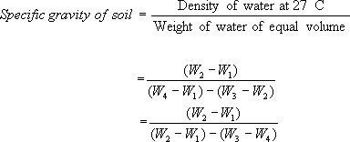
Interpretation
Unless or otherwise specified specific gravity values reported shall be based on water at 27⁰ C. So the specific gravity at 27⁰C = K*Sp. gravity at T_{x}⁰C.

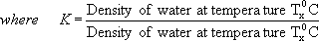

Result

The specific gravity of the soil sample is .

EXPERIMENT NO-2
GRAIN SIZE DISTRIBUTION BY SIEVE ANALYSIS

Objective

Determine the relative proportions of different grain sizes which make up a given soil mass.

Need and scope of experiment

The grain size analysis is widely used in classification of soils. The data obtained from grain size distribution curves is used in the design of filters for earth dams and to determine suitability of soil for road construction, air field etc. Information obtained from grain size analysis can be used to predict soil water movement although permeability tests are more generally used.

Theory

Soils having particle larger than 0.075mm size are termed as coarse grained soils. In these soils more than 50% of the total material by mass is larger 75 micron. Coarse grained soil may have boulder, cobble, gravel and sand.
The following particle classification names are given depending on the size of the particle:

- BOULDER: particle size is more than 300mm.

- COBBLE: particle size in range 80mm to 300mm.

- GRAVEL (G): particle size in range 4.75mm to 80mm.

  - Coarse Gravel: 20 to 80mm.

  - Fine Gravel: 4.75mm to 20mm.

- SAND (S): particle size in range 0.075mm to 4.75mm.

  - Coarse sand: 2.0mm to 4.75mm.

  - Medium Sand: 0.425mm to 2.0mm.

  - Fine Sand: 0.075mm to o.425mm.

Dry sieve is performed for cohesion less soils if fines are less than 5%. Wet sieve analysis is carried out if fines are more than 5% and of cohesive nature. In simpler way the particle size distribution curve for coarse grain soil as follows,

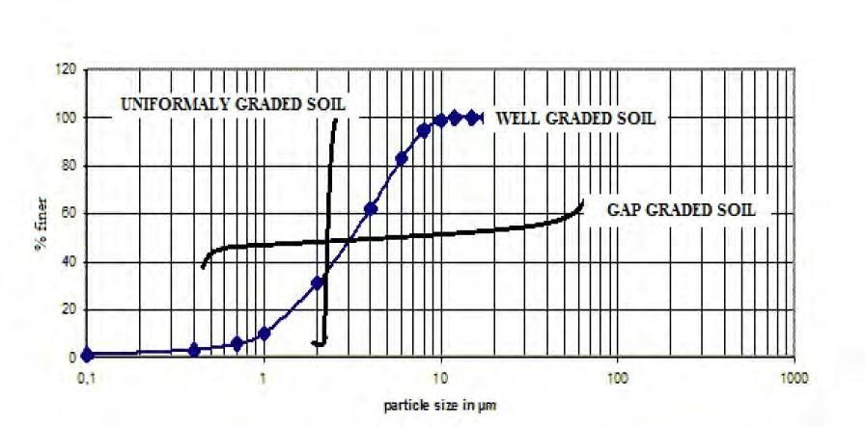

Gravels and sands may be either poorly graded (Uniformly graded) or well graded depending on the value of coefficient of curvature and uniformity coefficient.
Coefficient of curvature (Cc) may be estimated as:
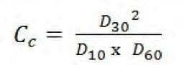
Coefficient of curvature (Cc) should lie between 1 and 3 for well grade gravel and sand. Uniformity coefficient (Cu) is given by:
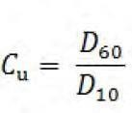
Its value should be more than 4 for well graded gravel and more than 6 for well graded sand. Were, D60 = particle size at 60% finer.
D30 = particle size at 30% finer. D10 = particle size at 10% finer.

Apparatus
    - Balance

    - I.s sieves

    - Rubber pestle and mortar

    - Manual/mechanical sieve shaker

Procedure
- For soil samples of soil retained on 75 micron i.s sieve

  - The proportion of soil sample retained on 75 micron i.s sieve is weighed and recorded weight of soil sample is as per i.s 2720.
  - I.S.sieves are selected and arranged in the order as shown in the table.

  - The soil sample is separated into various fractions by sieving through above sieves placed in the above mentioned order.
  - The weight of soil retained on each sieve is recorded.

  - The moisture content of soil if above 5% it is to be measured and recorded.

- The sieves for soil tests: 4.75 mm to 75 microns.

- No particle of soil sample shall be pushed through the sieves.

- The balance to be used must be sensitive to the extent of 0.1% of total weight of sample taken.

Observations

Weight of soil sample taken:
Tab 5.1 Calculation sheet for soil particle % finer

S.No | I.S sieve number or size mm | Wt.  Retained in each sieve (gm) | Percentage on each sieve | Cumulative  %age retained on each sieve | % finer
1 | 4.75
2 | 2.00
3 | 1.00
4 | 0.600
5 | 0.425
6 | 0.300
7 | 0.150
8 | 0.075

RESULT:

1. The given soil is................................
- Coefficient of curvature (Cc) =
- Uniformity coefficient (Cu) =

EXPERIMENT- 3

FIELD DENSITY TEST BY CORE CUTTER METHOD

Objective
Determine the dry density of the soil by using core cutter method.

Apparatus required
- Cylindrical core cuter, 100 mm internal diameter and 130 mm long
- Steel rammer, mass 9kg. Overall length, with the foot and staff about 900mm
- Steel dolly, 25 mm high and 100mm internal diameter
- Weighing balance, accuracy 1g.
- Palette knife
- Straight edge, steel rule etc

Theory
A cylindrical core cutter is a seamless steel tube. For determination of the dry density of the soil, the cutter is pressed into the soil mass so that it is filled with the soil. The cutter filled with the soil is lifted up. The mass of the soil is determined. The dry density is obtained as
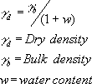

M = mass of wet soil in the cutter

V = internal volume of the cutter

Procedure

  - Determine the internal diameter and height of the core cutter to the nearest 0.25 mm.
  - Determine the mass (M₁) of the cutter to the nearest gram.
  - Expose a small area of the soil mass to be tested. Level the surface, about 300 mm square in area.
  - Place dolley over the top of the core cutter and press the core cutter in to the soil mass using the rammer. Stop the process of pressing when about 15 mm of the dolley protrudes above the soil surface.
  - Remove the soil surrounding the core cutter and takeout the core cutter. Some soil would project from the lower end of the cutter.
  - Remove the dolley. Trim the top and bottom surface of the core cutter carefully using a straight edge.
  - Weigh the core cutter filled with the soil to the nearest gram (M₂).
  - Remove the core of the soil from the cutter. Take a representative sample for the water content determination.

Observations and Calculations
Tab 4.1 Calculation sheet for dry density of soil

S.No | Observations | Sample No.
 |  | 1 | 2 | 3
1 | Internal diameter
2 | Internal Height
3 | Mass of empty core cutter (M₁)
4 | Mass of core cutter with soils (M₂)
5 | Mass of wet soil, M = M₂-M₁
6 | Volume of the cutter, V
7 | Water content (%), w
8 | Bulk Density = M / V
9 | Dry density = Bulk Density/ (1+ w)

Result: The field dry density of the soil is .

EXPERIMENT- 4

SAND REPLACEMENT METHOD

OBJECTIVE
Determine the in situ density of natural or compacted soils using sand pouring cylinders.

NEED AND SCOPE

The in situ density of natural soil is needed for the determination of bearing capacity of soils, for the purpose of stability analysis of slopes, for the determination of pressures on underlying strata for the calculation of settlement and the design of underground structures.
It is very quality control test, where compaction is required, in the cases like embankment and pavement construction.

APPARATUS REQUIRED

  - Sand pouring cylinder of 3 litre/16.5 litre capacity mounted above a pouring come and separated by a shutter cover plate.
  - Tools for excavating holes, suitable tools such as scraper tool to make a level surface.
  - Cylindrical calibrating container with an internal diameter of 100 mm/200 mm and an internal depth of 150 mm/250 mm fitted with a flange 50 mm/75 mm wide and about 5 mm surrounding the open end.
  - Balance to weigh unto an accuracy of 1g.
  - Metal containers to collect excavated soil.
  - Metal tray with 300 mm/450 mm square and 40 mm/50 mm deep with a 100 mm/200 mm diameter hole in the centre.
  - Glass plate about 450 mm/600 mm square and 10mm thick.
  - Clean, uniformly graded natural sand passing through 1.00 mm i.s.sieve and retained on the 600micron i.s.sieve. It shall be free from organic matter and shall have been oven dried and exposed to atmospheric humidity.
  - Suitable non-corrodible airtight containers.
  - Thermostatically controlled oven with interior on non-corroding material to maintain the temperature between 105⁰c to 110⁰c.
  - A desiccator with any desiccating agent other than sulphuric acid.

OBSERVATIONS AND CALCULATIONS

S. No. | Sample Details | 1 | 2 | 3
1 | Weight of sand in cone (of pouring cylinder) W2 gm
2 | Volume of calibrating container (V) in cc
3 | Weight of sand + cylinder before pouring W3 gm
4 | Weight of sand + cylinder after pouring W3 gm
5 | Weight of sand to fill calibrating containers  Wa = (W1-W3-W2) gm
6 | Bulk density of sand s = Wa / V gm/cc

S. No | Measurement of Soil Density | 1 | 2 | 3
1 | Weight of wet soil from hole Ww gm
2 | Weight of sand + cylinder before pouring W1 gm
3 | Weight of sand + cylinder after pouring W4 gm
4 | Weight of sand in hole Wb = (W1-W2-W4) gm
5 | Bulk density b = (Ww /Wb)x s gm/cc
 | Water content determination
1 | Container number
2 | Weight of wet soil
3 | Weight of dry soil
4 | Moisture content (%)
5 | Dry density d = b / (1+w) gm/cc

THEORY

By conducting this test it is possible to determine the field density of the soil. The moisture content is likely to vary from time and hence the field density also. So it is required to report the test result in terms of dry density. The relationship that can be established between the dry density with known moisture content is as follows:

PROCEDURE

Calibration of the Cylinder

- Fill the sand pouring cylinder with clean sand so that the level of the sand in the cylinder is within about 10 mm from the top. Find out the initial weight of the cylinder plus sand (W1) and this weight should be maintained constant throughout the test for which the calibration is used.
- Allow the sand of volume equal to that of the calibrating container to run out of the cylinder by opening the shutter, close the shutter and place the cylinder on the glass sand takes place in the cylinder close the shutter and remove the cylinder carefully. Weigh the sand collected on the glass plate. Its weight (W2) gives the weight of sand filling the cone portion of the sand pouring cylinder. Repeat this step at least three times and take the mean weight (W2) Put the sand back into the sand pouring cylinder to have the same initial constant weight (W1)

Determination of Bulk Density of Soil

- Determine the volume (V) of the container be filling it with water to the brim. Check this volume by calculating from the measured internal dimensions of the container.
- Place the sand poring cylinder centrally on the top of the calibrating container making sure that constant weight (W1) is maintained. Open the shutter and permit the sand to run into the container. When no further movement of sand is seen close the shutter, remove the pouring cylinder and find its weight (W3).

Determination of Dry Density of Soil in Place

- Approximately 60 sq.cm of area of soil to be tested should be trimmed down to a level surface, approximately of the size of the container. Keep the metal tray on the level surface and excavate a circular hole of volume equal to that of the calibrating container. Collect all the excavated soil in the tray and find out the weight of the excavated soil (Ww). Remove the tray, and place the sand pouring cylinder filled to constant weight so that the base of the cylinder covers the hole concentrically. Open the shutter and permit the sand to run into the hole. Close the shutter when no further movement of the sand is seen. Remove the cylinder and determine its weight (W3).
- Keep a representative sample of the excavated sample of the soil for water content determination.

OBSERVATION AND CALCULATION TABLE:

Internal diameter of cutter (cm): _ _ _ _ _ _ _ _

Height of the cutter (cm): _ _ _ _ _ _ _ _

Cross sectional area of the cutter (cm²): _ _ _ _ _ _ _ _

Volume of the cutter, V (cm³): _ _ _ _ _ _ _ _

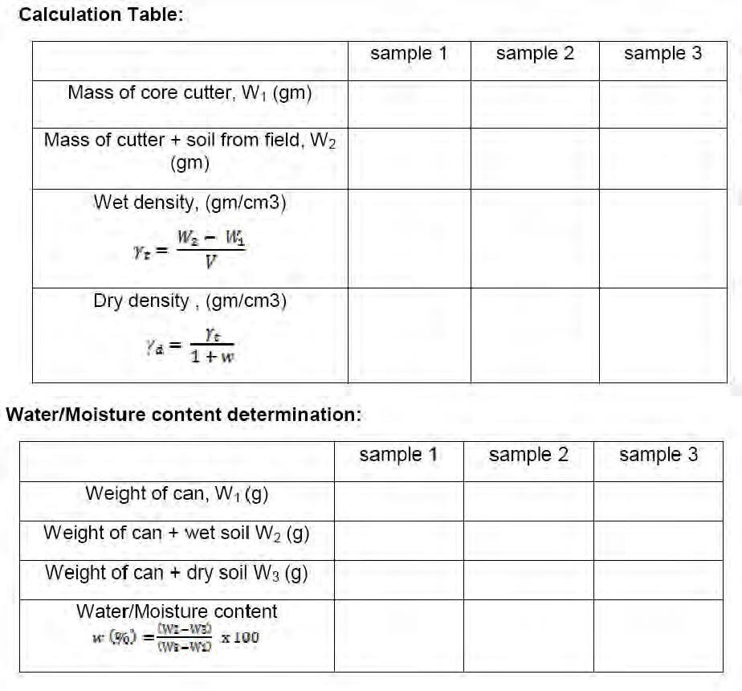

Result:

EXPERIMENT – 05 DETERMINATION ATTERBERG’S
Determination of Liquid Limit

Objective

To determine the liquid limit, plastic limit, shrinkage limit of the given soil sample.

THEORY:

The definitions of the consistency limits proposed by Atterberg are not, by themselves, adequate for the determination of their numerical values in the laboratory, especially in view of the arbitrary nature of these definitions. In view of this, Arthur Casagrande and others suggested more practical definitions with special reference to the laboratory devices and methods developed for the purpose of the determination of the consistency limits. In this sub-section, the laboratory methods for determination of the liquid limit, plastic limit, shrinkage limit, and other related concepts and indices will be studied, as standardized and accepted by the Indian Standard Institution and incorporated in the codes or practice.

APPARATUS:

  - Casagrande’s liquid limit device and grooving tool
  - Spatula
  - Balance
  - Glass plate
  - Hot air oven maintainedat 105 ± 1⁰C
  - Moisture Containers

STANDARD REFERENCE:

FOR LIQUID LIMIT:
IS: 2720(Part V)–1985.

FOR PLASTIC LIMIT:

IS: 2720, Part V–1985.

TERMS:

Shrinkage limit: The shrinkage limit (SL) is the water content where further loss of moisture will not result in any more volume reduction. The shrinkage limit is much less commonly used than the liquid limit and the plastic limit.

Plastic limit:

The plastic limit (PL or wP) is the water content where soil starts to exhibit plastic behaviour. A thread of soil is at its plastic limit when it is rolled to a diameter of 3 mm or begins to crumble.
To improve consistency, a 3 mm diameter rod is often used to gauge the thickness of the thread when conducting the test. (AKA Soil Snake Test).
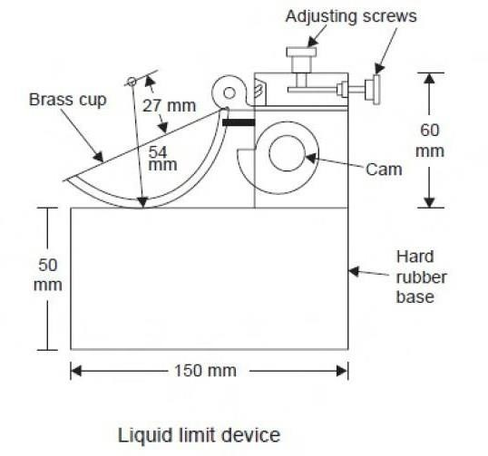

Liquid limit:

Liquid limit (LL or wL) is defined as the arbitrary limit of water content at which the soil is just about to pass from the plastic state into the liquid state. At this limit, the soil possesses a small value of shear strength, losing its ability to flow as a liquid. In other words, the liquid limit is the minimum moisture content at which the soil tends to flow as a liquid.

PLATICITY INDEX:

Plasticity index (PI or Ip ) is the range of water content within which the soil exhibits plastic properties; that is, it is the difference between liquid and plastic limits.
PI (or Ip ) = (LL - PL) = (wL - wP )

When the plastic limit cannot be determined, the material is said to be non-plastic(NP). Plasticity index for sands is zero.
For proper evaluation of the plasticity properties of a soil, it has been found desirable to use both the liquid limit and the plasticity index values.

SHRINKAGE INDEX:

Shrinkage index (SI OR Is) is defined as the difference between the plastic and shrinkage limits of a soil; in other words, it is the range of water content within which a soil is in a semisolid state of consistency.

CONSISTENCY INDEX:

Consistency index or Relative consistency (CI OR IC ) is defined as the ratio of the difference between liquid limit and the natural water content to the plasticity index of a soil:
Where w = natural water content of the soil (water content of a soil in the undisturbed condition in the ground).
If IC= 0, w = LL

IC = 1, w = PL

IC > 1, the soil is in semi-solid state and is stiff.

IC < 0, the natural water content is greater than LL, and the soil behaves like a liquid.

LIQUIDITY INDEX:

Liquidity index (LI OR IL) or Water-plasticity ratio is the ratio of the difference between the natural water content and the plastic limit to the plasticity index:
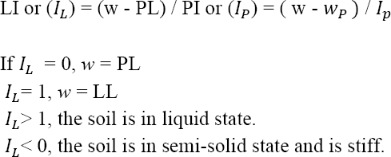

Obviously, CI + LI = 1

PROCEDURE:

1. FOR DETERMINATION OF LIQUID LIMIT:

- About 120 gm of air-dried soil from thoroughly mixed portion of material passing 425 micron I.S sieve is to be obtained.
- Distilled water is mixed to the soil thus obtained in a mixing disc to form uniform paste. The paste shall have a consistency that would require 30 to 35 drops of cup to cause closer of standard groove for sufficient length.
- A portion of the paste is placed in the cup of Casagrande apparatus and spread into portion with few strokes of spatula.
- Trim it to a depth of 1cm at the point of maximum thickness and return excess of soil to the dish.
- The soil in the cup shall be divided by the firm strokes of the grooving tool along the diameter through the centre line of the follower so that clean sharp groove of proper dimension is formed.
- Lift and drop the cup by turning crank at the rate of two revolutions per second until the two halves of soil cake come in contact with each other for a length of about 1 cm by flow only.
- The number of blows required to cause the groove close for about 1 cm shall be recorded.

- A representative portion of soil is taken from the cup for water content determination.

- Repeat the test with different moisture contents at least three more times for blows between 10 and 40.

Atterberg Limits Determination
Natural water content of given soil =

LIQUID LIMIT DETERMINATION

Can No.
Mass of can (g)
Mass of wet soil + can (g)
Mass of dry soil + can (g)
Mass of dry soil (g)
Mass of water (g)
Water content, (%)
No. of drops
Plastic Limit Determination

Can No.
Mass of can (g)
Mass of wet soil + can (g)
Mass of dry soil + can (g)
Mass of dry soil (g)
Mass of water (g)
Water content, (%)

CALCULATIONS:

  - Plasticity index =

  - Shrinkage index =

  - Consistency index =

  - Liquidity index=

2. FOR DETERMINATION OF PLASTIC LIMIT:

1. Take about 20gm of thoroughly mixed portion of the material passing through 425 micron
I.S. sieve obtained in accordance with I.S. 2720 (part 1).

- Mix it thoroughly with distilled water in the evaporating dish till the soil mass becomes plastic enough to be easily moulded with fingers.
- Allow it to season for sufficient time (for 24 hrs) to allow water to permeate throughout the soil mass
- Take about 10gms of this plastic soil mass and roll it between fingers and glass plate with just sufficient pressure to roll the mass into a threaded of uniform diameter throughout its length. The rate of rolling shall be between 60 and 90 strokes per minute.
- Continue rolling till you get a threaded of 3 mm diameter.
- Kneed the soil together to a uniform mass and re-roll.
- Continue the process until the thread crumbles when the diameter is 3 mm.

- Collect the pieces of the crumbled thread in air tight container for moisture content determination.
- Repeat the test to atleast 3 times and take the average of the results calculated to the nearest whole number.

3. FOR DETERMINATION OF SHRINKAGE LIMIT

Preparation of soil paste
- Take about 100 gm of soil sample from a thoroughly mixed portion of the material passing through 425-micron I.S. sieve.
- Place about 30 gm of the above soil sample in the evaporating dish and thoroughly mix it with distilled water and make a creamy paste. Use water content somewhere around the liquid limit.

Filling the shrinkage dish

- Coat the inside of the shrinkage dish with a thin layer of Vaseline to prevent the soil sticking to the dish.
- Fill the dish in three layers by placing approximately 1/3 rd of the amount of wet soil with the help of spatula. Tap the dish gently on a firm base until the soil flows over the edges and no apparent air bubbles exist. Repeat this process for 2nd and 3rd layers also till the dish is completely filled with the wet soil. Strike off the excess soil and make the top of the dish smooth. Wipe off all the soil adhering to the outside of the dish.
- Weigh immediately, the dish with wet soil and record the weight.

- Air-dry the wet soil cake for 6 to 8hrs, until the colour of the pat turns from dark to light. Then oven-dry the soil to constant weight at 105⁰C to 110⁰C say about 12 to 16 hrs.
- Remove the dried disk of the soil from oven. Cool it in a desiccator. Then obtain the weight of the dish with dry sample.
- Determine the weight of the empty dish and record.

- Determine the volume of shrinkage dish which is evidently equal to volume of the wet soil as follows. Place the shrinkage dish in an evaporating dish and fill the dish with mercury till it overflows slightly. Press it with plain glass plate firmly on its top to remove excess mercury. Pour the mercury from the shrinkage dish into a measuring jar and find the volume of the shrinkage dish directly. Record this volume as the volume of the wet soil pat.

CALCULATION
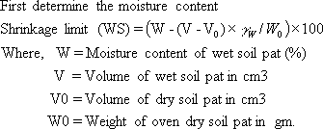

Volume of the Dry Soil Pat

- Determine the volume of dry soil pat by removing the pat from the shrinkage dish and immersing it in the glass cup full of mercury in the following manner.
- Place the glass cup in a larger one and fill the glass cup to overflowing with mercury. Remove the excess mercury by covering the cup with glass plate with prongs and pressing it. See that no air bubbles are entrapped. Wipe out the outside of the glass cup to remove the adhering mercury. Then, place it in another larger dish, which is, clean and empty carefully.
- Place the dry soil pat on the mercury. It floats submerge it with the pronged glass plate which is again made flush with top of the cup. The mercury spills over into the larger plate. Pour the mercury that is displayed by the soil pat into the measuring jar and find the volume of the soil pat directly.

RESULT:

For given soil:

  - Liquid limit =
  - Plastic limit =
  - Plasticity index =
  - Shrinkage index =
  - Consistency index =
  - Liquidity index=
  - Shrinkage limit =
EXPERIMENT – 06

PROCTOR COMPACTION TEST

Aim:
To determine the water content – dry density relationship for a given soil by Indian Standard light compaction test and hence, to obtain optimum moisture content and maximum dry density for the given soil.

Theory:

Definition of compaction; necessity of compacting the soil in the field; standard Proctor and modified Proctor compaction tests (and their Indian Standard versions); compaction curves; optimum moisture content and maximum dry density; zero air voids line; line of optimum; factors affecting compaction.

Apparatus
- A cylindrical metal mould of capacity 1000 cm3, with an internal diameter of 100 mm and an internal affective height of 127.3 mm. The mould is fitted with a detachable base plate and a removable extension collar approximately 60 mm high.
- A metal rammer of 50 mm diameter with a circular face and mass 2.6 kg with a free fall of 310 mm.
- A steel straight edge about 30 cm in length and with one beveled edge.
- 4.75 mm I.S. sieve
- Balance – (a) with a capacity of 10 kg and accuracy of 1 g
(b) with a capacity of 200 g and accuracy of 0.01 g
- Thermostatically controlled hot air oven.
- Airtight and non-corrodible containers for water content determination
- Mixing tools like tray, trowel and spatula.

Procedure
- Measure the inner diameter and inner height of the cylindrical mould and hence, calculate the volume of the mould. Compare them with standard values.
- Take about 3 kg of air dried soil passing 4.75mm IS sieve and mix it with a suitable amount of water depending on the soil type (For sandy and gravelly soils, an initial moisture content of 4 to 6% and for cohesive soils, an initial moisture content of (wp- 10)% to (wp-8)% would be suitable, where wp is the plastic limit of the soil). Keep the soil in a sealed container for saturation for a minimum period of about 16 hrs.
- Clean the mould with the base plate and record its mass. Attach the collar to the mould. Place it on a solid base such as concrete floor.

- Remix the soil thoroughly. Compact the moist soil in to the mould, with the collar attached, in three equal layers, each layer being given 25 blows from a 2.6 kg rammer dropped from a height to 310mm above the soil surface. The blows should be uniformly distributed over the surface of each layer. The surface of each layer of the compacted soil shall be roughened with a spatula before laying the next layers. The final layer shall project not more than 6 mm above the top of the mould after the collar is removed.
- Remove the collar and level off the compacted soil surface to the top of the mould carefully. Then, record the mass of the mould with the base plate and compacted soil.
- Remove the compacted soil specimen from the mould and place it on the mixing tray. Keep a representative soil sample of the specimen for water content determination.
- Mix the remaining soil with the reminder of the originally mixed soil in the tray. Add water in suitable increments to the soil sample and mix the soil thoroughly and repeat the above procedure.
- Conduct a minimum of 5 determinations such that the optimum moisture content lies within this range.
- Plot the Indian Standard light compaction curve (w % along x-axis and d along y- axis). Obtain OMC and d max from the plotted curve. Plot also the ZAV line.

Results and Discussions
------------------------------------------------------------------------------------------------------------

Observations and Calculations
- Type of soil:
- Specific gravity of the soil:
3. | Diameter of the mould (D) = ---------------------------------------- |  | cm
4. | Height of the mould (H) | = ---------------------------------------- | cm
5. | Volume of the mould (V) | = ---------------------------------------- | cm
6. | Mass of the rammer | = 2.6 kg
7. | Free fall of the rammer | = 310 mm

TABLE - I
Determination No. |  |  | 1 | 2 | 3 | 4 | 5 | 6 | 7 | 8 | 9 | 10
(a) Determination of Bulk Density:
1. | Mass of the (mould +
 | Compacted soil) | g
2. | Mass of mould | g
3. | Mass of compacted soil (M) | g
4. | Bulk density (b) | g/cm3

(b) Determination of water content and dry density of the soil:
1. | Container No.
2. | Mass of (container+wetsoil)g
3. | Mass of (container + dry soil) | g
4. | Mass of water | g
5. | Mass of container | g
6. | Mass of the dry soil | g
7. | Water content (w) | Ratio
8. | Dry density (d) | g/cm3
Specimen Calculations
  - Bulk density = b = Mass of compacted wet soil          M = ---------------------------- g/cm3
Volume ofthe mould V Mass of water
2. Water content = w = =------------------------------------ %
Mass of dry soil
❒
b
(1 + w)=

- Dry density

To plot ZAV line

= d
=
-----g/cm³

(w)ZAV Ratio
(d)ZAV g/cm3

Specimen Calculation
 | Gρ
(ρd)ZAV = | {1 + (w)ZAVw | G}= ----------------------------------- | g/cm3

Relevant BIS Code:
  - IS: 2720, Part-7, 1980 (Reaffirmed 1987)
  - IS: 9198, 1979 (Reaffirmed 1987)
IS: 10074, 1982

OPTIMUM MOISTURE CONTENT AND MAXIMUM DRY DENSITY FOR THE GIVEN SOIL

Aim: To determine the water content – dry density relationship for a given soil by Indian Standard heavy compaction test and hence, to obtain optimum moisture content and maximum dry density for the given soil.

Apparatus
- A cylindrical metal mould of capacity 1000 cm3, with an internal diameter of 100 mm and an internal affective height of 127.3 mm. The mould is fitted with a detachable base plate and a removable extension collar approximately 60 mm high.
- A metal rammer of 50 mm diameter with a circular face and mass 4.9 kg with a free fall of 450 mm.
- Steel straight edge about 30 cm in length and with one beveled edge.
- 4.75 mm I.S. sieve
- Balance – (a) with a capacity of 10 kg and accuracy of 1 g
(b) with a capacity of 200 g and accuracy of 0.01 g
- Thermostatically controlled hot air oven.
- Airtight and non-corrodible containers for water content determination
- Mixing tools like tray, trowel and spatula.

Procedure
- Measure the inner diameter and inner height of the cylindrical mould and hence, calculate the volume of the mould. Compare them with standard values.
- Take about 3 kg of air dried soil passing 4.75mm IS sieve and mix it with a suitable amount of water depending on the soil type (For sandy and gravelly soils, an initial moisture content of 4 to 6% and for cohesive soils, an initial moisture content of (wp- 10)% to (wp-8)% would be suitable, where wp is the plastic limit of the soil). Keep the soil in a sealed container for saturation for a minimum period of about 16 hrs.
- Clean the mould with the base plate and record its mass. Attach the collar to the mould. Place it on a solid base such as concrete floor.
- Remix the soil thoroughly. Compact the moist soil in to the mould, with the collar attached, in five equal layers, each layer being given 25 blows from a 4.9 kg rammer dropped from a height to 450 mm above the soil surface. The blows should be uniformly distributed over the surface of each layer. The surface of each layer of the compacted soil shall be roughened with a spatula before laying the next layers. The final layer shall project not more than 6 mm above the top of the mould after the collar is removed.
- Remove the collar and level off the compacted soil surface to the top of the mould carefully. Then, record the mass of the mould with the base plate and compacted soil.
- Remove the compacted soil specimen from the mould and place it on the mixing tray. Keep a representative soil sample of the specimen for water content determination.
- Mix the remaining soil with the reminder of the originally mixed soil in the tray. Add water in suitable increments to the soil sample and mix the soil thoroughly and repeat the above procedure.

- Conduct a minimum of 5 determinations such that the optimum moisture content lies within this range.
- Plot Indian Standard heavy compaction curve (w % along x-axis and d along y- axis). Obtain OMC and d max from the plotted curve. Plot also the ZAV line.

Results and Discussions
------------------------------------------------------------------------------------------------------------

Observations and Calculations
- Type of soil:
- Specific gravity of the soil:
3. | Diameter of the mould (D) = ---------------------------------------- |  | cm
4. | Height of the mould (H) | = ---------------------------------------- | cm
5. | Volume of the mould (V) | = ---------------------------------------- | cm
6. | Mass of the rammer | = 4.9 kg
7. | Free fall of the rammer | = 450 mm

TABLE - I
Determination No. |  |  | 1 | 2 | 3 | 4 | 5 | 6 | 7 | 8 | 9 | 10
(a) Determination of Bulk Density:
1. | Mass of the (mould +
 | Compacted soil) | g
2. | Mass of mould | g
3. | Mass of compacted soil (M) | g
4. | Bulk density (b) | g/cm3

(b) Determination of water content and dry density of the soil:
1. | Container No.
2. | Mass of (container+wetsoil)g
3. | Mass of (container + dry soil) | g
4. | Mass of water | g
5. | Mass of container | g
6. | Mass of the dry soil | g
7. | Water content (w) | Ratio
8. | Dry density (d) | g/cm3

Specimen Calculations

1. Bulk density = b = Mass of compacted wet soil M = g/cm3
Volume of the mould V
2. Water content = w = Mass of water  ---------------------------- %
Mass of dry soil
b

= --
Dry density = = d = 1  w  g/cm3

Relevant BIS Code:
IS: 2720, Part-8, 1983
IS: 9198, 1979 (Reaffirmed 1987)
IS: 10074, 1982
- -- -
-- - - --

EXPERIMENT – 07
CONSTANT AND VARIABLE HEAD TESTS

Aim
Determine the coefficient of permeability of a given soil sample by using constant head method.

Need and scope

The knowledge of this property is much useful in solving problems involving yield of water bearing strata, seepage through earthen dams, stability of earthen dams, and embankments of canal bank affected by seepage, settlement etc.

Apparatus
- Permeameter mould of non-corrodible material having a capacity of 1000 ml, with an internal diameter of 100mm and internal effective height of 127.3 mm.
- The mould shall be fitted with a detachable base plate and removable extension counter.
- Compacting equipment: 50 mm diameter circular face, weight 2.76 kg and height of fall 310 mm as specified in I.S 2720 part VII 1965.
- Drainage bade: A bade with a porous disc, 12 mm thick which has the permeability 10 times the expected permeability of soil.
- Drainage cap: A porous disc of 12 mm thick having a fitting for connection to water inlet or outlet.
- Constant head tank: A suitable water reservoir capable of supplying water to the Permeameter under constant head.
- Graduated glass cylinder to receive the discharge.
- Stop watch to note the time.
- A meter scale to measure the head differences and length of specimen.

Preparation of specimen for testing

Undisturbed soil sample

  - Note down the sample number, bore hole number and its depth at which the sample was taken.
  - Remove the protective cover (paraffin wax) from the sampling tube.
  - Place the sampling tube in the sample extraction frame, and push the plunger to get a cylindrical form sample not longer than 35 mm in diameter and having height equal to that of mould.
  - The specimen shall be placed centrally over the porous disc to the drainage base.
  - The angular space shall be filled with an impervious material such as cement slurry or wax, to provide sealing between the soil specimen and the mould against leakage from the sides.
  - The drainage cap shall then be fixed over the top of the mould.
  - Now the specimen is ready for the test.

Disturbed soil sample

  - A 2.5 kg sample shall be taken from a thoroughly mixed air dried or oven dried material.
  - The initial moisture content of the 2.5 kg sample shall be determined. Then the soil shall be placed in the air tight container.
  - Add required quantity of water to get the desired moisture content.
  - Mix the soil thoroughly.
  - Weigh the empty permeameter mould.
  - After greasing the inside slightly, clamp it between the compaction base plate and extension collar.
  - Place the assembly on a solid base and fill it with sample and compact it.
  - After completion of a compaction the collar and excess soil are removed.
  - Find the weight of mould with sample.
  - Place the mould with sample in the Permeameter, with drainage base and cap having discs that are properly saturated.

Test procedure
- For the constant head arrangement, the specimen shall be connected through the top inlet to the constant head reservoir.
- Open the bottom outlet.
- Establish steady flow of water.
- The quantity of flow for a convenient time interval may be collected.
- Repeat three times for the same interval.

Observation and recording
The flow is very low at the beginning, gradually increases and then stands constant. Constant head permeability test is suitable for cohesion less soils. For cohesive soils falling head method is suitable.

Computation of result
Coefficient of permeability for a constant head test is given by
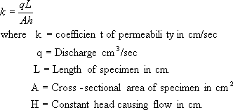

Presentation of data

The coefficient of permeability is reported in cm/sec at 27º C. The dry density, the void ratio and the degree of saturation shall be reported. The test results should be tabulated as below:

Details of sample

Diameter of specimen cm Length of specimen (L) cm Area of specimen (A) cm² Specific gravity of soil G_{s} Volume of specimen (V) cm³ Weight of dry specimen (W_{s}) gm Moisture content %

Tab 10.1 Observation sheet for Permeability determination
Experiment No. |  | 1 | 2 | 3
Length of specimen | L(cm)
Area of specimen | A(cm²)
Time t | (sec)
Discharge | q(cm³)
Height of water | h(cm)
Temperature | (º C)

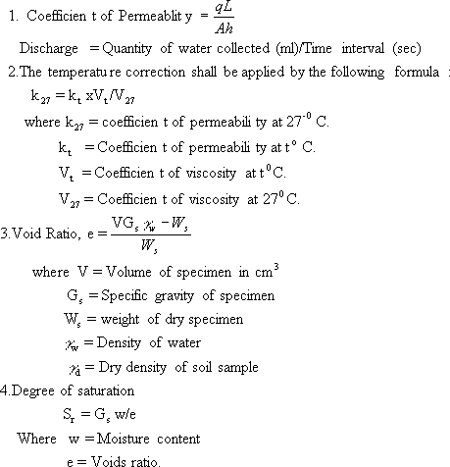

EXPERIMENT NO-8

PERMEABILITY TEST BY FALLING HEAD METHOD

Objective
Determine the coefficient of permeability of the given soil sample, using falling head method.

Need and scope
The test results of the permeability experiments are used

- To estimate ground water flow.
- To calculate seepage through dams.
- To find out the rate of consolidation and settlement of structures.
- To plan the method of lowering the ground water table.
- To calculate the uplift pressure and piping.
- To design the grouting.
- To design pits for recharging.
- And also for soil freezing tests.

Thus the study of seepage of water through soil is very important, with wide field applications.

The falling head method of determining permeability is used for soil with low discharge, where as the constant head permeability test is used for coarse-grained soils with a reasonable discharge in a given time. For very fine-grained soil, capillarity permeability test is recommended.

Principle of the experiment
The passage of water through porous material is called seepage. A material with continuous voids is called a permeable material. Hence permeability is a property of a porous material which permits passage of fluids through inter connecting conditions. Hence permeability is defined as the rate of flow of water under laminar conditions through a unit cross-sectional area perpendicular to the direction of flow through a porous medium under unit hydraulic gradient and under standard temperature conditions.

The principle behind the test is Darcy’s law for laminar flow. The rate of discharge is proportional to (i x A) q= kiA

Where, q= Discharge per unit time.
A=Total area of c/s of soil perpendicular to the direction of flow. i=hydraulic gradient.
k=Darcy’s coefficient of permeability
= the mean velocity of flow that will occur through the cross-sectional area under unit hydraulic gradient.

Apparatus
- Permeameter with its accessories.
- Standard soil specimen.
- Deaired water.
- Balance to weigh up to 1 gm.
- I.s sieves 4.75 mm and 2 mm.
- Mixing pan.
- Stop watch.
- Measuring jar.
- Meter scale.
- Thermometer.
- Container for water.
- Trimming knife etc.

Knowledge of equipment
- The permeameter is made of non-corrodible material with a capacity of 1000 ml, with an internal diameter of 100/0.1 mm and effective height of 127.3/ 0.1 mm.
- The mould has a detachable base plate and a removable exterior collar.
- The compacting equipment has a circular face with 50 mm diameter and a length of 310 mm with a weight of 2.6 kg.
- The drainage base is a porous disc, 12 mm thick with a permeability 10 times that of soil.
- The drainage cap is also a porous disc of 12 mm thickness with an inlet/outlet fitting.
- The container tank has an overflow valve. There is also a graduated jar to collect discharge.
- The stand pipe arrangements are done on a board with 2 or 3 glass pipes of different diameters.

Preparation of the specimen
The preparation of the specimen for this test is important. There are two types of specimen, the undisturbed soil sample and the disturbed or made up soil sample.

Undisturbed soil specimen

The preparation of the sample is as follows.

  - Note down-sample no., borehole no., depth at which sample is taken.
  - Remove the protective cover (wax) from the sampling tube.
  - Place the sampling tube in the sample extractor or and push the plunger to get a cylindrical shaped specimen not larger than 85 mm diameter and height equal to that of the mould.
  - This specimen is placed centrally over the drainage disc of base plate.
  - The annular space in between the mould and specimen is filled with an impervious material like cement slurry to block the side leakage of the specimen.
  - Protect the porous disc when cement slurry is poured.

  - Compact the slurry with a small tamper.
  - The drainage cap is also fixed over the top of the mould.
  - The specimen is now ready for test.

Disturbed specimen

The disturbed specimen can be prepared by static compaction or by dynamic compaction.

Preparation of statically compacted (disturbed) specimen

  - Take 800 to 1000 gms of representative soil and mix with water to O.M.C determined by I.S Light Compaction test. Then leave the mix for 24 hours in an airtight container.
  - Find weight W of soil mix for the given volume of the mould and hence find the dry
  - Now, assemble the permeameter for static compaction. Attach the 3 cm collar to the bottom end of
0.3 liters mould and the 2 cm collar to the top end. Support the mould assembly over 2.5 cm end plug, with 2.5 cm collar resting on the split collar kept around the 2.5 cm- end plug. The inside of the
0.3 lit. Mould is lightly greased.
  - Put the weighed soil into the mould. Insert the top 3 cm end plug into the top collar, tamping the soil with hand.
  - Keep, now the entire assembly on a compressive machine and remove the split collar. Apply the compressive force till the flanges of both end plugs touch the corresponding collars. Maintain this load for 1 mt and then release it.
  - Then remove the top 3 cm plug and collar place a filter paper on fine wire mesh on the top of the specimen and fix the perforated base plate.
  - Turn the mould assembly upside down and remove the 2.5 cm end plug and collar. Place the top perforated plate on the top of the soil specimen and fix the top cap on it, after inserting the seating gasket.
  - Now the specimen is ready for test.

Preparation of Dynamically Compacted Disturbed sample

  - Take 800 to 1000 gm of representative soil and mix it with water to get O.M.C, if necessary. Have the mix in airtight container for 24 hours.
  - Assemble the permeameter for dynamic compaction. Grease the inside of the mould and place it upside down on the dynamic compaction base. Weigh the assembly correct to a gram (w). Put the 3 cm collar to the other end.
  - Now, compact the wet soil in 2 layers with 15 blows to each layer with a 2.5 kg dynamic tool. Remove the collar and then trim off the excess. Weigh the mould assembly with the soil (W₂).
  - Place the filter paper or fine wore mesh on the top of the soil specimen and fix the perforated base plate on it.
  - Turn the assembly upside down and remove the compaction plate. Insert the sealing gasket and place the top perforated plate on the top of soil specimen. And fix the top cap.
  - Now, the specimen is ready for test.

Experimental Procedure

- Prepare the soil specimen as specified.
- Saturate it. Deaired water is preferred.
- Assemble the permeameter in the bottom tank and fill the tank with water.
- Inlet nozzle of the mould is connected to the stand pipe. Allow some water to flow until steady flow is obtained.
- Note down the time interval t for a fall of head in the stand pipe h.
- Repeat step 5 three times to determine t for the same head.
- Find a by collecting q for the stand pipe. Weigh it correct to 1 gm and find a from q/h=a.

Therefore the coefficient of permeability
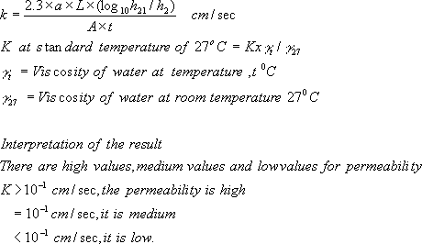

Observations

Tab 11.1 Observation sheet for coefficient of permeability determination

S.No | Details | 1st set | 2nd set
1 | Area of stand pipe (dia. 5 cm) a
2 | Cross sectional area of soil specimen A
3 | Length of soil specimen L
4 | Initial reading of stand pipe h₁
5 | Final reading of stand pipe h₂
6 | Time t
7 | Test temperature T
8 | Coefficient of permeability at T k_{t}
9 | Coefficient of permeability at 27º C k₂₇

General Remarks

- During test there should be no volume change in the soil, there should be no compressible air present in the voids of soil i.e. soil should be completely saturated. The flow should be laminar and in a steady state condition.

- Coefficient of permeability is used to assess drainage characteristics of soil, to predict rate of settlement founded on soil bed.

EXPERIMENT NO-9
CBR TEST
Aim
Determine the california bearing ratio by conducting a load penetration test in the laboratory.

Need and scope

The california bearing ratio test is penetration test meant for the evaluation of sub grade strength of roads and pavements. The results obtained by these tests are used with the empirical curves to determine the thickness of pavement and its component layers. This is the most widely used method for the design of flexible pavement.
This instruction sheet covers the laboratory method for the determination of c.b.r. Of undisturbed and remoulded /compacted soil specimens, both in soaked as well as unsoaked state.

Planning and organization
Equipments and tool required are

- Cylindrical mould with inside dia 150 mm and height 175 mm, provided with a detachable extension collar 50 mm height and a detachable perforated base plate 10 mm thick.
- Spacer disc 148 mm in dia and 47.7 mm in height along with handle.
- Metal rammers. Weight 2.6 kg with a drop of 310 mm (or) weight 4.89 kg a drop 450 mm.
- Weights. One annular metal weight and several slotted weights weighing 2.5 kg each, 147 mm in dia, with a central hole 53 mm in diameter.
- Loading machine. With a capacity of at least 5000 kg and equipped with a movable head or base that travels at an uniform rate of 1.25 mm/min. Complete with load indicating device.
- Metal penetration piston 50 mm dia and minimum of 100 mm in length.
- Two dial gauges reading to 0.01 mm.
- Sieves. 4.75 mm and 20 mm i.s. Sieves.
- Miscellaneous apparatus, such as a mixing bowl, straight edge, scales soaking tank or pan, drying oven, filter paper and containers.

Definition of CBR
It is the ratio of force per unit area required to penetrate a soil mass with standard circular piston at the rate of 1.25 mm/min. to that required for the corresponding penetration of a standard material.
C.B.R. = Test load/Standard load * 100

The following table gives the standard loads adopted for different penetrations for the standard material with a C.B.R. value of 100%
Tab 18.1 values of Penetration vs Standard load

Penetration of plunger(mm) | Standard load (kg)
2.5 | 1370
5 | 2055
7.5 | 2630
10 | 3180
12.5 | 3600

The test may be performed on undisturbed specimens and on remoulded specimens which may be compacted either statically or dynamically.

Preparation of Test Specimen

- Undisturbed specimen

Attach the cutting edge to the mould and push it gently into the ground. Remove the soil from the outside of the mould which is pushed in. When the mould is full of soil, remove it from weighing the soil with the mould or by any field method near the spot.
Determine the density

Remoulded specimen

Prepare the remoulded specimen at Proctor’s maximum dry density or any other density at which C.B.R. is required. Maintain the specimen at optimum moisture content or the field moisture as required. The material used should pass 20 mm I.S. sieve but it should be retained on 4.75 mm I.S. sieve. Prepare the specimen either by dynamic compaction or by static compaction.
Dynamic Compaction

  - Take about 4.5 to 5.5 kg of soil and mix thoroughly with the required water.

  - Fix the extension collar and the base plate to the mould. Insert the spacer disc over the base (See Fig.38). Place the filter paper on the top of the spacer disc.
  - Compact the mix soil in the mould using either light compaction or heavy compaction. For light compaction, compact the soil in 3 equal layers, each layer being given 55 blows by the 2.6 kg rammer. For heavy compaction compact the soil in 5 layers, 56 blows to each layer by the 4.89 kg rammer.
  - Remove the collar and trim off soil.
  - Turn the mould upside down and remove the base plate and the displacer disc.
  - Weigh the mould with compacted soil and determine the bulk density and dry density.
  - Put filter paper on the top of the compacted soil (collar side) and clamp the perforated base plate on to it.

Static compaction

- Calculate the weight of the wet soil at the required water content to give the desired density when occupying the standard specimen volume in the mould from the expression.
W =desired dry density * (1+w) V

- Where W = Weight of the wet soil
- w = desired water content
- V = volume of the specimen in the mould = 2250 cm³ (as per the mould available in laboratory)
- Take the weight W (calculated as above) of the mix soil and place it in the mould.
- Place a filter paper and the displacer disc on the top of soil.
- Keep the mould assembly in static loading frame and compact by pressing the displacer disc till the level of disc reaches the top of the mould.
- Keep the load for some time and then release the load. Remove the displacer disc.
- The test may be conducted for both soaked as well as unsoaked conditions.
- If the sample is to be soaked, in both cases of compaction, put a filter paper on the top of the soil and place the adjustable stem and perforated plate on the top of filter paper.
- Put annular weights to produce a surcharge equal to weight of base material and pavement expected in actual construction. Each 2.5 kg weight is equivalent to 7 cm construction. A minimum of two weights should be put.
- Immerse the mould assembly and weights in a tank of water and soak it for 96 hours. Remove the mould from tank.
- Note the consolidation of the specimen.

Procedure for Penetration Test

- Place the mould assembly with the surcharge weights on the penetration test machine.
- Seat the penetration piston at the center of the specimen with the smallest possible load, but in no case in excess of 4 kg so that full contact of the piston on the sample is established.
- Set the stress and strain dial gauge to read zero. Apply the load on the piston so that the penetration rate is about 1.25 mm/min.

4. Record the load readings at penetrations of 0.5, 1.0, 1.5, 2.0, 2.5, 3.0, 4.0, 5.0, 7.5, 10 and 12.5 mm. Note the maximum load and corresponding penetration if it occurs for a penetration less than 12.5 mm.
5. Detach the mould from the loading equipment. Take about 20 to 50 g of soil from the top 3 cm layer and determine the moisture content.
6.

Observations

For Dynamic Compaction

Optimum water content (%) :

Weight of mould + compacted specimen g :

Weight of empty mould g :

Weight of compacted specimen g :

Volume of specimen cm³ :
Bulk density g/cc :

Dry density g/cc :

For static compaction

Dry density g/cc :

Moulding water content % :

Wet weight of the compacted soil, (W)g :

Period of soaking 96 hrs. (4days) :

For penetration Test

Calibration factor of the proving ring 1 Div. = 1.176 kg Surcharge weight used (kg) 2.0 kg per 6 cm construction Water content after penetration test %
Least count of penetration dial 1 Div. = 0.01 mm

If the initial portion of the curve is concave upwards, apply correction by drawing a tangent to the curve at the point of greatest slope and shift the origin. Find and record the correct load reading corresponding to each penetration.

C.B.R. = P_{T}/P_{S} * 100
Where P_{T} = Corrected test load corresponding to the chosen penetration from the load penetration curve.
P_{S} = Standard load for the same penetration taken from the table .
Tab 18.2 Tabulation for CBR test

Penetration Dial |  | Load Dial |  | Corrected Load
Readings | Penetration (mm) | Proving ring reading | Load (kg)

Results

C.B.R. of specimen at 2.5 mm penetration:……………

C.B.R. of specimen at 5.0 mm penetration:…………….

EXPERIMENT 10
DIRECT SHEAR TEST

Aim: To determine the shear strength parameters of a soil (i.e. Cohesion intercept and angle of internal friction) by direct shear test.

Theory: Direct shear test – description, merits and limitations.

Apparatus
  - Shear box assembly consisting of upper and lower parts of shear box coupled together with two pins or clamping screws.
    - Container for shear box
    - Grid plates – two pairs
    - Base plate with cross grooves on its top face to fit into the shear box.
    - Loading pad with a steel ball on its top which distributes the load over the specimen, normal to the shear plane.
- Loading frame
- Calibrated weights
- Proving ring with dial gauge to measure shear force
- Balance with weights.
- Dial gauge
- Spatula, straight edge, sample trimmer.

Preparation of the specimen

Remoulded specimens: Cohesive soils may be compacted to the required density and moisture content in a separate mould. The sample is extracted and trimmed to the required size.
The soil may be compacted to the required density and moisture content directly into the shear box after fixing the two halves of the shear box together by means of fixing screws.
* Non Cohesive soils may be tamped in the shear box for required density with the base plate and the grid plate at the bottom of the box.

Procedure: (Undrained Test)
- Assemble the shear box with the base plate at the bottom and a grid plate over it, the two halves of the box being connected by the locking screws. The serrations of the grid plate should be at right angles to the direction of shear.
- Place the specimen over the bottom grid plate. Place another grid plate at the top of the specimen such that the serrations of the plate or in contact with the specimen and at right angles to the direction of shear. Place the loading pad on the top of the grid plate.

- Place the shear box inside the container of the shear box. The container can move over roller supports at its bottom.
- Set the lower part of the shear box to bear against the load jack, the upper part of the box against the proving ring. Set the gauge of the proving ring to read zero.
- Apply the required normal stress on the specimen inside the shear box through a lever arrangement.
- Remove the locking screws or pins so that both the parts of the shear box are free to move relative to each other.
- Conduct the test by applying a horizontal shear load to failure or to 20% longitudinal displacement, whichever occurs first. Take the proving ring dial readings corresponding to known displacement dial readings.
- At the end of the test, remove the specimen from the box and determine its final water content (for cohesive soil only).
- Repeat the test on identical specimens, under different normal stresses (0.25 kgf/cm2,
kgf/cm2, 1 kgf/cm2, 1.5 kgf/cm2, 2 kgf/cm2, and 2.5 kgf/cm2 etc.). A minimum of three (preferably four) tests shall be made on separate specimens of the samedensity.

Results and Discussions:
------------------------------------------------------------------------------------------------------------

Observations and Calculations

1. Type of soil:
2. Are of the specimen (Ao) | = ---------------------------------------- | cm2
3. Volume of the specimen (V) | = ---------------------------------------- | cm3
4. Bulk density (b) | = ---------------------------------------- | g/cm3
- Moisture content (w)  - Rate of strain | = ----------------------------------------  = ---------------------------------------- | %
7. Proving ring constant | = ----------------------------------------
8.
 | Normal | Displacement | Displacement | Corrected | Proving | Shear | Shear
Trial | stress | dial reading |  | Area | ring | force | Stress
No. |  | Div. | cm | (A) | reading | (P)
 | kgf/cm2 |  |  |  | Div. | kgf | kgf/cm2
1.

Corrected area = A = = ---------------------------------------- | cm2
Shear load = P = Proving ring reading x Proving ring constant = ------------------ | kgf
Shear stress = P/A =

Conduct the test for different normal stresses (at least four normal stresses). For each test, plot shear stress vs displacement curve to obtain maximum shear stress at failure.

Tabulation

Trial No.
Normal stress () | kg/cm2
Shear stress at failure (f) | kgf/cm2

Plot the graph of normal stress (x – axis) vs. maximum shear stress (y-axis). Adopt same scale to plot both normal stress and maximum shear stress.
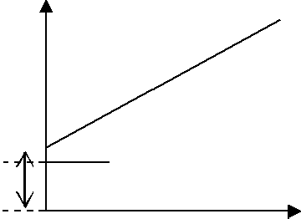

Relevant BIS Code: IS: 2720, Part-13, 1986

Result
Angle of shearing resistance =  = c
Cohesion intercept = c = kgf/cm2

EXPERIMENT 11
UNCONFINED COMPRESSION TEST

Aim: To determine the unconfined compressive strength of clayey soil.

Theory: Unconfined compressive strength; UCC test and its limitations.

Apparatus
  - Compression device of suitable type
  - Sample ejector
  - Deformation measuring dial gauge
  - Remoulding apparatus – for specimen preparation
  - Thermostatically controlled oven
  - Balance with weights
  - Vernier callipers.
  - Air tight, non-corrodible containers for water content determination.

Preparation of the Specimen
- The specimen for the test shall have a minimum diameter of 38 mm and a height to diameter ratio of 2. The largest particle contained within the test specimen should be smaller than 1/8th the specimen diameter.

- The remoulded specimen may be prepared by compacting the soil at the considered water content and dry density in a bigger mould, and then extracted using sampling tube.
- The remoulded specimen may be prepared directly using a split mould.

Procedure
- Measure the initial length, diameter and mass of the specimen.
- Place the specimen on the bottom plate of the loading device. Adjust the upper plate to make contact with the specimen. Set the load dial gauge (i.e. proving ring dial) and the compression dial gauge to zero.
- Apply axial compressive load so as to produce axial strain at a rate of 0.5 to 2 percent per minute. Take the proving ring dial readings corresponding to compression dial readings at suitable intervals.
- Compress the specimen until failure surfaces have definitely developed or the stress- strain curve is well past its peak or until an axial strain of 20% is reached, whichever occurs first.
- Stop loading; Remove the failed specimen; Sketch the failure pattern; Keep the soil sample taken from the failure zone for moisture content determination.

Observations and Calculations
- Type of soil:
- Specimen preparation procedure: Undisturbed / remoulded / compacted
- Initial dia of the specimen (D0) = cm.
- Initial length of the specimen (L0) = cm
- Initial area of the cross section of the specimen
(A0) = cm2
6. Rate of strain = ……………………………………
- Water content determination (initial)
Container No. |  | 1 | 2
Mass of (container + wet soil) | g
Mass of (container + dry soil) | g
Mass of dry soil | g
Mass of container | g
Mass of water | g
Water content (wi) | %

Specimen | Initial mass (m), | b, g/cm3 | (wi), % | d, g/cm3
No. | G
1.
2.
3.

 | Axial | Proving | Axial | Axial | Corrected | Axial | Remarks
Compression | compression of
dial reading | the specimen | ring | load | Strain | area | stress
 | (L) | reading | (P) | () | (A) | ()
div | Cm | div | kgf | Ratio | cm2 | kgf/cm2

Results and Discussions:

Conduct tests on three identical specimens.
After the test
Specimen No. | Failure Pattern | Sketch of the failed specimen
1.
2.
3.

  - Water content determination (final)
Container No. |  | 1 | 2 | 3
Mass of (container + wet soil) | g
Mass of (container + dry soil) | g
Mass of dry soil | g
Mass of container | g
Mass of water | g
Water content | %

  - Plot the graph of axial stress Vs. Axial strain. From the graph:

SPECIMEN CALCUALTIONS;
Axial load (P)= Proving ring constant x proving ring reading = kgf
Axial strain = L/Lo = ………………………………………
Corrected area (A) = Ao/(1 - ) = cm2
Axial stress = P/A = kgf/cm2

Result
Unconfined compressive strength = qu =… kgf/cm2

EXPERIMENT 12
UNDRAINED TRIAXIAL TEST
Aim
To find the shear parameters of the soil by undrained triaxial test.

Need and scope
The standard consolidated undrained test is compression test, in which the soil specimen is first consolidated under all round pressure in the triaxial cell before failure is brought about by increasing the major principal stress.
It may be performing with or without measurement of pore pressure although for most applications the measurement of pore pressure is desirable.

Knowledge of equipment
A constant rate of strain compression machine of which the following is a brief description of one is in common use.
- A loading frame in which the load is applied by a yoke acting through an elastic dynamometer, more commonly called a proving ring which used to measure the load. The frame is operated at a constant rate by a geared screw jack. It is preferable for the machine to be motor driven, by a small electric motor.
- A hydraulic pressure apparatus including an air compressor and water reservoir in which air under pressure acting on the water raises it to the required pressure, together with the necessary control valves and pressure dials.
A tri axial cell is to take 3.8 cm dia and 7.6 cm long samples, in which the sample can be subjected to an all round hydrostatic pressure, together with a vertical compression load acting through a piston. The vertical load from the piston acts on a pressure cap. The cell is usually designed with a non-ferrous metal top and base connected by tension rods and with walls formed of Perspex.

Apparatus for preparation of the sample
- 3.8 cm (1.5 inch) internal diameter 12.5 cm (5 inches) long sample tubes.
- Rubber ring.
- An open ended cylindrical section former, 3.8 cm inside dia, fitted with a small rubber tube in its side.
- Stop clock.
- Moisture content test apparatus.
- A balance of 250 gm capacity and accurate to 0.01 gm.

Experimental Procedure
- The sample is placed in the compression machine and a pressure plate is placed on the top. Care must be taken to prevent any part of the machine or cell from jogging the sample while it is being setup, for example, by knocking against this bottom of the loading piston. The probable strength of the sample is estimated and a suitable proving ring selected and fitted to the machine.

- The cell must be properly set up and uniformly clamped down to prevent leakage of pressure during the test, making sure first that the sample is properly sealed with its end caps and rings (rubber) in position and that the sealing rings for the cell are also correctly placed.

- When the sample is setup water is admitted and the cell is fitted under water escapes from the beed valve, at the top, which is closed. If the sample is to be tested at zero lateral pressure water is not required.

- The air pressure in the reservoir is then increased to raise the hydrostatic pressure in the required amount. The pressure gauge must be watched during the test and any necessary adjustments must be made to keep the pressure constant.

- The handle wheel of the screw jack is rotated until the under side of the hemispherical seating of the proving ring, through which the loading is applied, just touches the cell piston.

- The piston is then removed down by handle until it is just in touch with the pressure plate on the top of the sample, and the proving ring seating is again brought into contact for the begging of the test.

Observations
- The machine is set in motion (or if hand operated the hand wheel is turned at a constant rate) to give a rate of strain 2% per minute.
- The strain dial gauge reading is then taken and the corresponding proving ring reading is taken the corresponding proving ring chart. The load applied is known.
- The experiment is stopped at the strain dial gauge reading for 15% length of the sample or 15% strain.

Tab : Tabulation sheet for Tri axial test

Cell pressure kg/cm² | Strain dial | Proving ring reading | Load on sample kg | Corrected area cm² | Deviator stress

Tab 16.2 Tabulation sheet for shear strength determination

Sample No. | Wet bulk density gm/cc | Cell pressure kg/cm² | Compressive stress at failure | Strain at failure | Moisture content | Shear strength (kg/cm²) | Angle of shearing resistance
1
2
3

General Remarks

- It is assumed that the volume of the sample remains constant and that the area of the sample increases uniformly as the length decreases. The calculation of the stress is based on this new area at failure, by direct calculation, using the proving ring constant and the new area of the sample. By constructing a chart relating strain readings, from the proving ring, directly to the corresponding stress.

- The strain and corresponding stress is plotted with stress abscissa and curve is drawn. The maximum compressive stress at failure and the corresponding strain and cell pressure are found out.

- The stress results of the series of triaxial tests at increasing cell pressure are plotted on a mohr stress diagram. In this diagram a semicircle is plotted with normal stress as abscissa shear stress as ordinate.

- The condition of the failure of the sample is generally approximated to by a straight line drawn as a tangent to the circles, the equation of which is  = C +  tan. The value of cohesion, C is read of the shear stress axis, where it is cut by the tangent to the mohr circles, and the angle of shearing resistance () is angle between the tangent and a line parallel to the shear stress.

Result
Shear Strength of the given soil sample is…………

EXPERIMENT 13
DIFFERENTIAL FREE SWELL (DFS)
Aim
To determine the free swell index of soil as per IS: 2720
Apparatus
i) IS Sieve of size 425µm
ii) Oven
iii) Balance, with an accuracy of 0.01g
iv) Graduated glass cylinder- 2 nos., each of 100ml capacity
Procedure
i) Take two specimens of 10g each of pulverised soil passing through 425µm IS Sieve and oven-dry.
ii) Pour each soil specimen into a graduated glass cylinder of 100ml capacity.
iii) Pour distilled water in one and kerosene oil in the other cylinder upto 100ml mark.
iv) Remove entrapped air by gently shaking or stirring with a glass rod.
v) Allow the suspension to attain the state of equilibrium (for not less than 24hours).
vi) Final volume of soil in each of the cylinder should be read out.
FORMULAE
Free swell index = [V_{d} – V_{k}] / V_{k} x 100%
where,
V_{d} = volume of soil specimen read from the graduated cylinder containing distilled water.
V_{k} = volume of soil specimen read from the graduated cylinder containing kerosene.
Comparison
Free Swell  Index | Degree of  expansiveness | LL | PL | SL
<20 | Low | 0.50 | 0-35% | >17%
20-35 | Moderate | 40-60% | 25-50% | 8-18%
35-50 | High | 50-75% | 35-65% | 6-12%
>50 | Very high | >60% | >45% | <10%
RESULTS
EXPERIMENT 14
HYDROMETER ANALYSIS

IS: 2720 (Part 4) – 1985 (Reaffirmed-2006)

THEORY:
Soil gradation (sieve analysis) is the distribution of particle sizes expressed as a percent of the total dry weight. The percentage of sand, silt and clay in the inorganic fraction of soil is measured in this procedure. The method is based on Stoke’s law governing the rate of sedimentation of particles suspended in water.

NEED AND SCOPE:
The results of testing will reflect the condition and characteristics of the aggregate from which the sample is obtained. Therefore, when sampling, it is important to obtain a disturbed representative sample that is representative of the source being tested becausethe distribution of different grain sizes affects the engineering properties of soil.

APPARATUS REQUIRED:
- Glass cylinders of 1000-ml capacity
- Thermometer
- Hydrometer
- Electric mixer with dispersing cup
- Balance sensitive to ± 0.01g
- Stop watch & Beaker

RE-AGENTS REQUIRED:
Dispersing solution-4% (Dissolve 5 g of sodium hexa-metaphosphate in de-ionized water of 125 ml)

PROCEDURE:
Soil passing 4.75mm I.S. Sieve and retained on 75micron I.S. Sieve contains no fines. Those soils can be directly dry sieved rather than wet sieving.

Wet Sieving:
If the soil contains a substantial quantity (say more than 5%) of fine particles, a wet sieve analysis is required.
All lumps are broken into individual particles.
  - Take 200gm of oven dried soil sample and soaked with water.
  - If de-flocculation is required, 2% calgon solution is used instead of water.
  - The sample is stirred and left for soaking period of at least 1 hour.
  - The slurry is then sieved through 4.75 mm sieve and washed with a jet of water.
  - The material retained on the sieve is the gravel fraction, which should be dried in oven and weighed.
  - The material passing through 4.75 mm sieve is sieved through 75 micron sieve.
  - The material is washed until the water filtered becomes clear.
  - The soilpassed through 75 micron sieve is collected and dried in oven.

Hydrometer Analysis:
- Take 40 gm of the oven dry soil sample after removing soluble salts and organic matter if any.
- It is then mixed with 4% solution of dispersing agent in water to get a known amount of suspension by volume and stirred well.
- This suspension should be made 24 hrs before testing.
- After 24 hours, the suspension is again mixed using Electric mixer with dispersing cup and
- Following stirring with mixer, the suspension which is made up to 1000 ml in the measuring cylinder is turned end to end for even distribution of particles before the time‘t’ begins to be measured.
- The hydrometer readings are recorded at regular intervals as indicated in the data sheet. From the data obtained the particle size distribution curve is plotted in the semi-logarithmic graph sheet along with the dry sieve analysis results.

CORRECTIONS (INDIVIDUAL):

Meniscus Correction (C_{m}):
Since the suspension is opaque, the readings will be taken at the top of the meniscus while the actual should be from the bottom of the meniscus. It is constant for a hydrometer (Always positive).

Temperature Correction (C_{t}):
If the temperature is less than 27⁰C, the correction is negative and vice-versa. Temperature should be measured from starting till end of the tests at regular intervals and are averaged. Then it is compared with the standard temperature (27⁰C).

Dispersion Agent Correction (C_{d}):
Addition of calgon always increases the specific gravity of the specimen. Hence, this correction is always negative.

ALTERNATIVE CORRECTIONS (COMBINED):

Composite Correction for Dispersion Agent and Temperature, (C_{t} – C_{d}):
Insert the hydrometer in the comparison cylinder containing dispersant solution in distilled water with the same concentration as used for making the soil suspension. The Composite correction (C_{t} – C_{d}) is negative of the hydrometer reading corresponding to the top meniscus. It has to be taken every 30 minutes throughout the test.

Tabulation
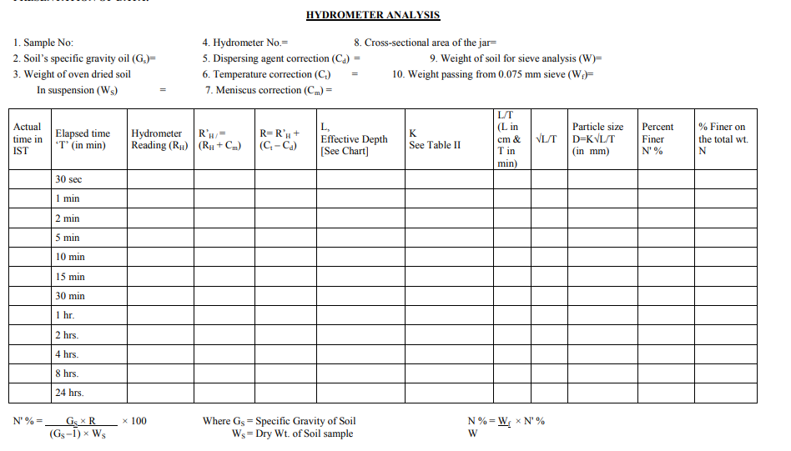

Calculation

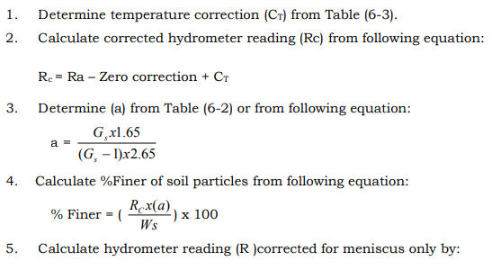
Result

EXPERIMENT 15

CONSOLIDATION TEST

Aim
Determine the settlements due to primary consolidation of soil by conducting one dimensional test.

Need and scope
The test is conducted to determine the settlement due to primary consolidation. To determine the following

- Rate of consolidation under normal load.
- Degree of consolidation at any time.
- Pressure-void ratio relationship.
- Coefficient of consolidation at various pressures.
- Compression index.

From the above information it will be possible for us to predict the time rate and extent of settlement of structures founded on fine-grained soils. It is also helpful in analyzing the stress history of soil. Since the settlement analysis of the foundation depends mainly on the values determined by the test, this test is very important for foundation design.

Planning and organization
- Consolidometer consisting essentially
  - A ring of diameter = 60mm and height = 20mm

  - Two porous plates or stones of silicon carbide, aluminum oxide or porous metal.

  - Guide ring.

  - Outer ring.

  - Water jacket with base.

  - Pressure pad.

  - Rubber basket.

- Loading device consisting of frame, lever system, loading yoke dial gauge fixing device and weights.
- Dial gauge to read to an accuracy of 0.002mm.
- Thermostatically controlled oven.
- Stopwatch to read seconds.
- Sample extractor.
- Miscellaneous items like balance, soil trimming tools, spatula, filter papers, sample containers.

Principle
When a compressive load is applied to soil mass, a decrease in its volume takes place, the decrease in volume of soil mass under stress is known as compression and the property of soil mass pertaining to its tendency to decrease in volume under pressure is known as compressibility. In a saturated soil mass having its void filled with incompressible water, decrease in volume or compression can take place when water is expelled out of the voids. Such a compression resulting from a long time static load and the consequent escape of pore water is termed as consolidation.
Then the load is applied on the saturated soil mass, the entire load is carried by pore water in the beginning. As the water starts escaping from the voids, the hydrostatic pressure in water gets gradually dissipated and the load is shifted to the soil solids which increases effective on them, as a result the soil mass decrease in volume. The rate of escape of water depends on the permeability of the soil.

- From the sample tube, eject the sample into the consolidation ring. The sample should project about one cm from outer ring. Trim the sample smooth and flush with top and bottom of the ring by using a knife. Clean the ring from outside and keep it ready from weighing.
- Remolded sample:

  - Choose the density and water content at which sample has to be compacted from the moisture density relationship.
  - Calculate the quantity of soil and water required to mix and compact.

  - Compact the specimen in compaction mould in three layers using the standard rammers.

  - Eject the specimen from the mould using the sample extractor.

Procedure
- Saturate two porous stones either by boiling in distilled water about 15 minute or by keeping them submerged in the distilled water for 4 to 8 hrs. Wipe away excess water. Fittings of the consolidometer which is to be enclosed shall be moistened.
- Assemble the consolidometer, with the soil specimen and porous stones at top and bottom of specimen, providing a filter paper between the soil specimen and porous stone. Position the pressure pad centrally on the top porous stone.
- Mount the mould assembly on the loading frame, and center it such that the load applied is axial.
- Position the dial gauge to measure the vertical compression of the specimen. The dial gauge holder should be set so that the dial gauge is in the begging of its releases run, allowing sufficient margin for the swelling of the soil, if any.
- Connect the mould assembly to the water reservoir and the sample is allowed to saturate. The level of the water in the reservoir should be at about the same level as the soil specimen.
- Apply an initial load to the assembly. The magnitude of this load should be chosen by trial, such that there is no swelling. It should be not less than 50 g/cm³ for ordinary soils & 25 g/cm² for very soft soils. The load should be allowed to stand until there is no change in dial gauge readings for two consecutive hours or for a maximum of 24 hours.

- Note the final dial reading under the initial load. Apply first load of intensity 0.1 kg/cm² start the stop watch simultaneously. Record the dial gauge readings at various time intervals. The dial gauge readings are taken until 90% consolidation is reached. Primary consolidation is gradually reached within 24 hrs.
- At the end of the period, specified above take the dial reading and time reading. Double the load intensity and take the dial readings at various time intervals. Repeat this procedure fir successive load increments. The usual loading intensity are as follows :
a. 0.1, 0.2, 0.5, 1, 2, 4 and 8 kg/cm².
- After the last loading is completed, reduce the load to the value of the last load and allow it to stand for 24 hrs. Reduce the load further in steps of the previous intensity till an intensity of 0.1 kg/cm² is reached. Take the final reading of the dial gauge.
- Reduce the load to the initial load, keep it for 24 hrs and note the final readings of the dial gauge.
- Quickly dismantle the specimen assembly and remove the excess water on the soil specimen in oven, note the dry weight of it.

Observation and Reading
Data and observation sheet for consolidation test pressure, compression and time. Name of the project Borehole no:
Depth of the sample: Description of soil:

Empty weight of ring: Area of ring:

Diameter of ring: Volume of ring:

Height of ring: Specific gravity of soil sample:
Dial Gauge (least count)

Tab 17.1 Observation sheet for time- pressure of consolidation test

Pressure Intensity (Kg/cm²) | 0.1 | 0.2 | 0.5 | 1 | 2 | 4 | 8
Elapsed Time
0.25
1
2.5
4
6.25
9
16
25
30
1 hr
2 hrs
4 hrs
8 hrs
24 hrs

Calculations

- Height of solids (H_{S}) is calculated from the equation H_{S} = W_{S}/G * A

- Void ratio. Voids ratio at the end of various pressures are calculated from equation e = (H - H_{S})/H_{S}

- Coefficient of consolidation. The Coefficient of consolidation at each pressures increment is calculated by using the following equations:

  - C_{v} = 0.197 d²/t₅₀ (Log fitting method)
  - C_{v} = 0.848 d²/t₉₀ (Square fitting method)

In the log fitting method, a plot is made between dial readings and logarithmic of time, the time corresponding to 50% consolidation is determined.
In the square root fitting method, a plot is made between dial readings and square root of time and the time corresponding to 90% consolidation is determined. The values of C_{v} are recorded in table .

- Compression Index. To determine the compression index, a plot of voids ratio (e) V_{s} logt is made. The initial compression curve would be a straight line and the slope of this line would give the compression index C_{c}.

- Coefficient of compressibility. It is calculated as follows a_{v} = 0.435 C_{c}/Avg. pressure for the increment
where Cc = Coefficient of compressibility

- Coefficient of permeability. It is calculated as follows K = C_{v}.a_{v} *(unit weight of water)/(1+e).
Graphs
- Dial reading V_{S} log of time or
Dial reading V_{S} square root of time.
- Voids ratio V_{S} log (average pressure for the increment

Results:

EXPERIMENT 16

VANE SHEAR TEST

Objective

Determine the shear strength of a given soil specimen.

Need and scope

The structural strength of soil is basically a problem of shear strength. Vane shear test is a useful method of measuring the shear strength of clay. It is a cheaper and quicker method. The test can also be conducted in the laboratory. The laboratory vane shear test for the measurement of shear strength of cohesive soils is useful for soils of low shear strength (less than 0.3 kg/cm²) for which triaxial or unconfined tests cannot be performed. The test gives the undrained strength of the soil. The undisturbed and remoulded strength obtained are useful for evaluating the sensitivity of soil.

Equipment

  - Vane shear apparatus
  - Specimen
  - Specimen container
  - Calipers

Experimental procedure
- Prepare two or three specimens of the soil sample of dimensions of at least 37.5 mm diameter and 75 mm length in specimen.(L/D ratio 2 or 3).
- Mount the specimen container with the specimen on the base of the vane shear apparatus. If the specimen container is closed at one end, it should be provided with a hole of about 1 mm diameter at the bottom.
- Gently lower the shear vanes into the specimen to their full length without disturbing the soil specimen. The top of the vanes should be at least 10 mm below the top of the specimen. Note the readings of the angle of twist.
- Rotate the vanes at an uniform rate say 0.1º/s by suitable operating the torque application handle until the specimen fails.
- Note the final reading of the angle of twist.
- Find the value of blade height in cm.
- Find the value of blade width in cm.

Calculations & Observations
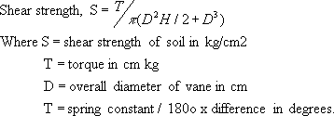

Tab 13.1 Observation sheet for shear strength determination

S.No | Initial Reading | Final Reading | Difference | T=Spring Constant* Difference/180 | G=1/π(D² H/2  + D³/6) | S=TxG | Average 'S' | Spring Constant
 | (Deg) | (Deg.) | (Deg.) | Kg-cm |  | Kg/cm² | Kg/cm² | Kg-cm

Result

The shear strength of the soil sample is

